

WBEA Low Level Design Documentation
By Chris Tornabene, Heather Hitchler & Michael Herzig
Discovery completed July 2021

Contents

Contents 2
Executive Summary 3
Rationale 4
Current Environment 5
Proposed Low Level Solution Overview 6
File containing AWS environment diagram: 6
Active Directory 7
Findings overview 7
File containing full AD discovery: 7
Compute sizing 8
File including detailed compute sizing: 8
Site to Site VPN 9
Virtual Private Gateways 9
DNS 10
SSO 10
Storage and Backup 10
Future modernization effort notes 10
Acceptance Sign-Off 11

Executive Summary
WBEA currently has on premise infrastructure at Q9 colocation site which they are looking to move into the AWS cloud. Q9 will be decommissioned after migration. WBEA has asked Insight to provide a review of the existing on-premise environment that is to be migrated in order to provide the basis for a target environment and AWS architecture.
The intent of this engagement was to perform the necessary workshops to develop a design that could be used for migration. This is known as Phase I. A separate SOW for the support of the migration will be provided once the current document is accepted.

Rationale
1. Cost reduction Cost reduction is the most popular migration motivator, as retiring legacy infrastructure in favor of more efficient AWS solutions is virtually
certain to bring costs down.

2. Agility & staff productivity Flexible AWS architecture improves business agility, while
automation allows staff to increase the pace of innovation and dedicate more time to important tasks. Security: Application and client visibility will allow increased network control allowing WBEA to identify friendly and malicious applications and act accordingly.

3. Improved security & operational resilience Migrating and modernizing with AWS hardens security to help protect against cyber-attacks, define and manage access policies, and prevent unauthorized disclosure and modification using encryption and policy-driven controls. AWS also helps ensure resiliency, providing high availability with virtually unlimited failover capacity.

4. Hardware/software end-of-life Many organizations migrate to AWS due to the end-of-life (EOL) of their hardware/software licensing and/or support. These companies see the cloud as an opportunity to improve depreciating capabilities and to end or shorten refresh cycles. This is especially compelling for organizations running Windows workloads and applications. AWS runs nearly 2x more Windows Server instances than the next largest cloud provider, according to an IDC report.

5. Data center consolidation Organizations can spend less time managing data centers and more time running their businesses by migrating to AWS.
6. Digital transformation Migrating to AWS helps businesses achieve digital transformation by boosting agility, enabling broader use of advanced technologies, and facilitating culture change.

7. Going global quickly, mergers & acquisitions (M&A) AWS customers gain access to a global network of datacenters—enabling rapid, strategic scalability. AWS also makes it easier to integrate digital assets, shortening and streamlining M&A procedures.

8. New technologies (AI/ML & IoT) Migrating to AWS is a more economical and practical solution
for meeting the data storage and computational requirements
of emerging technologies such as artificial intelligence/machine
learning (AI/ML) and internet of things (IoT).

AWS:” 8 Business Drivers That Motivate Cloud Migrations”

Current Environment
A review of the on-premise infrastructure was performed as part of the Scope of Work. All servers and dependencies were reviewed during a series of workshops. Customer provided documentation was reviewed.

Current Q9 environment:
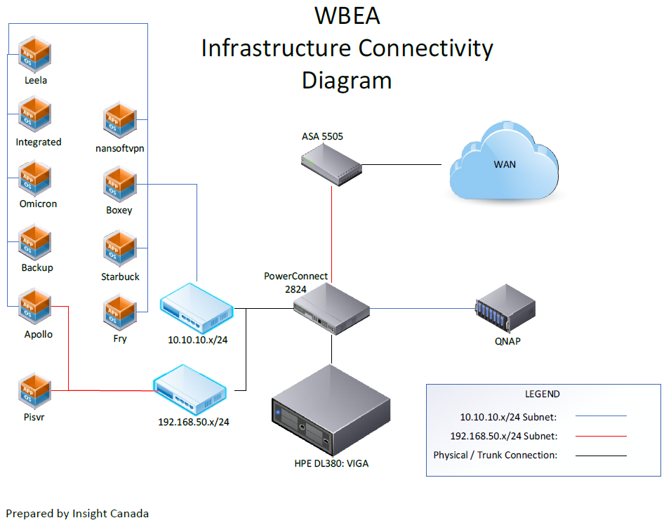

Proposed Low Level Solution Overview
The dominant migration strategy for WBEA is migrate, then modernize in the future. Server mapping was performed to provide instance sizing and estimated cost.
Workshops to explore various AWS resources were performed. As a result the below design was created.
Migration priorities:
- Ensure HIPAA compliance
- Use encryption wherever possible
- Ensure no hard-coded IPs exist prior to migration
- Ensure no certificate issues prior to migration

Proposed AWS environment:
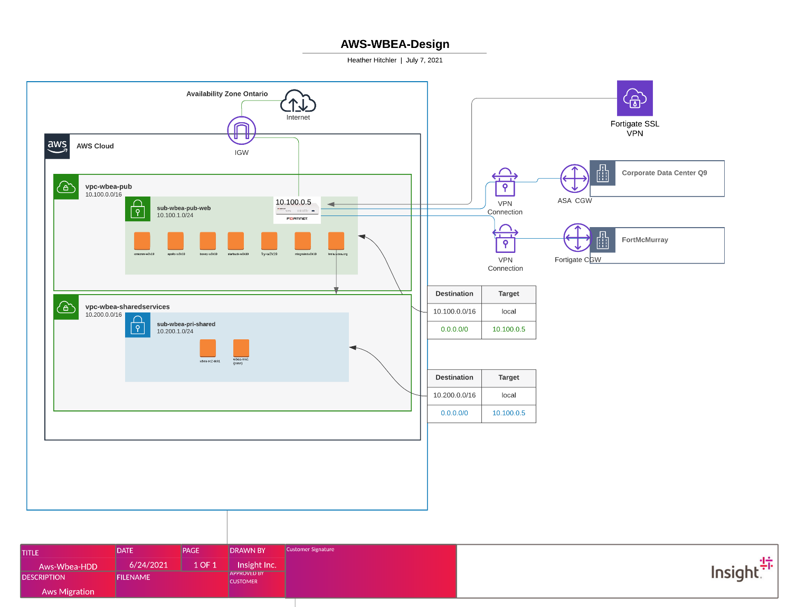

File containing AWS environment diagram:

Active Directory
WBEA will be retiring the Active Directory infrastructure at Q9. Active Directory from Fort McMurray will be extended into AWS. Once VMs are migrated to AWS, they will be joined to Fort McMurray AD.
An AD Health Check was performed on the target AD environment. Upon review of the health check, it was suggested to remediate some items within the AD infrastructure. Below is a brief summary of these findings, and the file containing the full discovery.

Findings overview

The following section can be referenced for a high level of the findings in the following document. Any findings are discussed in greater detail in their referenced section.

Issue Description | Result | Remediation
Privileged Accounts | There are Enterprise, Schema, and Domain Admin accounts. | Schema Admin and Enterprise admin groups should only be used when needed and removed from the user account after work is performed.  Limit the number of Domain admin accounts to limit the attack surface.
Password Policies | There are numerous accounts which haven’t had the passwords reset in over 60 days.  There are accounts which are set to password never expires.  There are accounts which are set to password not required. | Implement a password policy which requires passwords to be reset every 60 days and remove the password never expires setting from user accounts.  Remove the password not required setting.
Replication | Some scans were incomplete due to a server shutdown event.  After a reboot the scans completed successfully, and everything looks good. | Perform a reboot of domain controllers and rerun AD scans.  No addition remediation needed.

File containing full AD discovery:

Compute sizing
As part of the discovery process, existing VMs were monitored for several weeks. A brief recommended sizing is included below, as well as an embedded file with additional details.
Server.HostName | Recommendation.EC2.Instance.Model | Recommendation.EC2.Instance.vCPUCount | Recommendation.EC2.Instance.RAM.TotalSizeinMB | Server.OS.Name
boxey-w2k19 | t3a.large | 2 | 8192 | WindowsOS - Windows 2019 Datacenter x64
wbea-vm1 | t3a.medium | 2 | 4096 | WindowsOS - Windows 2003 SP 2
starbuck-w2k19 | t3a.large | 2 | 8192 | WindowsOS - Windows 2019 Datacenter x64
fry-w2k19 | t3a.medium | 2 | 4096 | WindowsOS - Windows 2019 Datacenter x64
leela.wbea.org | t3a.medium | 2 | 4096 | Linux - CentOS release 6.3 (Final) x86_64 (Linux 2.6.32-279.el6.x86_64)
integratedw2k19 | t3a.medium | 2 | 4096 | WindowsOS - Windows 2019 Datacenter x64
apollo-w2k19 | t3a.medium | 2 | 4096 | WindowsOS - Windows 2019 Datacenter x64
omicron-w2k19 | r5a.large | 2 | 16384 | WindowsOS - Windows 2019 Datacenter x64

File including detailed compute sizing:

Site to Site VPN
Connectivity from on Premise to AWS will utilize the AWS Internet Gateway. There will be 2 VPN attachments added to the Transit Gateway to connect to the on premise Fortinet. Active/Passive IPsec Tunnels will be configured for redundancy . The Transit Gateway spans across 2 availability zones for zero touch failover.

Snip from diagram:
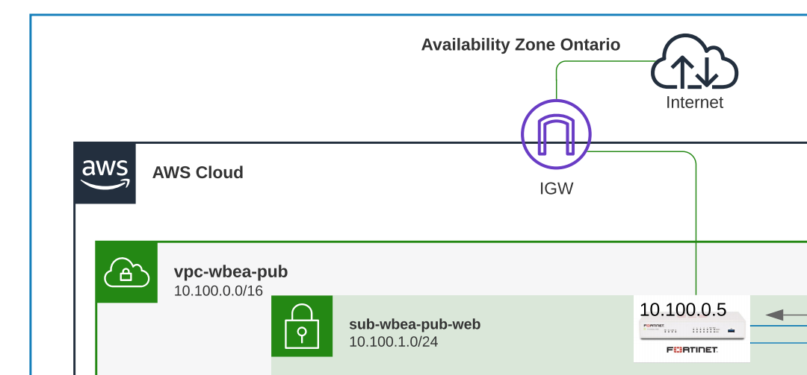

Virtual Private Gateways
The solution uses 1 Public VPC and 1 private VPCs that will span across 2 availability zones. The use of the Public VPC is for the Web Servers, 3rd party Firewalls(1 Fortinet in each AZ), and 3rd party web security appliances(1 Fortinet in each AZ). Each private VPC will contain (2) subnets .
VPC to VPC routing will occur via the Transit Gateway.

DNS
As part of Customers migration to AWS, DNS will be migrated to Route 53. Records as of 5/25/2021 are included here. An updated set of zone records may be obtained from WBEA upon migration project start.

SSO
As part of the migration, WBEA would like to implement AWS SSO. This will increase

Storage and Backup
Instances will use their native SSD volumes to store data. Snapshots will be taken of the SSDs on a per-instance basis using a GFS scheme. The Snapshots will be stored in S3 buckets. After 1 year snapshots will be deleted. Backups may be used to recover in a different AZ if the region experiences an AZ outage
Desired RPO is 15-30 minutes
Desired RTO is 45 min to 1 hour

Future modernization effort notes
Once WBEA Q9 to AWS migration is complete, they’d like to move toward modernizing their applications. Below are notes on potential strategies discussed throughout the discovery process:
- Completely retire the use of Azure
- Implement AWS SSO
- Consider migrating SQL databases to RDS
- Long-term goal: Use IoT & data lakes
- Modernize apps to become more resilient (examples include autoscaling groups, load balancers, etc.)
- Consider automating backup recovery process in case of AZ outage
- Secondary project goal: Migrate website from GreenGeeks to AWS

Acceptance Sign-Off
Project Information
Client
Project Code
Engagement Kick-off Date
Presentation Date

We have reviewed and agreed to the information described in this document and referenced attachments.

Client Acceptance Signoff Signature
Jacob Jesheem | Date of Acceptance

