**RESUME**

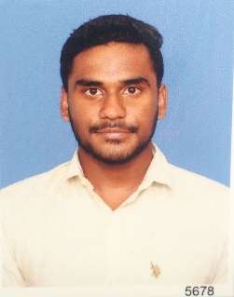Name :Shanmugasundaram P

Date of Birth :18/09/1998

Phone Number :9930778797

Email :anandanandkumar83@gmail.com

Address :43/4,

Pavalli Road,

Virudhunagar.

**Academic Qualifications:**

|  |  |  |  |  |
| --- | --- | --- | --- | --- |
| COURSE | INSTITUTION | NAME OF THE BOARD | YEAR OF PASSING | % OF MARKS |
| SSC | St.Anne’s High School | State board | 2014 | 60.2 |
| Diploma in Computer Engineering | S.Vellaichamy Nadar Polytechnic College. | Autonomous | 2017 | 86.4 |
| B. E | PSG Institute of Technology and Applied Research. | Anna University | 2020 | 60.4 upto 7th Semester |

**SUBJECTS OF SPECIALIZATION**

* Web Designing.
* Computer Networks.
* Cryptography and Network Security.

**PROJECT WORK**

* Hostel Management System.
* Water Dissolved Solids, Mineral Monitor and Predictor for Smart Cities

**FIELD OF INTEREST**

* Designing.
* Networking.

**DECLARATION**

I hereby declare that the particulars given in these applications are true and correct to the best of my knowledge and belief.

**PERESONAL DETAILS**

* Father : Palanikumar M
* Father’s occupation : Service
* Mother Name : Radha P
* Mother’s occupation : Service
* Religion : Hindu
* Mother tong : Tamil
* Nationality : India
* Languages Known : English,Hindi,Marathi,Tamil.

Place: Yours truly,

Date: Shanmugasundaram.P