HCL Training Project Report
on
VenueVista: EventPro Ticketing & Venue Management System

Submitted By
Anmol Anand (2400320100210)
B.Tech - Computer Science and Engineering

Under the Supervision of
Sakshi
(HCL Trainer)

ABES ENGINEERING COLLEGE, GHAZIABAD
AFFILIATED TO
Dr. A P J ABDUL KALAM TECHNICAL UNIVERSITY, LUCKNOW
October 2026

Table of Contents
1. Introduction
1.1 Project Overview
1.2 Objectives
2. Project Description
2.1 System Description
2.2 Features
3. System Design
3.1 System Architecture
3.2 Tech Stack Used
3.3 Modules
4. Functional Requirements
4.1 User Authentication
4.2 Event Management
4.3 Venue Management
4.4 Seat & Seating Management
4.5 Ticket Booking
4.6 Booking & Ticket Management
4.7 Admin Dashboard & Analytics
4.8 REST API Requirements
5. Database Design
5.1 Database Tables
5.2 ER Diagram
6. Future Enhancements
7. Conclusion

1. Introduction

1.1 Project Overview
VenueVista: EventPro Ticketing & Venue Management System is a full-stack web application designed to manage events, venues, seating arrangements, ticket bookings, and sales information through a centralized platform. The system combines an Angular frontend with a Java Spring Boot backend and Oracle Database for persistent storage.
The application provides two major roles: User and Admin. Users can browse available events, view event and venue details, select seats, make bookings, and access their booking history. Administrators can manage venues, events, seats, bookings, users, and sales analytics.
The application follows a layered architecture consisting of Angular presentation components, Spring Boot Controller and Service layers, Repository/Data Access components, and JPA/Hibernate-based persistence. RESTful APIs are used for communication between the frontend and backend.
A key aspect of VenueVista is seat-aware ticket booking. Seats are associated with a venue and are selected for a particular event during booking. The backend validates seat availability and creates booking and ticket records using transactional operations to reduce the possibility of duplicate or inconsistent bookings.

1.2 Objectives
- To develop a centralized platform for event discovery, venue management, and ticket booking.
- To allow administrators to create and manage venues, events, and seating arrangements.
- To provide users with a simple interface for browsing events and booking available seats.
- To maintain event, seat, booking, and ticket information in an Oracle relational database.
- To implement secure authentication and role-based access for User and Admin operations.
- To prevent invalid or duplicate seat bookings through backend validation and transactional processing.
- To provide basic sales and booking analytics to help administrators understand event performance.
- To provide RESTful APIs that separate frontend presentation from backend business logic.

2. Project Description

2.1 System Description
VenueVista is a web-based event ticketing and venue management application developed using Angular, Java Spring Boot, and Oracle Database. It provides a structured environment where event organizers or administrators can maintain venue information, define seating layouts, create events, and monitor bookings.
Registered users can browse upcoming events and open an event details page to view its date, time, venue, description, and available seats. During booking, the system displays a simple seating layout and indicates the availability of seats. Selected seats are summarized before confirmation, and the backend calculates the booking amount using the stored ticket/seat prices.
After a successful booking, the system creates a booking record and associated ticket records. Users can later view their bookings and ticket details. Administrators can access dashboards containing counts of events, venues, users, bookings, and revenue, along with event-wise sales information.

2.2 Features
- User Registration and Login: Users can create accounts and authenticate securely.
- Role-Based Access: Separate permissions are provided for User and Admin roles.
- Event Management: Administrators can create, view, update, and delete event information.
- Venue Management: Administrators can manage venue details such as name, address, city, and capacity.
- Seating Management: Seats can be configured for venues with row, number, type, and price information.
- Event Discovery: Users can browse and search available events.
- Seat Selection: Users can select available seats from a simple visual seating layout.
- Ticket Booking: Users can confirm selected seats and create a booking.
- Booking History: Users can view their previous and current bookings.
- Ticket Details: Each confirmed booking provides ticket information and a booking reference.
- Admin Dashboard: Administrators can view key system counts and recent booking information.
- Sales Analytics: The system provides event-wise ticket sales, bookings, and revenue information.
- REST APIs: Angular communicates with Spring Boot through HTTP/JSON APIs.
- Oracle Persistence: Application data is stored in relational tables using JPA/Hibernate.
- Validation and Error Handling: Invalid requests and booking conflicts are handled through backend validation and meaningful error responses.

Key / Unique Features
- Seat-aware event booking: ticket booking is linked to actual venue seats instead of only storing a ticket quantity.
- Centralized event and venue management: events, venues, seats, bookings, and tickets are managed through one system.
- Role-based workflow: administrative operations and customer booking operations are separated.
- Transactional booking: booking creation and ticket creation are treated as a single backend operation.
- Sales visibility: administrators can obtain basic event-wise booking and revenue information.

3. System Design

3.1 System Architecture
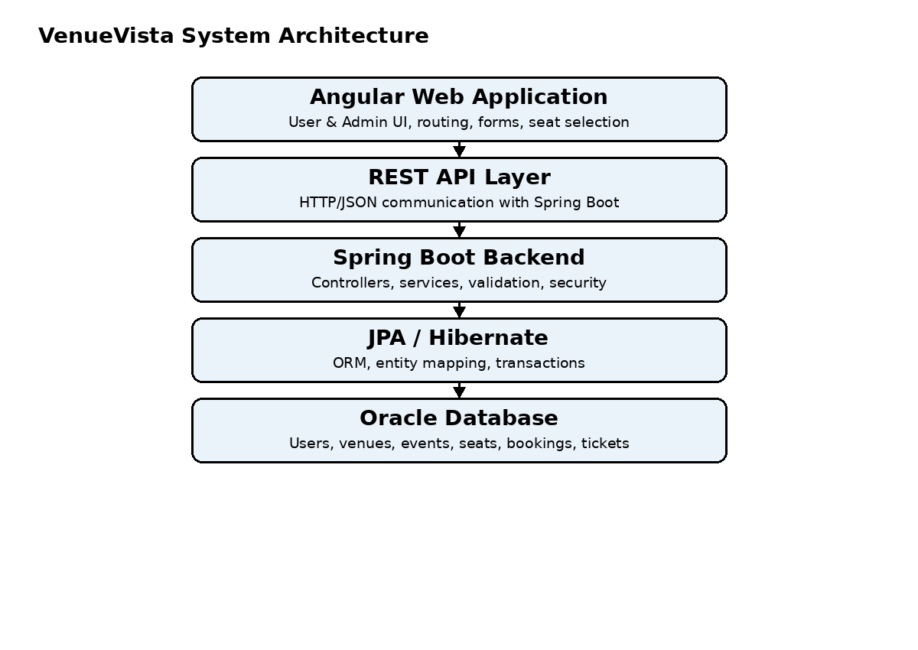
The architecture follows a layered full-stack flow. Angular provides the presentation layer, REST APIs provide communication, Spring Boot contains application and business logic, JPA/Hibernate performs ORM and persistence operations, and Oracle Database stores the application data.

3.2 Tech Stack Used
Technology | Purpose
Java | Core programming language for backend development
Spring Boot | Backend application and REST API development
Spring Web | HTTP/REST controller implementation
Spring Security | Authentication and role-based authorization
JWT | Token-based authentication for API requests
Spring Data JPA | Database access and repository abstraction
Hibernate | ORM and entity-to-table mapping
Oracle Database | Relational database for persistent application data
Angular | Frontend web application development
TypeScript | Programming language for Angular application logic
HTML/CSS | Structure and styling of the frontend
Maven | Dependency and build management for Spring Boot
REST API / JSON | Communication between Angular and backend
Postman | API testing and verification
VS Code / IntelliJ IDEA | Development environment

3.3 Modules
Module | Purpose
User Authentication Module | Handles registration, login, JWT authentication, password hashing, logout, and role-based access.
Event Management Module | Allows administrators to create, view, update, and delete events and provides event information to users.
Venue Management Module | Maintains venue name, address, city, capacity, and description.
Seat & Seating Module | Stores venue seats and their row, number, type, and price. Provides availability information for event booking.
Ticket Booking Module | Handles seat selection, booking validation, total amount calculation, booking creation, and ticket generation.
Booking & Ticket Module | Allows users to view booking history and ticket details and supports permitted booking status operations.
Admin Dashboard & Analytics Module | Provides summary counts, recent bookings, event-wise ticket sales, and revenue information.

4. Functional Requirements

4.1 User Authentication
- The system shall allow a new user to register using name, email, password, and phone.
- The system shall validate registration fields before creating an account.
- The system shall store passwords in hashed form rather than plain text.
- The system shall allow registered users to log in using email and password.
- The system shall issue an authentication token after successful login.
- The system shall restrict protected operations to authenticated users.
- The system shall distinguish between User and Admin roles.
- The system shall prevent normal users from accessing administrative endpoints.

4.2 Event Management
- The system shall allow administrators to add new events.
- Each event shall contain title, description, category, date, start time, end time, venue, and status.
- The system shall allow administrators to view all events and retrieve an event by ID.
- The system shall allow administrators to update event details.
- The system shall allow administrators to delete or deactivate events according to booking rules.
- Users shall be able to view active/upcoming events.
- Users shall be able to search or filter events by relevant information such as title, category, city, or date.

4.3 Venue Management
- The system shall allow administrators to add venue information.
- Venue information shall include name, address, city, capacity, and description.
- The system shall allow administrators to view, update, and delete venues where no conflicting records exist.
- The system shall associate events with a selected venue.
- The system shall maintain the seating configuration of each venue.

4.4 Seat & Seating Management
- The system shall allow administrators to create seats for a venue.
- Each seat shall contain row number, seat number, seat type, price, and venue association.
- Seat types may include Regular, Premium, and VIP.
- The system shall return seat availability for an event's venue.
- The system shall show selected and unavailable seats differently from available seats.
- The system shall prevent a user from booking a seat that has already been booked for the event.

4.5 Ticket Booking
- The system shall allow authenticated users to initiate a booking for an active event.
- The system shall display the seating layout of the event venue.
- The system shall allow users to select one or more available seats.
- The system shall display a booking summary containing selected seats and total amount.
- The backend shall verify event validity and seat availability before confirmation.
- The backend shall calculate the total booking amount using database values rather than trusting client-supplied prices.
- The system shall create the booking and associated tickets as a transactional operation.
- The system shall generate a unique booking reference for a confirmed booking.

4.6 Booking & Ticket Management
- The system shall allow users to view their bookings.
- The system shall allow users to open an individual booking and view event, venue, seat, amount, and status information.
- The system shall provide ticket numbers or ticket records associated with confirmed bookings.
- The system shall support cancellation of a booking where cancellation rules permit it.
- The system shall update ticket/booking status consistently when a valid cancellation occurs.
- The system shall not expose another user's booking information.

4.7 Admin Dashboard & Analytics
- The system shall display total users, venues, events, bookings, and revenue to administrators.
- The system shall display recent bookings with user, event, seats, amount, date, and status.
- The system shall provide event-wise ticket sales information.
- The system shall provide event-wise revenue information.
- Analytics shall be calculated from persisted booking and ticket data.
- The system shall restrict dashboard and analytics endpoints to Admin users.

4.8 REST API Requirements
The system shall expose RESTful endpoints for authentication, events, venues, seats, bookings, tickets, and administrative analytics. Requests and responses shall use HTTP and JSON. Protected endpoints shall require valid authentication credentials and appropriate role authorization.
Area | Example Endpoints
Authentication | POST /api/auth/register  POST /api/auth/login
Events | GET /api/events  GET /api/events/{id}  POST /api/events  PUT /api/events/{id}  DELETE /api/events/{id}
Venues | GET /api/venues  POST /api/venues  PUT /api/venues/{id}  DELETE /api/venues/{id}
Seats | GET /api/venues/{venueId}/seats  POST /api/venues/{venueId}/seats  PUT /api/seats/{id}
Bookings | POST /api/bookings  GET /api/bookings/my  GET /api/bookings/{id}  PUT /api/bookings/{id}/cancel
Admin Analytics | GET /api/admin/dashboard  GET /api/admin/analytics/sales  GET /api/admin/analytics/events

5. Database Design

5.1 Database Tables
Table | Main Fields | Purpose
Users | id, name, email, password, phone, role, created_at | Stores registered users and their roles.
Venues | id, name, address, city, capacity, description | Stores event venue information.
Seats | id, venue_id, row_number, seat_number, seat_type, price, status | Stores the seating configuration of each venue.
Events | id, title, description, category, event_date, start_time, end_time, venue_id, status | Stores event details and venue association.
Bookings | id, user_id, event_id, booking_date, total_amount, status, booking_reference | Stores user booking and payment/booking summary information.
Tickets | id, booking_id, seat_id, ticket_number, price, status | Stores individual tickets generated for selected seats.

5.2 ER Diagram
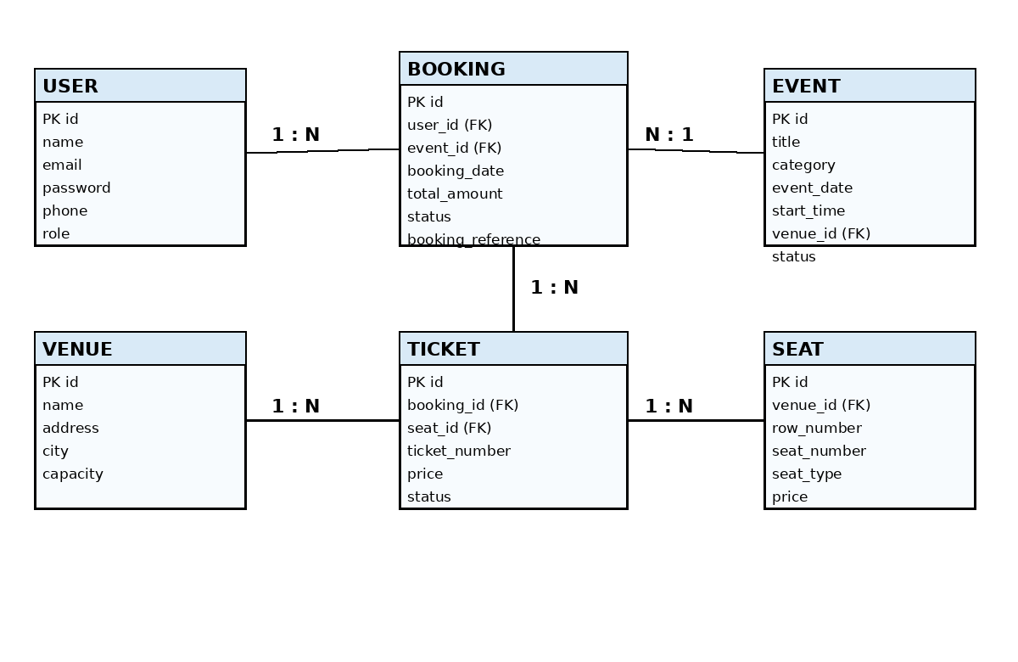
The ER model connects users to their bookings, bookings to events and tickets, events to venues, and tickets to seats. A venue contains multiple seats and can host multiple events. A booking belongs to one user and one event and can contain multiple tickets.

6. Future Enhancements
- Online Payment Gateway: Integrate a real payment service such as a supported card/UPI payment provider for production transactions.
- Email and SMS Notifications: Send booking confirmation, cancellation, and event reminder notifications.
- QR Code Tickets: Generate QR codes for tickets and support scanning at venue entry.
- Advanced Seating Configuration: Add a graphical admin tool for creating rows, sections, aisles, and special seating zones.
- Dynamic Pricing: Support different ticket prices based on event category, seat section, demand, or booking period.
- Advanced Analytics: Add time-based revenue trends, occupancy rates, cancellation analysis, and venue utilization reports.
- Event Recommendations: Recommend events based on categories and user booking history.
- Multi-Venue and Organizer Support: Allow different organizers to manage their own events and venues.
- Cloud Deployment: Deploy the application using a cloud-hosted Angular frontend, Spring Boot backend, and managed Oracle database.
- Audit Logging: Maintain administrative activity logs for important create, update, delete, and booking operations.
- Enhanced Security: Add refresh tokens, stronger password policies, rate limiting, and additional API security controls for production use.

7. Conclusion
VenueVista: EventPro Ticketing & Venue Management System provides a structured full-stack solution for managing events, venues, seating, ticket bookings, and sales information. The system combines Angular for the user interface, Java Spring Boot for backend services, and Oracle Database for persistent storage.
The application separates user and administrator workflows through authentication and role-based authorization. Its event and venue modules provide the administrative foundation, while seat-aware booking and ticket management provide the core customer workflow. The use of REST APIs, JPA/Hibernate, transactional operations, and layered architecture supports maintainability and clear separation of responsibilities.
The system also provides a foundation for future improvements such as online payments, QR-based tickets, notifications, advanced seating configuration, and richer analytics. Overall, VenueVista demonstrates the implementation of a complete event ticketing and venue management workflow using the specified full-stack technologies.

