1.Do the below programs in anonymous function & IIFE.

Print odd numbers in an array

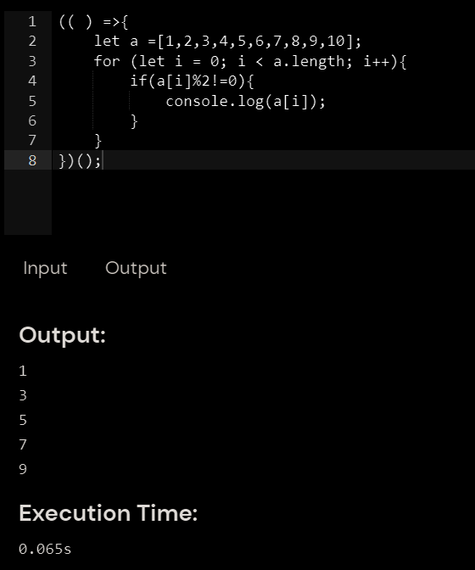

Convert all the strings to title caps in a string array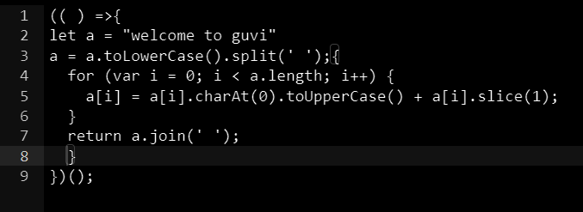

Sum of all numbers in an array

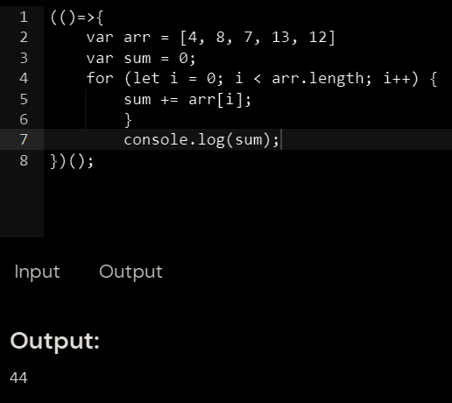

Do the below programs in arrow functions

1. Print odd numbers in an array

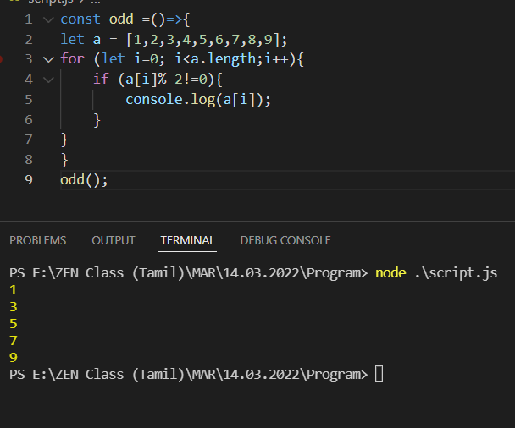

1. Convert all the strings to title caps in a string array

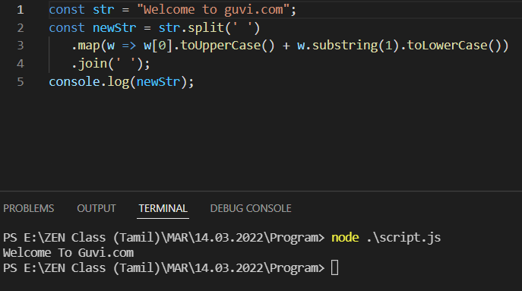

1. Sum of all numbers in an array

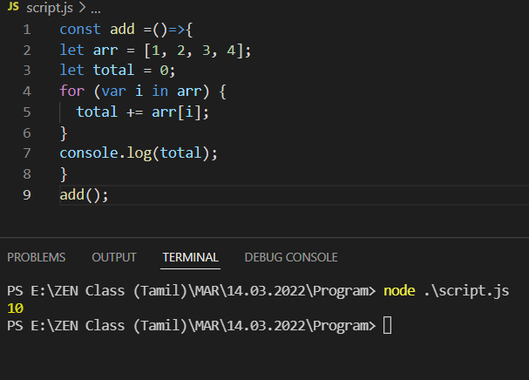

1. Return all the prime numbers in an array

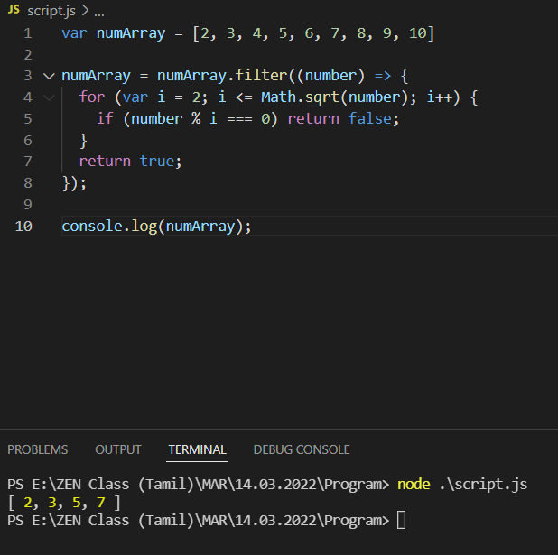

1. Return all the palindromes in an array