**Assignment – 1** (Submitted by Anandaram S)

1. Report View

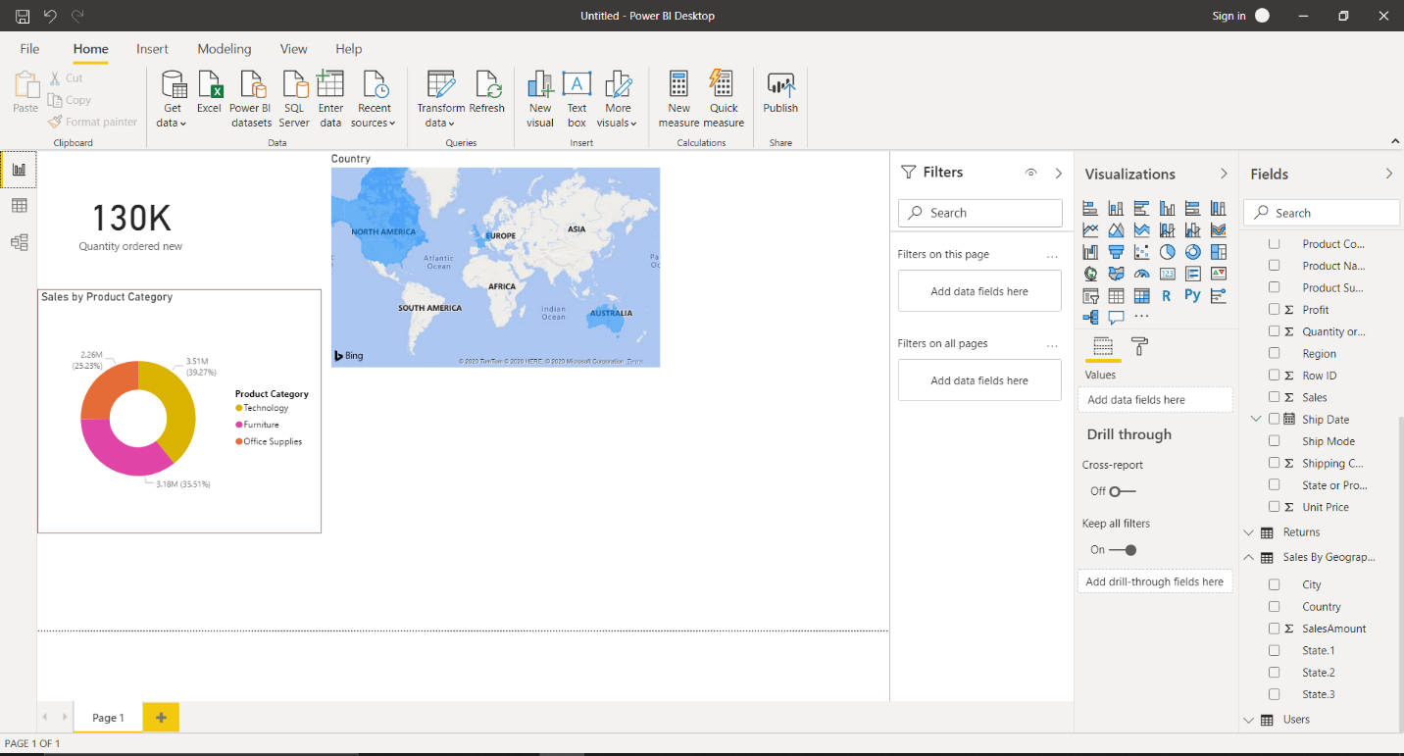

1. Data View

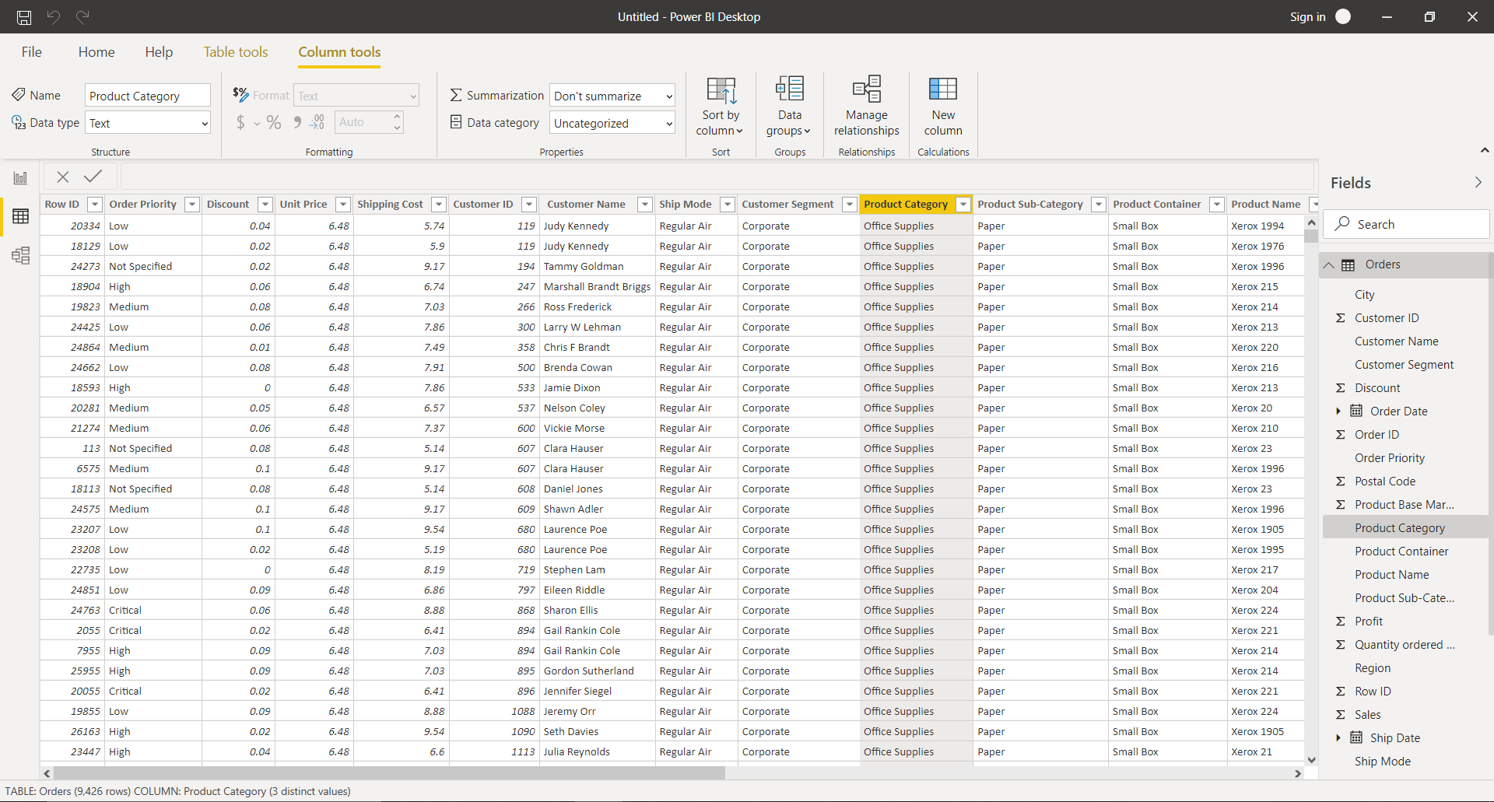

1. Model View
2. Power Query Editor

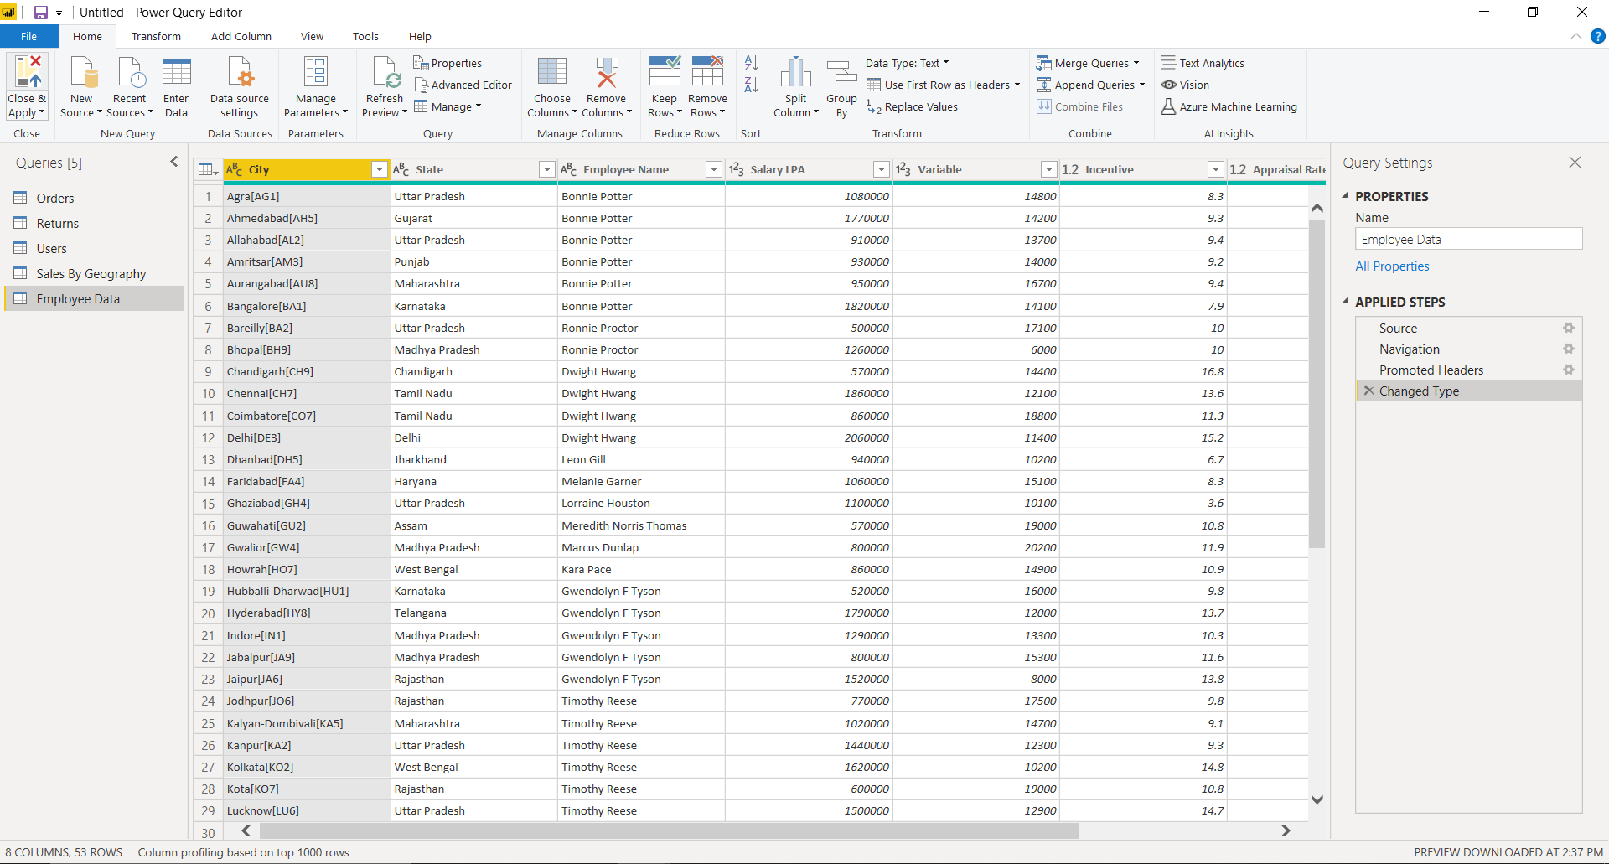

1. Advance Editor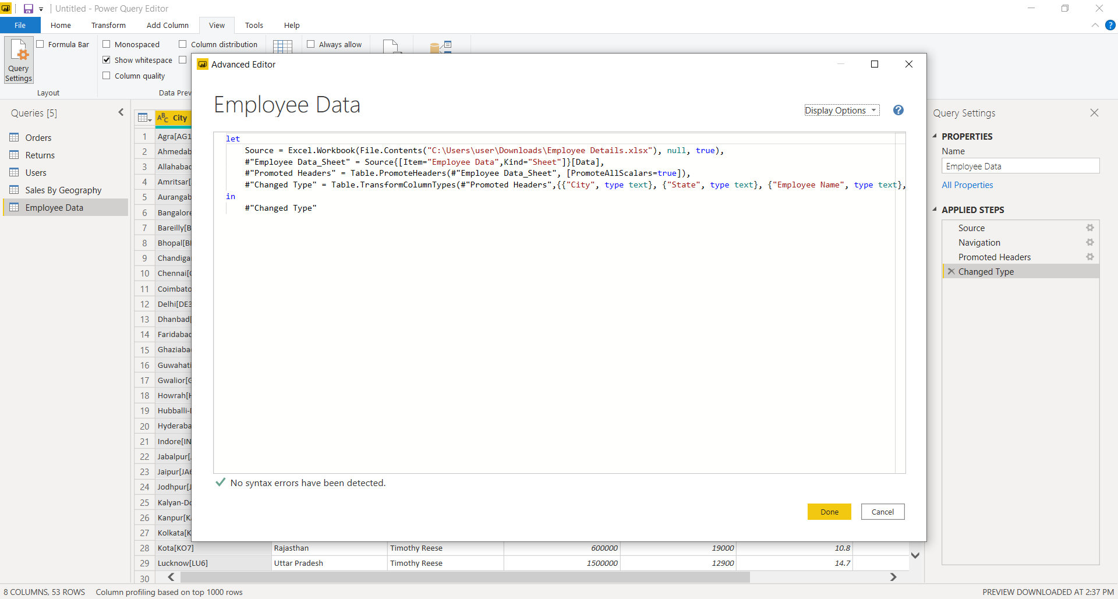

**Power BI**

1. Power BI Desktop – FREE

Features :

* You can connect and import data from over 70 cloud-based and on-premises sources
* The same rich visualisations and filters from Power BI Pro
* Auto-detect that finds and creates data relationships between tables and formats
* Export your reports to CSV, Microsoft Excel, Microsoft PowerPoint and PDF
* Python support
* Save, upload and publish your reports to the Web and the full Power BI service
* Storage limit of 10 GB per user

1. Power BI Pro – Rs.660/month

Features :

* Ability to embed Power BI visuals into apps (PowerApps, SharePoint, Teams, etc)
* Native integration with other Microsoft solutions (Azure Data Services)
* Share datasets, dashboards and reports with other Power BI Pro users
* Can create App Workspaces and peer-to-peer sharing

1. Power BI Premium – Rs.330,190/year

Features :

* Increased data capacity limits and maximum performance
* Access to one API surface
* Ability to embed Power BI visuals into apps (PowerApps, SharePoint, Teams, etc)
* Larger storage sizes for extended deployments
* Geo distribution, higher refresh rates, isolation, pin to memory, read-only replicas
* Power BI Report Server