#### **LIBRARY MANAGEMENT SYSTEM**

(Mini Project)



CO110

S-8 Section

**Submitted By:**

1. Ananda Rao H

Roll.No : 14CO103

2. Nikhil B.M.

Roll.No : 14EC134

#### **LIBRARY MANAGEMENT SYSTEM**

The Library Management System is gaining  more importance as the number of its users are increasing rapidly. As the number is rising there is a need of effective management of library, one such effective system is our Library Management System.

Library Management System is a simple management system for monitoring and controlling transactions in a library. The Project is developed in C language. The main objectives of this project is to

1. Access and update details of the users

2. Access and update details of the books

3. Issue and Return a book

4. Add new books

OVERVIEW OF THE PROJECT

This project will be implemented using two main modules containing multiple sub modules.

The two main modules are :

1. Admin Module

2. User Module

*1. ADMIN MODULE:*

The admin module deals with accessing and updating the details of the books and users. Admin module also has the right to issue books and collect the fine if necessary. Admin also add ne books to the database. Access to the admin module is protected with a password.

*2. USER MODULE:*

User module can be used to search for books by name, author. This module can also be used to track the books issued by a specific user using userid.

*FLOWCHART*

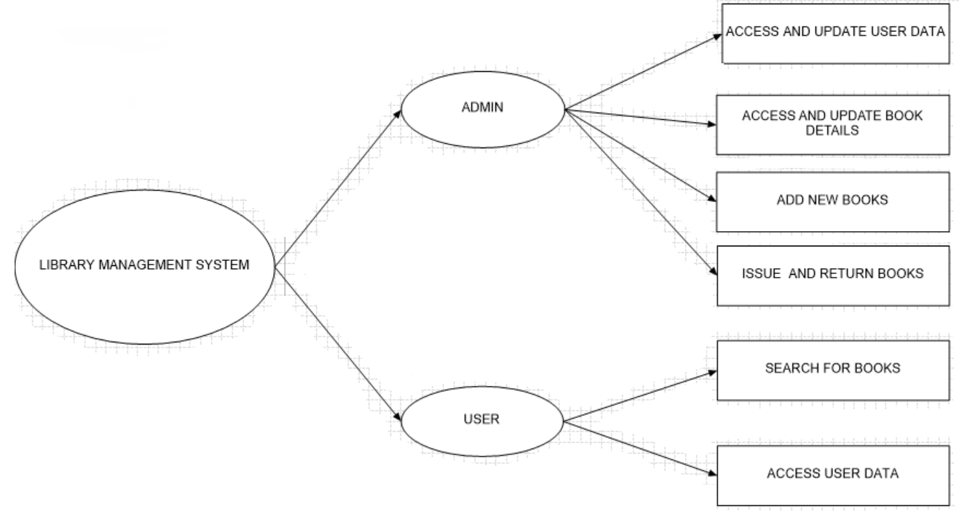

*REFERENCES*

1. http://www.codewithc.com/mini-project-in-c-library-management-system/

2. http://www.cbseportal.com/exam/Projects/Download-Library-Management-Code-in-C

3. Flowchart Software : http://brc.nitk.ac.in/?Subject:2013-14_%5BEven%5D:CO111-Computer_Programming_Lab