Dashboard
Team ID | MCA
Project Name | Smartphone usage,Digital Addiction & Well-Being Analytics
Maximum Marks | 5 Marks

Executive Overview & Key Metrics
The Digital Well-Being & Addiction Insights Dashboard is designed to track user behavior, screen dependency, and wellness indicators. Based on the aggregate user data presented, here are the high-level operational key performance indicators (KPIs):
• Total Tracked User Base: 7,500 total user IDs registered in the dataset.
• Total Logged Activity Transactions: 5,308 discrete transaction events recorded.
• Average Weekend Screen Time: 9.24 hours, indicating heightened device usage during leisure days.
• Average Sleep Duration: 6.74 hours, sitting just under the universally recommended 7–8 hour healthy baseline.
Major Insights & Project Outcomes
• Age Distribution Dominance: The largest user segment is young adults, with the 20–29 age group making up 55.09% (4.13K users) of the total cohort, followed by the 30–39 demographic at 34.25% (2.57K users).
• Prevalence of Severe Addiction: Out of all tracked transaction classifications, the "Moderate" addiction bracket accounts for the maximum share at 38.32% (2.87K transactions), followed closely by the "Severe" bracket at 32.45% (2.43K transactions), indicating a strong critical need for digital wellness interventions.
• Impact of Screen Habits on Rest: There is negligible variation in average sleep hours relative to addiction categories. Severe, Moderate, Mild, and Non-addicted users all maintain an average sleep duration fluctuating strictly between 6.7 and 6.8 hours, suggesting sleep deficit is systemic across the entire sampled pool rather than isolated to highly addicted individuals.
• Weekend Spikes in Overuse: Users categorized as "Addicted" exhibit an extreme surge in device engagement over weekends, averaging 10.2 hours of screen time compared to 6.9 hours logged by non-addicted individuals.
• High App Open Frequency Across Stress Levels: App interaction remains consistently high regardless of psychological stress metrics. "Medium" stress level individuals top the chart with 98.71 average app opens per day, while "High" stress users still trigger device activations an average of 97.28 times daily.
• Gender-Neutral Screen Habits: Daily screen time is almost perfectly uniform across gender groups, with Male users averaging 7.6 hours, Other users at 7.5 hours, and Female users at 7.4 hours per day.

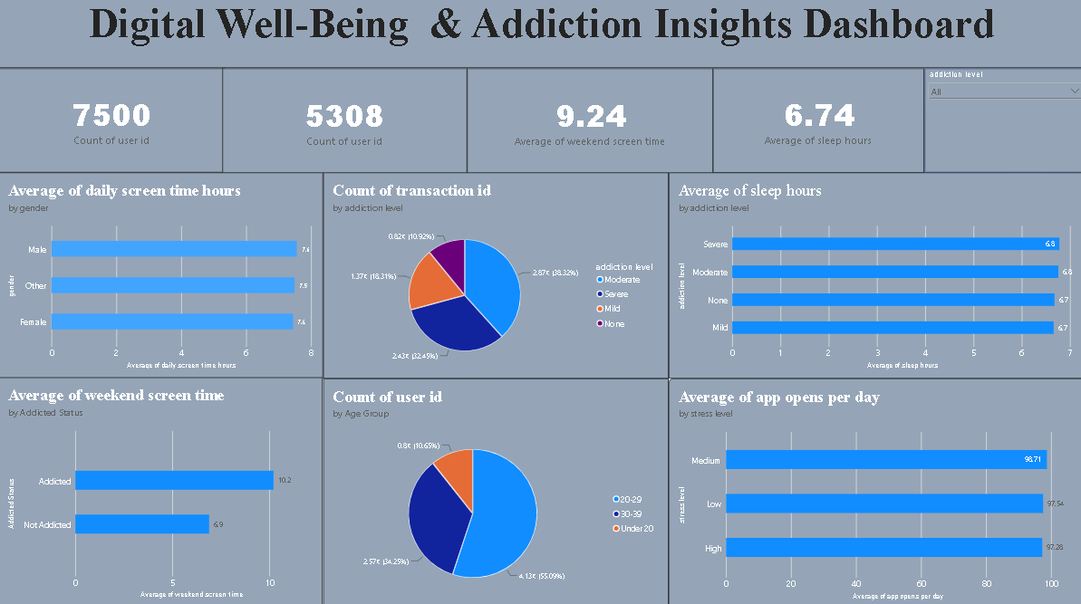
Dashboard Design Principles Applied
In alignment with Activity 1: Interactive and visually appealing dashboards, this project incorporates several core design elements:
• Clear and Intuitive Layout: Utilizes a standard top-down dashboard grid where high-level KPI cards sit at the header, transitioning into granular category breakups in the body grid.
• Color and Theming: Uses a cohesive visual system pairing cold blue gradients against contrasting vibrant accents (orange and purple) to clearly divide separate categorical attributes without creating visual clutter.
• Interactive Filters and Slicers: Features an active "addiction level" dropdown slicer in the top-right corner, empowering stakeholders to drill down and filter the workspace globally.

