REPORT
Team ID | MCA
Project Focus | Smartphone Usage, Digital Addiction & Well-Being Analytics
Maximum Marks | 5 Marks

Digital Addiction & Screen Time Behavior Analysis
1. Operational Baselines & KPI Metrics
- Average App Opens Per Day: Users interface with their devices rapidly, maintaining a high volume baseline of 97.83 app opens daily.
- Average Social Media Hours: A significant portion of standard conscious time allocation goes to social channels, averaging 3.27 hours daily.
- Average Notifications Per Day: Devices actively draw engagement via a demanding flow of 134.26 notifications every 24 hours.
2. Behavioral Cross-Comparisons & Screen Distribution
- Addiction Level Cohorts: The volume breakdown for user gender counts across addiction brackets displays Mild at 1,373 users, Moderate peaking at 2,874 users, None at 819 users, and Severe climbing aggressively to 2,434 users.
- Academic/Work Study Resiliency: Work study dedication shows minimal variance when paired against academic work impact levels, holding steady at 3.28 hours for those tracking 'No' impact vs. 3.21 hours for those with a 'Yes' classification.
- Weekend Expansion Scaling: Weekend usage accelerates intensely based on addiction severity. Severe tier users log 10.4 weekend screen hours and Moderate tiers experience 10.1 hours, contrasting heavily against unaddicted users who sit at 6.2 hours.
3. User Demographics & Filtering Profiles
- Age Group Segments: The tracked distribution is led heavily by the 20-29 cohort registering 4,132 individuals, followed by the 30-39 range at 2,569 users, and a smaller group of Under 20 users standing at 799.
- Gender Balance: The analyzed framework displays an even spread with 1,394 Female users and 1,389 Male users paired alongside 1,349 classified under other specific demographic metrics.
- Stress Allocation: High stress classifications account for 475 distinct profiles, Medium stress charts at 458, and Low stress traces closely at 456.
4. Summary & Strategic Interventions
- Target Audience Priority: Intervention programs must prioritize young adults within the 20-29 demographic because they form the operational volume of extreme users.
- Stress-Addiction Correlation: The alignment across high stress markers and intense weekend extensions requires automated lockouts to decouple persistent application loops.

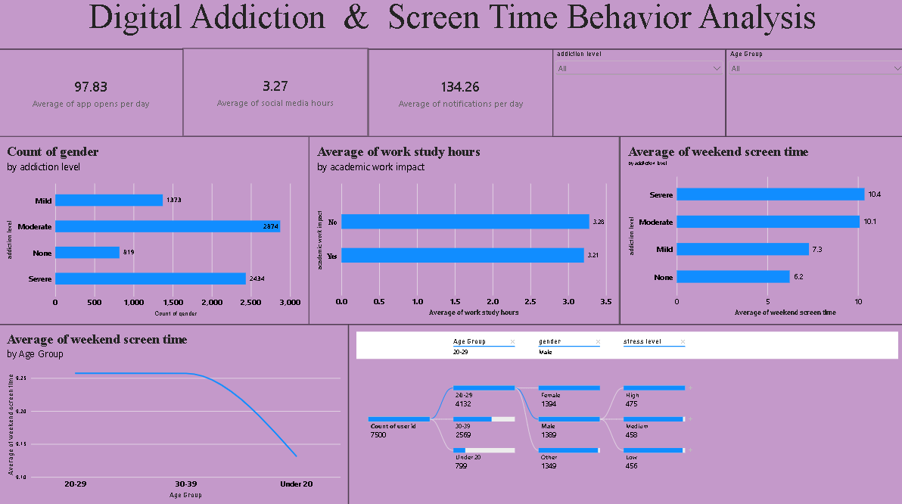

Smartphone Addiction & Digital Well-Being Insights
1. Advanced Operational Baselines
- Average Gaming Hours: Users spend an average of 2.01 hours per day on active mobile gaming entertainment.
- Average Cohort Age: The universal mean age for this specific well-being tracking group rests cleanly at 26.57 years.
- Critical Sleep Metrics: Average sleep duration shows profound biological compression, bottoming out at an alarming 4.54 hours daily.
- Average Work Study Hours: Baseline academic and professional focus maintains an average allocation of 3.24 hours per day.
2. Key Influencers & Multiplier Triggers
- Screen Time Addiction Multiplier: When a user's daily screen time crosses foundational limits, the mathematical likelihood of their status escalating to Addicted surges by a massive 25.75x.
- Social Media Expansion Impact: An increase of social media usage by 1.59 hours directly increases the likelihood of severe addiction transitions by 10.21x.
- Weekend Retraction Factor: Conversely, when weekend screen time successfully rolls backward by 2.72 hours, the probability of escaping the addiction profile moves down by 1.15x.
3. Health & Database Macro Stratification
- Stress Distribution Profiles: Across the baseline cohort of 7.5K individual active profiles, high stress touches 34.13% (2.56K users), low stress maps to 33.37% (2.5K users), and medium stress records 32.49% (2.44K users).
- Sleep Decay Trajectory: Tracking sleep across age tiers shows that users under 20 preserve the highest sleep metrics (~6.75 hours). However, sleep metrics drop rapidly into deep deprivation curves for the 20-29 and 30-39 groups.
- Social Media by Addiction Tier: Severe addiction profiles generate an average of nearly 4 full hours of dedicated social media usage daily, surpassing moderate and mild cohorts who sit closer to 2.5 and 2 hours respectively.
- Macro Enterprise Classification: Out of a broad transactional data framework registering 56M global logs, 33.87% (19M) are explicitly flagged as High Screen Time Users, while 66.13% (37M) retain a Normal Usage footprint.
4. Summary & Algorithmic Mitigation
- Intervention Urgency: The 25.75x surge in addiction status driven by daily screen time indicates that casual habit patterns transform rapidly into clinical dependencies.
- Sleep Strategy Mandate: The clear compression of sleep down to 4.54 hours requires standard screen reduction protocols to avert severe physical burnout across active professional sectors.

