START

USERNAME

PASSWORD

ADMIN

PENDAFTARAN

LOGIN

Input Admin

Input

Database

Layout/ Desain Awal

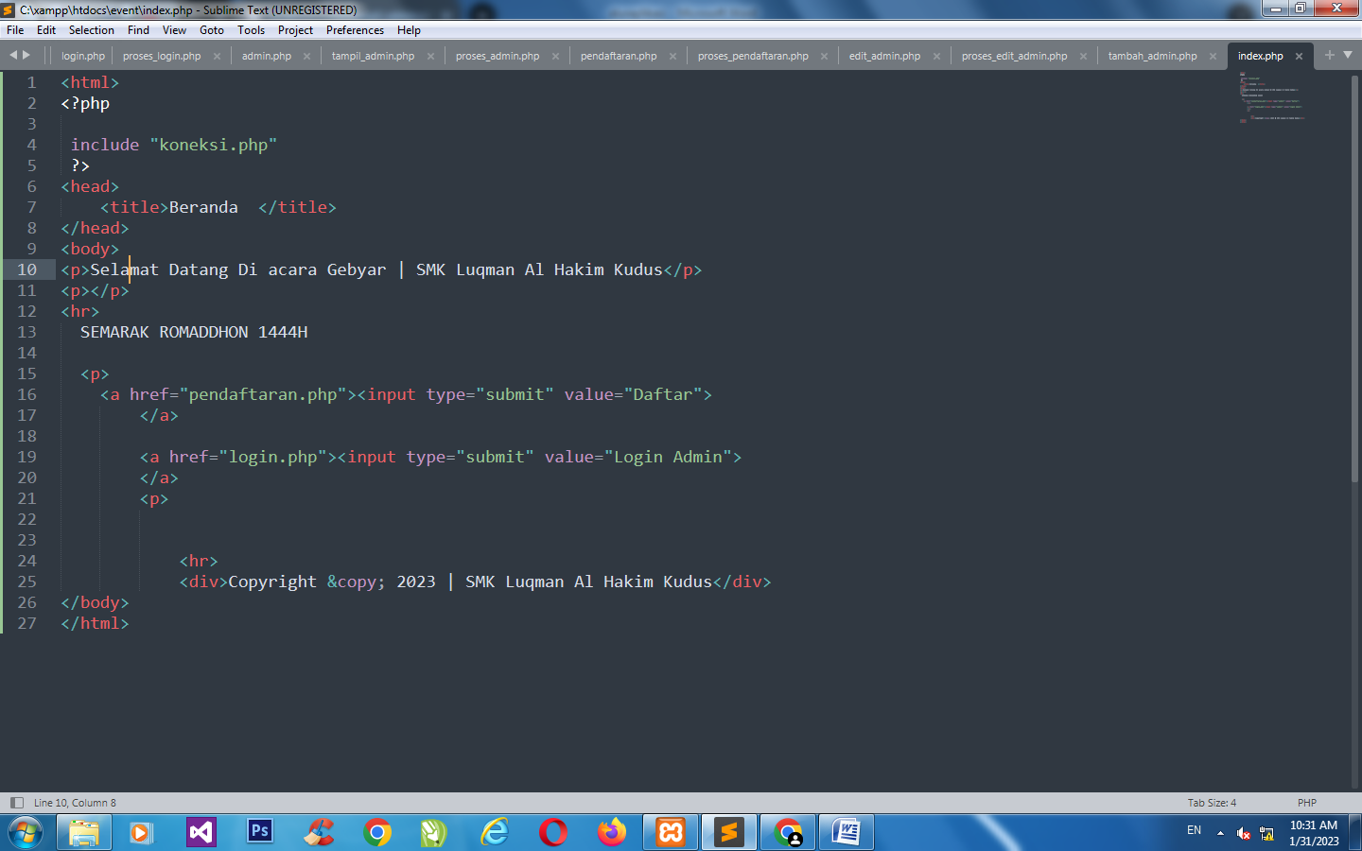

https://pklanandawahyu.blogspot.com/2023/01/tugas-pkl-1.html