
SS 2011


_{CUDA Lab Report}

Project: Hoffman Coding

Team:
Anand Babu - 2693567
Lijo Cherian – 2697291

Synopsis

The goal of this project was to explore the potential performance improvements that could be gained through the use of GPU processing techniques within the CUDA architecture for Huffman coding algorithm.

The advent of modern GPUs for general purpose computing has provided a platform to write applications that can run on hundreds of small cores. CUDA (Compute Unified Device Architecture) is NVIDIA’s implementation of this parallel architecture on their GPUs and provides APIs for programmers to develop parallel applications using the C programming language. CUDA provides a software abstraction for the hardware called blocks which are a group of threads that can share memory.

Now, compression is an important and useful technique that can be slow on current CPUs. We wanted to investigate ways to parallelize compression specifically on GPUs where hundreds of cores are available for computation. In addition, our goal was to not only to parallelize applications for the architecture but also to find the strengths and weaknesses of that architecture.

The Huffman encoding algorithm is an optimal compression algorithm when only the frequency of individual letters is used to compress the data. The parallelism in compression is data level parallelism. The input file can be broken into chunks of contiguous data, and each chunk can be compresses independently.

The project aimed at parallelizing the classic algorithm of Huffman coding for compression. Also, blocks of threads in grids were exploited to attain maximum parallelism to run the code.
The algorithm involved the implementation of a tree namely the Huffman tree. Hence, the algorithm had high data dependency and proved tricky to parallelize.

Acknowledgment

- At the foremost, we would like to be grateful to the Institute of Parallel and Distributed Systems for offering the course which enabled us to explore the world of parallel processing.

- Next, we would like to extend our gratitude to
Dr. rer. nat. Mireille Grégoire for her guidance and advice throughout the project.

- Last but not the least; we would like to appreciate the ones who opened the lab doors for us every time we disturbed them… ☺

Contents

1.INTRODUCTION 5
1.1 CUDA Architecture 5
1.2 Huffman Coding 6
Compression 6
Decompression 6
2. Algorithm 7
3. How to parallelize Huffman Coding? 8
4. Results 9
4.1 By Varying Block Size 9
4.2 By Varying Number of Input Characters 10
5. Limitations 11
6. Future Scope 11
7. References 11

1.INTRODUCTION

1.1 CUDA Architecture

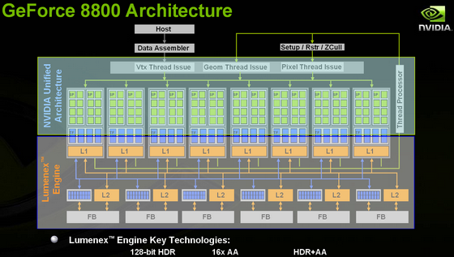

Fig 1.1 GeForce Architecture

- 4-16 streaming multiprocessors each having memory
      - contain ~8-16 scalar processors accommodating up to 512 threads, each has local memory
- program in blocks, where each block is independent of another
- SPMT architecture, similar to SPMD
- non-parallel sections will still run on the architecture, but key to performance will be vector-type processing, with little or no
- synchronization between blocks

1.2 Huffman Coding
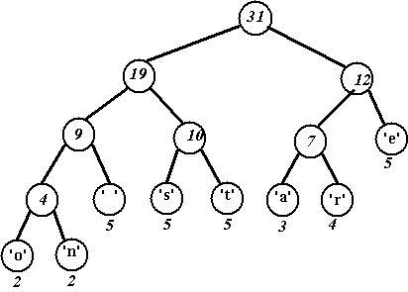

Fig 1.2 A Huffman Tree

In computer science and information theory, Huffman coding is an entropy encoding algorithm used for lossless data compression. The term refers to the use of a variable-length code table for encoding a source symbol (such as a character in a file) where the variable-length code table has been derived in a particular way based on the estimated probability of occurrence for each possible value of the source symbol.

Compression
The technique works by creating a binary tree of nodes. These can be stored in a regular array, the size of which depends on the number of symbols, n. A node can be either a leaf node or an internal node. Initially, all nodes are leaf nodes, which contain the symbol itself, the weight (frequency of appearance) of the symbol and optionally, a link to a parent node which makes it easy to read the code (in reverse) starting from a leaf node. Internal nodes contain symbol weight, links to two child nodes and the optional link to a parent node. As a common convention, bit '0' represents following the left child and bit '1' represents following the right child. A finished tree has up to n leaf nodes and n − 1 internal nodes.

Decompression

The process of decompression is simply a matter of translating the stream of prefix codes to individual byte values; usually by traversing the Huffman tree node by node as each bit is read from the input stream (reaching a leaf node necessarily terminates the search for that particular byte value). Before this can take place, however, the Huffman tree must be somehow reconstructed. In the simplest case, where character frequencies are fairly predictable, the tree can be pre-constructed (and even statistically adjusted on each compression cycle) and thus reused every time, at the expense of at least some measure of compression efficiency.

2. Algorithm

Input array

C | U | D | A |  | i | s |  | F | U | N | !

Huffman Table

Characters | Frequency | Binary code
 | 3 | 01
! | 1 | 1101
A | 1 | 1100
C | 1 | 1111
D | 1 | 1110
F | 1 | 1001
N | 1 | 1000
U | 2 | 00
i | 1 | 1011
s | 1 | 1010

Compression

Input array, Ai:
C | U | D | A |  | i | s |  | F | U | N | !

Initialized array, Aj: Array Size, As

Initialize a new Array Back to the CPU

Launch a New Kernel Add Bits
To
Compressed
Array

Compressed Array, Ac to File
ó | ± | d | ‡ | @

3. How to parallelize Huffman Coding?

The input file, Ai is taken as an array sequence and copied from the host memory to the device memory, viz. global memory.

Each character is read from the array and the frequency of each array is noted on to the table. Based on the frequency, the Huffman tree is created. The tree is traversed to get the binary code for each character. The bits are noted and it ensures the completion of Huffman table.

For compression, threads are initialized and each thread access each input data from the array, Ai, following which the threads access the Huffman table to get the binary code.

A new array, Aj, is initialized to zero and partitioned into separate blocks of equal size. From the input array (in the device memory), the compressed data is copied into this new array.
The copied array is copied in such a way that the code for each letter fits ideally into each block.

In parallel, we create another array, As, with size equal to the number of bits written in each block of the previous array, Aj. This array will keep a count on the size of the array, Aj. Precisely, the array As keeps the number of characters that are put into each block.

Moving on, a new kernel is launched to add the contents of the array to get a sum S.

Further, a new array Ac is created of size S and a kernel is launched and the array Ac is filled with the compressed bits.

Finally, the compressed data is sent back to CPU and written to a file.

More……

So far, three kernels were invoked
- To get the input array, create the Huffman table and place the characters in a new array, divided with a fixed length (as block) and another array keeps a tab on the number of characters in a block.
- Second kernel is invoked to add the contents of the array whose sum is used to create a new array along with the launch of the third kernel.
- The third Kernel is invoked to copy the bits to the compressed array.

On further analysis, a third kernel is avoided by removing the second kernel invocation (used to sum up the array) and it is included in the first kernel launch. As a result, we use only two kernel launches which ensure speed up.

Results

4.1 By Varying Block Size

By varying the block size and keeping the input data constant, the performance of the GPU and CPU was analyzed. The speedup achieved was remarkable with values averaging 11.5.

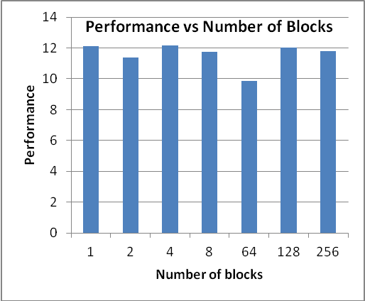
Number of Blocks | Performance
1 | 12.13563
2 | 11.3766
4 | 12.14211
8 | 11.75834
64 | 9.870915
128 | 12.04152
Table 4.1 Performance vs Number of Blocks
Fig 4.1 Performance vs Number of Blocks
Number of Blocks | Speed of CPU | Speed of GPU
1 | 16 | 1.318432
2 | 15 | 1.318496
4 | 16 | 1.317728
8 | 16 | 1.360736
64 | 15 | 1.519616
128 | 16 | 1.328736
256 | 16 | 1.357152

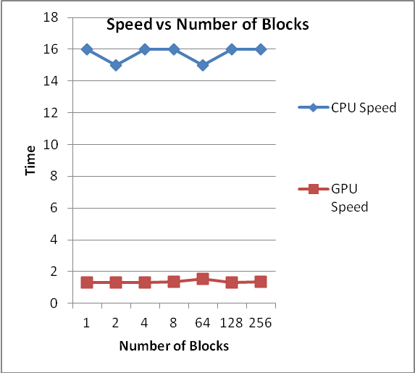
Table 4.2 Speed vs Number of Blocks for GPU and CPU

Fig 4.2 Speed vs Number of Blocks for GPU and CPU

4.2 By Varying Number of Input Characters

By varying the input characters and keeping the block size constant, the performance of the GPU and CPU was analyzed. The speedup achieved was remarkable, again, for lower number of characters. However, as the number of characters increased, the speedup reduced.

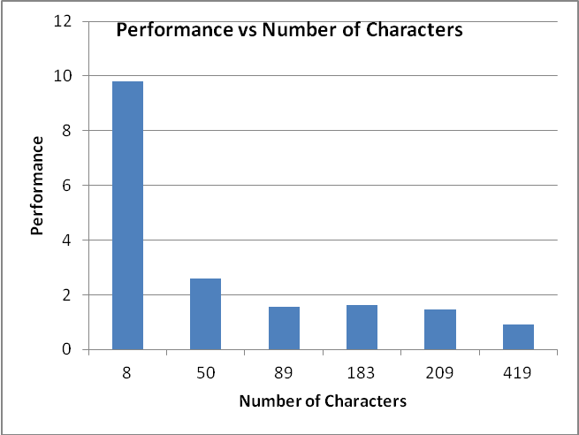
Number of Characters | Performance
8 | 9.806896
50 | 2.609236
89 | 1.549776
183 | 1.61843
209 | 1.459097
419 | 0.910538
Table 4.3 Performance vs Number of Blocks
Fig 4.3 Performance vs Number of Blocks

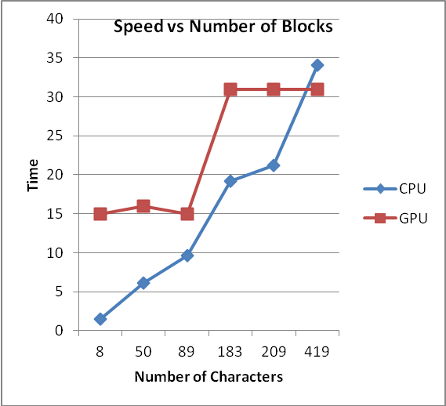
Number of Characters | Speed of CPU | Speed of GPU
8 | 15 | 1.529536
50 | 16 | 6.132064
89 | 15 | 9.678816
183 | 31 | 19.15437
209 | 31 | 21.24602
419 | 31 | 34.04582
8 | 15 | 1.529536
Table 4.4 Speed vs Number of Blocks for GPU and CPU

Fig 4.3 Speed vs Number of Blocks for GPU and CPU

Limitations

- After the initial success in speed up after using global memory, the excitement drove us to use constant memory instead of global memory. Constant memory behaves as cache, hence the idea looked promising. However, the algorithm encountered memory requirements more than what constant memory could offer.

- The algorithm can be enhanced for input data length less than 500 characters per GPU core. As a result, speed up is limited by the number of characters per core.

Future Scope

Decompression is one area which can be worked upon later. However, the inherent nature of the algorithm and the problem itself doesn’t allow one to solve the problem. As a result, complex solutions are required.
Intense research is still being done on the same algorithm and some of the papers provided below give a positive outlook to implement decompression on the GPU.

- http://ieeexplore.ieee.org/xpls/abs_all.jsp?arnumber=5693828&tag=1
- http://www.openu.ac.il/home/wiseman/dcc.pdf
- http://www.sciencedirect.com/science/article/pii/0020019096000907

References

- Addison Wesley CUDA by Example
- NVIDIA Basics Of CUDA
- Wikipedia
- http://developer.nvidia.com/cuda-education-training

