- linux vs windows os:-
Unix/Linux uses a tree like hierarchical file system.
- There are no drives in Linux , unlike windows
- Peripherals like hard drives , cd rom , printers are also considered files in Linux/Unix
- There are 3 types of user account types 1) Regular , 2) Root and 3) Service Account
- Root user is the super user and has all administrative privileges
- Linux file naming convention is case sensitive. Thus , sample and SAMPLE are 2 different files in Linux/Unix operating system
- For every user /home/username directory is created which is called his home directory.

- types of files
General Files
General Files also called as Ordinary files. They can contain image, video, program or simply text.
Directory Files
These files are a warehouse for other file types. You can have a directory file within a directory (sub-directory)

Device Files:n MS Windows, devices like Printers, CD-ROM and hard drives are represented as drive letters like G: H:. In Linux, there are represented as files.

Users in Linux
Regular user:-A regular user account is created for you when you install Ubuntu on your system.

Root User:-Other than your regular account another user account called root is created at the time of installation. The root account is a super user who can access restricted files, install software and has administrative privileges. Whenever you want to install software, make changes to system files or perform any administrative task on Linux; you need to log in as a root user

Service user: Linux is widely used as a Server Operating System. Services such as Apache, Squid, mail, etc. have their own individual service accounts.

Linux articture
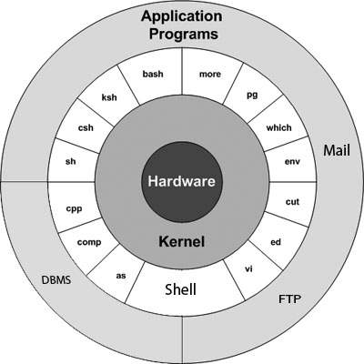
Kernel: The kernel is the heart of the operating system. It interacts with hardware and most of the tasks like memory management, task scheduling and file management.

Os -The computer programs that allocate the system resources and coordinate all the details of the computer's internals is called the operating system or kernel.

CLI :- CTRL + Alt + T
Comparatively , Commands offer more options & are flexible .Piping and stdin/stdout are immensely powerful are not available in GUI

Moving, renaming 1000's of file in GUI will be time consuming (Using Control /Shift to select multiple files) ,while in CLI , using regular expressions so can do the same task in a single command.

CLI load fast and do not consume RAM compared to GUI. In crunch scenarios this matters.

1) Go to the Dash and type terminal
2) Or you can press CTRL + Alt + T to launch the Terminal

beryl@beryl-System-Product-Name:~$
USERNAME, COMPUTERNAME, SEPERATOR,HOME DIRECTORY,REGULAR USER

pwd = print working directory
used for present working directory

cd = chande your current directory
by defualt user is in home directory

cd . = print currrent directory

cd .. = move onr up parent directory

cd / = move to root directory

..................................................

ls = listing all flles and directories in working directory

directory = blue color
files = white color

ls – R = lists files in subdirectories as well as all files but not sub dirctories

ls -al = gives detaild information of the files

ist column - files and access permission
2nd column - no of block
3rd column - owner and creator of files
4th column - group of owner
5th column - file size in bytes
6th column - date and time of creation of file
7th column – directory or files
...............................................................

cat = display only text files
it is also used for copy , combine, create new text files only
cat filename
cat > filename
hi this is file content
cat >> append in file

..............................................................

rm = remove only files
rmdir – remove directory
rm delete files without confirmation
rm -rf filename. === deltes directory recoursively forefully

rm filename
rmdire directory_name
................................................................
mv = move a file , rename a file

mv oldfile newfile
........................................................

mkdir = create a subdirectory in ur present working directory
mkdir file1 file 2 file3 = cretes multiple directory at a single time

lsb_release -a = gives the version of ubuntu

cp = for copy

cp fiel1 new_place
...............................................................

chmod
to change the permission of files

r = read
w = write
x = execute

o= owner
u= user
yy | Copies the current line.

g= group

+ = add the permission $chmod o+wx testfile

- remove the permission $chmod u-x testfile

= set the permission $chmod g=rx testfile

chown= change owner permission
chgrp = change group permission

$ chgrp group filelist
$ chgrp special testfile
...........................................................................

free = gives details about memory avilable and used

..................................................................

vi editor =editor enable you to edit lines in context with other lines in the file.

It's usually available on all the flavors of Unix system.
- Its implementations are very similar across the board.
- It requires very few resources.
- It is more user friendly than any other editors like ed or ex.
vi filename = Creates a new file if it already does not exist, otherwise opens existing file.\

vi -R filename= Opens an existing file in read only mode.

k | Moves the cursor up one line.
j | Moves the cursor down one line.
h | Moves the cursor to the left one character position.
l | Moves the cursor to the right one character position.

x | Deletes the character under the cursor location.
X | Deletes the character before the cursor location.

D | Deletes from the cursor position to the end of the current line.
dd | Deletes the line the cursor is on.

yy | Copies the current line.
........................................................................

gzip = to compress file
gzip filname

gunzip = unzip filename

cfar cf – folder11| gzip > abcde.gz == compress the directory

gunzip abcde.gz
.................................................................

head = to read top lines
head -2 sam.txt
tail = to read bottom lines

tail -2 sam.txt
.............................................................

ifconfig = gives the ip address
reboot= reboot the system
poweroff= shutdown the system
.................................................................
date = gives the present date and loca time
................................................................
ps = gives the process id and parent process id
kill = kill the procss

kill -9 processid = forcefull kills the procss
..................................................................
grep = to matchig pattern
top = gives the realtime cpu utlization of system.
...............................................................

GIT HUB
Version Control System (VCS) is a software that helps software developers to work together and maintain a complete history of their work.
Listed below are the functions of a VCS:
- Allows developers to work simultaneously.
- Does not allow overwriting each other’s changes.
- Maintains a history of every version.
Following are the types of VCS:
- Centralized version control system (CVCS).
- Distributed/Decentralized version control system (DVCS).
In this chapter, we will concentrate only on distributed version control system and especially on Git. Git falls under distributed version control system.

entralized version control system (CVCS) uses a central server to store all files and enables team collaboration. But the major drawback of CVCS is its single point of failure, i.e., failure of the central server. Unfortunately, if the central server goes down for an hour, then during that hour, no one can collaborate at all. And even in a worst case, if the disk of the central server gets corrupted and proper backup has not been taken, then you will lose the entire history of the project. Here, distributed version control system (DVCS) comes into picture.
DVCS clients not only check out the latest snapshot of the directory but they also fully mirror the repository. If the server goes down, then the repository from any client can be copied back to the server to restore it. Every checkout is a full backup of the repository. Git does not rely on the central server and that is why you can perform many operations when you are offline. You can commit changes, create branches, view logs, and perform other operations when you are offline. You require network connection only to publish your changes and take the latest changes.

Git
= server
= central repository
ex- github.com

Advantages of Git

Fast and small

Implicit backup

Security

No need of powerful hardware

Easier branching
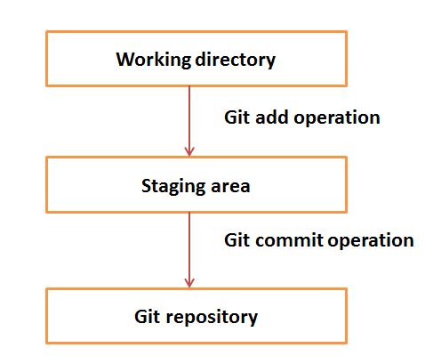

sudo apt-get install git-core
ISTALL GITHUBB

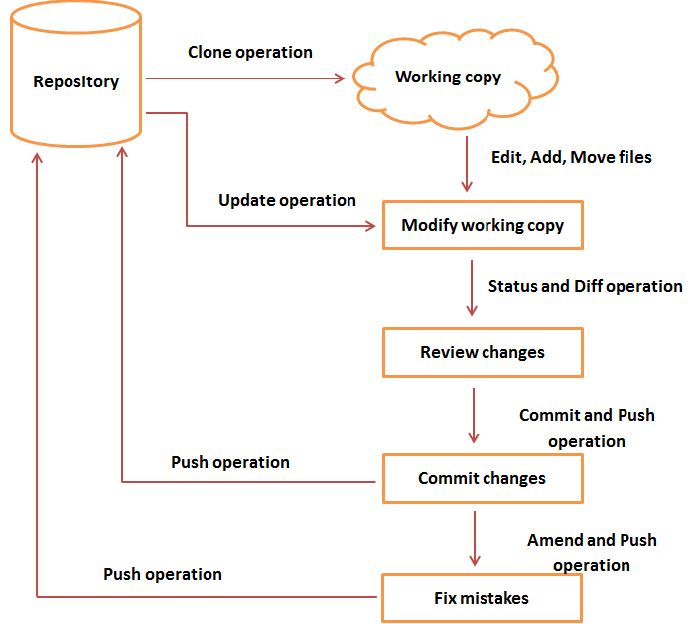

mkdir file1
git init
git add file1
git commit -m “logical message”
git push -u origin master

git add file1, file2, file3
git commit -m “modefiled and multiple file commit” file1 file2 file3
git push

git clone https:\\www.git\anandberylsystem\git_learning

git pull

git status = to check status from staging server

