DOTNET (C# BASIC PROGRAMS-DAY 22)
1.Write a C# program for adding two numbers
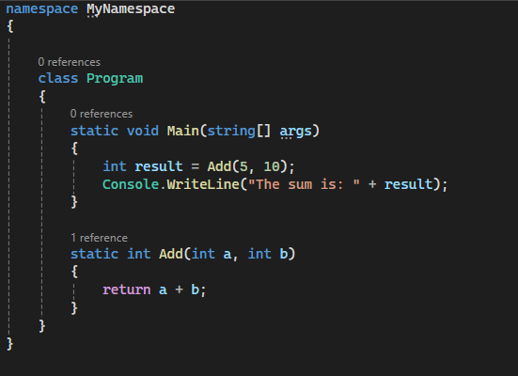

Output:
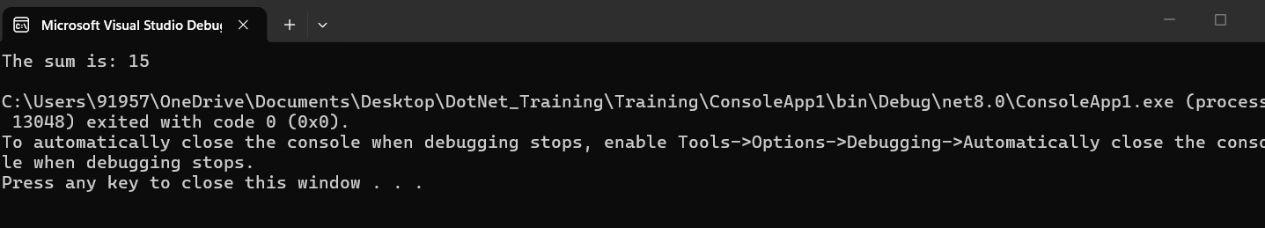

2) Write a C# program to implement Power function
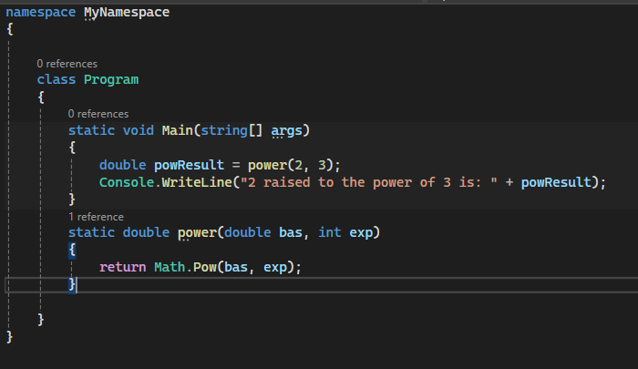

Output:
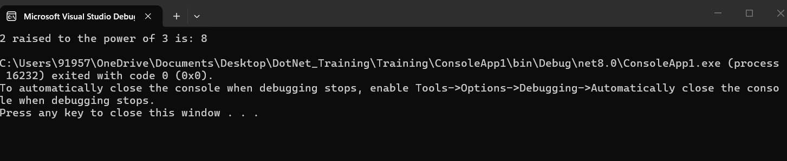

3.Write a C# program for subtracting two numbers
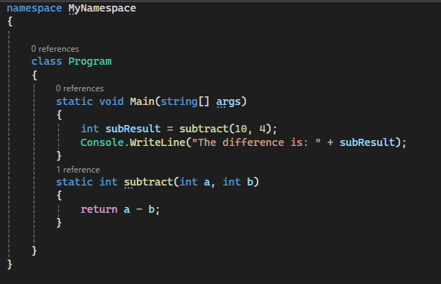

Output:
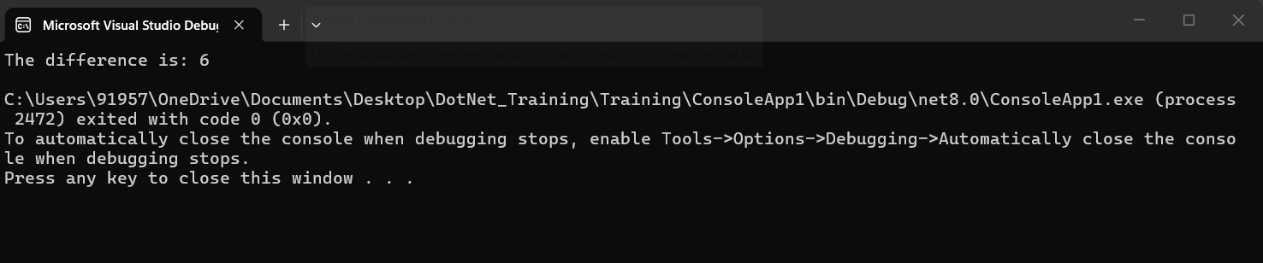

4.Write a C# program for multiply two numbers
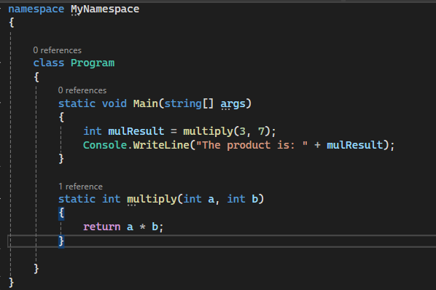

Output:
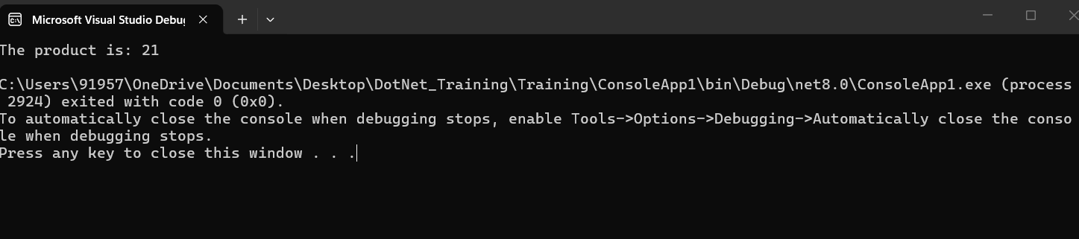

5.Write a C# program for swaping two numbers
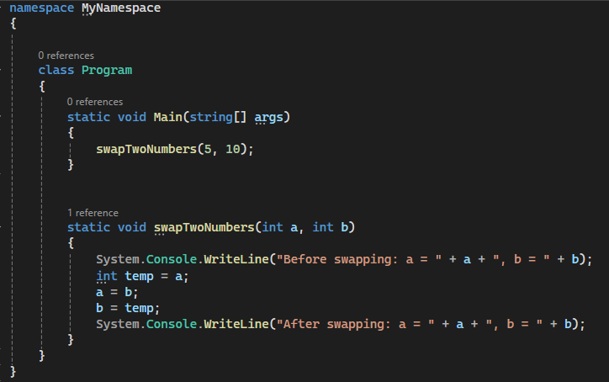

Output:
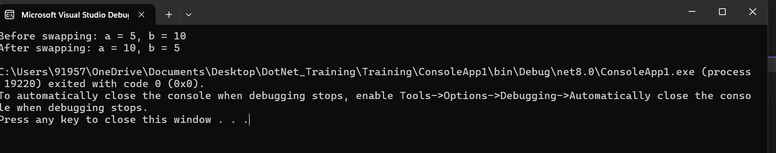

6.Write a C# program for displaying the details take input from console.
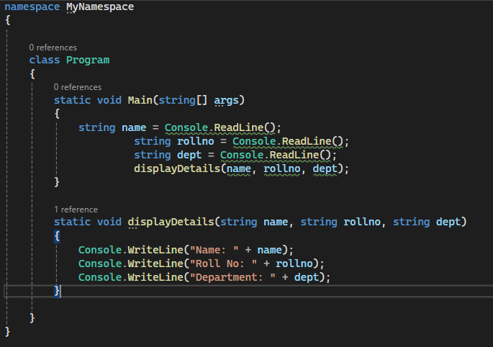

Output:
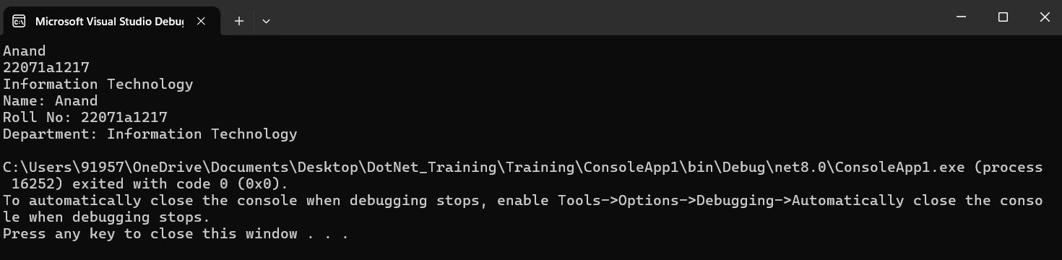

7.Write a C# program for printing a table
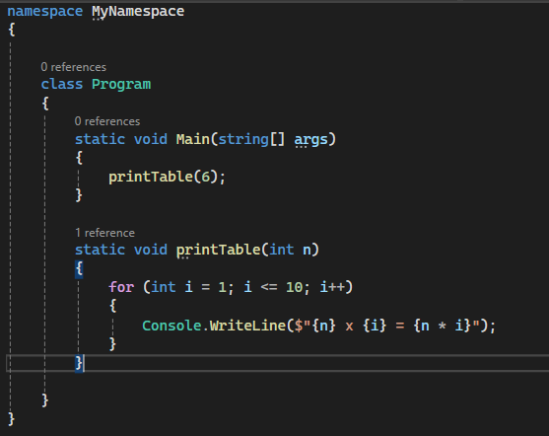

Output:
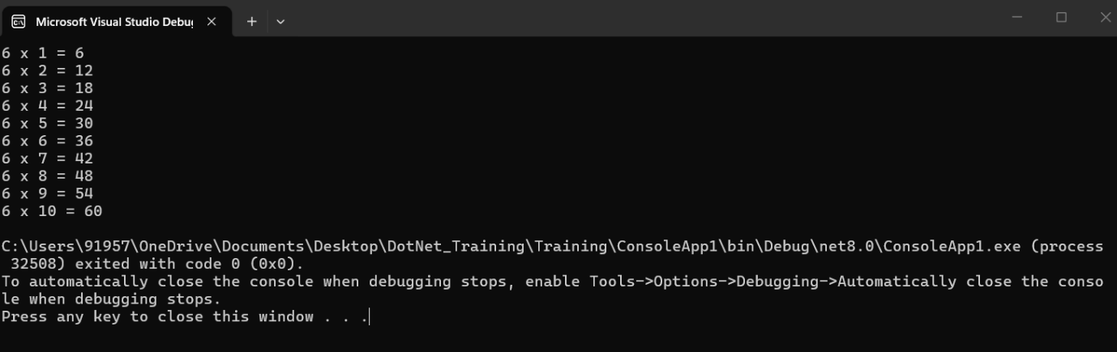

8.Write a C# program for replacing a charater at particular index
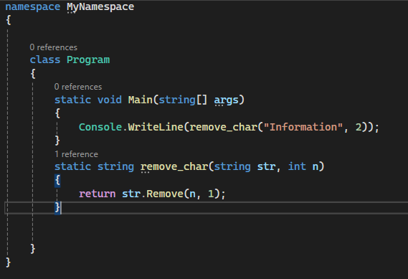

Output:
