**Basic_Training_Day_3_Git_Assignment**

1. **Create a private Github repo named "i-am-a-git-noob"**

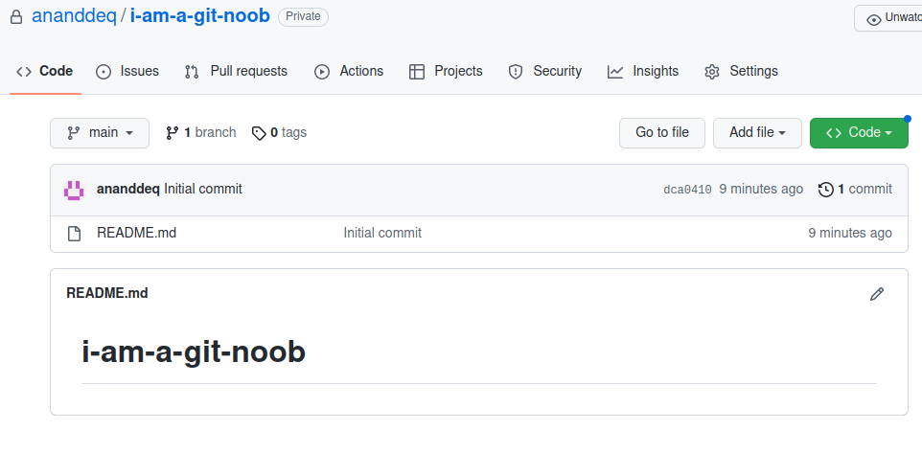

1. **Create a new repository on local in an empty directory**



A .git file gets created which is a hidden file, it contains all necessary information related to commits, remote repositories. It also contains information about refs, tags and series of commits which helps us to rollback the commit.

1. **Point remote of your local git repo to the newly created repo on Github**



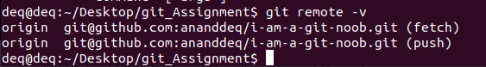

1. **Print current git configs on terminal**

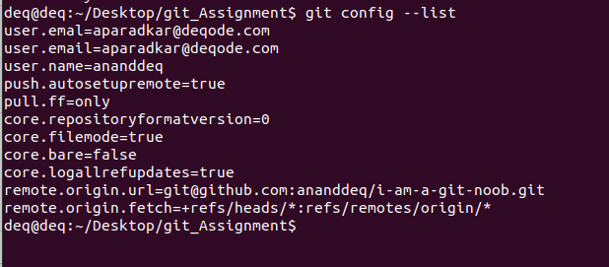

1. **Update git config with your name and email address (only for current repository)**

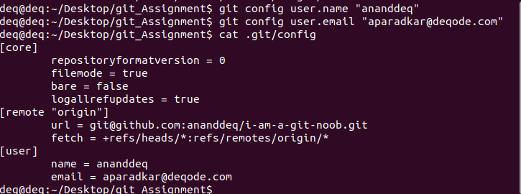

1. **Create a file named "test1.txt"**

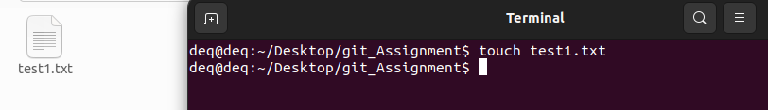

1. **Added line with text "first line in file" in "test1.txt".**

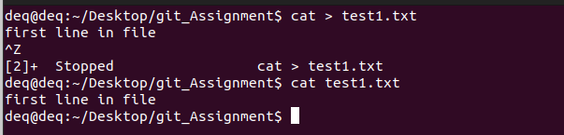

1. **Push this file to your Github repo.**

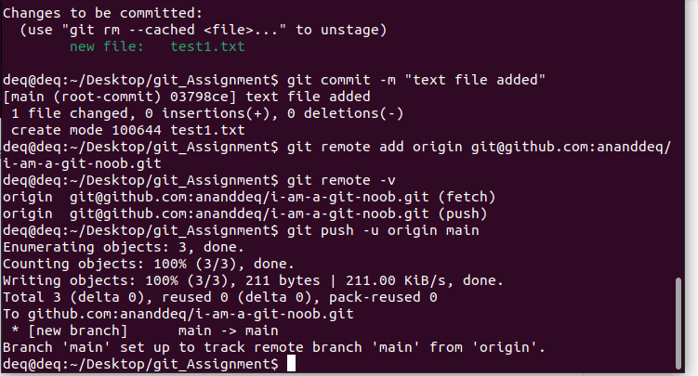

1. **Append line with text "second line in file" in "test1.txt".**

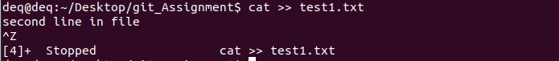

1. **Add file to the staging area.**

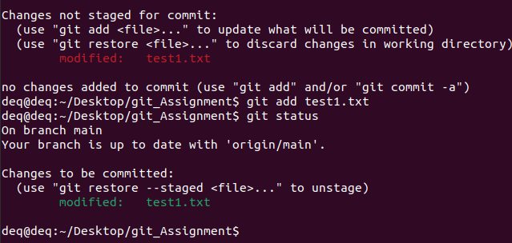

1. **Check the status of the file in all staging area**

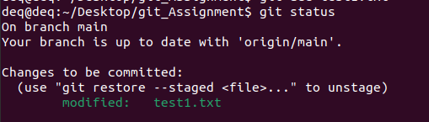

1. **Append line with text "Third line in file" in "test1.txt".** Note status of files across different areas).

Status after making modifications

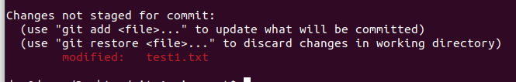

Status after add command

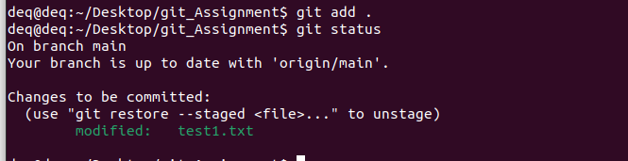

1. **Remove "test1.txt" from the staging area.**

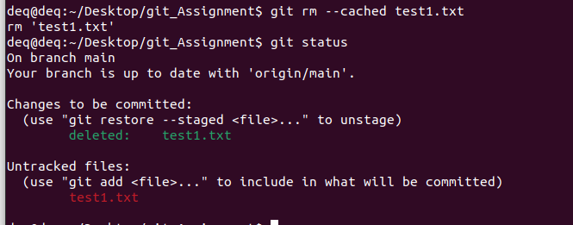

1. **Create commit with message "My First Commit"**

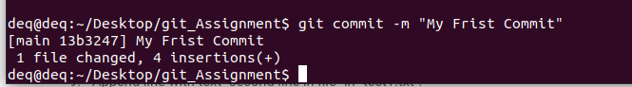

1. **Push commit to the remote repo**

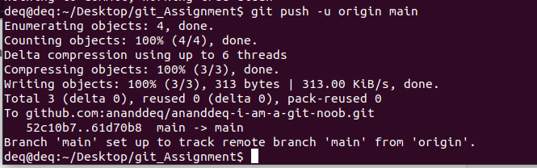

1. **Update message of last commit "My First Commit" to "My Second Commit" (without creating a new commit)**

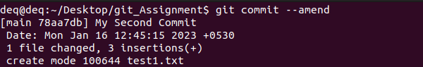

1. **Push commit with the updated message to the remote repo**

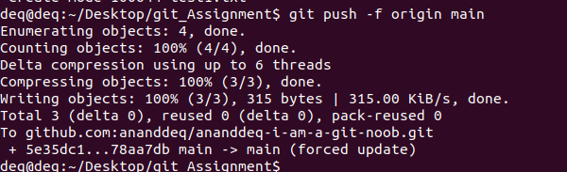

1. **Check the difference between the last and second last commits.**

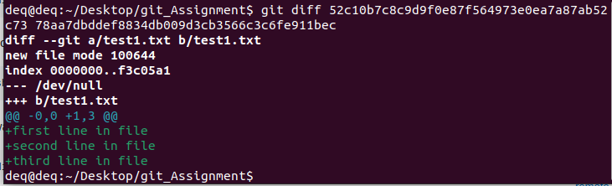

1. **Revert the last commit and check the updated commit logs history.**

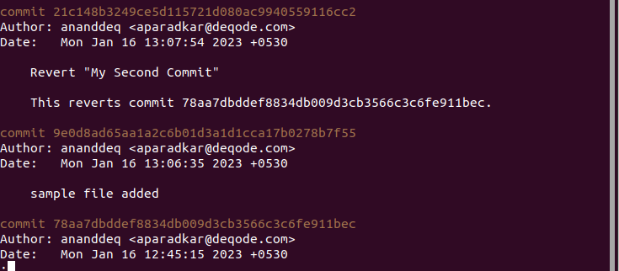

1. **Append line with text "Fourth line in file" in "test1.txt" and commit it.**

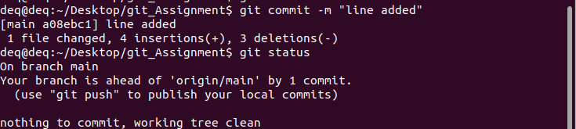

1. **Update the last commit such that the "test1.txt" also contains "Fifth line in file" (without creating a new commit)**

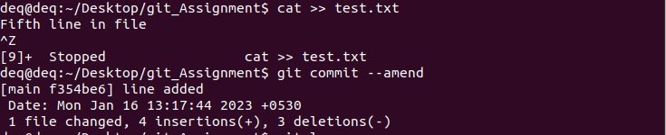

1. **Push the updated commits to the remote repository**

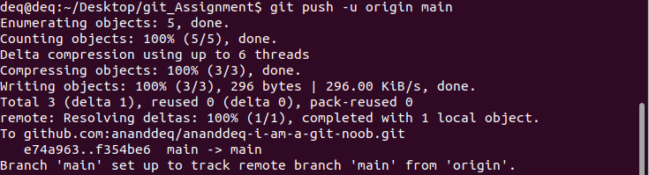

1. **Append some content in "test1.txt" file**

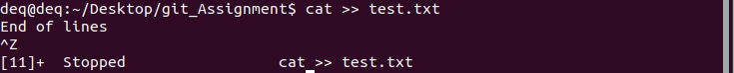

1. **Pull all the content from remote repository to local repository**



1. **Clone the remote repository to some other directory in your local system.**

