A
Project Report
On
MULTI-THREADED CLIENT-SERVER CHAT APPLICATION USING JAVA SOCKETS, SWING, AND MYSQL
Submitted in partial fulfillment for the award of degree of
Bachelor of Technology
Degree Of
Rajasthan Technical University, KOTA
JAIPUR ENGINEERING COLLEGE AND RESEARCH CENTRE
2026-2027
Submitted By:  Anand Gaur (Roll No: <Roll No.>)  Sunanda (Roll No: <Roll No.>)  <Team Member 3> (Roll No: <Roll No.>) | ITS Coordinator (CC)  <Faculty Name>  <Designation>  Dept. of CSE (AI)

DEPARTMENT OF
COMPUTER SCIENCE & ENGINEERING (ARTIFICIAL INTELLIGENCE)
JAIPUR ENGINEERING COLLEGE AND RESEARCH CENTRE
Shri Ram ki Nangal, via Sitapura RIICO, Tonk Road, Sukhpuria, Bambala, Jaipur, Rajasthan

TABLE OF CONTENTS
Introduction ................................................ | 1
Objective ................................................... | 2
Methodology And Planning .................................... | 3
Literature Review ........................................... | 4
Applications of the Project ................................. | 5
Block Diagram ............................................... | 6
UML Diagram ................................................. | 7
Screenshots ................................................. | 8
References .................................................. | 9
Approval of the Project ..................................... | 10

1. Introduction
In the contemporary computing era, distributed applications and networked real-time communication systems are vital for organizational collaboration. This project, titled 'Multi-Threaded Client-Server Chat Application', implements a comprehensive, multi-user communication environment programmed in pure Core Java (JDK 25). The system utilizes reliable transport-layer TCP/IP sockets via java.net, high-throughput worker thread management via java.util.concurrent.ExecutorService, an interactive Swing Graphical User Interface, and persistent relational data storage using MySQL 8.0 and JDBC.
The project is architected to address standard challenges in networked desktop applications, including thread exhaustion, UI freezes caused by blocking I/O, secure credential storage, and synchronized real-time client presence.
2. Objective
The primary objectives of this project are:
1. Concurrency Management: Build a multi-threaded server using ExecutorService thread pooling that dynamically handles multiple simultaneous client connections.
2. Bi-directional Messaging: Provide both global broadcast messaging (all active users) and private point-to-point messaging (1-to-1 dialogue).
3. Real-Time Presence Detection: Maintain an accurate, synchronized active contacts roster with live status updates upon client connection or disconnection.
4. Robust Persistence & Security: Authenticate users against a MySQL database using SHA-256 password hashing, preventing SQL injection via JDBC PreparedStatements, and load past chat history upon login.
5. Fluid GUI Architecture: Design a non-blocking Swing GUI where network I/O operations are strictly segregated from the Event Dispatch Thread (EDT).

3. Methodology And Planning
The development methodology followed an iterative, component-driven engineering model divided into four distinct phases:
Phase 1 - Database Schema & Persistence Layer:
Designed the relational schema consisting of 'users' and 'messages' tables in MySQL. Implemented DBHandler.java using standard JDBC. PreparedStatements were utilized to parameterize all queries, and MessageDigest was applied to compute 64-character SHA-256 password hashes.
Phase 2 - Network Protocol & Server Engineering:
Formulated a clean, deterministic pipe-delimited application layer protocol (e.g., LOGIN|<user>|<pass>, BROADCAST|<msg>, PRIVATE|<rcpt>|<msg>). Engineered ChatServer.java with a ServerSocket listening on TCP port 12345, utilizing Executors.newCachedThreadPool() to assign ClientHandler runnables dynamically. Client sessions are stored thread-safely in a ConcurrentHashMap.
Phase 3 - Client Networking & GUI Construction:
Developed ChatClient.java with a dedicated background thread to read inbound socket data. Constructed ChatGUI.java using Java Swing (CardLayout, JTextPane, JList). Applied SwingUtilities.invokeLater() to ensure thread-safe updates to the UI.
Phase 4 - System Integration & Verification:
Conducted end-to-end integration tests using JDK 25 and MySQL 8.0, verifying concurrent logins, message delivery latency, and clean resource deallocation on window closing events.
4. Literature Review
Distributed messaging architectures have evolved from early monolithic, synchronous systems to event-driven and multi-threaded paradigms. Harold (2014) highlights that traditional single-threaded socket architectures create severe I/O bottlenecks when scaling beyond minimal client counts, advocating for thread pooling mechanisms that reuse operating system threads rather than instantiating unbounded threads per connection. Goetz et al. (2006) discuss concurrent synchronization primitives, noting that ConcurrentHashMap achieves high concurrency through lock-free reads and granular write locks, which is ideal for server-side active user registries. Furthermore, Schildt (2021) emphasizes that graphical desktop frameworks like Swing follow a single-thread rule where all visual mutations must occur on the Event Dispatch Thread (EDT) to avert deadlock and race conditions. This project synthesizes these established paradigms to construct a production-quality, educational client-server framework.

5. Applications of the Project
1. Academic & Institutional Intranets: Provides private, secure, local-network messaging for computer science laboratories and campus faculties.
2. Corporate Internal Chat: Serves as a standalone, internal communication tool that operates without reliance on external cloud servers, preserving company data sovereignty.
3. Real-Time Customer Support Systems: The underlying multi-threaded socket and routing infrastructure can be extended to customer assistance desks for immediate agent-client interactions.
4. Modular Foundation for Distributed Systems: Acts as a foundational framework for distributed computing labs, illustrating advanced synchronization, socket state machines, and relational storage.
6. Block Diagram

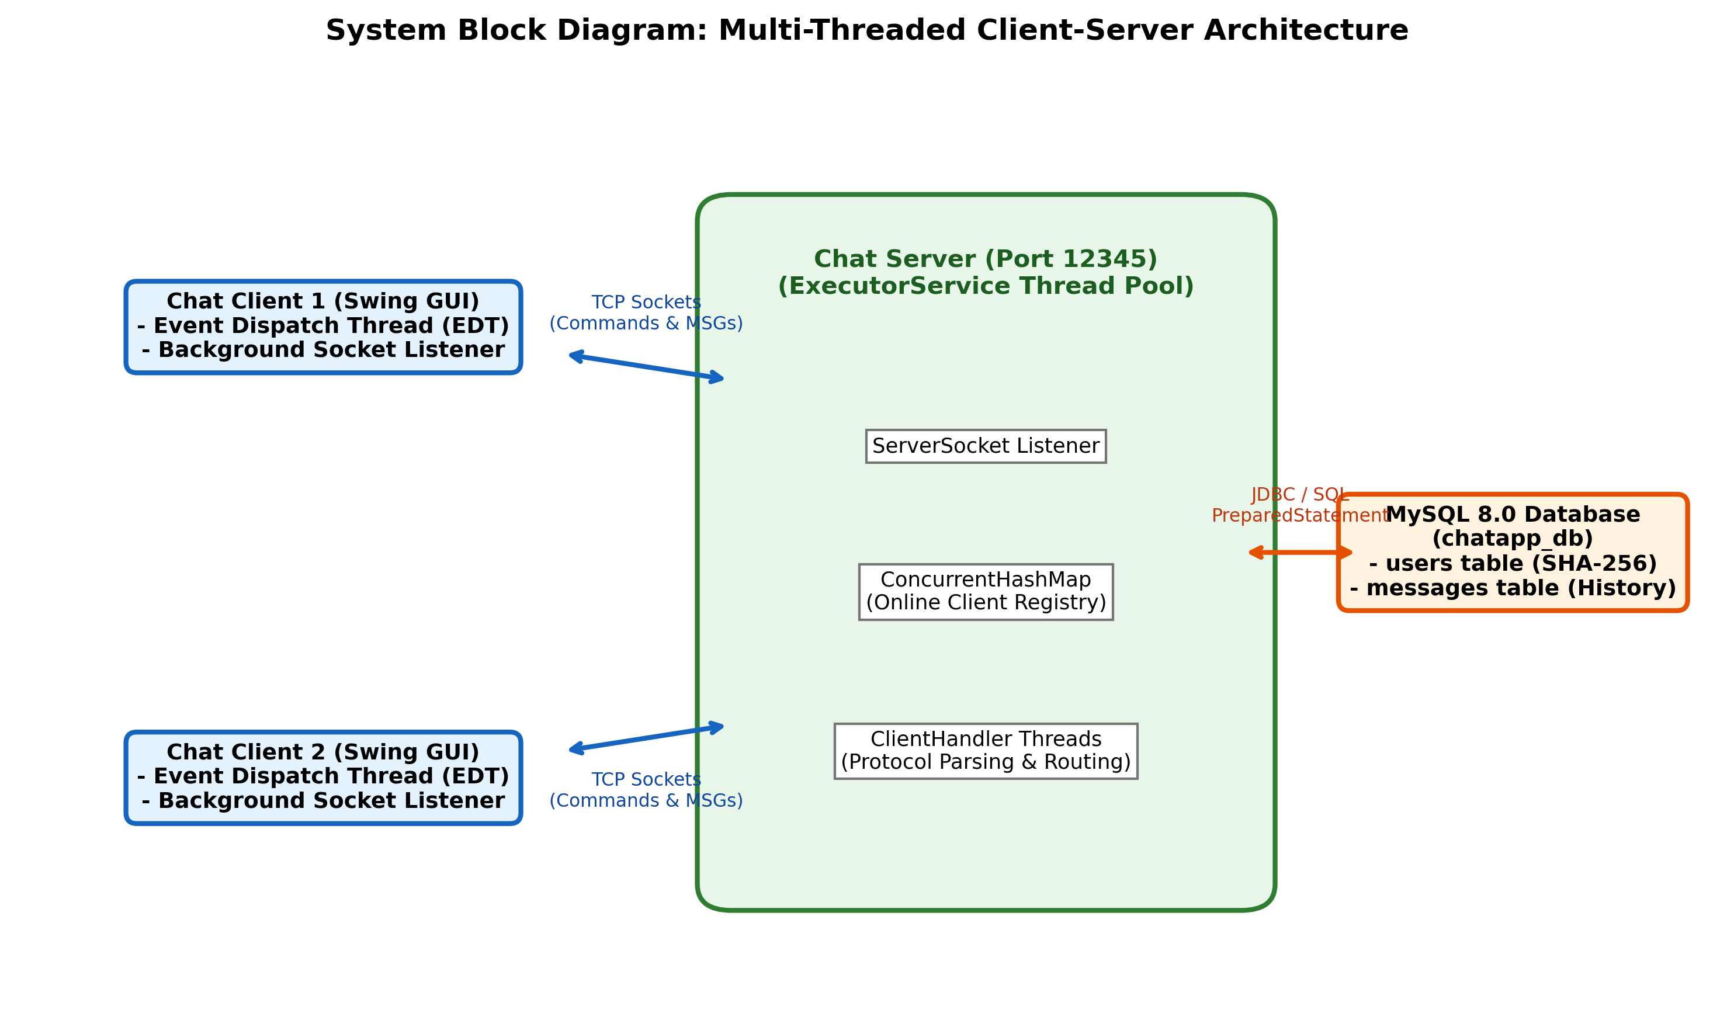
Figure 6.1: High-Level System Architecture and Component Interfacing

7. UML Diagram

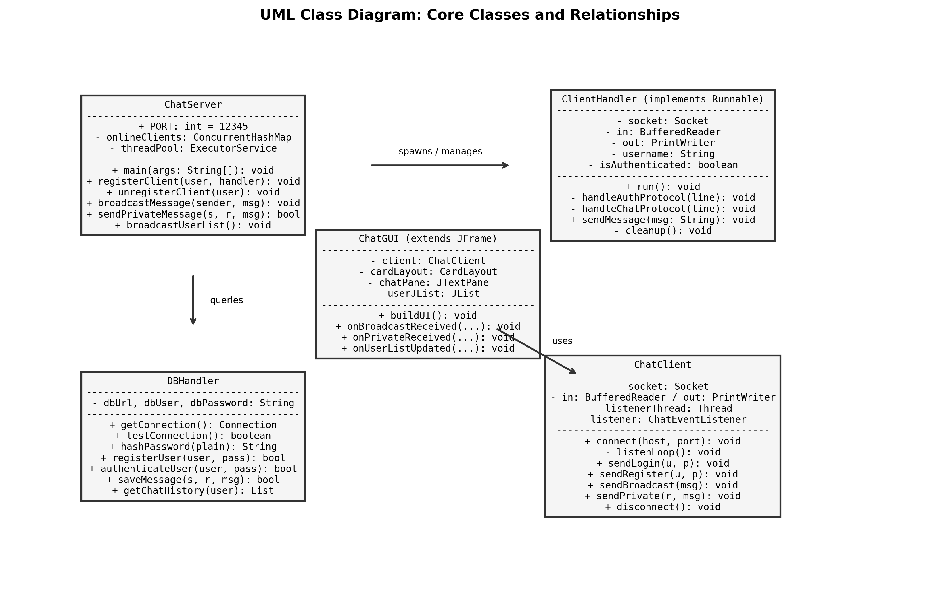
Figure 7.1: UML Class Diagram Depicting Classes, Methods, and Inter-Object Associations
8. Screenshots

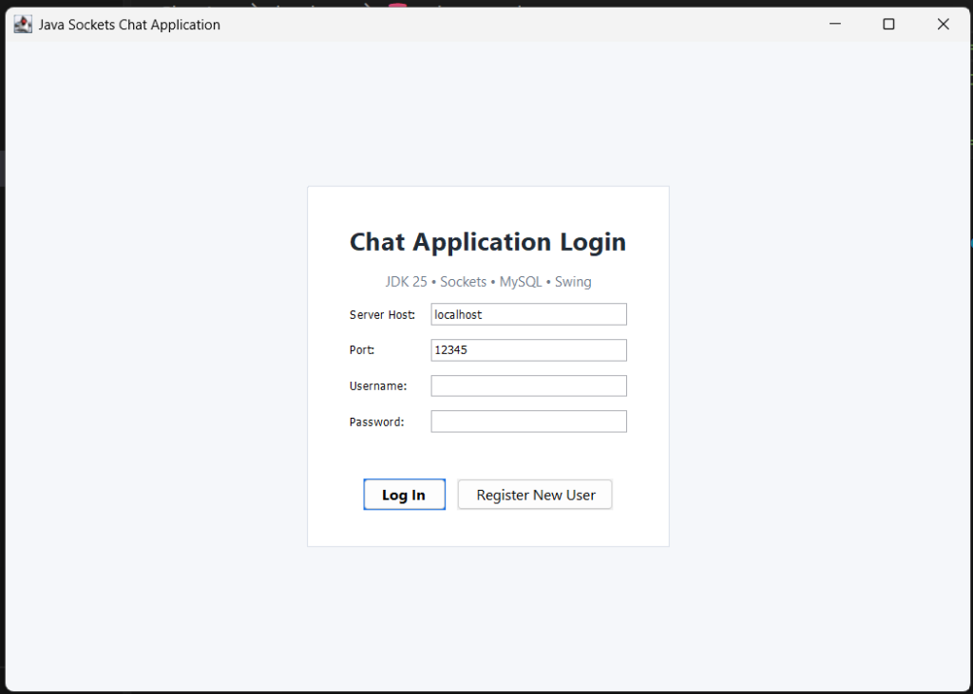
Figure 8.1: Swing Graphical User Interface - Authentication Screen (Login & Registration)

9. References
[1] Herbert Schildt, 'Java: The Complete Reference', 12th Edition, McGraw-Hill Education, 2021.
[2] Elliotte Rusty Harold, 'Java Network Programming: Developing Networked Applications', 4th Edition, O'Reilly Media, 2014.
[3] Brian Goetz, Tim Peierls, Joshua Bloch, Joseph Bowbeer, David Holmes, Doug Lea, 'Java Concurrency in Practice', Addison-Wesley Professional, 2006.
[4] Oracle Corporation, 'Java Platform, Standard Edition Documentation - Socket, ServerSocket & Concurrency Utilities', Oracle Technology Network.
[5] Paul DuBois, 'MySQL Developer's Library', 5th Edition, Addison-Wesley Professional, 2013.
[6] Loy, M., Eckstein, R., Wood, D., Elliott, J., & Cole, B., 'Java Swing', 2nd Edition, O'Reilly Media, 2002.
10. Approval of the Project
This is to certify that the project entitled 'MULTI-THREADED CLIENT-SERVER CHAT APPLICATION USING JAVA SOCKETS, SWING, AND MYSQL' submitted by Anand Gaur, Sunanda, and <Team Member 3> in partial fulfillment for the award of the degree of Bachelor of Technology in Computer Science & Engineering (Artificial Intelligence) at Jaipur Engineering College and Research Centre, Jaipur, affiliated with Rajasthan Technical University, Kota, is an authentic record of bonafide work carried out by them under my guidance and supervision.
To the best of my knowledge, the matter embodied in this project report has not been submitted to any other University / Institute for the award of any degree or diploma.

________________________  Signature of Project Guide  <Faculty Name>  <Designation> | ________________________  Signature of HOD  Head of Department  Dept. of CSE (AI)

