A
Project
SYNOPSIS
Of
MULTI-THREADED CLIENT-SERVER CHAT APPLICATION USING JAVA SOCKETS, SWING, AND MYSQL
Submitted in partial fulfillment for the award of degree of
Bachelor of Technology
Degree Of
Rajasthan Technical University, KOTA
JAIPUR ENGINEERING COLLEGE AND RESEARCH CENTRE
2026-2027
Submitted By:  Anand Gaur (Roll No: <Roll No.>)  Sunanda (Roll No: <Roll No.>)  <Team Member 3> (Roll No: <Roll No.>) | ITS Coordinator (CC)  <Faculty Name>  <Designation>  Dept. of CSE (AI)

DEPARTMENT OF
COMPUTER SCIENCE & ENGINEERING (ARTIFICIAL INTELLIGENCE)
JAIPUR ENGINEERING COLLEGE AND RESEARCH CENTRE
Shri Ram ki Nangal, via Sitapura RIICO, Tonk Road, Sukhpuria, Bambala, Jaipur, Rajasthan

ABSTRACT
In modern distributed computing and collaborative environments, real-time peer-to-peer and group communication platforms form the backbone of productivity and information sharing. This project, titled 'Multi-Threaded Client-Server Chat Application', presents a robust, full-duplex communication system engineered in Core Java (JDK 25) leveraging standard TCP networking (java.net.Socket and java.net.ServerSocket), concurrency utilities (java.util.concurrent.ExecutorService), graphical user interface design (Java Swing), and relational persistence through JDBC and MySQL 8.0.
The architecture incorporates a centralized multi-threaded server capable of handling multiple client connections simultaneously without performance degradation or thread exhaustion through an elastic cached thread pool. The client interface offers a modern, intuitive graphical interface built with Java Swing, featuring an authentication screen, a real-time active contact roster with visual online/offline indicators, and a multi-mode messaging pane that seamlessly toggles between global broadcast communication and private peer-to-peer dialogues. Security is enforced through SHA-256 cryptographic password hashing, while comprehensive chat histories and user registrations are persisted into an ACID-compliant MySQL database. All network socket I/O is decoupled from the Swing Event Dispatch Thread (EDT), guaranteeing fluid, zero-latency user interactions. This project comprehensively demonstrates practical applications of socket programming, multithreading synchronization, relational database integration, and UI event-driven design.

INTRODUCTION
• Problem Statement: Traditional desktop communications often suffer from rigid, single-threaded architectures that lock up the user interface during active network operations, lack secure authentication, and lose historical conversation context upon disconnection. Furthermore, many educational networking systems fail to bridge the gap between low-level socket primitives and high-level relational data persistence. There is a need for a modular, responsive, and persistent multi-threaded client-server messaging application built using pure core Java standards.
• Scope of the Project: The project encompasses a complete end-to-end communication system that operates over local area networks (LAN) or the Internet using standard TCP/IP protocols. Its operational scope includes user account registration, secure login with one-way cryptographic hashing, real-time presence detection, bi-directional message dispatching (group broadcast and private 1-to-1), chronological chat history loading from an ACID-compliant database, and graceful teardown upon client exit.
• Technologies Used: • Programming Language & Runtime: Core Java (OpenJDK 25)
• Networking Library: java.net (Socket, ServerSocket) using custom text-based delimiter protocol
• Multithreading & Concurrency: java.util.concurrent (ExecutorService, ConcurrentHashMap)
• Graphical User Interface: Java Swing (JFrame, CardLayout, JTextPane, JList, JSplitPane, EDT)
• Persistence & Database: MySQL 8.0 via MySQL Connector/J 9.7.0 (JDBC PreparedStatement)
• Security: java.security.MessageDigest (SHA-256 Hashing)
• Methodology: The system is built upon a layered Client-Server Architecture. The Server listens continuously on a designated TCP port (12345) and delegates each incoming client socket to a managed worker thread inside an ExecutorService. Thread safety is guaranteed by storing active client streams in a ConcurrentHashMap. On the client side, network listening is segregated onto a background daemon thread, while GUI updates are dispatched strictly onto the Swing Event Dispatch Thread (EDT) via SwingUtilities.invokeLater() to ensure non-blocking UI behavior.
• Expected Outcome: A high-performance, fault-tolerant desktop chat platform capable of sustaining concurrent user sessions, maintaining zero GUI freezes during intensive message broadcasts, securely authenticating users without plain-text vulnerability, and reliably persisting and restoring historical dialogues from MySQL.
• Applications of Project: • Internal Enterprise Communication: Secure, lightweight communication within university or corporate intranets.
• Collaborative Learning Environments: Real-time discussion rooms for educational labs and classrooms.
• Reference Architecture: Academic benchmark demonstrating core multithreading, sockets, and JDBC integration.

CONCLUSIONS AND FUTURE ENHANCEMENTS
Conclusions:
The development of the Multi-Threaded Client-Server Chat Application successfully demonstrates the power and flexibility of Core Java for distributed enterprise solutions. By implementing an ExecutorService-backed thread pool, the server seamlessly manages simultaneous client sockets without incurring the hazardous overhead of unmanaged thread creation. The integration of JDBC with PreparedStatement ensures parameterized, injection-free database transactions, while SHA-256 hashing secures sensitive credentials. The Swing client maintains high responsiveness through disciplined Event Dispatch Thread (EDT) concurrency separation. Overall, the project fulfills all academic and functional requirements of a high-performance chat system.
Future Enhancements:
1. End-to-End Encryption (E2EE): Incorporating RSA/AES hybrid cryptography to encrypt socket payload data in transit.
2. Multimedia & File Sharing: Enhancing the socket protocol with binary streaming for transferring images, audio, and documents.
3. Voice and Video Conferencing: Implementing Java Media Framework (JMF) or WebRTC for real-time audiovisual calling.
4. Push Notifications & Read Receipts: Extending the protocol to support delivery status acknowledgments and typing indicators.
System Architecture & Communication Flow
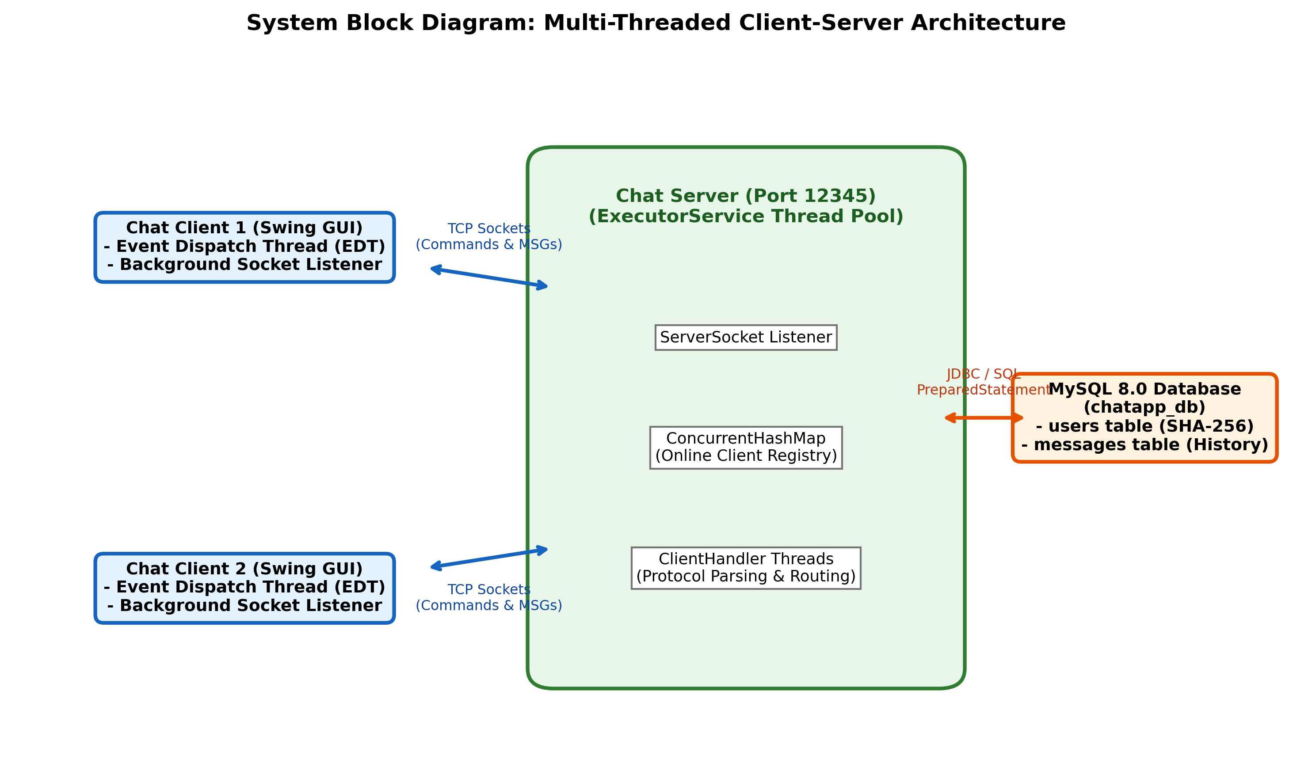

References
[1] Herbert Schildt, 'Java: The Complete Reference', 12th Edition, McGraw-Hill Education, 2021.
[2] Elliotte Rusty Harold, 'Java Network Programming: Developing Networked Applications', 4th Edition, O'Reilly Media, 2014.
[3] Brian Goetz, Tim Peierls, Joshua Bloch, Joseph Bowbeer, David Holmes, Doug Lea, 'Java Concurrency in Practice', Addison-Wesley Professional, 2006.
[4] Oracle Corporation, 'Java Platform, Standard Edition Documentation - Socket, ServerSocket & Concurrency Utilities', Oracle Technology Network.
[5] Paul DuBois, 'MySQL Developer's Library', 5th Edition, Addison-Wesley Professional, 2013.
[6] Loy, M., Eckstein, R., Wood, D., Elliott, J., & Cole, B., 'Java Swing', 2nd Edition, O'Reilly Media, 2002.

