A
Project Report
On
REAL-TIME GENERALIZED N-GON AND SIERPINSKI FRACTAL GENERATOR USING CHAOS GAME AND ITERATED FUNCTION SYSTEMS IN C++ & SFML
Submitted in partial fulfillment for the award of degree of
Bachelor of Technology
Degree Of
Rajasthan Technical University, KOTA
2026-2027
Submitted By:  Abhinav Bhatra (24EJCCA009)  Amit kumar (24EJCCA027)  Anand Gaur (24EJCCA030)  Abhishek Sihag (24EJCCA012) | ITS Coordinator (CC):  Ms. Mona Nagar  Assistant Professor  Dept. of CSE (AI)
DEPARTMENT OF
COMPUTER SCIENCE & ENGINEERING (ARTIFICIAL INTELLIGENCE)
JAIPUR ENGINEERING COLLEGE AND RESEARCH CENTRE
Shri Ram ki Nangal, via Sitapura RIICO, Tonk Road, Sukhpuria, Bambala, Jaipur, Rajasthan - 302022

TABLE OF CONTENTS
Chapter / Section Title | Page No.
Introduction | 1
Objective | 5
Methodology And Planning | 6
Literature Review | 13
Applications of the Project | 16
Block Diagram | 18
UML Diagram | 20
Screenshots | 23
References | 29
Approval of the Project | 30

1. Introduction
Euclidean geometry deals with smooth, integer-dimensional entities such as lines (1D), circles and polygons (2D), and spheres and polyhedra (3D). However, nature exhibits intricate geometric shapes that display infinite irregularity and fine detail regardless of the magnification scale—including coastlines, lightning paths, blood vessels, mountain ridges, and cloud formations. In 1975, Benoit Mandelbrot established the field of Fractal Geometry to describe objects that exhibit self-similarity and possess non-integer Hausdorff dimensions.
1.1 The Sierpinski Gasket / Triangle
First described by Polish mathematician Wacław Sierpiński in 1915, the Sierpinski Triangle (or Sierpinski Gasket) is an archetypal fractal. It is traditionally constructed deterministically by starting with an equilateral triangle, connecting the midpoints of its three sides to form an inverted central triangle, excising that central triangle, and recursively repeating the excision infinitely on the three remaining sub-triangles.
1.2 Mathematical Derivation of Hausdorff Dimension
In Euclidean geometry, when an object with dimension D is scaled down by a linear scaling factor s, it divides into N self-similar pieces according to the relation: N = (1/s)^D.
Taking natural logarithms on both sides: ln(N) = D * ln(1/s). Therefore: D = ln(N) / ln(1/s).
For the Sierpinski Triangle, each iteration subdivides the shape into N = 3 identical copies, each scaled by s = 1/2 = 0.5. Substituting into the formula:
D = ln(3) / ln(1 / 0.5) = ln(3) / ln(2) ~ 1.098612 / 0.693147 ~ 1.5849625...
Because 1 < 1.585 < 2, the Sierpinski Triangle has greater complexity and boundary detail than a 1D line, but is too sparse to occupy a 2D Euclidean surface area.
1.3 The Area and Perimeter Paradox
Let the initial solid equilateral triangle have area A_0 and perimeter P_0. At step k, exactly 1/4 of the remaining area is excised:
A_k = A_0 * (3/4)^k --> lim_{k -> infinity} A_k = 0 (Area converges to zero).
Conversely, each step exposes new internal edges, multiplying perimeter by 3/2:
P_k = P_0 * (3/2)^k --> lim_{k -> infinity} P_k = infinity (Perimeter tends to infinity).
This mathematical paradox—a shape possessing zero surface area enclosed by an infinite perimeter—is a hallmark of fractal geometry.

2. Objective
The primary objective of this project is to bridge theoretical fractal mathematics and real-time computer graphics by developing an interactive, GPU-accelerated C++ application using SFML 2.5+.
- Stochastic Chaos Game Simulation: Implement the random midpoint contraction algorithm to demonstrate how deterministic self-similar fractals emerge from pseudo-random point walks.
- Deterministic Subdivision Comparison: Implement the classic recursive triangle-splitting method (depths 0 to 8) to compare top-down hierarchical tessellation with bottom-up stochastic iteration.
- Generalization to Arbitrary N-Gons: Expand the attractor boundary from an equilateral triangle (N=3) to regular polygons up to N=12 (N-Flakes), computing mathematically exact contraction ratios r(N).
- Stable 60 FPS Performance: Use persistent off-screen framebuffers (sf::RenderTexture) to render over 500,000 points without frame drops.
- Multi-Modal Interactive User Input: Empower users to drag polygon vertices in real time using the mouse, click to set custom starting seed points, click on-screen GUI buttons, use keyboard shortcuts, or input parameters via terminal prompt.
3. Methodology And Planning
3.1 Algorithm 1: The Chaos Game
The Chaos Game operates iteratively: 1) Initialize N polygon vertices V_0 ... V_{N-1}. 2) Choose an arbitrary starting point P_0. 3) Discard the first 25 warmup iterations. 4) In each frame, select a random vertex V_i with probability 1/N. 5) Compute the contracted position P_{k+1} = (1 - r)*P_k + r*V_i. 6) Draw the new point to the persistent buffer.
3.2 Iterated Function Systems & Hutchinson Operator
An Iterated Function System (IFS) consists of contractive affine mappings {f_1, ..., f_N}. By the Banach Fixed-Point Theorem and Hutchinson's Theorem (1981), there exists a unique compact attractor A satisfying A = Union_{i=1}^N f_i(A). Elton's Ergodic Theorem guarantees that the random orbit generated by the Chaos Game is dense in A with probability 1.
3.3 Generalization to Regular N-Gons & Contraction Ratio r(N)
For an arbitrary regular N-gon, vertices are placed parametrically: V_k = (cx + R*cos(theta_k), cy + R*sin(theta_k)), with theta_k = -pi/2 + 2*pi*k/N. To ensure sub-polygons touch without overlapping, the contraction ratio r(N) is derived:
r(N) = 1 / [ 2 * ( 1 + sum_{k=1}^{floor(N/4)} cos(2*pi*k / N) ) ]
For N=3: r = 0.500 (Sierpinski Gasket). For N=4: r = 0.500 (Sierpinski Carpet under non-adjacent rule). For N=5: r = (3 - sqrt(5))/2 ~ 0.382 (Dürer's Pentagasket / Golden Ratio). For N=6: r = 1/3 ~ 0.333 (Hexaflake). For N=8: r = 1/(2 + sqrt(2)) ~ 0.293 (Octaflake).
3.4 Team Work Distribution
Member Name | Roll No. | Project Responsibilities
Anand Gaur | 24EJCCA030 | Mathematical derivation of r(N), GPU texture caching, Git repo setup.
Abhinav Bhatra | 24EJCCA009 | Chaos Game engine, Mersenne Twister RNG, and warmup discard logic.
Amit kumar | 24EJCCA027 | Recursive subdivision, solid/wireframe mesh generation, depth handling.
Abhishek Sihag | 24EJCCA012 | Mouse vertex dragging, click-to-seed, HUD controls, documentation.

4. Literature Review
The mathematical foundation of fractals dates back to Wacław Sierpiński (1915) and Felix Hausdorff (1918). Benoit Mandelbrot's seminal 1982 work 'The Fractal Geometry of Nature' unified these concepts and demonstrated that complex natural phenomena obey scale-invariant fractal laws rather than Euclidean geometry.
John Hutchinson (1981) placed fractals on a rigorous analytical foundation by formulating Iterated Function Systems on complete metric spaces. Michael Barnsley (1988) popularized the Chaos Game in 'Fractals Everywhere', proving that stochastic iterations faithfully trace deterministic attractors.
In modern computer graphics, SFML provides an optimal balance between low-level OpenGL GPU acceleration and clean C++ object-oriented architecture, enabling hardware-buffered texture caching for massive point clouds.
5. Applications of the Project
- Procedural Modeling in Game Engines: Procedural generation of terrain, mountains, foliage, and textures in game engines like Unreal Engine and Unity.
- Fractal Antenna Engineering: Design of compact multiband cellular and satellite antennas utilizing self-similar Sierpinski geometries.
- Fractal Image Compression: Compressing images by encoding local self-similar domain-to-range contractive affine maps.
- AI & Computer Vision: Using fractal dimensions as texture feature descriptors for biomedical image analysis (e.g. tumor boundary detection).
6. Block Diagram
The software architecture comprises four distinct interacting subsystems:
- 1. User Input Layer: Captures mouse drag coordinates, canvas click seeds, on-screen GUI buttons, keyboard hotkeys, and console input.
- 2. Mathematics & Geometry Engine: Computes parametric polygon vertices, calculates optimal jump ratio r(N), executes random contraction mappings, and manages recursive tessellation.
- 3. SFML Render Pipeline: Batches new points into sf::VertexArray and draws incrementally to a persistent off-screen sf::RenderTexture.
- 4. Presentation Layer: Blits cached texture sprite, draws vertex halo handles, renders HUD sidebar, and displays at 60 FPS.

7. UML Diagram
7.1 Class Structure
The system architecture is organized into modular classes and structures:
- FractalConfig: Encapsulates global simulation parameters (numSides, jumpRatio, targetPoints, pointsPerFrame, pointSize, recursionDepth, wireframeMode).
- GUIButton: Stores bounding rectangles, action IDs, and dynamic labels for clickable HUD buttons.
- FractalEngine: Contains core mathematical algorithms: initPolygon(), chaosGameStep(), generateRecursive(), and computeOptimalJumpRatio().
- InputManager: Processes SFML events, detects vertex hover and dragging, handles button clicks, and prompts terminal input.
7.2 Execution Sequence
In each frame cycle: 1) sf::Event polling handles user mouse/keyboard input. 2) If vertex is dragged, polygon coordinates update. 3) chaosGameStep() executes M contraction iterations. 4) Points are blitted to sf::RenderTexture. 5) Main window draws the persistent canvas sprite, vertex handles, and HUD panel.
8. Screenshots & Visual Outputs
The application was compiled and tested on Windows 10/11 using MinGW GCC and SFML 2.5.1. Below are authentic visual outputs captured from the running software:
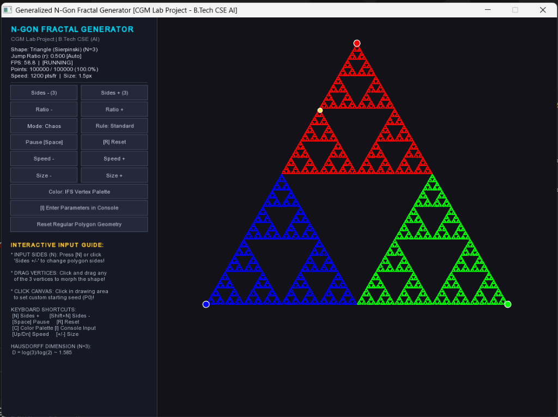
Figure 8.1: Real-Time Sierpinski Triangle (N=3, r=0.500) generated with 100,000 points and IFS 3-Vertex Color Palette at 58.8 FPS.
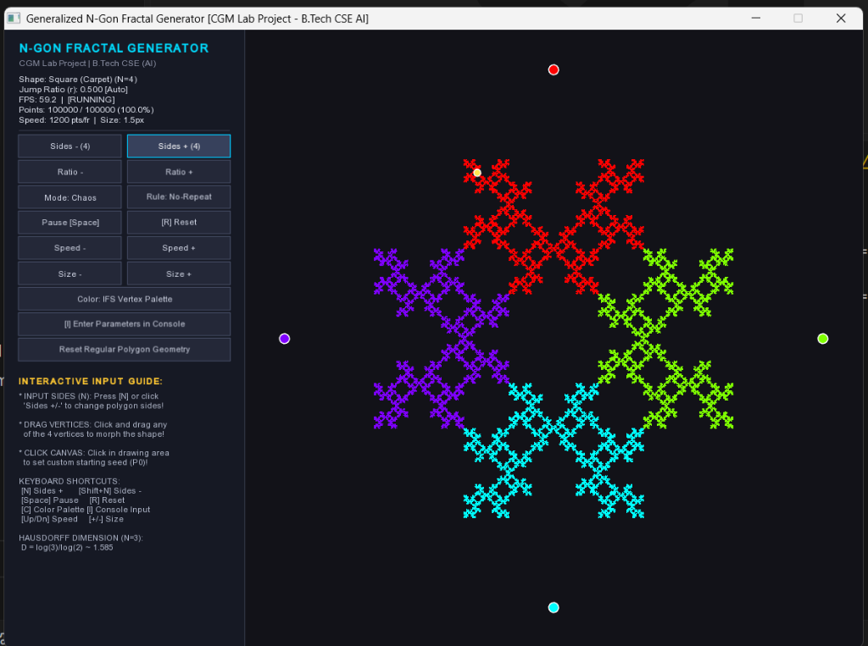
Figure 8.2: Real-Time Sierpinski Carpet (N=4, r=0.500) generated under Non-Adjacent Vertex Restriction Rule at 59.2 FPS.

9. References
[1] Mandelbrot, B. B. (1982). The Fractal Geometry of Nature. W. H. Freeman and Company, New York.
[2] Sierpinski, W. (1915). Sur une nouvelle courbe continue qui remplit toute une aire plane. Bulletin International de l'Academie des Sciences de Cracovie, Serie A, 577-578.
[3] Barnsley, M. F. (1988). Fractals Everywhere. Academic Press, Boston.
[4] Hutchinson, J. E. (1981). Fractals and self similarity. Indiana University Mathematics Journal, 30(5), 713-747.
[5] Elton, J. H. (1987). An ergodic theorem for iterated function systems. Ergodic Theory and Dynamical Systems, 7(4), 481-488.
[6] Hearn, D., & Baker, M. P. (2004). Computer Graphics with OpenGL (3rd ed.). Pearson Prentice Hall.
[7] SFML Team. (2022). Simple and Fast Multimedia Library Documentation (Version 2.5.1). Available: https://www.sfml-dev.org/documentation/2.5.1/
[8] Devaney, R. L. (1990). Chaos, Fractals, and Dynamics: Computer Experiments in Mathematics. Addison-Wesley.
[9] Foley, J. D., van Dam, A., Feiner, S. K., & Hughes, J. F. (1996). Computer Graphics: Principles and Practice in C (2nd ed.). Addison-Wesley Professional.

10. APPROVAL OF THE PROJECT
JAIPUR ENGINEERING COLLEGE AND RESEARCH CENTRE
DEPARTMENT OF COMPUTER SCIENCE & ENGINEERING (ARTIFICIAL INTELLIGENCE)
CERTIFICATE OF APPROVAL
This is to certify that the project report entitled 'REAL-TIME GENERALIZED N-GON AND SIERPINSKI FRACTAL GENERATOR USING CHAOS GAME AND ITERATED FUNCTION SYSTEMS IN C++ & SFML' submitted by:
• Abhinav Bhatra (Roll No: 24EJCCA009)
• Amit kumar (Roll No: 24EJCCA027)
• Anand Gaur (Roll No: 24EJCCA030)
• Abhishek Sihag (Roll No: 24EJCCA012)
in partial fulfillment of the requirements for the award of the degree of Bachelor of Technology in Computer Science & Engineering (Artificial Intelligence) of Rajasthan Technical University, Kota, is an authentic record of the work carried out by them under my guidance and supervision.
To the best of my knowledge, the matter embodied in this project report has not been submitted to any other university or institute for the award of any degree or diploma.
_____________________________  Ms. Mona Nagar  Project Coordinator (CC) / Assistant Professor  Department of CSE (AI), JECRC | _____________________________  Head of Department  Department of CSE (AI)  JECRC, Jaipur
_____________________________
External Examiner
Date: ________________________

