A
Project
SYNOPSIS
Of
REAL-TIME GENERALIZED N-GON AND SIERPINSKI FRACTAL GENERATOR USING CHAOS GAME ALGORITHM IN C++ & SFML
Submitted in partial fulfillment for the award of degree of
Bachelor of Technology
Degree Of
Rajasthan Technical University, KOTA
2026-2027
Submitted By:  Abhinav Bhatra (24EJCCA009)  Amit kumar (24EJCCA027)  Anand Gaur (24EJCCA030)  Abhishek Sihag (24EJCCA012) | ITS Coordinator (CC):  Ms. Mona Nagar  Assistant Professor  Dept. of CSE (AI)
DEPARTMENT OF
COMPUTER SCIENCE & ENGINEERING (ARTIFICIAL INTELLIGENCE)
JAIPUR ENGINEERING COLLEGE AND RESEARCH CENTRE
Shri Ram ki Nangal, via Sitapura RIICO, Tonk Road, Sukhpuria, Bambala, Jaipur, Rajasthan - 302022

ABSTRACT
Fractal geometry plays an indispensable role in contemporary Computer Graphics and Multimedia (CGM), offering rigorous mathematical formulations to simulate self-similar natural phenomena and procedural structures. The Sierpinski Triangle is an archetypal fractal displaying exact self-similarity, zero Lebesgue area, and infinite perimeter, characterized by a fractional Hausdorff dimension of D = log(3) / log(2) ~ 1.585.
This project presents a high-performance C++ desktop application developed with the Simple and Fast Multimedia Library (SFML 2.5+) to simulate and visualize fractal generation through two fundamental paradigms: the stochastic Chaos Game (Iterated Function Systems / random midpoint contraction) and deterministic Recursive Subdivision.
Furthermore, this work extends the classic 3-vertex Sierpinski triangle into an arbitrary N-sided regular polygon generator (N = 3 to 12)—commonly classified as Generalized N-Flakes (including the Sierpinski Carpet for N=4, Dürer's Pentagasket for N=5, and the Hexaflake for N=6). To prevent sub-shape overlap for higher-order polygons, the system dynamically calculates the mathematically optimal contraction ratio: r(N) = 1 / [2 * (1 + sum(cos(2*pi*k/N)))].
The rendering engine leverages hardware-accelerated persistent framebuffers (sf::RenderTexture), guaranteeing sustained 60 FPS performance even when accumulating over 500,000 vertices. The application incorporates extensive user input modalities, including real-time mouse dragging of polygon vertices for dynamic shape deformation, interactive click-to-seed starting point placement, on-screen graphical buttons, keyboard hotkeys, and an interactive terminal parameter prompt.

INTRODUCTION
- Problem Statement: Traditional computer graphics curricula often introduce fractals through static equations, obscuring how deterministic geometric order emerges from stochastic random walks. Moreover, conventional lab programs restrict students to fixed triangles, omitting polygon generalization and suffering from severe GPU lag as plotted points exceed 100,000.
- Scope of the Project: Implementation of both Stochastic Chaos Game and Recursive Subdivision; generalization to regular N-gons (N=3 to 12) with mathematical jump ratios; real-time mouse vertex dragging for dynamic shape morphing; click-to-seed canvas input; and GPU texture caching sustaining 60 FPS at 500,000+ points.
- Technologies Used: C++14/C++17, SFML 2.5.1 (Simple and Fast Multimedia Library), Mersenne Twister Engine (std::mt19937), CMake, MinGW g++, and Git/GitHub.
- Methodology: Parametric circle coordinate generation for N-gon vertices; contractive affine transformations P_new = (1 - r)*P + r*V_chosen; 25 warmup iteration discards; and persistent off-screen framebuffer accumulation via sf::RenderTexture.
- Expected Outcome: An interactive desktop GUI that visually demonstrates order out of chaos, allowing users to alter polygon sides, drag vertices, adjust speeds, and change colors in real time without frame drops.
- Applications of Project: Procedural landscape and texture generation in video games, multiband fractal antenna design in telecommunications, fractal image compression, and educational tools for computer graphics.

CONCLUSIONS AND FUTURE ENHANCEMENTS
Conclusions
The project successfully demonstrates that stochastic random midpoint iterations under contractive affine constraints strictly converge to the deterministic self-similar attractors predicted by Hutchinson's Theorem. By generalizing the system to regular N-gons with mathematically computed contraction ratios r(N) and off-screen persistent GPU caching, the application maintains high interactive frame rates (60 FPS) and provides a rich experimental platform for computer graphics education.
Future Enhancements
- 3D Fractal Extrusion: Extending the 2D affine mapping engine to 3D Euclidean space to generate interactive 3D Sierpinski Tetrahedra and Menger Sponges using OpenGL shaders.
- Compute Shader Parallelism: Offloading random point generation from CPU to GPU compute shaders (GLSL/HLSL) to simulate 10 million points per second.
- Audio-Reactive Visualization: Connecting audio FFT frequency bands to polygon vertex deformation and palette transitions for live multimedia installations.
System Visual Outputs
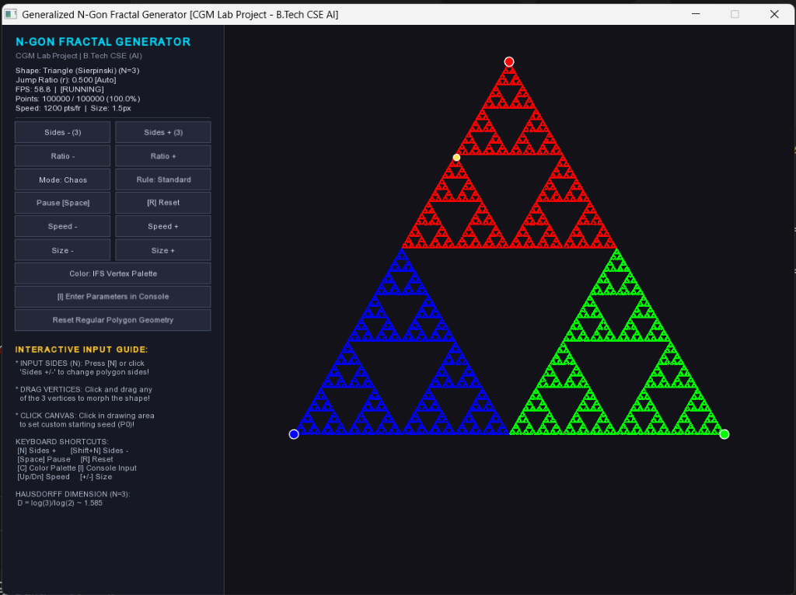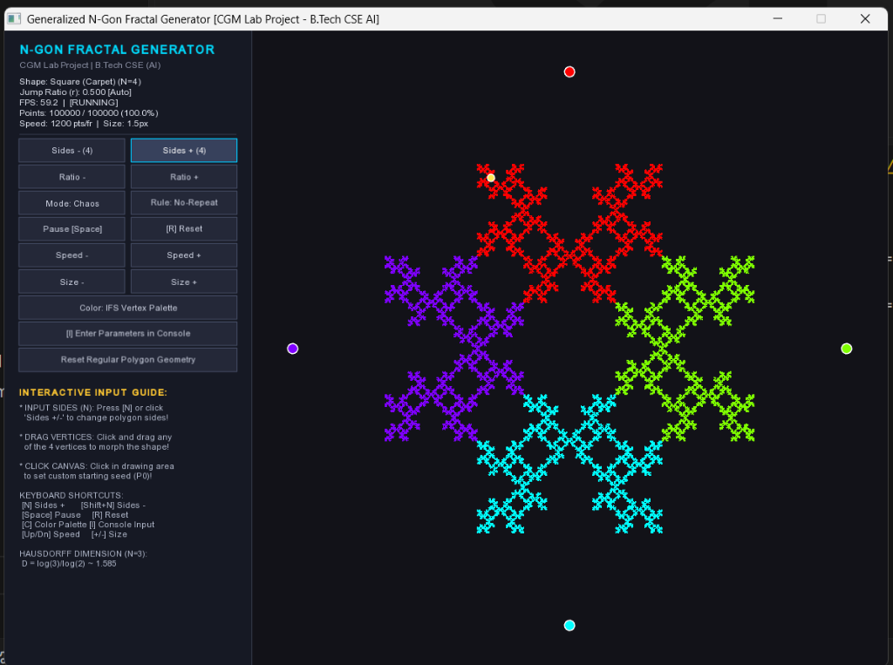
Figure: Real-time application outputs. Left: Sierpinski Triangle (N=3, r=0.500). Right: Sierpinski Carpet (N=4, r=0.500) with non-adjacent rule.

References
[1] Mandelbrot, B. B. (1982). The Fractal Geometry of Nature. W. H. Freeman and Company, New York.
[2] Sierpinski, W. (1915). Sur une nouvelle courbe continue qui remplit toute une aire plane. Bulletin International de l'Academie des Sciences de Cracovie, Serie A, 577-578.
[3] Barnsley, M. F. (1988). Fractals Everywhere. Academic Press, Boston.
[4] Hutchinson, J. E. (1981). Fractals and self similarity. Indiana University Mathematics Journal, 30(5), 713-747.
[5] Elton, J. H. (1987). An ergodic theorem for iterated function systems. Ergodic Theory and Dynamical Systems, 7(4), 481-488.
[6] Hearn, D., & Baker, M. P. (2004). Computer Graphics with OpenGL (3rd ed.). Pearson Prentice Hall.
[7] SFML Team. (2022). Simple and Fast Multimedia Library Documentation (Version 2.5.1). Available: https://www.sfml-dev.org/documentation/2.5.1/
[8] Devaney, R. L. (1990). Chaos, Fractals, and Dynamics: Computer Experiments in Mathematics. Addison-Wesley.

