A
Project Report
On
SORTING ANALYSIS COMPARATOR (SAC)
Submitted in partial fulfillment for the award of degree of
Bachelor of Technology
Degree Of
Rajasthan Technical University, KOTA
JAIPUR ENGINEERING COLLEGE AND RESEARCH CENTRE
2026-2027
Submitted By:  Abhinav Bhatra (24EJCCA009)  Amit kumar (24EJCCA027)  Anand Gaur (24EJCCA030) | ITS Coordinator (CC)  Mona Nagar  Faculty Mentor
DEPARTMENT OF COMPUTER SCIENCE & ENGINEERING (ARTIFICIAL INTELLIGENCE)
JAIPUR ENGINEERING COLLEGE AND RESEARCH CENTRE
Shri Ram ki Nangal, via Sitapura RIICO,
Tonk Road, Sukhpuria, Bambala, Jaipur, Rajasthan

TABLE OF CONTENTS
Introduction . . . . . . . . . . . . . . . . . . . . . . . . . . . . . . . . . . . . . . . . . . . . . . . . . . . 1
Objective . . . . . . . . . . . . . . . . . . . . . . . . . . . . . . . . . . . . . . . . . . . . . . . . . . . . . . . . . 3
Methodology And Planning . . . . . . . . . . . . . . . . . . . . . . . . . . . 4
Literature Review . . . . . . . . . . . . . . . . . . . . . . . . . . . . . . . . . . . . . . . . . 6
Applications of the Project . . . . . . . . . . . . . . . . . . . . . 8
Block Diagram . . . . . . . . . . . . . . . . . . . . . . . . . . . . . . . . . . . . . . . . . . . . . . . . . 9
UML Diagram . . . . . . . . . . . . . . . . . . . . . . . . . . . . . . . . . . . . . . . . . . . . . . . . . . . . . 10
Screenshots . . . . . . . . . . . . . . . . . . . . . . . . . . . . . . . . . . . . . . . . . . . . . . . . . . . . . 11
References . . . . . . . . . . . . . . . . . . . . . . . . . . . . . . . . . . . . . . . . . . . . . . . . . . . . . . . 13
Approval of the Project . . . . . . . . . . . . . . . . . . . . . . . . . . . . . 14

1. Introduction
Sorting is one of the most fundamental operations in computer science, serving as an algorithmic building block for information retrieval, database indexing, computer graphics, computational geometry, and distributed big-data pipelines. An algorithm's asymptotic complexity, expressed using Big-O notation, provides a theoretical upper bound on its growth rate as input scale expands toward infinity. However, in physical computing hardware, real-world execution latency frequently deviates from pure mathematical models due to CPU cache hierarchies (L1/L2/L3), memory latency, branch prediction behavior, instruction pipelining, and data distribution topology.
The Sorting Analysis Comparator (SAC) is an engineering and laboratory analysis system built entirely in modern C++17 with an interactive graphical interface powered by Simple and Fast Multimedia Library (SFML 2.5). The system is engineered to bridge theoretical algorithm design and empirical runtime behavior. By benchmarking four seminal sorting paradigms—Merge Sort (Divide-and-Conquer), Quick Sort (Partitioning), Heap Sort (Selection via Priority Queue), and Radix Sort (Non-comparative Distribution)—SAC provides rigorous hardware telemetry across multiple input scales (N = 100 to 50,000) and topological distributions (Uniform Random, Nearly Sorted, Reverse Sorted, and Many Duplicates).
Beyond statistical benchmarks, SAC incorporates a real-time 60 FPS animation engine that visually traces comparison and swap operations, supports an unprecedented 4-Way Head-to-Head Race Mode, and enables user-defined custom array insertion with dynamic number labels drawn directly on bars.

2. Objective
The primary objectives of the Sorting Analysis Comparator project are defined as follows:
Empirical Complexity Verification: Measure real execution wall-clock time with sub-microsecond hardware counters (Windows QueryPerformanceCounter) and determine whether observed scaling ratios T(n2)/T(n1) align with theoretical O(n log n), O(n^2), and O(d(n+k)) Big-O complexity predictions.
Exact Operation Telemetry: Accurately count comparisons and element swaps/assignments across identical input permutations, highlighting the invariant nature of deterministic operations independent of CPU clock fluctuations.
Stress Testing Across Topologies: Investigate algorithm resilience against pathological input distributions, specifically verifying Quick Sort's quadratic degradation on high duplicate frequency and Merge Sort's consistent performance.
Interactive Multi-Paradigm Visualization: Develop a high-performance graphical visualizer with three operational modes (Single Sort Bar Animation, 4-Way Race Mode, and Benchmark Growth Curves Plotter) and mouse-driven controls.
Custom Data Tracing: Empower students and researchers to input arbitrary integer sequences, visually verifying correctness and invariants of sorting passes with real-time on-bar numeric tracking.

3. Methodology And Planning
The project architecture is segregated into four decoupled layers to maintain modularity, testability, and deterministic timing fidelity:
Dual-Variant Architecture: Every sorting algorithm is implemented in two distinct variants: a Fast Variant compiled with -O3 aggressive optimizations, preallocated buffers, and zero telemetry overhead for genuine benchmark timing; and an Instrumented Variant that records an AnimationStep event log alongside operation counters.
Hardware Sub-Microsecond Timer: Standard MinGW GCC implementations of std::chrono::high_resolution_clock suffer from a 15.6 ms resolution tick floor on Windows. SAC implements an operating-system-level HighResClock utilizing Windows QueryPerformanceCounter (QPC), capturing latency down to nanosecond precision.
Data Generation Engine: Four distinct stochastic generators synthesize arrays across six logarithmic scales: N in {100, 500, 1000, 5000, 10000, 50000}. Distributions include Uniform Random (discrete uniform distribution in [1, 100000]), Nearly Sorted (~5% random index swaps), Reverse Sorted (strictly descending), and Many Duplicates (domain [1, 10]).
Empirical Ratio & Power Fitting: Calculates observed growth ratios R_obs = T(n2)/T(n1) between successive scales and fits the empirical power exponent alpha = ln(R_obs)/ln(n2/n1). Alpha ~ 1.0 indicates linear O(n), alpha ~ 1.05-1.2 indicates O(n log n), and alpha ~ 2.0 flags quadratic O(n^2).
SFML Render Pipeline: An asynchronous event loop renders vertical bar geometries at 60 FPS. Operations are color-coded: Yellow for Comparisons, Red for Swaps, Purple for Overwrites/Assignments, and Emerald Green for permanently sorted elements.

4. Literature Review
The study of comparison-based and distribution-based sorting algorithms has a rich academic history spanning several decades. Fundamental findings from classical literature form the foundation of this research:
Merge Sort (John von Neumann, 1945): Formulated on the divide-and-conquer strategy, Merge Sort guarantees Theta(n log n) comparisons in all cases by recursively bisecting arrays and merging sorted subarrays. Its primary drawback is auxiliary spatial complexity Theta(n), making in-place variants challenging on memory-constrained systems.
Quick Sort (C. A. R. Hoare, 1959): Quick Sort employs in-place partitioning around a selected pivot element. While exhibiting an average time complexity of Theta(n log n) with an exceptionally small constant factor due to cache-friendly contiguous memory scanning, naive pivot selection degrades to O(n^2) when partitioning degenerates on sorted or duplicate-heavy arrays. Median-of-three pivot selection and tail-recursion elimination mitigate these risks.
Heap Sort (J. W. J. Williams & R. W. Floyd, 1964): Constructs a complete binary max-heap in Theta(n) time using bottom-up sift-down operations, followed by n - 1 successive root extractions in O(log n) each, achieving strict O(n log n) upper bound in-place with O(1) auxiliary space.
Radix Sort (Herman Hollerith, 1887; Harold H. Seward, 1954): Radix Sort circumvents the Omega(n log n) information-theoretic lower bound for comparison sorts by examining positional key digits using stable Counting Sort passes. Its theoretical time complexity is Theta(d * (n + k)), rendering it strictly linear when key length d and radix base k are constant.
Algorithm | Best Case | Average Case | Worst Case | Auxiliary Space
Merge Sort | O(n log n) | O(n log n) | O(n log n) | O(n)
Quick Sort | O(n log n) | O(n log n) | O(n^2) | O(log n)
Heap Sort | O(n log n) | O(n log n) | O(n log n) | O(1)
Radix Sort | O(d*(n+k)) | O(d*(n+k)) | O(d*(n+k)) | O(n+k)

5. Applications of the Project
The Sorting Analysis Comparator serves practical engineering and educational utility across multiple domains:
Academic Pedagogy: Equips universities and computer science institutions with an interactive laboratory instrument that transforms abstract asymptotic recurrence relations into tangible visual and statistical telemetry.
Systems & Database Engineering: Assists database engine developers in benchmarking sort-merge join operators and selecting optimal sorting heuristics based on data presortedness and cardinality.
Embedded Systems Constraint Profiling: Facilitates memory-constrained runtime evaluations, proving Heap Sort's zero-allocation advantage over Merge Sort in microcontrollers.
Algorithmic Invariant Verification: Enables visual tracing of loop invariants (e.g. max-heap property preservation, partition pivot boundary defense) on user-provided edge case arrays.

6. Block Diagram
Figure 6.1 illustrates the architectural block diagram of the Sorting Analysis Comparator system, depicting the workflow from input data synthesis through dual-variant execution to telemetry calculation and graphical rendering.
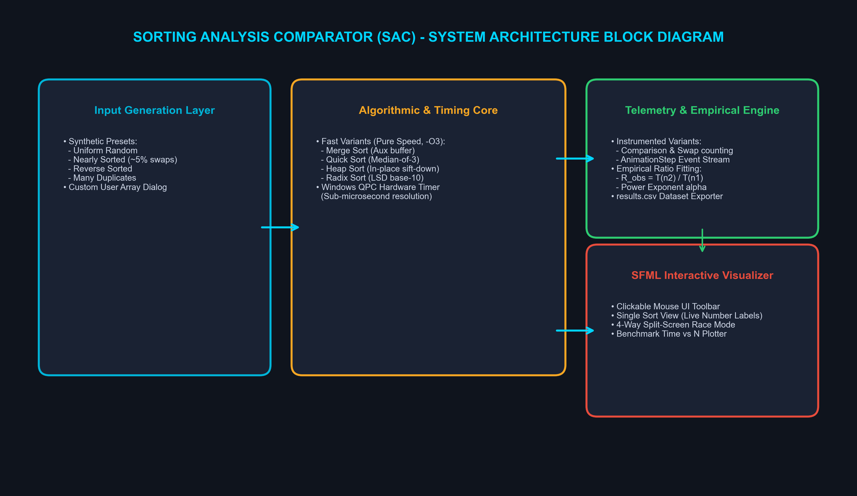
Figure 6.1: System Architecture Block Diagram of SAC

7. UML Diagram
Figure 7.1 presents the Unified Modeling Language (UML) Class Diagram of SAC, modeling class relationships, public/private member contracts, and event structures across the visualizer and engine.
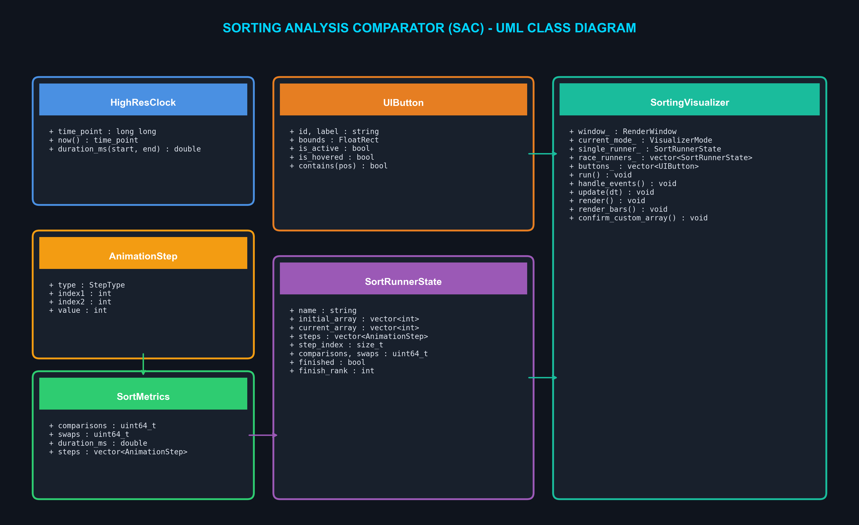
Figure 7.1: UML Class Diagram for Sorting Analysis Comparator

8. Screenshots
The following figures illustrate the operational user interfaces and benchmarking visual outputs generated by the system:
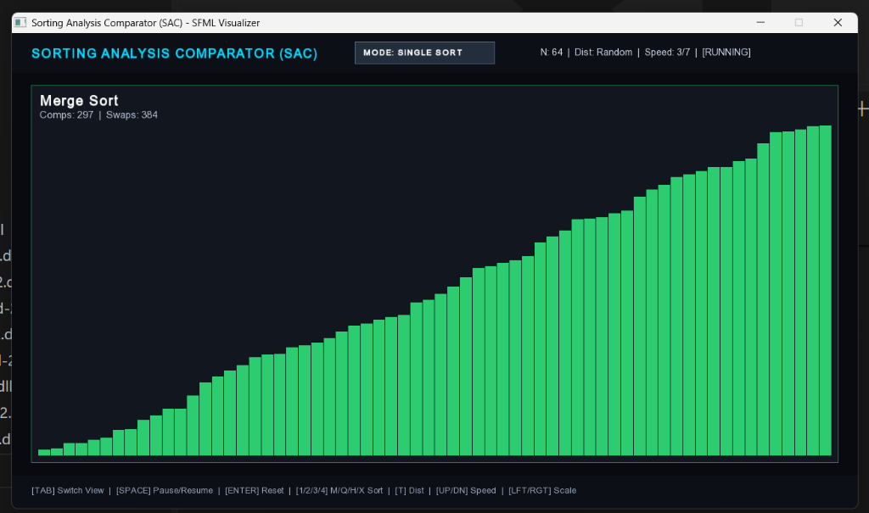
Figure 8.1: Single Sort Animation Mode with Real-Time Telemetry HUD
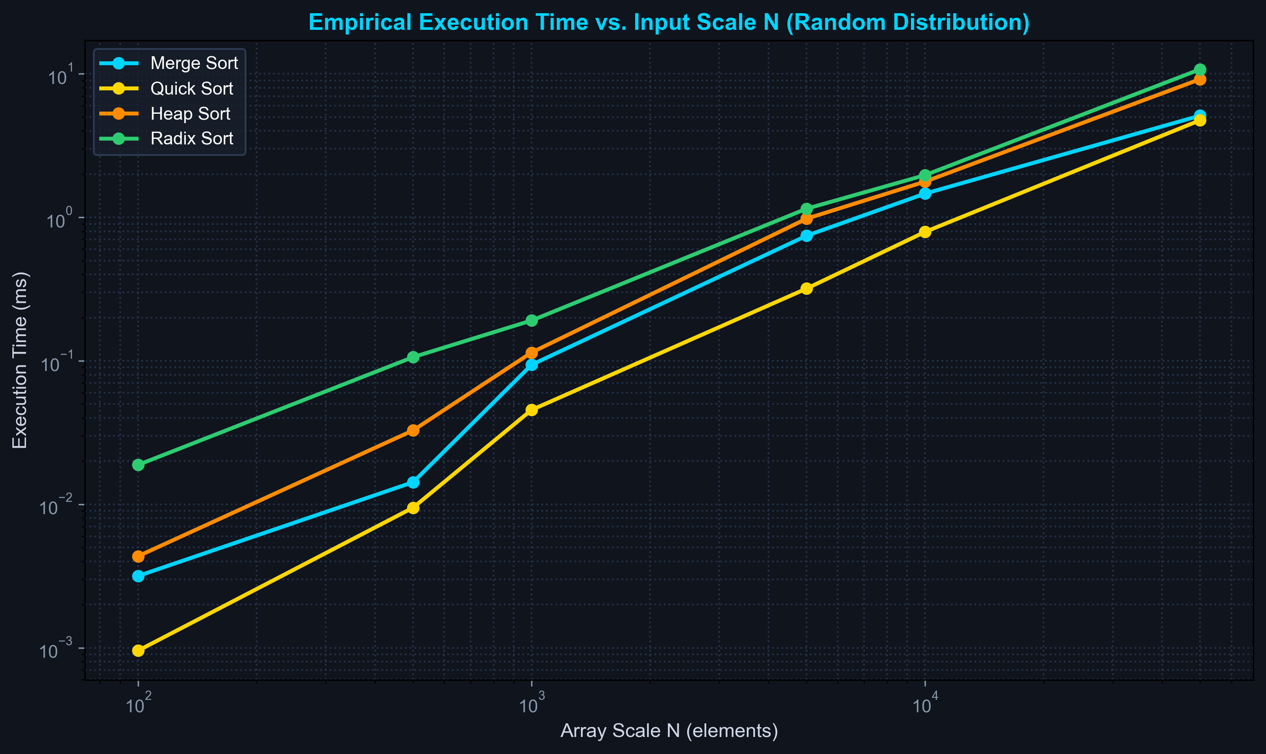
Figure 8.2: Empirical Benchmark Plot: Execution Time vs. Input Scale N

9. References
1. Cormen, T. H., Leiserson, C. E., Rivest, R. L., & Stein, C. (2022). Introduction to Algorithms (4th ed.). MIT Press.
2. Knuth, D. E. (1998). The Art of Computer Programming, Volume 3: Sorting and Searching (2nd ed.). Addison-Wesley.
3. Sedgewick, R., & Wayne, K. (2011). Algorithms (4th ed.). Addison-Wesley Professional.
4. SFML Development Team. (2024). Simple and Fast Multimedia Library Documentation (Release 2.5.1). https://www.sfml-dev.org/documentation/2.5.1/
5. ISO/IEC. (2017). ISO/IEC 14882:2017 - Programming Languages — C++17. International Organization for Standardization.
6. Williams, J. W. J. (1964). Algorithm 232: Heapsort. Communications of the ACM, 7(6), 347-348.
7. Hoare, C. A. R. (1962). Quicksort. The Computer Journal, 5(1), 10-16.

10. Approval of the Project
This is to certify that the project report entitled "SORTING ANALYSIS COMPARATOR (SAC)" submitted by Abhinav Bhatra (24EJCCA009), Amit kumar (24EJCCA027), and Anand Gaur (24EJCCA030) in partial fulfillment of the requirements for the award of the degree of Bachelor of Technology in Computer Science & Engineering (Artificial Intelligence) from JAIPUR ENGINEERING COLLEGE AND RESEARCH CENTRE, affiliated to Rajasthan Technical University, KOTA, is a bona fide record of the work carried out under our supervision.
The results embodied in this report have not been submitted to any other university or institute for the award of any degree or diploma.
_________________________  Project Coordinator  Mona Nagar  ITS Coordinator (CC) | _________________________  Head of Department (HOD)  Department of CSE (AI)  JECRC, Jaipur
Date: ___________________
Place: Jaipur

