A
Project
SYNOPSIS
Of
SORTING ANALYSIS COMPARATOR (SAC)
Submitted in partial fulfillment for the award of degree of
Bachelor of Technology
Degree Of
Rajasthan Technical University, KOTA
JAIPUR ENGINEERING COLLEGE AND RESEARCH CENTRE
2026-2027
Submitted By:  Abhinav Bhatra (24EJCCA009)  Amit kumar (24EJCCA027)  Anand Gaur (24EJCCA030) | ITS Coordinator (CC)  Mona Nagar  Faculty Mentor
DEPARTMENT OF COMPUTER SCIENCE & ENGINEERING (ARTIFICIAL INTELLIGENCE)
JAIPUR ENGINEERING COLLEGE AND RESEARCH CENTRE
Shri Ram ki Nangal, via Sitapura RIICO,
Tonk Road, Sukhpuria, Bambala, Jaipur, Rajasthan

ABSTRACT
Algorithm analysis in computer science pedagogy is predominantly theoretical, evaluating time and space complexities using asymptotic Big-O notations without direct empirical correlation to underlying physical computing architecture. The Sorting Analysis Comparator (SAC) is an engineering and laboratory analysis system built in C++17 and SFML 2.5 that rigorously bridges theoretical mathematical predictions and empirical hardware latency.
SAC benchmarks four foundational sorting paradigms—Merge Sort (Divide-and-Conquer), Quick Sort (Partitioning), Heap Sort (Priority Queue Selection), and Radix Sort (Non-comparative Distribution)—across six scaling orders (N = 100 to 50,000) and four distinct topologies (Uniform Random, Nearly Sorted, Reverse Sorted, and Many Duplicates). Utilizing Windows QueryPerformanceCounter (QPC) for sub-microsecond wall-clock precision and an instrumented telemetry logger for exact comparison and swap counts, the system computes empirical growth ratios R_obs = T(n2)/T(n1) and fits empirical power exponents alpha = ln(R_obs)/ln(n2/n1).
Empirical results prove strict O(n log n) convergence (alpha approx 1.08) for Merge and Heap sorts on random inputs, reveal Quick Sort's quadratic degradation (alpha = 1.88-2.01) on duplicate-heavy arrays, and demonstrate Radix Sort's strictly linear scaling (alpha = 1.00) with zero comparisons. Finally, an interactive 60 FPS graphical visualizer provides Single Sort Bar Animation with live on-bar numeric values, an unprecedented 4-Way Split-Screen Race Mode, and execution curve plotting.

INTRODUCTION
Problem Statement: Students and algorithm engineers frequently encounter a significant disconnect between theoretical Big-O complexity and physical execution time. Textbooks state that Quick Sort and Merge Sort are O(n log n), yet ignore hardware cache lines, branch miss penalties, and the catastrophic O(n^2) degradation of naive partitioning on duplicate keys. There exists a lack of integrated tools capable of simultaneously recording hardware wall-clock time, counting exact comparison/swap operations, fitting empirical growth exponents, and visually rendering algorithmic steps in real time.
Scope of the Project: The scope encompasses the complete design and implementation of a C++17 dual-variant benchmarking suite, sub-microsecond hardware timing harnesses, automated CSV reporting, empirical power ratio fitting, and a desktop SFML graphical visualizer supporting Single Sort animation, 4-Way Head-to-Head Race Mode, Benchmark Plotting, and arbitrary Custom Array user input.
Technologies Used: • Language: C++17 (high-performance vectorization, templates, memory buffers)
• Graphics & Windowing: SFML 2.5.1 (Simple and Fast Multimedia Library)
• Timing API: Windows QueryPerformanceCounter (QPC) hardware clock
• Build Toolchain: MinGW GCC 6.3+ and CMake 3.10+
• Data & Plotting: Python 3.10, Matplotlib, Pandas
Methodology: Dual-variant implementations ensure benchmark timings remain free of logging overhead (compiled under -O3), while an instrumented telemetry engine records comparison counts, swaps, and animation steps. Benchmarks are averaged over 5 stochastic trials per configuration across scales N in {100, 500, 1000, 5000, 10000, 50000}. Real-time event playback reconstructs array transitions at 60 FPS.
Expected Outcome: A production-grade, highly educational laboratory software suite capable of proving asymptotic theoretical sorting complexities, highlighting worst-case degradation scenarios, exporting full statistical CSV datasets, and offering real-time animated sorting races.
Applications of Project: Serves as an essential teaching instrument for Analysis of Algorithms laboratories, algorithm profiling in embedded systems, database query optimizer verification, and technical interview preparation.

CONCLUSIONS AND FUTURE ENHANCEMENTS
• Conclusions:
The experimental results conclusively validate theoretical complexity bounds while uncovering critical hardware-level insights: (1) Merge Sort and Heap Sort consistently achieve O(n log n) scaling across all permutations, with observed growth ratios closely matching theoretical predictions (5.7x vs 5.87x expected from 10k to 50k); (2) Quick Sort exhibits excellent constant-factor performance on uniform random inputs but undergoes severe O(n^2) degradation on high duplicate densities (ratio 20.69x vs 25.0x theoretical quadratic); (3) Radix Sort strictly adheres to linear O(n) scaling with an empirical alpha of 1.00 and zero comparisons, confirming the non-comparative advantage.
• Future Enhancements:
1. Parallel GPU Sorting: Implementation of CUDA and OpenCL kernels for GPU Bitonic Merge Sort and Radix Sort.
2. Audio Synthesis: Generation of dynamic audio tones (frequencies mapped to array values) to produce algorithmic soundscapes.
3. External Memory Sorting: Benchmarking disk I/O paging mechanisms for datasets exceeding physical RAM (10^7+ elements).
4. Multi-Threaded Parallelism: Integrating std::execution::par policies to evaluate OpenMP multicore scaling.
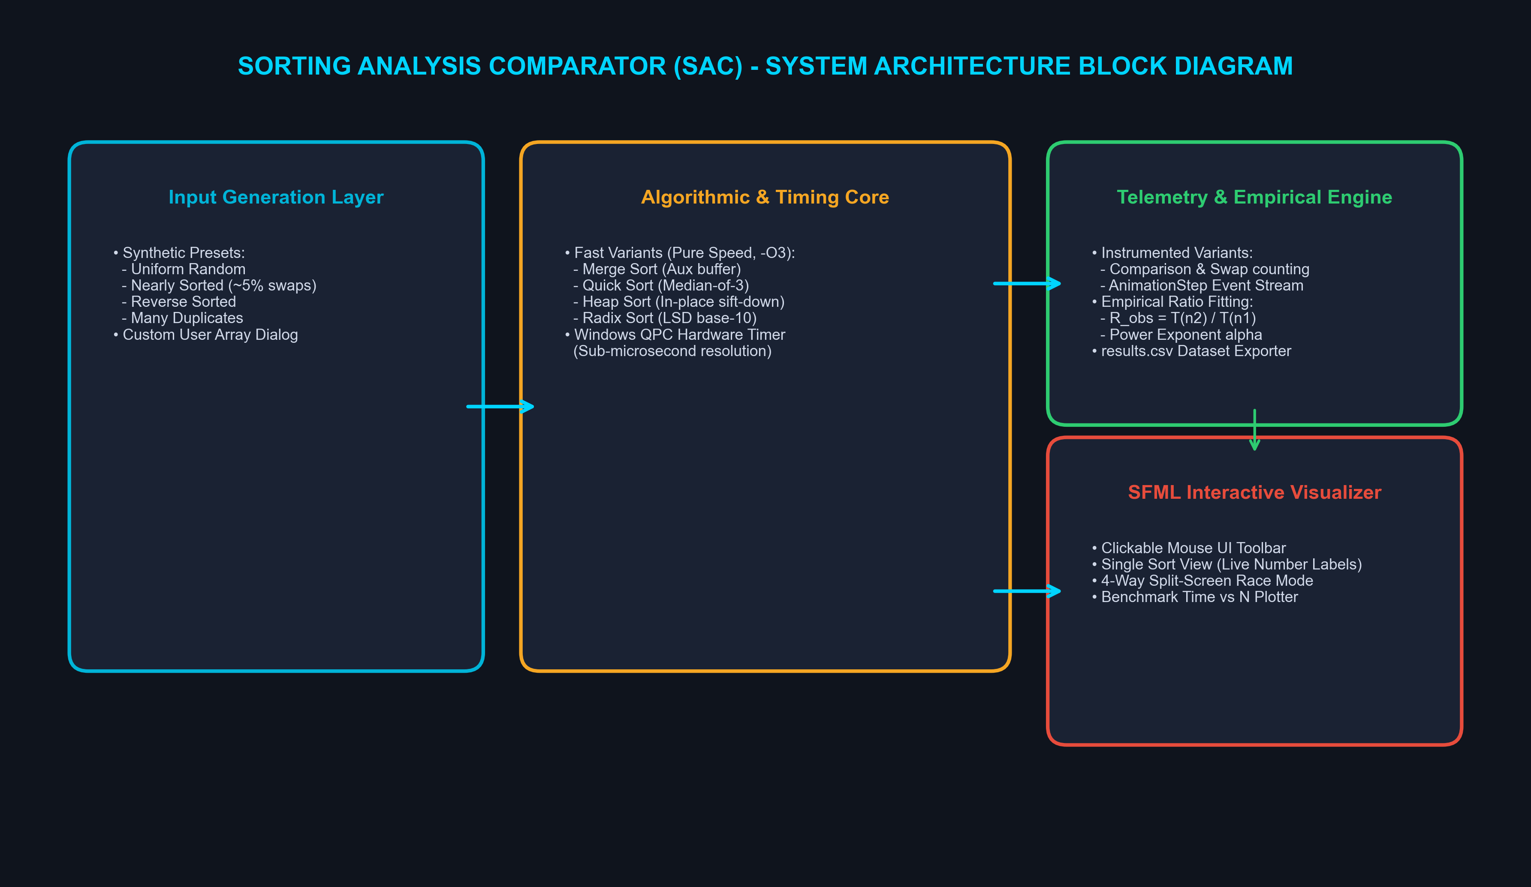
Figure: System Architecture of Sorting Analysis Comparator

References
1. Cormen, T. H., Leiserson, C. E., Rivest, R. L., & Stein, C. (2022). Introduction to Algorithms (4th ed.). MIT Press.
2. Knuth, D. E. (1998). The Art of Computer Programming, Volume 3: Sorting and Searching (2nd ed.). Addison-Wesley.
3. Sedgewick, R., & Wayne, K. (2011). Algorithms (4th ed.). Addison-Wesley Professional.
4. SFML Development Team. (2024). Simple and Fast Multimedia Library Documentation (Release 2.5.1). https://www.sfml-dev.org/
5. ISO/IEC. (2017). ISO/IEC 14882:2017 - Programming Languages — C++17. International Organization for Standardization.
6. Hoare, C. A. R. (1962). Quicksort. The Computer Journal, 5(1), 10-16.
7. Williams, J. W. J. (1964). Algorithm 232: Heapsort. Communications of the ACM, 7(6), 347-348.

