A
Project Report
On
STATIC CODE ANALYZER & ACCURACY SCORER IN C++
Submitted in partial fulfillment for the award of degree of
Bachelor of Technology
Degree Of
Rajasthan Technical University, KOTA
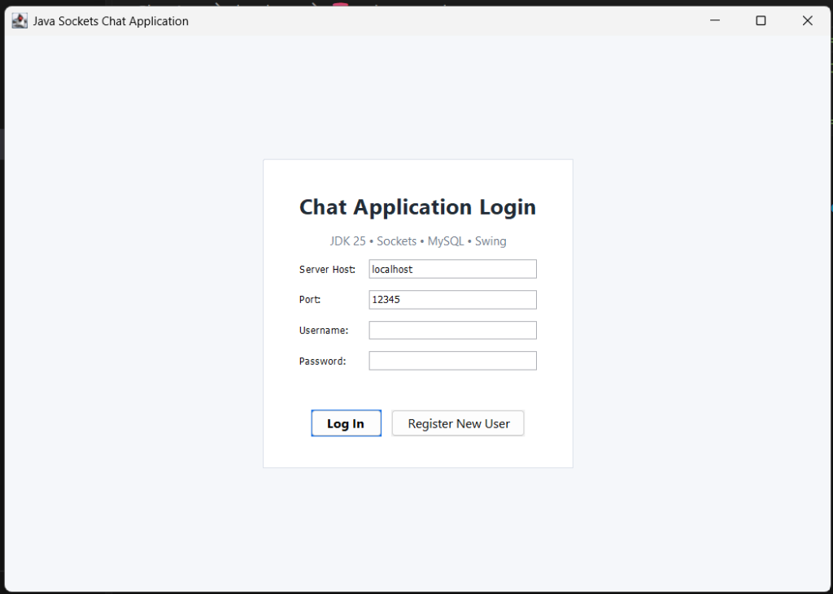
JAIPUR ENGINEERING COLLEGE AND RESEARCH CENTRE
2026-2027
Submitted By:  Anand Gaur  <Roll No.>  3rd Year, B.Tech CSE (AI) | ITS Coordinator (CC):  <Faculty Name>  <Designation>  Dept. of CSE (AI)
DEPARTMENT OF
COMPUTER SCIENCE & ENGINEERING (ARTIFICIAL INTELLIGENCE)
JAIPUR ENGINEERING COLLEGE AND RESEARCH CENTRE
Shri Ram ki Nangal, via Sitapura RIICO, Tonk Road, Sukhpuria, Bambala, Jaipur, Rajasthan

TABLE OF CONTENTS
1. Introduction ............................................. | 1
2. Objective ................................................ | 2
3. Methodology And Planning .................................. | 3
4. Literature Review ........................................ | 5
5. Applications of the Project ............................... | 6
6. Block Diagram ............................................ | 7
7. UML Diagrams ............................................. | 8
8. Screenshots .............................................. | 10
9. References ............................................... | 13
10. Approval of the Project .................................. | 14

1. Introduction
In modern software engineering, software quality, code correctness, and algorithmic maintainability are paramount. While dynamic testing checks execution correctness for specific test vectors, it cannot exhaustively identify edge cases, unused memory structures, dead code paths, or architectural complexity. Static code analysis addresses this limitation by inspecting and verifying source code directly without execution, enforcing language grammars, semantic invariants, and structural best practices.
This project, titled 'Static Code Analyzer & Accuracy Scorer', develops a complete, production-grade command-line static analyzer written in pure standard C++17. Designed as an applied Compiler Design practical project, it implements the complete front-end and middle-end phases of compiler architecture from first principles without relying on third-party parser generators (such as Flex, Bison, or ANTLR) or external library dependencies (such as Boost).
The system accepts C/C++ source code through interactive terminal prompts, shell pipes, or file inputs. It executes deterministic finite automaton (DFA) lexical analysis, LL(1) recursive descent syntax parsing, abstract syntax tree (AST) generation via the Composite and Visitor design patterns, scoped symbol table tracking, and multiple static analysis passes. Finally, it calculates an automated Code Accuracy & Quality Score (0% to 100%, Grade A+ to F) with an itemized deduction breakdown, rendering formatted diagnostic reports directly in the user's terminal.
2. Objective
The primary objectives of this project are:
- 1. Hand-Written DFA Lexical Tokenizer: Implement an explicit state machine recognizing keywords, identifiers, numeric literals (integer/floating-point), string literals, compound operators (==, !=, <=, >=, &&, ||, ++, --), delimiters, and comments while tracking 1-indexed (line, column) coordinates.
- 2. Recursive Descent LL(1) Syntax Parser: Construct a top-down parser that enforces Context-Free Grammar (CFG) rules for functions, variable declarations, control structures (if-else, while, for), and expressions using operator precedence climbing, featuring panic-mode error recovery.
- 3. Abstract Syntax Tree (AST) Hierarchy: Establish a strongly typed node hierarchy utilizing modern C++ unique ownership pointers (std::unique_ptr) and the Visitor Design Pattern to decouple tree representation from analysis passes.
- 4. Scoped Symbol Table Management: Engineer a stack of hash maps to manage lexical scoping, accurately distinguishing variable declarations, shadowing, and usages to detect unused variables and undeclared identifiers.
- 5. Control-Flow & Complexity Metrics: Calculate McCabe's Cyclomatic Complexity V(G) = P + 1, measure maximum block nesting depth, detect long functions exceeding configurable LOC thresholds, and identify unreachable dead code after block terminators.
- 6. Calibrated Accuracy & Quality Scoring Engine: Develop a quantifiable scoring engine starting at 100.0% with transparent deductions for syntax errors (-20%), semantic errors (-15%), dead code (-8%), unused variables (-5%), high nesting (-5%), and high complexity (-6%), mapping to letter grades A+ through F.
- 7. Pure Terminal Output Engine: Deliver an interactive terminal experience supporting direct typing, stdin piping, and ANSI-highlighted diagnostics with exact line and column caret pointers.
3. Methodology And Planning
The project development adopted an iterative, compiler-driven engineering methodology divided into four structured phases:
Phase 1 - Lexical Engineering & DFA Construction
Designed the lexical specification for C/C++ tokens in Token.h and Lexer.h. Formulated a hand-written DFA state machine in Lexer.cpp handling states START, IN_IDENTIFIER, IN_NUMBER, IN_STRING, IN_CHAR, IN_SLASH, and comment handlers. Implemented the maximal-munch rule to prioritize compound operators (e.g. '++' over '+') and engineered coordinate tracking to record the exact line number and column offset for every emitted token.
Phase 2 - Context-Free Grammar & Recursive Descent Parser
Formulated the grammar productions for declarations, statements, and expressions. Implemented Parser.cpp using recursive descent. To prevent left recursion and maintain proper operator associativity, layered precedence climbing was designed (Primary < Postfix < Unary < Multiplicative < Additive < Relational < Equality < Logical AND < Logical OR < Assignment). Constructed an AST node hierarchy in AST.h rooted at ASTNode with unique pointer tree ownership. Implemented panic-mode synchronization on statement delimiters (';', '}') to prevent cascading syntax aborts.
Phase 3 - Scoped Symbol Table & Static Analysis Passes
Constructed SymbolTable.cpp implementing lexical environments via std::vector<std::unordered_map<std::string, SymbolInfo>>. Pushed scopes upon entering blocks and popped on exit, flagging unreferenced variables. Implemented the ASTVisitor interface in Analyzer.cpp to compute McCabe Cyclomatic Complexity V(G) = P + 1 (counting if, while, for, &&, || predicate points), evaluate dynamic control-flow nesting depth, inspect statement sequences for dead code following return/break, and verify function line-count thresholds.
Phase 4 - Accuracy Scoring Engine & Interactive CLI
Formulated the mathematical scoring formula subtracting calibrated penalties from 100.0%. Developed an interactive input reader in main.cpp supporting terminal keyboard entry terminated by 'END' or Ctrl+Z, standard input pipes (cat/Get-Content), and file paths. Constructed ReportGenerator in Report.cpp to render colored ANSI banners, risk assessment tables, itemized deduction lists, and source code line pointers.
4. Literature Review
Static code analysis and compiler front-end architectures have a deep theoretical foundation in computer science:
- Formal Grammars and Automata (Hopcroft et al., 2006): Chomsky's hierarchy classifies programming language lexicons as Regular Grammars recognized by Deterministic Finite Automata (DFA), whereas syntax structures require Context-Free Grammars (CFG) recognized by Pushdown Automata. Our tokenizer applies DFA state transition matrices to guarantee O(N) linear-time scanning.
- Top-Down LL(1) Parsing (Aho, Lam, Sethi, & Ullman, 'Dragon Book', 2006): The Dragon Book establishes that recursive descent parsers evaluate LL(1) grammars efficiently without backtracking by utilizing 1-token lookaheads. Precedence climbing provides deterministic operator resolution while panic-mode error recovery ensures compiler survivability across multiple syntax faults.
- Software Complexity Measurement (Thomas J. McCabe, IEEE TSE, 1976): McCabe introduced Cyclomatic Complexity V(G) = E - N + 2P based on graph theory, where E is edges, N is vertices, and P is connected components. For structured single-entry single-exit functions, this equals P + 1 (predicate decision nodes). Empirical studies show functions with V(G) > 10 exhibit exponentially higher defect densities and testing costs.
- Static Analysis Paradigms (Chess & McGraw, 2004): Static analysis detects security vulnerabilities (buffer overflows, uninitialized memory) and code smells early in the development lifecycle (Shift-Left principle). In-memory AST visitor passes provide efficient syntactic and semantic property verification without execution overhead.
5. Applications of the Project
- 1. Automated Academic Lab Grading & Assessment: Universities and coding platforms can utilize the analyzer to automatically grade student programming assignments, penalizing dead code, undeclared variables, high complexity, and deeply nested loops while generating a transparent 0-100% Accuracy Score.
- 2. Continuous Integration (CI/CD) Pre-Commit Quality Gates: The analyzer executable can be integrated into Git pre-commit hooks or GitHub Actions pipelines to block commits that introduce excessive cyclomatic complexity or dead code.
- 3. Safety-Critical & Embedded Software Auditing: Safety standards (such as MISRA C/C++ and ISO 26262) mandate strict upper bounds on nesting depth, function length, and cyclomatic complexity to guarantee testability and predictable stack usage.
- 4. Pedagogical Compiler Design Demonstrator: The modular separation between DFA lexing, LL(1) parsing, AST construction, and symbol table resolution serves as an educational model for compiler design coursework.
6. Block Diagram
The system architecture follows a decoupled, sequential pipelining model. Source code enters through the input handler, undergoes lexical tokenization, syntax analysis, AST generation, semantic validation, and metric scoring before the terminal report is emitted.
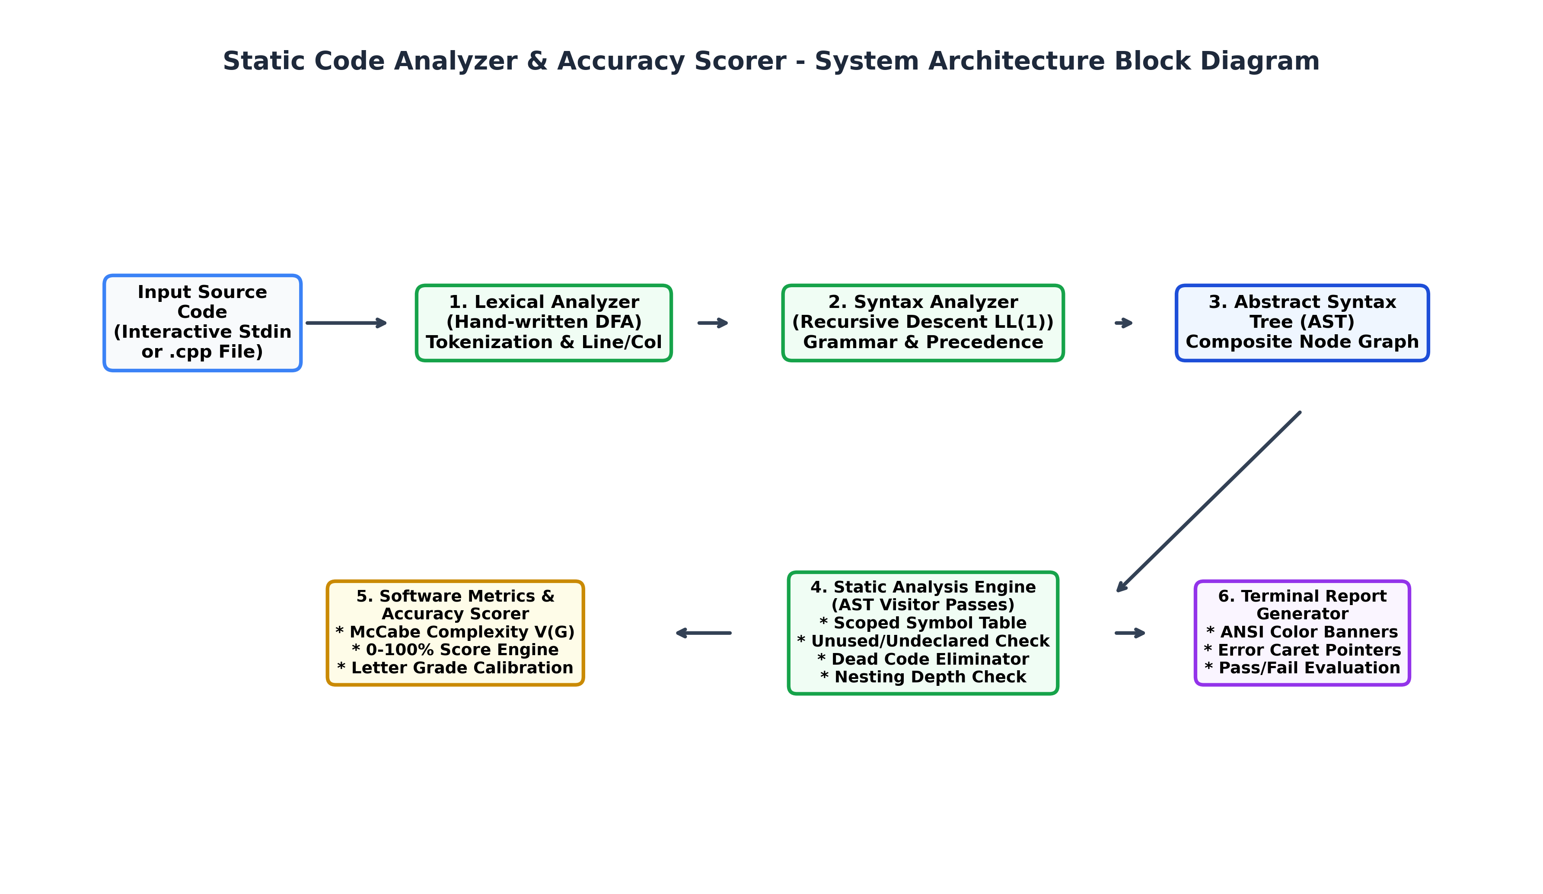
Figure 6.1: High-Level System Architecture and Component Interfacing Block Diagram
7. UML Diagrams
7.1 UML Class Diagram
The UML Class Diagram illustrates the object-oriented design of the AST hierarchy, the Visitor pattern implementation, and the core operational classes (Lexer, Parser, SymbolTable, Analyzer, ReportGenerator).
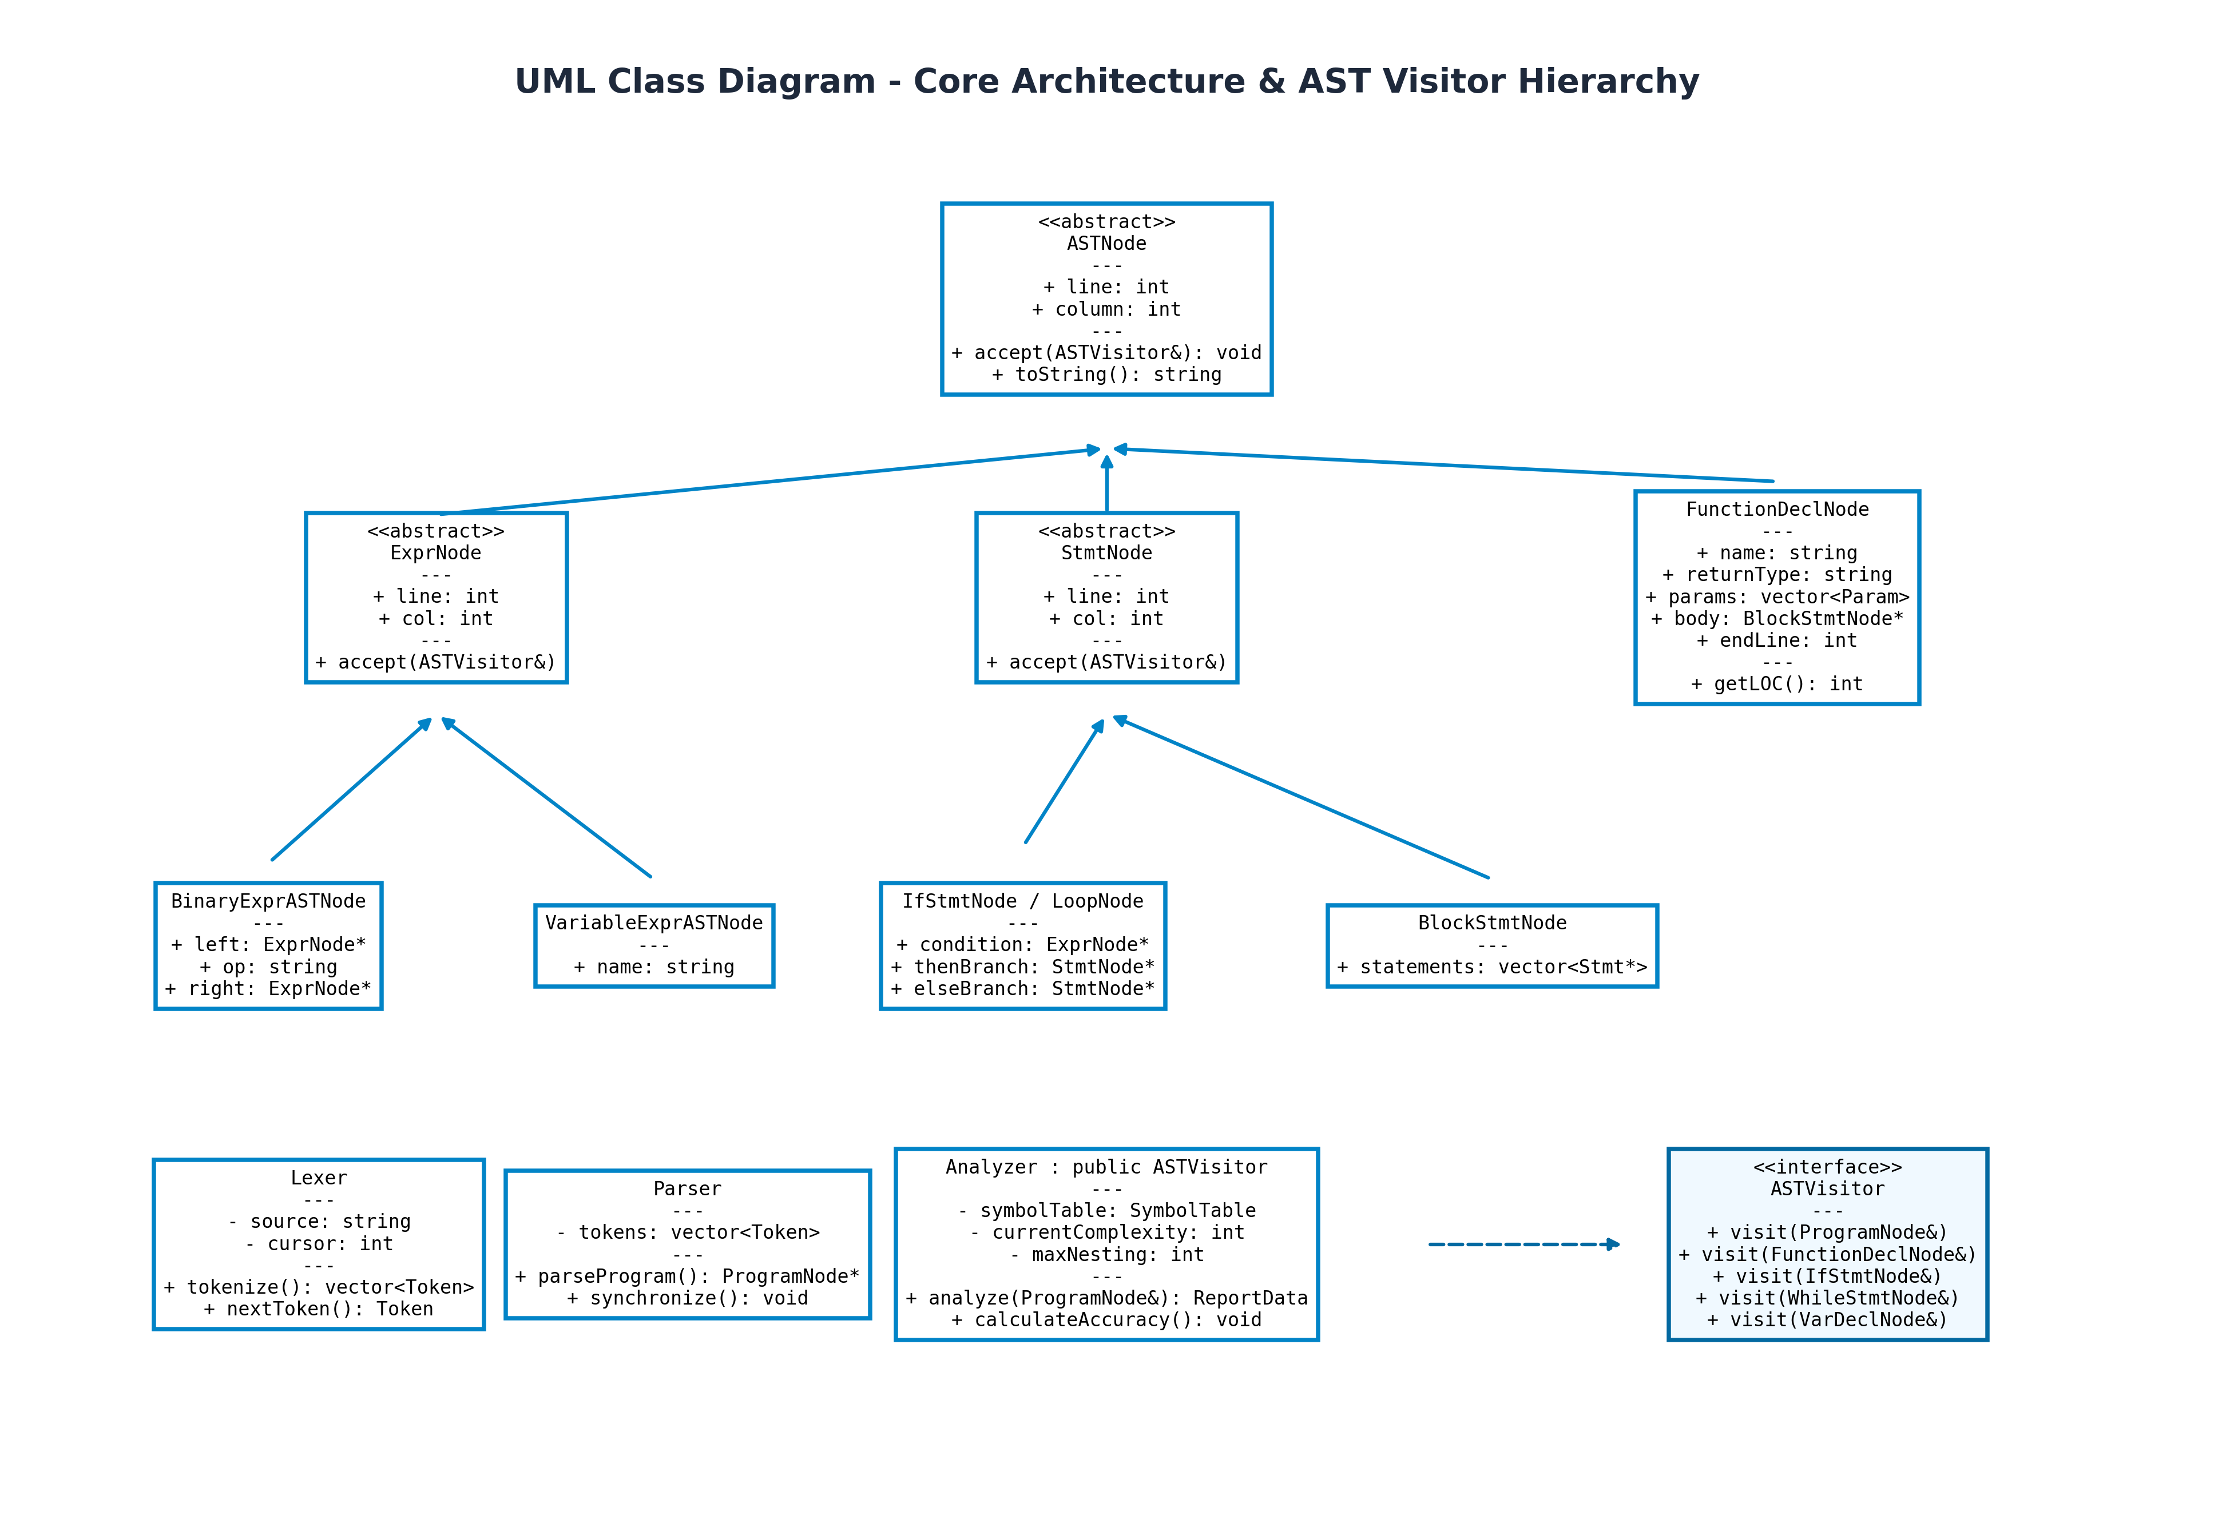
Figure 7.1: UML Class Diagram Representing AST Nodes and Visitor Design Pattern
7.2 UML Sequence Diagram
The UML Sequence Diagram models the dynamic interaction between objects across time, tracking message flow from user input down through tokenization, parsing, traversal, and terminal reporting.
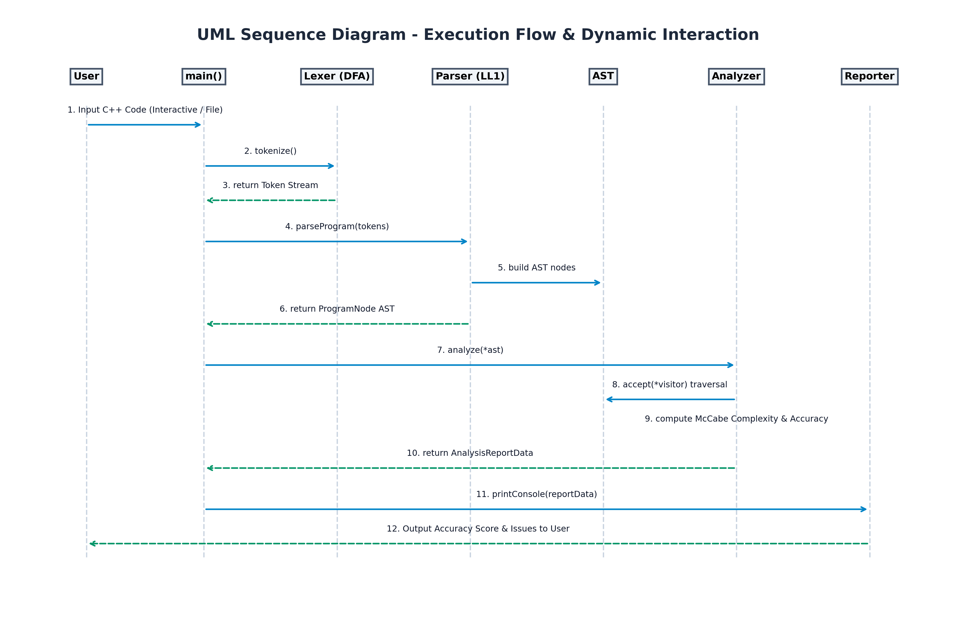
Figure 7.2: UML Sequence Diagram Illustrating Runtime Execution Pipeline
7.3 UML Activity Diagram
The UML Activity Diagram outlines the control-flow state transitions of the static analysis engine from initialization to final quality rating calculation.
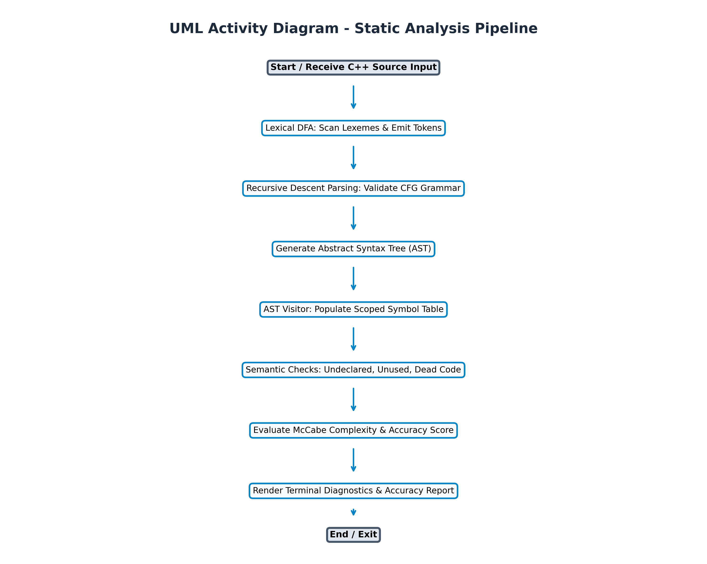
Figure 7.3: UML Activity Diagram Depicting Step-by-Step Analysis Workflow
8. Screenshots
The following screenshots document the actual runtime execution of the Static Code Analyzer in the Windows PowerShell environment, demonstrating interactive code input, accuracy evaluation, function metrics calculation, and diagnostic reports.
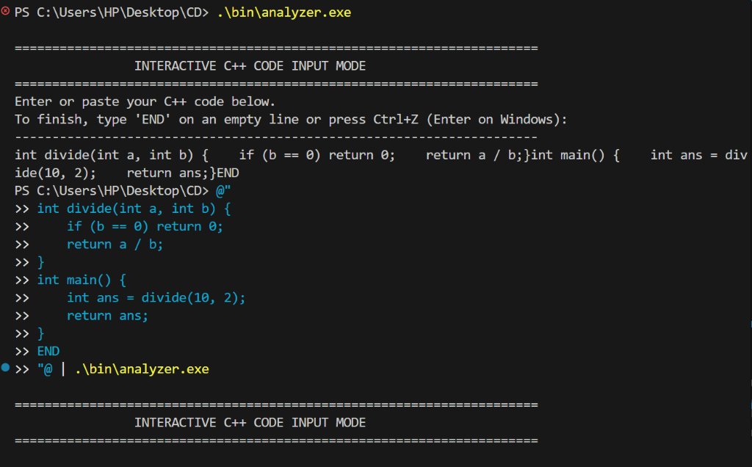
Figure 8.1: Live Terminal Execution - Interactive C++ Code Input via PowerShell Pipeline
Figure 8.1 illustrates the interactive input mechanism. The user pipes C++ source code directly into the analyzer executable. The program reads the multi-line input buffer and passes it into the compiler front-end pipeline without requiring a physical file.
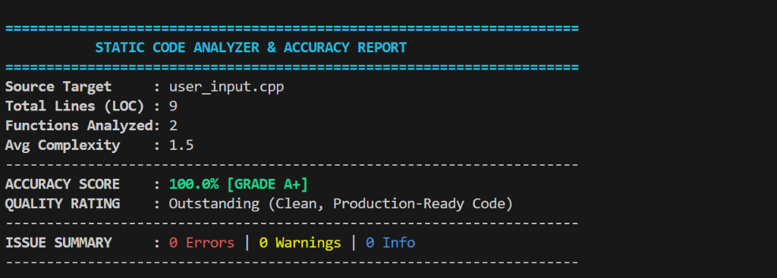
Figure 8.2: Static Code Analyzer & Accuracy Report Header (100% Accuracy Score, Grade A+)
Figure 8.2 demonstrates the Accuracy & Quality Assessment output for clean code. The system evaluated the input code, awarded a 100.0% Accuracy Score (Grade A+), and confirmed zero syntax, semantic, or structural violations.
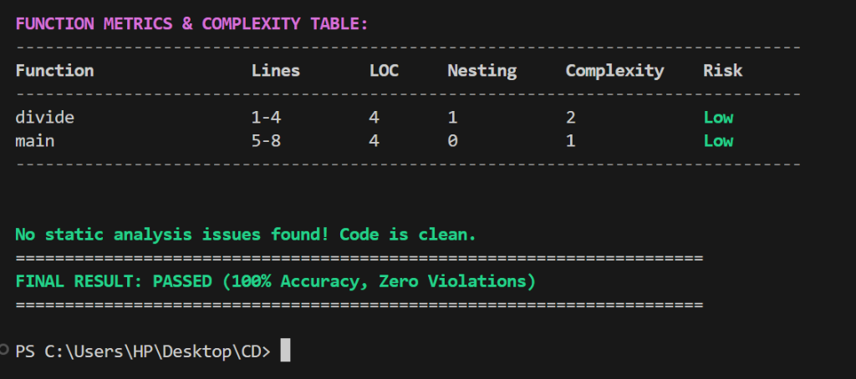
Figure 8.3: Function Metrics Table, McCabe Cyclomatic Complexity, and Final Passed Status
Figure 8.3 shows the per-function complexity metrics table. Each function's line span, LOC, maximum control flow nesting depth, McCabe cyclomatic complexity, and risk level are tabulated, followed by the final clean pass status.
9. References
Aho, A. V., Lam, M. S., Sethi, R., & Ullman, J. D. (2006). Compilers: Principles, Techniques, and Tools (2nd ed.). Addison-Wesley (The Dragon Book).
McCabe, T. J. (1976). A Complexity Measure. IEEE Transactions on Software Engineering, SE-2(4), 308-320.
Hopcroft, J. E., Motwani, R., & Ullman, J. D. (2006). Introduction to Automata Theory, Languages, and Computation (3rd ed.). Pearson.
Stroustrup, B. (2018). A Tour of C++ (2nd ed.). Addison-Wesley Professional.
Gamma, E., Helm, R., Johnson, R., & Vlissides, J. (1994). Design Patterns: Elements of Reusable Object-Oriented Software. Addison-Wesley.
ISO/IEC 14882:2017. (2017). Programming Languages - C++ (Standard C++17). International Organization for Standardization.
Chess, B., & McGraw, G. (2004). Static Analysis for Security. IEEE Security & Privacy, 2(6), 76-79.
MISRA C++:2008. (2008). Guidelines for the Use of the C++ Language in Critical Systems. Motor Industry Software Reliability Association.
10. Approval of the Project
This is to certify that the project report entitled 'STATIC CODE ANALYZER & ACCURACY SCORER IN C++' submitted by Anand Gaur (Roll No: <Roll No.>) in partial fulfillment of the requirements for the award of the degree of Bachelor of Technology in Computer Science & Engineering (Artificial Intelligence) of Rajasthan Technical University, Kota, is an authentic work carried out under my guidance and supervision at Jaipur Engineering College and Research Centre, Jaipur.
To the best of my knowledge, the matter embodied in this report has not been submitted to any other University / Institute for the award of any degree or diploma.

____________________________  Signature of Candidate  Anand Gaur  Roll No: <Roll No.> | ____________________________  Signature of Faculty Coordinator  <Faculty Name>  <Designation>, CSE (AI)

