A
Project
SYNOPSIS
Of
STATIC CODE ANALYZER & ACCURACY SCORER IN C++
Submitted in partial fulfillment for the award of degree of
Bachelor of Technology
Degree Of
Rajasthan Technical University, KOTA
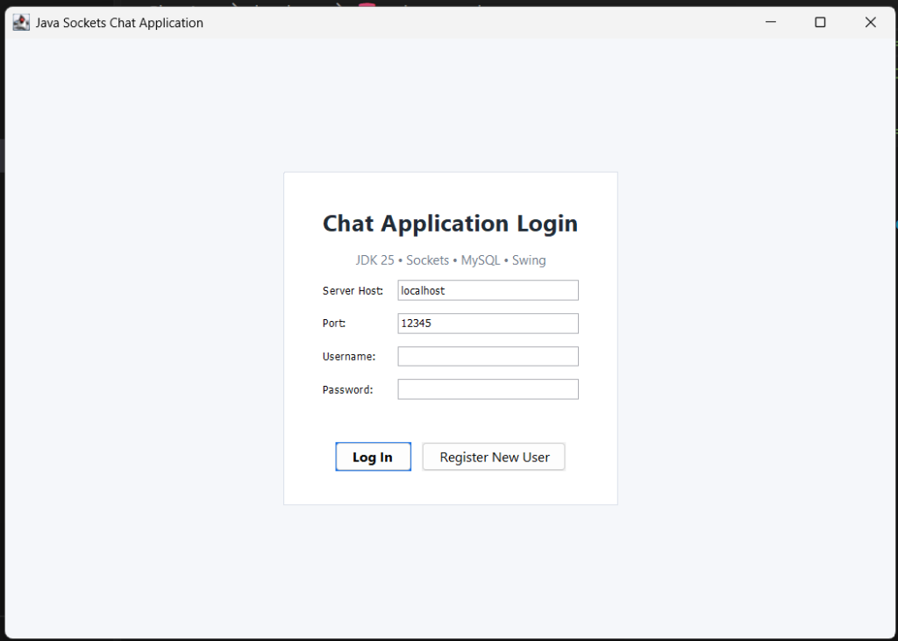
JAIPUR ENGINEERING COLLEGE AND RESEARCH CENTRE
2026-2027
Submitted By:  Anand Gaur  <Roll No.>  3rd Year, B.Tech CSE (AI) | ITS Coordinator (CC):  <Faculty Name>  <Designation>  Dept. of CSE (AI)
DEPARTMENT OF
COMPUTER SCIENCE & ENGINEERING (ARTIFICIAL INTELLIGENCE)
JAIPUR ENGINEERING COLLEGE AND RESEARCH CENTRE
Shri Ram ki Nangal, via Sitapura RIICO, Tonk Road, Sukhpuria, Bambala, Jaipur, Rajasthan

ABSTRACT
Static code analysis is a crucial discipline in compiler design and software engineering that inspects source code without dynamic execution to evaluate correctness, detect logical anti-patterns, and measure algorithmic complexity. This project presents a robust, standalone Static Code Analyzer and Accuracy Scoring System implemented in pure C++17. The system embodies classical compiler construction principles by engineering a hand-written Deterministic Finite Automaton (DFA) for lexical tokenization, an LL(1) Recursive Descent parser for Context-Free Grammar (CFG) analysis, and an Abstract Syntax Tree (AST) using the Visitor pattern.
The middle-end features a scoped symbol table that evaluates lexical environments to catch unused variables and undeclared identifiers. Static analysis passes calculate McCabe's Cyclomatic Complexity (V(G) = P + 1), track control-flow nesting depth, and detect dead / unreachable code after block terminators. The system computes a calibrated Code Accuracy Score (0% to 100%, Grade A+ to F) with an itemized deduction breakdown. Supporting direct interactive typing, standard input pipes, and file inputs, the tool delivers ANSI-formatted diagnostics and line caret pointers directly in the terminal with zero external dependencies.

INTRODUCTION
- Problem Statement: Standard software testing relies on dynamic execution test cases, which fail to detect unexercised code paths, memory leaks, unreachable dead code, and cyclomatic complexity bloat. Developers need early, automated feedback on code correctness and structural health directly in their command-line workflow.
- Scope of the Project: The project encompasses a complete compiler front-end and static checking engine for C/C++ source code, featuring DFA tokenization, LL(1) recursive descent grammar verification, scoped symbol table tracking, and an automated accuracy scoring model.
- Technologies Used: Pure Standard C++17 (STL), CMake build system, MinGW GCC toolchain, and Git version control, completely independent of external parser generators or third-party libraries.
- Methodology: Component-driven engineering organized into four phases: (1) DFA lexical tokenizer, (2) Recursive descent LL(1) parser with precedence climbing, (3) AST Visitor static analysis passes, and (4) Accuracy scoring and terminal diagnostics.
- Expected Outcome: A high-performance command-line tool capable of ingesting C/C++ code, diagnosing syntax/semantic faults with exact coordinate pointers, evaluating McCabe complexity, and calculating an accurate 0-100% quality grade.
- Applications of Project: Academic programming evaluation, CI/CD automated code reviews, safety-critical software compliance checks, and pedagogical compiler demonstrations.

CONCLUSIONS AND FUTURE ENHANCEMENTS
Conclusions
The developed C++ Static Code Analyzer successfully realizes the foundational theories of Compiler Design—lexical analysis, syntax analysis, and semantic checking—into an industry-applicable software quality auditing tool. By eliminating external parser generators, the project demonstrates mastery over DFA state transitions, LL(1) parsing, operator precedence climbing, and AST visitor patterns. The integration of McCabe's Cyclomatic Complexity and a transparent accuracy deduction scoring formula provides an objective, quantifiable assessment of source code quality.
Future Enhancements
- 1. Dataflow & Taint Analysis: Extend the AST passes to perform intra-procedural dataflow analysis (e.g., reaching definitions, live variable analysis) to catch null pointer dereferences and uninitialized memory reads.
- 2. Modern Language Server Protocol (LSP): Wrap the core analyzer into an LSP daemon compatible with Visual Studio Code, Cursor, and Neovim for real-time in-editor linting.
- 3. LLVM / Clang AST Frontend Integration: Provide an optional LLVM Clang frontend ingestion mode to support full C++20/C++23 template metaprogramming and concepts.
Reference Screenshots
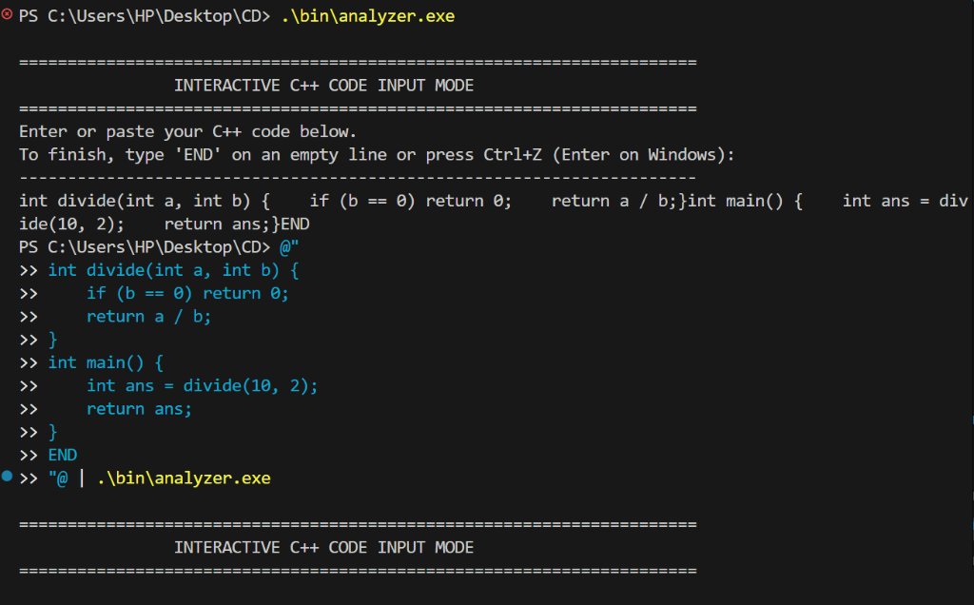
Figure: Interactive Pipeline Code Execution & Real-Time Terminal Analysis

References
Aho, A. V., Lam, M. S., Sethi, R., & Ullman, J. D. (2006). Compilers: Principles, Techniques, and Tools (2nd ed.). Addison-Wesley.
McCabe, T. J. (1976). A Complexity Measure. IEEE Transactions on Software Engineering, SE-2(4), 308-320.
Hopcroft, J. E., Motwani, R., & Ullman, J. D. (2006). Introduction to Automata Theory, Languages, and Computation (3rd ed.). Pearson.
Stroustrup, B. (2018). A Tour of C++ (2nd ed.). Addison-Wesley Professional.
ISO/IEC 14882:2017. (2017). Programming Languages - C++ (Standard C++17). International Organization for Standardization.

