Objective Questions

1. Are there any tables with duplicate or missing null values? If so, how would you handle them?

* There are No Duplicate and Null Values In The tables**.**

1. What is the distribution of user activity levels (e.g., number of posts, likes, comments) across the user base?

* select count(*) as total_posts from photos; -- 257

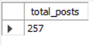

* select count(*) as total_likes from likes; -- 8782



* select count(*) as total_comments from comments; -- 7488



1. Calculate the average number of tags per post (photo_tags and photos tables).

SELECT AVG(tag_count) AS avg_tags_per_post

FROM (SELECT photo_id, COUNT(tag_id) AS tag_count

FROM photo_tags

GROUP BY photo_id

) AS tag_counts;

1. Identify the top users with the highest engagement rates (likes, comments) on their posts and rank them.

SELECT u.id AS user_id,u.username,

COALESCE(engagement.total_likes, 0) AS total_likes,

COALESCE(engagement.total_comments, 0) AS total_comments,

COALESCE(engagement.total_likes, 0) + COALESCE(engagement.total_comments, 0) AS total_engagement,

RANK() OVER (ORDER BY COALESCE(engagement.total_likes, 0) + COALESCE(engagement.total_comments, 0) DESC) AS rnk

FROM users u

LEFT JOIN (

SELECT p.user_id,COUNT(DISTINCT l.user_id) AS total_likes, -- Counting distinct users who liked a photo

COUNT(DISTINCT c.id) AS total_comments -- Counting distinct comments

FROM photos p

LEFT JOIN likes l ON p.id = l.photo_id

LEFT JOIN comments c ON p.id = c.photo_id

GROUP BY p.user_id

) AS engagement ON u.id = engagement.user_id

ORDER BY total_engagement DESC

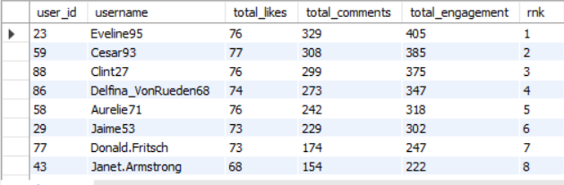limit 20;

1. Which users have the highest number of followers and followings?

SELECT u.id AS user_id, u.username,

COUNT(DISTINCT f1.follower_id) AS total_followers,

COUNT(DISTINCT f2.followee_id) AS total_followings

FROM users u

LEFT JOIN follows f1 ON f1.followee_id = u.id

LEFT JOIN follows f2 ON f2.follower_id = u.id

GROUP BY u.id, u.username

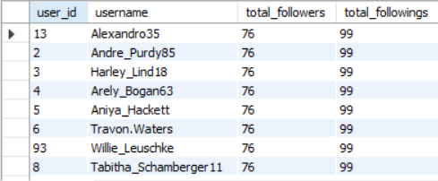ORDER BY total_followers, total_followings;

1. Calculate the average engagement rate (likes, comments) per post for each user.

WITH Post_Engagement AS (

-- Count likes and comments for each post

SELECT

p.user_id,

p.id AS photo_id,

COALESCE(COUNT(DISTINCT l.user_id), 0) AS total_likes,

COALESCE(COUNT(DISTINCT c.id), 0) AS total_comments

FROM photos p

LEFT JOIN likes l ON p.id = l.photo_id

LEFT JOIN comments c ON p.id = c.photo_id

GROUP BY p.user_id, p.id

),

User_Posts AS (

-- Count the total number of posts for each user

SELECT user_id, COUNT(*) AS total_posts

FROM photos

GROUP BY user_id

)

SELECT

u.username,

up.total_posts,

-- Calculate total engagement (likes + comments) for each user

COALESCE(SUM(pe.total_likes + pe.total_comments), 0) AS total_engagement,

-- Calculate average engagement rate per post

CASE

WHEN up.total_posts > 0 THEN

COALESCE(SUM(pe.total_likes + pe.total_comments), 0) * 1.0 / up.total_posts

ELSE 0

END AS average_engagement_rate_per_post

FROM users u

LEFT JOIN Post_Engagement pe ON u.id = pe.user_id

LEFT JOIN User_Posts up ON u.id = up.user_id

GROUP BY u.id, u.username, up.total_posts

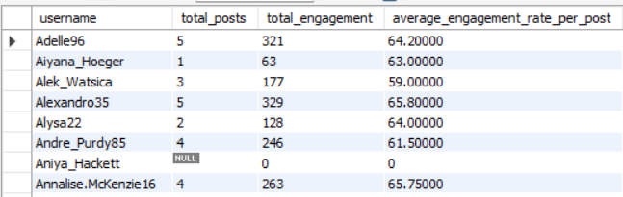ORDER BY u.username;

1. Get the list of users who have never liked any post (users and likes tables)

select u.id,u.username

from users u

left join likes l

on u.id=l.user_id

where l.user_id is NULL; -- this checks for the presence of non matching rows with users table.

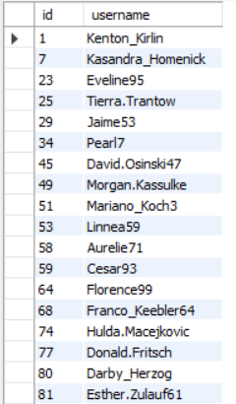

1. How can you leverage user-generated content (posts, hashtags, photo tags) to create more personalized and engaging ad campaigns?

-- The query is counting how many photos are associated with each tag, which gives insight into how popular each tag is.

-- I have also ranked each tag as per their popularity.

select tag_id,t.tag_name,

count(pt.photo_id) as total_posts,

dense_rank() over(order by count(pt.photo_id) desc) as ranking

from photo_tags pt

join tags t

on pt.tag_id=t.id

group by t.tag_name

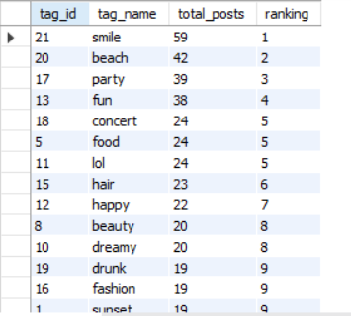order by total_posts desc;

Based On The Output:

* The tags with the highest number of posts (such as "smile," "beach," and "party") reveal the most common themes users are interested in. This information can help you understand the main interests of your audience. For example, users who frequently engage with tags like "beach" and "party" might be interested in travel, leisure, or event-related content.
* **By analyzing the top tags, we can design ads that align with popular themes. For example:**
* Ads for beauty or fashion brands can target users who interact with tags like "beauty" and "fashion."
* Travel companies could target users who engage with "beach" and "sunset" tags, promoting travel packages or beachwear.
* **By focusing on these popular tags, we can understand what topics people are really into.**

**For example:**

* If "beach" and "party" are popular tags, we could create ads that highlight summer products or travel destinations.
* If "food" is trending, ads could focus on restaurants, cooking gadgets, or meal kits.

Using these popular tags lets us match ads with things that people already enjoy talking about. This way, ads feel more relevant to users, which can increase their interest and engagement.

1. Are there any correlations between user activity levels and specific content types (e.g., photos, videos, reels)? How can this information guide content creation and curation strategies?

SELECT u.id AS user_id, u.username,

COUNT(DISTINCT p.id) AS total_photos,

COUNT(DISTINCT l.user_id) AS total_likes,

COUNT(DISTINCT c.user_id) AS total_comments

FROM users u

LEFT JOIN photos p ON u.id = p.user_id

LEFT JOIN likes l ON p.id = l.photo_id

LEFT JOIN comments c ON p.id = c.photo_id

GROUP BY u.id, u.username

ORDER BY total_photos DESC;

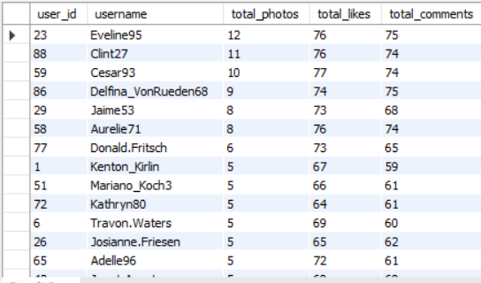

Since we only have data on photos (and not videos or reels), this analysis focuses on user engagement with photos—specifically, the number of photos each user has posted, as well as the total likes and comments they’ve received.

1. **Correlation in User Activity**:
   * Users who post more photos often receive more likes and comments. This shows that being active (posting frequently) tends to increase engagement.
   * Users who get more likes and comments can be seen as more popular. These users are valuable to understand because their posts are reaching and engaging more people.
2. **How This Helps Content Strategy**:
   * By identifying users whose photos get a lot of engagement, we can understand what type of photos (like travel, food, lifestyle, etc.) attract people. This insight helps in creating content that others are likely to enjoy.
   * Although we don’t have data on videos or reels, seeing high engagement on photos could suggest that these users might also enjoy and engage with other types of content. If videos or reels were added to this platform, they might be popular as well.
   * For users who interact a lot with photos, personalized content or ad suggestions can be designed around their interests. For instance, users who often like travel photos could be shown more travel-related content or ads.
3. **Insights for Ad Campaigns**:
   * Users who get a lot of likes and comments could be good candidates for influencer campaigns or brand partnerships.
   * Learning from users with high engagement can guide us on what type of content works well, helping us plan better ad campaigns or featured posts.
4. Calculate the total number of likes, comments, and photo tags for each user.

-- for calculating user wise likes, comments and photo_tags we need to join the following tables

-- users, likes, comments, photos, photo_tags

SELECT p.user_id,u.username,

COALESCE(COUNT(DISTINCT l.user_id), 0) AS total_likes, -- Count of distinct users who liked the user's photos

COALESCE(COUNT(DISTINCT c.id), 0) AS total_comments, -- Count of distinct comments

COALESCE(COUNT(DISTINCT pt.tag_id), 0) AS total_tags -- Count of distinct tags

FROM photos p

LEFT JOIN likes l ON p.id = l.photo_id -- Join to count likes per photo

LEFT JOIN comments c ON p.id = c.photo_id -- Join to count comments per photo

LEFT JOIN photo_tags pt ON p.id = pt.photo_id -- Join to count tags per photo

LEFT JOIN users u ON p.user_id = u.id -- Join to get the username

GROUP BY p.user_id, u.username

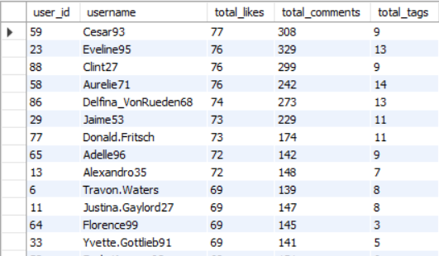ORDER BY total_likes DESC; -- Order by total likes

1. Rank users based on their total engagement (likes, comments, shares) over a month.

-- since there is no share data of the users I am considering only likes and comments

-- for getting the total engagement we have to sum total likes and total comments

SELECT u.id AS user_id,u.username,

COALESCE(engagement.total_likes, 0) AS total_likes,

COALESCE(engagement.total_comments, 0) AS total_comments,

COALESCE(engagement.total_likes, 0) + COALESCE(engagement.total_comments, 0) AS total_engagement,

RANK() OVER(ORDER BY COALESCE(engagement.total_likes, 0) + COALESCE(engagement.total_comments, 0) DESC) AS ranking

FROM users u

LEFT JOIN (SELECT p.user_id,

COUNT(DISTINCT l.photo_id) AS total_likes,

COUNT(DISTINCT c.user_id) AS total_comments

FROM photos p

LEFT JOIN likes l ON p.id = l.photo_id

LEFT JOIN comments c ON p.id = c.photo_id

GROUP BY p.user_id

) AS engagement

ON u.id = engagement.user_id

ORDER BY total_engagement DESC;

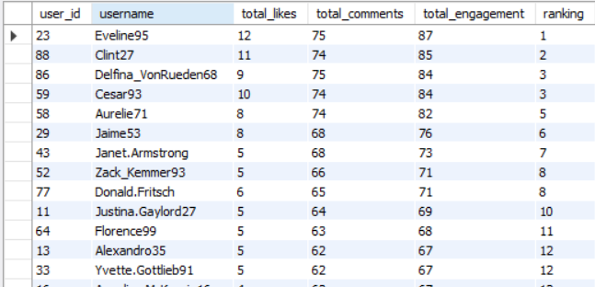

1. Retrieve the hashtags that have been used in posts with the highest average number of likes. Use a CTE to calculate the average likes for each hashtag first.

WITH PhotoLikes AS (

SELECT p.id AS photo_id,COUNT(l.user_id) AS total_likes

FROM photos p

LEFT JOIN likes l ON p.id = l.photo_id

GROUP BY p.id

),

TagLikes AS (

SELECT t.id,t.tag_name,AVG(pl.total_likes) AS avg_likes

FROM tags t

JOIN photo_tags pt ON t.id = pt.tag_id

JOIN PhotoLikes pl ON pt.photo_id = pl.photo_id

GROUP BY t.id, t.tag_name

)

SELECT tag_name,avg_likes

FROM TagLikes

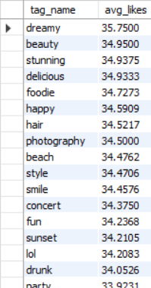ORDER BY avg_likes DESC;

1. Retrieve the users who have started following someone after being followed by that person.

* DUE TO INSUFFICIENT DATA IT CAN’T BE DETERMINED, THERE IS NO SEQUENTIAL DATE GIVEN IN FOLLOWS TABLE.

Subjective Questions

1. Based on user engagement and activity levels, which users would you consider the most loyal or valuable? How would you reward or incentivize these users?

QUERY:

WITH User_Engagement AS (

-- Calculate total likes, comments, and tags per user

SELECT u.id AS user_id,u.username,

COALESCE(COUNT(DISTINCT l.user_id), 0) AS total_likes, -- Count distinct users who liked

COALESCE(COUNT(DISTINCT c.id), 0) AS total_comments, -- Count distinct comments

COALESCE(COUNT(DISTINCT pt.tag_id), 0) AS total_tags -- Count distinct tags

FROM users u

LEFT JOIN photos p ON u.id = p.user_id

LEFT JOIN likes l ON p.id = l.photo_id

LEFT JOIN comments c ON p.id = c.photo_id

LEFT JOIN photo_tags pt ON p.id = pt.photo_id

GROUP BY u.id, u.username

)

SELECT user_id, username,al_likes,al_comments,total_tags,

-- Calculate total engagement (likes + comments + tags)

(total_likes + total_comments + total_tags) AS total_engagement,

-- Rank users based on total engagement

RANK() OVER (ORDER BY (total_likes + total_comments + total_tags) DESC) AS engagement_rank

FROM User_Engagement

ORDER BY engagement_rank;

OUTPUT:

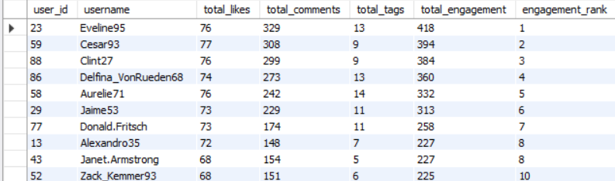

Explanation:

**To identify the most loyal or valuable users based on their engagement and activity levels, and propose strategies to reward or incentivize these users let's highlight the top three users:**

1. Eveline95 (user_id 23): Total Engagement = 418, Engagement Rank = 1
2. Cesar93 (user_id 59): Total Engagement = 394, Engagement Rank = 2
3. Clint27 (user_id 88): Total Engagement = 384, Engagement Rank = 3

These top users are highly engaged and active on the platform, indicating their loyalty and value to the community. Their high levels of likes, comments, and tags suggest they significantly contribute to the platform’s activity and community growth.

To further incentivize and reward these valuable users, consider implementing the following strategies:

1. **Latest Content and Features:** Provide them with early access to new features or exclusive content tailored to their interests.
2. **Public Recognition:** Feature these users in a "Top Contributors" section on platform or social media shout-outs.
3. **Discounts and Offers:** Offer personalized discounts, gift cards, or special promotions to show appreciation for their engagement.
4. **Gamification:** Introduce badges, levels, or a point system that can be redeemed for rewards, encouraging continued participation.
5. **Events and Contests:** Organize exclusive events or contests where these users can be recognized and rewarded for their contributions.
6. For inactive users, what strategies would you recommend to re-engage them and encourage them to start posting or engaging again?

QUERY:

WITH User_Engagement AS (

-- Calculate total likes, comments, and tags per user

SELECT u.id AS user_id,u.username,

COALESCE(COUNT(DISTINCT l.user_id), 0) AS total_likes, -- Count distinct users who liked

COALESCE(COUNT(DISTINCT c.id), 0) AS total_comments, -- Count distinct comments

COALESCE(COUNT(DISTINCT pt.tag_id), 0) AS total_tags -- Count distinct tags

FROM users u

LEFT JOIN photos p ON u.id = p.user_id

LEFT JOIN likes l ON p.id = l.photo_id

LEFT JOIN comments c ON p.id = c.photo_id

LEFT JOIN photo_tags pt ON p.id = pt.photo_id

GROUP BY u.id, u.username

)

SELECT user_id, username,total_likes,total_comments,total_tags,

-- Calculate total engagement (likes + comments + tags)

(total_likes + total_comments + total_tags) AS total_engagement

FROM User_Engagement

where (total_likes + total_comments + total_tags)=0;

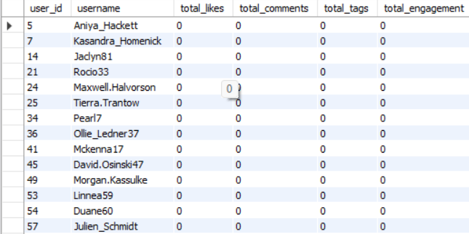OUT PUT:

Explanation:

* By going through the output we got 26 users who haven't posted anything and have an engagement rate of zero.

To re-engage inactive users and encourage them to start posting or interacting again, we could consider a few targeted strategies:

* Send personalized notifications or emails Offering rewards, badges, or incentives for coming back to the platform, posting, or interacting with others.
* Highlight their previous comments or popular posts they may have missed to make the experience.
* Create limited-time challenges or contests that encourage users to post content, comment, or like others' posts.
* Show off new features, updates, or trending content that the user might find interesting.
* Provide content recommendations based on their past interests, like suggesting accounts to follow or posts they may like.

1. Which hashtags or content topics have the highest engagement rates? How can this information guide content strategy and ad campaigns?

QUERY:

* select t.tag_name,coalesce(eng.total_engagement, 0) as total_engagement,p.total_posts,

case when p.total_posts > 0 then eng.total_engagement / p.total_posts else 0 end as engagement_rate

from tags t

left join (

select pt.tag_id,coalesce(sum(l.total_likes), 0) + coalesce(sum(c.total_comments), 0) as total_engagement

from photo_tags pt

left join (select photo_id, count(*) as total_likes from likes

group by photo_id) l on pt.photo_id = l.photo_id

left join (select photo_id, count(*) as total_comments from comments group by photo_id) c on pt.photo_id = c.photo_id

group by pt.tag_id

) eng on t.id = eng.tag_id

left join (

select pt.tag_id, count(pt.photo_id) as total_posts

from photo_tags pt

group by pt.tag_id

) p on t.id = p.tag_id

order by engagement_rate desc;

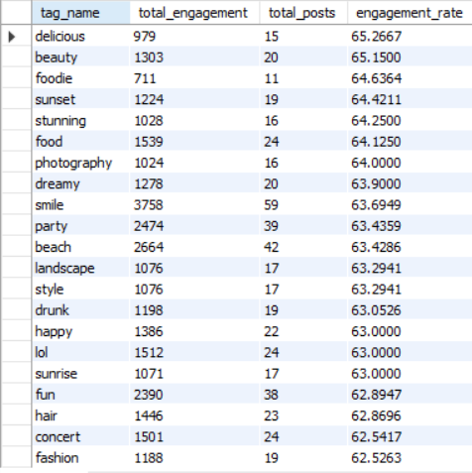

**Based on the provided output, here are insights that address the question:**

**1. Top-Performing Hashtags**

* **The hashtags with the highest engagement are:**
  + #delicious: 65.27%
  + #beauty: 65.15%
  + #foodie: 64.64%
  + #sunset: 64.42%
  + #stunning: 64.25%
* These hashtags show that people like content related to food, beauty, and nature. Topics like food (#food, #foodie), travel (#sunset, #landscape), looks (#beauty, #stunning), and fun (#party, #concert) get a lot of attention.
* This means people are drawn to content that’s visually interesting, positive, and lifestyle-focused.

**2. Content Strategy**

* Focus on Popular Topics: Create content around the top hashtags. For example, content about food (#delicious, #foodie), beauty (#beauty), and travel (#sunset, #landscape) tends to get more engagement.
* Use Great Visuals: Since these hashtags are for visually appealing topics, using high-quality photos and videos can help grab attention.
* Add Positive Themes: Hashtags like #smile and #happy show that people enjoy positive content. Using uplifting and happy messages can make content more appealing.

**3. Ad Campaign Strategy**

* Target Ads by Interests: Use these popular hashtags as keywords in ads to reach people who like these themes. For example, ads for food products can use #delicious or #foodie to attract food lovers.
* Plan for Events and Seasons: Hashtags like #party and #concert suggest people engage more around events. Try running ads during festivals or events when people are more likely to interact.
* Work with Influencers: Partner with influencers who are popular in these areas, like beauty and food. They can help spread the content to a wider audience and get more engagement from people interested in these topics.

1. Are there any patterns or trends in user engagement based on demographics (age, location, gender) or posting times? How can these insights inform targeted marketing campaigns?

QUERY:

SELECT DAYOFWEEK(p.created_dat) AS post_day, -- Extracts the day of the week (1=Sunday, 7=Saturday)

EXTRACT(HOUR FROM p.created_dat) as post_hour,

COUNT(DISTINCT p.id) AS total_photos,

COUNT(DISTINCT l.user_id) AS total_likes,

COUNT(DISTINCT c.id) AS total_comments,

coalesce(COUNT(DISTINCT p.id),0)+ coalesce(COUNT(DISTINCT l.user_id),0)+coalesce(COUNT(DISTINCT c.user_id),0) as total_engagement

FROM users u

LEFT JOIN photos p ON u.id = p.user_id

LEFT JOIN likes l ON p.id = l.photo_id

LEFT JOIN comments c ON p.id = c.photo_id

GROUP BY EXTRACT(HOUR FROM p.created_dat),DAYOFWEEK(p.created_dat)

ORDER BY total_engagement DESC;

EXPLANATION:

* As per the question, there is no demographics data(age,location,gender) present in the dataset, and the date provided in the columns of each table are same because of now timestamp.
* So, to achieve the trends in engagement I extracted hour-wise and day of week-wise total engagement.
* If we had proper data on post time we will succeed to achive our target using the approach I mentioned above in the query.
* I used EXTRACT() & DAYOFWEEK function to achieve this output based on the given dataset.

1. Based on follower counts and engagement rates, which users would be ideal candidates for influencer marketing campaigns? How would you approach and collaborate with these influencers?

Query:

WITH FollowerCounts AS (

SELECT followee_id AS user_id,COUNT(DISTINCT follower_id) AS follower_count

FROM follows

GROUP BY followee_id

),

UserEngagement AS (

SELECT p.user_id,(COUNT(DISTINCT l.user_id) + COUNT(DISTINCT c.id)) / NULLIF(COUNT(DISTINCT p.id), 0) AS engagement_rate

FROM photos p

LEFT JOIN likes l ON p.id = l.photo_id

LEFT JOIN comments c ON p.id = c.photo_id

GROUP BY p.user_id

)

SELECT u.id AS user_id,u.username,fc.follower_count,ue.engagement_rate

FROM users u

JOIN FollowerCounts fc ON u.id = fc.user_id

JOIN UserEngagement ue ON u.id = ue.user_id

ORDER BY fc.follower_count DESC, ue.engagement_rate DESC

LIMIT 10; -- Only selecting the top influencers

OUTPUT:

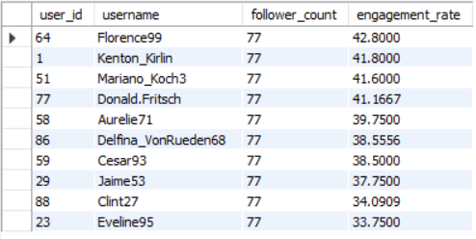

**CALCULATION FOR ENGAGEMENT RATE:** (TOTAL LIKES+TOTAL COMMENTS)/TOTAL POSTS

* Based on the output, the top 10 users listed here all have a follower count of 77, but they vary in engagement rates. The top candidates for influencer marketing would be:
  + - 1. **Florence99** (Engagement Rate: 42.8%)
      2. **Kenton_Kirlin** (Engagement Rate: 41.8%)
      3. **Mariano_Koch3** (Engagement Rate: 41.6%)
      4. **Donald.Fritsch** (Engagement Rate: 41.2%)

These users have the highest engagement rates, meaning their followers are more likely to interact with their content. This makes them ideal for influencer campaigns, as their audience is active and responsive.

* **Approach for Collaboration:**
* **Offer Exclusive Deals or Content**: Engage these influencers by providing them with exclusive products, discounts, or content they can share with their followers.
* **Create Sponsored Posts**: Partner with them to create posts promoting your brand. Focus on authentic messaging that aligns with the influencer’s style.
* **Provide Performance Bonuses**: Offer additional incentives and Online E-Vouchers for shopping based on the engagement or reach, each post achieves, motivating them to create high-quality content.

1. Based on user behaviour and engagement data, how would you segment the user base for targeted marketing campaigns or personalised recommendations?

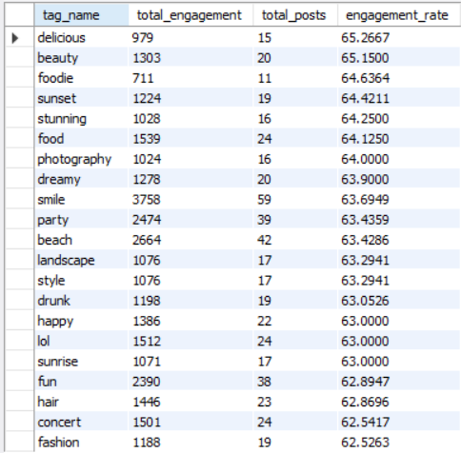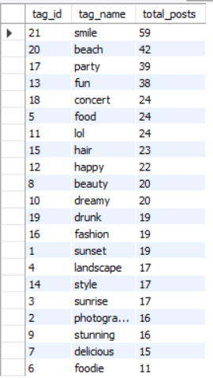Explanation:

* **High Engagement, High Volume Tags**:
  + - Tags such as"smile," "party," "beach," "fun".
* These tags have a high number of posts and high engagement rates, indicating they are popular and engaging.
* We should Focus on creating content that aligns with these themes. Use these tags to reach a broad and highly engaged audience.
* **High Engagement, Low Volume Tags**:
* Tags such as "delicious," "beauty," "foodie," "sunset," "stunning"
* These tags have high engagement rates but fewer posts. Users interacting with these tags are highly engaged but represent a niche audience.
* We canCreate specialized content targeting these interests. Personalized recommendations can be more specific, serving to the unique preferences of this segment.
* **Moderate Engagement, Moderate Volume Tags**:
* Tags such as "concert," "fashion," "photography," "dreamy," "happy"
* These tags have moderate engagement rates and a moderate number of posts. Users interacting with these tags have a balanced level of activity and engagement.
* We shouldDevelop content that attract to these interests, maintaining a balance between broad interest and relative things.
* **Low Engagement, High Volume Tags**:
* Tags like "lol," "drunk," "style," "landscape"
* These tags have a high number of posts but lower engagement rates, indicating they are popular but not as engaging.
* We should Improve the quality and relevance of content associated with these tags to increase engagement. Consider using these tags for awareness campaigns rather than engagement-focused campaigns.
* **Low Engagement, Low Volume Tags**:
* Tags like "hair," "sunrise," "delicious," "foodie"
* These tags have low engagement rates and fewer posts. Users interacting with these tags are less active and engaged.
* Reevaluate the use of these tags. Consider whether they align with the brand's goals or if they need to be replaced with more engaging tags.
* **Personalized Recommendations**
  + Recommend content based on popular and engaging tags.
  + Highlight trending and high-engagement tags to users.
  + Suggest content and tags based on user behaviour and past interactions.
  + Use engagement data to personalize recommendations.

1. If data on ad campaigns (impressions, clicks, conversions) is available, how would you measure their effectiveness and optimize future campaigns?

If we have data on ad campaigns (like how many people saw the ad, clicked on it, or took an action we wanted), here’s a simple way to see how well the ads are working and how to make them better:

1. **Look at How Many People Clicked**:

This tells us if the ad caught people’s attention. If not many people clicked, we might need to make the ad more interesting.

1. **Check How Many People Took Action**:

After clicking, did people do what we wanted (like buy something or sign up)? If a lot did, the ad is working well. If not, we might need to make the landing page or the ad message clearer.

1. **Find Out Which Audience Works Best**:

Look at which types of people (like age group or interests) interacted most with the ad. Then, focus future ads on those groups to get better results.

1. **Try Different Versions of the Ad**:

Test out different images, headlines, or messages to see which one gets the most clicks or actions. This helps us learn what people like best.

1. **Make Adjustments as We Go**:

If something isn’t working, change it or try something new. The goal is to keep testing and improving the ads to get better results each time.

By keeping track of these simple things, we can make ads that reach the right people and get more value out of our expectations.

1. How can you use user activity data to identify potential brand ambassadors or advocates who could help promote Instagram's initiatives or events?

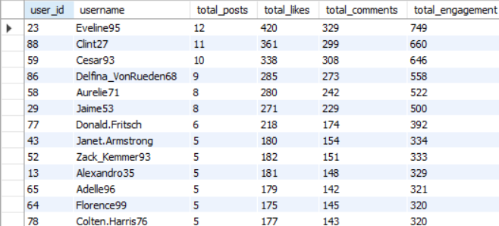Explanation:

* **Top Engaged Users**
* Users with the most total engagement (likes + comments) have strong connections with their followers. For example:
* **Eveline95** has the highest engagement with 749 interactions, followed by **Clint27** with 660, and **Cesar93** with 646.
* These users seem to post content that their followers enjoy and respond to, making them great candidates for promoting Instagram’s initiatives.
* **Consistent Posting and High Engagement**
* Users who post often and keep up a high level of engagement make good ambassadors because they’re active on the platform and have followers who interact with them regularly.
* **Eveline95** (12 posts), **Clint27** (11 posts), and **Cesar93** (10 posts) not only post frequently but also get a lot of engagement, showing that they influence their followers.
* **Balanced Interaction (Likes and Comments)**
* Users with a good mix of likes and comments show that their followers are not just liking but also engaging in conversations on their posts.
* **Eveline95** (420 likes, 329 comments) and **Clint27** (361 likes, 299 comments) have a strong balance of both, which means they’re good at sparking discussions and keeping their audience interested—great qualities for a brand ambassador.
* **Potential Micro-Influencers**
* Some users post a little less often but still get a lot of engagement, like **Delfina_VonRueden68** (558 total engagements from 9 posts) and **Aurelie71** (522 total engagements from 8 posts). These users have a dedicated following and might be able to reach specific groups effectively.

Based on this data, users such as **Eveline95**, **Clint27**, and **Cesar93** are excellent choices as brand ambassadors due to their high engagement, consistent posting, and balanced interaction with followers. Additionally, **Delfina_VonRueden68** and **Aurelie71** can be considered as micro-influencers for targeted campaigns, reaching more specific or loyal audiences. These users are likely to be influential and effective in promoting Instagram's initiatives or events.

1. How would you approach this problem, if the objective and subjective questions weren't given?

**If the objective and subjective questions weren't given, I would still approach the project systematically by focusing on the key areas of user engagement and behavior. Here's how I would approach it:**

* + - 1. **Understand the Data**:
* Look at the tables to understand what data you have, like users, posts, comments, likes, followers, and hashtags.
  + - 1. **Clean the Data**:
* Check for missing or duplicate data and fix it by removing duplicates or filling in missing values.
  + - 1. **Define Key Metrics**:
* Identify what is important, like the number of posts, likes, comments, followers, and hashtags used.
  + - 1. **Analyze User Activity**:
* Look at how active each user is by counting their posts, likes, comments, and hashtags used.
  + - 1. **Hashtag Analysis**:
* Find out which hashtags are used the most and which ones get the most engagement (likes, comments). This can help in understanding what content is popular.
  + - 1. **Find Patterns**:
* Check if certain types of posts (like photos or videos) and hashtags get more engagement (more likes or comments).
  + - 1. **Personalized Ads**:
* Use popular hashtags and user activity to create more targeted ads. For example, users who use specific hashtags can be shown ads related to those topics.
  + - 1. **Identify Top Users**:
* Find the users with the most followers or highest engagement, and see which hashtags they use the most.
  + - 1. **Suggestions**:
* Encourage users to use trending hashtags to increase their engagement, and look at what hashtags have the highest engagement to guide content creation.

1. Assuming there's a "User_Interactions" table tracking user engagements, how can you update the "Engagement_Type" column to change all instances of "Like" to "Heart" to align with Instagram's terminology?

**For this I will use UPDATE query:**

UPDATE User_Interactions

SET Engagement_Type = 'Heart'

WHERE Engagement_Type = 'Like';

-------END OF FILE-------