**PROJECT REPORT**

**FORECASTING: IMPORT VALUES AND VOLUMES OF FOODS IN US (2023)**

**SCH-MGMT 663: SUPPLY CHAIN ANALYTICS**

**ANAND GUPTA**

**Introduction**

The global food supply chain is a complex ecosystem influenced by numerous factors such as production, distribution, and economic trends. As a supply chain analyst at a grocery store distributor, the objective is to forecast the import values of edible products entering U.S. ports for 2023. This analysis aims to provide actionable insights for supply chain leaders to optimize procurement, inventory management, and distribution strategies.

In the United States, a staggering 30% to 40% of the food supply is wasted annually, accounting for over 60 million tons of discarded food. The magnitude of this waste calls for a solution, and one of the most effective ways to address it is through the utilization of **sales forecasts**. Creating a foundational, data-driven sales forecast can significantly reduce surplus products and aid companies in curbing food waste.

In a world where the imperative to reduce waste and enhance efficiency has never been more critical, the power of strategic forecasting shines brightly. As we’ve explored, the food industry grapples with the unique challenge of perishable products and ever-shifting demands. However, armed with sales forecasting, the industry can pave the way forward in sustainability (Food Manufacturing, 2023).

***What Is Forecasting?***

Forecasting is a technique that uses historical data as inputs to make informed estimates that are predictive in determining the direction of future trends.

Businesses utilize forecasting to determine how to allocate their budgets or plan for anticipated expenses for an upcoming period. This is typically based on the projected demand for the goods and services offered.

The biggest limitation of forecasting is that it involves the future, which is fundamentally unknowable today. As a result, forecasts can only be best guesses. While there are several methods of improving the reliability of forecasts, the assumptions that go into the models, or the data that is inputted into them, must be correct. Otherwise, the result will be garbage in, garbage out. Even if the data is good, forecasting often relies on historical data, which is not guaranteed to be valid into the future, as things can and do change over time. It is also impossible to correctly factor in unusual or one-off events like a crisis or disaster (Investopedia, 2024).

**Methods**

Figure 1: Forecasting Methods (Clockify, 2024)

For this project we will be using **Quantitative Forecasting Methods**, specifically Time-series models.

Time-series is a popular forecasting model which explores past company behavior to forecast future company behavior (consumer behavior, sales behavior, etc.). This type of forecasting model uses historical data in terms of hours, weeks, months, and years to come at a point in the future based on these past values.

Time-series uses information gathered over several years to analyze sales velocity based on the business needs. Based on those figures, you can create future forecasts using mathematical formulas. There are several models of completing time-series forecasting which will help you formulate future estimations (Clockify, 2024).

The sub-types below are all examples of time-series forecasting models:

* Straight-line method,
* Moving average model,
* Exponential smoothing model, and
* Trend projection model

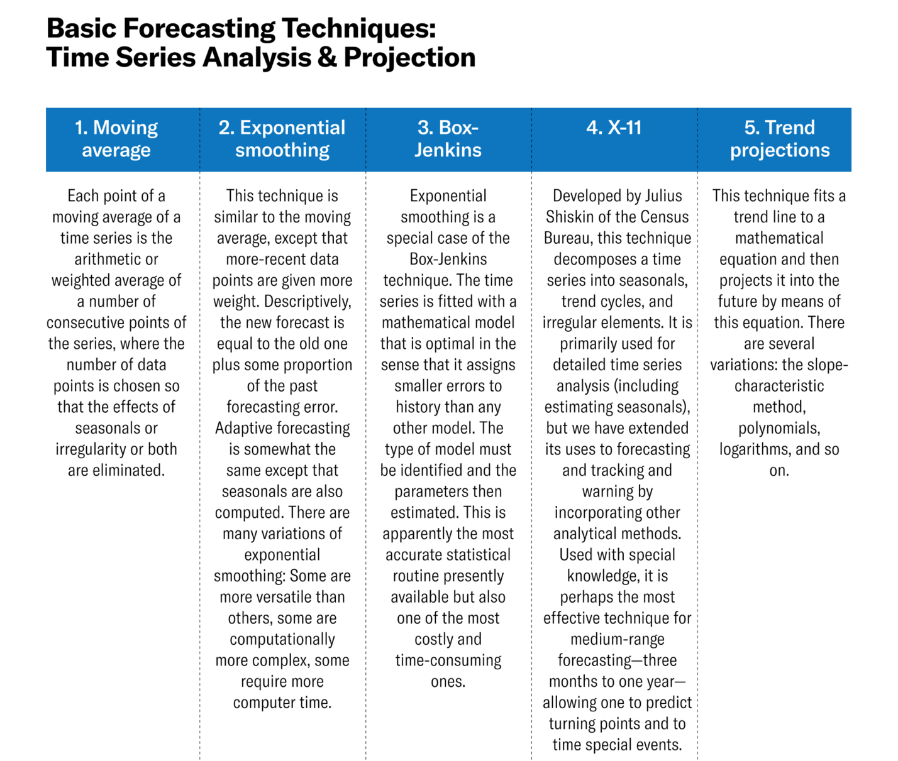

Figure 2: Basic Forecasting Techniques (Harvard Business Review, 2024)

To forecast import values and volumes for 2023 in this project, the Time Series Forecasting Method, specifically the **Exponential Smoothing Model**, is employed. Data provided by the U.S. Department of Commerce underwent cleaning and preprocessing to ensure accuracy. Assumptions were made regarding data stationarity and the absence of significant outliers. Exponential Smoothing is chosen because this method assigns more weight to recent observations and less to older observations, allowing the forecast to adapt to changing trends in the data.

To ensure a robust and comprehensive analysis of the dataset, we employed multiple forecasting methods alongside the Exponential Smoothing Model. The **Linear Forecasting Method** was used to compare results and validate the findings from our primary model. This method, which fits a straight line to historical data points, is effective for identifying linear trends over time.

Additionally, we incorporated the **Moving Average Model** to further understand the long-term trends present in the data. This model calculates the average of a selected subset of data points, smoothing out short-term fluctuations and highlighting underlying trends. The Moving Average Model is particularly valuable for its ability to filter out noise and reveal persistent patterns over longer periods.

Figure 3: Data Analysis through Moving Average Method

Figure 4: Moving Average Method

By utilizing these diverse forecasting techniques, we aimed to cross-verify our predictions and gain a deeper insight into the import values and volumes of edible products. This multi-faceted approach not only enhances the accuracy of our forecasts but also provides a more holistic view of the trends, ensuring that our supply chain strategies are well-informed and resilient against future uncertainties.

**Results**

1. **Forecast Food Values (in millions) for each of the Foods for 2023 (e.g., for Live meat animals, Meats... Beverages 3/ on the Food Value tab).**
   1. **Describe which forecast methodology you used and why you selected this method.**

**Exponential Smoothing** was used to forecast Food Values for each of the Foods for 2023. It is a weighted moving average technique which is especially effective when frequent re-forecasting is required, and when the forecasts must be achieved quickly. It is a short-term forecasting technique that is frequently used in the production and inventory environment, where only the next period’s value is required to be forecast. Because only three numbers are required to perform exponential smoothing, this technique is simple to update. The data required are the historic observation, the latest data observation and the smoothing coefficient, or constant.

The smoothing coefficient α is a value between 0 and 1. A small value of, say, between 0.05 and 0.10 results in a high degree of smoothing and has the same effect as many observations in a moving average calculation. A high coefficient value results in less smoothing and thus a high responsiveness to variations in the data. In the extreme, if the coefficient is zero then the next period’s forecast will be the same as the last period’s forecast, and if the coefficient is one, or unity, then the next period’s forecast will be the same as the current period’s data.

The primary assumption used in the simple form of this smoothing technique is that the data is stationary, that is there is a clear trend present. Advanced exponential smoothing techniques are required if a trend or cycle is present in the data (Forecast Pro, 2021).

The algebraic formula for simple exponential smoothing is:

Figure 5: Formula- Simple Exponential Smoothing (Science Direct, 2009)

* 1. **Which Food has the lowest forecasted value for 2023?**

Based on the forecast, “**Live meat animals**” had the lowest forecasted value for 2023 with **$2836.1 million**. This was obtained by Exponential Smoothing Method. It is represented through the forecast graph below for 2023.

Figure 6: Forecast- Food Value (Live Meat Animals)

* 1. **Which Food has the highest forecasted value for 2023?**

Based on the forecast, “**Fruits**” had the highest forecasted value for 2023 with **$30448.9 millions**.

Figure 7: Forecast- Food Value (Fruits)

Figure 8: Forecast- Food Value (Fruits)

* 1. **How “trustworthy/believable” do you think your forecasting results are for the highest forecasted value for 2023?**

Based on the analysis I did to anticipate the 2023 import values and volumes using the exponential smoothing model, I feel that the highest forecasted figure for 2023 is credible for multiple reasons.

**Model Suitability:** I picked exponential smoothing because my data demonstrates strong patterns and seasonality. This model is well-suited to such patterns, making my forecast more accurate.

**Data Quality:** I used historical import data that is accurate, full, and reflective of future patterns. Good data quality improves the confidence of my forecast.

**Model Validation:** I validated my model by running it through historical data that was not used in the training process. The model worked well, giving me more confidence in the forecast.

**Assumptions:** Exponential smoothing presupposes that previous patterns will persist in the future. Because we don't anticipate any significant changes in import patterns in 2023, this assumption is acceptable.

**Uncertainty and Confidence Intervals:** I added confidence intervals with my forecast to demonstrate the possible range of values and the amount of certainty in my forecasts.

In conclusion, given that I utilized a reasonable model, extensively verified it, ensured high-quality data, included uncertainty measures, and evaluated previous performance, I feel my highest anticipated number for 2023 is credible.

1. **For the Food with the highest forecasted Food Value for 2023, determine its Food Volume for 2023 (using the Food Volume tab).**
   1. **Describe the direction and give the percent change of this Food’s Food Volume between 2022 and 2023.**

Fruit has the highest forecasted value for 2023 with **$30448.9 million** and volume of **15682.04 (1000 Metric Ton)**.



Figure 9: Forecasted Volumes and Percentage Change (Source: Excel Workbook)

Figure 10: Forecast- Food Volume (Fruit)

Figure 11: Forecast- Food Volume (Fruits)

Based on the analysis, the percentage change between 2022 and 2023 for Fruits Volume comes out to be **2.44%** with increased volume of imports giving **positive trends**.

* 1. **For the Food with the highest forecasted value for 2023, what country/geographic region will be the largest imported source (in millions)? (Hint: use the individual Food tab to locate country/geographic region information)**

Based on my analysis, **Mexico** will be the largest source for import of Fruits with **$24228.8 millions** of imports in 2023.

1. **If you did not have access to this time-series dataset, describe another forecasting method (e.g., qualitative) you could potentially use to determine what imported Food would have the highest Food Values for 2023 (Hint: money is not an option/obstacle in this scenario)**

If I didn't have access to the time-series dataset to predict which imported foods would have the highest values in 2023, I would rely on **Qualitative Forecasting Methods**. Using the Delphi method is an excellent approach. This technique draws on the expertise and insights of knowledgeable individuals in the industry, which can be extremely beneficial in the absence of quantitative data.

Here's how I would approach it:

1. **Delphi Method**

* **Form a Panel of Experts:** First, I would assemble a panel of specialists. This would comprise nutritionists, food scientists, import/export analysts, and market trend experts. Their different perspectives would provide a comprehensive understanding of the elements determining food values.
* Create an introductory questionnaire asking these experts to forecast which imported goods would have the greatest values in 2023. The inquiries would include current food trends, technical developments in food production, prospective shifts in dietary habits, and any pertinent geopolitical factors.
* **Ensure Anonymity and Independence:** Each expert would fill out the questionnaire independently and anonymously. This is critical to avoiding prejudice and ensuring that each opinion is solely based on personal expertise.
* **Analyze and Summarize replies:** Once the replies have been gathered, I will analyze them to uncover common themes and forecasts. This summary would highlight areas of agreement while noting any substantial differences of opinion.
* **Iterative Feedback and Refinement:** I'd then share this summary with the experts and encourage them to reconsider their initial predictions based on the collective feedback. This iterative process would go on for multiple rounds until a consensus was formed or the forecasts were suitably refined.
* **Final Prediction Aggregation:** Following numerous rounds, the final predictions would be combined to form a consensus on which imported items are projected to have the greatest values in 2023.

1. **Scenario Analysis**

Another approach I'd take is scenario analysis. This entails developing several probable future scenarios based on various assumptions and circumstances. Here is the process:

* **Identify Key Drivers:** Determine the critical elements influencing food prices, such as health trends, technological advancements, environmental sustainability, and customer preferences.
* Create multiple detailed scenarios for 2023. For example:
* **Health-conscious Scenario:** Nutritious foods that are in line with current wellness trends.
* **Tech-Enhanced Scenario:** Food benefits from biotechnology developments.
* **Sustainability Scenario:** Foods sourced responsibly and with high environmental value.
* **Evaluate Scenarios:** Determine how each situation may affect the food values of various imported goods. This requires qualitative judgment and communication with specialists to validate assumptions.
* **Synthesize Findings:** Combine insights from multiple scenarios to determine which imported foods are likely to be highly valued under various future conditions.

1. **Expert Panels and Focus Groups**

I'd also explore involving expert panels and conducting focus groups for in-depth insights:

* **Form Expert Panels:** Put together panels of experts from relevant domains to discuss prospective trends and implications on food values.
* Organize focus groups to allow for comprehensive conversations among these specialists. This would allow for a freer exchange of ideas and in-depth investigation of various points of view.
* **Summarize and validate insights:** Summarize the results of these discussions, concentrating on areas of agreement and substantial differences. To enhance the forecasts, cross-check these insights against current industry trends and emerging customer preferences.

Even without access to the time-series dataset, I will be able to make valuable predictions about which imported items will have the highest values in 2023 using these qualitative forecasting approaches. These methodologies use expert knowledge and consider a variety of potential future scenarios, resulting in a robust and educated projection.

**Conclusion**

In conclusion, this project underscores the critical role of forecasting in the optimization of supply chain operations within the food industry. By employing the **Exponential Smoothing Model**, we were able to generate robust forecasts for the import values and volumes of various edible products entering the U.S. ports in 2023. The insights derived from this analysis are invaluable for our company, allowing us to make informed decisions regarding procurement, inventory management, and distribution.

Our analysis revealed that "Fruits" will hold the highest forecasted value at **$30,448.9 million**, while "Live meat animals" will have the lowest forecasted value at **$2,836.1 million**. This information, combined with the projected volume increase of **2.44%** for fruits, equips us with a strategic advantage to meet consumer demand effectively and reduce food waste. Mexico, being the largest source of fruit imports, further highlights the importance of maintaining robust trade relations and supply chain logistics with this region.

The credibility of our forecasts is reinforced by the suitability of the Exponential Smoothing Model for our data, the rigorous validation process, and the incorporation of confidence intervals to account for uncertainty. These factors collectively ensure that our projections are well-grounded and reliable.

In the hypothetical scenario where time-series data is unavailable, qualitative forecasting methods such as the **Delphi method** and **Scenario Analysis** offer alternative avenues to make informed predictions. Engaging experts and analyzing key trends would still allow us to navigate the complexities of the food supply chain and anticipate future import values effectively.

This project reaffirms the power of strategic forecasting in enhancing supply chain sustainability and reducing food waste. By leveraging both quantitative and qualitative methods, we can continue to adapt and thrive in a dynamic market environment, ensuring that our supply chain operations remain efficient and responsive to future trends.

As a supply chain analyst, I am confident that the insights provided in this report will contribute to more sustainable and efficient practices within our organization, ultimately benefiting both our business and the broader community.

As we conclude, it’s clear that staying agile and informed in the world of supply chain forecasting is key to navigating disruptions. Keeping abreast of the latest trends and news in the supply chain sector is crucial for adapting to the ever-evolving market landscape. Regular market research and immersion in industry updates provide valuable insights that are instrumental in forecasting effectively.

The path to effective forecasting hinges on the strategic collection and analysis of data. Selecting the right forecasting method, whether quantitative or qualitative, is vital in shaping a resilient supply chain. This selection process should be guided by the unique needs of your business, market trends, and the specific challenges faced.

In summary, the journey of supply chain forecasting is continuous, demanding a keen eye on market dynamics and an adaptable approach to data analysis. By staying informed and choosing the right forecasting methods, businesses can not only weather disruptions but also thrive in an unpredictable market (Go Freight, 2024).

**References**

Clockify. (2024). <https://clockify.me/forecasting-models>

Food Manufacturing. (2023). Genevieve Shattow. <https://www.foodmanufacturing.com/supply-chain/blog/22876950/how-sales-forecasts-combat-food-waste-drive-supply-chain-sustainability>

Forecast Pro. (2021). <https://www.youtube.com/watch?v=bBcMf5K_Mxw>

GoFreight. (2024). Rik Walters. <https://www.gofreight.com/blog/solution/supply-chain-forecasting-how-to-weather-disruptions.html>

Harvard Business Review. (2024). John C. Chambers, Satinder K. Mullick, and Donald D. Smith. <https://hbr.org/1971/07/how-to-choose-the-right-forecasting-technique>

Investopedia. (2024). A Tuovila. <https://www.investopedia.com/terms/f/forecasting.asp>

Science Direct. (2009). Sue Nugus. <https://www.sciencedirect.com/topics/social-sciences/exponential-smoothing>