# Inheritance

1. Write a program to inherit the parent class (with class method ) to child class (with class method ) and create the object for child class to access the parent class and child class methods.

class **parent**:

a=10

def **display1**(*self*):

print(*"a="*,*self*.a)

pass

class **child**(parent):

b=12

def **display2**(*self*):

print(*"b="*,*self*.b)

pass

ob=child()

ob.display2()

ob.display1()

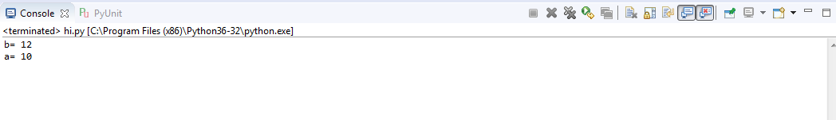

1. Write a program to inherit the parent class (with class method and class variable ) to child class (with class method and class variable) and create the object for child class to access the parent class and child class methods (outside the class ).

class **parent**:

a=10

def **display1**(*self*):

print(*"a="*,*self*.a)

pass

class **child**(parent):

b=12

def **display2**(*self*):

print(*"b="*,*self*.b)

pass

ob=child()

ob.display2()

ob.display1()

print(*"outside"*)

print(*"a"*,ob.a,*"b"*,ob.b)

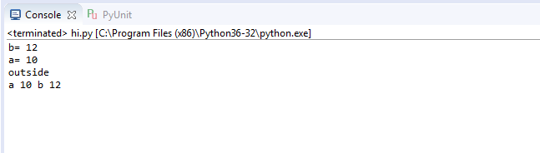

1. Write a program to inherit the parent class (with class method and class variable ) to child class (with class method and class variable) and create the object for child class to access the parent class and child class methods (Access the parent class method from child class method).

class **parent**:

a=10

def **display1**(*self*):

print(*"a="*,*self*.a)

pass

class **child**(parent):

b=12

def **display2**(*self*):

print(*"b="*,*self*.b)

*self*.display1()

pass

ob=child()

ob.display2()

print(*"outside"*)

print(*"a"*,ob.a,*"b"*,ob.b)

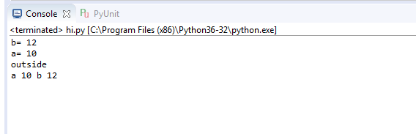

1. Write a program to inherit the parent class (with class method and class variable ) to child class (with class method and class variable) and create the object for child class to access the parent class and child class methods (Access the parent class method and variable from child class method).

class **parent**:

a=10

def **display1**(*self*):

print(*"a="*,*self*.a)

pass

class **child**(parent):

b=12

def **display2**(*self*):

print(*"b="*,*self*.b,*"(A)="*,*self*.a)

*self*.display1()

pass

ob=child()

ob.display2()

