1. Program to print the Factors of a Number N

def **factors**(a):

print(*"The factors of"*,a)

for i in range(1, a+1):

if a% i==0:

print(i)

num=250

factors(num)

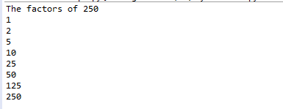

2. Program to check whether given Integer is Prime or Not

print("Enter the input :");  
  
a=int(input());  
count=0  
for i in range(2,a):  
    if(a%i==0):  
        count=1;  
if(count<=0):  
    print("Prime");  
else:  
    print("Not Prime");

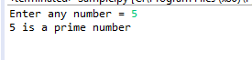

3. Program to print the Prime numbers between two intervals

l = int(input(*"Enter lower range = "*))

u = int(input(*"Enter upper range = "*))

for num in range(l,u + 1):

    if num > 1:

        for i in range(2,num):

            if (num % i) == 0:

                break

            else:

                print(num)

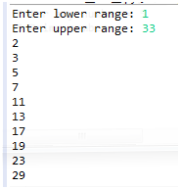

4. Program to check whether the given digit is occurred in a Number

a=*"12456789"*

print(*'1'* in a)

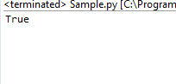

5. Program to count the occurrence of digit

n=int(input(*"Enter number:"*))

count=0

while(n>0):

count=count+1

n=n//10

print(*"The number of digits in the number are:"*,count)



6. Program to find the first digit of a number

num = int(input(*"Please Enter any Number: "*))

first = num

while (first >= 10):

first = first // 10

print(*"The First Digit from a Given Number {0} = {1}"*.format(num, first))

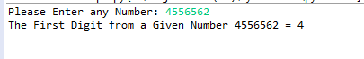

7. Program to print all the numbers which are less than given key element from a given list.

l=[7,2,3,4,5,6,1,8,9,10]

l.sort()

print(l)

print(*"Enter the number"*)

a=int(input())

for i in range(0,a-1):

print(l[i])

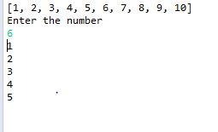

8. Program to find Second Largest element in the list

l=[1,2,3,4,5,6]

a=max(l)

l.remove(a)

print(max(l))



9. Program to find Second smallest element in the list

l=[1,2,3,4,5,6]

a=min(l)

l.remove(a)

print(min(l))



10. Program to delete an element in an list

stu=[1,2,3,4,5,6,7,8,9]

print(stu)

del(stu[2]);

print(stu)



11. Program to Reverse the Elements in list

stu=[1,2,3,4,5,6,7,8,9]

print(stu)

print(stu.reverse());

print(stu)

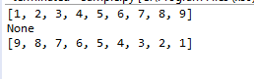

12. Count the occurrences of given Character in a String

str=*'sample'*

print(str)

print(str.count(*'a'*));



13. Covert Lowercase characters to Uppercase Characters

str=*'sample'*

print(str.upper());



14. Covert Uppercase characters to Lowercase Characters

str=*'SAMPLE'*

print(str.lower());



15. Count the number of vowels in given string

str=*"hi im studying in karpagam intitute of technology"*

vowels=0

for i in str:

if(i==*'a'* or i==*'e'* or i==*'i'* or i==*'o'* or i==*'u'*):

vowels=vowels+1

print(*"Number of vowels are:"*)

print(vowels)

