Write the program to execute the following methods and verify the output  
  
calendar(year,w = 2,l = 1,c = 6)  
firstweekday( )  
isleap(year)  
leapdays(y1,y2)  
month(year,month,w = 2,l = 1)  
monthcalendar(year,month)   
monthrange(year,month)  
prcal(year,w = 2,l = 1,c = 6)  
prmonth(year,month,w = 2,l = 1)  
setfirstweekday(weekday)  
timegm(tupletime)  
weekday(year,month,day)

import calendar as c

print(c.calendar(1999,w=2,l=1,c=6))

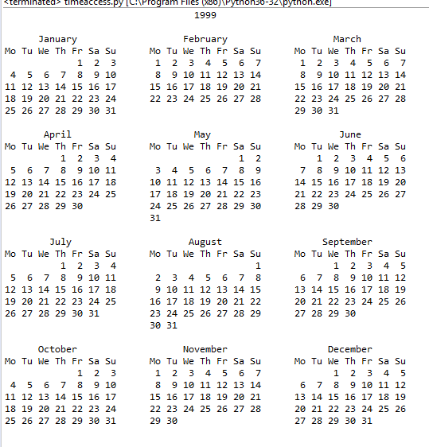

import calendar as c

print(c.firstweekday)

import calendar as c

print(c.isleap(1999))

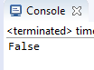

import calendar as c

print(c.leapdays(2000, 2020))



import calendar as c

print(c.month(2019,5,w=2,l=1))

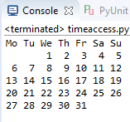

import calendar as c

print(c.monthcalendar(1999,2))

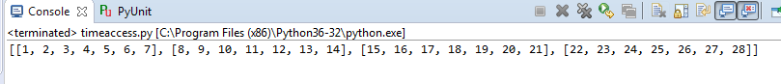

import calendar as c

print(c.monthrange(1999, 2))



import calendar as c

print(c.prcal(1999,w=2,l=1))

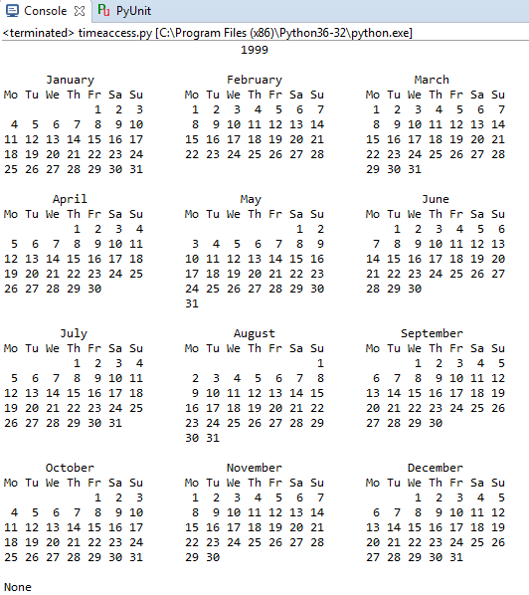

import calendar as c

print(c.prmonth(1999,2,w=2,l=1))

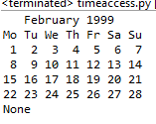

import calendar as c

print(c.setfirstweekday(4))



import calendar as c

print(c.weekday(1999, 8, 29))

