Tell method

f=open(*'F:\\python\\name.txt'*,*'r'*)

print(f.tell())

print(f.read(7))

print(f.tell())

print(f.read(7))

print(f.tell())

print(f.read(7))

f.close()

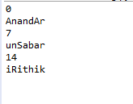

Seek method

f=open(*'F:\\python\\name.txt'*,*'r'*)

f.seek(5)

print(f.tell())

print(f.read(7))

print(f.tell())

print(f.read(7))

print(f.tell())

print(f.read(7))

f.close()

