1. Write a program to execute the following method and verify the output  
time.time( )

time.localtime()

import time as t

print(t.time())

print(t.localtime())



2.

time.altzone   
time.asctime([tupletime])   
time.clock( )   
time.ctime()   
time.gmtime()

time.strptime(str,fmt = '%a %b %d %H:%M:%S %Y') 

import time as t

print(t.asctime())

print(t.altzone)

print(t.clock())

print(t.timezone)

print(t.tzname)

print(t.ctime(25000))

print(t.strptime(*"140-20-5-2019-10-26-30"* ,*"%j-%d-%m-%Y-%H-%M-%S"*))

print(t.gmtime())

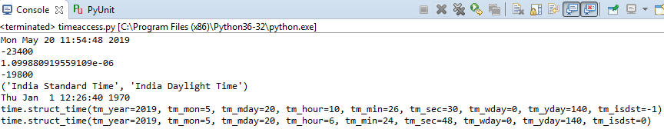

3.

time**.tzset()  
time.sleep(secs**)   
time.mktime(tupletime)

import time as t

print(t.tzname)

l=2019,5,20,1,45,30,1,140,0

print(t.mktime(l))

print(t.sleep(25))



time.strftime(fmt[,tupletime])

import time as t

print(t.strftime(*"%d\*%m\*%Y"*))

