ACADEMIQ (AI-DRIVEN LMS)
MAJOR PROJECT-II
(20SSP65)
Submitted by
ANANDHACHITAN A
21MSS002
Under the Guidance of
Dr. A. SUBHASHINI M.Sc., M.Phil., MCA., Ph.D.,SET.,NET.
Associate Professor
Department of Software Systems
In partial fulfillment of the requirements for the award of the degree of
MASTER OF SCIENCE IN SOFTWARE SYSTEMS
(Five-Years Integrated Programme)
of Bharathiar University

DEPARTMENT OF SOFTWARE SYSTEMS
PSG COLLEGE OF ARTS & SCIENCE
An Autonomous College - Affiliated to Bharathiar University
Accredited with ‘A⁺⁺’Grade by NAAC (4th Cycle)
College with Potential for Excellence
(Status Awarded by the UGC)
Star College Status Awarded by DBT - MST
An ISO 9001:2015 Certified Institution
Coimbatore - 641 014

April 2026

DEPARTMENT OF SOFTWARE SYSTEMS
PSG COLLEGE OF ARTS & SCIENCE
An Autonomous College - Affiliated to Bharathiar University
Accredited with ‘A⁺⁺’Grade by NAAC (4th Cycle)
College with Potential for Excellence
(Status Awarded by the UGC)
Star College Status Awarded by DBT - MST
An ISO 9001:2015 Certified Institution
Coimbatore - 641 014

CERTIFICATE
This is to certify that this project work entitled “AI Recruiter” is a bonafide record of work done by Anandhachitan A (21MSS002) in partial fulfillment of the requirements for the award of Degree of Master of Science in Software Systems (Five Years Integrated Course) of Bharathiar University.

Faculty Guide Head of the Department

Submitted for Viva-Voce Examination held on ____________________

Internal Examiner External Examiner

DECLARATION

I, Anandhachitan A (21MSS002), hereby declare that this Project work entitled “AI Recruiter” is submitted to PSG College of Arts & Science (Autonomous), Coimbatore in partial fulfillment for the award of Master of Science in Software Systems, is a record of original work done by me under the supervision and guidance of Dr. A. Subhashini M.Sc.,M.Phil.,MCA.,Ph.D.,SET.,NET., Associate Professor & Head of the Department, in Department of Software Systems, PSG College of Arts & Science, Coimbatore.
This report has not been submitted by me for the award of any other Degree/ Diploma/Associate ship/ Fellowship or any other similar degree to any other university

Place: Coimbatore Anandhachitan A
Date: 21MSS002

ACKNOWLEDGEMENT
My venture stands imperfect without dedicating my gratitude to a few people who have contributed a lot towards the victorious completion for my project work.
I would like to thank Thiru L. Gopalakrishnan, Managing Trustee, PSG & Sons Charities, for providing me a prospect and surroundings that made the work possible.
I take this opportunity to express my deep sense of gratitude to Dr. T. Kannaian M.Tech.,Ph.D., Secretary, PSG College of Arts & Science, Coimbatore for permitting and doing the needful towards the successful completion of this project.
I express my deep sense of gratitude and sincere thanks to our Principal Dr. D. Brindha M.Sc.,M.Phil.,Ph.D.,MA (Yoga)., for her valuable advice and concern for students. I am very thankful to Dr. M Umarani M.B.A.,M.Phil.,Ph.D., Vice Principal ,for their support towards my project.
I sincerely thank Dr. K.V. Rukmani MCA.,M.E.,Ph.D., Associate Professor and Head of the Department, Department of Software Systems for her wholehearted help to complete this project successfully by giving valuable suggestions.
I convey my heartiest and passionate sense of thankfulness to my project guide
Dr. A. Subhashini M.Sc.,M.Phil.,MCA.,Ph.D., Assistant Professor, Department of Software Systems, for his timely suggestion which enabled me in completing the project successfully.
I express my sincere gratitude to Mr. Sajish Kumar Athra Pulikkal Mohanan,Assistant Manager - Web Development, GIBS - Digital - eCommerce Development, Avantor, Inc., for providing me with valuable guidance, continuous support, and expert insights throughout the development of this project.
This note of acknowledgment will be incomplete without paying my heartful devotion to my parents, my friends, and other people, for their blessings, encouragement, financial support, and the patience, without which it would have been impossible for me to complete the job.

Anandhachitan A
21MSS002

INTERNSHIP OFFER LETTER
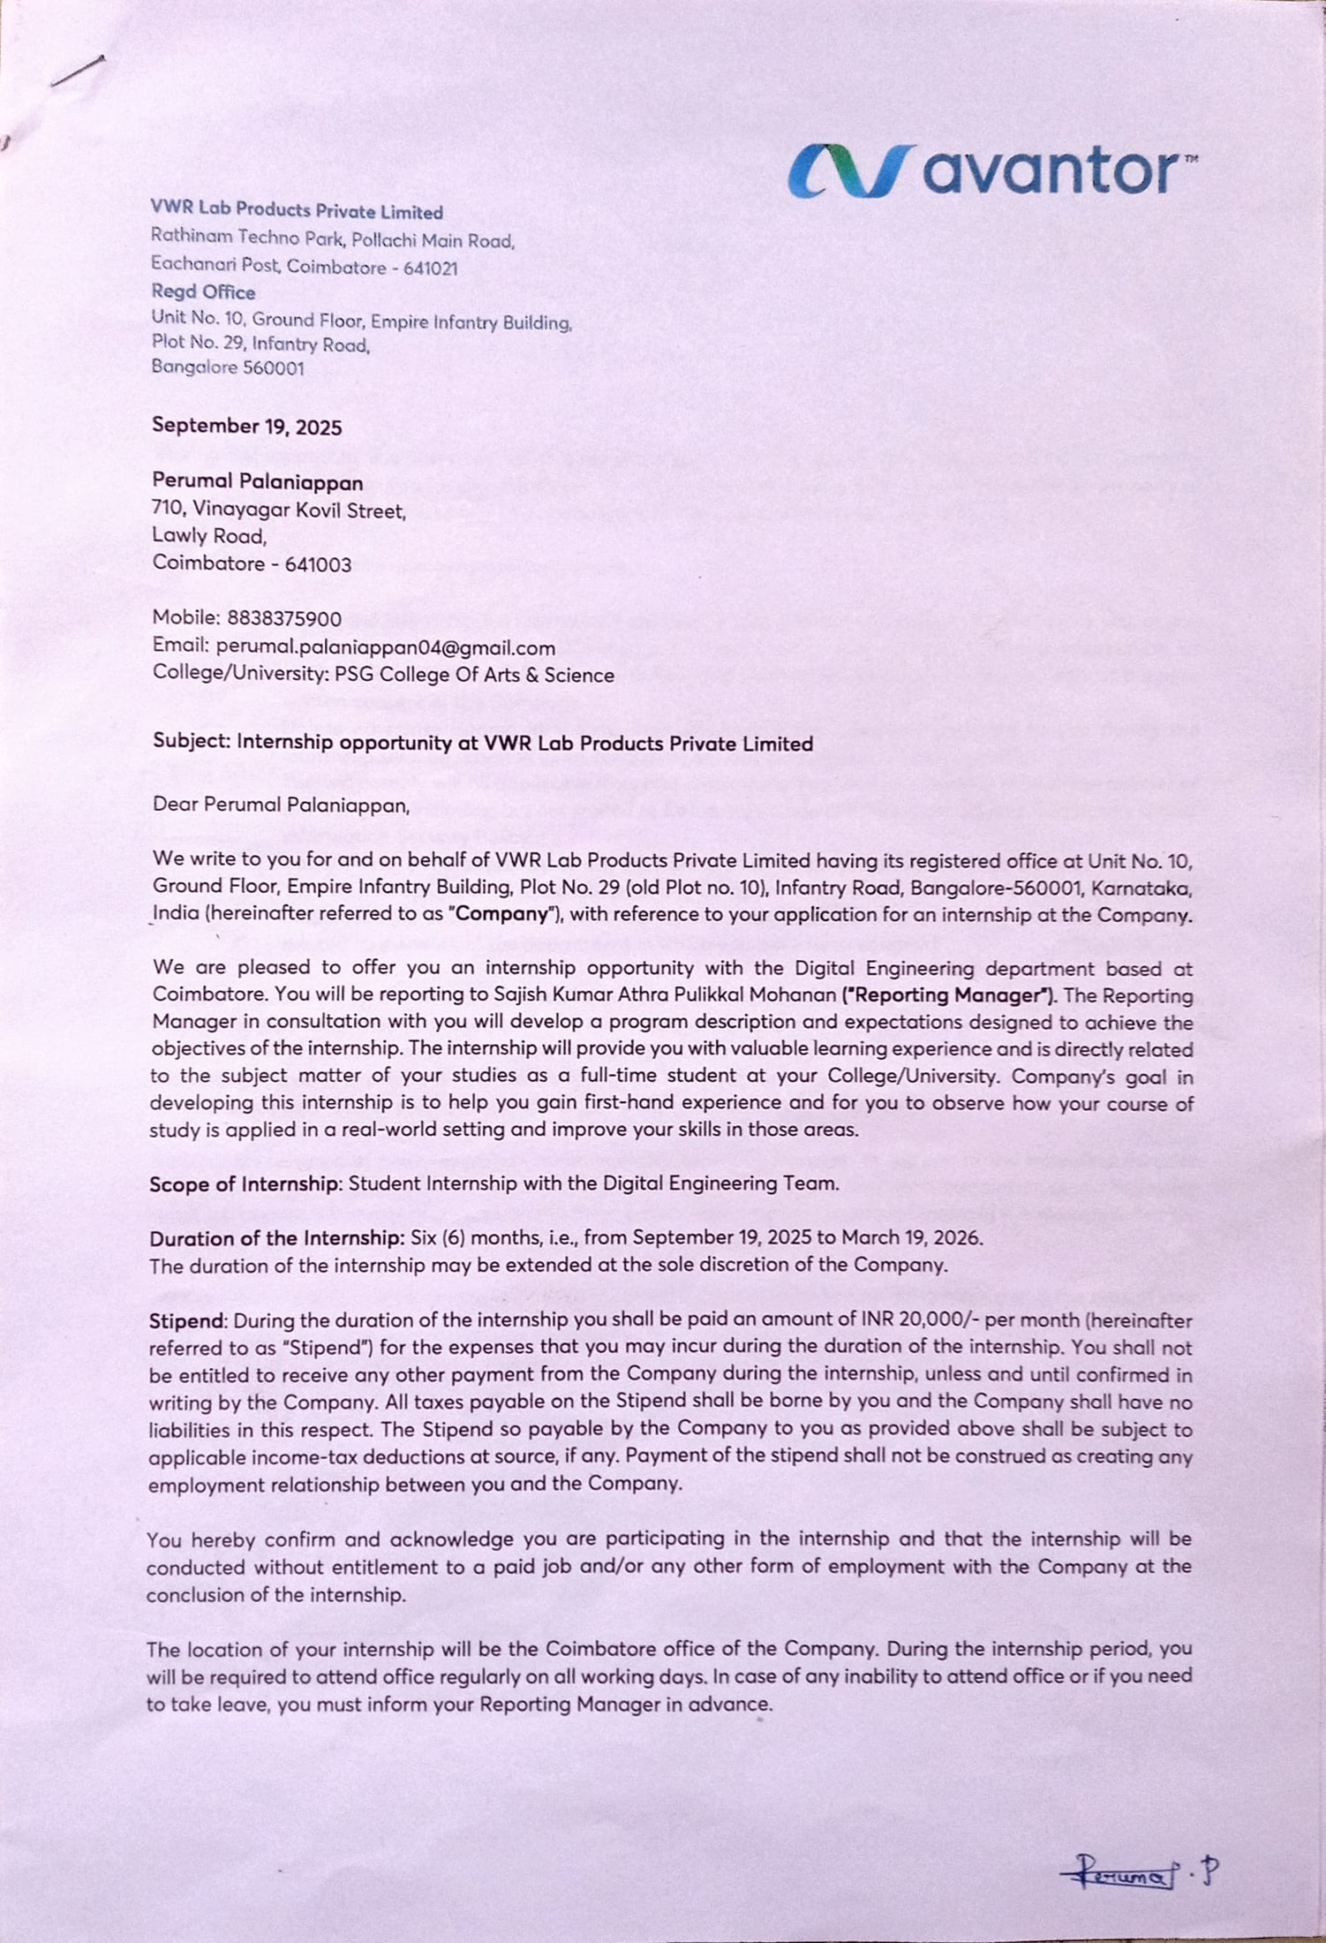

INTERNSHIP COMPLETION LETTER
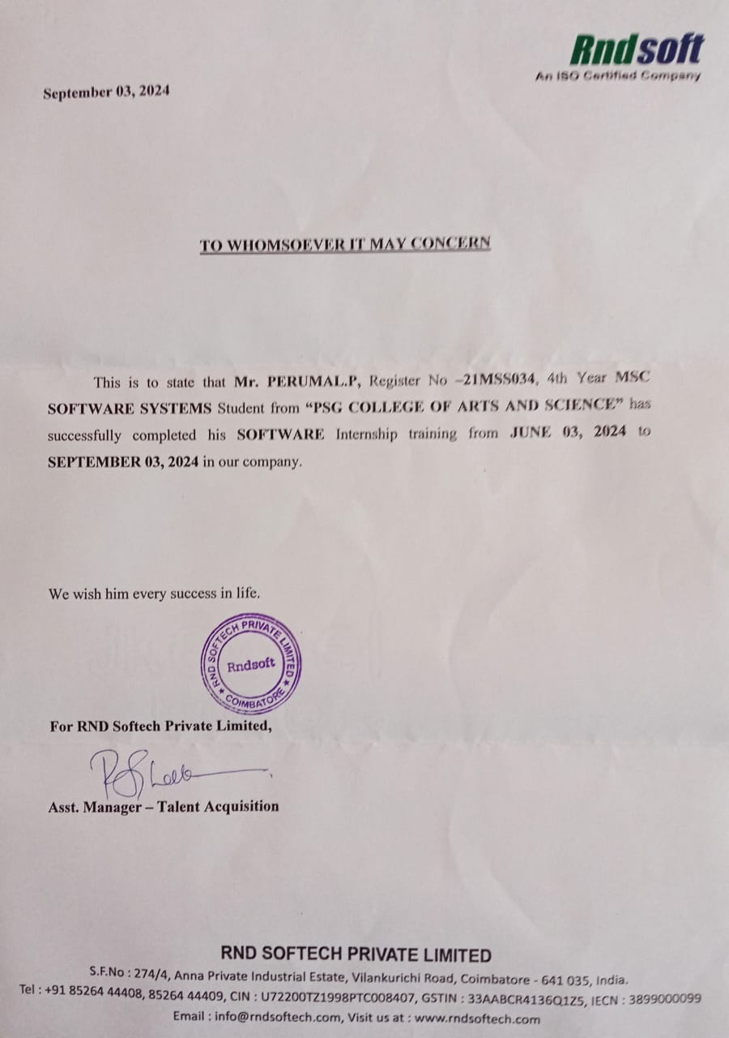

SYNOPSIS
AI Recruiter is an AI‑powered recruitment platform designed to modernize and streamline the hiring process through intelligent automation and a user‑friendly interface. The system integrates modules such as interview scheduling, candidate evaluation, recruiter dashboards, and automated reporting into a single platform. It uses modern frontend technologies like Next.js and Tailwind CSS to deliver a responsive, fast, and seamless experience tailored specifically for recruiters.
The platform incorporates secure authentication through Supabase Google Auth, ensuring frictionless login and secure session management. Recruiters are provided with a dedicated dashboard that centralizes interview creation, candidate tracking, and evaluation reports, enabling structured workflows and controlled access. The backend, powered by Node.js, Express.js, and Supabase’s managed PostgreSQL, efficiently handles candidate data while maintaining scalability, security, and smooth API communication across the system.
A key highlight of AI Recruiter is its integration with advanced AI services such as GPT‑based models for dynamic interview question generation and Vapi for voice agent functionality and speech‑to‑text transcription. These intelligent features enable automated interviews, structured evaluation reports, and personalized candidate feedback. By combining a powerful technical stack with Supabase authentication and smart AI capabilities, AI Recruiter delivers a next‑generation recruitment solution that is efficient, interactive, and adaptable to the evolving needs of modern hiring practices.

TABLE OF CONTENTS

CHAPTER NO | CONTENTS | PAGE  NO
1 | INTRODUCTION
 | 1.1 Company Profile | 1
 | 1.2 Project Overview | 2
 | 1.3 Module Description | 3
2 | SYSTEM ANALYSIS
 | 2.1 Existing System | 5
 | 2.2 Proposed System | 5
3 | SYSTEM CONFIGURATION
 | 3.1 Hardware Specification | 6
 | 3.2 Software Specification | 6
4 | SOFTWARE DESCRIPTION
 | 4.1 Node.js (Backend Runtime Environment) | 7
 | 4.2 Express.js (Web Framework) | 7
 | 4.3 React.js (Frontend Library) | 7
 | 4.4 Tailwind CSS (Styling Framework) | 8
 | 4.5 PostgreSQL (Database Management System) | 8
 | 4.6 Cohere AI (Command-A Model – AI Integration) | 8
5 | SYSTEM DESIGN
 | 5.1 Data Flow Diagram | 9
 | 5.2 Entity Relationship Diagram | 12
 | 5.3 Input Design | 13
 | 5.4 Output Design | 13
6 | SYSTEM IMPLEMENTATION & TESTING | 14
7 | CONCLUSION & FUTURE RECOMMENDATION | 17
 | BIBLIOGRAPHY | 19
 | APPENDIX
 | Screenshots | 20
 | Sample Coding | 24

CHAPTER 1

INTRODUCTION

  - COMPANY PROFILE

Avantor is a global life‑science tools company that supplies mission‑critical products, materials, and services to customers in biopharma, healthcare, education and government, and advanced technologies, operating through a worldwide manufacturing, distribution, and digital network. The VWR brand and the vwr.com channel form a core part of Avantor’s go‑to‑market model, serving customers in over 180 countries and shipping to hundreds of thousands of locations across the globe. These operations are supported by a broad portfolio and a dedicated e‑commerce ecosystem designed to streamline laboratory procurement and services.
In India, VWR functions as Avantor’s channel for laboratory products and services, offering local commercial support and access to the global catalogue through region‑specific portals and contact hubs. This integrated presence connects Indian customers with Avantor’s worldwide supply chain and service standards, ensuring consistent access to laboratory consumables, equipment, chemicals, and related solutions.
The Coimbatore site is publicly referenced as a Global Business Center that supports VWR/Avantor’s back‑end and shared‑services operations, located at Rathinam Techno Park, Eachanari, on Pollachi Main Road. Listings describing the campus identify its role in corporate services and provide local switchboard details, reflecting the site’s position within Avantor’s broader channel and shared‑services strategy. These sources place the facility within the Eachanari/Coimbatore Industrial Estate area and highlight its growth as part of VWR’s India footprint.

1.1.1 CONTACT
Company: VWR Lab Products Private Limited (VWR, part of Avantor) Coimbatore
Address: Rathinam Techno Park, Eachanari (PO), Pollachi Main Road, Coimbatore, Tamil Nadu 641021, India
Phone: +91 422 434 3300

PROJECT OVERVIEW

AI Recruiter is an AI‑driven recruitment platform developed to transform hiring workflows through automation, intelligent assistance, and a modern recruiter‑centric interface. The platform enables seamless management of interviews, candidate evaluations, feedback reports, and recruiter dashboards within a single system. Built with Next.js and Tailwind CSS on the frontend and powered by Node.js, Express.js, and Supabase on the backend, AI Recruiter ensures a smooth, scalable, and secure environment for digital recruitment. It supports authentication through Supabase Google Auth, offering a secure and frictionless login experience while enforcing structured access for recruiters.
A highlight of AI Recruiter is its integration of advanced AI services such as GPT‑based models for dynamic interview question generation and Vapi for voice agent capabilities and speech‑to‑text transcription. These intelligent features enable automated interviews, structured evaluation reports, and personalized candidate feedback. By combining a robust technical stack with Supabase authentication and smart AI capabilities, AI Recruiter delivers an innovative recruitment solution that enhances productivity, reduces manual workload, and supports modern hiring needs with efficiency and intelligence.

1.3 MODULE DESCRIPTION

Authentication & User Access Module
This module handles secure login through traditional credentials as well as OAuth providers like Google and GitHub. Users select their role during registration, and the system automatically assigns permissions and redirects them to their respective dashboards. It ensures proper session handling, protected routes, and secure access control for all roles.
1.3.1 STUDENT MODULES
- Student Dashboard Module
The student dashboard displays personalized learning insights such as total courses, generated notes, flashcards, and quiz status. It provides quick access to AI tools and recently viewed courses, helping students resume their learning seamlessly. A visual activity graph highlights their weekly learning performance.

Explore Courses & Learning Module
Students can browse and enroll in courses categorized by subject and difficulty. Each course provides structured modules, downloadable resources, and lesson‑wise content. The module ensures smooth navigation through the entire learning journey.

AI Notes Generator Module
Students can generate instant notes on any topic using Cohere Command‑A by selecting difficulty and content preferences. The generated notes are neatly structured for learning and revision. Recent generations are stored for quick future reference.

AI Flashcards Generator Module
This module allows students to create topic‑based flashcards by selecting difficulty levels and card count. The AI generates concise, easy‑to‑remember flashcards to support faster revision. Students can save and reuse flashcards anytime.
- Quiz Module
Students can attempt quizzes assigned by instructors, categorized into Pending, Completed, and New. Each quiz displays the number of questions and instructor details before starting. After submission, students can view scores and track their quiz performance history.

1.3.2 INSTRUCTOR MODULES

Instructor Dashboard Module
The instructor dashboard highlights metrics like total courses created, enrolled students, and quizzes assigned. A graphical overview shows how students interact with the instructor’s content. Shortcut buttons allow quick creation of courses and quizzes.

Course Creation & Management Module
Instructors can create structured courses with banners, objectives, and multi‑module content. They can also specify special features like certificates or downloadable PDFs. All created courses can be edited, published, or managed from the “My Courses” section.

Quiz Creation & Management Module
This module enables instructors to create quizzes with various question types such as MCQs and checkboxes. Instructors can set titles, instructions, and publish quizzes to students. They can also track quiz status (Pending/Accepted) and edit them when needed.
1.3.3 SUPERADMIN MODULES

SuperAdmin Dashboard Module
The SuperAdmin dashboard provides platform‑wide analytics such as total users, courses, quizzes, and recent registrations. Graphs visualize user growth and platform activity in real time. It also includes quick controls for managing users, courses, and quizzes.

User Management Module
SuperAdmins can view all platform users, update their roles, or remove inactive accounts. This module ensures only authorized individuals have access to sensitive or creation-based features. It maintains the overall stability and integrity of the platform.

Course & Quiz Oversight Module
SuperAdmins can review all courses and quizzes, ensuring quality and compliance with platform guidelines. They can adjust visibility, monitor instructor activity, and maintain content standards. This module ensures smooth academic workflow across the system.
1.3.3 GLOBAL MODULE

Settings & Account Management Module
Users can update personal information, modify passwords, and switch between light and dark themes. The settings area centralizes all customization options for better user control. It also contains a “Danger Zone” that allows users to permanently delete their accounts.

CHAPTER 2

SYSTEM ANALYSIS

EXISTING SYSTEM

The current recruitment processes rely heavily on manual scheduling, interviewer availability, and subjective evaluation, which increases time consumption and reduces efficiency. Many hiring platforms lack integrated AI features, forcing recruiters to depend on external tools for conducting interviews, transcribing responses, and generating evaluation reports. Authentication systems in traditional recruitment applications are often basic and do not provide seamless integration with modern authentication providers. Monitoring and analytics tools are limited, restricting visibility into candidate performance and overall recruitment activity. Recruiters usually do not have access to automated assistants for conducting interviews or generating structured feedback, resulting in repetitive tasks and inconsistent evaluation standards.

PROPOSED SYSTEM
AI Recruiter introduces an AI‑powered recruitment platform that automates key hiring processes such as interview scheduling, voice‑enabled interviews, and structured evaluation reporting using GPT models and Vapi for voice agent and speech‑to‑text transcription. The system integrates secure and modern authentication through Supabase Google Auth, ensuring seamless access and enhanced security. A recruiter‑centric dashboard is implemented, offering centralized control over interview creation, candidate tracking, and feedback management to streamline workflow. Recruiters can efficiently generate dynamic interview questions, conduct automated voice interviews, and receive AI‑driven evaluation reports, reducing manual workload and improving consistency.
The platform also provides advanced analytics and monitoring tools, enabling recruiters to gain insights into candidate performance and overall hiring activity. By combining structured workflows, intelligent automation, and modern web technologies, AI Recruiter enhances productivity, reduces bias, and delivers a next‑generation recruitment solution tailored to the evolving needs of digital hiring.

CHAPTER 3

SYSTEM CONFIGURATION

HARDWARE SPECIFICATION

COMPONENTS REQUIREMENTS

- Processor : Intel Core i3 (10th Gen) / AMD Ryzen 3
- Hard Disk : 256 GB SSD
- RAM : 8 GB
- System Type : 64-bit operating system, x64-based processor
- Keyboard : Standard 104‑key keyboard
- Mouse : Optical Mouse

SOFTWARE SPECIFICATION

COMPONENTS REQUIREMENTS
- Operating System : Windows 10 / Windows 11
- Frontend Development Tools : Next.js, Tailwind CSS
- Backend Development Tools : Node.js, Express.js
- Database & Authentication : Supabase (PostgreSQL + Google Auth)
- AI Integration : GPT-4o, Vapi
- Version Control : Git & GitHub
- Execution Environment : Visual Studio Code
- Browser : Google Chrome / Microsoft Edge

CHAPTER 4

SOFTWARE DESCRIPTION

Node.js (Backend Runtime Environment)

Node.js is a high‑performance JavaScript runtime built on Chrome’s V8 engine, enabling fast and non-blocking backend server execution. It is widely used to develop REST APIs, handle asynchronous processes, and support scalable server-side logic. Node.js integrates seamlessly with npm (Node Package Manager), allowing developers to install thousands of libraries for authentication, routing, database connectivity, and more. Its event‑driven architecture ensures efficient handling of multiple client requests.

Express.js (Web Framework)
Express.js is a lightweight and flexible Node.js framework used to build backend APIs and routing structures. It simplifies server creation, middleware management, and request handling, making development faster and more organized. In AI Recruiter, Express.js powers secure routing, authentication middleware, and integration with Supabase and Vapi services. Its modular structure enables maintainable and clean backend code, ensuring recruiters can reliably access dashboards, candidate data, and AI‑driven interview features.
  - Next.js (Frontend Library)
Next.js is a powerful React‑based framework that enables server‑side rendering (SSR), static site generation (SSG), and optimized routing for modern web applications. It improves performance, SEO, and scalability by pre‑rendering pages and delivering fast, interactive experiences. In AI Recruiter, Next.js is used to build recruiter dashboards, interview creation forms, and evaluation report pages with seamless navigation and responsive layouts. Its integration with Supabase APIs and AI services ensures recruiters experience smooth workflows and real‑time updates during the hiring process.

Tailwind CSS (Styling Framework)
Tailwind CSS is a utility‑first CSS framework that enables rapid and responsive UI development. It eliminates the need for writing large CSS files by providing pre‑built classes that can be applied directly within JSX components. Tailwind helps create clean, modern, and mobile‑friendly designs throughout the recruiter interface. It also supports full customization through configuration files for colors, spacing, typography, and themes, ensuring AI Recruiter maintains a consistent and professional look across devices.

Supabase (Database & Authentication Platform)
Supabase is an open‑source backend‑as‑a‑service built on PostgreSQL, providing managed database storage, authentication, and real‑time APIs. In AI Recruiter, Supabase handles secure recruiter authentication via Google Auth and manages candidate data, interview logs, and evaluation reports. Its integration with Express.js ensures smooth API communication, while its scalable infrastructure supports reliable data storage and retrieval. Supabase simplifies backend operations by combining database management and authentication into a single platform.
4.6 GPT‑4o & Vapi (AI Integration)
GPT‑4o powers intelligent recruitment tools such as dynamic interview question generation, candidate evaluation, and automated feedback reporting. It delivers accurate, context‑aware outputs based on recruiter preferences and candidate responses. Vapi provides voice agent functionality and speech‑to‑text transcription, enabling AI Recruiter to conduct automated voice interviews and convert candidate answers into structured text for analysis. Together, GPT‑4o and Vapi automate critical recruitment tasks, reduce manual workload, and enhance the overall efficiency of the hiring process.

CHAPTER 5

SYSTEM DESIGN

DATA FLOW DIAGRAM
A data flow diagram (DFD) is a graphical representation of the “flow” of data through an information system. DFD can also be used for the visualization of data processing. The purposes of DFD are as follows:
    - To show the scope and boundaries of a system.
    - To show that the whole system has been considered.
    - May be used as a communication tool between a system analyst and any person who plays a part in the system.
    - To act as the starting point for redesigning a system.

The representation used to frame a data flow diagram is:

      - The circle represents the process. It shows the pair of processes that transform input to output.

      - The arrow represents the graphical flow into or out of the
process.

      - The terminator represents external entities with system communication.

- The store is used to model a collection of data packets at rest.

Level 0:

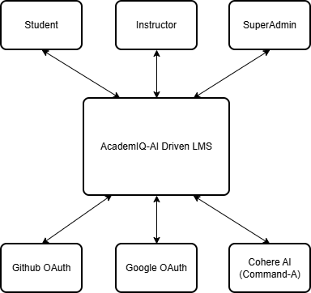

Figure 5.1.1 Level 0 DFD

Level 1:

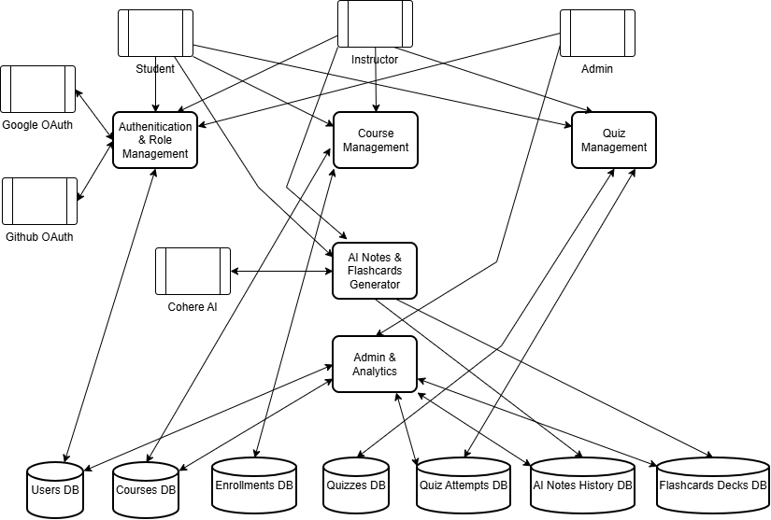

Figure 5.1.2 Level 1 DFD

5.2 ENTITY RELATIONSHIP DIAGRAM
An Entity Relationship Diagram (ERD) is a specialized graphic that illustrates the relationship between entities in a database. It is a data modeling technique that graphically illustrates an information system’s entities and the relationships between those entities.
An ERD is a conceptual and representational model of data used to represent the entity framework infrastructure.

The elements of an ERD are:
    - Entities

    - Relationship

    - Attributes

      - The diamond is used to represent relationships

      - The box is used to represent the entities

      - The oval is used to represent the attributes

      - The line is used to represent the flow

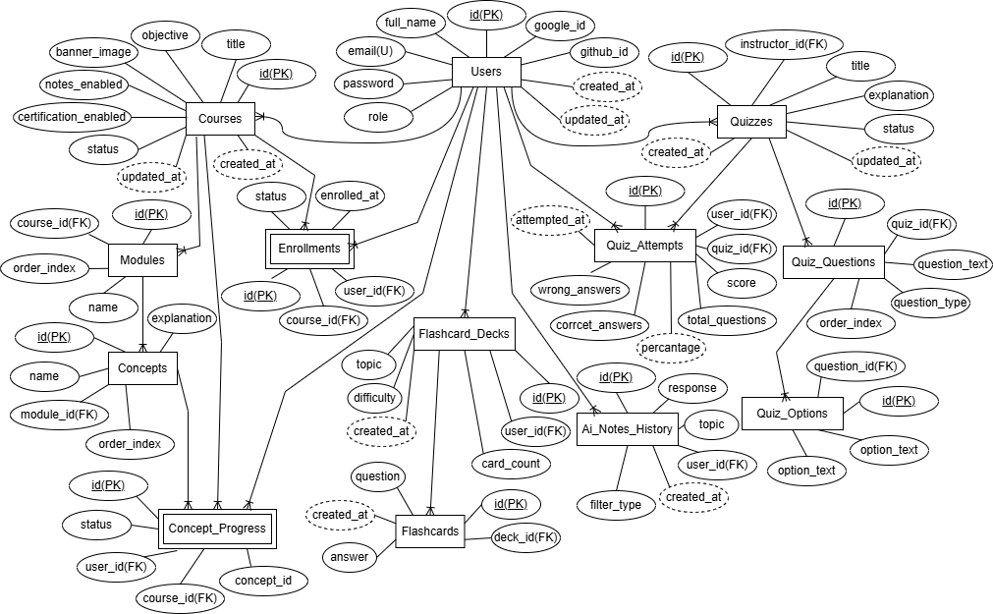

Figure 5.2.1 Entity Relationship Diagram

5.3 INPUT DESIGN
The input design of AI Recruiter focuses on creating a structured, user‑friendly, and secure method for capturing all necessary information from recruiters during the hiring process. It ensures that each form such as login, interview creation, candidate details entry, and question generation collects accurate data through validated fields and guided input patterns. The system uses dropdowns, text fields, date/time pickers, and file upload controls to simplify data entry while minimizing user errors. Proper client‑side and server‑side validation ensures that inputs such as candidate information, interview parameters, and authentication credentials are processed reliably. Overall, the input design guarantees a smooth and accurate data flow into the system, supporting both usability and data integrity for recruiters.

OUTPUT DESIGN
The output design of AI Recruiter delivers clear, interactive, and visually organized results to recruiters through dashboards, analytics charts, interview reports, and AI‑generated evaluations. Information is presented in a structured layout using cards, tables, and formatted content to help recruiters easily understand candidate performance and interview outcomes. Recruiters view interview schedules, candidate responses, evaluation scores, and AI‑generated feedback summaries, all displayed in real time. The system also provides structured reports that can be exported or shared, ensuring recruiters have actionable insights for decision‑making. This output design ensures that system responses are meaningful, accessible, and reliable, enabling recruiters to conduct efficient and data‑driven hiring processes.

CHAPTER 6
SYSTEM IMPLEMENTATION AND TESTING

SYSTEM IMPLEMENTATION
The implementation of AI Recruiter involved building a complete AI‑powered recruitment platform using a structured and modular development approach. The frontend was developed using Next.js and Tailwind CSS, enabling server‑side rendering, dynamic page generation, smooth navigation, and consistent UI components across recruiter dashboards, interview creation forms, candidate tracking pages, and analytics screens. Every recruiter interaction from login to interview scheduling was mapped into responsive components to ensure seamless experience on different devices.
On the backend, Node.js and Express.js were used to build secure REST APIs responsible for authentication, interview management, candidate data handling, evaluation reporting, and AI services. Supabase was chosen as the database and authentication provider because of its managed PostgreSQL structure and built‑in support for Google Auth. Supabase efficiently manages entities such as recruiters, candidates, interviews, questions, and evaluation reports. Proper relational mapping and optimized queries ensured fast data retrieval, even with multiple interconnected tables.
AI integration was implemented using OpenRouter with GPT‑4 mini for dynamic interview question generation, candidate evaluation, and automated feedback reporting. In addition, Vapi was integrated to provide voice agent functionality and speech‑to‑text transcription, enabling the system to conduct automated voice interviews and convert candidate responses into structured text for analysis. Supabase authentication with Google login was added to simplify recruiter onboarding and enhance security. Each recruiter module was implemented with route protection, ensuring that only authorized users could access sensitive features

6.2 SOFTWARE TESTING
Testing is a process, which reveals errors in the program. It is the major quality measure employed during software development. During testing, the program is executed with a set of conditions known as test cases, and the output is evaluated to determine whether the program is performing as expected.
The process of testing the functionality and correctness of software by running it is called software testing. It is the process of executing a program with the intent of finding an error. A good test case has a high probability of finding an undiscovered error. Software testing is usually performed for two main reasons:
    - Defect detection
    - Reliability estimation.

6.2.1 Functional Testing
Functional testing was performed to verify that every feature works according to the system requirements. All major modules authentication, interview scheduling, candidate data entry, question generation, voice interview handling, and evaluation reporting were executed and validated. Each screen and API was tested to ensure accurate input processing and correct output generation. This guaranteed that recruiter actions such as creating interviews, viewing reports, and managing candidate details functioned smoothly without errors.

6.2.2 Integration Testing
Integration testing ensured proper communication between the frontend, backend, database, and AI services. Next.js components were tested against Express APIs to confirm that data was transmitted and received correctly. Supabase interactions, such as storing candidate details, retrieving interview logs, and updating evaluation reports, were validated thoroughly. This testing confirmed that combined modules worked together as a unified system.

6.2.3 User Interface (UI) Testing
User interface testing checked the consistency, responsiveness, and clarity of all screens such as recruiter dashboards, interview creation forms, and evaluation report pages. The UI was validated across different screen sizes to ensure that layouts, buttons, forms, and navigation elements displayed properly. This testing confirmed that the design was intuitive and user‑friendly for recruiters.

6.2.4 Security Testing
Security testing focused on access protection, token validation, and route restrictions. Routes were tested to ensure unauthorized users could not access recruiter dashboards or sensitive data. Input validation was checked to prevent invalid data submission. Supabase authentication with Google login was tested to confirm secure handling of recruiter sessions..

6.2.5 User Acceptance Testing (UAT)
User acceptance testing involved navigating through the entire system like a real recruiter to validate usability and end-to-end functionality. All workflows login, creating interviews, generating questions, conducting voice interviews, and viewing evaluation reports were executed in real conditions. This testing confirmed that the system meets recruiter expectations and provides a smooth, reliable experience.

CHAPTER 7

CONCLUSION & FUTURE RECOMMENDATION

7.1 CONCLUSION
AI Recruiter demonstrates how modern web development and artificial intelligence can come together to create a practical and effective recruitment platform. The system integrates a responsive user interface with reliable server-side services and a well-structured relational database so that every feature works smoothly from recruiter login and authentication to interview scheduling, candidate evaluation, and analytics. The inclusion of OpenRouter GPT-4 mini for generating interview questions and structured feedback, combined with Vapi’s voice agent and speech-to-text transcription, reduces manual effort for recruiters and provides faster access to consistent evaluation reports. Supabase authentication ensures secure access, while the recruiter-centric dashboard delivers the right tools and views to simplify daily hiring operations.
Through careful implementation and systematic testing, the platform has proven to be stable, secure, and ready for real usage. Functional checks verified that every workflow behaves as intended. Integration checks validated data flow across the client, the server, the database, and external AI services. Interface checks confirmed that pages are clear and consistent across devices. The overall outcome is a dependable recruitment system that improves hiring productivity, supports structured candidate evaluation, and gives recruiters clear visibility and control. AI Recruiter provides a solid foundation for future extensions such as richer analytics, multilingual interview support, ATS (Applicant Tracking System) integration, and deeper automation of recruitment workflows.

7.2 FUTURE RECOMMENDATION
- Advanced Candidate Analytics and Predictive Insights
Future versions can include deeper analytics such as prediction of candidate success, identification of skill gaps, and automated insights for recruiters. This would help in making data‑driven hiring decisions and improve the accuracy of candidate selection.
- Real-Time Virtual Interview Rooms
A live interview module can be added where recruiters conduct real‑time sessions using video streaming and integrated voice agents. Features such as attendance tracking, live chat, and interactive evaluation notes would further strengthen the recruitment environment.
- Adaptive Question Generation
The system can be enhanced with adaptive AI algorithms that analyze candidate responses and automatically adjust the difficulty or type of interview questions. This would help personalize the interview experience and provide recruiters with more accurate assessments.
- Enhanced Candidate Identity Verification
Future versions can include advanced security features such as mandatory ID proof submission and automated face matching against passport‑size photos. This would help recruiters verify candidate authenticity, reduce impersonation risks, and ensure that only genuine applicants participate in interviews.
- AI-Usage Detection During Interviews
The system can be expanded with mechanisms to identify whether candidates are relying on external AI tools to answer questions. By analyzing response patterns, timing, and consistency, recruiters can gain insights into the originality of candidate answers and ensure fair evaluation.
- Eye-Tracking for Focus Validation
Future improvements can include lightweight eye-tracking technology that monitors whether candidates maintain focus on the camera for 3–4 seconds during interviews. This feature would help detect distractions such as switching to other tabs or using mobile devices, ensuring that candidates remain attentive and engaged throughout the session.

BIBLIOGRAPHY
The following books and websites were referred to during the analysis and execution phase of the project.

WEBSITE REFERENCE
- Tailwind Labs. (2024). Tailwind CSS Documentation. Retrieved from https://tailwindcss.com/docs
- Node.js Foundation. (2024). Node.js Documentation. Retrieved from https://nodejs.org/en/docs
- Express.js. (2024). Express – Fast, unopinionated, minimalist web framework for Node.js. Retrieved from https://expressjs.com/
- Supabase. (2025). Supabase Documentation – Authentication, Database, and APIs. Retrieved from https://supabase.com/docs
- Next.js. (2024). Next.js Documentation – React Framework for Production. Retrieved from https://nextjs.org/docs
- Google Developers. (2024). Google Identity: OAuth 2.0 for Web Server Applications. Retrieved from https://developers.google.com/identity/protocols/oauth2
- OpenRouter. (2025). OpenRouter API Reference – GPT Models. Retrieved from https://openrouter.ai/docs
- Chart.js. (2024). Chart.js Documentation. Retrieved from https://www.chartjs.org/docs/latest/
- Vapi. (2025). Vapi Documentation – Voice Agent and Speech-to-Text APIs. Retrieved from https://docs.vapi.ai

APPENDIX

SCREENSHOTS

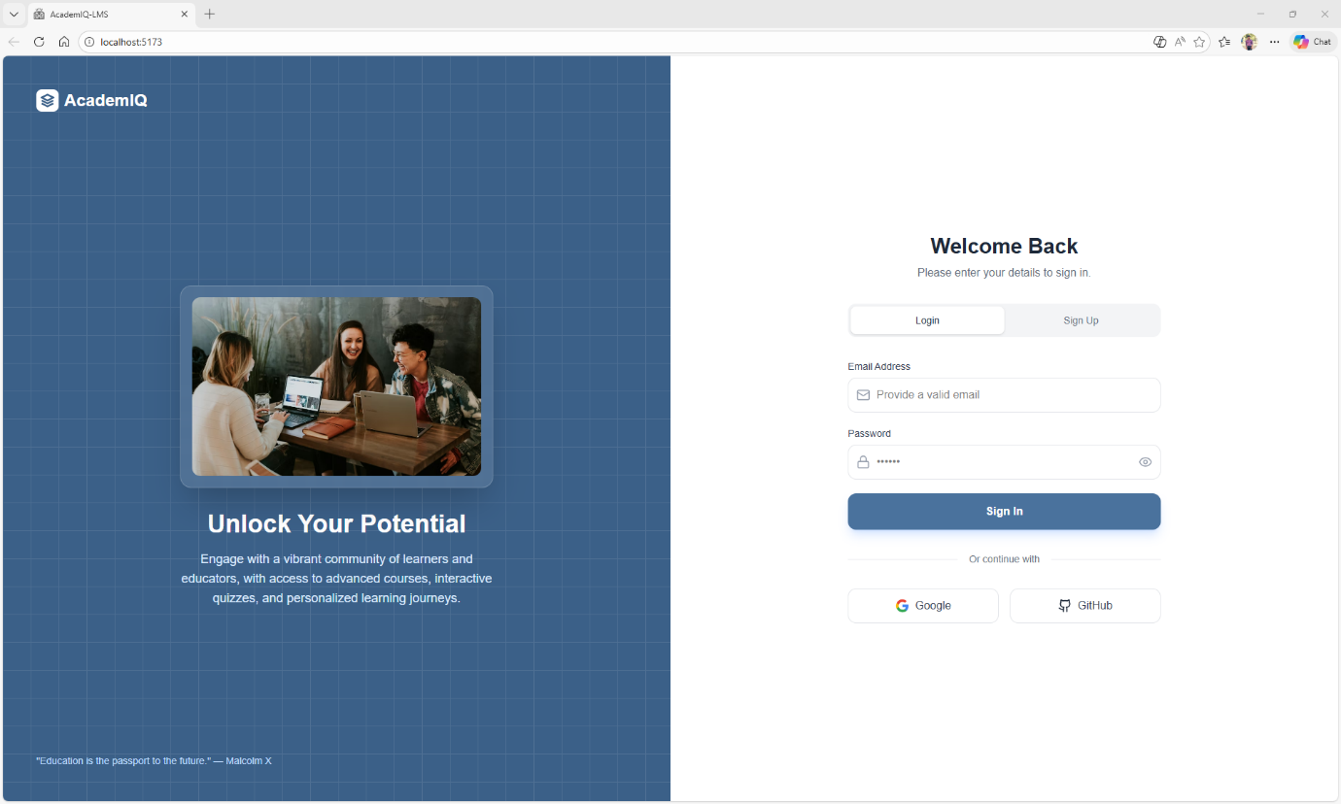
Figure. Login Page

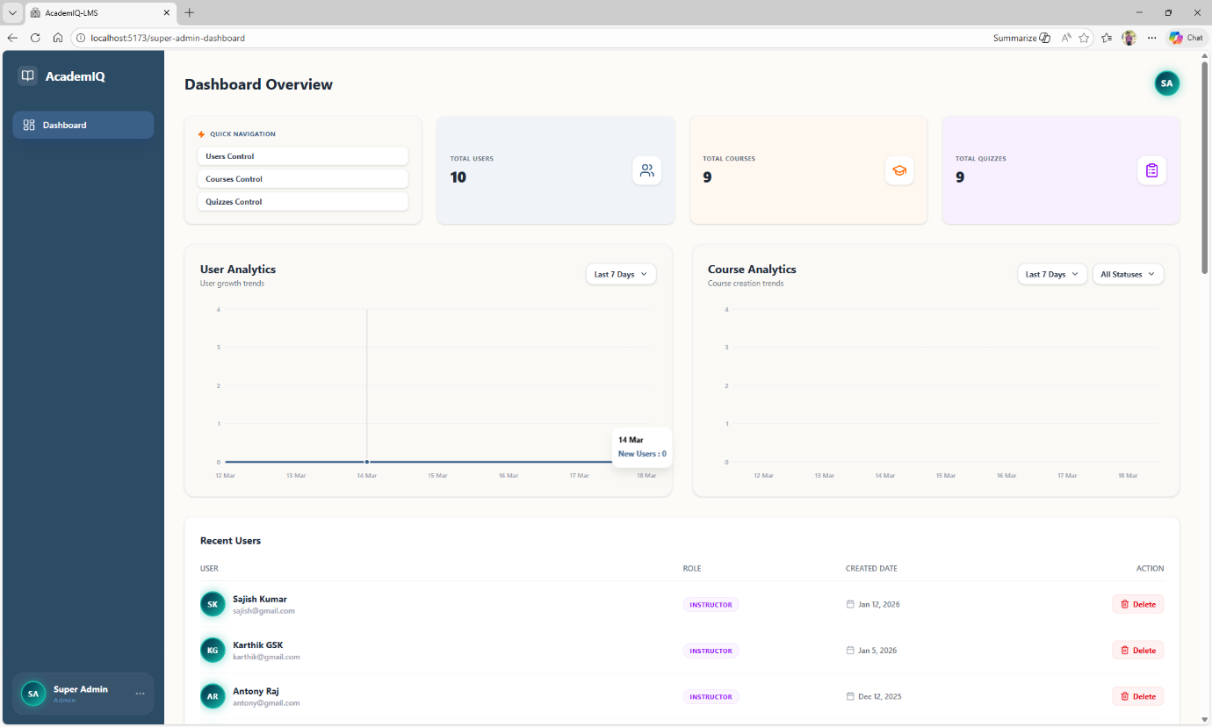
Figure. Admin Control Page

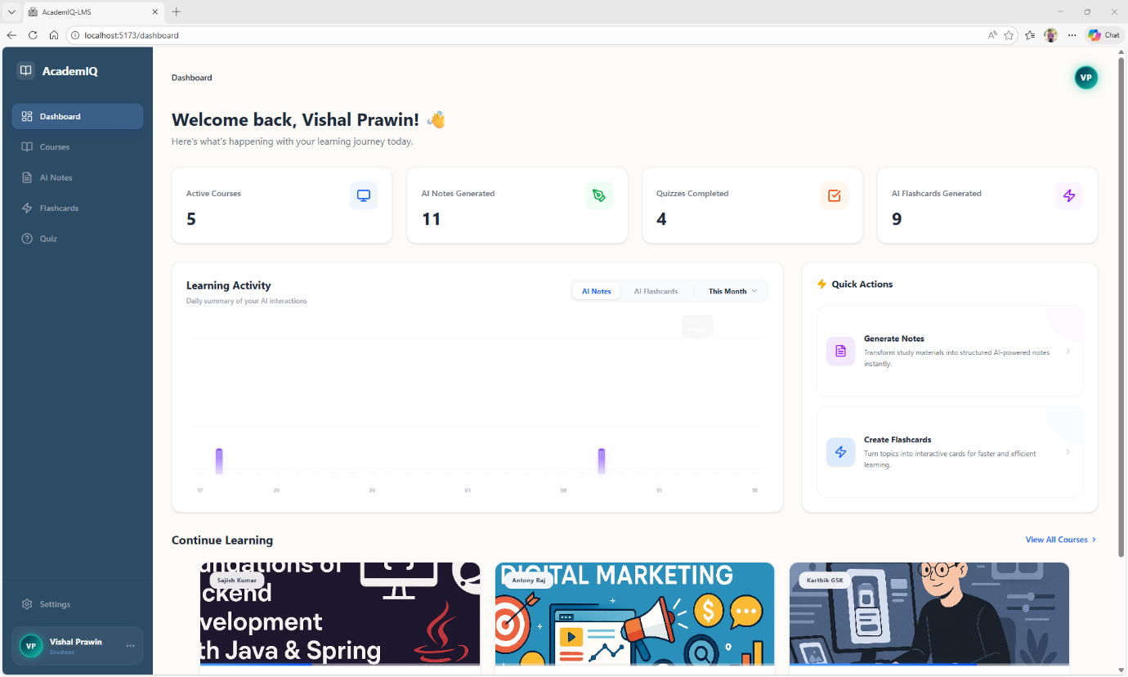
Figure. Dashboard Page

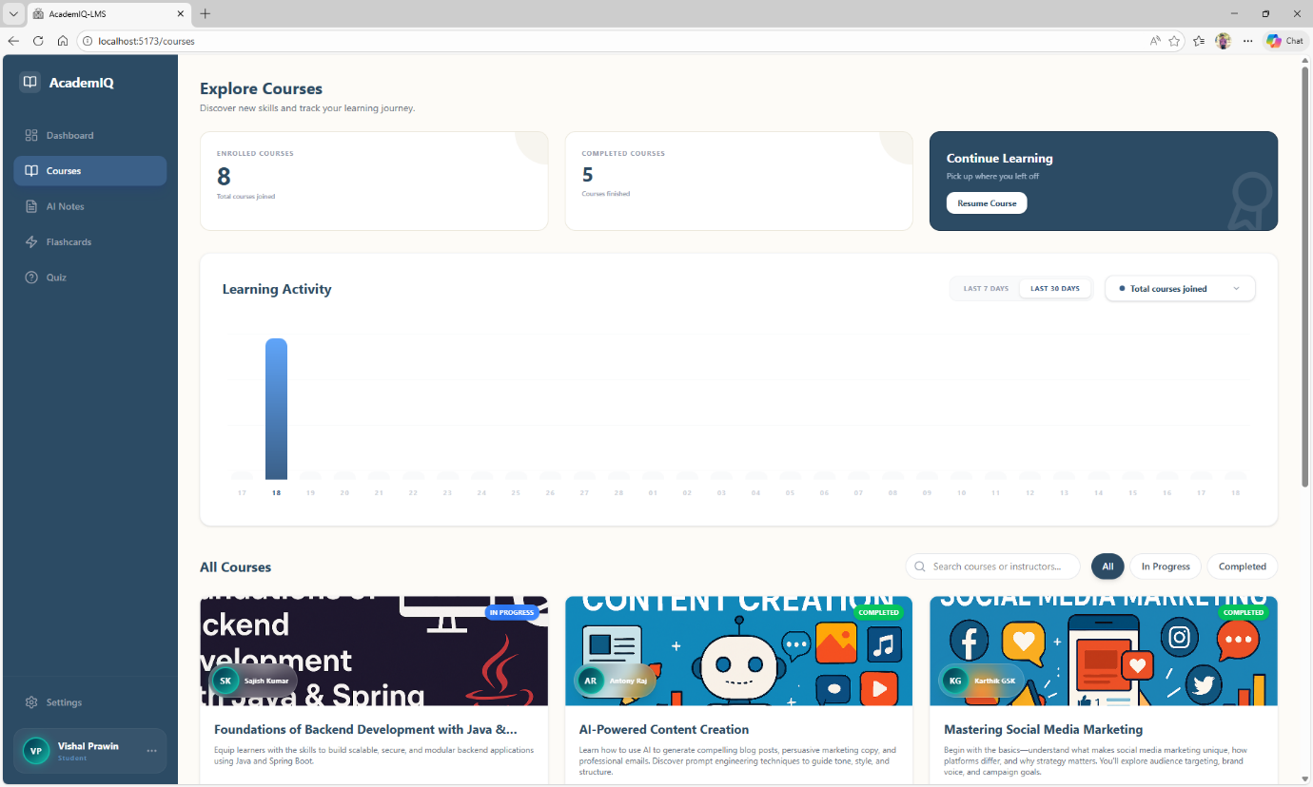
Figure. Courses Page

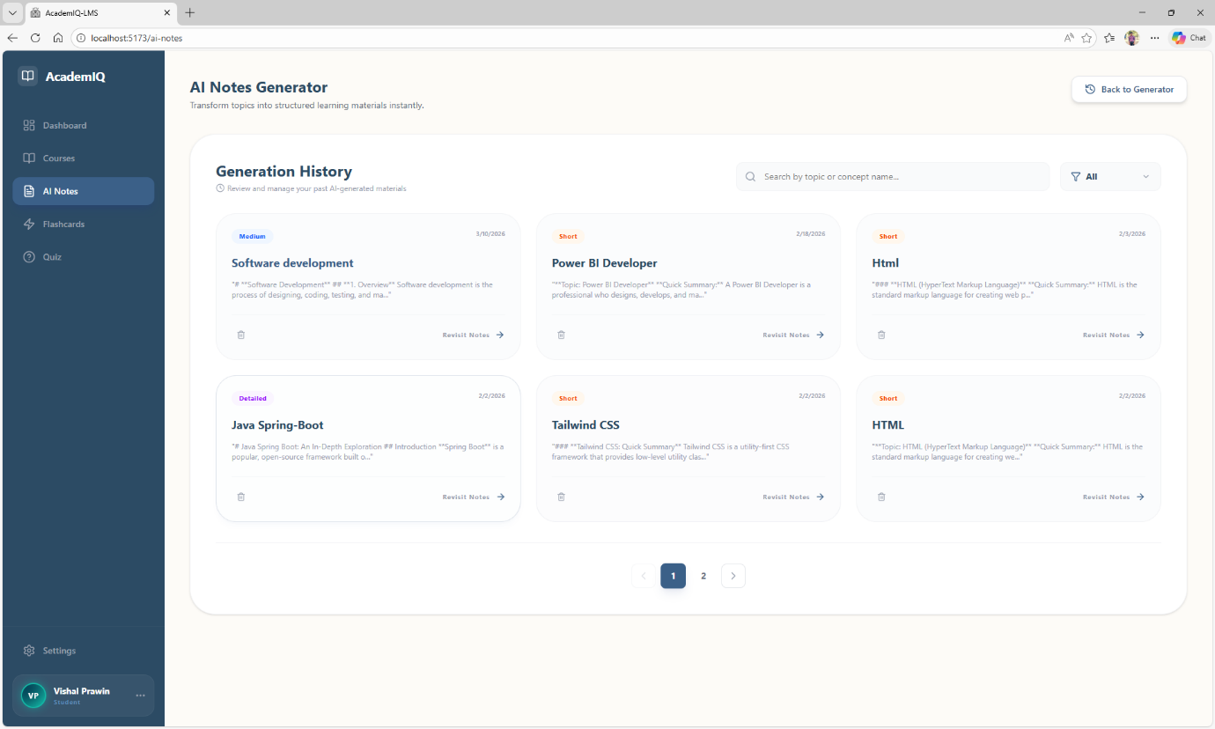
Figure. AI Notes Generation Page

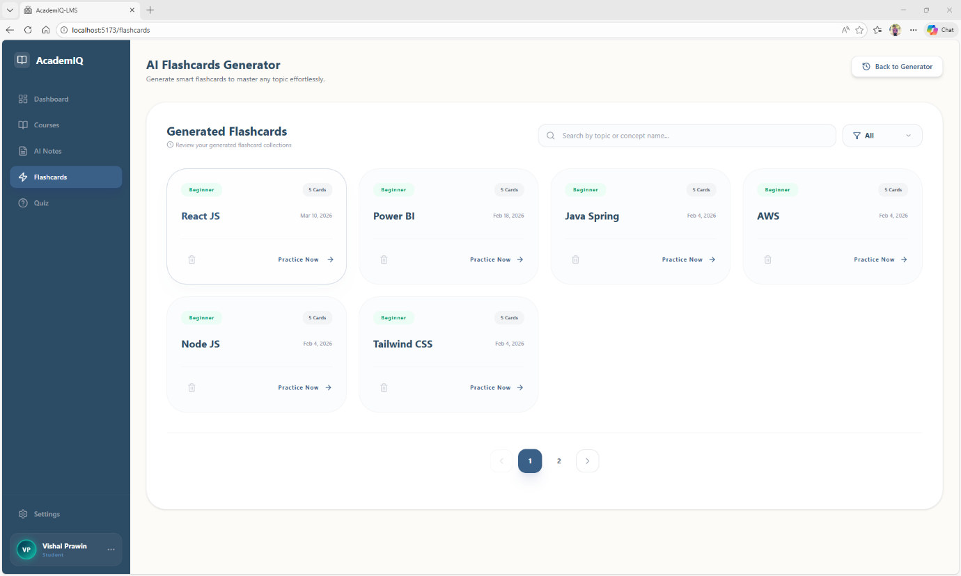
Figure. AI Flashcards Page

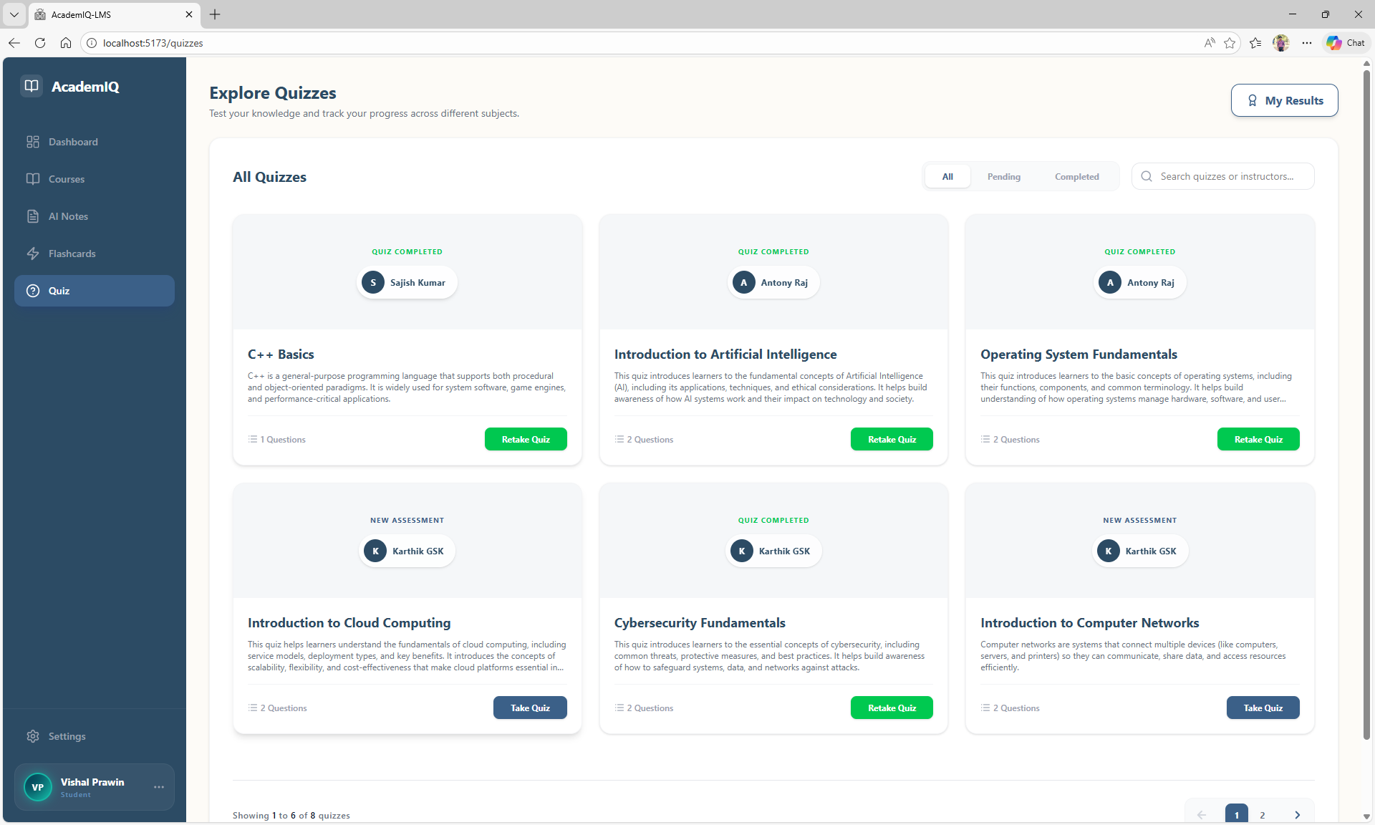
Figure. Quizzes Page

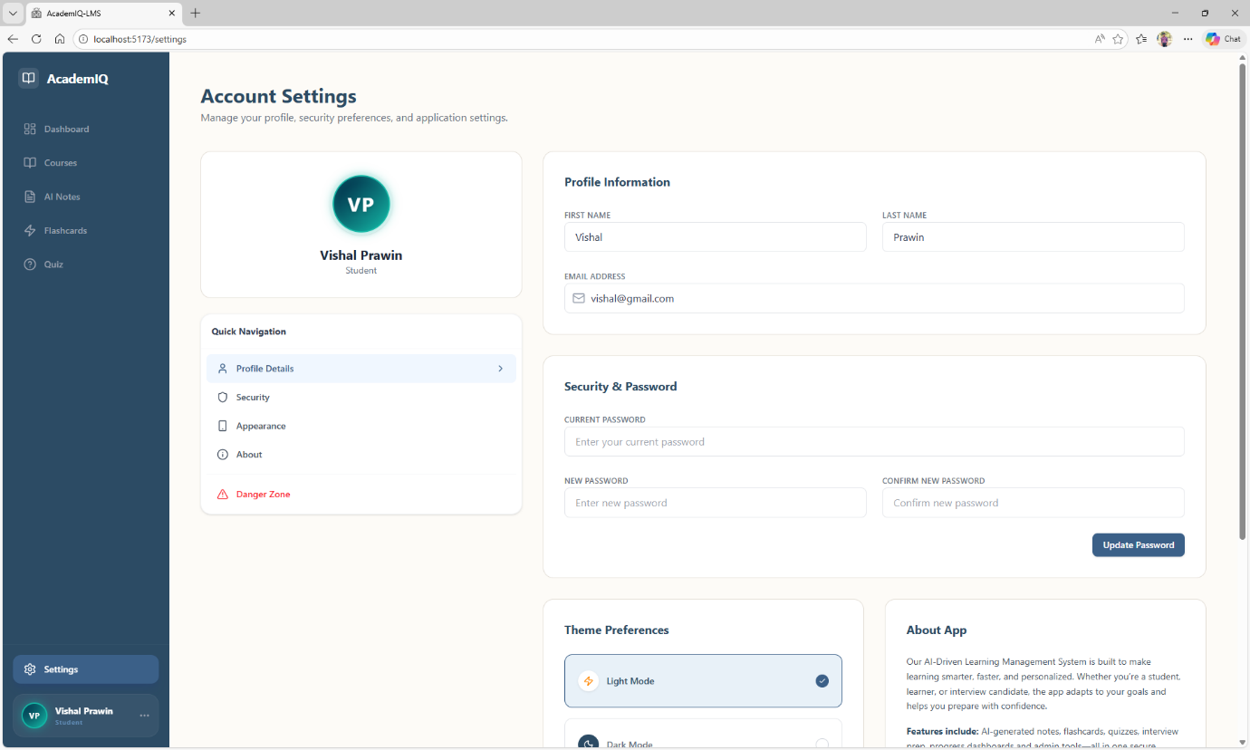
Figure. Settings Page

SAMPLE CODE:
"use client";
import { Button } from "@/components/ui/button";
import { supabase } from "@/services/supabaseClient";
import Image from "next/image";
import React from "react";

function Login() {

const signInWithGoogle = async () => {
const { error } = await supabase.auth.signInWithOAuth({
provider: 'google',
})
if (error) {
console.error('Error', error.message)
}
}

return (
<div className="flex flex-col items-center justify-center h-screen">
<div className="flex flex-col items-center border rounded-2xl p-8">
<Image
src={"/logo.png"}
alt="logo"
width={400}
height={100}
className="w-[180px]"
/>
<div className="flex items-center flex-col">
<Image
src={"/login.jpg"}
alt="logo"
width={600}
height={400}
className="w-[400px] h-[500px]"
/>
<h2 className="text-2xl font-bold text-center mt-5">
Welcome to AiCruit
</h2>
<p className="text-gray-500 text-center">
Sign In With Google Authentication
</p>
<Button className="mt-7 w-full" onClick={signInWithGoogle}>
{" "}
Login With Google
</Button>
</div>
</div>
</div>
);
}

export default Login;

import { QUESTION_PROMPT } from "@/services/Constants";
import { NextResponse } from "next/server";
import OpenAI from "openai";

export async function POST(req) {
const { jobPosition, jobDescription, duration, type } = await req.json();

const FINAL_PROMPT = QUESTION_PROMPT.replace("{{jobTitle}}", jobPosition)
.replace("{{jobDescription}}", jobDescription)
.replace("{{duration}}", duration)
.replace("{{type}}", type);
console.log(FINAL_PROMPT);

try {
const openai = new OpenAI({
baseURL: "https://openrouter.ai/api/v1",
apiKey: process.env.OPENROUTER_API_KEY,
});

const completion = await openai.chat.completions.create({
model: "openai/gpt-4o-mini",
messages: [
{
role: "user",
content: FINAL_PROMPT,
},
],
});

return NextResponse.json(completion.choices[0].message);
} catch (e) {
console.log(e);
return NextResponse.json(e);
}
}

import { Phone, Video } from "lucide-react";
import React from "react";
import Link from "next/link";
function CreateOptions() {
return (
<div className="grid grid-cols-2 gap-5">
<Link
href={"/dashboard/create-interview"}
className="bg-white border border-gray-200 rounded-lg p-5 flex flex-col gap-2 cursor-pointer"
>
<Video className="p-3 text-primary bg-blue-50 rounded-lg h-12 w-12" />
<h2 className="font-bold">Create New Interview</h2>
<p className="text-gray-500">
Create AI Interviews and schedule then with Candidates
</p>
</Link>
<div className="bg-white border border-gray-200 rounded-lg p-5 flex flex-col gap-2">
<Phone className="p-3 text-primary bg-blue-50 rounded-lg h-12 w-12" />
<h2 className="font-bold">Create Phone Screening Call</h2>
<p className="text-gray-500">
Schedule phone screening call with Candidates
</p>
</div>
</div>
);
}

export default CreateOptions;

"use client";
import { Button } from "@/components/ui/button";
import { Camera, Video } from "lucide-react";
import React, { useState } from "react";

function LatestInterviewsList() {
const [interviewList, setInterviewList] = useState([]);
return (
<div className="my-5">
<h2 className="font-bold text-2xl">Previously Created Interviews</h2>
{interviewList?.length == 0 && (
<div className="p-5 flex flex-col gap-3 items-center mt-5">
<Video className="h-10 w-10 text-primary" />
<h2>You don't have any interview created!</h2>
<Button>+ Create New Interview</Button>
</div>
)}
</div>
);
}

export default LatestInterviewsList;

"use client";
import { Progress } from "@/components/ui/progress";
import { ArrowLeft } from "lucide-react";
import { useRouter } from "next/navigation";
import React, { useState } from "react";
import FormContainer from "./_components/FormContainer";
import QuestionList from "./_components/QuestionList";
import { toast } from "sonner";
import InterviewLink from "./_components/InterviewLink";

function page() {
const router = useRouter();
const [step, setStep] = useState(1);
const [formData, setFormData] = useState();
const [interviewId, setInterviewId] = useState();
const onHandleInputChange = (field, value) => {
setFormData((prev) => ({
...prev,
[field]: value,
}));
console.log("formData", formData);
};

const onGoToNext = () => {
if (
!formData?.jobPosition ||
!formData?.jobDescription ||
!formData?.duration ||
!formData?.type
) {
toast("Please enter all details!");
return;
}
setStep(step + 1);
};

const onCreateLink = (interview_id) => {
setInterviewId(interview_id);
setStep(step + 1);
};
return (
<div className="mt-5 px-10 md:px-24 lg:px-44 xl:px-56">
<div className="flex gap-5 items-center">
<ArrowLeft onClick={() => router.back()} className="cursor-pointer" />
<h2 className="font-bold text-2xl">Create New Interview</h2>
</div>
<Progress value={step * 33.33} className="my-5" />
{step === 1 ? (
<FormContainer
onHandleInputChange={onHandleInputChange}
GoToNext={onGoToNext}
/>
) : step === 2 ? (
<QuestionList
formData={formData}
onCreateLink={(interview_id) => onCreateLink(interview_id)}
/>
) : step === 3 ? (
<InterviewLink interview_id={interviewId} formData={formData} />
) : null}
</div>
);
}

export default page;

SYNOPSIS

AI Recruiter is an AI‑powered recruitment platform designed to modernize and streamline the hiring process through intelligent automation and a user‑friendly interface. The system integrates modules such as interview scheduling, candidate evaluation, recruiter dashboards, and automated reporting into a single platform. It uses modern frontend technologies like Next.js and Tailwind CSS to deliver a responsive, fast, and seamless experience tailored specifically for recruiters.
The platform incorporates secure authentication through Supabase Google Auth, ensuring frictionless login and secure session management. Recruiters are provided with a dedicated dashboard that centralizes interview creation, candidate tracking, and evaluation reports, enabling structured workflows and controlled access. The backend, powered by Node.js, Express.js, and Supabase’s managed PostgreSQL, efficiently handles candidate data while maintaining scalability, security, and smooth API communication across the system.
A key highlight of AI Recruiter is its integration with advanced AI services such as GPT‑based models for dynamic interview question generation and Vapi for voice agent functionality and speech‑to‑text transcription. These intelligent features enable automated interviews, structured evaluation reports, and personalized candidate feedback. By combining a powerful technical stack with Supabase authentication and smart AI capabilities, AI Recruiter delivers a next‑generation recruitment solution that is efficient, interactive, and adaptable to the evolving needs of modern hiring practices.




Anandhachitan A(21MSS002), Fifth Year M.Sc.Software Systems,
Batch (2021-2026), PSG College of Arts & Science, Coimbatore

