Program 1:
Program to demonstrate Friend Function in C++
A friend function can access private and protected members of a class

#include <iostream>
#include <string>
using namespace std;

class Student {
private:
string name;
int rollNo;
int marks;

public:
// Function to enter student details
void enterDetails() {
cout << "Enter student name: ";
cin >> name;
cout << "Enter roll number: ";
cin >> rollNo;
cout << "Enter marks: ";
cin >> marks;
}
// Declaring friend function
friend void displayDetails(Student s);
};
// Friend function to display details
void displayDetails(Student s) {
cout << "\nStudent Details:" << endl;
cout << "Name : " << s.name << endl;
cout << "Roll No : " << s.rollNo << endl;
cout << "Marks : " << s.marks << endl;
}

int main() {
Student s[3];

// Input details for 3 students
for (int i = 0; i < 3; i++) {
cout << "\nEnter details for Student " << i + 1 << endl;
s[i].enterDetails();
}
// Display details
cout << "\n--- Student Records ---" << endl;
for (int i = 0; i < 3; i++) {
displayDetails(s[i]);
}
return 0;
}
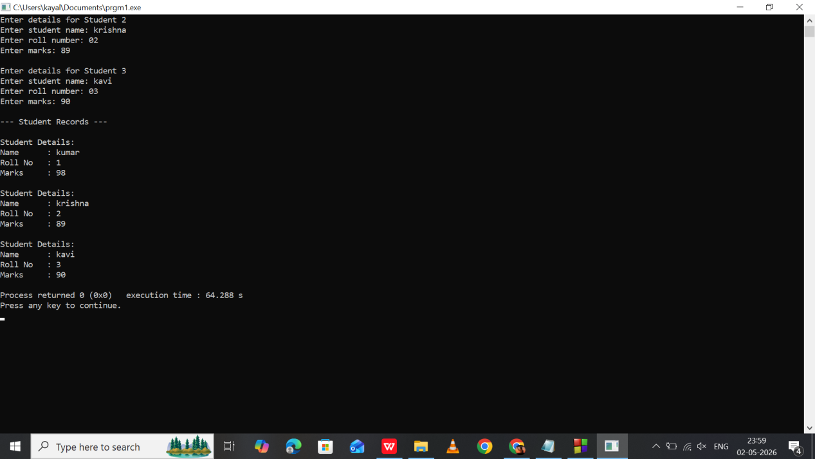

Program 2:
Program to demonstrate Friend Function in C++
Simple Bank Program using friend function

#include <iostream>
#include <string>
using namespace std;

class BankAccount {
private:
string customerName;
int accountNumber;
float balance=5500;

public:
// Function to enter account details
void enterDetails() {
cout << "Enter customer name: ";
cin >> customerName;

cout << "Enter account number: ";
cin >> accountNumber;

}

// Friend function declaration
friend void displayAccount(BankAccount b);

// Function to deposit money
void deposit() {
float amount;
cout << "Enter amount to deposit: ";
cin >> amount;
balance += amount;
}
};

// Friend function definition
void displayAccount(BankAccount b) {
cout << "\n--- Account Details ---" << endl;
cout << "Customer Name : " << b.customerName << endl;
cout << "Account Number: " << b.accountNumber << endl;
cout << "Balance : " << b.balance << endl;
}

int main() {
BankAccount b1;

b1.enterDetails();
b1.deposit();

// Displaying details using friend function
displayAccount(b1);

return 0;
}

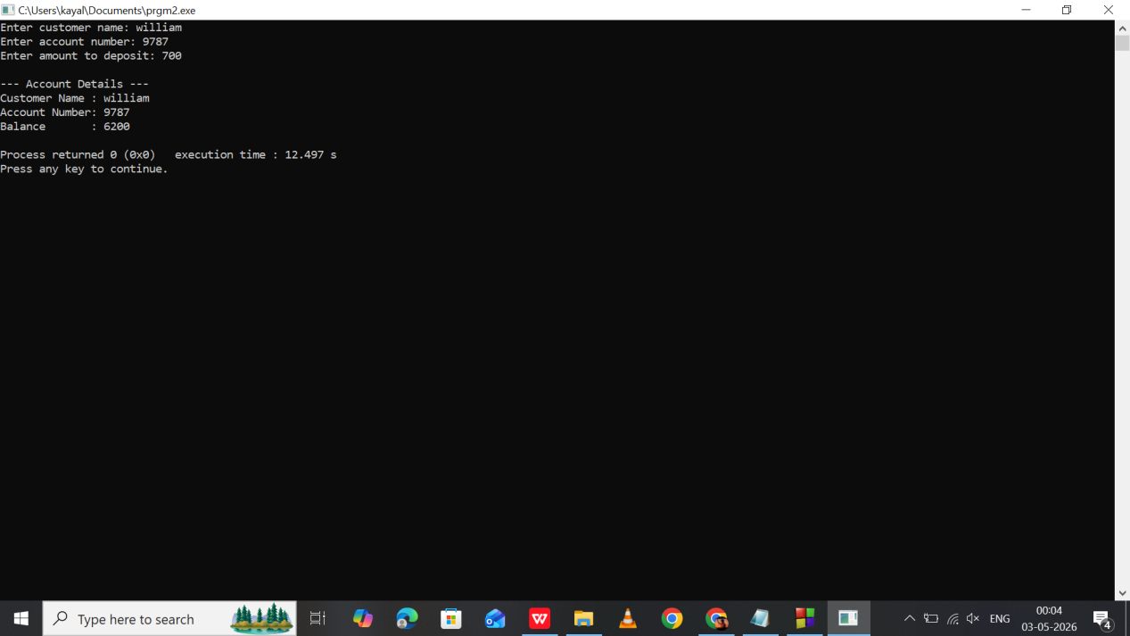

Program 3:
Program to demonstrate Friend Function in C++
Library system to store and display book details

#include <iostream>
#include <string>
using namespace std;

class Library {
private:
string bookName;
string author;
int bookID;

public:
// Function to enter book details
void enterDetails() {
cout << "Enter book name: ";
cin >> bookName;

cout << "Enter author name: ";
cin >> author;

cout << "Enter book ID: ";
cin >> bookID;
}

// Friend function declaration
friend void displayBook(Library b);
};

// Friend function definition
void displayBook(Library b) {
cout << "\n--- Book Details ---" << endl;
cout << "Book Name : " << b.bookName << endl;
cout << "Author : " << b.author << endl;
cout << "Book ID : " << b.bookID << endl;
}

int main() {
Library b1;

b1.enterDetails();

// Display details using friend function
displayBook(b1);

return 0;
}

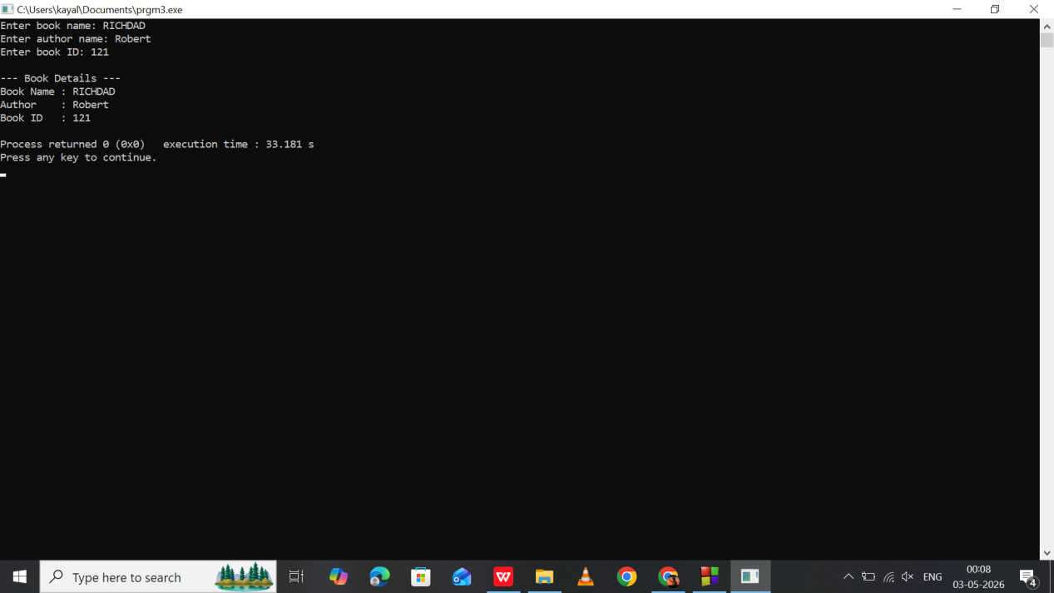

Program 4:
Program to demonstrate Friend Function in C++
Employee Salary Details using friend function

#include <iostream>
#include <string>
using namespace std;

class Employee {
private:
string name;
int empID;
float basicSalary;
float bonus;
float totalSalary;

public:
// Function to enter employee details
void enterDetails() {
cout << "Enter employee name: ";
cin >> name;

cout << "Enter employee ID: ";
cin >> empID;

cout << "Enter basic salary: ";
cin >> basicSalary;

cout << "Enter bonus: ";
cin >> bonus;
}

// Friend function declaration
friend void calculateSalary(Employee &e);
};

// Friend function definition
void calculateSalary(Employee &e) {
e.totalSalary = e.basicSalary + e.bonus;

cout << "\n--- Employee Salary Details ---" << endl;
cout << "Employee Name : " << e.name << endl;
cout << "Employee ID : " << e.empID << endl;
cout << "Basic Salary : " << e.basicSalary << endl;
cout << "Bonus : " << e.bonus << endl;
cout << "Total Salary : " << e.totalSalary << endl;
}

int main() {
Employee e1;

e1.enterDetails();

// Friend function calculates and displays salary
calculateSalary(e1);

return 0;
}

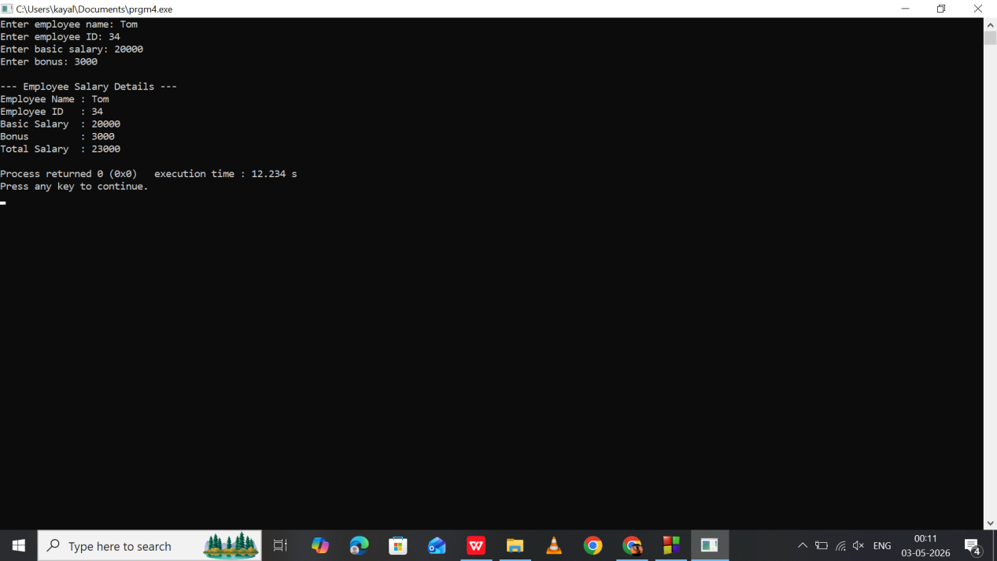

Program 5:
Program to demonstrate Friend Function in C++
Electricity Bill Calculator using friend function

#include <iostream>
#include <string>
using namespace std;

class ElectricityBill {
private:
string customerName;
int unitsConsumed;
float billAmount;

public:
// Function to enter details
void enterDetails() {
cout << "Enter customer name: ";
cin >> customerName;

cout << "Enter units consumed: ";
cin >> unitsConsumed;
}

// Friend function declaration
friend void calculateBill(ElectricityBill &e);
};

// Friend function definition
void calculateBill(ElectricityBill &e) {
if (e.unitsConsumed <= 100) {
e.billAmount = e.unitsConsumed * 2.5;
} else if (e.unitsConsumed <= 300) {
e.billAmount = e.unitsConsumed * 4.0;
} else {
e.billAmount = e.unitsConsumed * 6.0;
}

cout << "\n--- Electricity Bill Details ---" << endl;
cout << "Customer Name : " << e.customerName << endl;
cout << "Units Consumed : " << e.unitsConsumed << endl;
cout << "Total Bill : " << e.billAmount << endl;
}

int main() {
ElectricityBill e1;

e1.enterDetails();

// Friend function calculates bill
calculateBill(e1);

return 0;
}
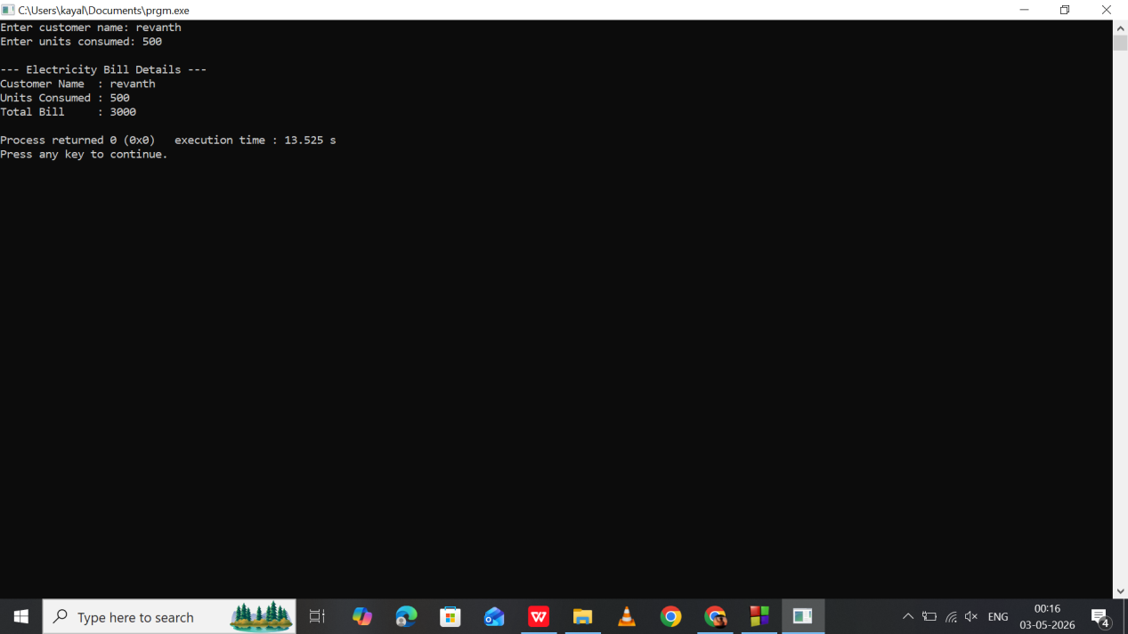

Program 6:
Program to demonstrate Operator Overloading in C++
Calculator program

#include <iostream>
using namespace std;

class Calculator {
private:
float num;

public:
// Function to input number
void getNumber() {
cout << "Enter number: ";
cin >> num;
}

// Overloading + operator
Calculator operator + (Calculator c) {
Calculator temp;
temp.num = num + c.num;
return temp;
}

// Overloading - operator
Calculator operator - (Calculator c) {
Calculator temp;
temp.num = num - c.num;
return temp;
}

// Overloading * operator
Calculator operator * (Calculator c) {
Calculator temp;
temp.num = num * c.num;
return temp;
}

// Overloading / operator
Calculator operator / (Calculator c) {
Calculator temp;

if (c.num == 0) {
cout << "Error: Division by zero is not allowed!" << endl;
temp.num = 0;
} else {
temp.num = num / c.num;
}

return temp;
}

// Display result
void display() {
cout << "Result = " << num << endl;
}
};

int main() {
Calculator c1, c2, result;

cout << "Enter first number" << endl;
c1.getNumber();

cout << "Enter second number" << endl;
c2.getNumber();

// Addition
result = c1 + c2;
cout << "\nAfter Addition:" << endl;
result.display();

// Subtraction
result = c1 - c2;
cout << "\nAfter Subtraction:" << endl;
result.display();

// Multiplication
result = c1 * c2;
cout << "\nAfter Multiplication:" << endl;
result.display();

// Division
result = c1 / c2;
cout << "\nAfter Division:" << endl;
result.display();

return 0;
}

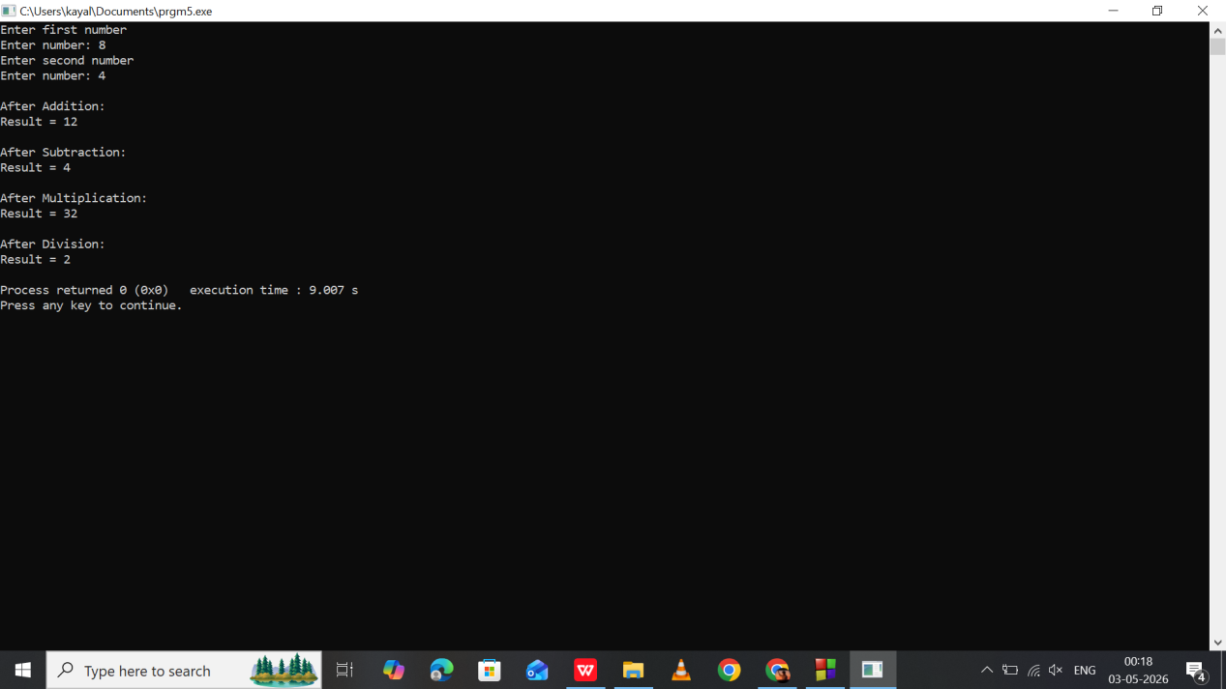

Program 7:
Distance Addition using Operator Overloading
adding two distances

#include <iostream>
using namespace std;

class Distance {
private:
int meters;

public:
void getDistance() {
cout << "Enter distance in meters: ";
cin >> meters;
}

Distance operator + (Distance d) {
Distance temp;
temp.meters = meters + d.meters;
return temp;
}

void display() {
cout << "Total Distance = " << meters << " meters" << endl;
}
};

int main() {
Distance d1, d2, result;

d1.getDistance();
d2.getDistance();

result = d1 + d2;
result.display();

return 0;
}

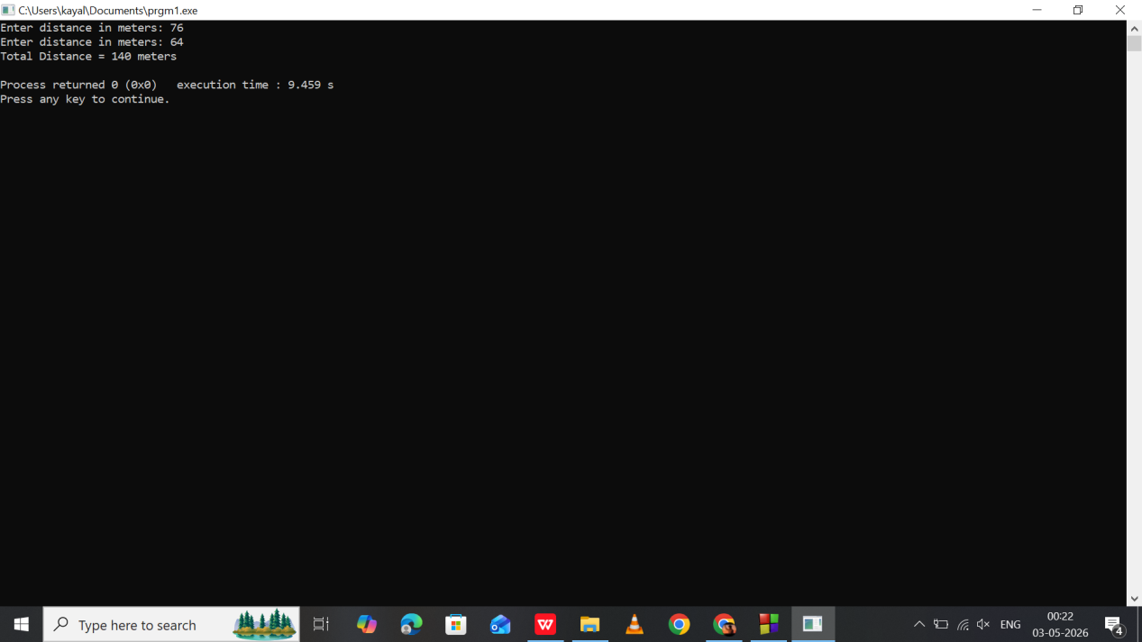

Program 8:
//Salary Comparison using Operator Overloading
//comparing employee salaries

#include <iostream>
using namespace std;

class Salary {
private:
float amount;

public:
void getSalary() {
cout << "Enter salary: ";
cin >> amount;
}

bool operator > (Salary s) {
return amount > s.amount;
}

void display() {
cout << "Salary = " << amount << endl;
}
};

int main() {
Salary s1, s2;

s1.getSalary();
s2.getSalary();

if (s1 > s2)
cout << "First person salary is greater." << endl;
else
cout << "Second person salary is greater." << endl;

return 0;
}

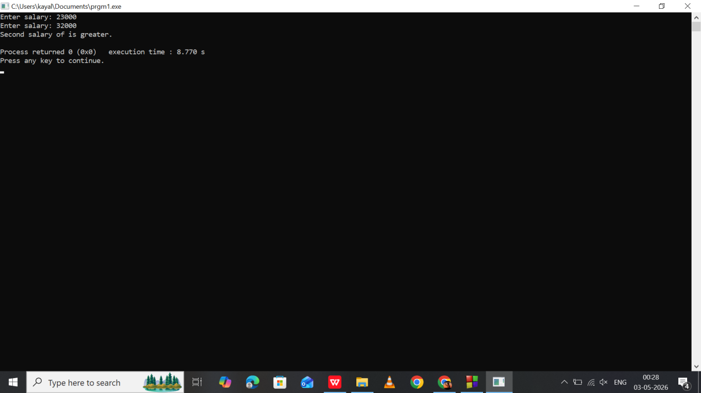

Program 9:
Product Price Addition using Operator Overloading
calculating total shopping cost

#include <iostream>
using namespace std;

class Product {
private:
float price;

public:
void getPrice() {
cout << "Enter product price: ";
cin >> price;
}

Product operator + (Product p) {
Product temp;
temp.price = price + p.price;
return temp;
}

void display() {
cout << "Total Price = " << price << endl;
}
};

int main() {
Product p1, p2, total;

p1.getPrice();
p2.getPrice();

total = p1 + p2;
total.display();

return 0;
}

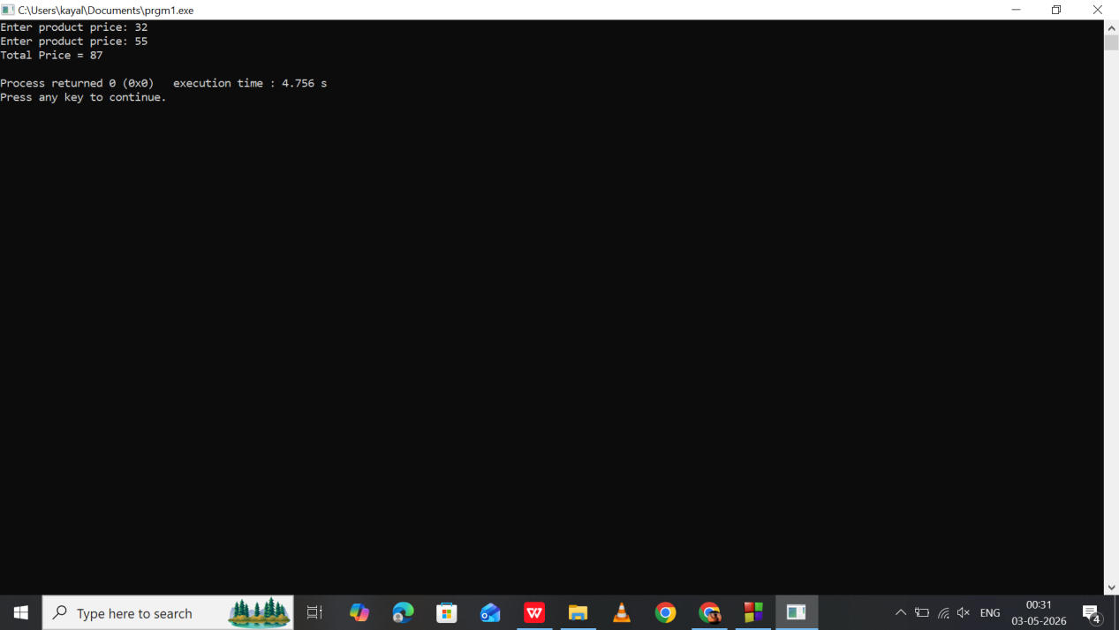

Program 10:
Time Addition using Operator Overloading
adding two time durations

#include <iostream>
using namespace std;

class Time {
private:
int hours, minutes;

public:
void getTime() {
cout << "Enter hours: ";
cin >> hours;
cout << "Enter minutes: ";
cin >> minutes;
}

Time operator + (Time t) {
Time temp;
temp.hours = hours + t.hours;
temp.minutes = minutes + t.minutes;

if (temp.minutes >= 60) {
temp.hours++;
temp.minutes -= 60;
}

return temp;
}

void display() {
cout << "Total Time = " << hours << " hours " << minutes << " minutes" << endl;
}
};

int main() {
Time t1, t2, result;

t1.getTime();
t2.getTime();

result = t1 + t2;
result.display();

return 0;
}

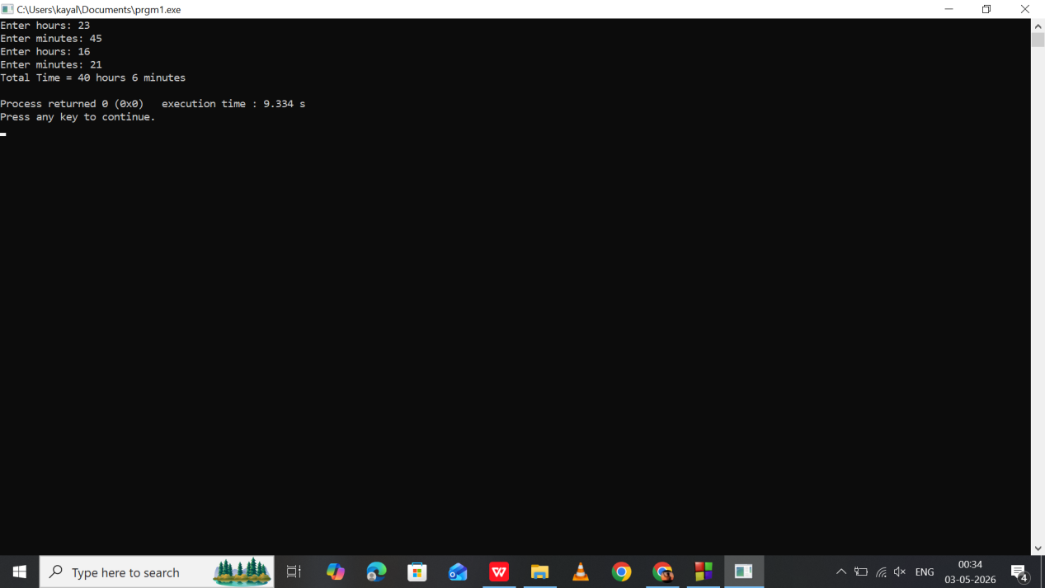

Program 11:
//Mobile Data Usage using Operator Overloading
//combining internet data usage

#include <iostream>
using namespace std;

class DataUsage {
private:
float gb;

public:
void getData() {
cout << "Enter data used (in GB): ";
cin >> gb;
}

DataUsage operator + (DataUsage d) {
DataUsage temp;
temp.gb = gb + d.gb;
return temp;
}

void display() {
cout << "Total Data Used = " << gb << " GB" << endl;
}
};

int main() {
DataUsage d1, d2, result;

d1.getData();
d2.getData();

result = d1 + d2;
result.display();

return 0;
}
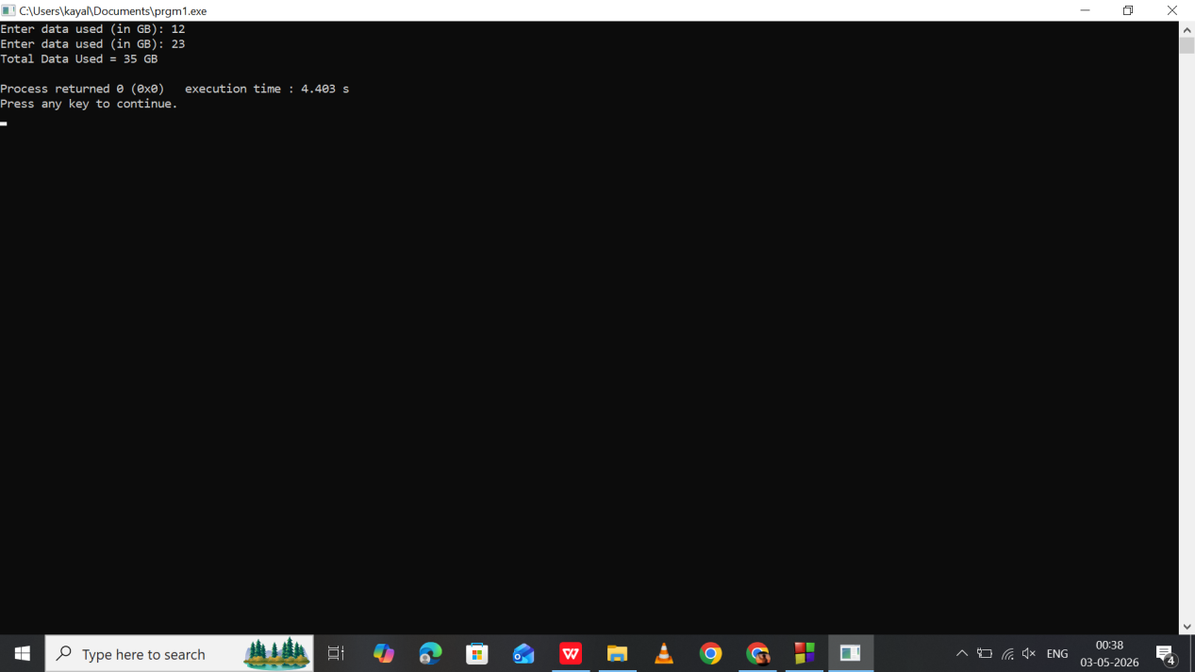

Program 12:
Single Inheritance
Student inherits Person

#include <iostream>
#include <string>
using namespace std;

class Person {
protected:
string name;

public:
void getPerson() {
cout << "Enter name: ";
cin >> name;
}
};

class Student : public Person {
private:
int marks;

public:
void getStudent() {
cout << "Enter marks: ";
cin >> marks;
}

void display() {
cout << "Name: " << name << endl;
cout << "Marks: " << marks << endl;
}
};

int main() {
Student s;
s.getPerson();
s.getStudent();
s.display();
return 0;
}

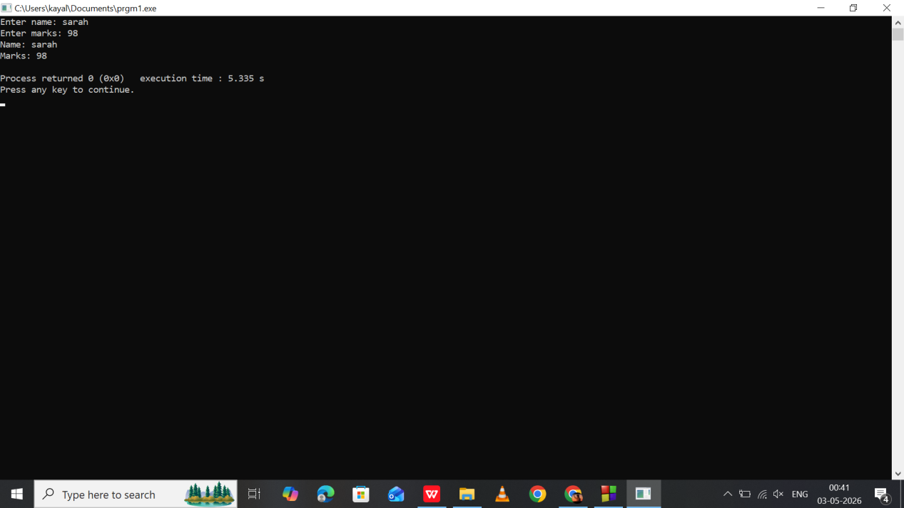

Program 13:
//Single Inheritance
//Employee inherits Company

#include <iostream>
#include <string>
using namespace std;

class Company {
protected:
string companyName;

public:
void getCompany() {
cout << "Enter company name: ";
cin >> companyName;
}
};

class Employee : public Company {
private:
string employeeName;

public:
void getEmployee() {
cout << "Enter employee name: ";
cin >> employeeName;
}

void display() {
cout << "Company: " << companyName << endl;
cout << "Employee: " << employeeName << endl;
}
};

int main() {
Employee e;
e.getCompany();
e.getEmployee();
e.display();
return 0;
}
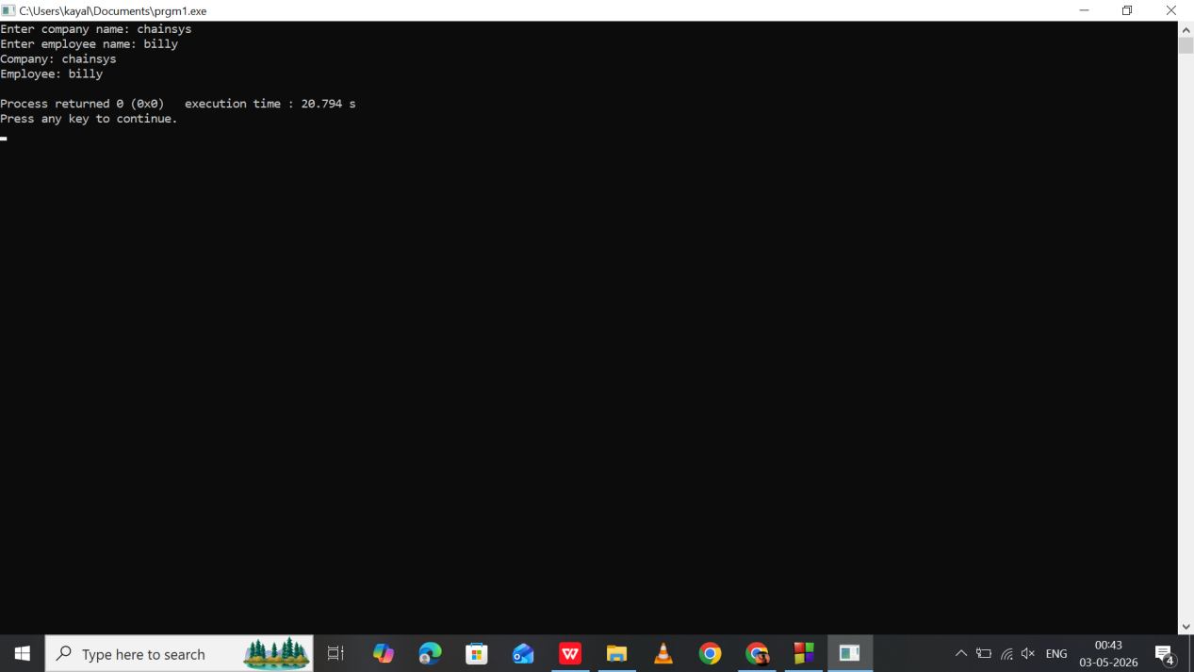

Program 14:
Multilevel Inheritance
Vehicle -> Car -> SportsCar

#include <iostream>
#include <string>
using namespace std;

// Base class
class Vehicle {
protected:
string brand;
int year;

public:
void getVehicleDetails() {
cout << "Enter vehicle brand: ";
cin >> brand;

cout << "Enter manufacturing year: ";
cin >> year;
}
};

// Derived class from Vehicle
class Car : public Vehicle {
protected:
int speed;
float price;

public:
void getCarDetails() {
cout << "Enter top speed (km/h): ";
cin >> speed;

cout << "Enter price: ";
cin >> price;
}
};

// Derived class from Car
class SportsCar : public Car {
private:
string modelName;

public:
void getSportsCarDetails() {
cout << "Enter sports car model name: ";
cin >> modelName;
}

void displayDetails() {
cout << "\n--- Sports Car Details ---" << endl;
cout << "Brand : " << brand << endl;
cout << "Manufacturing Year : " << year << endl;
cout << "Model Name : " << modelName << endl;
cout << "Top Speed : " << speed << " km/h" << endl;
cout << "Price : " << price << endl;

if (speed > 250)
cout << "Category : High Performance Sports Car" << endl;
else
cout << "Category : Standard Sports Car" << endl;
}
};

int main() {
SportsCar s;

cout << "Enter Sports Car Information" << endl;

s.getVehicleDetails();
s.getCarDetails();
s.getSportsCarDetails();

s.displayDetails();

return 0;
}

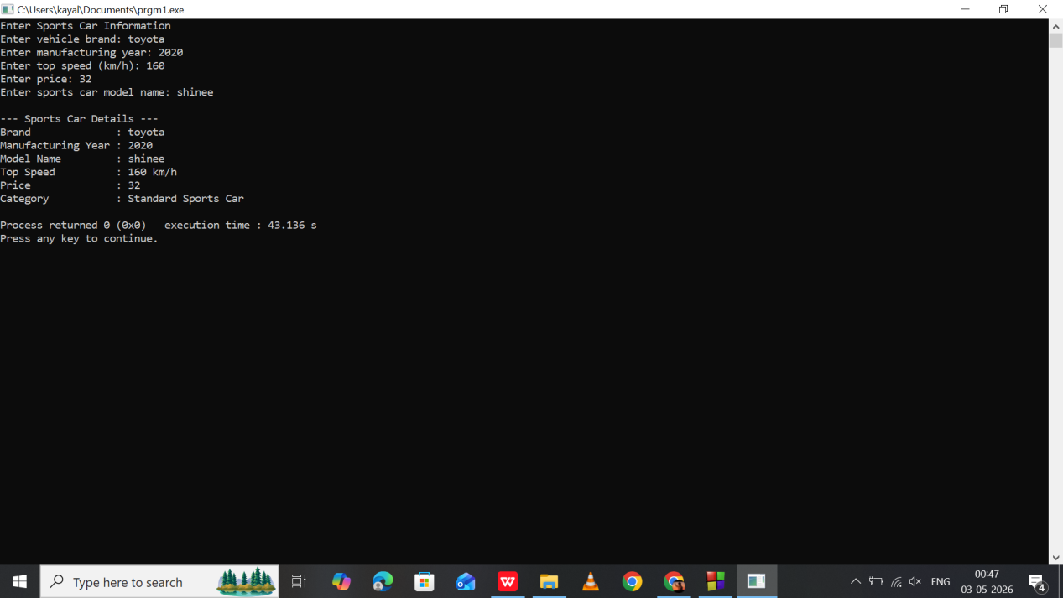

Program 15:
//Multilevel Inheritance
//School -> Teacher -> HeadTeacher

#include <iostream>
#include <string>
using namespace std;

class School {
protected:
string schoolName;
string location;

public:
void getSchoolDetails() {
cout << "Enter school name: ";
cin >> schoolName;
cout << "Enter school location: ";
cin >> location;
}
};

class Teacher : public School {
protected:
string subject;
int experience;

public:
void getTeacherDetails() {
cout << "Enter subject handled: ";
cin >> subject;
cout << "Enter years of experience: ";
cin >> experience;
}
};

class HeadTeacher : public Teacher {
private:
string headName;

public:
void getHeadDetails() {
cout << "Enter head teacher name: ";
cin >> headName;
}

void display() {
cout << "\n--- Head Teacher Details ---" << endl;
cout << "Name : " << headName << endl;
cout << "School : " << schoolName << endl;
cout << "Location : " << location << endl;
cout << "Subject : " << subject << endl;
cout << "Experience : " << experience << " years" << endl;
}
};

int main() {
HeadTeacher h;

h.getSchoolDetails();
h.getTeacherDetails();
h.getHeadDetails();
h.display();
Return 0;
}

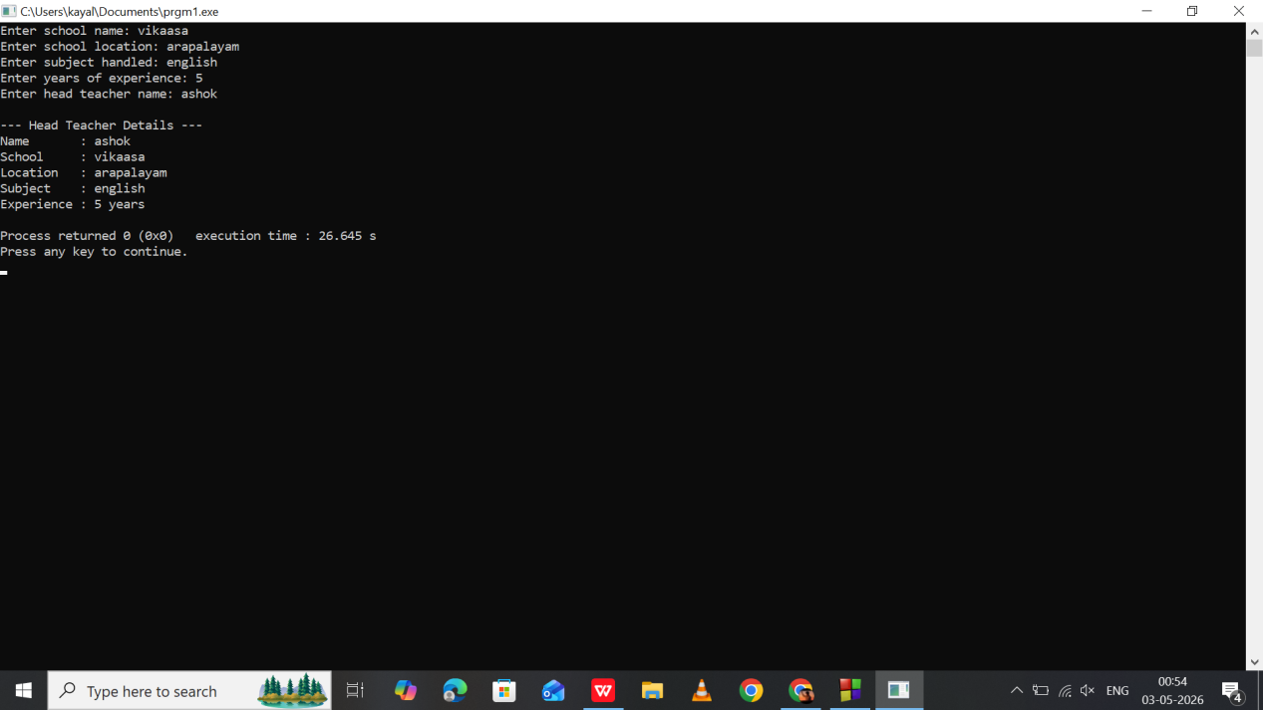

Program 16:
Multiple Inheritance
Athlete + Student = ScholarAthlete

#include <iostream>
#include <string>
using namespace std;

class Athlete {
protected:
string sport;
int medals;

public:
void getAthleteDetails() {
cout << "Enter sport: ";
cin >> sport;
cout << "Enter number of medals: ";
cin >> medals;
}
};

class StudentInfo {
protected:
int marks;
string grade;

public:
void getStudentDetails() {
cout << "Enter marks: ";
cin >> marks;
cout << "Enter grade: ";
cin >> grade;
}
};

class ScholarAthlete : public Athlete, public StudentInfo {
private:
string name;

public:
void getDetails() {
cout << "Enter student name: ";
cin >> name;
getAthleteDetails();
getStudentDetails();
}

void display() {
cout << "\n--- Scholar Athlete Details ---" << endl;
cout << "Name : " << name << endl;
cout << "Sport : " << sport << endl;
cout << "Medals : " << medals << endl;
cout << "Marks : " << marks << endl;
cout << "Grade : " << grade << endl;
}
};

int main() {
ScholarAthlete s;
s.getDetails();
s.display();
return 0;
}

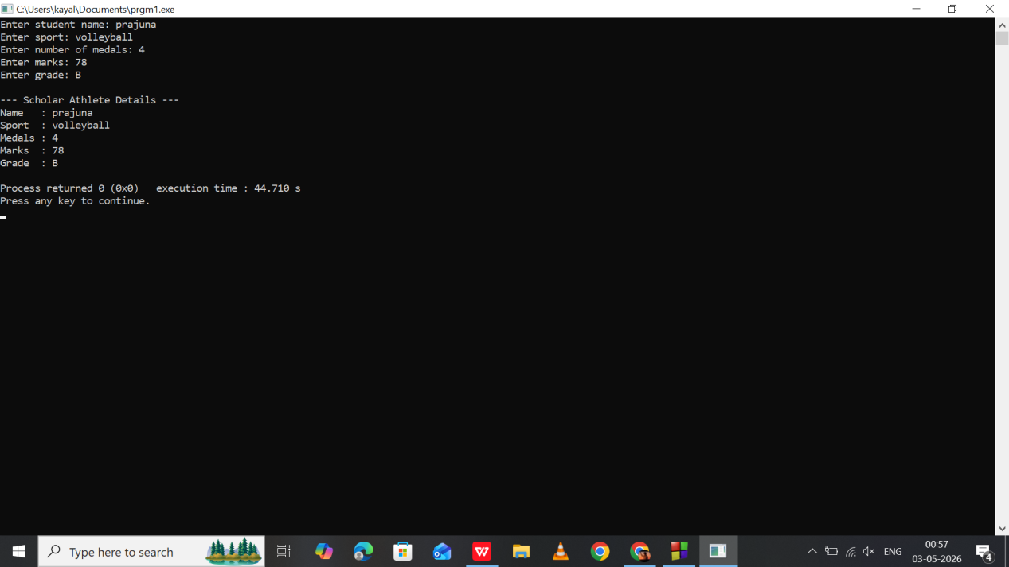

Program 17:
Multiple Inheritance
Singer + Actor = Celebrity

#include <iostream>
#include <string>
using namespace std;

class Singer {
protected:
string famousSong;

public:
void getSingerDetails() {
cout << "Enter famous song: ";
cin >> famousSong;
}
};

class Actor {
protected:
string famousMovie;

public:
void getActorDetails() {
cout << "Enter famous movie: ";
cin >> famousMovie;
}
};

class Celebrity : public Singer, public Actor {
private:
string name;
int age;

public:
void getDetails() {
cout << "Enter celebrity name: ";
cin >> name;
cout << "Enter age: ";
cin >> age;
getSingerDetails();
getActorDetails();
}

void display() {
cout << "\n--- Celebrity Details ---" << endl;
cout << "Name : " << name << endl;
cout << "Age : " << age << endl;
cout << "Famous Song : " << famousSong << endl;
cout << "Famous Movie : " << famousMovie << endl;
}
};

int main() {
Celebrity c;
c.getDetails();
c.display();
return 0;
}

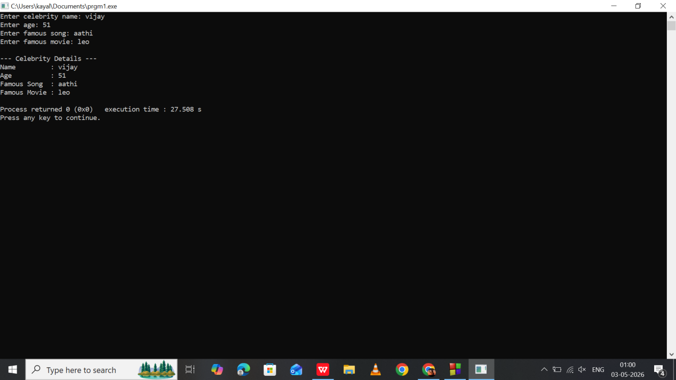

Program 18:
Hierarchical Inheritance
Animal -> Dog, Cat

#include <iostream>
#include <string>
using namespace std;

class Animal {
protected:
string name;
int age;
};

class Dog : public Animal {
public:
void getDogDetails() {
cout << "Enter dog name: ";
cin >> name;
cout << "Enter dog age: ";
cin >> age;
}

void displayDog() {
cout << "\nDog Name : " << name << endl;
cout << "Dog Age : " << age << endl;
}
};

class Cat : public Animal {
public:
void getCatDetails() {
cout << "Enter cat name: ";
cin >> name;
cout << "Enter cat age: ";
cin >> age;
}

void displayCat() {
cout << "\nCat Name : " << name << endl;
cout << "Cat Age : " << age << endl;
}
};

int main() {
Dog d;
Cat c;

d.getDogDetails();
d.displayDog();

c.getCatDetails();
c.displayCat();

return 0;
}

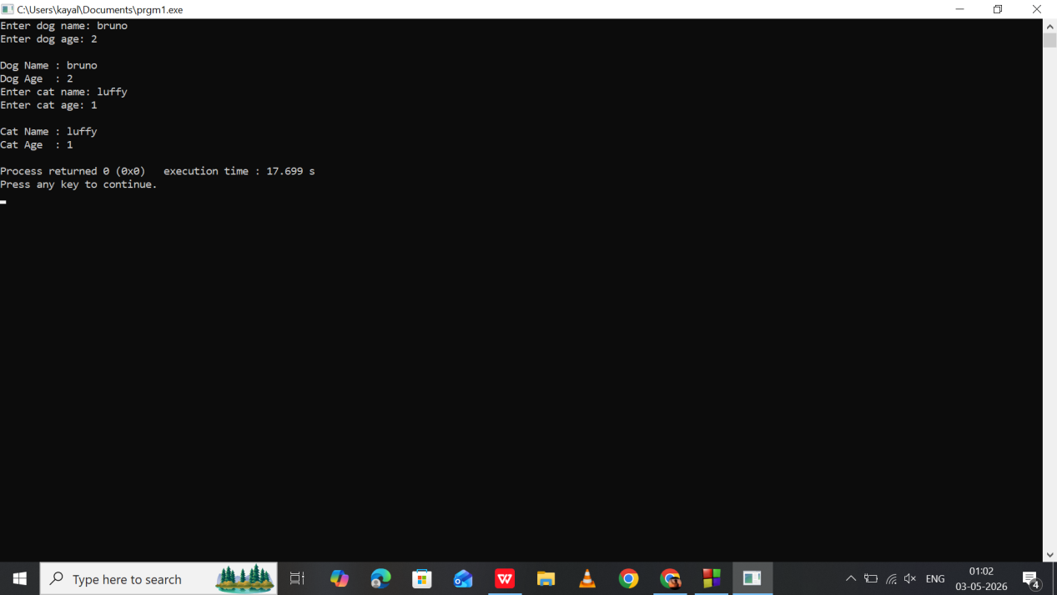

Program 19:
//Hierarchical Inheritance
//Account -> Savings, Current

#include <iostream>
using namespace std;

class Account {
protected:
float balance;
};

class Savings : public Account {
private:
float interest;

public:
void getSavingsDetails() {
cout << "Enter savings balance: ";
cin >> balance;
cout << "Enter interest: ";
cin >> interest;
}

void displaySavings() {
cout << "\nSavings Balance : " << balance << endl;
cout << "Interest : " << interest << "%" << endl;
}
};

class Current : public Account {
private:
float overdraft;

public:
void getCurrentDetails() {
cout << "Enter current balance: ";
cin >> balance;
cout << "Enter overdraft limit: ";
cin >> overdraft;
}

void displayCurrent() {
cout << "\nCurrent Balance : " << balance << endl;
cout << "Overdraft Limit : " << overdraft << endl;
}
};

int main() {
Savings s;
Current c;

s.getSavingsDetails();
s.displaySavings();

c.getCurrentDetails();
c.displayCurrent();

return 0;
}

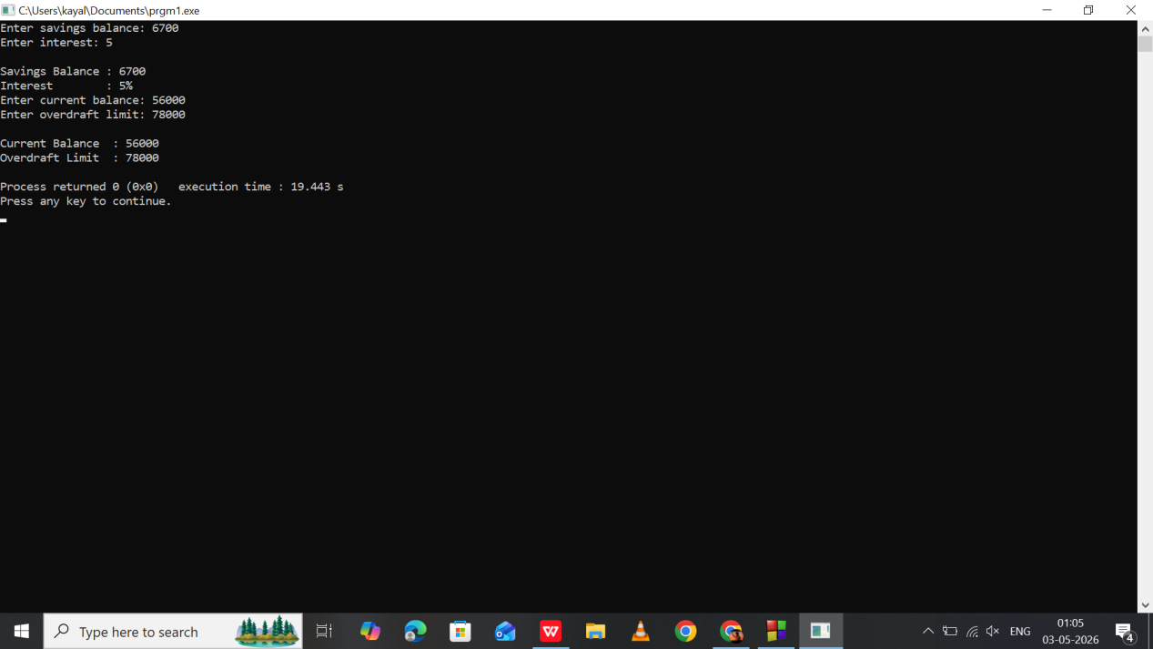

Program 20:
Student Record using Pointer in Class

#include <iostream>
#include <string>
using namespace std;

class Student {
private:
string *name;
int *marks;

public:
Student() {
name = new string;
marks = new int;
}

void getDetails() {
cout << "Enter student name: ";
cin >> *name;
cout << "Enter student marks: ";
cin >> *marks;
}

void display() {
cout << "\nStudent Name: " << *name << endl;
cout << "Marks : " << *marks << endl;
}

~Student() {
delete name;
delete marks;
}
};

int main() {
Student s;
s.getDetails();
s.display();
return 0;
}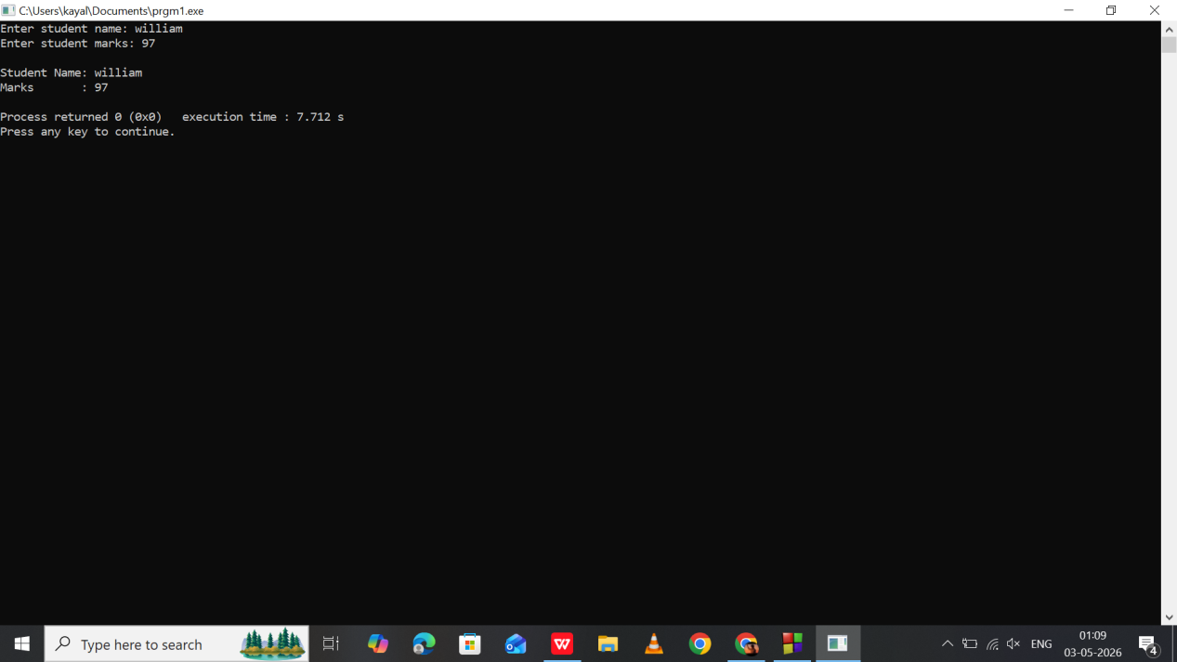

Program 21:
Employee Salary using Pointer in Class

#include <iostream>
#include <string>
using namespace std;

class Employee {
private:
string *name;
float *salary;

public:
Employee() {
name = new string;
salary = new float;
}

void getDetails() {
cout << "Enter employee name: ";
cin >> *name;
cout << "Enter salary: ";
cin >> *salary;
}

void display() {
cout << "\nEmployee Name: " << *name << endl;
cout << "Salary : " << *salary << endl;
}

~Employee() {
delete name;
delete salary;
}
};

int main() {
Employee e;
e.getDetails();
e.display();
return 0;
}

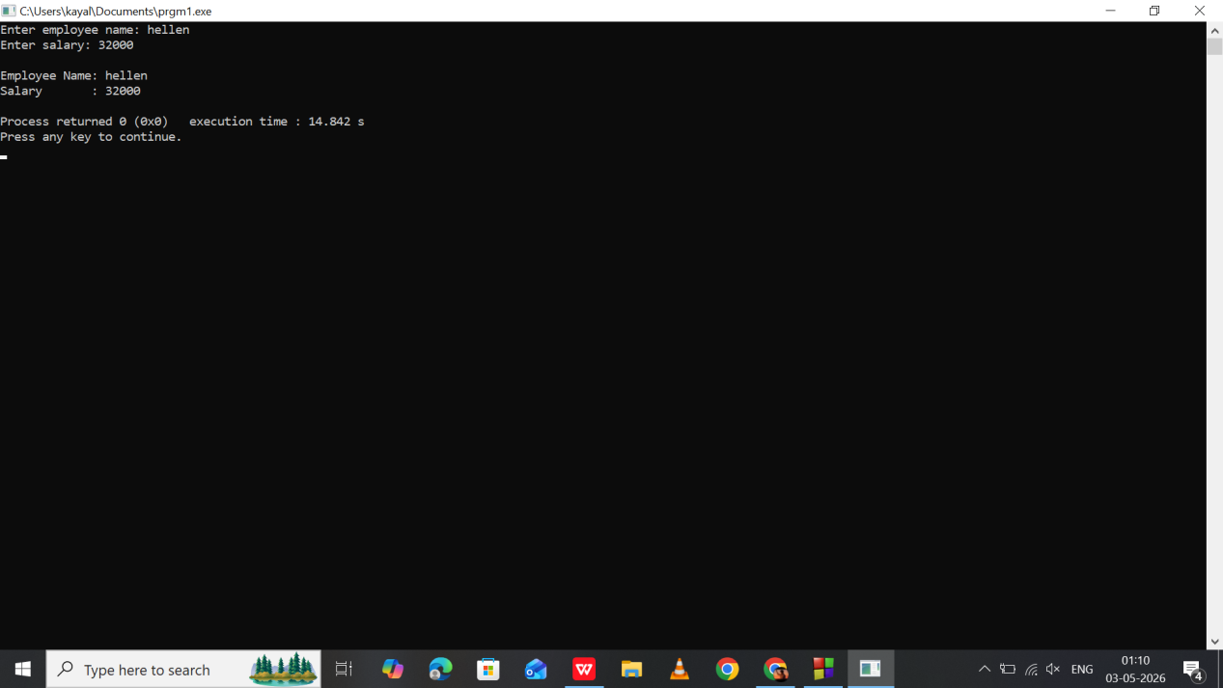

Program 22:
Product Billing using Pointer in Class

#include <iostream>
using namespace std;

class Product {
private:
int *quantity;
float *price;

public:
Product() {
quantity = new int;
price = new float;
}

void getDetails() {
cout << "Enter quantity: ";
cin >> *quantity;
cout << "Enter price: ";
cin >> *price;
}

void display() {
cout << "\nTotal Bill: " << (*quantity) * (*price) << endl;
}

~Product() {
delete quantity;
delete price;
}
};

int main() {
Product p;
p.getDetails();
p.display();
return 0;
}

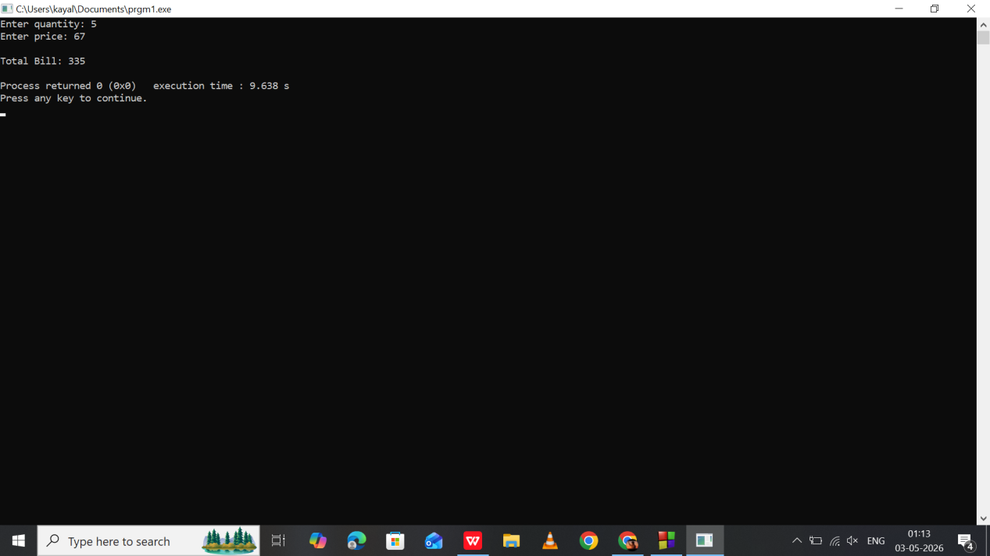

Program 23:
Bank Account using Pointer in Class

#include <iostream>
using namespace std;

class BankAccount {
private:
int *accNo;
float *balance;

public:
BankAccount() {
accNo = new int;
balance = new float;
}

void getDetails() {
cout << "Enter account number: ";
cin >> *accNo;
cout << "Enter balance: ";
cin >> *balance;
}

void deposit() {
float amount;
cout << "Enter deposit amount: ";
cin >> amount;
*balance += amount;
}

void display() {
cout << "\nAccount Number: " << *accNo << endl;
cout << "Updated Balance: " << *balance << endl;
}

~BankAccount() {
delete accNo;
delete balance;
}
};

int main() {
BankAccount b;
b.getDetails();
b.deposit();
b.display();
return 0;
}

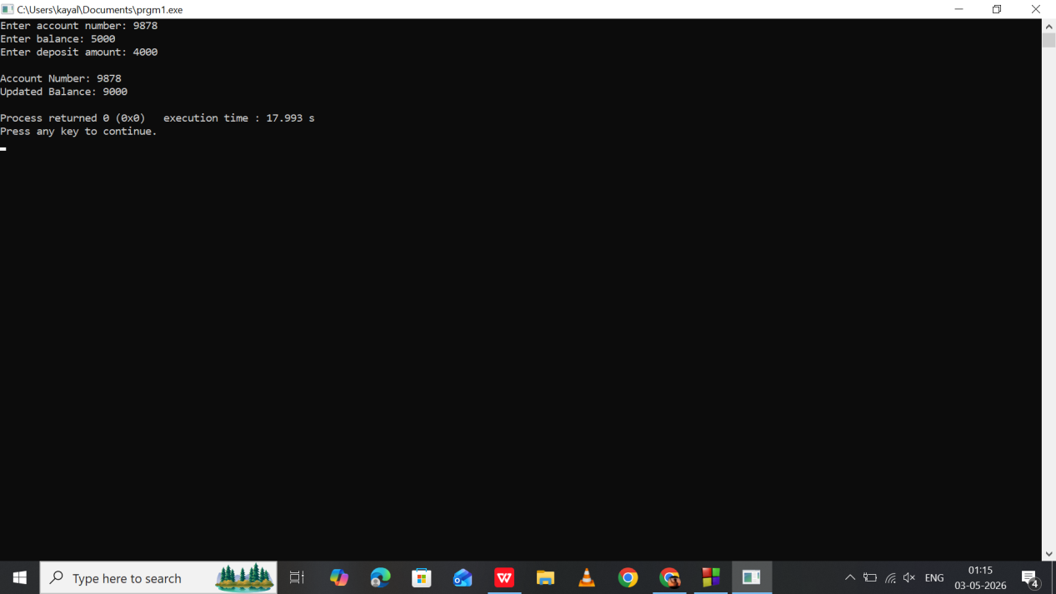

Program 24:
Library Book using Pointer in Class

#include <iostream>
#include <string>
using namespace std;

class Book {
private:
string *title;
int *bookID;

public:
Book() {
title = new string;
bookID = new int;
}

void getDetails() {
cout << "Enter book title: ";
cin >> *title;
cout << "Enter book ID: ";
cin >> *bookID;
}

void display() {
cout << "\nBook Title: " << *title << endl;
cout << "Book ID : " << *bookID << endl;
}

~Book() {
delete title;
delete bookID;
}
};

int main() {
Book b;
b.getDetails();
b.display();
return 0;
}

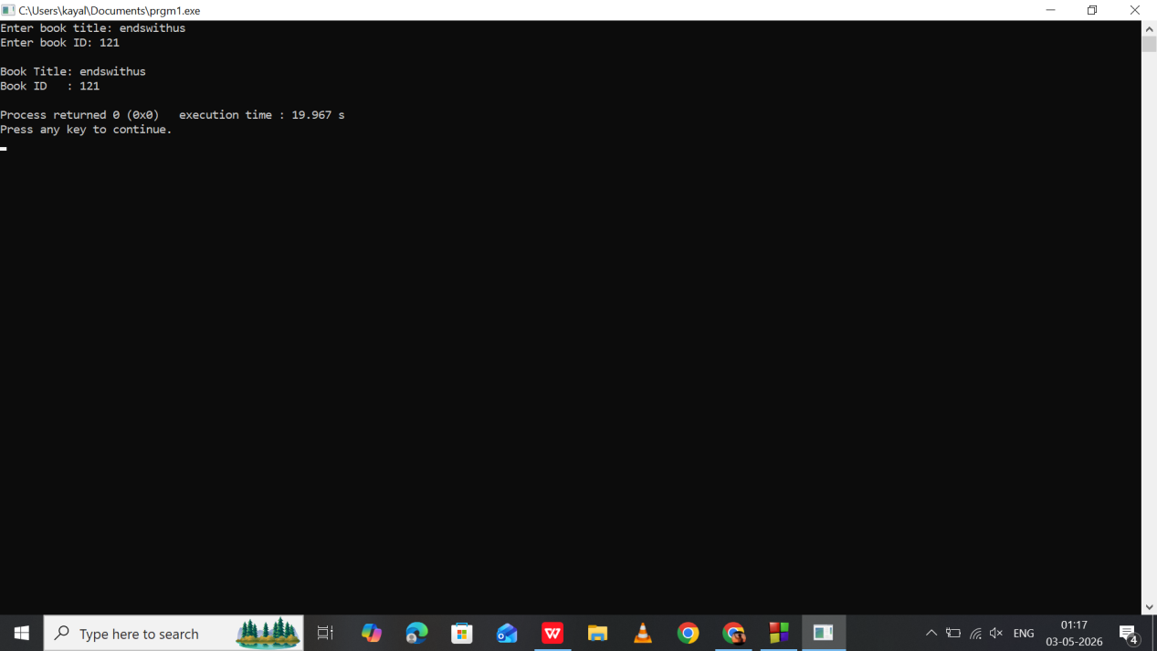

Program 25:
Hospital Patient Record using Pointer in Class

#include <iostream>
#include <string>
using namespace std;

class Patient {
private:
string *name;
int *age;

public:
Patient() {
name = new string;
age = new int;
}

void getDetails() {
cout << "Enter patient name: ";
cin >> *name;
cout << "Enter patient age: ";
cin >> *age;
}

void display() {
cout << "\nPatient Name: " << *name << endl;
cout << "Age : " << *age << endl;
}

~Patient() {
delete name;
delete age;
}
};

int main() {
Patient p;
p.getDetails();
p.display();
return 0;
}

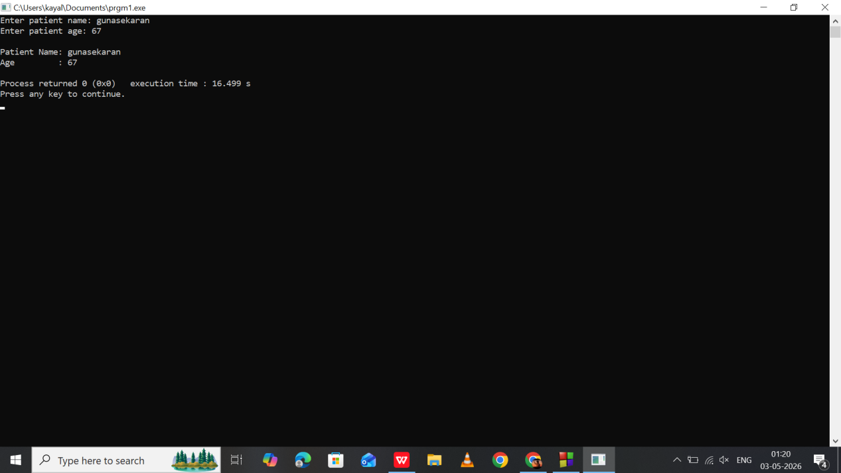

Program 26:
Mobile Recharge using Pointer in Class

#include <iostream>
using namespace std;

class Recharge {
private:
int *mobileNo;
float *amount;

public:
Recharge() {
mobileNo = new int;
amount = new float;
}

void getDetails() {
cout << "Enter mobile number: ";
cin >> *mobileNo;
cout << "Enter recharge amount: ";
cin >> *amount;
}

void display() {
cout << "\nMobile Number : " << *mobileNo << endl;
cout << "Recharge Amount : " << *amount << endl;
}

~Recharge() {
delete mobileNo;
delete amount;
}
};

int main() {
Recharge r;
r.getDetails();
r.display();
return 0;
}

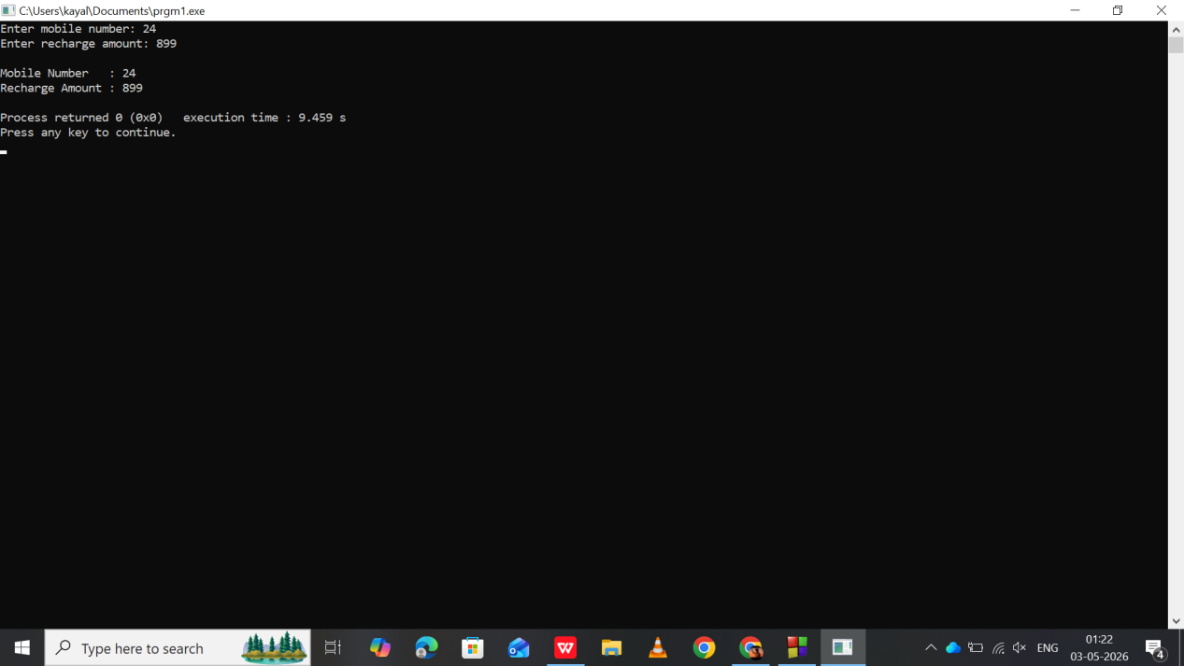

Program 27:
Abstract Class - Online Payment System

#include <iostream>
using namespace std;

class Payment {
public:
virtual void pay(float amount) = 0; // pure virtual function
};

class UPI : public Payment {
public:
void pay(float amount) {
cout << "Payment of " << amount << " completed through UPI." << endl;
}
};

int main() {
UPI u;
u.pay(1500);
return 0;
}

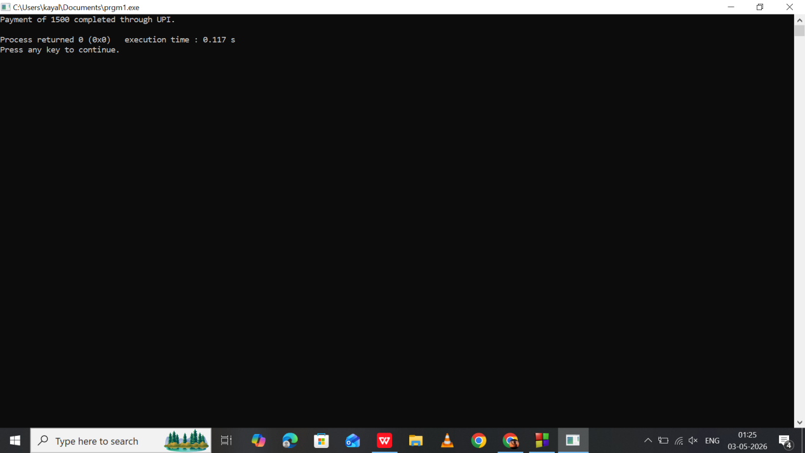

Program 28:
Virtual Function - Food Delivery App

#include <iostream>
using namespace std;

class Delivery {
public:
virtual void service() {
cout << "General delivery service." << endl;
}
};

class ExpressDelivery : public Delivery {
public:
void service() {
cout << "Express delivery within 30 minutes." << endl;
}
};

int main() {
Delivery *d;
ExpressDelivery e;

d = &e;
d->service();

return 0;
}

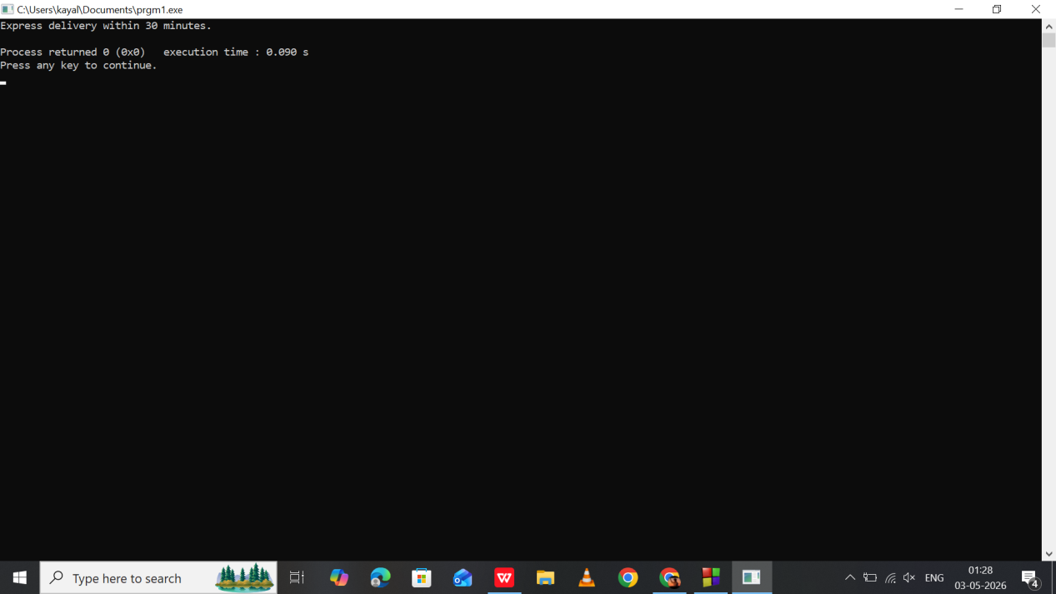

Program 29:
Abstract Class - Vehicle Rental

#include <iostream>
using namespace std;

class Rental {
public:
virtual void rent() = 0;
};

class BikeRental : public Rental {
public:
void rent() {
cout << "Bike rented for city travel." << endl;
}
};

int main() {
BikeRental b;
b.rent();
return 0;
}

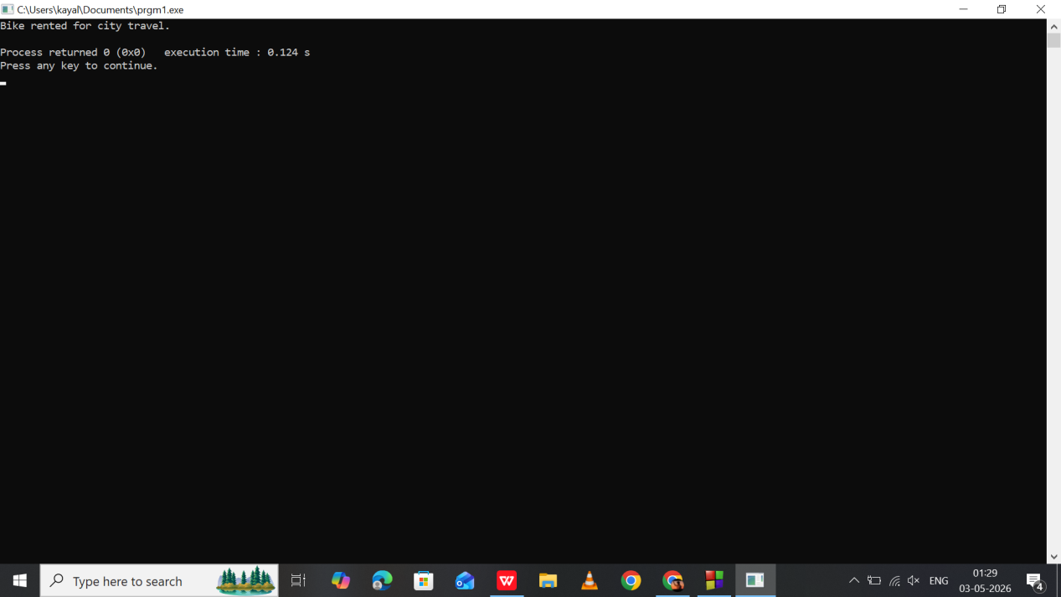

Program 30:
Virtual Function - Smart Home Devices

#include <iostream>
using namespace std;

class Device {
public:
virtual void operate() {
cout << "Device is operating." << endl;
}
};

class Fan : public Device {
public:
void operate() {
cout << "Fan is spinning at medium speed." << endl;
}
};

int main() {
Device *d;
Fan f;

d = &f;
d->operate();

return 0;
}

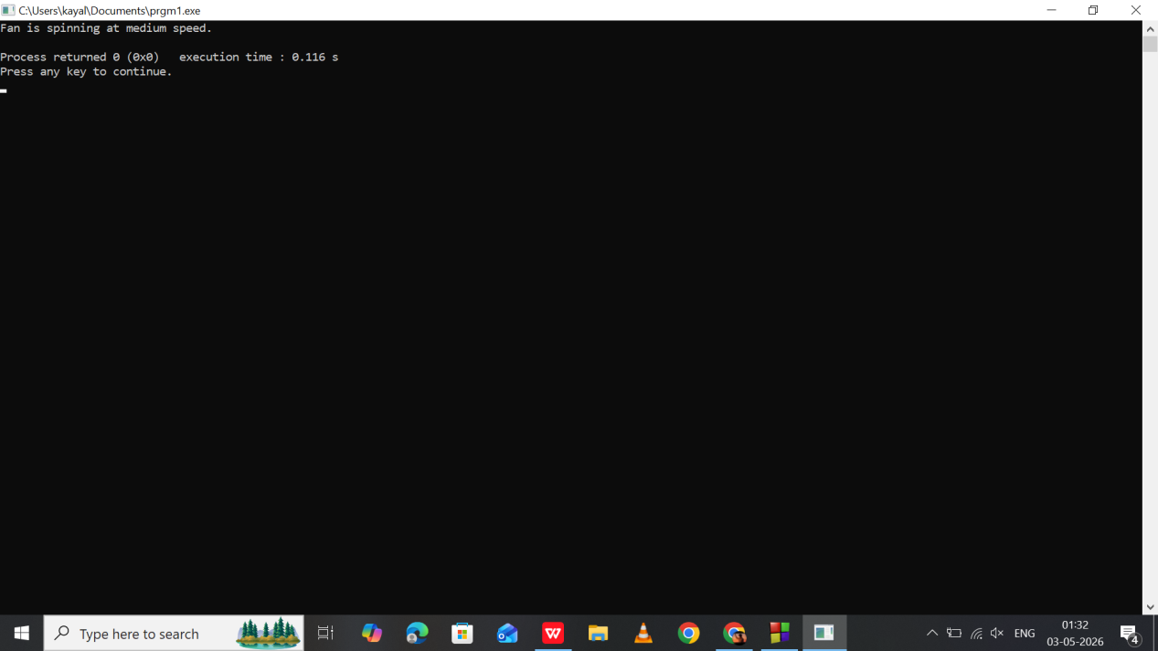

Program 31:
Virtual Function - E-commerce Shipping

#include <iostream>
using namespace std;

class Shipping {
public:
virtual void shipOrder() {
cout << "Order shipped by standard delivery." << endl;
}
};

class SameDayShipping : public Shipping {
public:
void shipOrder() {
cout << "Order shipped with same-day delivery." << endl;
}
};

int main() {
Shipping *s;
SameDayShipping sd;

s = &sd;
s->shipOrder();

return 0;
}

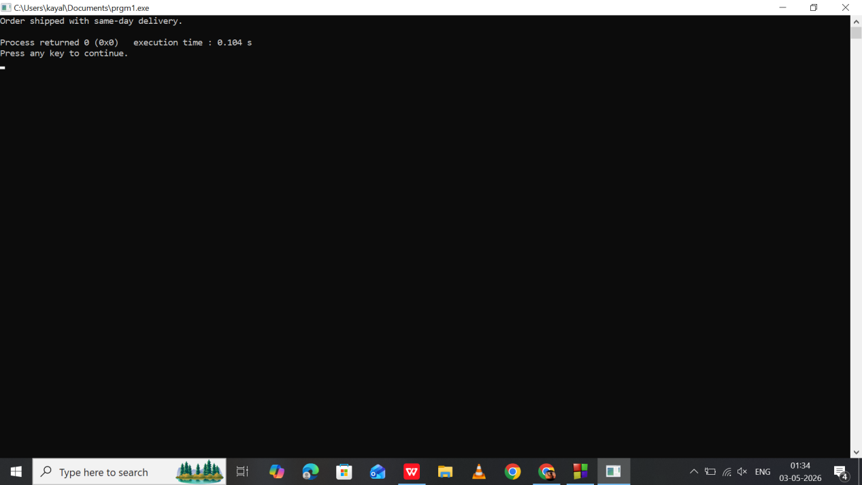

Program 32:
Abstract Class - Entertainment Subscription

#include <iostream>
using namespace std;

class Subscription {
public:
virtual void watchContent() = 0;
};

class PremiumPlan : public Subscription {
public:
void watchContent() {
cout << "Streaming in 4K Ultra HD." << endl;
}
};

int main() {
PremiumPlan p;
p.watchContent();
return 0;
}

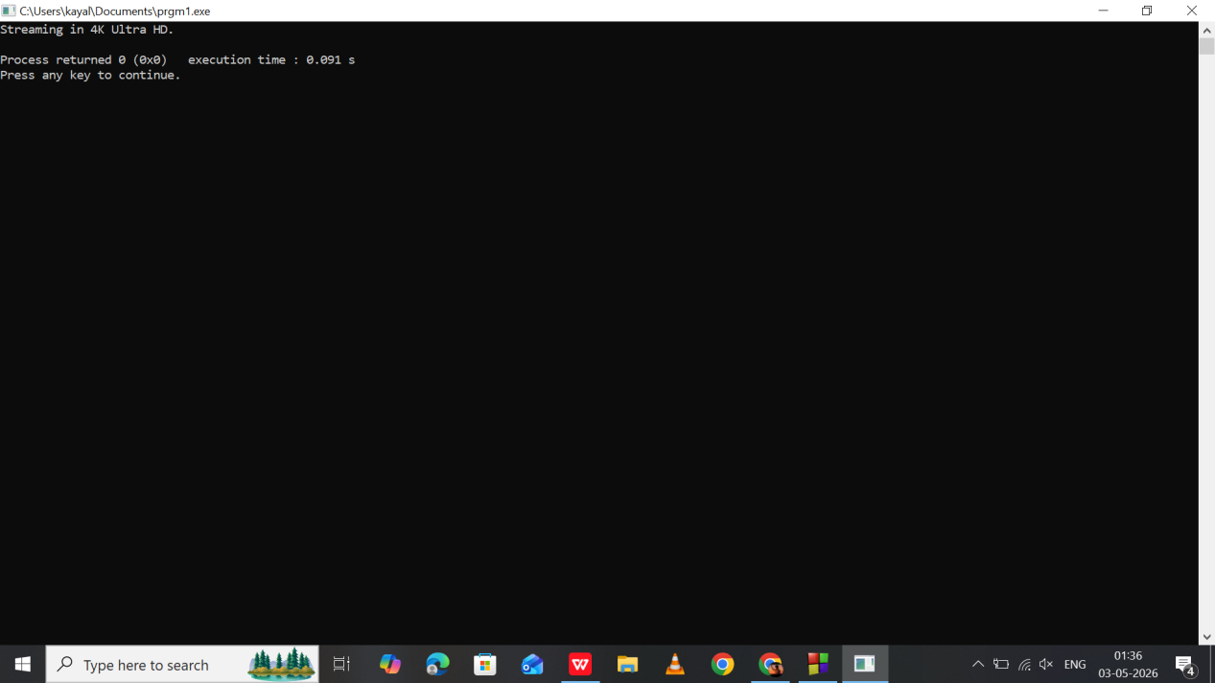

Program 33:
Movie Ticket Booking with Exception Handling
Checks if requested seats are available

#include <iostream>
using namespace std;

int main() {
int availableSeats = 50, bookingSeats;

try {
cout << "Enter number of seats to book: ";
cin >> bookingSeats;

if (bookingSeats > availableSeats) {
throw "Requested seats not available!";
}

cout << "Booking successful for " << bookingSeats << " seats." << endl;
}
catch (const char* msg) {
cout << "Exception: " << msg << endl;
}

return 0;
}

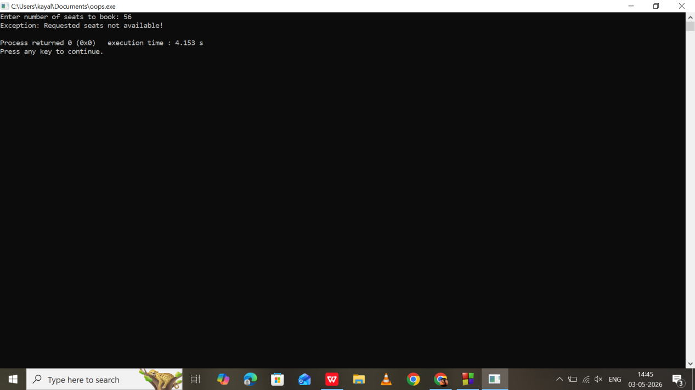

Program 34:
Parking Management with Exception Handling
Prevents parking if slots are full

#include <iostream>
using namespace std;

int main() {
int totalSlots = 20, occupiedSlots;

try {
cout << "Enter occupied parking slots: ";
cin >> occupiedSlots;

if (occupiedSlots >= totalSlots) {
throw "Parking Full! No slots available.";
}

cout << "Parking available. Remaining slots: "
<< totalSlots - occupiedSlots << endl;
}
catch (const char* msg) {
cout << "Exception: " << msg << endl;
}

return 0;
}

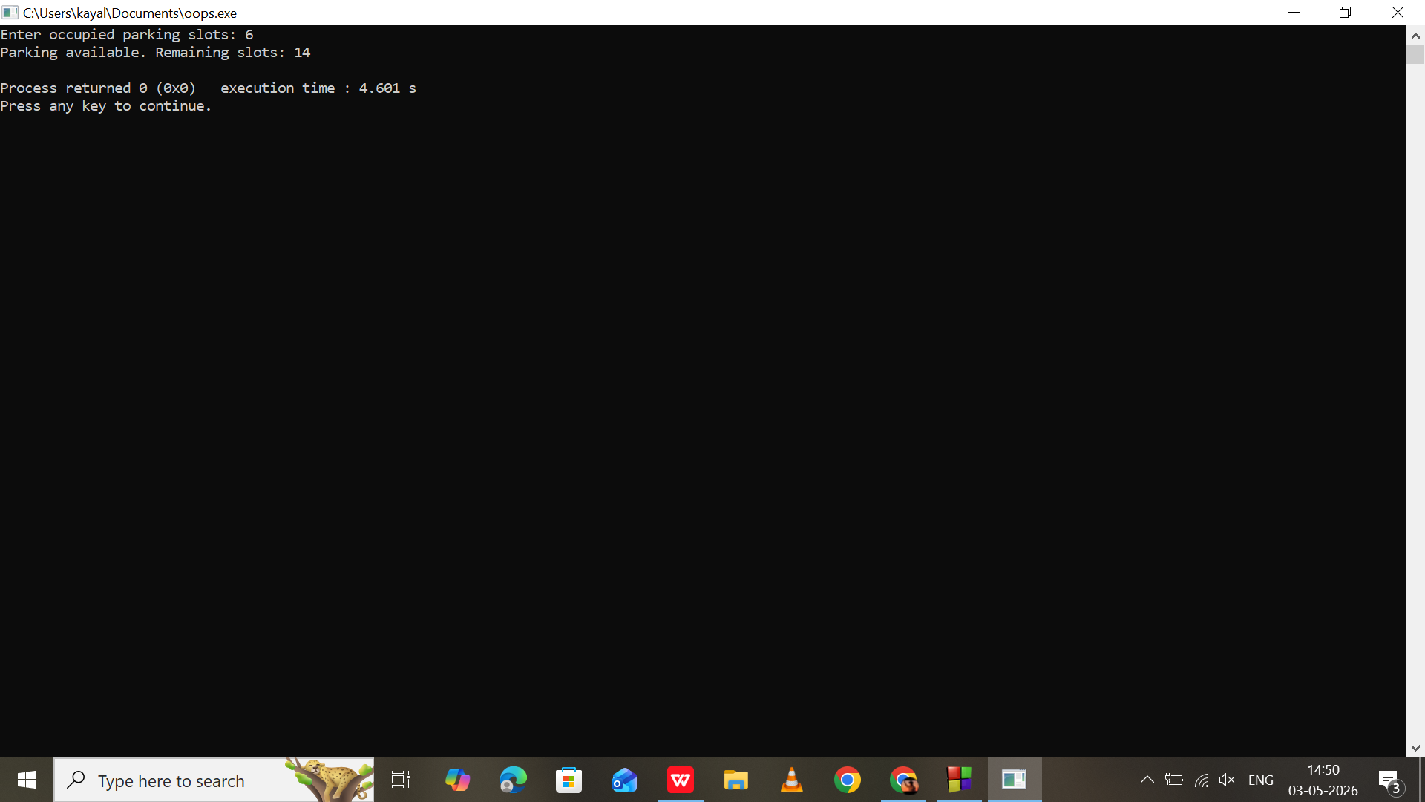

Program 35:
ATM Withdrawal with Exception Handling

#include <iostream>
using namespace std;

int main() {
int choice;
float balance = 10000, amount;

do {
cout << "\n1. Check Balance" << endl;
cout << "2. Withdraw Money" << endl;
cout << "3. Exit" << endl;
cout << "Enter your choice: ";
cin >> choice;

try {
switch (choice) {
case 1:
cout << "Current Balance: " << balance << endl;
break;

case 2:
cout << "Enter amount to withdraw: ";
cin >> amount;

if (amount > balance) {
throw "Insufficient balance!";
}

balance -= amount;
cout << "Withdrawal successful." << endl;
break;

case 3:
cout << "Thank you for using ATM." << endl;
break;

default:
throw "Invalid choice!";
}
}
catch (const char* msg) {
cout << "Exception: " << msg << endl;
}

} while (choice != 3);

return 0;
}

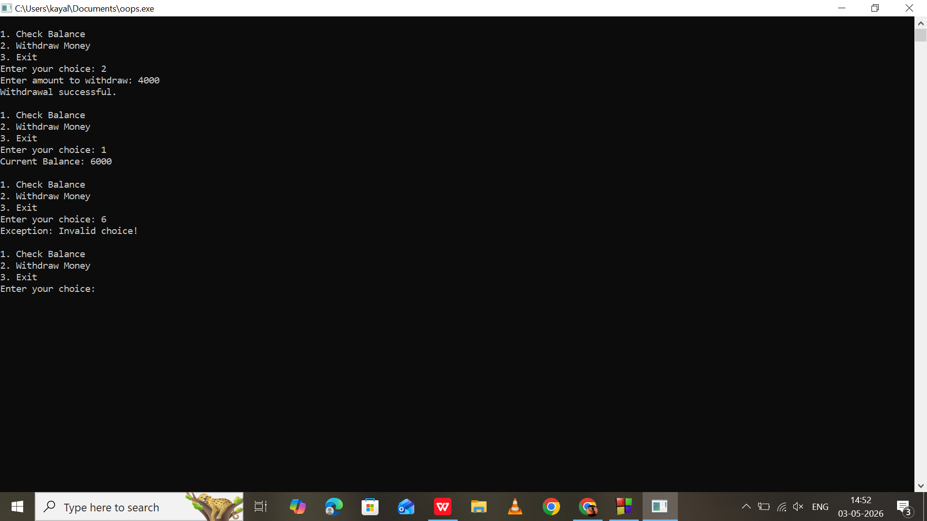

Program 36:
Append Employee Records to a File

#include <iostream>
#include <fstream>
using namespace std;

int main() {
ofstream file("employee.txt", ios::app);

string name;
float salary;

cout << "Enter employee name: ";
cin >> name;

cout << "Enter salary: ";
cin >> salary;

file << "Employee: " << name << " | Salary: " << salary << endl;

file.close();

cout << "Employee record added successfully." << endl;

return 0;
}
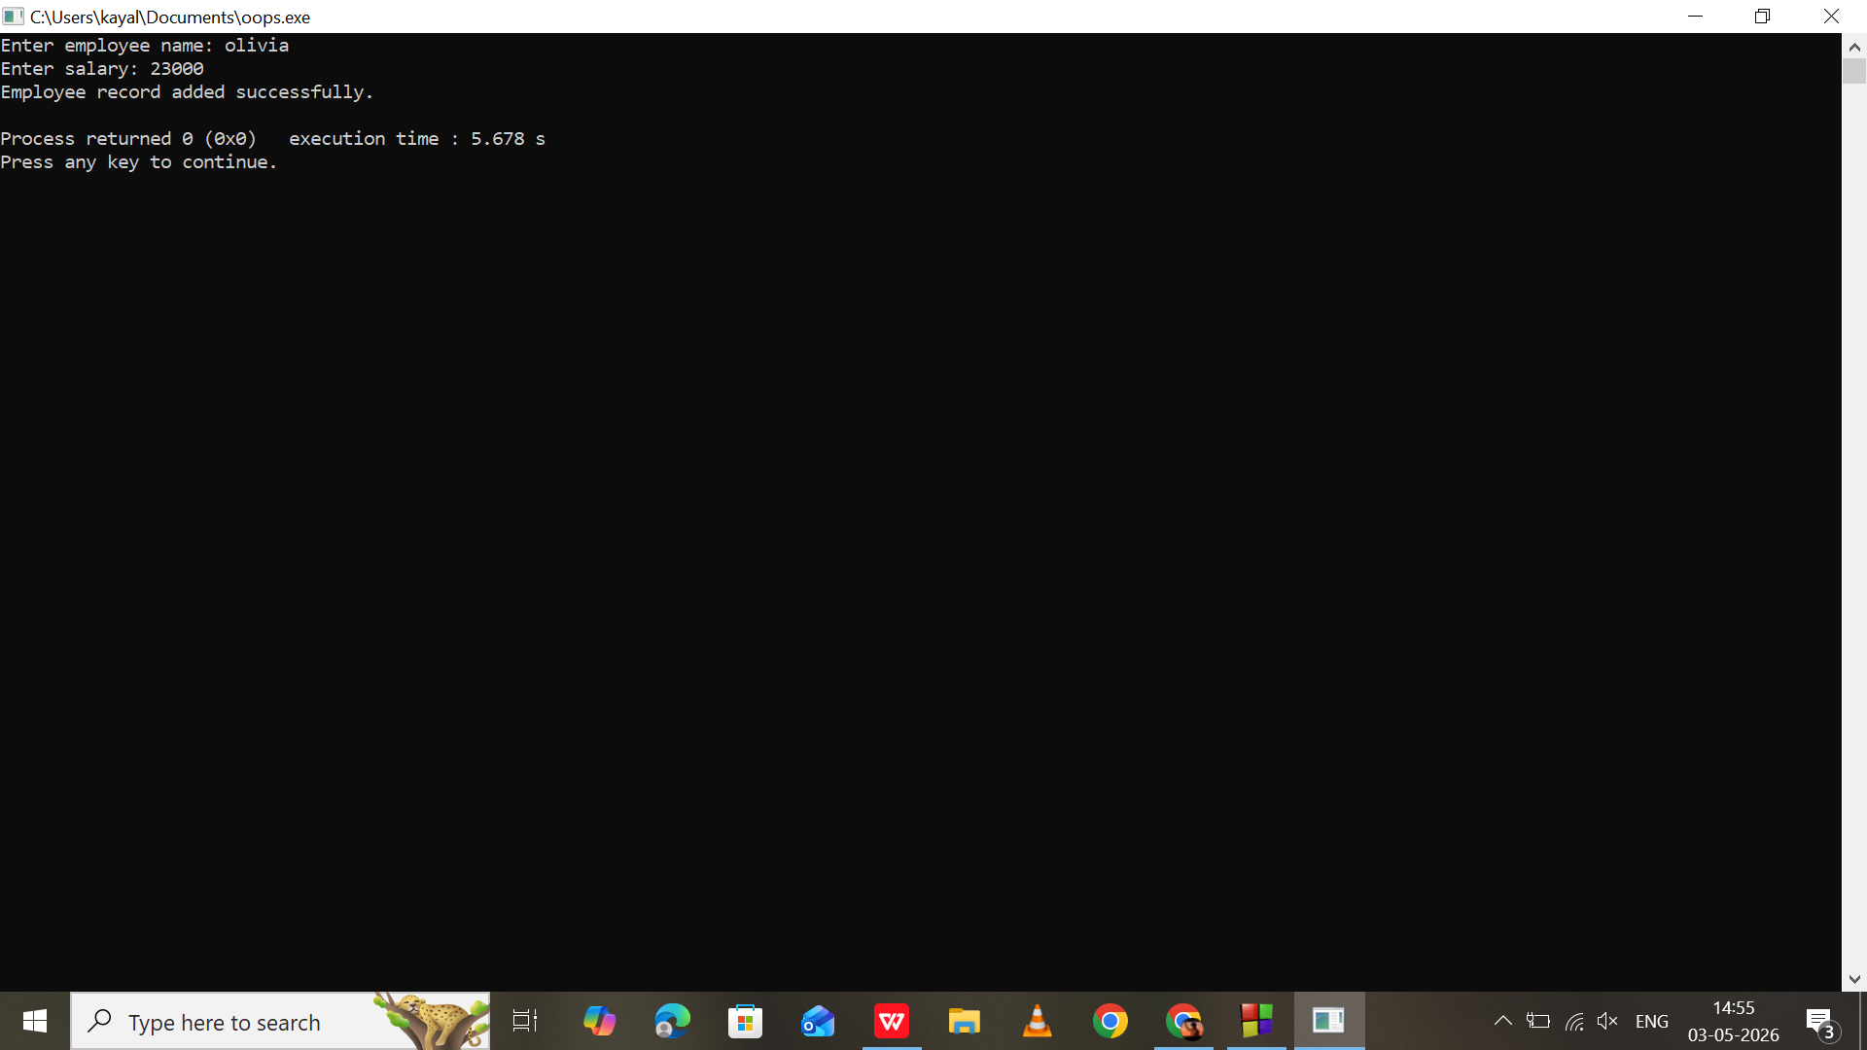

Program 37:
Count Number of Characters in a File

#include <iostream>
#include <fstream>
using namespace std;

int main() {
ifstream file("employee.txt");
char ch;
int count = 0;

while (file.get(ch)) {
count++;
}

file.close();

cout << "Total characters in file: " << count << endl;

return 0;
}

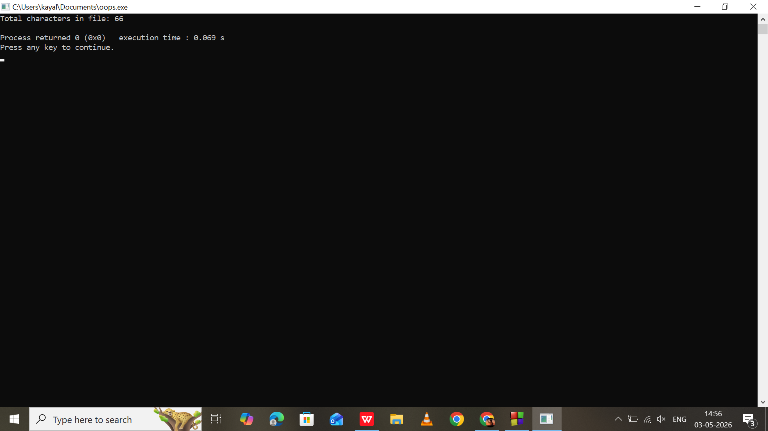

Program 38:
Function Template for Finding Maximum

#include <iostream>
using namespace std;

// Template function
template <class T>
T findMax(T a, T b) {
if (a > b)
return a;
else
return b;
}

int main() {
cout << "Maximum of 10 and 20: " << findMax(10, 20) << endl;
cout << "Maximum of 5.5 and 2.3: " << findMax(5.5, 2.3) << endl;

return 0;
}

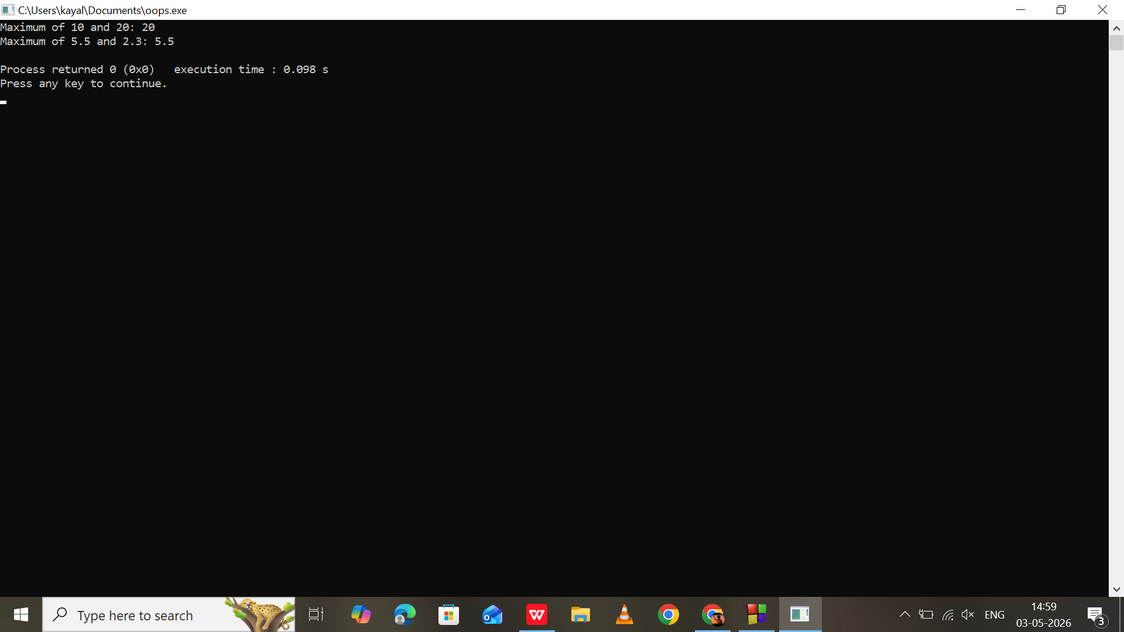

Program 39:
STL vector example

#include <iostream>
#include <vector>
using namespace std;

int main() {
vector<string> tasks;

tasks.push_back("Study");
tasks.push_back("Exercise");
tasks.push_back("Code Practice");

cout << "Daily Tasks:" << endl;

for (int i = 0; i < tasks.size(); i++) {
cout << i + 1 << ". " << tasks[i] << endl;
}

return 0;
}

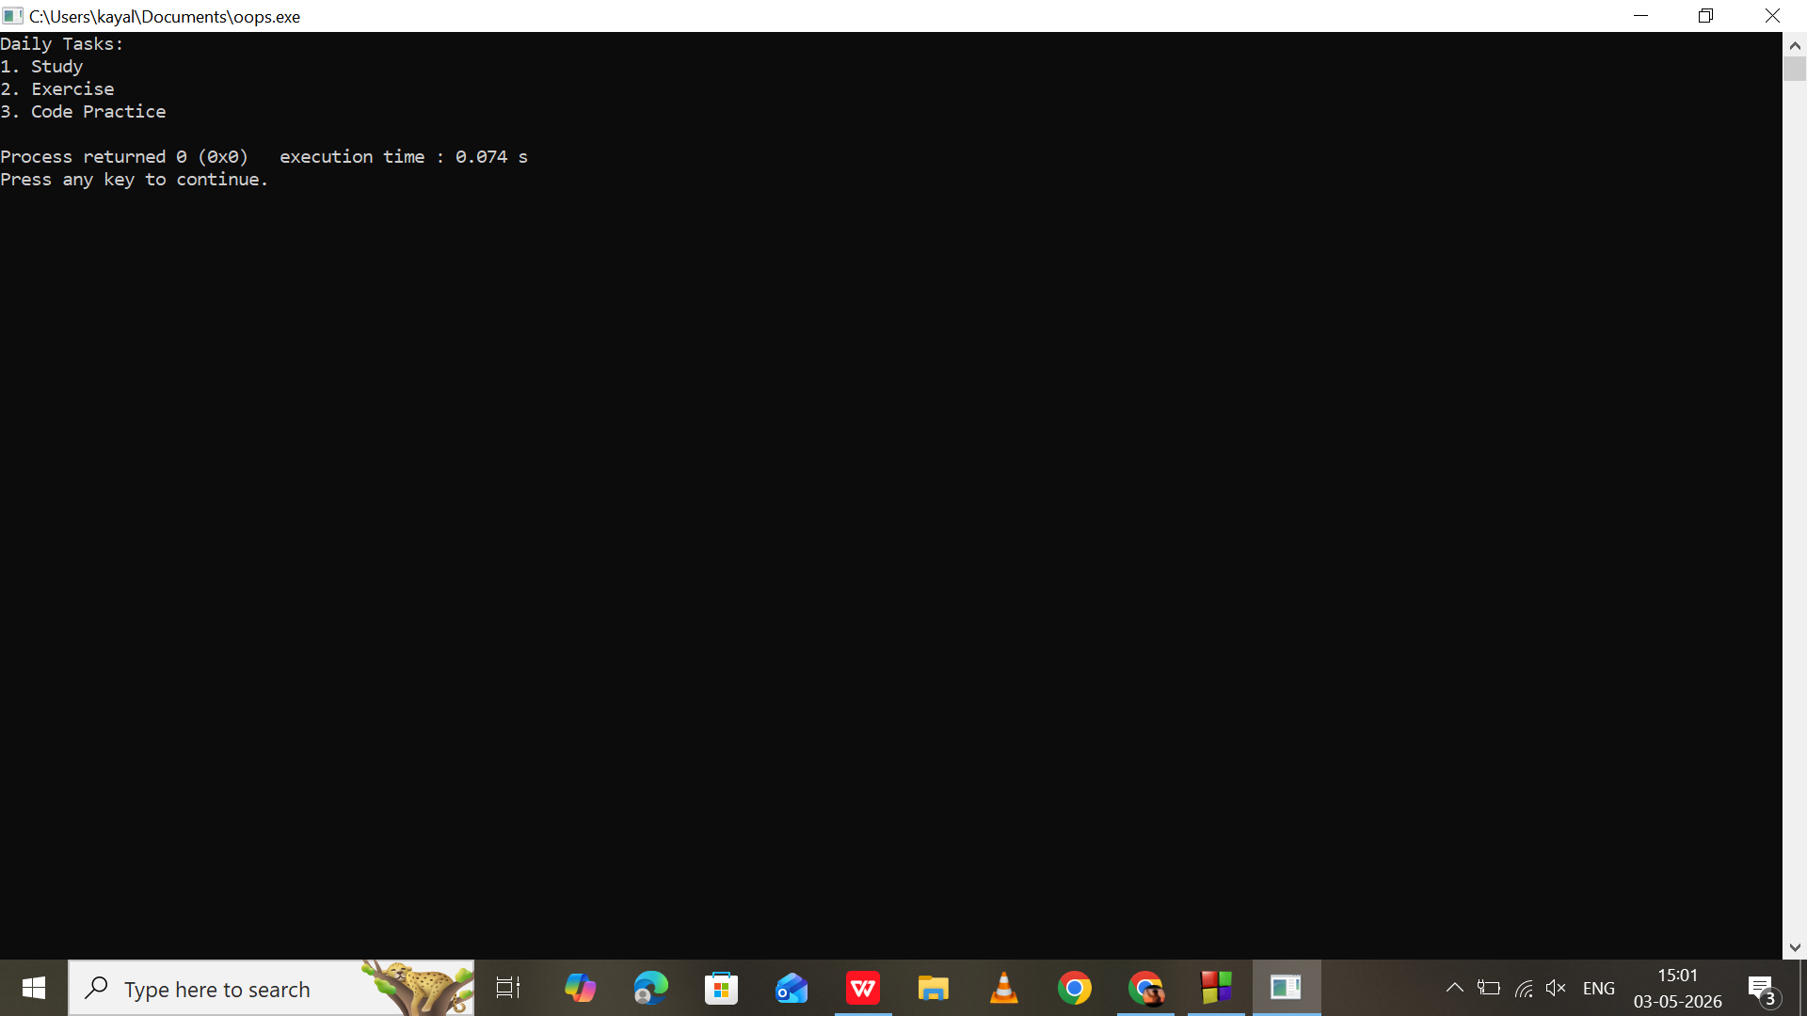

Program 40:
Class template with simple calculator

#include <iostream>
using namespace std;

template <class T>
class Calculator {
private:
T num1, num2;

public:
void getValues() {
cout << "Enter two values: ";
cin >> num1 >> num2;
}

void displaySum() {
cout << "Sum = " << num1 + num2 << endl;
}

void displayProduct() {
cout << "Product = " << num1 * num2 << endl;
}
};

int main() {
Calculator<int> c;

c.getValues();
c.displaySum();
c.displayProduct();

return 0;
}

