Single Point
User Manual
How each role onboards and uses the platform — with worked examples

Covers Resident, Community Admin, Service Provider and Super Admin.
Screens are from the demo environment (release tag mvp-13 + design system v2). Generated 2026-09-06.

How to use this manual
Single Point is one platform with three apps:
App | Who uses it | Where
Mobile app (Expo) | Residents, Community Admins, Service Providers | iOS / Android, or a browser
Super Admin console | The platform operator | Web — a laptop browser
(shared API) | — | All apps talk to the same backend

Work through the section for your role. Every task lists the exact steps, and the screenshots show the demo community “Green Meadows” with sample data.

The demo environment
If you are trying the app against the demo/UAT backend, use these:
Setting | Value
Backend API | http://localhost:18080 (mgmt/health on :18081)
Super Admin console | http://localhost:19020
Mobile app (browser) | npx expo start --web → http://localhost:19012
Sign-in | Mobile number + a 6-digit OTP. In demo mode the code is shown on the screen — no SMS is sent.
Super Admin | +91 90000 00000 (“Platform Owner”)
Green Meadows admin | +91 90000 00101
Service provider (Sparky Electricals) | +91 90000 00301
Resident (Ravi Kumar) | +91 98881 00001

Note On a real phone you receive the OTP by SMS. Everything else is identical.

1. Signing in (all roles)
- Open the app. You land on the sign-in screen.
- Enter your mobile number in international format (e.g. +91 98881 00001) and tap Send code.
- Enter the 6-digit code. In the demo it is displayed on screen; on a real device it arrives by SMS.
- You are taken to your home screen. Your role decides which app / tabs you see.
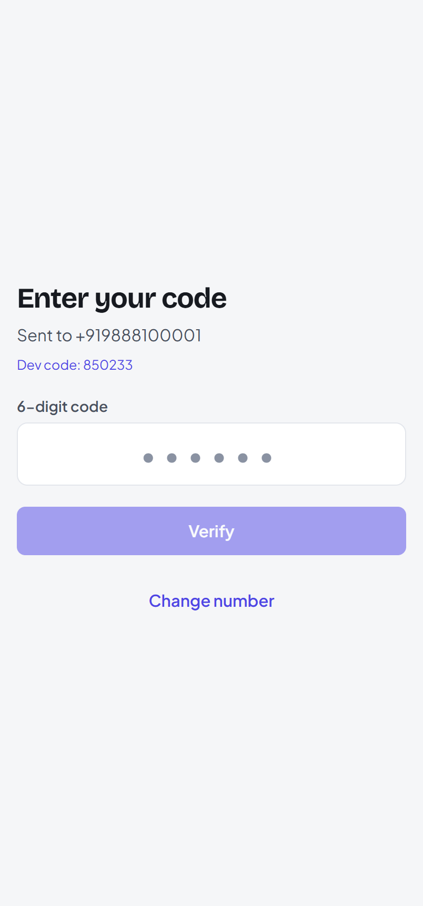  The verification-code screen (demo shows the code). | 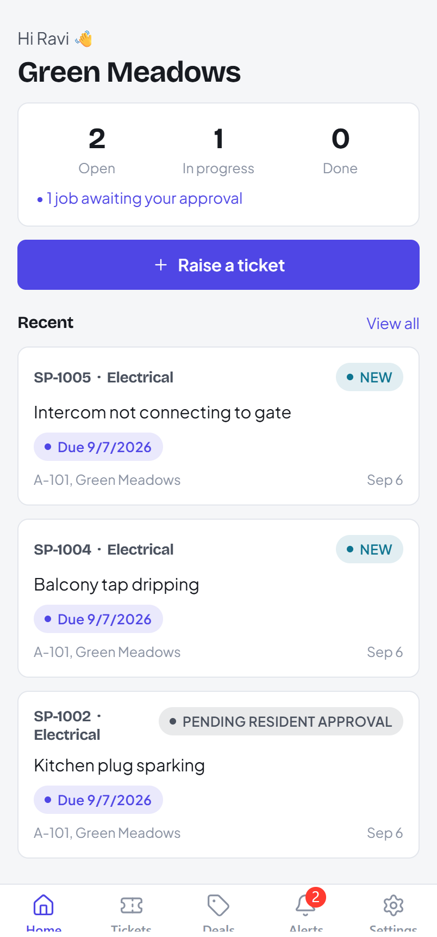  A resident's home screen after signing in.

Note Your session lasts 24 hours and renews as you use the app. If you sign in on a new device you may be asked to verify again — see “Devices” under the Resident guide.

2. Resident guide
A resident raises and tracks service requests, books verified vendors, redeems offers, manages their household, and controls their own account.

2.1 Onboarding — join your community
- Sign in with your mobile number (section 1).
- Enter your name and email when prompted — this completes your profile.
- You need an invite code from your community admin (or you can send a join request for the admin to approve). Search for your community, enter the code, and tap Join.
- You now see your community name on the home screen and can raise tickets.
Note No community yet? You can still book a verified provider directly — tap Book a service on the home screen.

2.2 Raise a ticket
- On the home screen tap Raise a ticket.
- Pick a category (e.g. Electrical), type what's wrong, and set a priority.
- Add the service location — your flat is pre-filled; adjust the address, drop a pin, or add a landmark. Attach photos if it helps.
- Tap Submit. The ticket gets a reference like SP-1005 and starts in NEW.
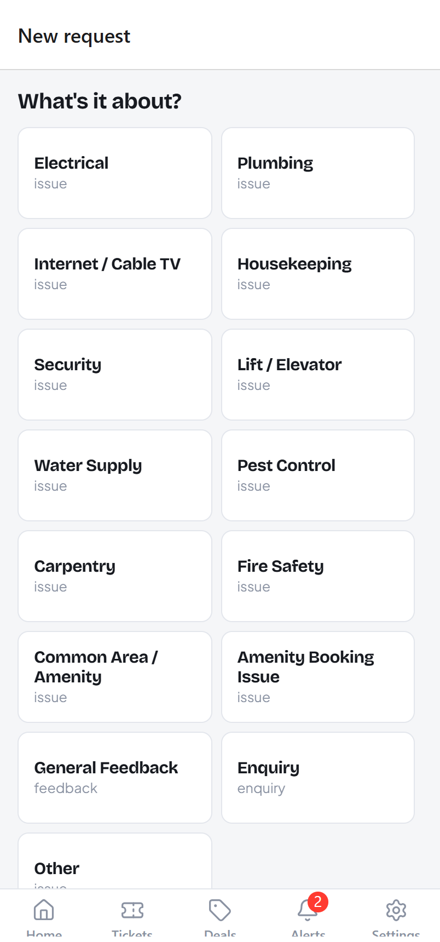  The raise-a-ticket form. | 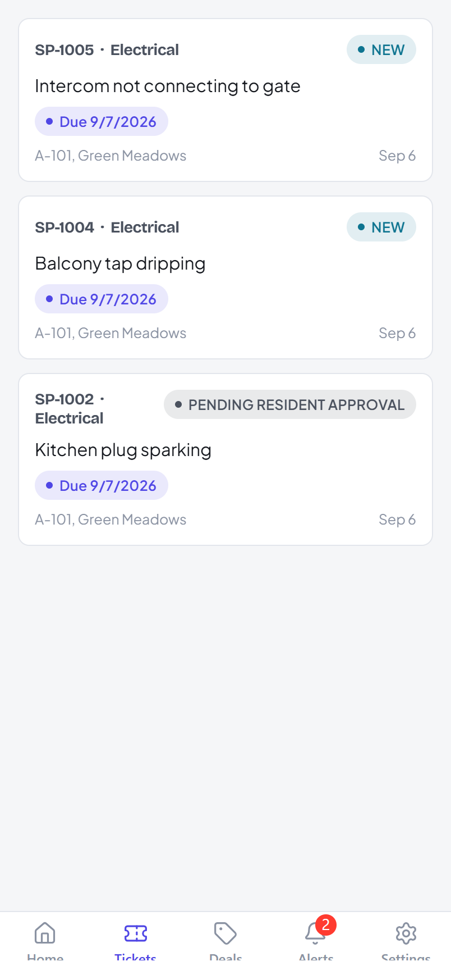  Your tickets, newest first, each with a status pill.

2.3 Track a ticket to closure
Open any ticket to see its full timeline — who did what and when.
- NEW → ACKNOWLEDGED — the admin has seen it.
- ASSIGNED — a provider (e.g. Sparky Electricals) is coming. You may be asked to approve the provider.
- IN PROGRESS → RESOLVED — the work is done.
- You then Close the ticket with a 1–5 star rating, or Reopen it if it isn't fixed. A resolved ticket you don't touch auto-closes after a few days.

2.4 Deals and feedback
- Open the Deals tab to see offers targeted at your community or at you personally.
- Tap an offer, then Redeem — you can redeem each offer once, and some offers have a total cap.
- After redeeming you can leave a star rating and a comment for the provider.
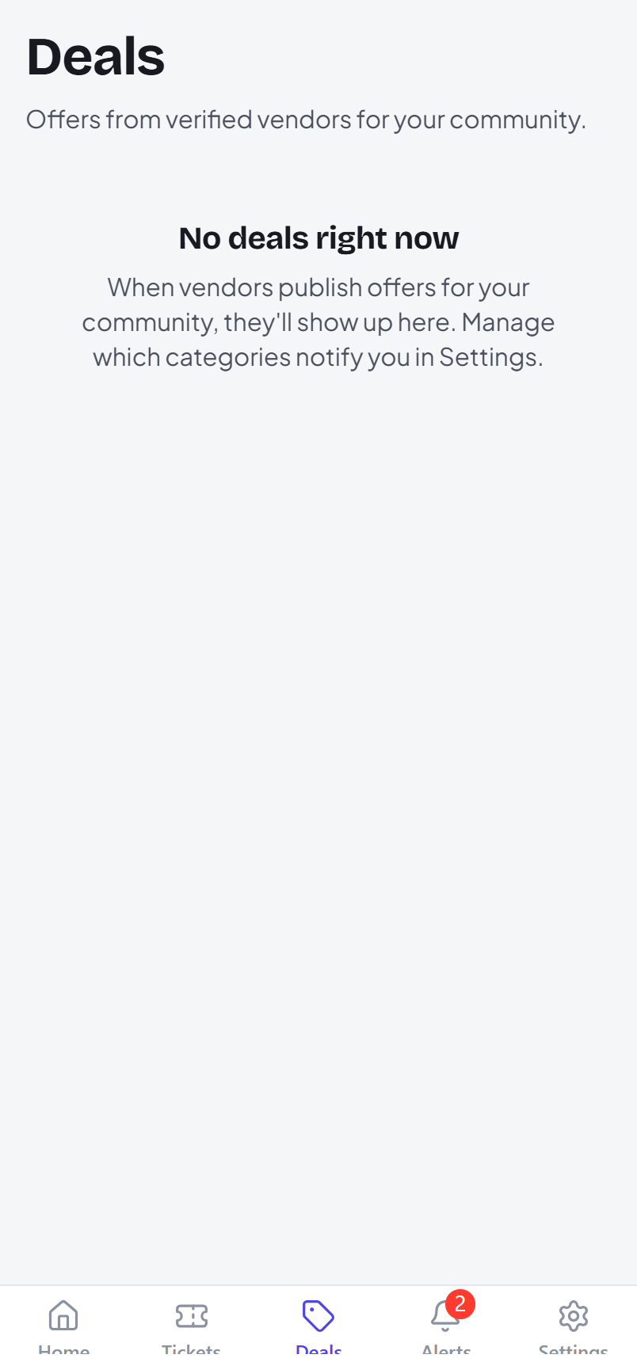
The Deals tab.

2.5 Alerts — your notification inbox
The Alerts tab collects every ticket update, offer and community announcement. A red badge shows the unread count. Tap a row to mark it read, or use Mark all read.
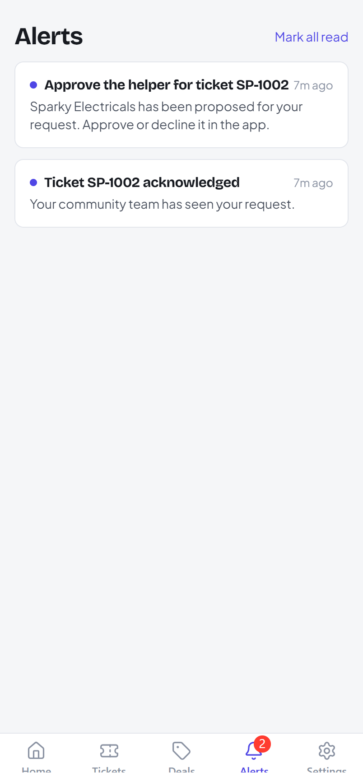
The in-app notification inbox.

2.6 Household
- From your community screen open Household.
- As the flat's primary member, tap Invite and share the household code with a family member.
- They redeem it during sign-up and join your flat as a secondary member — no admin approval needed.
- You can remove a secondary member from the same screen.

2.7 Settings — notifications, devices, privacy
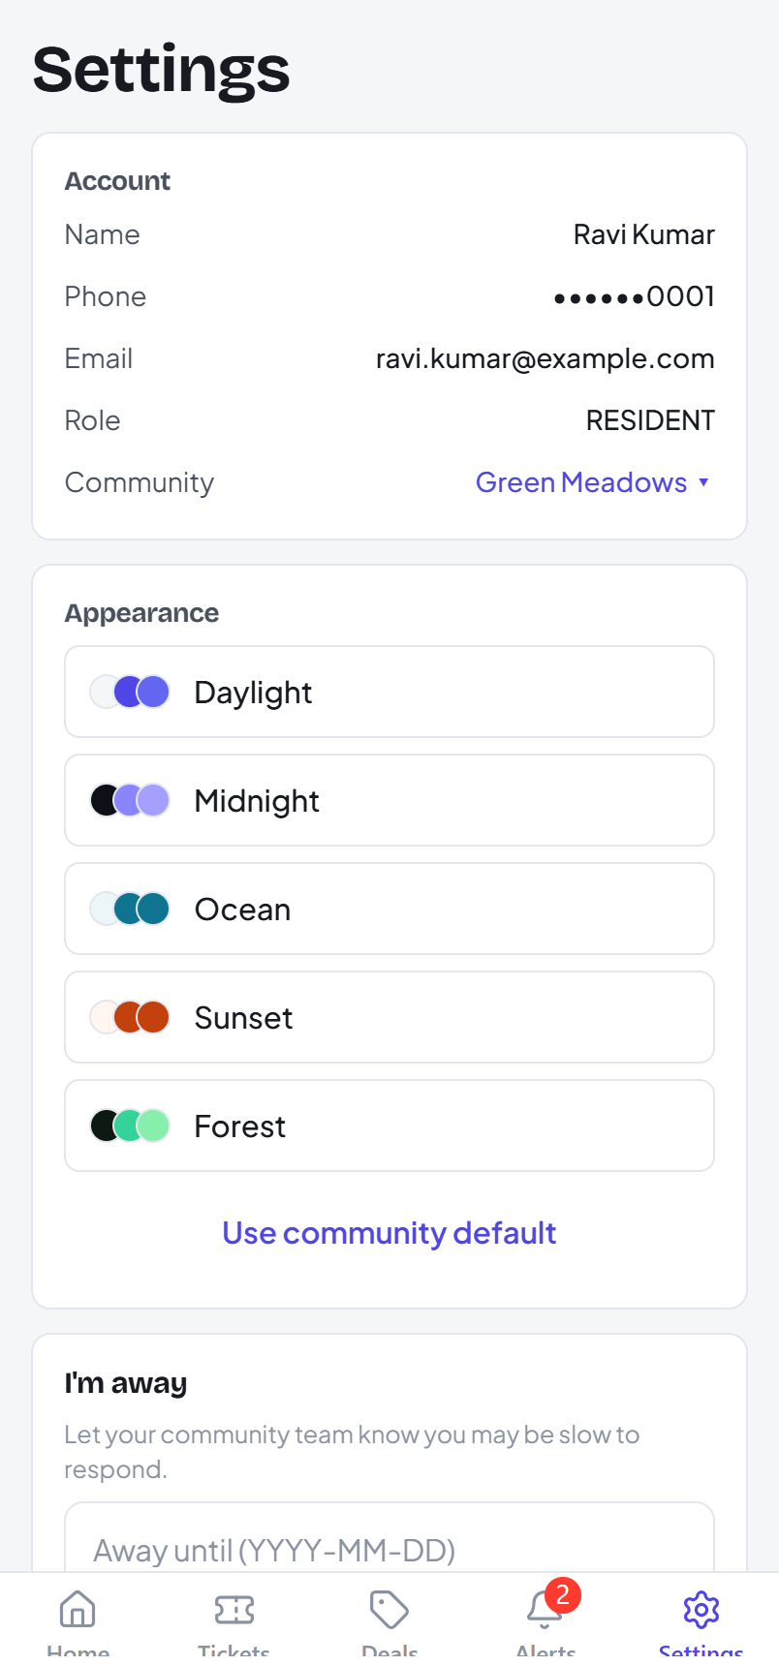
Resident settings.
- Notifications — turn push on/off; opt in to Offers on WhatsApp.
- Devices — see everywhere you're signed in. Sign out a lost device, or Sign out all other devices.
- Download my data — get a single JSON file with everything the platform holds about you.
- Delete my account — closes and anonymises your account. Blocked while you have an open ticket or an unpaid bill; clear those first.

3. Community Admin guide
A community admin runs one or more communities: triaging tickets, managing members and flats, enrolling providers, sending announcements, and looking after the community's plan.

3.1 The ticket queue
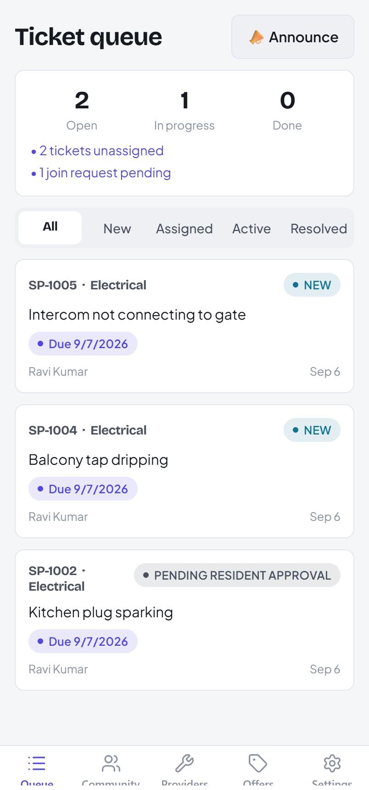
The admin queue with action items at the top.
The queue shows every ticket in your community with filters (New / Assigned / Active / Resolved) and highlights what needs you — unassigned tickets, pending join requests, SLA breaches.
Open a ticket to act on it:
- Acknowledge — tell the resident you've seen it.
- Assign to provider — pick an enrolled, verified provider; they're notified.
- Reroute — move it to a different provider.
- Resolve directly — close it out with in-house staff and resolution notes.

3.2 Members
- Open Community → Members for the roster.
- Removal check — before removing someone the app lists any open tickets or unsettled bills; these must be cleared first (there is no override).
- Remove — the person keeps their app account but loses this community's features.

3.3 Community setup
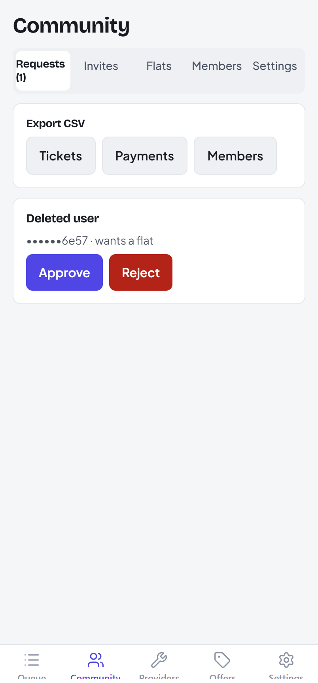
Community management — flats, locations, codes.
- Flats & locations — register blocks/flats and the community's locations.
- Invite codes — issue codes for residents to self-join (community-wide or flat-specific).
- Direct service — allow residents to book verified providers directly.
- Branding — set the community name, default theme and an accent colour.

3.4 Providers
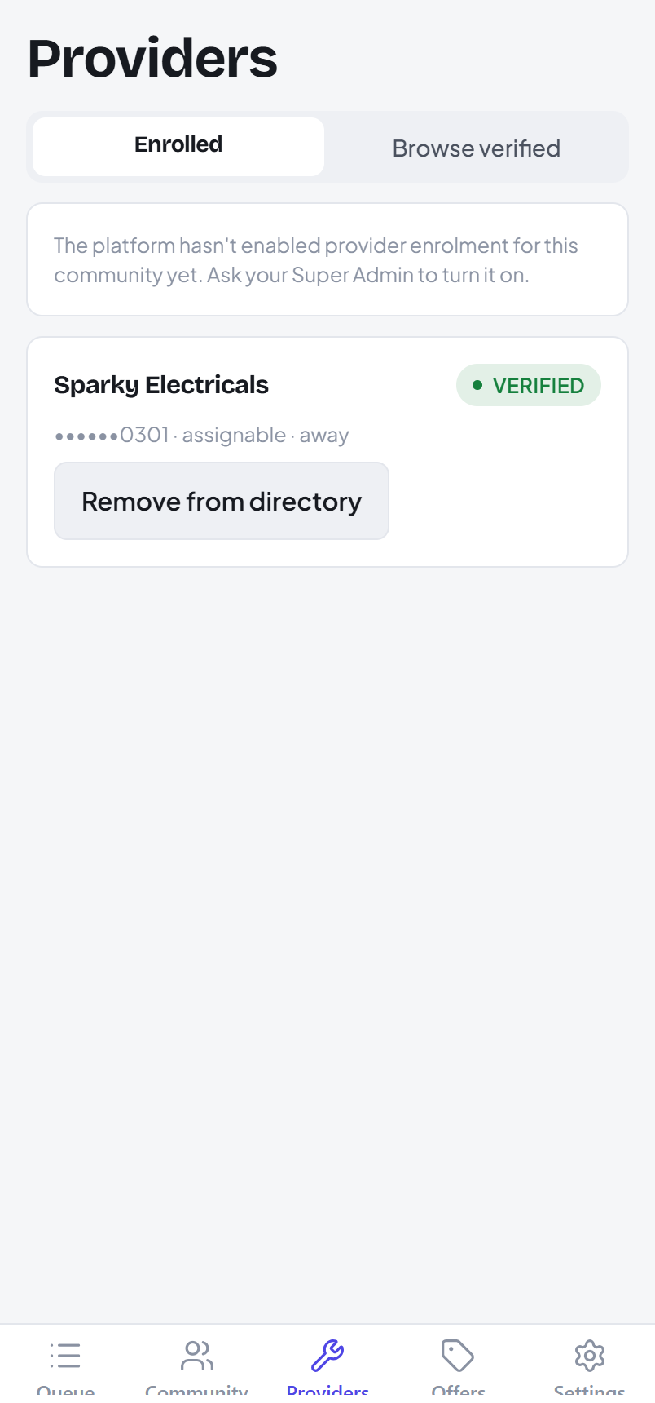
Browse the verified catalogue and enrol providers.
You can browse the platform's verified providers and Enrol one into your community so it becomes assignable. Verification and KYC are done by the Super Admin — you only enrol.

3.5 Announcements
- From the queue tap Announce.
- Write a title and message. Leave Send at blank to send now, or pick a future time to schedule it.
- Scheduled announcements appear as PENDING and can be cancelled before they go out.
Note Announcements are rate-limited: a 60-second cooldown and 20 per day.

3.6 Billing
- Billing shows your plan, your usage against each limit, and any due invoices.
- Upgrade to a paid plan; a mid-cycle change is prorated.
- Pay a due invoice to get a payment link. With a saved payment method the plan renews automatically.

4. Service Provider guide
A verified provider accepts assigned jobs, records payment, keeps KYC current, and can submit offers for Super Admin approval.

4.1 Jobs
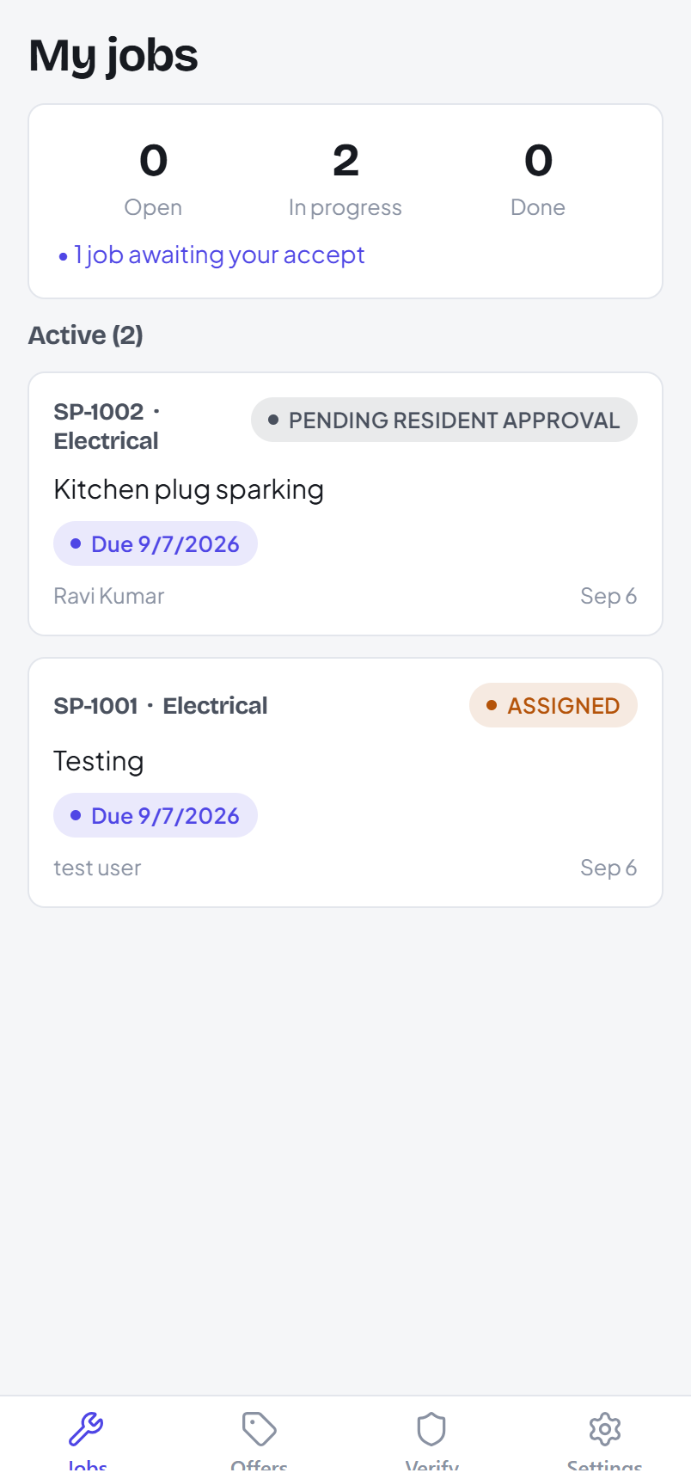
The provider's job list.
- A new job arrives as ASSIGNED with a notification. Open it and Accept (or decline — the resident can then rebook someone else).
- Move it along: mark yourself en route, then In progress.
- Resolve with resolution notes when the work is done. The resident closes and rates it.

4.2 Getting paid
- Online — create a charge on the ticket; the resident gets a payment link and pays. A receipt is issued automatically when the payment settles.
- Cash — mark it as cash; the resident reads you a one-time code; you confirm it to settle.
- Every settled payment produces a receipt you can share.

4.3 KYC and profile
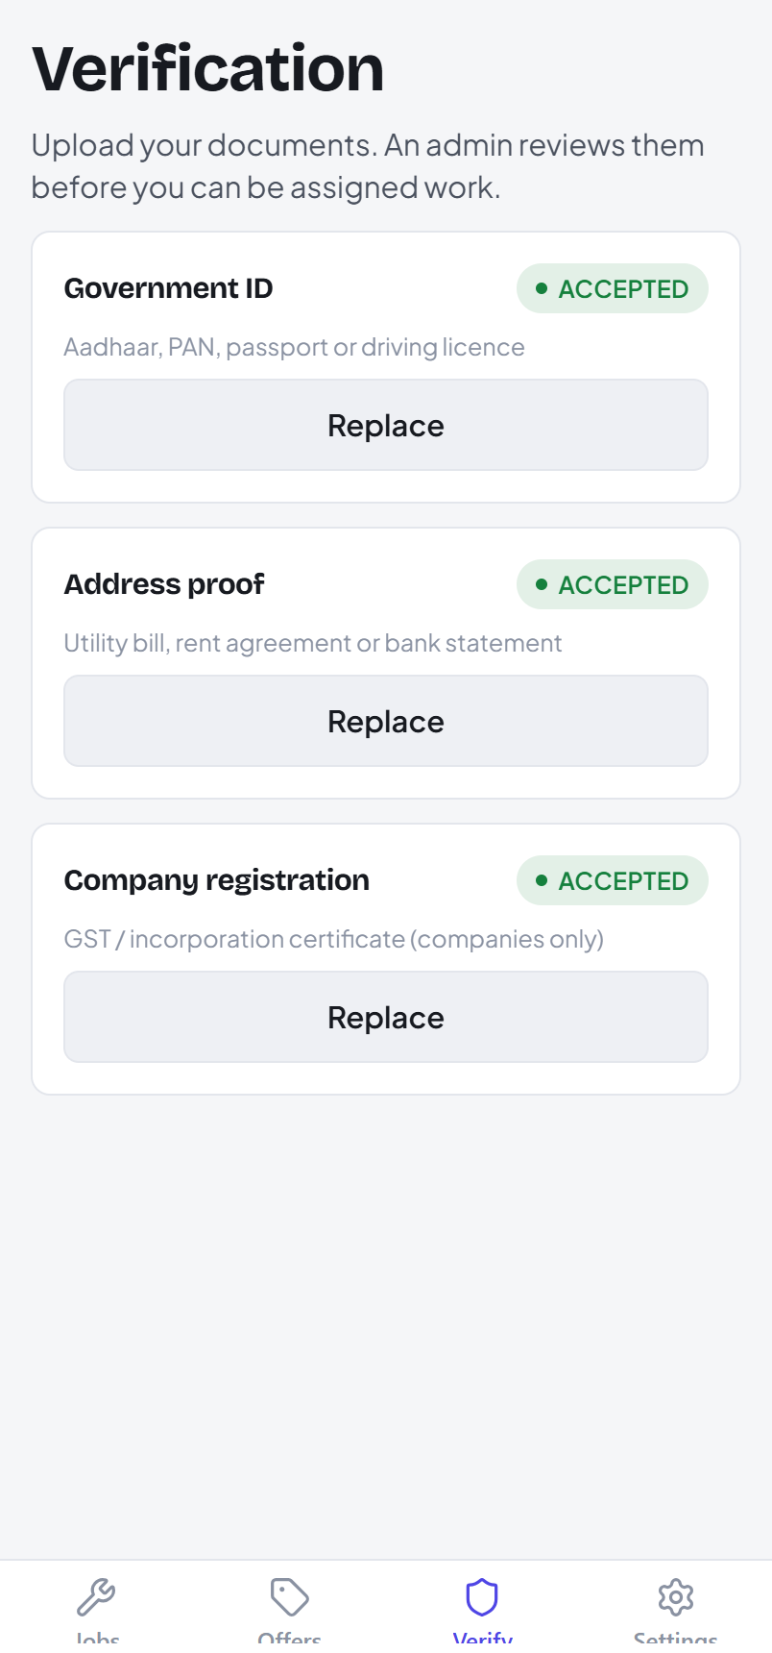
KYC document status.
- Upload the documents the Super Admin asks for; each shows Pending → Accepted.
- Keep your availability windows and service categories current — residents see these in the directory.

4.4 Offers
- Open Offers → New and set the discount, validity window and audience (a community, a set of communities, named individuals, or everyone).
- Submit for approval. The Super Admin approves or rejects it; once ACTIVE the audience is notified.

5. Super Admin guide (web console)
The Super Admin runs the platform from the web console at http://localhost:19020. Sign in with +91 90000 00000; the console rejects any non-Super-Admin.
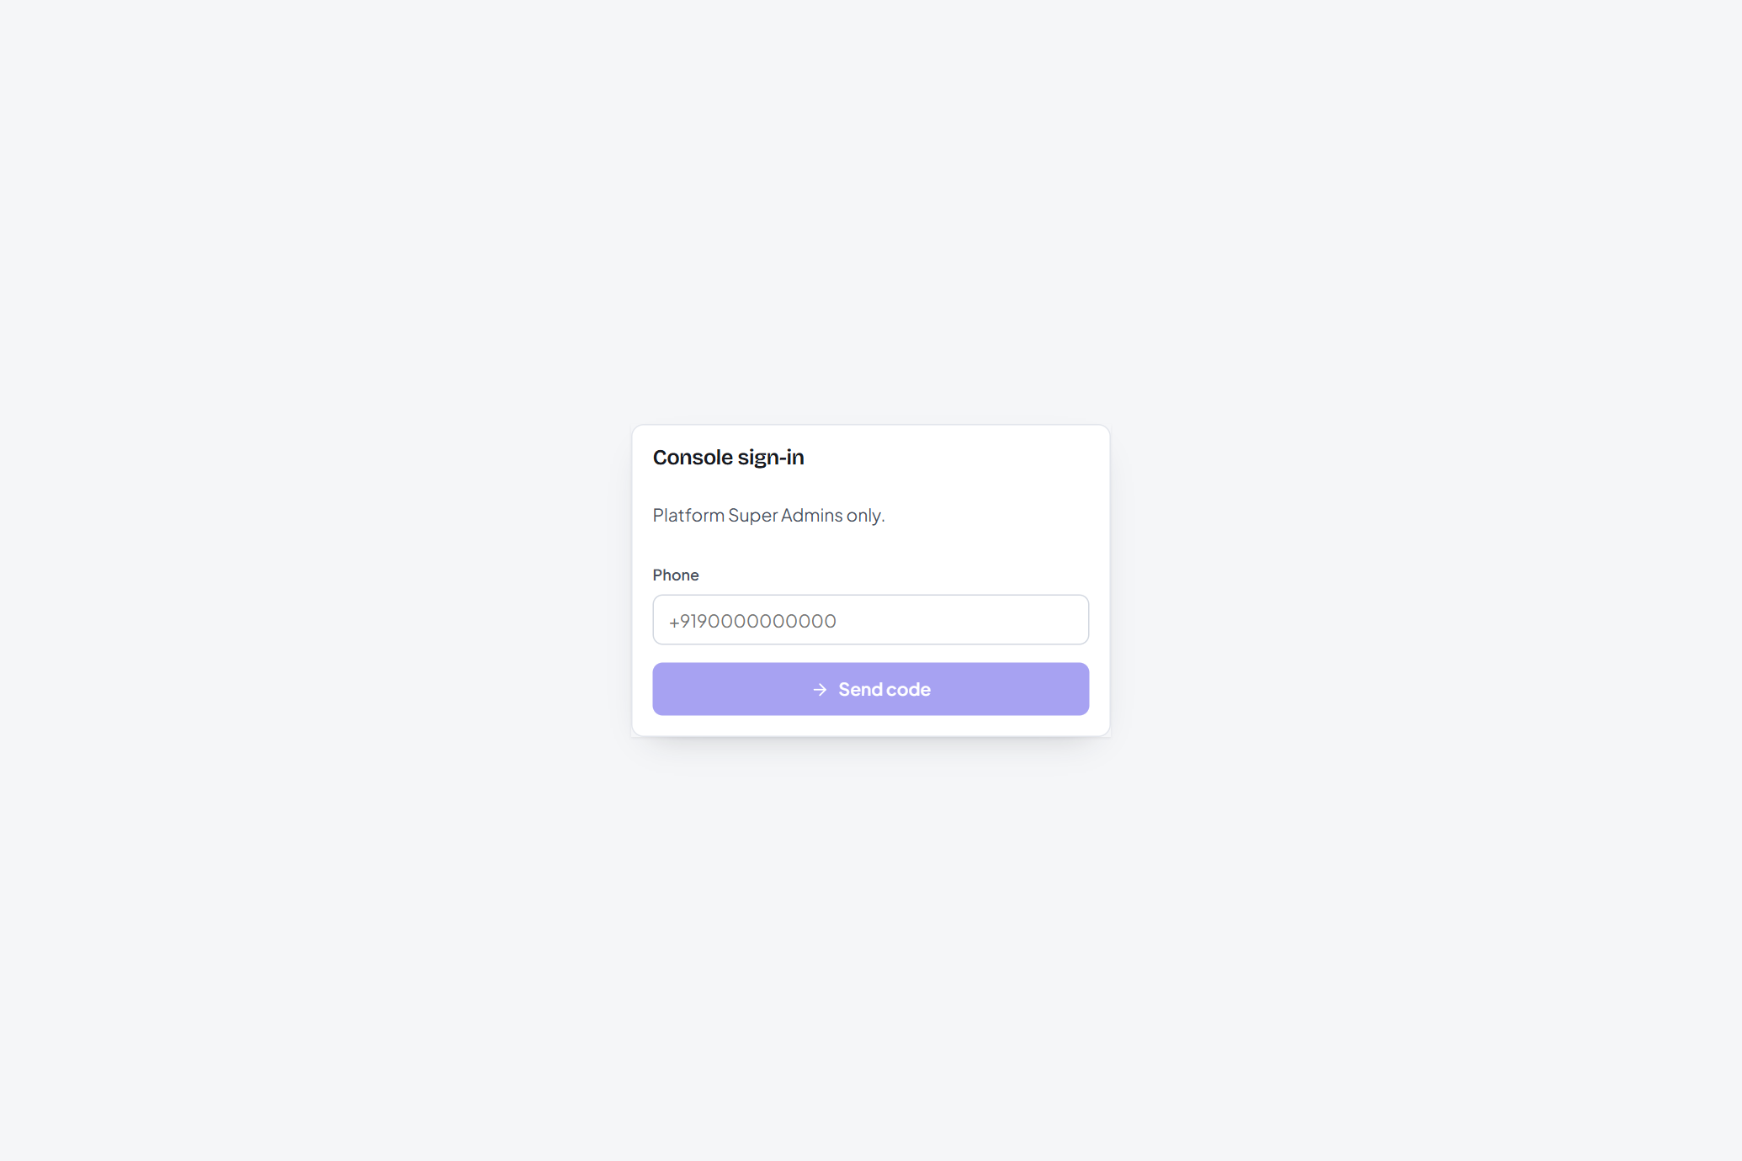
Console sign-in.

5.1 Dashboard
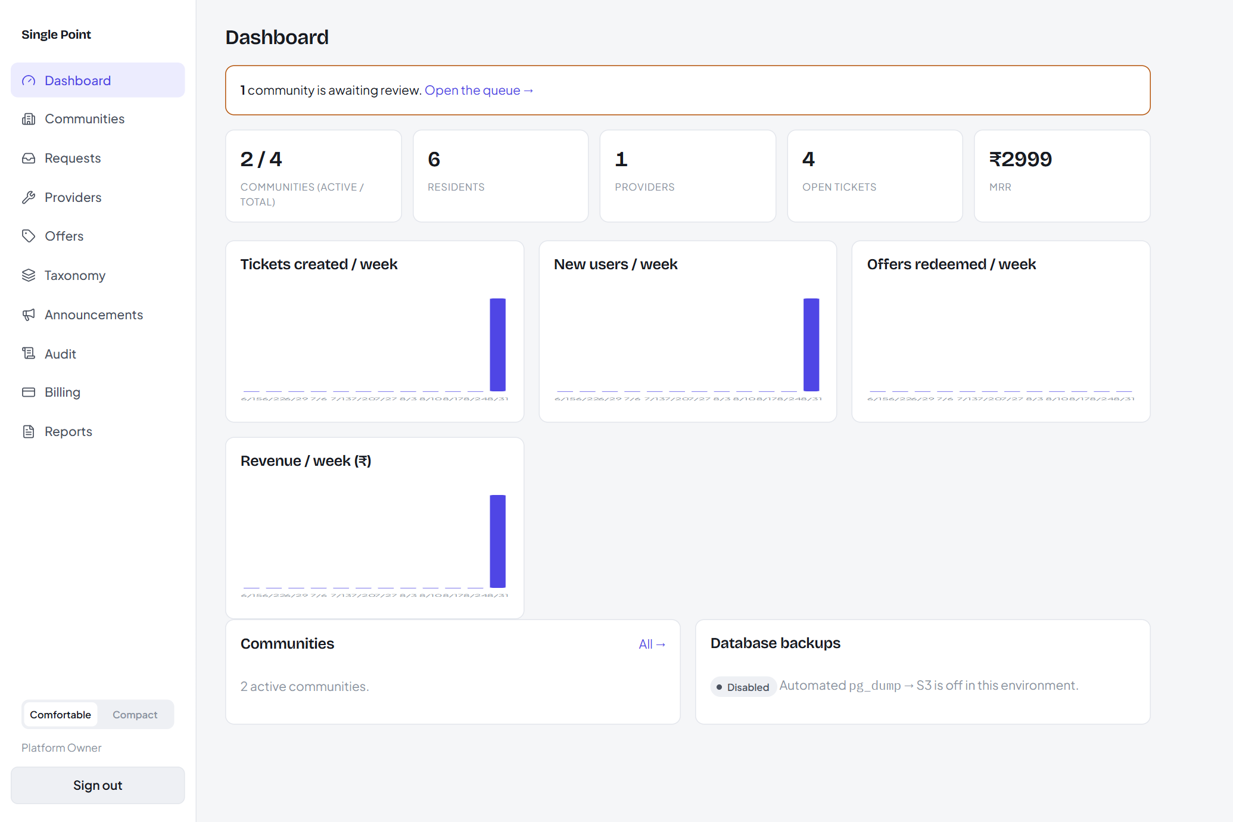
Platform totals, weekly trends, review queue and backup status.
The top strip shows active/total communities, residents, providers, open tickets and MRR. A callout flags communities awaiting review. The Database backups tile shows the last backup age (Disabled in the demo).

5.2 Communities and the onboarding queue
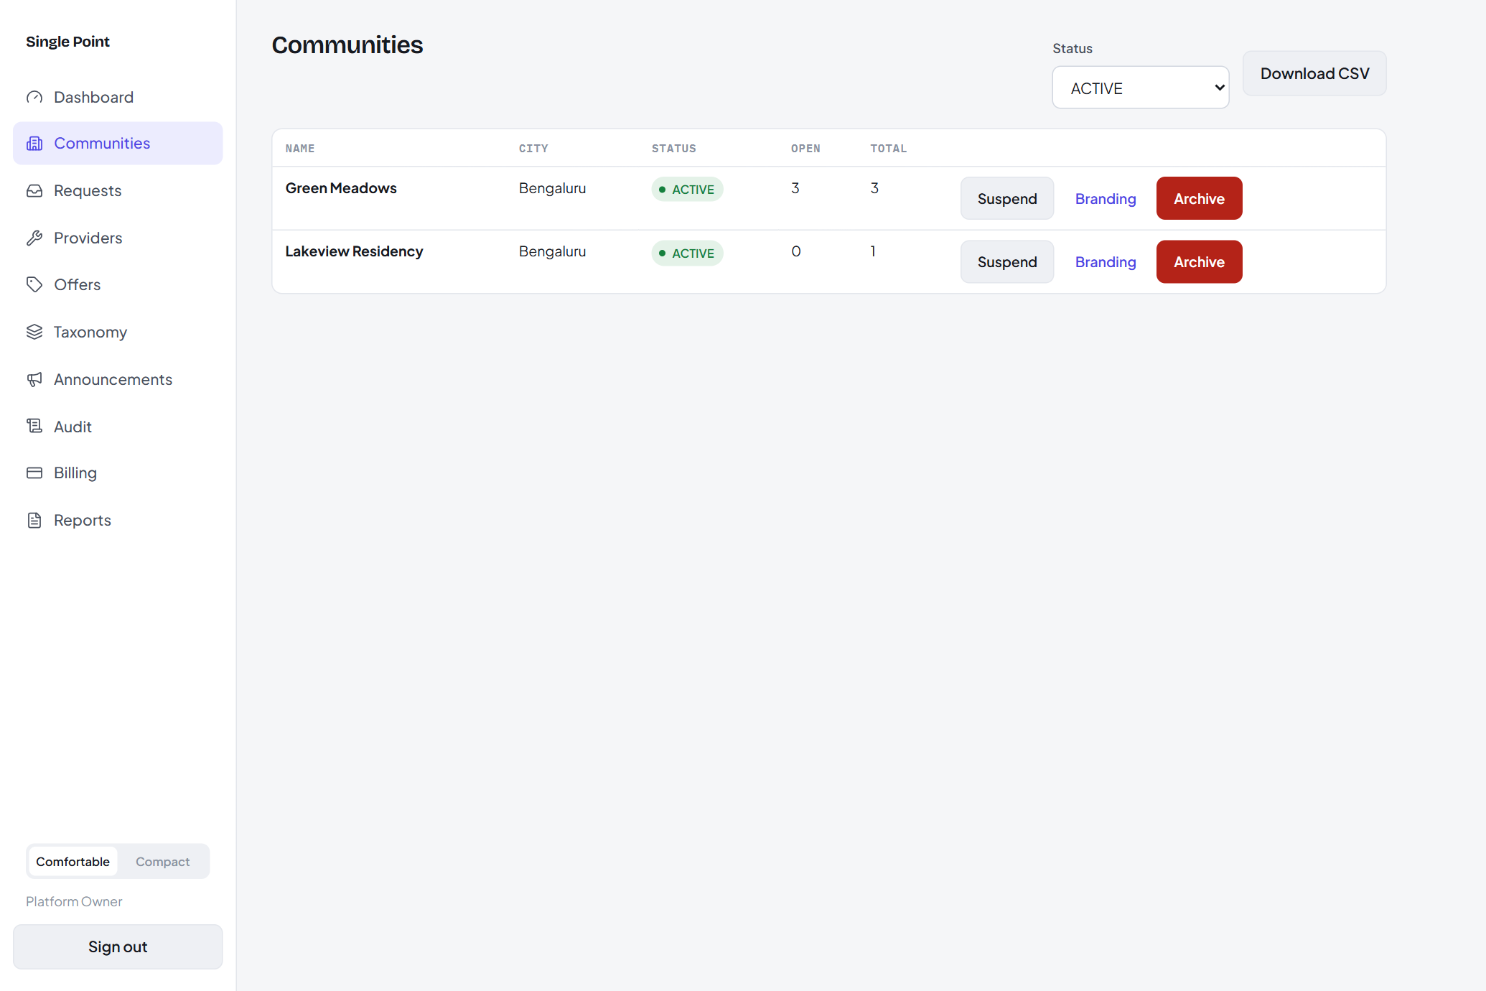
Communities with health, plus suspend / archive / reactivate.
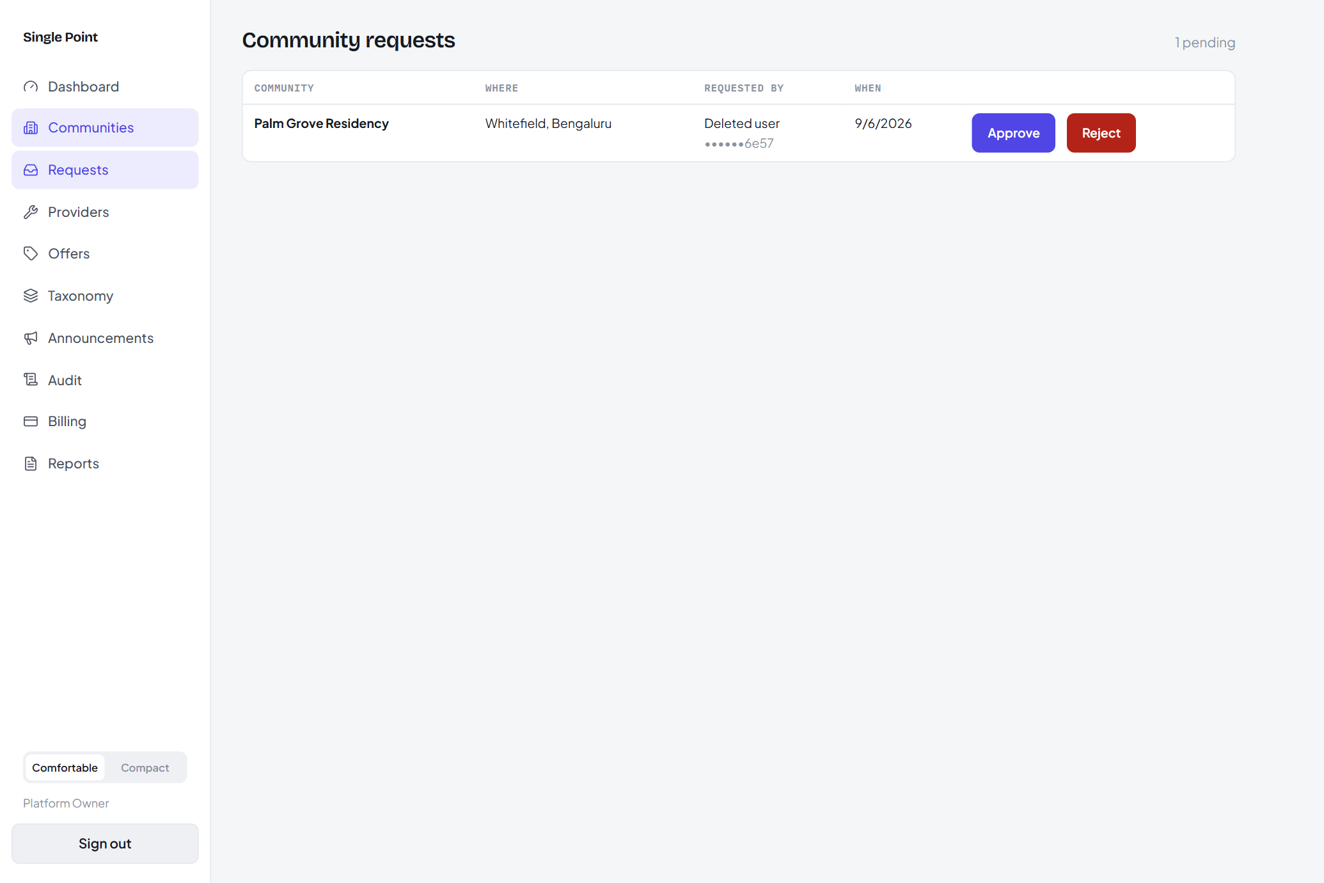
The self-onboarding request queue.
- Open Requests to see communities that have self-registered.
- Approve — the community goes live and the requester becomes its admin, with a “Main” location seeded.
- Reject with a reason — the requester is notified.
- On Communities you can suspend, archive or reactivate an existing community and edit its branding.

5.3 Providers — verify, KYC, tier
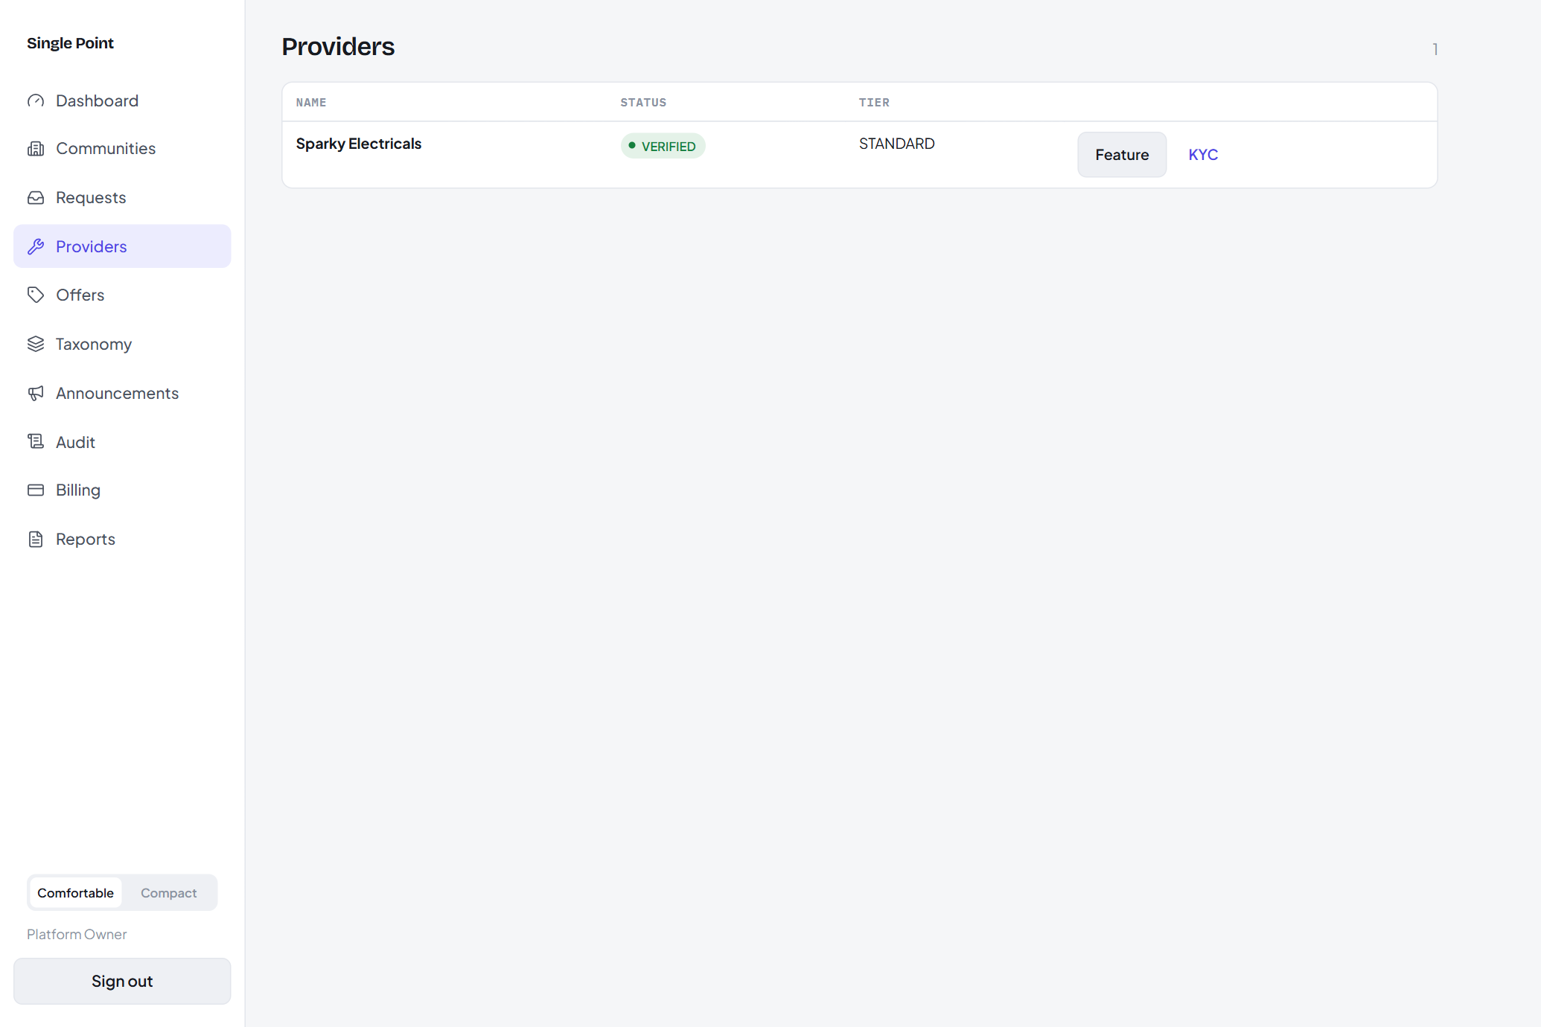
Provider onboarding and verification.
- Create a provider, then Verify it (VERIFIED / REJECTED).
- Review each KYC document and accept it.
- Set a tier — FEATURED providers sort ahead of STANDARD in the resident directory.

5.4 Billing — plans, subscriptions, invoices
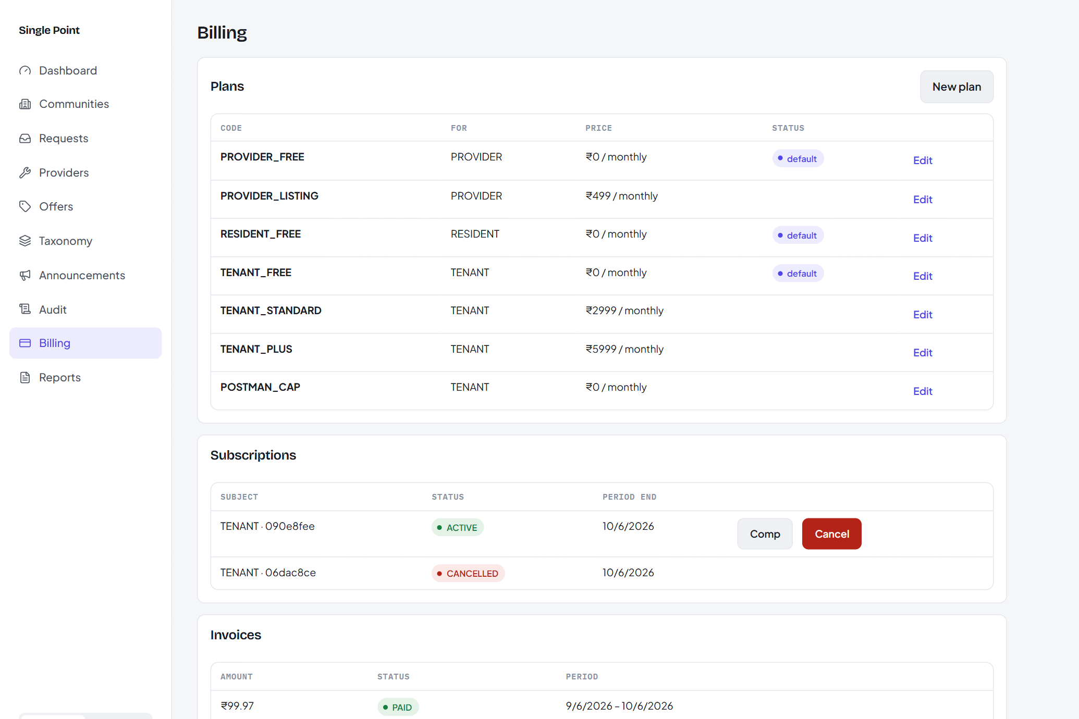
Plans, subscriptions (with a “recurring” pill) and invoices.
- Plans — create and edit plans and their entitlement limits (key → number).
- Subscriptions — comp or cancel one; a “recurring” pill marks a live gateway mandate.
- Invoices — mark an invoice paid (e.g. to reconcile an out-of-band payment).

5.5 Announcements
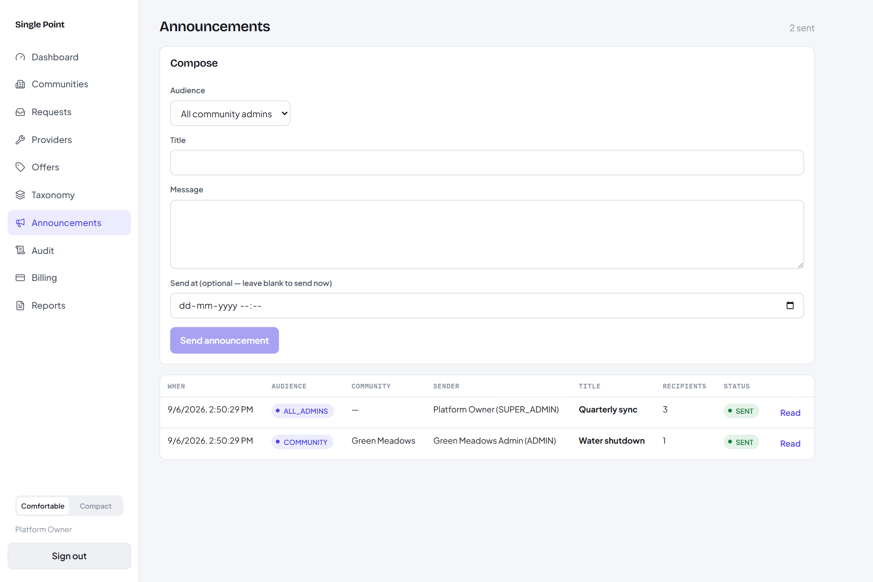
Compose, schedule and track announcements.
Send to all community admins, all users, or one community — immediately or scheduled. The history shows each announcement's status (SENT / PENDING / CANCELLED) and recipient count.

5.6 Audit log
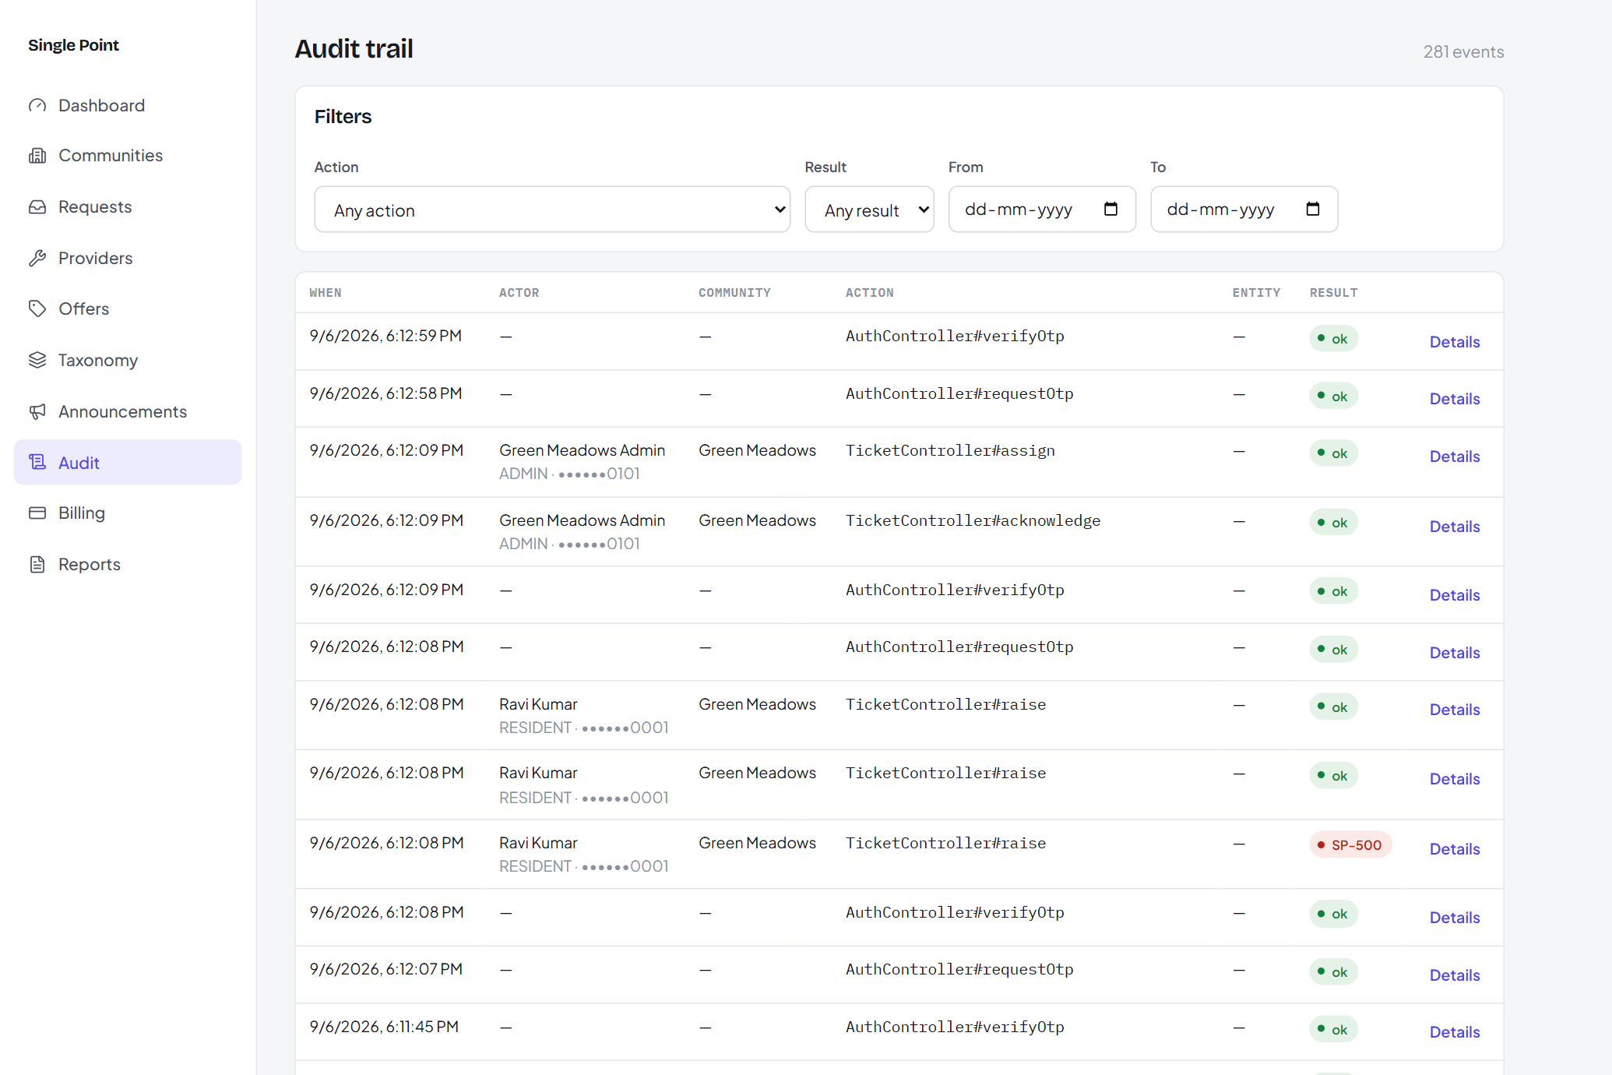
Every privileged action, filterable.
Filter by actor, action, community, outcome and date range; open a row for the full detail (method, endpoint, request id, duration, error code).

5.7 Reports
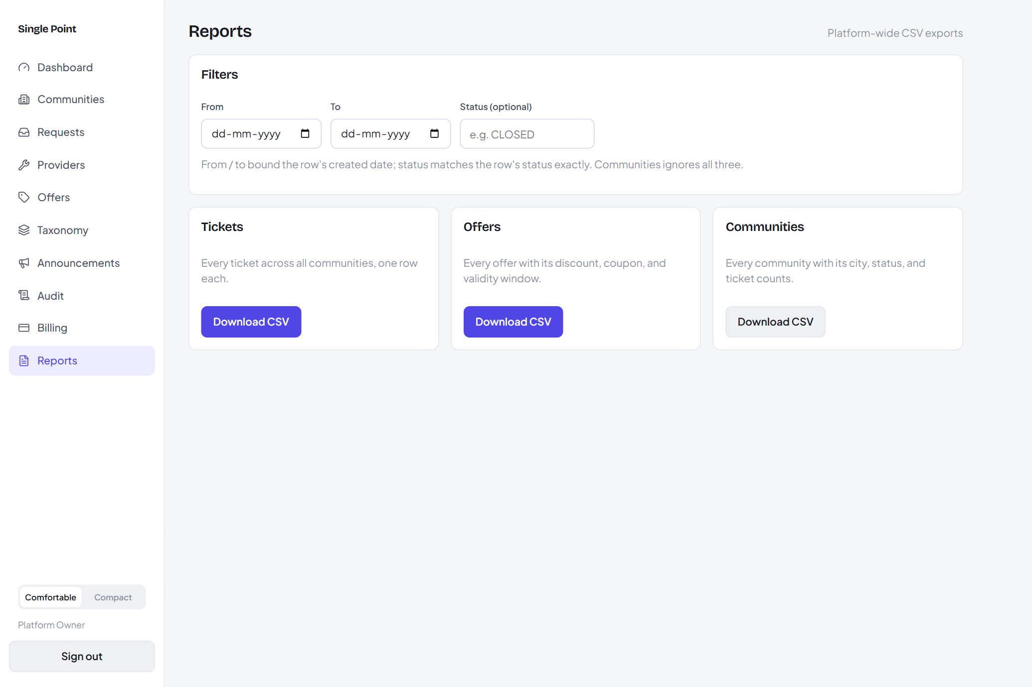
CSV exports.
Download tickets, offers and communities platform-wide (community admins get tickets / payments / members for their own community). Filter by date range and status; files open directly in Excel or Sheets.

5.8 Other console areas
- Offers — approve or reject provider-submitted offers; you can override the audience at approval.
- Taxonomy — maintain vendor verticals, vendor categories and global ticket categories.
- Act as admin — for a community with no admin, act on its behalf, then stop acting.

6. Messages you might see
Message / code | What it means | What to do
“No resident plans are available yet” (SP-400) | Residents don't have a paid plan to buy. | Nothing — residents stay on the free plan.
“You already have a membership here” (SP-409) | You're already in that community. | Open it from your communities list.
“This device was signed out” (SP-401-DEVICE) | This device was revoked from another device. | Sign in again.
“This account has been closed” (SP-401) | The account was deleted. | Register again with the same number if needed.
“Plan limit reached” (SP-402-QUOTA) | You've hit a plan limit (e.g. tickets this month). | Upgrade the plan or wait for the next cycle.
“Too many requests” (SP-429) | OTP or announcement rate limit. | Wait a minute and retry.
A removal / delete is blocked (SP-409) | Open tickets or unpaid bills exist. | Close / pay them, then retry.

Single Point · User Manual · demo screens (release mvp-13 + design v2) · 2026-09-06

