MARKET BASKET INSIGHTS

TEAM MEMBER:

ANANDH S,
CSE-III YEAR,
AI101(IBM-ARTIFICIAL GROUP 2),
TEAM NAME: MARKET BASKET INSIGHTS,
SRG ENGINEERING COLLEGE.

PROBLEM DEFINITION:

The Market Basket Analysis (MBA) method of data mining looks for a collection of items
that frequently occur together in a large dataset or database. This technology is used in
various industries like retail to promote cross selling and to help in product placement and in
fraud detection and other uses. Understanding consumer purchasing trends and preferences
has been made easier with the use of this technology. The use of it in international
corporations is widespread. Along with the advancement of technology, current business
trends have undergone a significant transformation. This technique analyses the purchasing
habits of customers by determining the relationships that exist between the various items that
are placed in the customers' shopping baskets. Because of shifts in the expectations of
customers, it is essential for businesses to improve the precision of their operations. In this
particular scenario, we examine a neighbourhood grocery store to investigate and contrast the
Apriori and FP Growth algorithms' respective run times. In this paper we also find the
combination of products that are sold together.

Keywords: FP Growth, Apriori, Market basket Analysis.

AIM / OBJECTIVE:

Retail business is one of the industries with high level competition. The growth of the
business is decided by the response speed and the ability to understand customers’ behaviour
[1]. The main challenge for this industry is customer data collection. Market basket analysis
is an acquisition of analytical techniques focused to find relations and relations among
products based on the customer’s purchase [2]. Market basket analysis helps to analyse the
probability of a customer purchasing different products together. Analysing purchase patterns
can help improve marketing methods to improve sales and increase profits. Most of the
unused data are stored in the archive to be used as sales report [3].
In the retail industry, the utilisation of data mining techniques is essential to the
accomplishment of company goals. Data mining techniques help uncover patterns of
consumer spending by disentangling the connections and associations that exist between
various products [4]. Association rules are applied in order to determine frequent item sets
based on support and confidence thresholds that are defined at different levels. The term
"frequent itemset" refers to a group of items with minimal support [5]. The number of
transactions for an itemset within the data set is known as support. The degree of each
revealed pattern's certainty serves as a measure of confidence.
2. LITERATURE SURVEY

Data mining is the process of discovering useful information hidden within large amounts of
data. The association between different goods in a dataset can be discovered using the data
mining technique known as market basket analysis [6]. It is widely used to mine transactions
or basket data, especially in retail. Using this technology has made it simpler to understand
consumer buying trends and preferences [7]. Market basket analysis aids in selecting
discounts and sales promotion strategies for distinct consumer segments [8]. Factors like
confidence, support, and lift are employed to determine the association or relationship
between the items. Support displays the frequency with which a given itemset appears in all
transactions. The degree of confidence indicates the possibility that if item A is purchased,
item B will follow [9-10]. The lift between the antecedent and consequent is the correlation.
ECLAT algorithm is a more efficient type pf Apriori algorithm. This is because ECLAT
algorithm works vertically while Apriori works horizontally and this makes ECLAT faster
[11]. FP Growth does not need creating candidate sets and therefore FP Growth is 5 times
faster.

2.1. Association Rule Mining

One of the most used data mining approaches is the association rule. Finding relationships
between the objects in a data set is helpful. This is accomplished by the analysis of recurring
patterns and numerous measures, including support, confidence, life, leverage, and
conviction. Support provides a summary of the frequency of a group of things that appear in
all transactions. We are supported by the percentage of all transactions in which the itemset
appears [12].

supp(X−>Y) = (Transactions containing both X and Y)
(Total No. of transactions)

An item set is referred to as a "frequent itemset" when the support is greater than the required
minimum support threshold. Low support rule is disregarded when seen from a business
standpoint.
Confidence is the probability that when item X is purchased, item Y will follow.

confidence(X−>Y) = support(X−>Y)
support(X)

When X is present in the shopping cart, the likelihood that Y is also present increases in
comparison to when X is absent. This can be determined through the use of the lift.
Lift(X−>Y) = confidence(X−>Y)/ support(X)
Given that A and C are not connected in any way, the disparity in the observed and expected
frequencies of X and Y occurring together is referred to as the "leverage," and it is
characterised by the term "leverage."
Leverage(X−>Y) = support(X−>Y) − support(X)∗support(Y)
Conviction can be defined as the frequency with which X takes place without Y divided by
the frequency with which the rule makes an incorrect prediction (i.e. the frequency with
which the rule makes an incorrect prediction). If X and Y were truly independent of one
another, the ratio of the frequency of incorrect predictions to the probability of X occurring
without Y should be equal to one (1).

Conviction(X−>Y)=support(Y)/confidence(X−>Y)

2.2. Apriori Algorithm

Apriori algorithm is utilized for mining regular item sets in a data set. This is a classical
technique in a data mining. This algorithm is formulated to work on data sets containing large
number of exchanges/ transactions. Apriori algorithm is a well-known rule to inspect
relations among items or variables in a large data set[13].

Apriori algorithm uses 2 principles.
1. All subsets of a frequent itemset must be frequent.
2. For any infrequent itemset, all its supersets must be infrequent too.

2.3. ECLAT Algorithm

Even in this day and age, the ECLAT algorithm is still a common option when considering
association rule algorithms (which stands for Equivalence Class Clustering and bottom-up
Lattice Traversal). It is more efficient than the Apriori algorithm, which is a direct
comparison for this method. By carrying out its operations in a horizontal fashion, the Apriori
algorithm is able to simulate the breadth-first search that occurs in a graph. The ECLAT
algorithm, on the other hand, takes a vertical approach by simulating the depth-first search
that occurs in a graph. Because of this, ECLAT is preferable to Apriori in terms of accuracy
while also being superior in terms of speed. You will not obtain any new subsets that are not
already present in the prefix tree when you use ECLAT.
In order to accomplish this, it computes the support value by finding the intersections of the
transaction sets. The ECLAT is superior to other tests of its kind because, unlike those other
tests, it does not require the candidate to search the database for evidence but rather uses k+1
item sets.

As it uses a Depth-First Search methodology, ECLAT is significantly more efficient than the
Apriori algorithm and needs a great deal less memory to function. A cursory examination of
the information is all that is required to carry out computations while being provided with
individualised assistance.

2.4. FP Growth

FP Growth is an improvement that can be made to the Apriori method. The database is
portrayed by FP Growth in the form of a tree known as an FP tree, which is also known as a
Frequent Pattern Tree. The relationship between the sets of items is maintained by the
structured tree. The structure of the tree is determined by the initial item sets contained within
the database. Each node in the FP tree, which is used to mine the pattern that occurs the most
frequently, is a representation of one of the item sets. The nodes further down the tree
represent the itemsets, while the node at the very top of the tree represents null. The
connection that exists between the tree's root node and its child nodes (itemsets) and their
respective neighbours is maintained while the tree is being constructed

3. RESEARCH METHODS

Association rules are found to be functional if minimum support threshold and minimum
confidence threshold meet the threshold set by the user or consultant. Market basket analysis
rules can be written as if {A} then {B} i.e. {A} => {B}.
The store data that we have collected is of the size 7501 x 20. Each transaction in the dataset
is the combination of products bought together by a customer. Figure 1 shows the head and
tail of the dataset.

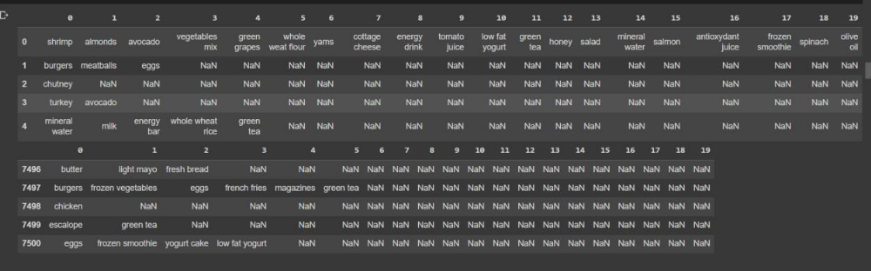
Figure 1. Head and tail of the dataset

This data needs a lot of pre-processing. TransactionEncoder() of mlxtend.
preprocessing does the pre-processing for us. TransactionEncoder() helps find the different
products in transaction and give each transaction a list that contains a binary array where
True represents a purchased product. The pre-processed data is visualised as bar charts and
each column represent distinct item. Figure 2 shows sales of unique items.
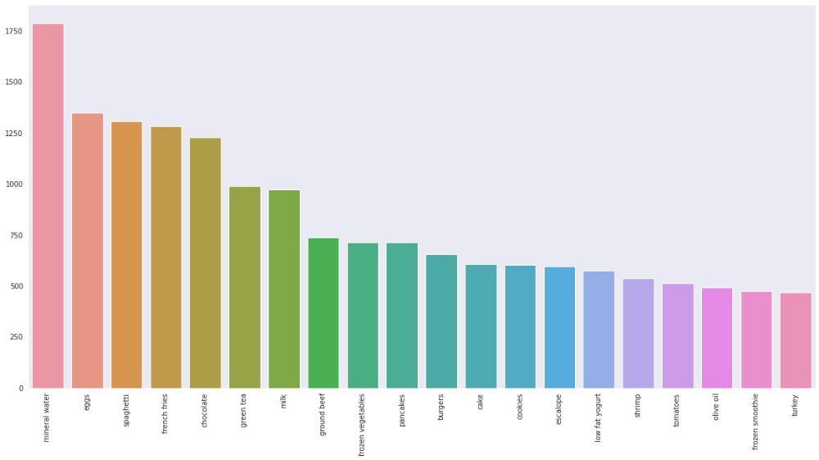
Figure 2. Sales of unique items
The most popular item in the store, as shown in figure 2 above, is mineral water. Rule
generation involves two steps in the process. The first rule is to create a list of repeating
items, and the second is to create a list of rules that are acceptable given the observed items.
One approach is to look at all potential subsets of the item set under consideration, look at the
item sets' support values, and then only consider the item sets with values higher than the
minimal threshold support value. The apriori algorithm is a support measure that opposes
monotonicity. As a result, the search space is smaller, which speeds up the construction of
repeating item sets. Apriori cuts back the supersets of an itemset that does not meet the
condition of minimum threshold value.

‘Bottom up’ approach is the process of expanding recurrent itemset
individually.

1. Create itemset that meets the minimum threshold that has only one item L1. Use self-join
and create all workable combinations of L1 and the outcome is L2.

2. At each step we create candidate item sets and for every candidate we examine the entire
database to identify support and separate candidates that do not meet the minimum threshold
value.

3. In the same way we create Lk from Lk-1 until self-join is not applicable.
The number of association rules that can be used if n elements are in a set is 3<supn- 2n+1 +
1. To generate all these rules requires relatively large number of steps. Apriori breaks down
this process. From all the workable rules we recognize the ones they are above the minimum
confidence level. Confidence of rules from the same itemset obey the anti-monotone
property.

Conf (A, B, C -> D) >= Conf (B, C-> A, D) >= Conf (C-> A, B, D)

Apriori requires numerous candidate item sets creation to examine the support of
every itemset created and this is computationally expensive. This limitation can be overcome
by FP Growth which is an advancement of Apriori algorithm. A pattern is created without
candidate generation. FP tree is a database representation in form of a tree. The association
between item sets is preserved in the tree. The database is unusable due to one common item.
The term "pattern fragment" refers to the broken or fractured portion. In contrast to the
Apriori algorithm, the itemsets of the fragmented patterns are examined, which decreases the
temporal complexity.

The FP tree is built using the itemsets that are located at the very beginning of the
database. Every node in the FP tree represents a different itemset in some way. The value null
is represented at the root node, while the itemsets are represented at the child nodes in the
hierarchy. During the process of tree formation, the connection between the nodes is
maintained.

Steps in FP Growth to mine frequent pattern.

1. Scan the database as in the Apriori.

2. To build the FP tree from the tree's root. Root is represented by Null.

3. Scan the database to study trransactions. The itemset with maximum transactions is
placed at the top. The item sets are arranged in descneding order of number of transactions.

4. Common itemsets are linked to the nodes of another itemset

5. The count of the common node and new node is increased by 1 as the nodes are
constructed and joined.
6. node is analysed frist along the links. The travesed path is called conditional pattern base.
7. Tree construction for conditional FP. The conditional FP tree is made up of the itemsets
that satisfy the threshold support.

8. FP with conditions Tree produces regular patterns.
Creation of candidate sets is not required by FP Growth and that is why FP Growth is faster
than Apriori algorithm.

4. RESULTS AND DISCUSSION

From Figure 2 we can conclude that mineral water must be in stock at all times.
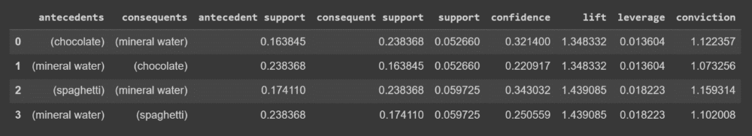
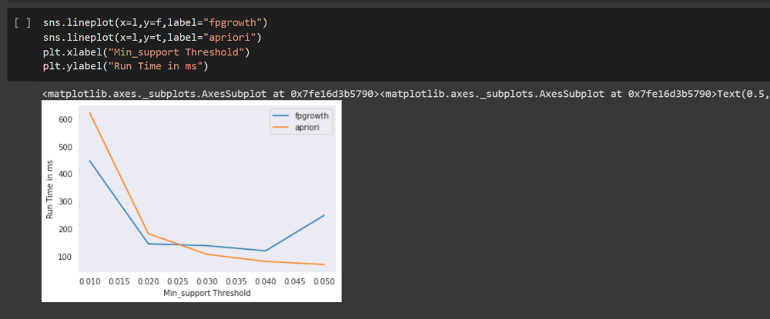
Figure 5. Run time comparison – Apriori and FP Growth

From Figure 5 we get the insights about the run time comparison between Apriori and FP
Growth. Apriori algorithm requires creation of candidate sets, therefore it is much slower
than FP Growth. FP Growth is five times faster.

5. CONCLUSION

Based on the findings, the FP Growth algorithm can be considered not only more
sophisticated than the Apriori algorithm, but also significantly quicker. This data shows that
mineral water is the most commonly purchased product. Thus, there must always be a supply
of mineral water for purchase.

REFERENCES
1. Raorane, A. A., R. V. Kulkarni, and B. D. Jitkar. "Association rule–extracting knowledge
using market basket analysis." Research Journal of Recent Sciences ISSN 2277 (2012): 2502.

2. Zheliznyak, Iryna, Zoriana Rybchak, and Iryna Zavuschak. "Analysis of clustering
algorithms." In Advances in Intelligent Systems and Computing, pp. 305-314. Springer,
Cham, 2017.

3. Rettinger, Achim, Uta Lösch, Volker Tresp, Claudia d’Amato, and Nicola Fanizzi.
"Mining the semantic web." Data Mining and Knowledge Discovery 24, no. 3 (2012): 613-
662.

4. Aguinis, Herman, Lura E. Forcum, and Harry Joo. "Using market basket analysis in
management research." Journal of Management 39, no. 7 (2013): 1799-1824.

5. Kumar, K. Suresh, T. Ananth Kumar, S. Sundaresan, and V. Kishore Kumar. "Green IoT
for Sustainable Growth and Energy Management in Smart Cities." In Handbook of Green
Engineering Technologies for Sustainable Smart Cities, pp. 155-172. CRC Press, 2021.

6. Aguinis, Herman, Lura E. Forcum, and Harry Joo. "Using market basket analysis in
management research." Journal of Management 39, no. 7 (2013): 1799-1824
7. Solnet, David, Yasemin Boztug, and Sara Dolnicar. "An untapped gold mine? Exploring
the potential of market basket analysis to grow hotel revenue." International Journal of
Hospitality Management 56 (2016): 119-125.

8. Wong, Jehn-Yih, Huei-Ju Chen, Pi-Heng Chung, and Nai-Ching Kao. "Identifying
valuable travelers and their next foreign destination by the application of data mining
techniques." Asia Pacific Journal of Tourism Research 11, no. 4 (2006): 355-373.

9. Miguéis, Vera L., Ana S. Camanho, and João Falcão e Cunha. "Customer data mining
for lifestyle segmentation." Expert Systems with Applications 39, no. 10 (2012): 9359-9366.

10. Usharani, S., P. Manju Bala, T. Ananth Kumar, R. Rajmohan, and M. Pavithra. "Smart
Energy Management Techniques in Industries 5.0." Hybrid Intelligent Approaches for Smart
Energy: Practical Applications (2022): 225-252.

11. Zhao, Qiankun, and Sourav S. Bhowmick. "Association rule mining: A survey."
Nanyang Technological University, Singapore 135 (2003).

12. Birant, Derya. "Data mining using RFM analysis." In Knowledge-oriented applications
in data mining. IntechOpen, 2011.

13. Badhe, Vivek, Ramjeevan Singh Thakur, and G. S. Thakur. "Profit Pattern Mining Using
Soft Computing for Decision Making: Pattern Mining Using Vague Set and Genetic
Algorithm." In Pattern and Data Analysis in Healthcare Settings, pp. 213-239. IGI Global,
2017.

