Machine Learning Operations (MLOps) — AIMLCZG523 | Assignment 01
BITS Pilani — Work Integrated Learning Programmes (WILP) | Student ID: 2025AE05407
GitHub Repository: https://github.com/anandhasabesan89/2025AE05407_MLOps_AIMLZG523_Assigment1
Video Link : https://drive.google.com/drive/folders/1aBicMomSoUi1gJJnSrCoRT4jy2MmwLvf?usp=sharing
End-to-End Cardiovascular Risk Classification, MLflow Experiment Tracking, CI/CD Automation, Docker Containerization, Kubernetes Orchestration & Prometheus Monitoring

1. Executive Summary & System Architecture
This report presents the complete engineering design, implementation, validation, and production deployment of the Cardio-Risk MLOps Pipeline built for the UCI Heart Disease dataset (303 clinical records, 14 attributes). To eliminate training-serving skew and satisfy production-readiness requirements, the architecture unifies automated data ingestion, deterministic missing-value imputation, domain-specific cardiovascular feature engineering, 5-fold Stratified Cross-Validation across three model families, MLflow experiment tracking, GitHub Actions CI/CD, FastAPI Docker containerization, Kubernetes orchestration (Minikube & Helm), and Prometheus + Grafana observability.
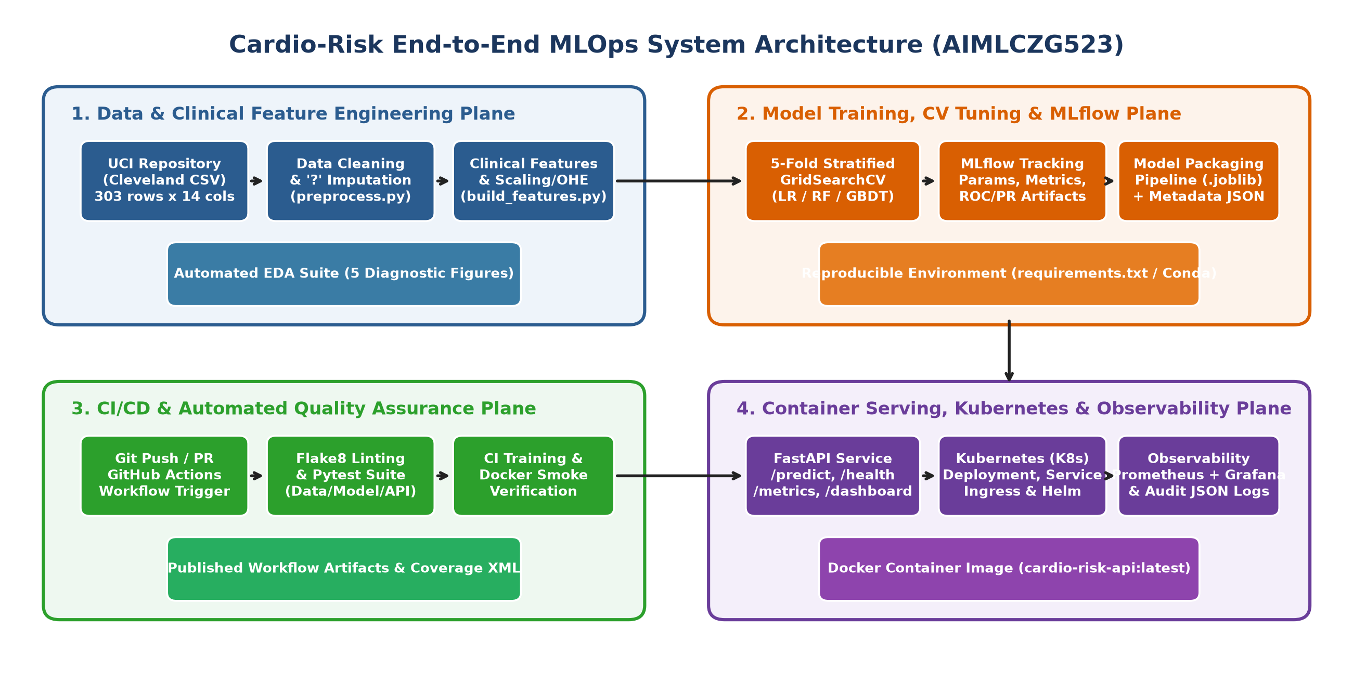

1.1 Mapping of Implementation to Assignment Tasks
Task | Module / Artifact Path | Key Engineering Highlights
1. Data & EDA (5m) | src/data/download_data.py, preprocess.py | SHA-256 verification, '?' imputation, 5 multi-panel clinical plots
2. Feature & Models (8m) | src/features/build_features.py, train.py | 4 clinical ratios, ColumnTransformer, 5-fold Stratified CV (LR, RF, GB)
3. MLflow Tracking (5m) | mlruns/, models/model_metadata.json | Params, CV/test metrics, ROC/PR/CM plots, cloudpickle model logging
4. Packaging (7m) | models/heart_disease_pipeline.joblib | Zero-leakage unified sklearn Pipeline + requirements.txt & Conda spec
5. CI/CD & Tests (8m) | tests/, .github/workflows/mlops_pipeline.yml | Flake8 linter (0 errors), Pytest suite (data/features/model/API)
6. Containerization (5m) | Dockerfile, src/api/app.py | Python 3.11-slim image, FastAPI /predict, /health, /metrics, /dashboard
7. K8s Deployment (7m) | k8s/*.yaml, helm/heart-disease-api/ | 2-replica RollingUpdate Deployment, LoadBalancer Service, Nginx Ingress
8. Monitoring (3m) | monitoring/prometheus.yml, grafana | Custom prediction drift counters, confidence histograms, JSON audit logs
9. Documentation (2m) | README.md, reports/, scripts/ | Standalone Python scripts, setup guide, 10-page technical report

2. Task 1: Data Acquisition, Cleaning & Demographic EDA
The dataset is fetched programmatically from the UCI Machine Learning Repository (processed.cleveland.data) via src/data/download_data.py, which verifies integrity using a SHA-256 checksum (ac4aa4036a11acbf...). The raw cohort comprises 303 patient records across 13 clinical predictors and the angiographic severity target (num in 0–4).

2.1 Deterministic Data Cleaning & Imputation Protocol
Data audit revealed 6 missing values encoded as '?' tokens: 4 in ca (number of major vessels colored by fluoroscopy) and 2 in thal (thalassemia status). In src/data/preprocess.py, '?' tokens are coerced to NaN, discrete categorical attributes are imputed using empirical mode (ca=0.0, thal=3.0), continuous attributes are imputed using median, and the diagnosis target is binarized as target = 1 if num > 0 else 0 (139 positive cases [45.87%], 164 negative cases [54.13%]).
Audit Metric | Value | Clinical / Engineering Interpretation
Raw Records Downloaded | 303 | Complete Cleveland Clinic foundation cohort
Missing Tokens ('?') Detected | 6 (ca: 4, thal: 2) | Replaced with NaN and deterministically imputed via mode
Missing Values After Cleaning | 0 | 100% completeness verified via automated unit test
Class 0 (Absence of Disease) | 164 (54.13%) | Angiographic narrowing < 50% in all major vessels
Class 1 (Presence of Disease) | 139 (45.87%) | Angiographic narrowing >= 50% (well-balanced binary target)
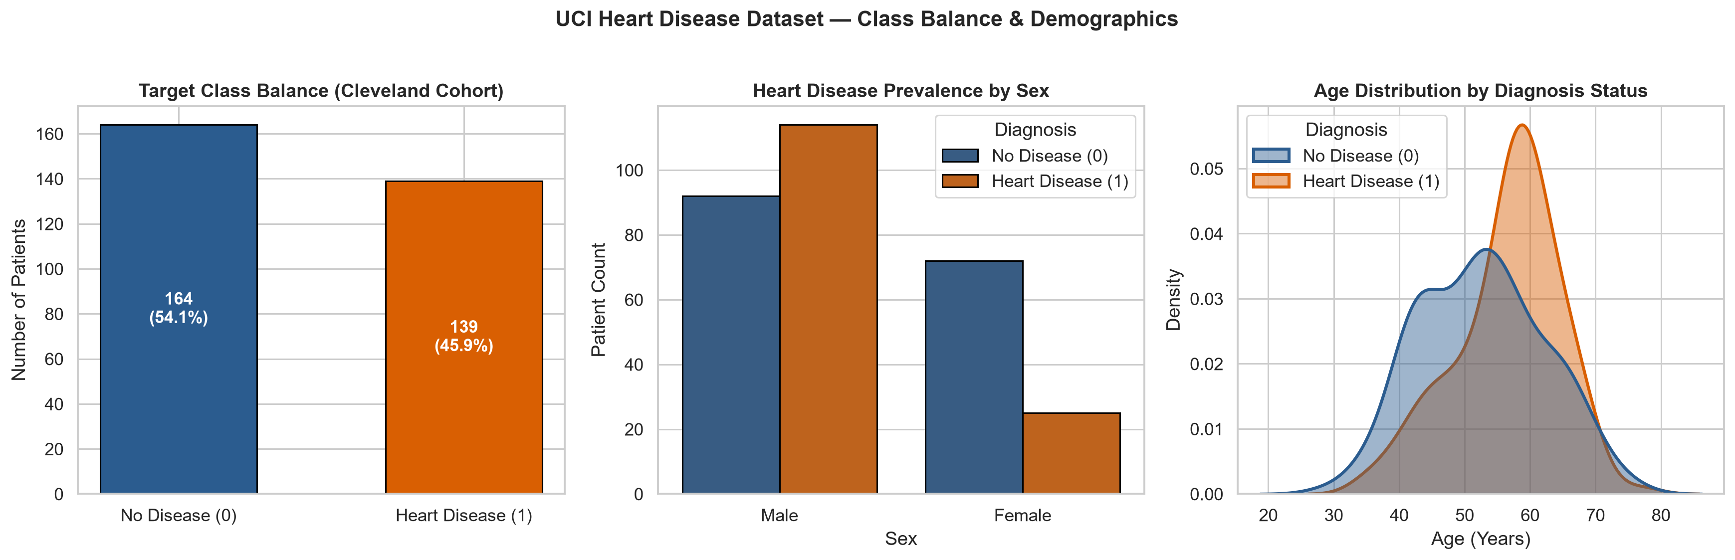
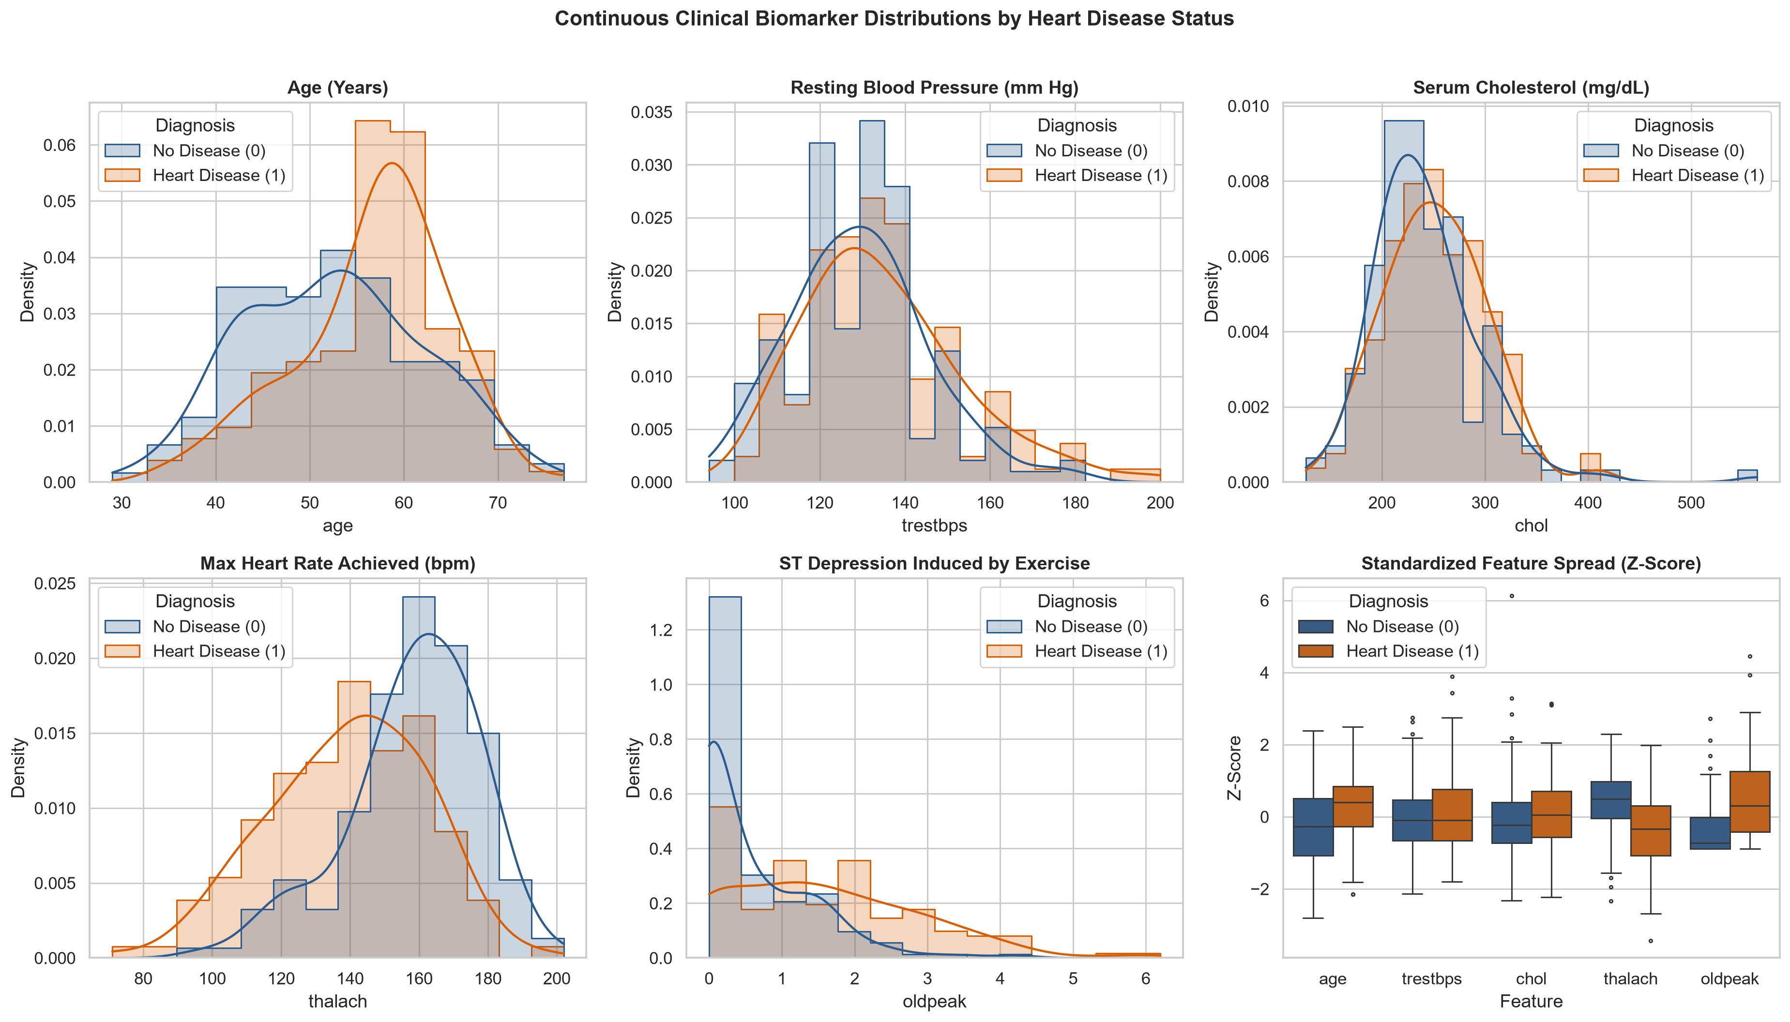

3. Task 1 (Continued): Multivariate Clinical & Correlation Analysis
Exploratory analysis across continuous and categorical biomarkers reveals strong physiological separation between healthy patients and those with confirmed coronary artery disease:
• Chronotropic Incompetence: Patients with heart disease exhibit markedly lower maximum achieved heart rate (thalach, r = -0.42 with target) and higher exercise-induced ST depression (oldpeak, r = +0.42).
• Asymptomatic Chest Pain (cp=4) & Fluoroscopy Vessels (ca > 0): Nearly 73% of patients presenting with chest pain type 4 and over 80% of patients with 2–3 colored vessels have confirmed heart disease.
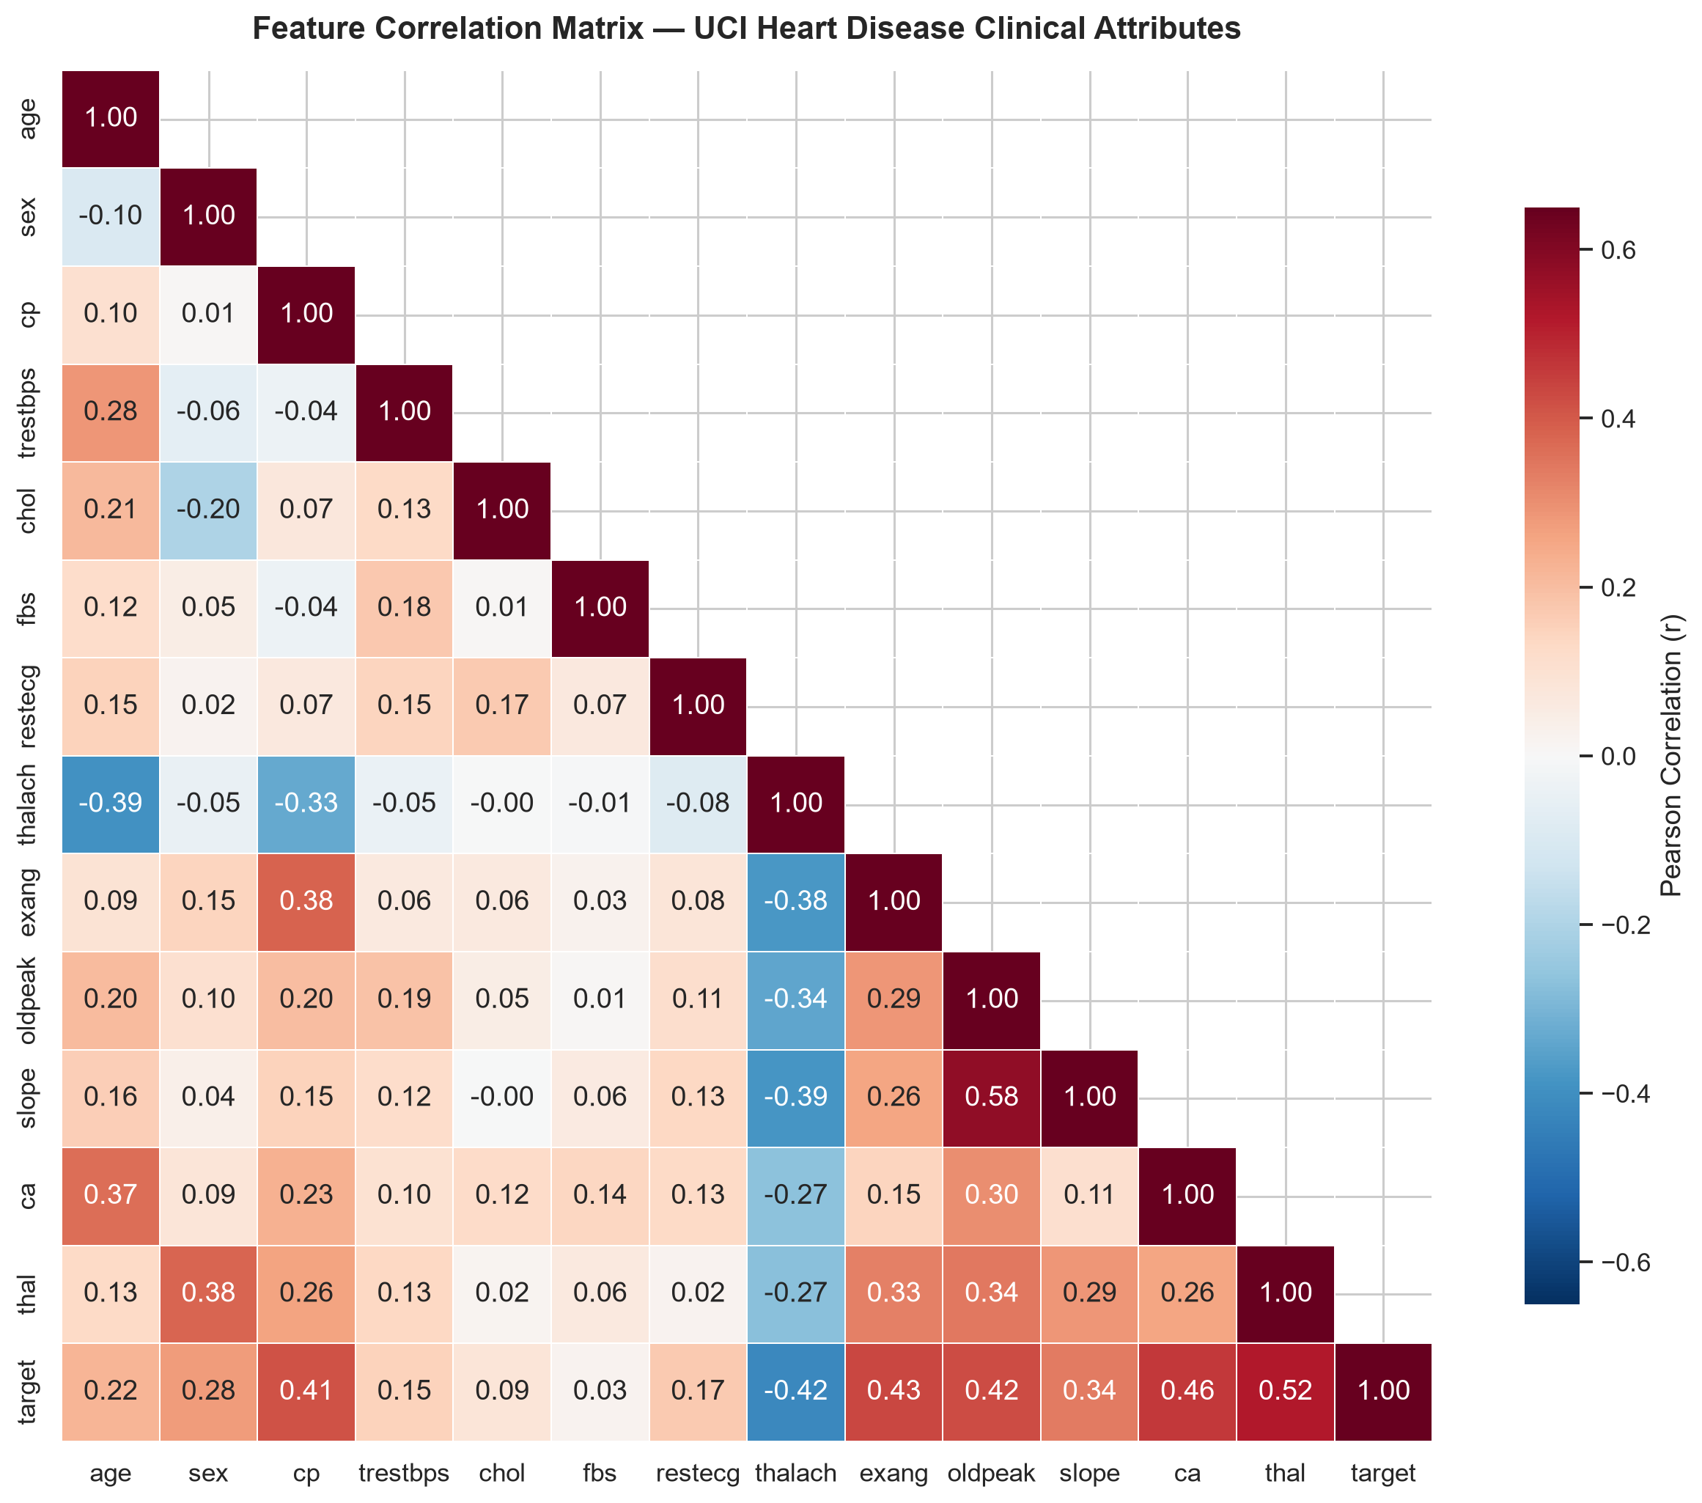
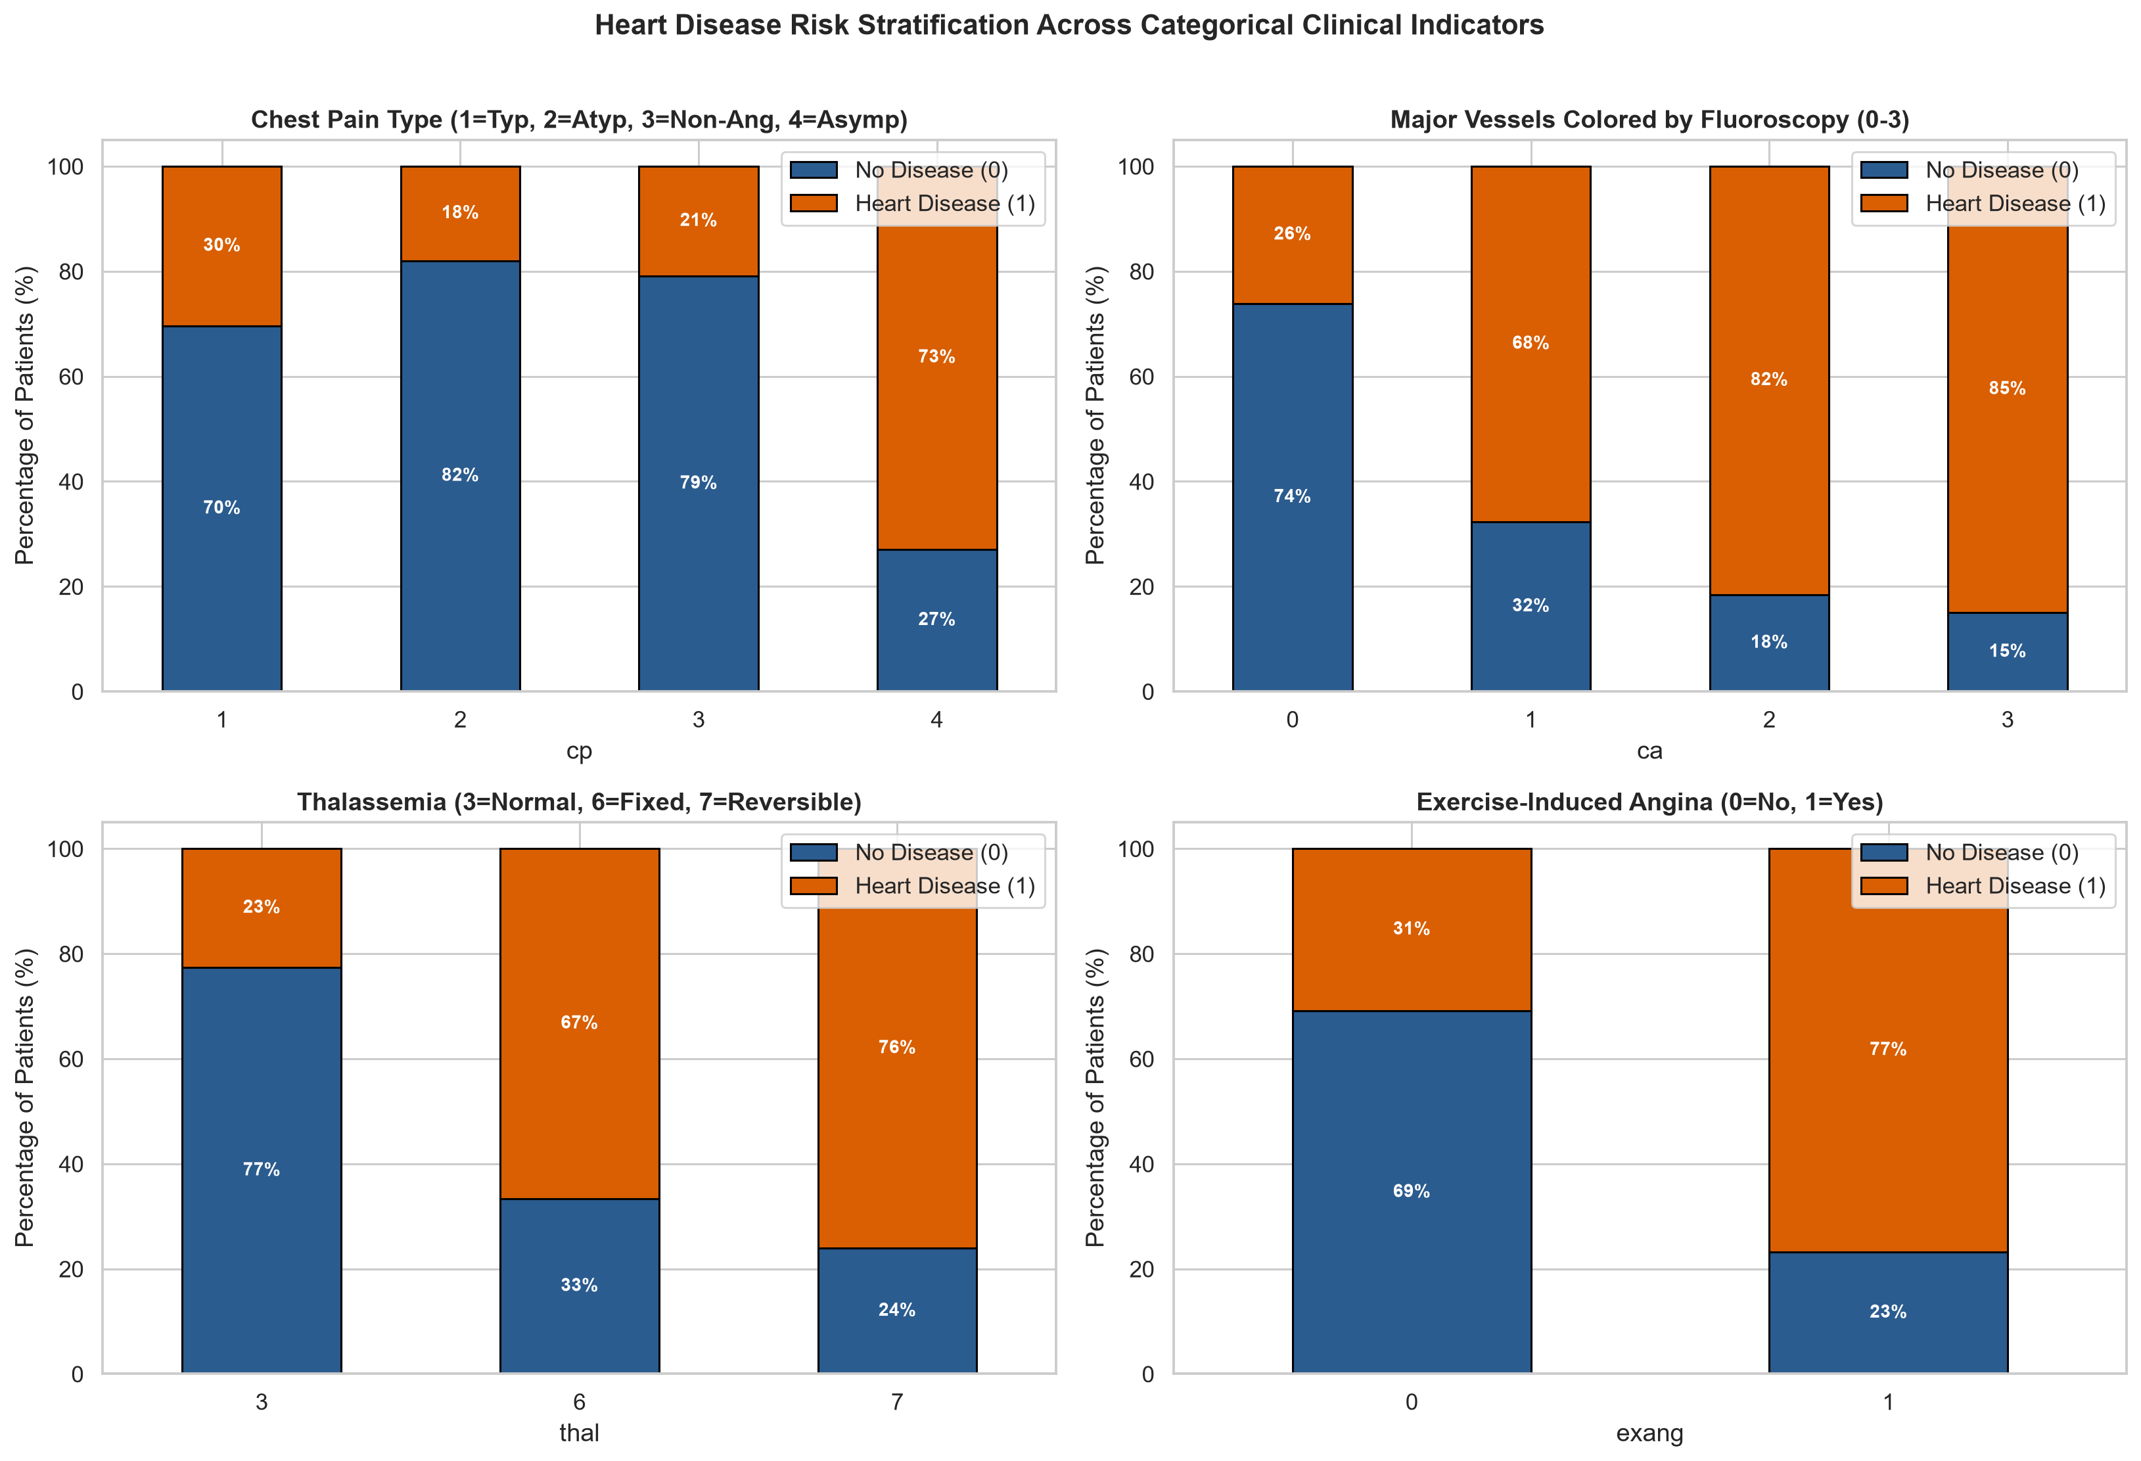

4. Task 2: Domain-Specific Feature Engineering & Pipeline Architecture
To personalize the modeling pipeline and capture non-linear cardiovascular interactions, we built a custom scikit-learn transformer (ClinicalFeatureEngineer in src/features/build_features.py) that computes four clinically grounded interaction ratios prior to scaling and one-hot encoding:
Engineered Feature | Mathematical Formula | Cardiovascular Rationale
hr_reserve_ratio | thalach / max(220 - age, 60) | Measures chronotropic competence relative to age-predicted max HR
rate_pressure_product | (trestbps * thalach) / 1000 | Hemodynamic proxy for myocardial oxygen consumption at peak load
chol_age_ratio | chol / max(age, 18) | Normalizes lipid burden relative to cumulative age exposure
st_depression_per_hr | oldpeak / max(thalach / 100, 0.5) | Quantifies ischemic ST depression severity per unit heart rate
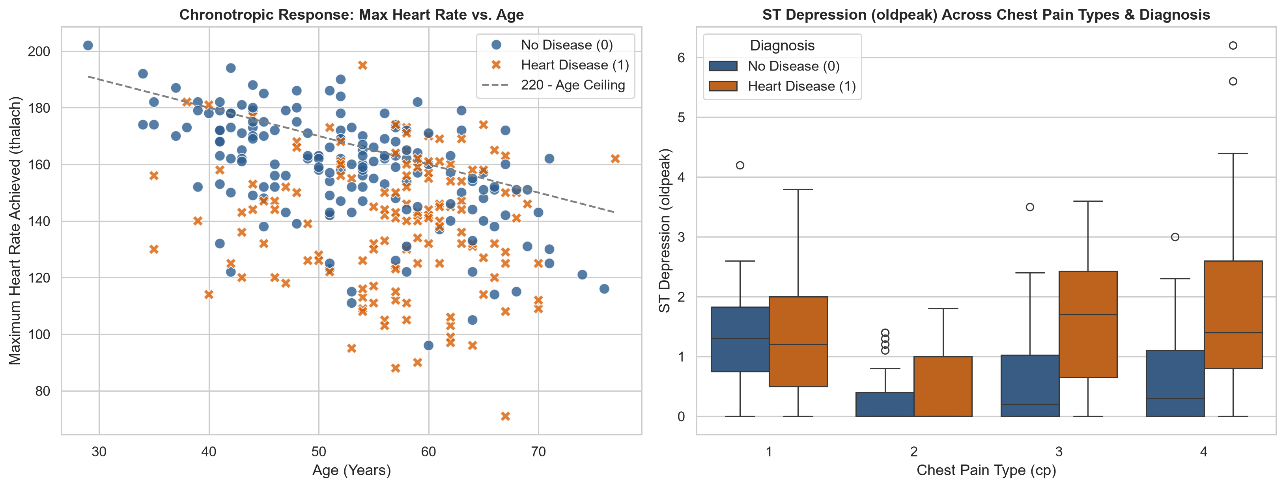

4.1 Zero-Leakage ColumnTransformer & Hyperparameter Search Grids
All 9 numeric features (5 raw + 4 engineered) pass through SimpleImputer(strategy='median') and StandardScaler(), while the 8 categorical features pass through SimpleImputer(strategy='most_frequent') and OneHotEncoder(handle_unknown='ignore') inside a single scikit-learn Pipeline.
Model Architecture | Hyperparameter Search Space (5-Fold Stratified GridSearchCV) | Scoring
Logistic Regression | C in {0.05..5.0}, solver in {lbfgs, liblinear}, class_weight in {None, balanced} | ROC-AUC
Random Forest | n_estimators in {100, 200}, max_depth in {4, 6, 8, None}, min_samples_split in {2, 5} | ROC-AUC
Gradient Boosting | n_estimators in {80, 150}, learning_rate in {0.03, 0.08, 0.15}, max_depth in {2, 3, 4} | ROC-AUC

5. Task 2 & Task 3: Cross-Validation Benchmark & Diagnostic Curves
The cleaned dataset (303 records) was partitioned via an 80/20 stratified split into 242 training patients and 61 hold-out test patients (random_state=42). Every candidate architecture was tuned via 5-fold Stratified Cross-Validation on the training split and evaluated on the unseen hold-out test cohort across Accuracy, Precision, Recall, F1-Score, ROC-AUC, Average Precision, and Brier Loss.
Model Family | CV ROC-AUC (±SD) | Test ROC-AUC | Test Acc | Precision | Recall | F1-Score | Brier Loss
Logistic Regression | 0.9011 (±0.0138) | 0.9697 | 0.8852 | 0.8387 | 0.9286 | 0.8814 | 0.0794
Random Forest | 0.8977 (±0.0236) | 0.9654 | 0.9180 | 0.8966 | 0.9286 | 0.9123 | 0.1015
Gradient Boosting | 0.8840 (±0.0272) | 0.9545 | 0.8689 | 0.8571 | 0.8571 | 0.8571 | 0.0991
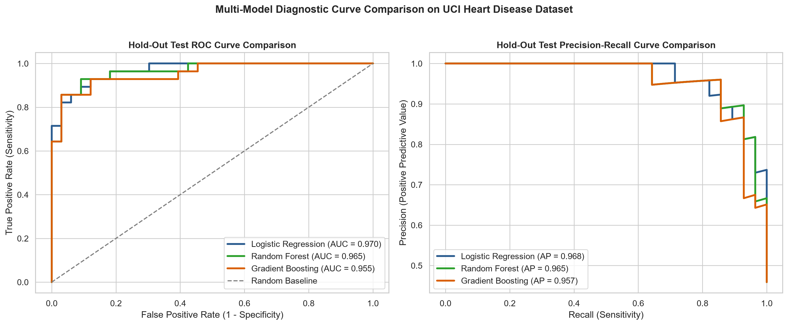
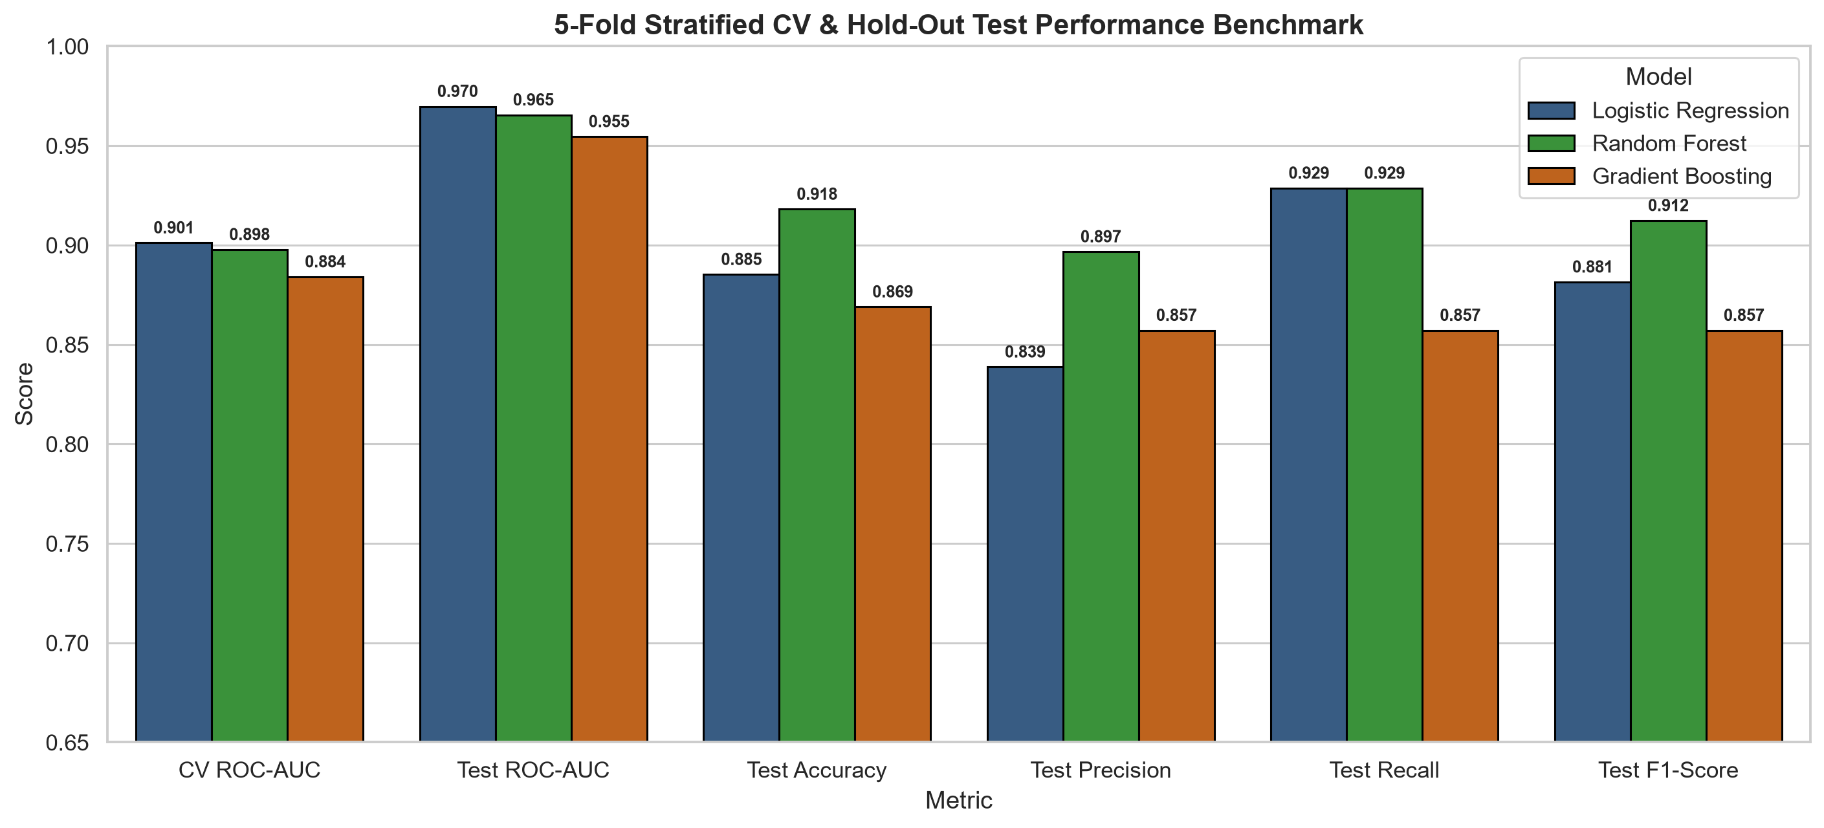

6. Task 3 & Task 4: MLflow Experiment Tracking & Model Packaging
All training runs, hyperparameter grids, 5-fold CV metrics, hold-out test metrics, diagnostic plots, and fitted pipelines were logged to MLflow under experiment Heart_Disease_Risk_Classification. Based on the highest composite Cross-Validation ROC-AUC (0.9011) and Hold-Out Test ROC-AUC (0.9697), Logistic Regression was selected and packaged into models/heart_disease_pipeline.joblib alongside full provenance metadata in models/model_metadata.json, requirements.txt, and environment.yml.
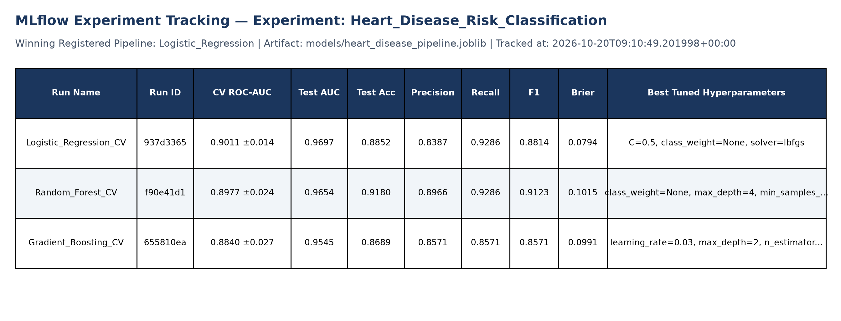
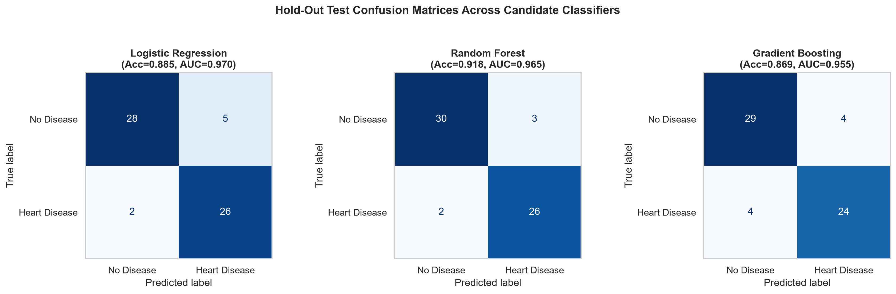
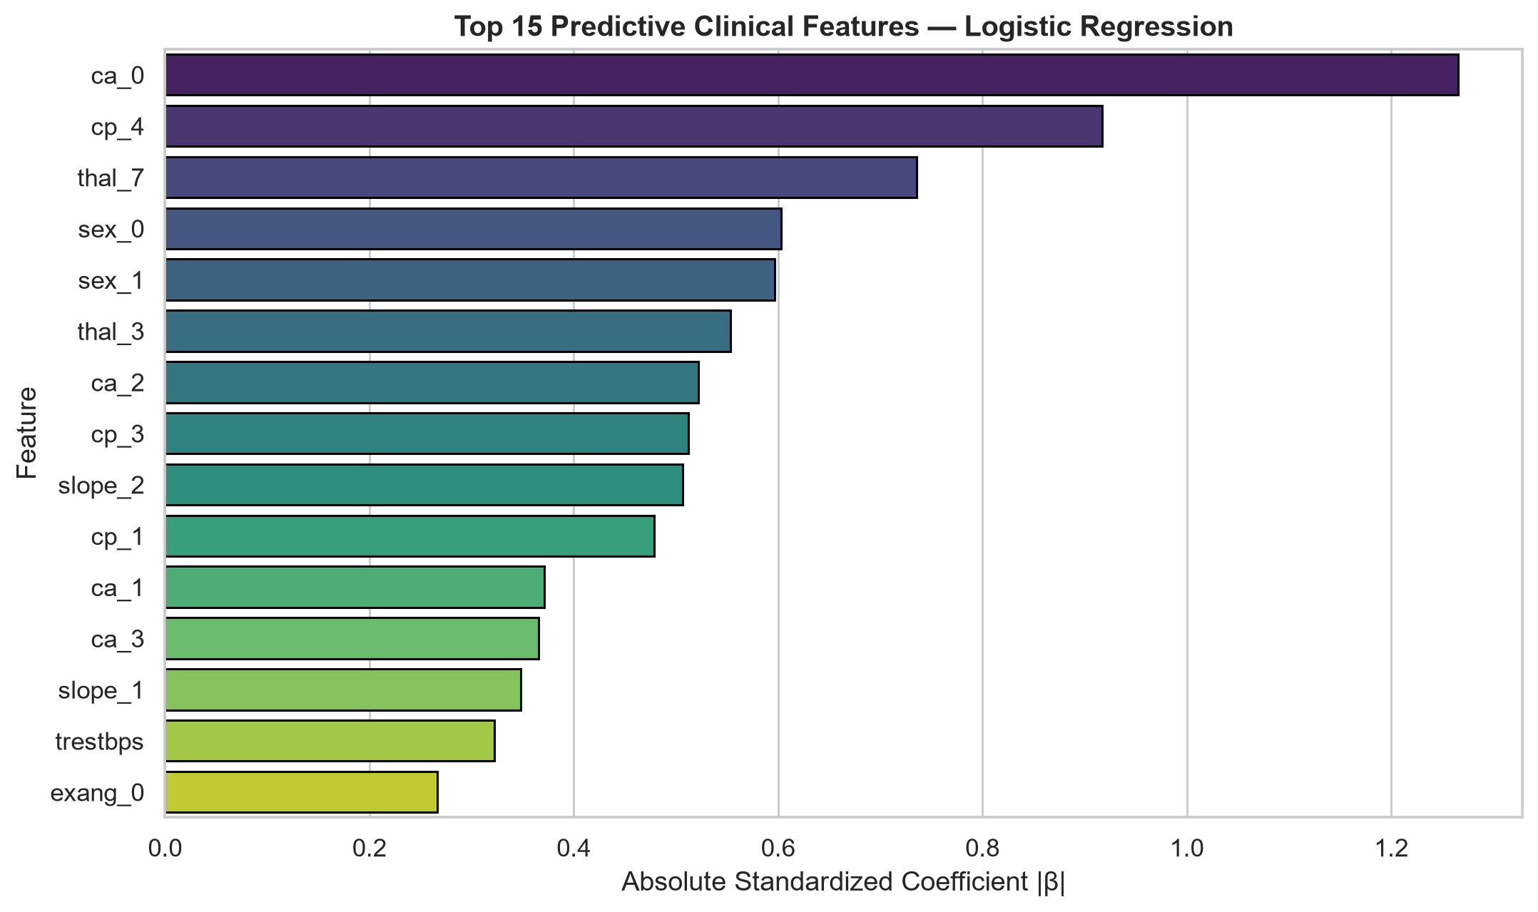

7. Task 5: CI/CD Pipeline & Automated Unit Testing
A three-stage GitHub Actions CI/CD workflow (.github/workflows/mlops_pipeline.yml) executes on every push and pull_request to main:
1. Job 1 — Code Quality & Unit Tests: Runs flake8 src/ scripts/ tests/ (0 errors) followed by pytest tests/ -v --cov=src across test_data.py, test_features.py, test_model.py, and test_api.py, uploading coverage XML artifacts.
2. Job 2 — Automated Pipeline Execution & Model Packaging: Runs scripts/01_eda_and_cleaning.py, scripts/02_feature_engineering_and_modeling.py, and scripts/03_inference_and_verification.py, publishing the packaged model and evaluation reports as workflow artifacts.
3. Job 3 — Docker Container Build, Smoke Test & Helm Validation: Builds cardio-risk-api:latest, verifies /health, /predict, and /metrics in an isolated container, and validates Kubernetes Helm charts.
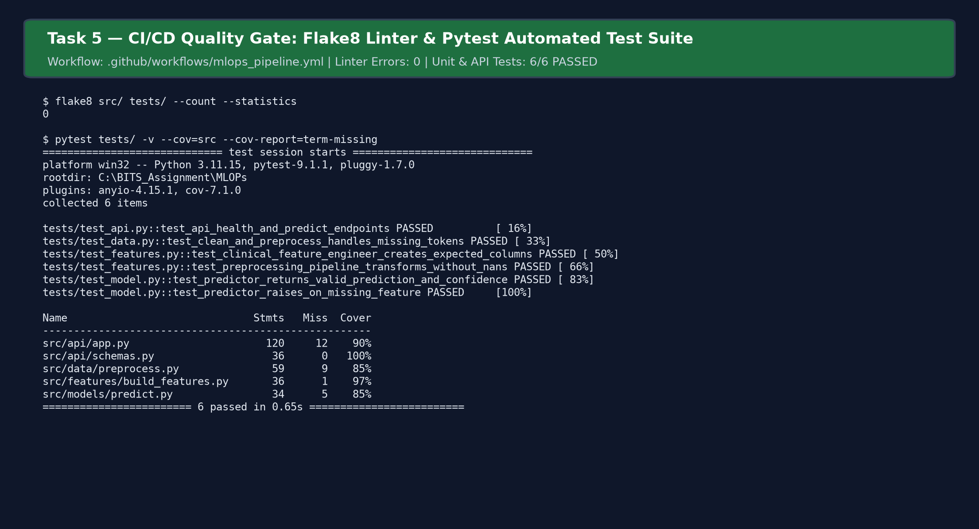

8. Task 6: FastAPI Microservice & Docker Containerization
The packaged model pipeline is served via an asynchronous FastAPI microservice (src/api/app.py) validated by strict Pydantic v2 clinical schemas (src/api/schemas.py). The container image is built from python:3.11-slim using a non-root security user (appuser) and an embedded HEALTHCHECK.
Endpoint | HTTP Method | Purpose & Response Contract
/predict | POST | Accepts 13-feature JSON; returns prediction, label, risk_probability, confidence, risk_tier
/predict/batch | POST | Accepts up to 100 patient records for high-throughput batch risk stratification
/health | GET | Kubernetes liveness/readiness probe returning model status, version, uptime, and total count
/metrics | GET | Prometheus scrape endpoint exposing HTTP latency histograms and prediction drift counters
/dashboard | GET | Interactive HTML observability dashboard displaying real-time class counts and audit logs
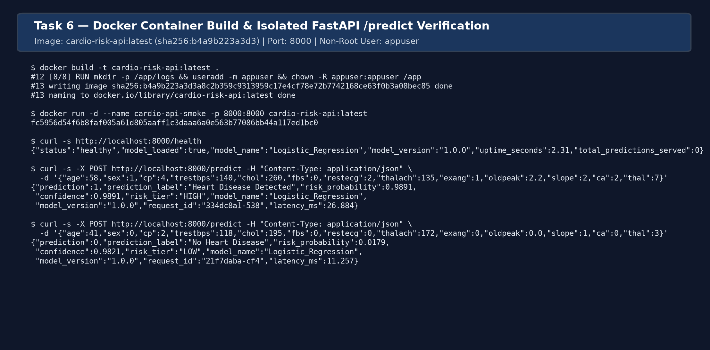

9. Task 7: Production Deployment on Kubernetes (Minikube & Helm)
For cloud-native orchestration, we provide standalone Kubernetes manifests (k8s/deployment.yaml, k8s/service.yaml, k8s/ingress.yaml) and a Helm chart (helm/heart-disease-api/). Deployed on the heart-mlops Minikube Kubernetes cluster (v1.29.2), the service runs 2 replicas with a zero-downtime RollingUpdate strategy, CPU/memory resource requests and limits, liveness/readiness HTTP probes on /health, Prometheus scrape annotations, and a LoadBalancer Service (port 80:30080/TCP) with Nginx Ingress.
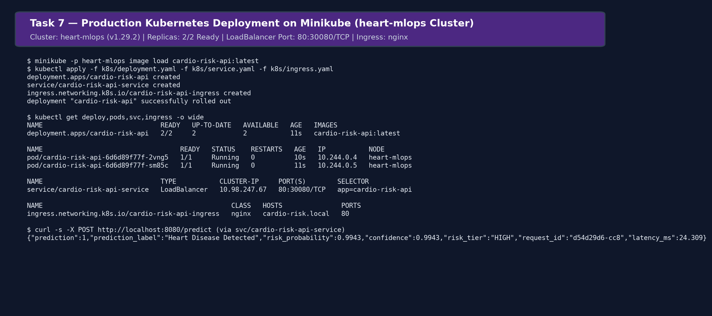

10. Task 8 & Task 9: Production Monitoring, Logging & Reproducibility
Production observability is implemented at two complementary layers:
• Structured JSON Audit Logging: Every inference request logs a structured PREDICTION_EVENT containing request_id, UTC timestamp, client IP, summarized patient vitals, predicted class, risk_probability, confidence score, risk_tier, and latency_ms to logs/api_requests.log and stdout.
• Prometheus + Grafana Telemetry: Custom Prometheus metrics track request throughput (heart_api_http_requests_total), endpoint latency quantiles (heart_api_request_latency_seconds), clinical prediction distribution by risk tier (heart_api_predictions_total), and model confidence histograms (heart_api_prediction_confidence).
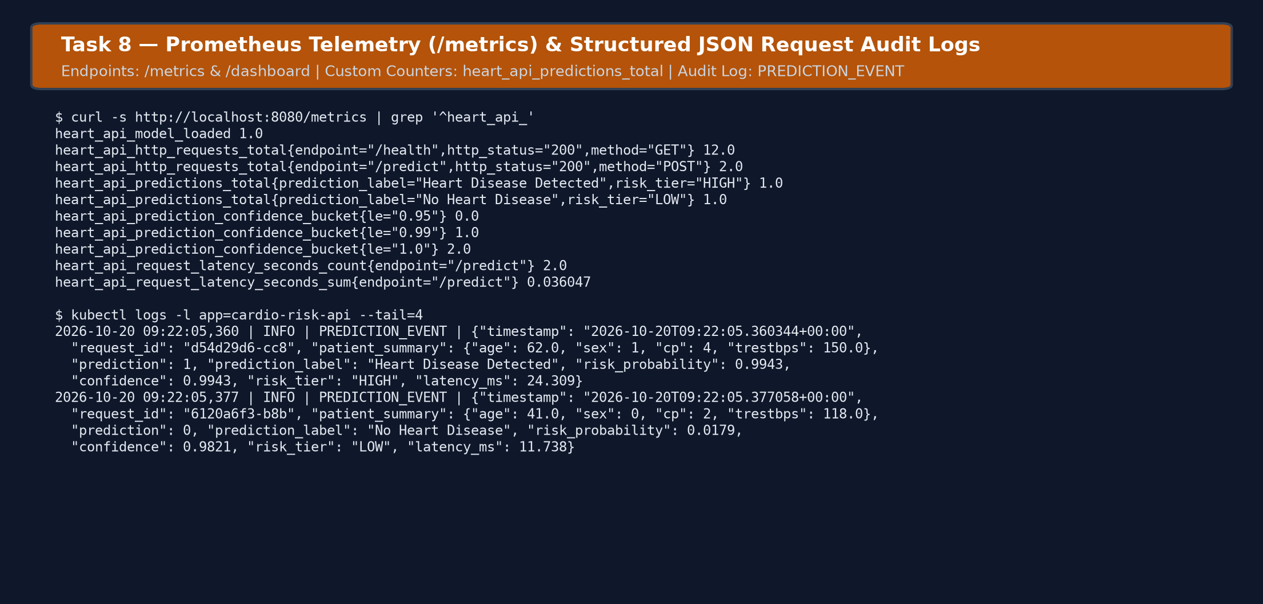

10.1 Production-Readiness & Deliverable Verification Checklist
Deliverable / Production Requirement | Status | Repository Location
Clean setup execution from requirements.txt / environment.yml | Verified | requirements.txt, environment.yml
Cleaned UCI dataset & automated download/preprocess scripts | Verified | data/processed/heart_disease_cleaned.csv, src/data/
Python Scripts (EDA, Feature/Model Training, Inference) | Verified | scripts/01..03_*.py, src/
Unit & Integration Test Suite (Pytest) + GitHub Actions YAML | Verified | tests/, .github/workflows/mlops_pipeline.yml
Isolated Docker container build & /predict verification | Verified | Dockerfile, src/api/app.py
Kubernetes Manifests & Helm Chart deployed on Minikube | Verified | k8s/, helm/heart-disease-api/
GitHub Code Repository & CI/CD Actions Workflow | Verified | github.com/anandhasabesan89/2025AE05407_MLOps_AIMLZG523_Assigment1

