# 

# Credit Card Fraud Detection

# Phase 4: Development part 2



# Submitted by:

ABHIJITH S S - 961721104001

ADARSH L S – 961721104003

ANANDHU S - 961721104302

AKHIL S S - 961721104301

ASHKAR MOHAMMED A M – 961721104305

# Credit Card Fraud Detection:

### Business Understanding

Credit Card Fraud Detection is a classic class-imbalance problem where the number of fraud transactions is much lesser than the number of legitimate transaction for any bank. Most of the approaches involve building model on such imbalanced data, and thus fails to produce results on real-time new data because of overfitting on training data and a bias towards the majoritarian class of legitimate transactions. Thus, we can see this as an anomaly detection problem.

1. What time does the Credit Card Frauds usually take place?
2. What are the general trends of amounts for Credit Card Fraud Transactions?
3. How do we balance the data to not let the model overfit on legitimate transactions?

# Importing Required Libraries  
import pandas as pd  
import numpy as np  
import matplotlib.pyplot as plt  
import seaborn as sns  
  
from sklearn.linear_model import LogisticRegression  
from sklearn.svm import SVC  
from sklearn.neighbors import KNeighborsClassifier  
from sklearn.tree import DecisionTreeClassifier  
from sklearn.ensemble import RandomForestClassifier  
from sklearn.linear_model import SGDClassifier  
  
from mlxtend.plotting import plot_learning_curves  
from sklearn.model_selection import train_test_split  
from imblearn.over_sampling import SMOTE  
from sklearn.metrics import precision_score, recall_score, f1_score, roc_auc_score, accuracy_score, classification_report  
from sklearn.model_selection import KFold, StratifiedKFold  
from sklearn.preprocessing import StandardScaler  
from sklearn.pipeline import Pipeline  
from sklearn.model_selection import GridSearchCV  
from sklearn.metrics import make_scorer, matthews_corrcoef  
  
import warnings  
warnings.filterwarnings("ignore")

### Data Understanding

The Dataset we use is the Kaggle Credit Card Fraud Detection Dataset enlisted in the following link: Link

* The Data has 32 features from V1-V28 which are unknown for confidentiality, TIme, Amount and Class
* The input features are V1-V28, Time and Amount
* The target variable is Class
* The Data does not have any missing values as evident from the below mentioned code, thus need not be handled
* The Data consists of all numerical features, and only the Target Variable Class is a categorical feature.
  + Class 0: Legitimate Transaction
  + Class 1: Fraud Transaction

# Read Data into a Dataframe  
df = pd.read_csv('creditcard.csv')

df

Time V1 V2 V3 V4 V5 \  
0 0.0 -1.359807 -0.072781 2.536347 1.378155 -0.338321   
1 0.0 1.191857 0.266151 0.166480 0.448154 0.060018   
2 1.0 -1.358354 -1.340163 1.773209 0.379780 -0.503198   
3 1.0 -0.966272 -0.185226 1.792993 -0.863291 -0.010309   
4 2.0 -1.158233 0.877737 1.548718 0.403034 -0.407193   
... ... ... ... ... ... ...   
284802 172786.0 -11.881118 10.071785 -9.834783 -2.066656 -5.364473   
284803 172787.0 -0.732789 -0.055080 2.035030 -0.738589 0.868229   
284804 172788.0 1.919565 -0.301254 -3.249640 -0.557828 2.630515   
284805 172788.0 -0.240440 0.530483 0.702510 0.689799 -0.377961   
284806 172792.0 -0.533413 -0.189733 0.703337 -0.506271 -0.012546   
  
 V6 V7 V8 V9 ... V21 V22 \  
0 0.462388 0.239599 0.098698 0.363787 ... -0.018307 0.277838   
1 -0.082361 -0.078803 0.085102 -0.255425 ... -0.225775 -0.638672   
2 1.800499 0.791461 0.247676 -1.514654 ... 0.247998 0.771679   
3 1.247203 0.237609 0.377436 -1.387024 ... -0.108300 0.005274   
4 0.095921 0.592941 -0.270533 0.817739 ... -0.009431 0.798278   
... ... ... ... ... ... ... ...   
284802 -2.606837 -4.918215 7.305334 1.914428 ... 0.213454 0.111864   
284803 1.058415 0.024330 0.294869 0.584800 ... 0.214205 0.924384   
284804 3.031260 -0.296827 0.708417 0.432454 ... 0.232045 0.578229   
284805 0.623708 -0.686180 0.679145 0.392087 ... 0.265245 0.800049   
284806 -0.649617 1.577006 -0.414650 0.486180 ... 0.261057 0.643078   
  
 V23 V24 V25 V26 V27 V28 Amount \  
0 -0.110474 0.066928 0.128539 -0.189115 0.133558 -0.021053 149.62   
1 0.101288 -0.339846 0.167170 0.125895 -0.008983 0.014724 2.69   
2 0.909412 -0.689281 -0.327642 -0.139097 -0.055353 -0.059752 378.66   
3 -0.190321 -1.175575 0.647376 -0.221929 0.062723 0.061458 123.50   
4 -0.137458 0.141267 -0.206010 0.502292 0.219422 0.215153 69.99   
... ... ... ... ... ... ... ...   
284802 1.014480 -0.509348 1.436807 0.250034 0.943651 0.823731 0.77   
284803 0.012463 -1.016226 -0.606624 -0.395255 0.068472 -0.053527 24.79   
284804 -0.037501 0.640134 0.265745 -0.087371 0.004455 -0.026561 67.88   
284805 -0.163298 0.123205 -0.569159 0.546668 0.108821 0.104533 10.00   
284806 0.376777 0.008797 -0.473649 -0.818267 -0.002415 0.013649 217.00   
  
 Class   
0 0   
1 0   
2 0   
3 0   
4 0   
... ...   
284802 0   
284803 0   
284804 0   
284805 0   
284806 0   
  
[284807 rows x 31 columns]

### Data Preparation

* The Data does not have any missing values and hence, need not be handled.
* The Data has only Target Variable Class as the categorical variable.
* Remaining Features are numerical and need to be only standardized for comparison after balancing the dataset
* The mean of the amount of money in transactions is 88.34
* The standard deviation of amount of money in transactions is 250.12
* The time is distributed throughout the data equitably and hence, serves as an independent feature
* It is best to not remove or drop any data or features in this case and try to tune the model assuming them as independent features initially

# Describe Data  
df.describe()

Time V1 V2 V3 V4 \  
count 284807.000000 2.848070e+05 2.848070e+05 2.848070e+05 2.848070e+05   
mean 94813.859575 1.165980e-15 3.416908e-16 -1.373150e-15 2.086869e-15   
std 47488.145955 1.958696e+00 1.651309e+00 1.516255e+00 1.415869e+00   
min 0.000000 -5.640751e+01 -7.271573e+01 -4.832559e+01 -5.683171e+00   
25% 54201.500000 -9.203734e-01 -5.985499e-01 -8.903648e-01 -8.486401e-01   
50% 84692.000000 1.810880e-02 6.548556e-02 1.798463e-01 -1.984653e-02   
75% 139320.500000 1.315642e+00 8.037239e-01 1.027196e+00 7.433413e-01   
max 172792.000000 2.454930e+00 2.205773e+01 9.382558e+00 1.687534e+01   
  
 V5 V6 V7 V8 V9 \  
count 2.848070e+05 2.848070e+05 2.848070e+05 2.848070e+05 2.848070e+05   
mean 9.604066e-16 1.490107e-15 -5.556467e-16 1.177556e-16 -2.406455e-15   
std 1.380247e+00 1.332271e+00 1.237094e+00 1.194353e+00 1.098632e+00   
min -1.137433e+02 -2.616051e+01 -4.355724e+01 -7.321672e+01 -1.343407e+01   
25% -6.915971e-01 -7.682956e-01 -5.540759e-01 -2.086297e-01 -6.430976e-01   
50% -5.433583e-02 -2.741871e-01 4.010308e-02 2.235804e-02 -5.142873e-02   
75% 6.119264e-01 3.985649e-01 5.704361e-01 3.273459e-01 5.971390e-01   
max 3.480167e+01 7.330163e+01 1.205895e+02 2.000721e+01 1.559499e+01   
  
 ... V21 V22 V23 V24 \  
count ... 2.848070e+05 2.848070e+05 2.848070e+05 2.848070e+05   
mean ... 1.656562e-16 -3.444850e-16 2.578648e-16 4.471968e-15   
std ... 7.345240e-01 7.257016e-01 6.244603e-01 6.056471e-01   
min ... -3.483038e+01 -1.093314e+01 -4.480774e+01 -2.836627e+00   
25% ... -2.283949e-01 -5.423504e-01 -1.618463e-01 -3.545861e-01   
50% ... -2.945017e-02 6.781943e-03 -1.119293e-02 4.097606e-02   
75% ... 1.863772e-01 5.285536e-01 1.476421e-01 4.395266e-01   
max ... 2.720284e+01 1.050309e+01 2.252841e+01 4.584549e+00   
  
 V25 V26 V27 V28 Amount \  
count 2.848070e+05 2.848070e+05 2.848070e+05 2.848070e+05 284807.000000   
mean 5.340915e-16 1.687098e-15 -3.666453e-16 -1.220404e-16 88.349619   
std 5.212781e-01 4.822270e-01 4.036325e-01 3.300833e-01 250.120109   
min -1.029540e+01 -2.604551e+00 -2.256568e+01 -1.543008e+01 0.000000   
25% -3.171451e-01 -3.269839e-01 -7.083953e-02 -5.295979e-02 5.600000   
50% 1.659350e-02 -5.213911e-02 1.342146e-03 1.124383e-02 22.000000   
75% 3.507156e-01 2.409522e-01 9.104512e-02 7.827995e-02 77.165000   
max 7.519589e+00 3.517346e+00 3.161220e+01 3.384781e+01 25691.160000   
  
 Class   
count 284807.000000   
mean 0.001727   
std 0.041527   
min 0.000000   
25% 0.000000   
50% 0.000000   
75% 0.000000   
max 1.000000   
  
[8 rows x 31 columns]

df.columns

Index(['Time', 'V1', 'V2', 'V3', 'V4', 'V5', 'V6', 'V7', 'V8', 'V9', 'V10',  
 'V11', 'V12', 'V13', 'V14', 'V15', 'V16', 'V17', 'V18', 'V19', 'V20',  
 'V21', 'V22', 'V23', 'V24', 'V25', 'V26', 'V27', 'V28', 'Amount',  
 'Class'],  
 dtype='object')

df.isna().sum()

Time 0  
V1 0  
V2 0  
V3 0  
V4 0  
V5 0  
V6 0  
V7 0  
V8 0  
V9 0  
V10 0  
V11 0  
V12 0  
V13 0  
V14 0  
V15 0  
V16 0  
V17 0  
V18 0  
V19 0  
V20 0  
V21 0  
V22 0  
V23 0  
V24 0  
V25 0  
V26 0  
V27 0  
V28 0  
Amount 0  
Class 0  
dtype: int64

def countplot_data(data, feature):  
 '''  
 Method to compute countplot of given dataframe  
 Parameters:  
 data(pd.Dataframe): Input Dataframe  
 feature(str): Feature in Dataframe  
 '''  
 plt.figure(figsize=(10,10))  
 sns.countplot(x=feature, data=data)  
 plt.show()  
  
def pairplot_data_grid(data, feature1, feature2, target):  
 '''  
 Method to construct pairplot of the given feature wrt data  
 Parameters:  
 data(pd.DataFrame): Input Dataframe  
 feature1(str): First Feature for Pair Plot  
 feature2(str): Second Feature for Pair Plot  
 target: Target or Label (y)  
 '''  
  
 sns.FacetGrid(data, hue=target, size=6).map(plt.scatter, feature1, feature2).add_legend()  
 plt.show()

countplot_data(df, df.Class)

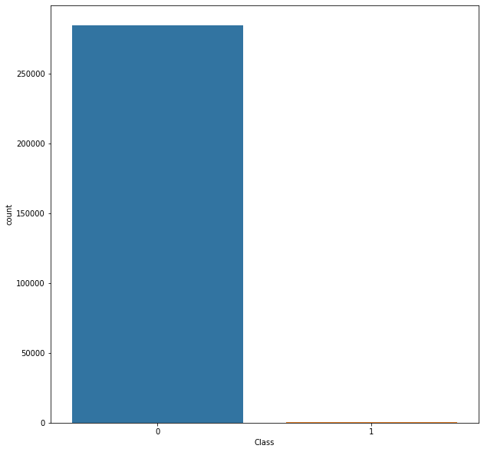

### Insights:

* The Dataset has 32 columns with unknown features labelled V1 to V28, Time, Amount and Class
* The target variable is 'Class' and rest of the variables are input features
* The Class has the following values:
  + 0: Legitimate Transactions
  + 1: Fraud Transactions
* The Dataset is highly imbalanced as evident from the countplot with majoritarian class label '0' and minority class label '1'
* Thus, if we run the model on such imbalanced data we may end up highly overfitting it on the data and resulting in non-deployable model
* Hence, we will perform Synthetic Minority Oversampling on the data to balance it out as shown later after exploring other features.

### What is relationship of fraud transactions with amount of money?

Let us try to determine the nature of transactions which are fraud and obtain a relevant set of the same with respect to their amount.

* We hypothesise based on our scatter plot that all fraud transactions occur for an amount less than 2500.

pairplot_data_grid(df, "Time", "Amount", "Class")

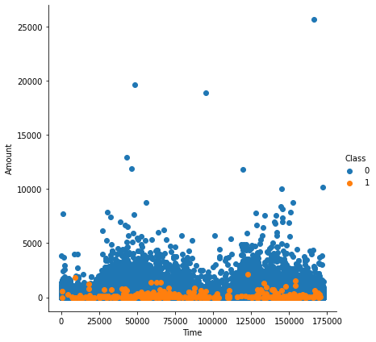

pairplot_data_grid(df, "Amount", "Time", "Class")

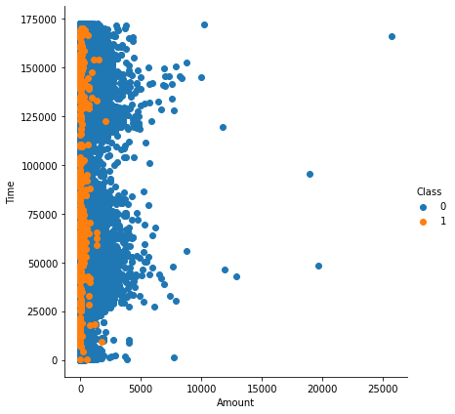

### Insights:

* It can be observed that the fraud transactions are generally not above an amount of 2500.
* It can also be observed that the fraud transactions are evenly distributed about time.
* Let us try to prove it

amount_more = 0  
amount_less = 0  
for i in range(df_refine.shape[0]):  
 if(df_refine.iloc[i]["Amount"] < 2500):  
 amount_less += 1  
 else:  
 amount_more += 1  
print(amount_more)  
print(amount_less)

449  
284358

percentage_less = (amount_less/df.shape[0])*100  
percentage_less

99.84234938045763

Hence, we observe that the 99.85% of transactions amount to less than 2500. Let us see how many of these are fraud and others legitimate

fraud = 0  
legitimate = 1  
for i in range(df_refine.shape[0]):  
 if(df_refine.iloc[i]["Amount"]<2500):  
 if(df_refine.iloc[i]["Class"] == 0):  
 legitimate += 1  
 else:  
 fraud+=1  
print(fraud)  
print(legitimate)

492  
283867

df_refine = df[["Time", "Amount", "Class"]]  
sns.pairplot(df_refine, hue="Class", size=6)  
plt.show()

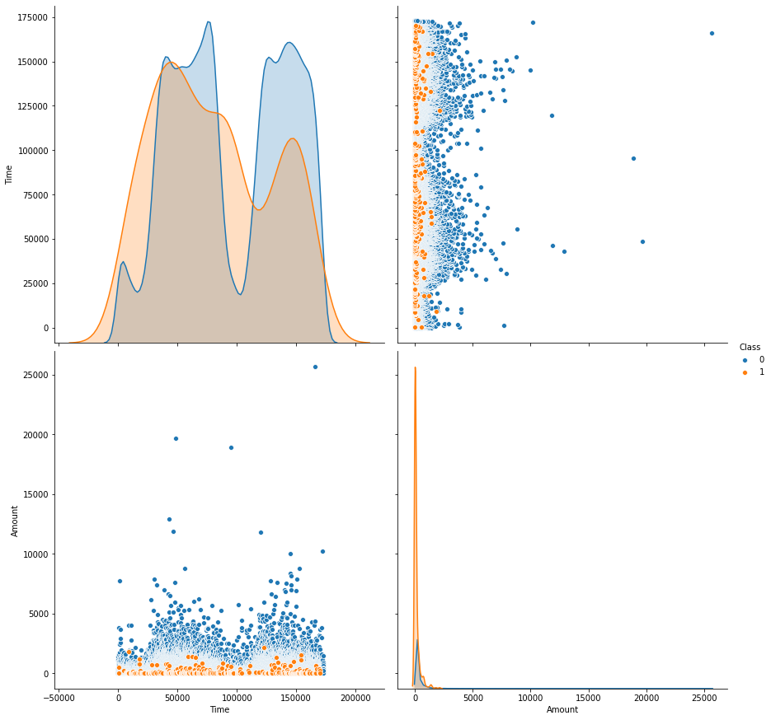

df.Class.value_counts()

0 284315  
1 492  
Name: Class, dtype: int64

Thus, we can conclude that since the number of fraud transaction below the amount of 2500 is same as the number of total fraud transactions. Hence, all fraud transactions are less than 2500.

### What is the relationship between Time and Transactions?

sns.FacetGrid(df_refine, hue="Class", size=6).map(sns.distplot,"Time").add_legend()  
plt.show()

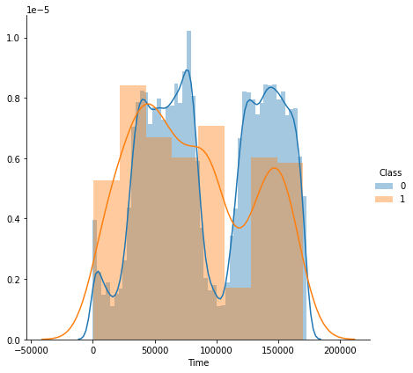

From the above distribution plot, it is clear that the fraudulent transactions are spread throughout the time period

### Modelling

* Study the Feature Correlations of the given data
* Plot a Heatmap
* Run GridSearch on the Data
* Fine Tune the Classifiers
* Create Pipelines for evaluation

plt.figure(figsize=(20,20))  
df_corr = df.corr()  
sns.heatmap(df_corr)

<matplotlib.axes._subplots.AxesSubplot at 0x7f397f77d700>

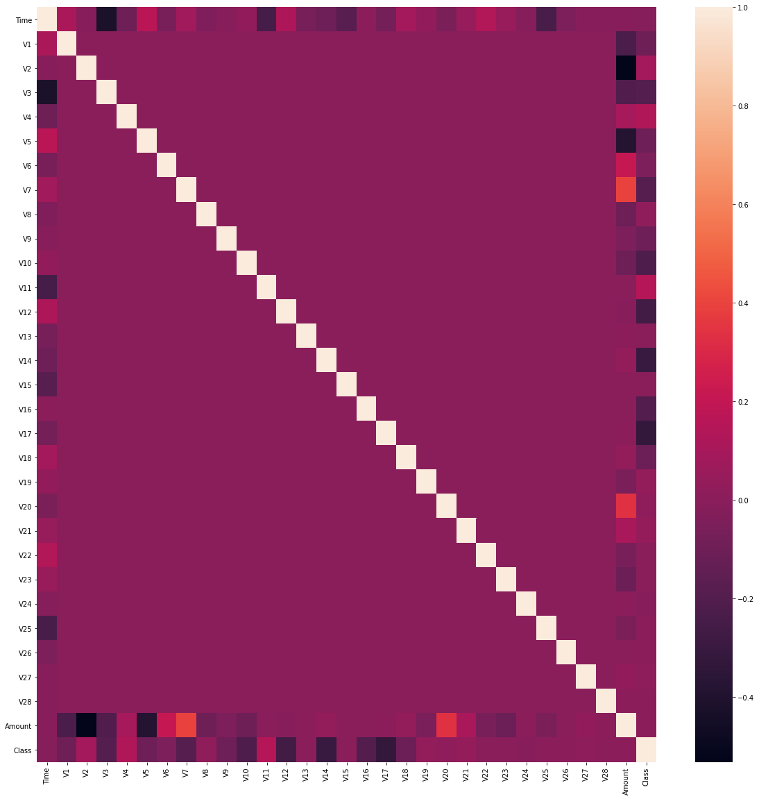

# Create Train and Test Data in ratio 70:30  
X = df.drop(labels='Class', axis=1) # Features  
y = df.loc[:,'Class'] # Target Variable  
  
  
X_train, X_test, y_train, y_test = train_test_split(X, y, test_size=0.3, random_state=1, stratify=y)

### How will you balance the fraud and legitimate transactions in data?

# Use Synthetic Minority Oversampling  
sm = SMOTE(random_state=42)  
X_res, y_res = sm.fit_resample(X_train, y_train)

from sklearn.feature_selection import mutual_info_classif  
mutual_infos = pd.Series(data=mutual_info_classif(X_res, y_res, discrete_features=False, random_state=1), index=X_train.columns)

mutual_infos.sort_values(ascending=False)

V14 0.535037  
V10 0.464777  
V12 0.456051  
V17 0.438193  
V4 0.427426  
V11 0.404044  
Amount 0.392941  
V3 0.387191  
V16 0.335318  
V7 0.304175  
V2 0.291492  
V9 0.256679  
Time 0.247989  
V21 0.235031  
V27 0.229915  
V1 0.220743  
V18 0.198264  
V8 0.174393  
V6 0.171974  
V28 0.170493  
V5 0.157362  
V20 0.107488  
V19 0.099837  
V23 0.067332  
V24 0.063567  
V26 0.046973  
V25 0.031607  
V22 0.031539  
V13 0.024931  
V15 0.022442  
dtype: float64

sns.countplot(y_res)

<matplotlib.axes._subplots.AxesSubplot at 0x7f1e74ae2ac0>

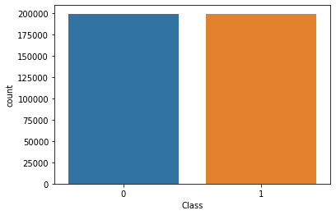

Hence, we can say that the most correlated features after resolving class imbalance using Synthetic Minority Oversampling are V14, V10, V4, V12 and V17.

### Evaluation

We make use of AUC-ROC Score, Classification Report, Accuracy and F1-Score to evaluate the performance of the classifiers

# Evaluation of Classifiers  
def grid_eval(grid_clf):  
 """  
 Method to Compute the best score and parameters computed by grid search  
 Parameter:  
 grid_clf: The Grid Search Classifier   
 """  
 print("Best Score", grid_clf.best_score_)  
 print("Best Parameter", grid_clf.best_params_)  
   
def evaluation(y_test, grid_clf, X_test):  
 """  
 Method to compute the following:  
 1. Classification Report  
 2. F1-score  
 3. AUC-ROC score  
 4. Accuracy  
 Parameters:  
 y_test: The target variable test set  
 grid_clf: Grid classifier selected  
 X_test: Input Feature Test Set  
 """  
 y_pred = grid_clf.predict(X_test)  
 print('CLASSIFICATION REPORT')  
 print(classification_report(y_test, y_pred))  
   
 print('AUC-ROC')  
 print(roc_auc_score(y_test, y_pred))  
   
 print('F1-Score')  
 print(f1_score(y_test, y_pred))  
   
 print('Accuracy')  
 print(accuracy_score(y_test, y_pred))

# The parameters of each classifier are different  
# Hence, we do not make use of a single method and this is not to violate DRY Principles  
# We set pipelines for each classifier unique with parameters  
param_grid_sgd = [{  
 'model__loss': ['log'],  
 'model__penalty': ['l1', 'l2'],  
 'model__alpha': np.logspace(start=-3, stop=3, num=20)  
}, {  
 'model__loss': ['hinge'],  
 'model__alpha': np.logspace(start=-3, stop=3, num=20),  
 'model__class_weight': [None, 'balanced']  
}]  
  
pipeline_sgd = Pipeline([  
 ('scaler', StandardScaler(copy=False)),  
 ('model', SGDClassifier(max_iter=1000, tol=1e-3, random_state=1, warm_start=True))  
])  
  
MCC_scorer = make_scorer(matthews_corrcoef)  
grid_sgd = GridSearchCV(estimator=pipeline_sgd, param_grid=param_grid_sgd, scoring=MCC_scorer, n_jobs=-1, pre_dispatch='2*n_jobs', cv=5, verbose=1, return_train_score=False)  
  
  
grid_sgd.fit(X_res, y_res)

Fitting 5 folds for each of 80 candidates, totalling 400 fits

[Parallel(n_jobs=-1)]: Using backend LokyBackend with 4 concurrent workers.  
[Parallel(n_jobs=-1)]: Done 42 tasks | elapsed: 48.4s  
[Parallel(n_jobs=-1)]: Done 192 tasks | elapsed: 3.2min  
[Parallel(n_jobs=-1)]: Done 400 out of 400 | elapsed: 6.0min finished

GridSearchCV(cv=5, error_score=nan,  
 estimator=Pipeline(memory=None,  
 steps=[('scaler',  
 StandardScaler(copy=False,  
 with_mean=True,  
 with_std=True)),  
 ('model',  
 SGDClassifier(alpha=0.0001,  
 average=False,  
 class_weight=None,  
 early_stopping=False,  
 epsilon=0.1, eta0=0.0,  
 fit_intercept=True,  
 l1_ratio=0.15,  
 learning_rate='optimal',  
 loss='hinge',  
 max_iter=1000,  
 n_iter_no_change=...  
 3.35981829e-01, 6.95192796e-01, 1.43844989e+00, 2.97635144e+00,  
 6.15848211e+00, 1.27427499e+01, 2.63665090e+01, 5.45559478e+01,  
 1.12883789e+02, 2.33572147e+02, 4.83293024e+02, 1.00000000e+03]),  
 'model__class_weight': [None, 'balanced'],  
 'model__loss': ['hinge']}],  
 pre_dispatch='2*n_jobs', refit=True, return_train_score=False,  
 scoring=make_scorer(matthews_corrcoef), verbose=1)

grid_eval(grid_sgd)

Best Score 0.9560162686072134  
Best Parameter {'model__alpha': 0.001, 'model__loss': 'log', 'model__penalty': 'l1'}

evaluation(y_test, grid_sgd, X_test)

CLASSIFICATION REPORT  
 precision recall f1-score support  
  
 0 1.00 0.99 1.00 85295  
 1 0.14 0.91 0.25 148  
  
 accuracy 0.99 85443  
 macro avg 0.57 0.95 0.62 85443  
weighted avg 1.00 0.99 0.99 85443  
  
AUC-ROC  
0.9479720619851928  
F1-Score  
0.2460973370064279  
Accuracy  
0.990391254988706

pipeline_rf = Pipeline([  
 ('model', RandomForestClassifier(n_jobs=-1, random_state=1))  
])  
param_grid_rf = {'model__n_estimators': [75]}  
grid_rf = GridSearchCV(estimator=pipeline_rf, param_grid=param_grid_rf, scoring=MCC_scorer, n_jobs=-1, pre_dispatch='2*n_jobs', cv=5, verbose=1, return_train_score=False)  
grid_rf.fit(X_res, y_res)

Fitting 5 folds for each of 1 candidates, totalling 5 fits

[Parallel(n_jobs=-1)]: Using backend LokyBackend with 4 concurrent workers.  
[Parallel(n_jobs=-1)]: Done 5 out of 5 | elapsed: 10.5min finished

GridSearchCV(cv=5, error_score=nan,  
 estimator=Pipeline(memory=None,  
 steps=[('model',  
 RandomForestClassifier(bootstrap=True,  
 ccp_alpha=0.0,  
 class_weight=None,  
 criterion='gini',  
 max_depth=None,  
 max_features='auto',  
 max_leaf_nodes=None,  
 max_samples=None,  
 min_impurity_decrease=0.0,  
 min_impurity_split=None,  
 min_samples_leaf=1,  
 min_samples_split=2,  
 min_weight_fraction_leaf=0.0,  
 n_estimators=100,  
 n_jobs=-1,  
 oob_score=False,  
 random_state=1,  
 verbose=0,  
 warm_start=False))],  
 verbose=False),  
 iid='deprecated', n_jobs=-1,  
 param_grid={'model__n_estimators': [75]}, pre_dispatch='2*n_jobs',  
 refit=True, return_train_score=False,  
 scoring=make_scorer(matthews_corrcoef), verbose=1)

grid_eval(grid_rf)

Best Score 0.9997538267139271  
Best Parameter {'model__n_estimators': 75}

evaluation(y_test, grid_rf, X_test)

CLASSIFICATION REPORT  
 precision recall f1-score support  
  
 0 1.00 1.00 1.00 85295  
 1 0.90 0.86 0.88 148  
  
 accuracy 1.00 85443  
 macro avg 0.95 0.93 0.94 85443  
weighted avg 1.00 1.00 1.00 85443  
  
AUC-ROC  
0.9323445023075716  
F1-Score  
0.879725085910653  
Accuracy  
0.9995903701883126

pipeline_lr = Pipeline([  
 ('model', LogisticRegression(random_state=1))  
])  
param_grid_lr = {'model__penalty': ['l2'],  
 'model__class_weight': [None, 'balanced']}  
grid_lr = GridSearchCV(estimator=pipeline_lr, param_grid=param_grid_lr, scoring=MCC_scorer, n_jobs=-1, pre_dispatch='2*n_jobs', cv=5, verbose=1, return_train_score=False)  
grid_lr.fit(X_res, y_res)

Fitting 5 folds for each of 2 candidates, totalling 10 fits

[Parallel(n_jobs=-1)]: Using backend LokyBackend with 4 concurrent workers.  
[Parallel(n_jobs=-1)]: Done 10 out of 10 | elapsed: 28.0s finished

GridSearchCV(cv=5, error_score=nan,  
 estimator=Pipeline(memory=None,  
 steps=[('model',  
 LogisticRegression(C=1.0,  
 class_weight=None,  
 dual=False,  
 fit_intercept=True,  
 intercept_scaling=1,  
 l1_ratio=None,  
 max_iter=100,  
 multi_class='auto',  
 n_jobs=None,  
 penalty='l2',  
 random_state=1,  
 solver='lbfgs',  
 tol=0.0001,  
 verbose=0,  
 warm_start=False))],  
 verbose=False),  
 iid='deprecated', n_jobs=-1,  
 param_grid={'model__class_weight': [None, 'balanced'],  
 'model__penalty': ['l2']},  
 pre_dispatch='2*n_jobs', refit=True, return_train_score=False,  
 scoring=make_scorer(matthews_corrcoef), verbose=1)

grid_eval(grid_lr)

Best Score 0.959816277887179  
Best Parameter {'model__class_weight': None, 'model__penalty': 'l2'}

evaluation(y_test, grid_lr, X_test)

CLASSIFICATION REPORT  
 precision recall f1-score support  
  
 0 1.00 0.99 1.00 85295  
 1 0.15 0.91 0.26 148  
  
 accuracy 0.99 85443  
 macro avg 0.57 0.95 0.63 85443  
weighted avg 1.00 0.99 0.99 85443  
  
AUC-ROC  
0.948212404326479  
F1-Score  
0.2557251908396946  
Accuracy  
0.9908711070538253

pipeline_knn = Pipeline([  
 ('model', KNeighborsClassifier(n_neighbors=5))  
])  
param_grid_knn = {'model__p': [2]}  
grid_knn = GridSearchCV(estimator=pipeline_knn, param_grid=param_grid_knn, scoring=MCC_scorer, n_jobs=-1, pre_dispatch='2*n_jobs', cv=5, verbose=1, return_train_score=False)  
grid_knn.fit(X_res, y_res)

Fitting 5 folds for each of 1 candidates, totalling 5 fits

[Parallel(n_jobs=-1)]: Using backend LokyBackend with 4 concurrent workers.  
[Parallel(n_jobs=-1)]: Done 5 out of 5 | elapsed: 15.9min finished

GridSearchCV(cv=5, error_score=nan,  
 estimator=Pipeline(memory=None,  
 steps=[('model',  
 KNeighborsClassifier(algorithm='auto',  
 leaf_size=30,  
 metric='minkowski',  
 metric_params=None,  
 n_jobs=None,  
 n_neighbors=5, p=2,  
 weights='uniform'))],  
 verbose=False),  
 iid='deprecated', n_jobs=-1, param_grid={'model__p': [2]},  
 pre_dispatch='2*n_jobs', refit=True, return_train_score=False,  
 scoring=make_scorer(matthews_corrcoef), verbose=1)

grid_eval(grid_knn)

Best Score 0.9980623930056313  
Best Parameter {'model__p': 2}

evaluation(y_test, grid_knn, X_test)

CLASSIFICATION REPORT  
 precision recall f1-score support  
  
 0 1.00 1.00 1.00 85295  
 1 0.50 0.86 0.63 148  
  
 accuracy 1.00 85443  
 macro avg 0.75 0.93 0.82 85443  
weighted avg 1.00 1.00 1.00 85443  
  
AUC-ROC  
0.9283095789968995  
F1-Score  
0.6318407960199005  
Accuracy  
0.9982678510820079

# The number of fraud transactions are very few comparted to legitimate transactions and it has to be balanced in order for a fair comparison to prevent the model from overfitting.Credit Card Fraud Detection

## Data frames

import pandas as pd

df = pd.read_csv('creditcard.csv')

df

Time V1 V2 V3 V4 V5 \  
0 0.0 -1.359807 -0.072781 2.536347 1.378155 -0.338321   
1 0.0 1.191857 0.266151 0.166480 0.448154 0.060018   
2 1.0 -1.358354 -1.340163 1.773209 0.379780 -0.503198   
3 1.0 -0.966272 -0.185226 1.792993 -0.863291 -0.010309   
4 2.0 -1.158233 0.877737 1.548718 0.403034 -0.407193   
... ... ... ... ... ... ...   
284802 172786.0 -11.881118 10.071785 -9.834783 -2.066656 -5.364473   
284803 172787.0 -0.732789 -0.055080 2.035030 -0.738589 0.868229   
284804 172788.0 1.919565 -0.301254 -3.249640 -0.557828 2.630515   
284805 172788.0 -0.240440 0.530483 0.702510 0.689799 -0.377961   
284806 172792.0 -0.533413 -0.189733 0.703337 -0.506271 -0.012546   
  
 V6 V7 V8 V9 ... V21 V22 \  
0 0.462388 0.239599 0.098698 0.363787 ... -0.018307 0.277838   
1 -0.082361 -0.078803 0.085102 -0.255425 ... -0.225775 -0.638672   
2 1.800499 0.791461 0.247676 -1.514654 ... 0.247998 0.771679   
3 1.247203 0.237609 0.377436 -1.387024 ... -0.108300 0.005274   
4 0.095921 0.592941 -0.270533 0.817739 ... -0.009431 0.798278   
... ... ... ... ... ... ... ...   
284802 -2.606837 -4.918215 7.305334 1.914428 ... 0.213454 0.111864   
284803 1.058415 0.024330 0.294869 0.584800 ... 0.214205 0.924384   
284804 3.031260 -0.296827 0.708417 0.432454 ... 0.232045 0.578229   
284805 0.623708 -0.686180 0.679145 0.392087 ... 0.265245 0.800049   
284806 -0.649617 1.577006 -0.414650 0.486180 ... 0.261057 0.643078   
  
 V23 V24 V25 V26 V27 V28 Amount \  
0 -0.110474 0.066928 0.128539 -0.189115 0.133558 -0.021053 149.62   
1 0.101288 -0.339846 0.167170 0.125895 -0.008983 0.014724 2.69   
2 0.909412 -0.689281 -0.327642 -0.139097 -0.055353 -0.059752 378.66   
3 -0.190321 -1.175575 0.647376 -0.221929 0.062723 0.061458 123.50   
4 -0.137458 0.141267 -0.206010 0.502292 0.219422 0.215153 69.99   
... ... ... ... ... ... ... ...   
284802 1.014480 -0.509348 1.436807 0.250034 0.943651 0.823731 0.77   
284803 0.012463 -1.016226 -0.606624 -0.395255 0.068472 -0.053527 24.79   
284804 -0.037501 0.640134 0.265745 -0.087371 0.004455 -0.026561 67.88   
284805 -0.163298 0.123205 -0.569159 0.546668 0.108821 0.104533 10.00   
284806 0.376777 0.008797 -0.473649 -0.818267 -0.002415 0.013649 217.00   
  
 Class   
0 0   
1 0   
2 0   
3 0   
4 0   
... ...   
284802 0   
284803 0   
284804 0   
284805 0   
284806 0   
  
[284807 rows x 31 columns]

df['Class'].value_counts()

0 284315  
1 492  
Name: Class, dtype: int64

### Data Pre-processing

from sklearn.model_selection import train_test_split

from sklearn.preprocessing import StandardScaler

scalar = StandardScaler()

X = df.drop('Class', axis=1)  
y = df.Class

X = scalar.fit_transform(X)

X_train, X_test, y_train, y_test = train_test_split(X, y, test_size=0.2, random_state=1)

## Modeling

from sklearn.svm import SVC

model_svc = SVC()

model_svc.fit(X_train, y_train)

SVC()

model_svc.score(X_train,y_train)

0.9996752178015756

model_svc.score(X_test,y_test)

0.999385555282469

y_predict = model_svc.predict(X_test)

## Implementing Report

from sklearn.metrics import classification_report , confusion_matrix

import numpy as np

cm = np.array(confusion_matrix(y_test, y_predict, labels=[1,0]))  
confusion = pd.DataFrame(cm, index=['is Fraud', 'is Normal'],columns=['predicted fraud','predicted normal'])  
confusion

predicted fraud predicted normal  
is Fraud 55 32  
is Normal 3 56872

import seaborn as sns

sns.heatmap(confusion, annot=True)

<matplotlib.axes._subplots.AxesSubplot at 0x1a0374fe948>

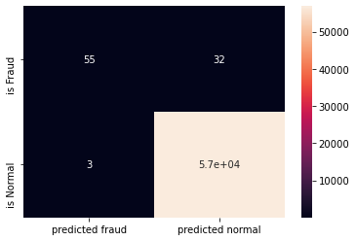

print(classification_report(y_test, y_predict))

precision recall f1-score support  
  
 0 1.00 1.00 1.00 56875  
 1 0.95 0.63 0.76 87  
  
 accuracy 1.00 56962  
 macro avg 0.97 0.82 0.88 56962  
weighted avg 1.00 1.00 1.00 56962

from google.colab import drive  
drive.mount('/content/drive')

Go to this URL in a browser: https://accounts.google.com/o/oauth2/auth?client_id=947318989803-6bn6qk8qdgf4n4g3pfee6491hc0brc4i.apps.googleusercontent.com&redirect_uri=urn%3aietf%3awg%3aoauth%3a2.0%3aoob&response_type=code&scope=email%20https%3a%2f%2fwww.googleapis.com%2fauth%2fdocs.test%20https%3a%2f%2fwww.googleapis.com%2fauth%2fdrive%20https%3a%2f%2fwww.googleapis.com%2fauth%2fdrive.photos.readonly%20https%3a%2f%2fwww.googleapis.com%2fauth%2fpeopleapi.readonly  
  
Enter your authorization code:  
··········  
Mounted at /content/drive

from matplotlib import pyplot as plt  
import warnings  
warnings.filterwarnings("ignore")  
import seaborn as sns  
import pandas as pd  
import numpy as np  
from imblearn.over_sampling import SMOTE  
from sklearn.preprocessing import StandardScaler  
from sklearn.model_selection import train_test_split  
import tensorflow as tf  
from tensorflow.keras.layers import Dense  
from tensorflow.keras.layers import Input  
from tensorflow.keras.models import Model

df = pd.read_csv("/content/drive/My Drive/creditcard.csv", encoding="utf-8")

df

Time V1 V2 ... V28 Amount Class  
0 0.0 -1.359807 -0.072781 ... -0.021053 149.62 0  
1 0.0 1.191857 0.266151 ... 0.014724 2.69 0  
2 1.0 -1.358354 -1.340163 ... -0.059752 378.66 0  
3 1.0 -0.966272 -0.185226 ... 0.061458 123.50 0  
4 2.0 -1.158233 0.877737 ... 0.215153 69.99 0  
... ... ... ... ... ... ... ...  
284802 172786.0 -11.881118 10.071785 ... 0.823731 0.77 0  
284803 172787.0 -0.732789 -0.055080 ... -0.053527 24.79 0  
284804 172788.0 1.919565 -0.301254 ... -0.026561 67.88 0  
284805 172788.0 -0.240440 0.530483 ... 0.104533 10.00 0  
284806 172792.0 -0.533413 -0.189733 ... 0.013649 217.00 0  
  
[284807 rows x 31 columns]

df.head()

Time V1 V2 V3 ... V27 V28 Amount Class  
0 0.0 -1.359807 -0.072781 2.536347 ... 0.133558 -0.021053 149.62 0  
1 0.0 1.191857 0.266151 0.166480 ... -0.008983 0.014724 2.69 0  
2 1.0 -1.358354 -1.340163 1.773209 ... -0.055353 -0.059752 378.66 0  
3 1.0 -0.966272 -0.185226 1.792993 ... 0.062723 0.061458 123.50 0  
4 2.0 -1.158233 0.877737 1.548718 ... 0.219422 0.215153 69.99 0  
  
[5 rows x 31 columns]

fig, ax = plt.subplots(figsize=(20,10))  
corr = df.corr()  
sns.heatmap(corr, cmap="gray", ax=ax)  
ax.set_title("Imbalanced Correlation Matrix", fontsize=14)  
plt.show()

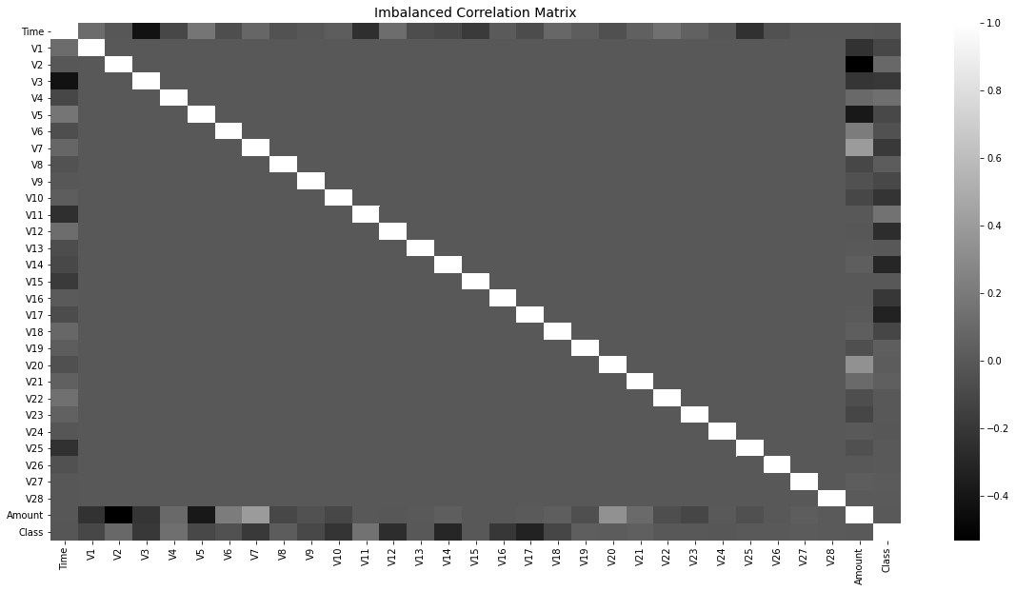

sns.countplot(x='Class',data=df)

<matplotlib.axes._subplots.AxesSubplot at 0x7f690eb54f60>

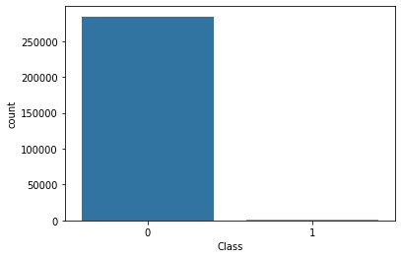

sm = SMOTE(sampling_strategy='minority', random_state=7)  
resampled_X, resampled_Y = sm.fit_resample(df.drop('Class', axis=1), df['Class'])  
oversampled_df = pd.concat([pd.DataFrame(resampled_X), pd.DataFrame(resampled_Y)], axis=1)  
oversampled_df.columns = df.columns  
oversampled_df['Class'].value_counts()

1 284315  
0 284315  
Name: Class, dtype: int64

sns.countplot(x='Class', data=oversampled_df)

<matplotlib.axes._subplots.AxesSubplot at 0x7f6908f63a20>

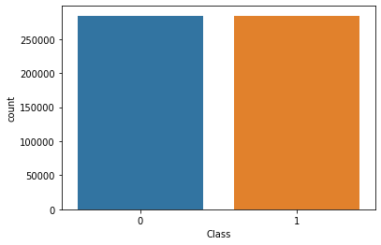

fig, ax = plt.subplots(figsize=(20,10))   
corr = oversampled_df.corr()  
sns.heatmap(corr, cmap='YlGnBu', annot_kws={'size':30}, ax=ax)  
ax.set_title("Imbalanced Correlation Matrix", fontsize=14)  
plt.show()

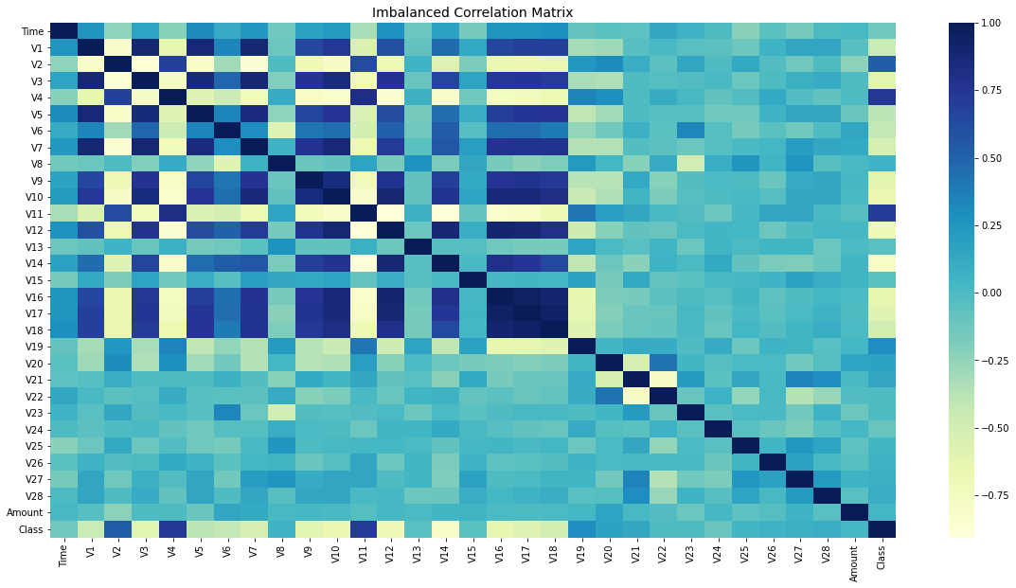

sc = StandardScaler()  
X = oversampled_df.iloc[:, 1:-1].values  
y = oversampled_df.iloc[:, -1].values  
y = y.reshape(-1, 1)  
print(X.shape, y.shape)  
  
X = sc.fit_transform(X)  
print(X[0])

(568630, 29) (568630, 1)  
[ 0.20495125 -0.54573636 1.0045184 -0.30168224 0.31098779 0.6920209  
 0.55516986 -0.03644768 0.76125221 0.67923829 -0.92061643 0.57128753  
 -0.94634073 0.71704508 1.64724241 0.48636415 0.62706212 0.50679008  
 0.04977222 0.06379384 -0.14589103 0.24649907 -0.10441593 0.22564242  
 0.16596895 -0.48756152 0.05492719 -0.14984388 0.2455859 ]

x_train, x_test, y_train, y_test = train_test_split(X, y, test_size=0.3, random_state=42)

adam = tf.keras.optimizers.Adam(learning_rate=0.0005)

x_features = X.shape[1]  
y_features = y.shape[1]

i = Input(shape=(x_features,))  
  
x = Dense(64, activation='relu')(i)  
x = Dense(64, activation='relu')(x)  
o = Dense(y_features, activation='sigmoid')(x)  
  
model = Model(i,o)  
model.compile(loss="binary_crossentropy", metrics=['accuracy'], optimizer=adam)  
print(model.summary())  
callback = tf.keras.callbacks.EarlyStopping(  
 monitor='val_loss', min_delta=0, patience=10, verbose=0, mode='auto',  
 baseline=None, restore_best_weights=True  
)

Model: "model"  
_________________________________________________________________  
Layer (type) Output Shape Param #   
=================================================================  
input_1 (InputLayer) [(None, 29)] 0   
_________________________________________________________________  
dense (Dense) (None, 64) 1920   
_________________________________________________________________  
dense_1 (Dense) (None, 64) 4160   
_________________________________________________________________  
dense_2 (Dense) (None, 1) 65   
=================================================================  
Total params: 6,145  
Trainable params: 6,145  
Non-trainable params: 0  
_________________________________________________________________  
None

r = model.fit(x_train, y_train, epochs=100, batch_size=512, verbose=1, validation_data=(x_test, y_test), callbacks=[callback])

Epoch 1/100  
778/778 [==============================] - 3s 4ms/step - loss: 0.1122 - accuracy: 0.9588 - val_loss: 0.0468 - val_accuracy: 0.9844  
Epoch 2/100  
778/778 [==============================] - 3s 4ms/step - loss: 0.0336 - accuracy: 0.9883 - val_loss: 0.0260 - val_accuracy: 0.9929  
Epoch 3/100  
778/778 [==============================] - 3s 4ms/step - loss: 0.0198 - accuracy: 0.9939 - val_loss: 0.0165 - val_accuracy: 0.9945  
Epoch 4/100  
778/778 [==============================] - 3s 4ms/step - loss: 0.0133 - accuracy: 0.9965 - val_loss: 0.0117 - val_accuracy: 0.9974  
Epoch 5/100  
778/778 [==============================] - 3s 4ms/step - loss: 0.0095 - accuracy: 0.9978 - val_loss: 0.0096 - val_accuracy: 0.9977  
Epoch 6/100  
778/778 [==============================] - 3s 4ms/step - loss: 0.0074 - accuracy: 0.9984 - val_loss: 0.0068 - val_accuracy: 0.9986  
Epoch 7/100  
778/778 [==============================] - 3s 4ms/step - loss: 0.0060 - accuracy: 0.9987 - val_loss: 0.0061 - val_accuracy: 0.9986  
Epoch 8/100  
778/778 [==============================] - 3s 4ms/step - loss: 0.0050 - accuracy: 0.9989 - val_loss: 0.0051 - val_accuracy: 0.9989  
Epoch 9/100  
778/778 [==============================] - 3s 4ms/step - loss: 0.0042 - accuracy: 0.9991 - val_loss: 0.0046 - val_accuracy: 0.9989  
Epoch 10/100  
778/778 [==============================] - 3s 4ms/step - loss: 0.0037 - accuracy: 0.9992 - val_loss: 0.0041 - val_accuracy: 0.9990  
Epoch 11/100  
778/778 [==============================] - 3s 4ms/step - loss: 0.0033 - accuracy: 0.9993 - val_loss: 0.0037 - val_accuracy: 0.9993  
Epoch 12/100  
778/778 [==============================] - 3s 4ms/step - loss: 0.0029 - accuracy: 0.9994 - val_loss: 0.0035 - val_accuracy: 0.9992  
Epoch 13/100  
778/778 [==============================] - 3s 4ms/step - loss: 0.0027 - accuracy: 0.9994 - val_loss: 0.0037 - val_accuracy: 0.9991  
Epoch 14/100  
778/778 [==============================] - 3s 4ms/step - loss: 0.0024 - accuracy: 0.9995 - val_loss: 0.0035 - val_accuracy: 0.9990  
Epoch 15/100  
778/778 [==============================] - 3s 4ms/step - loss: 0.0022 - accuracy: 0.9995 - val_loss: 0.0032 - val_accuracy: 0.9992  
Epoch 16/100  
778/778 [==============================] - 3s 4ms/step - loss: 0.0020 - accuracy: 0.9996 - val_loss: 0.0027 - val_accuracy: 0.9994  
Epoch 17/100  
778/778 [==============================] - 3s 4ms/step - loss: 0.0020 - accuracy: 0.9995 - val_loss: 0.0027 - val_accuracy: 0.9993  
Epoch 18/100  
778/778 [==============================] - 3s 4ms/step - loss: 0.0018 - accuracy: 0.9996 - val_loss: 0.0023 - val_accuracy: 0.9996  
Epoch 19/100  
778/778 [==============================] - 3s 4ms/step - loss: 0.0016 - accuracy: 0.9996 - val_loss: 0.0025 - val_accuracy: 0.9994  
Epoch 20/100  
778/778 [==============================] - 3s 4ms/step - loss: 0.0015 - accuracy: 0.9997 - val_loss: 0.0025 - val_accuracy: 0.9993  
Epoch 21/100  
778/778 [==============================] - 3s 4ms/step - loss: 0.0015 - accuracy: 0.9996 - val_loss: 0.0022 - val_accuracy: 0.9994  
Epoch 22/100  
778/778 [==============================] - 3s 4ms/step - loss: 0.0014 - accuracy: 0.9997 - val_loss: 0.0024 - val_accuracy: 0.9994  
Epoch 23/100  
778/778 [==============================] - 3s 4ms/step - loss: 0.0013 - accuracy: 0.9997 - val_loss: 0.0022 - val_accuracy: 0.9996  
Epoch 24/100  
778/778 [==============================] - 3s 4ms/step - loss: 0.0012 - accuracy: 0.9997 - val_loss: 0.0022 - val_accuracy: 0.9995  
Epoch 25/100  
778/778 [==============================] - 3s 4ms/step - loss: 0.0014 - accuracy: 0.9997 - val_loss: 0.0025 - val_accuracy: 0.9993  
Epoch 26/100  
778/778 [==============================] - 3s 4ms/step - loss: 0.0011 - accuracy: 0.9997 - val_loss: 0.0027 - val_accuracy: 0.9993  
Epoch 27/100  
778/778 [==============================] - 3s 4ms/step - loss: 9.9902e-04 - accuracy: 0.9997 - val_loss: 0.0023 - val_accuracy: 0.9995  
Epoch 28/100  
778/778 [==============================] - 3s 4ms/step - loss: 9.9616e-04 - accuracy: 0.9997 - val_loss: 0.0021 - val_accuracy: 0.9995  
Epoch 29/100  
778/778 [==============================] - 3s 4ms/step - loss: 8.8531e-04 - accuracy: 0.9998 - val_loss: 0.0020 - val_accuracy: 0.9995  
Epoch 30/100  
778/778 [==============================] - 3s 4ms/step - loss: 0.0010 - accuracy: 0.9997 - val_loss: 0.0018 - val_accuracy: 0.9996  
Epoch 31/100  
778/778 [==============================] - 3s 4ms/step - loss: 8.5445e-04 - accuracy: 0.9998 - val_loss: 0.0019 - val_accuracy: 0.9995  
Epoch 32/100  
778/778 [==============================] - 3s 4ms/step - loss: 9.3442e-04 - accuracy: 0.9997 - val_loss: 0.0016 - val_accuracy: 0.9997  
Epoch 33/100  
778/778 [==============================] - 3s 4ms/step - loss: 7.1790e-04 - accuracy: 0.9998 - val_loss: 0.0016 - val_accuracy: 0.9996  
Epoch 34/100  
778/778 [==============================] - 3s 4ms/step - loss: 7.2516e-04 - accuracy: 0.9998 - val_loss: 0.0016 - val_accuracy: 0.9996  
Epoch 35/100  
778/778 [==============================] - 3s 4ms/step - loss: 9.1578e-04 - accuracy: 0.9997 - val_loss: 0.0020 - val_accuracy: 0.9994  
Epoch 36/100  
778/778 [==============================] - 3s 4ms/step - loss: 6.7762e-04 - accuracy: 0.9998 - val_loss: 0.0015 - val_accuracy: 0.9997  
Epoch 37/100  
778/778 [==============================] - 3s 4ms/step - loss: 6.5826e-04 - accuracy: 0.9998 - val_loss: 0.0015 - val_accuracy: 0.9996  
Epoch 38/100  
778/778 [==============================] - 3s 4ms/step - loss: 7.5355e-04 - accuracy: 0.9998 - val_loss: 0.0016 - val_accuracy: 0.9996  
Epoch 39/100  
778/778 [==============================] - 3s 4ms/step - loss: 7.1149e-04 - accuracy: 0.9998 - val_loss: 0.0015 - val_accuracy: 0.9996  
Epoch 40/100  
778/778 [==============================] - 3s 4ms/step - loss: 5.8838e-04 - accuracy: 0.9999 - val_loss: 0.0024 - val_accuracy: 0.9994  
Epoch 41/100  
778/778 [==============================] - 3s 4ms/step - loss: 5.2743e-04 - accuracy: 0.9999 - val_loss: 0.0015 - val_accuracy: 0.9997  
Epoch 42/100  
778/778 [==============================] - 3s 4ms/step - loss: 7.9482e-04 - accuracy: 0.9998 - val_loss: 0.0019 - val_accuracy: 0.9995  
Epoch 43/100  
778/778 [==============================] - 3s 4ms/step - loss: 6.0553e-04 - accuracy: 0.9998 - val_loss: 0.0013 - val_accuracy: 0.9997  
Epoch 44/100  
778/778 [==============================] - 3s 4ms/step - loss: 6.0704e-04 - accuracy: 0.9998 - val_loss: 0.0020 - val_accuracy: 0.9995  
Epoch 45/100  
778/778 [==============================] - 3s 4ms/step - loss: 6.3886e-04 - accuracy: 0.9998 - val_loss: 0.0015 - val_accuracy: 0.9996  
Epoch 46/100  
778/778 [==============================] - 3s 4ms/step - loss: 5.7343e-04 - accuracy: 0.9998 - val_loss: 0.0013 - val_accuracy: 0.9997  
Epoch 47/100  
778/778 [==============================] - 3s 4ms/step - loss: 4.2137e-04 - accuracy: 0.9999 - val_loss: 0.0018 - val_accuracy: 0.9996  
Epoch 48/100  
778/778 [==============================] - 3s 4ms/step - loss: 6.0087e-04 - accuracy: 0.9998 - val_loss: 0.0016 - val_accuracy: 0.9997  
Epoch 49/100  
778/778 [==============================] - 3s 4ms/step - loss: 5.2967e-04 - accuracy: 0.9999 - val_loss: 0.0012 - val_accuracy: 0.9998  
Epoch 50/100  
778/778 [==============================] - 3s 4ms/step - loss: 5.2438e-04 - accuracy: 0.9998 - val_loss: 0.0012 - val_accuracy: 0.9997  
Epoch 51/100  
778/778 [==============================] - 3s 4ms/step - loss: 5.0218e-04 - accuracy: 0.9998 - val_loss: 0.0018 - val_accuracy: 0.9996  
Epoch 52/100  
778/778 [==============================] - 3s 4ms/step - loss: 6.3864e-04 - accuracy: 0.9998 - val_loss: 0.0020 - val_accuracy: 0.9995  
Epoch 53/100  
778/778 [==============================] - 3s 4ms/step - loss: 6.7778e-04 - accuracy: 0.9998 - val_loss: 0.0016 - val_accuracy: 0.9996  
Epoch 54/100  
778/778 [==============================] - 3s 4ms/step - loss: 4.3683e-04 - accuracy: 0.9999 - val_loss: 0.0017 - val_accuracy: 0.9996  
Epoch 55/100  
778/778 [==============================] - 3s 4ms/step - loss: 7.2916e-04 - accuracy: 0.9998 - val_loss: 0.0018 - val_accuracy: 0.9996  
Epoch 56/100  
778/778 [==============================] - 3s 4ms/step - loss: 4.6164e-04 - accuracy: 0.9999 - val_loss: 0.0017 - val_accuracy: 0.9996  
Epoch 57/100  
778/778 [==============================] - 3s 4ms/step - loss: 4.3985e-04 - accuracy: 0.9999 - val_loss: 0.0022 - val_accuracy: 0.9995  
Epoch 58/100  
778/778 [==============================] - 3s 4ms/step - loss: 4.4691e-04 - accuracy: 0.9999 - val_loss: 0.0015 - val_accuracy: 0.9996  
Epoch 59/100  
778/778 [==============================] - 3s 4ms/step - loss: 6.0507e-04 - accuracy: 0.9998 - val_loss: 0.0010 - val_accuracy: 0.9998  
Epoch 60/100  
778/778 [==============================] - 3s 4ms/step - loss: 4.2673e-04 - accuracy: 0.9999 - val_loss: 0.0027 - val_accuracy: 0.9995  
Epoch 61/100  
778/778 [==============================] - 3s 4ms/step - loss: 3.7599e-04 - accuracy: 0.9999 - val_loss: 0.0019 - val_accuracy: 0.9996  
Epoch 62/100  
778/778 [==============================] - 3s 4ms/step - loss: 6.4678e-04 - accuracy: 0.9998 - val_loss: 0.0024 - val_accuracy: 0.9995  
Epoch 63/100  
778/778 [==============================] - 3s 4ms/step - loss: 3.3452e-04 - accuracy: 0.9999 - val_loss: 0.0013 - val_accuracy: 0.9997  
Epoch 64/100  
778/778 [==============================] - 3s 4ms/step - loss: 4.5338e-04 - accuracy: 0.9999 - val_loss: 0.0022 - val_accuracy: 0.9995  
Epoch 65/100  
778/778 [==============================] - 3s 4ms/step - loss: 5.2037e-04 - accuracy: 0.9998 - val_loss: 0.0013 - val_accuracy: 0.9997  
Epoch 66/100  
778/778 [==============================] - 3s 4ms/step - loss: 3.9358e-04 - accuracy: 0.9999 - val_loss: 0.0014 - val_accuracy: 0.9997  
Epoch 67/100  
778/778 [==============================] - 3s 4ms/step - loss: 4.2975e-04 - accuracy: 0.9999 - val_loss: 0.0018 - val_accuracy: 0.9997  
Epoch 68/100  
778/778 [==============================] - 3s 4ms/step - loss: 3.7875e-04 - accuracy: 0.9999 - val_loss: 0.0012 - val_accuracy: 0.9997  
Epoch 69/100  
778/778 [==============================] - 3s 4ms/step - loss: 5.4449e-04 - accuracy: 0.9998 - val_loss: 0.0017 - val_accuracy: 0.9997

results = model.evaluate(x_test, y_test, batch_size=5, verbose=1)  
print("Loss: %.2f" % results[0])  
print("Acc: %.2f" % results[1])

34118/34118 [==============================] - 74s 2ms/step - loss: 0.0010 - accuracy: 0.9998  
Loss: 0.00  
Acc: 1.00

print(r.history.keys())  
plt.plot(r.history['loss'])  
plt.plot(r.history['val_loss'])  
plt.legend(['loss', 'val_loss'])  
plt.show()  
  
plt.plot(r.history['accuracy'])  
plt.plot(r.history['val_accuracy'])  
plt.legend(['accuracy', 'val_accuracy'])  
plt.show()

dict_keys(['loss', 'accuracy', 'val_loss', 'val_accuracy'])

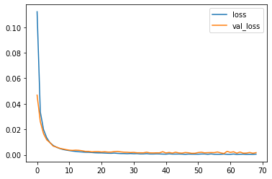

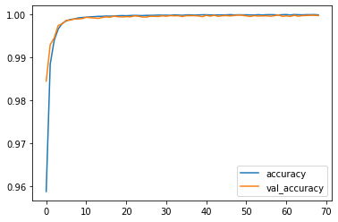

y_pred = model.predict(x_test)  
y_pred = np.round(y_pred, decimals=0).astype(int)

df_pred = pd.concat([pd.DataFrame(x_test), pd.DataFrame(y_test)], axis=1)  
df_pred.columns = df.drop('Time', axis=1).columns  
df_pred.rename(columns={"Class":"Old_class"}, inplace=True)  
df_pred['New_class'] = y_pred  
cm = pd.crosstab(df_pred["New_class"], df_pred['Old_class'])  
true_pos = np.sum(np.diag(cm))  
false_pos = cm[0][1]  
false_neg = cm[1][0]  
precision = true_pos / (true_pos + false_pos) * 100  
recall = true_pos / (true_pos + false_neg) * 100  
f1 = 2 * (precision * recall) / (precision + recall)  
print("Precision: %.3f%%" % (precision))  
print("Recall: %.3f%%" % (recall))  
print("F1: %.3f%%" % (f1))

Precision: 99.981%  
Recall: 100.000%  
F1: 99.991%

### Conclusion

* The K-Nearest Neighbors Classifier tuned with Grid Search with the best parameter being the Euclidean Distance (p=2) outperforms its counterparts to give a test accuracy of nearly 99.8% and a perfect F1-Score with minimal overfitting
* SMOTE overcomes overfitting by synthetically oversampling minority class labels and is successful to a great degree

### Summary

* All Fraud Transactions occur for an amount below 2500. Thus, the bank can infer clearly that the fraud committers try to commit frauds of smaller amounts to avoid suspicion.
* The fraud transactions are equitable distributed throughout time and there is no clear relationship of time with commiting of fraud.