1. **Aim**: Program to implement linear techniques using any standard dataset available in the public domain and evaluate its performance.

**Program**

import matplotlib.pyplot as plt

import numpy as np

from sklearn import datasets, linear_model

from sklearn.metrics import mean_squared_error, r2_score

df = datasets.load_diabetes()

print(df['feature_names'])

# Load the diabetes dataset

diabetes_X, diabetes_y = datasets.load_diabetes(return_X_y=True)

print(diabetes_X.shape)

# Use only one feature

diabetes_X = diabetes_X[:, np.newaxis, 2]

print(diabetes_X.shape)

# Split the data into training/testing sets

diabetes_X_train = diabetes_X[:-20]

diabetes_X_test = diabetes_X[-20:]

# Split the targets into training/testing sets

diabetes_y_train = diabetes_y[:-20]

diabetes_y_test = diabetes_y[-20:]

# Create linear regression object

regr = linear_model.LinearRegression()

# Train the model using the training sets

regr.fit(diabetes_X_train, diabetes_y_train)

# Make predictions using the testing set

diabetes_y_pred = regr.predict(diabetes_X_test)

# The coefficients

print("Coefficients: \n", regr.coef_)

# The mean squared error

print("Mean squared error: %.2f" % mean_squared_error(diabetes_y_test, diabetes_y_pred))

# The coefficient of determination: 1 is perfect prediction

print("Coefficient of determination: %.2f" % r2_score(diabetes_y_test, diabetes_y_pred))

# Plot outputs

plt.scatter(diabetes_X_test, diabetes_y_test, color="black")

plt.plot(diabetes_X_test, diabetes_y_pred, color="blue", linewidth=3)

plt.xlabel("age")

plt.ylabel("diabetes progression")

plt.xticks(())

plt.yticks(())

plt.show()

OUTPUT

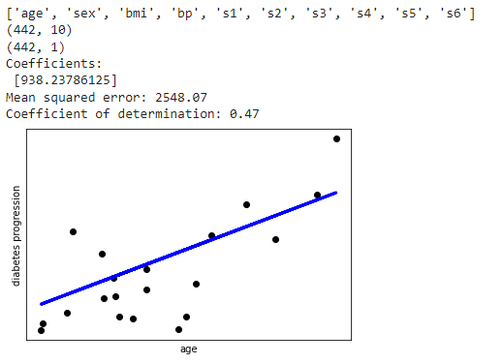

1. **Aim**: Program to implement K means clustering using any standard dataset available in the public domain and evaluate its performance.

**Program**

from sklearn import datasets

import matplotlib.pyplot as plt

import pandas as pd

from sklearn.cluster import KMeans

iris = datasets.load_iris()

X = iris.data[:, :2]

y = iris.target

plt.scatter(X[:,0], X[:,1], c=y, cmap='prism')

plt.xlabel('Spea1 Length', fontsize=18)

plt.ylabel('Sepal Width', fontsize=18)

km = KMeans(n_clusters = 3, init='k-means++', n_init=10, max_iter=300, tol=0.0001, verbose=0, random_state=21, copy_x=True, algorithm="auto")

km.fit(X)

centers = km.cluster_centers_

print(centers)

new_labels = km.labels_

print(new_labels)

print(y)

fig, axes = plt.subplots( 1,2, figsize=(16,8))

axes[0].scatter(X[:, 0], X[:, 1], c=y, cmap='prism',edgecolor='k', s=75)

axes[1].scatter(X[:, 0], X[:, 1], c=new_labels, cmap='jet',edgecolor='k', s=75)

axes[0].set_xlabel('Sepal length', fontsize=12)

axes[0].set_ylabel('Sepal width', fontsize=12)

axes[1].set_xlabel('Sepal length', fontsize=12)

axes[1].set_ylabel('Sepal width', fontsize=12)

axes[0].tick_params(direction='in', length=10, width=5, colors='k', labelsize=15)

axes[1].tick_params(direction='in', length=10, width=5, colors='k', labelsize=15)

axes[0].set_title('Actual', fontsize=18)

axes[1].set_title('Predicted', fontsize=18)

Output

