How to Install Python
Visit the link https://www.python.org to download the latest release of Python. In this process, we will install Python 3.12.4 on our Windows operating system. When we click on the above link, it will bring us the following page.
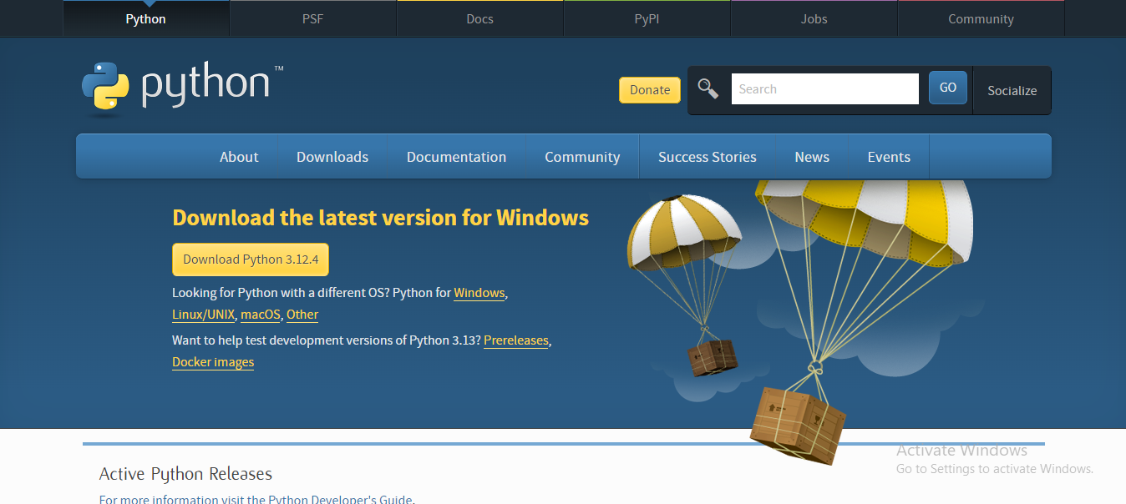
Step - 1: Select the Python's version to download.
Click on the download button to download the exe file of Python.

If in case you want to download the specific version of Python. Then, you can scroll down further below to see different versions from 2 and 3 respectively. Click on download button right next to the version number you want to download.
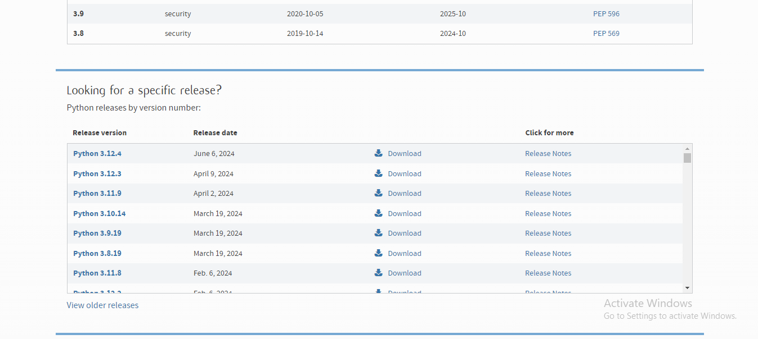

Step 2 − Download Python Executable Installer
All the available versions of Python will be listed. Select the version required by you and click on Download. Let suppose, we chose the Python 3.9.1 version.

On clicking download, various available executable installers shall be visible with different operating system specifications. Choose the installer which suits your system operating system and download the instlaller. either Windows installer (64-bit) or Windows installer (32-bit) and proceed to download the executable file.
Let suppose, we select the Windows installer(64 bits).
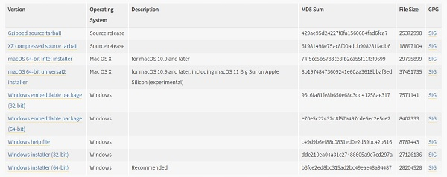

Step 3 − Run Executable Installer
We downloaded the Python 3.9.1 Windows 64 bit installer.
Run the installer. Make sure to select both the checkboxes at the bottom and then click Install New (or you can select Customize installation).
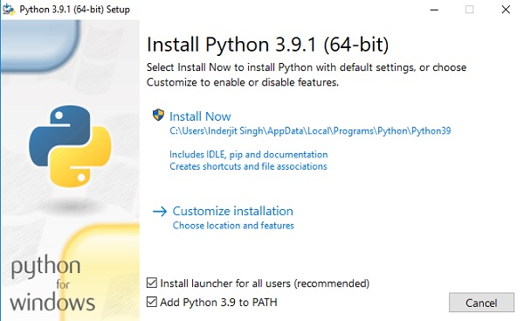
On clicking the Install Now, The installation process starts.
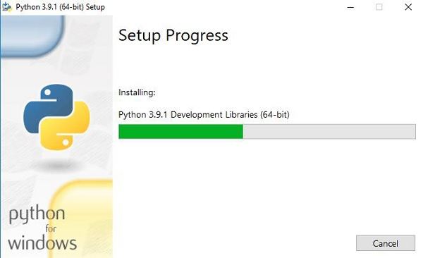
The installation process will take few minutes to complete and once the installation is successful, the following screen is displayed.
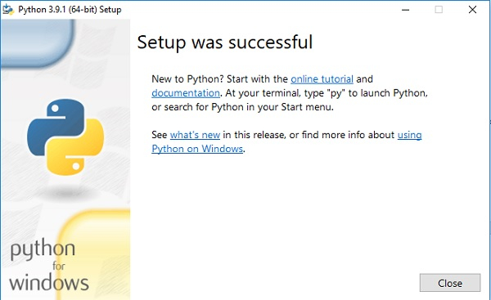

Step 4 − Verify Python is installed
- Go to "Start" button, and search " cmd ".
- Then type, " python - - version ".
- If python is successfully installed, then we can see the version of the python installed.
- If not installed, then it will print the error as “ ‘python’ is not recognized as an internal or external command, operable program or batch file. ".

We are ready to work with the Python.
Step - 5: Opening idle
Running IDLE opens Python's built-in IDE:
Now, to work on our first python program, we will go the interactive interpreter prompt (idle). To open this, go to "Start" and type idle. Then, click on open to start working on idle.
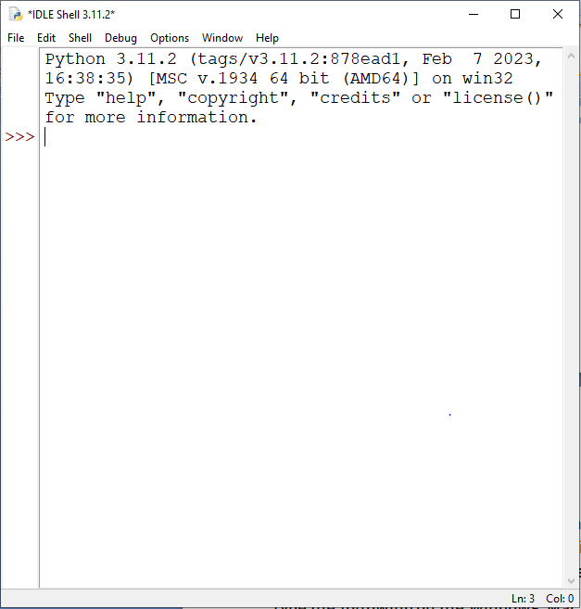

The Python Command Line
To test a short amount of code in python sometimes it is quickest and easiest not to write the code in a file. This is made possible because Python can be run as a command line itself.
Type the following on the Windows, Mac or Linux command line:
Or, if the "python" command did not work, you can try "py": C:\Users\ADMIN>py
From there you can write any python, including our hello world example.
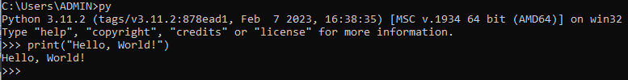
Whenever you are done in the python command line, you can simply type the following to quit the python command line interface:
Or you can use quit()

Python pip
PIP is a package manager for Python packages, or modules if you like.

Check if PIP is installed.
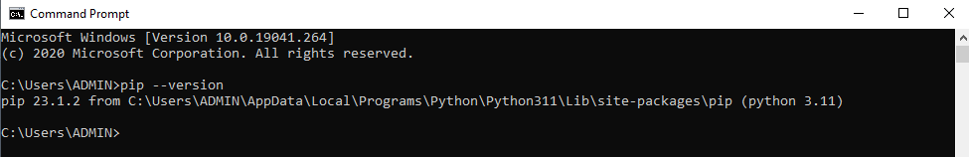
Python pip is a package management system that simplifies the process of installing and managing software packages written in Python. The term "pip" stands for "Pip Installs Packages" or "Preferred Installer Program
Installation: pip is installed by default with Python versions 3.4 and above (on most systems), but for older versions, you might need to install it manually.
Usage: You can use pip from the command line to install Python packages from the Python Package Index (PyPI) or other repositories. For example, pip install requests installs the requests package.
Package Management: pip helps you manage dependencies for your Python projects. It can install, upgrade, and uninstall packages, and it also supports installing packages from source code or version control.
Requirements Files: You can create requirements.txt files to specify a list of packages along with their versions. This file can then be used with pip to install all dependencies for a project in one go.
Virtual Environments: It's recommended to use pip within a virtual environment (created using venv or virtualenv) to isolate dependencies for different projects and avoid conflicts between them.
Other Commands: Besides installation (install), pip supports commands like uninstall, freeze (to list installed packages), show (to show information about installed packages), and more.
- pip install package name
- pip uninstall package name
Overall, pip is a crucial tool for Python developers and makes managing Python packages and dependencies straightforward and efficient.
Python virtual environment
A virtual environment in Python is a self-contained directory that encapsulates a specific Python interpreter and its dependencies. It allows you to create an isolated environment for Python projects, which can have its own set of packages without affecting other Python projects or the system-wide Python installation.
- Isolation: Virtual environments provide isolation by creating a directory structure that includes a Python interpreter and a copy of the standard library. Any packages installed in the virtual environment are isolated from those installed in other virtual environments or the global Python environment.

- Dependency Management: Virtual environments help manage dependencies for different projects. Each project can have its own set of libraries and versions, ensuring that dependencies are consistent and not conflicting across different projects.

- Easy Cleanup: Since virtual environments are just directories, you can easily delete them when you no longer need them, which helps in cleaning up unused dependencies and freeing up disk space.

- Creation: You can create a virtual environment using the venv module (available by default in Python 3.3 and later) or using third-party tools like virtualenv. Here’s how you can create a virtual environment using venv:

python –m venv environment name

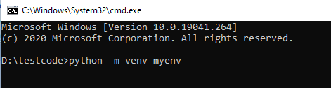

This command creates a new virtual environment named myenv in the current directory (Here D:\testcode).
- Activation and Deactivation: To use a virtual environment, you typically activate it using a script or command specific to your operating system:
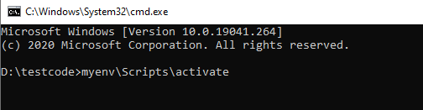
This modifies the shell's PATH environment variable to prioritize the virtual environment's Python interpreter and libraries.

- Managing Packages: Once activated, you can use pip to install packages into the virtual environment. Packages installed with pip in an activated virtual environment are isolated and do not affect the global Python installation or other virtual environments.

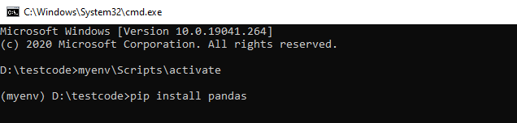

Virtual environments are essential for Python development because they allow developers to work on multiple projects with different dependencies without conflicts. They promote clean and reproducible environments, which is crucial for ensuring the stability and maintainability of Python applications.

Django installation
Installing Django can be done using Python's package manager, pip.
- Create a Virtual Environment (Optional but recommended)
- Once you have your virtual environment activated, you can install Django using pip.

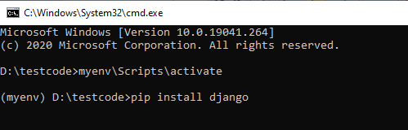
- Installing specific version
If you need to install a specific version of Django, you can specify it like this:
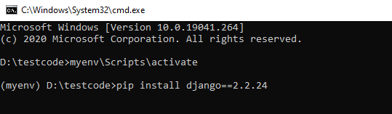
4. Verify Installation
Once Django is installed, you can verify it by checking the version installed:
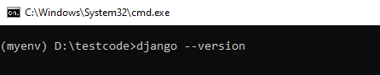
To use MySQL with Django, you'll need to make a few adjustments during the project setup and configuration.
Step 1: Install MySQL Server and Connector
You need the MySQL connector for Python (mysqlclient), which allows Django to interact with MySQL. Install it using pip:
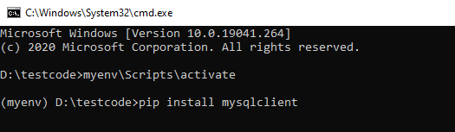
Step 2: Configure Django Settings
In your Django project directory, navigate to the settings.py file located inside your project directory (projectname/projectname/settings.py by default). Modify the DATABASES setting to use MySQL.
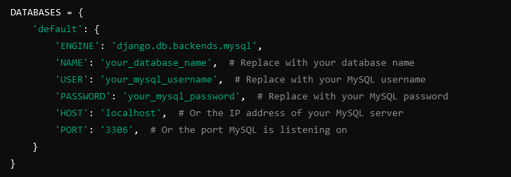
Step 3: Create the MySQL Database
Before you can use the MySQL database with Django, ensure that you have created the database in MySQL. You can create it using MySQL command line or any MySQL GUI tool like MySQL Workbench or phpMyAdmin.

Creating a Django Project
After installation, you can create a new Django project by running:
- Create a Django Project:
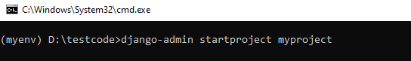
Replace myproject with the name of your project.
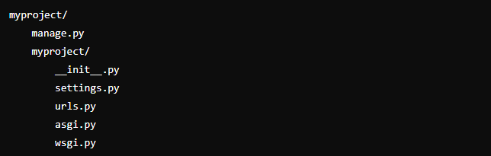
- Running the Development Server
Navigate into your project directory (myproject in this case) and start the development server:
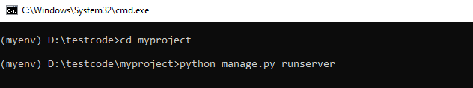
Now you can open your web browser and go to http://127.0.0.1:8000/ to see the default Django landing page.
- Create Django Apps
Django projects are composed of multiple apps. Each app can serve a specific functionality (e.g., blog, user authentication).
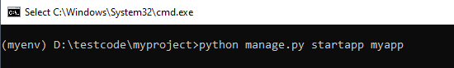
Replace myapp with your app name.
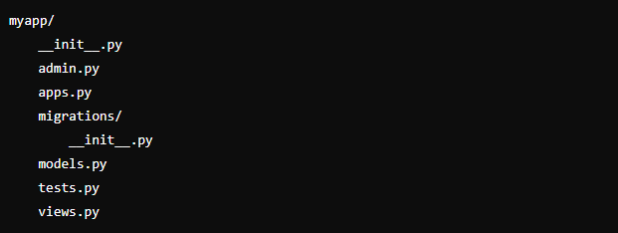
- Register the App:
Add the app to INSTALLED_APPS in settings.py:
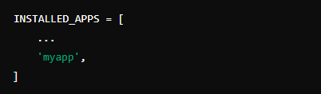

- Define URLs
URLs define how URLs map to views in your Django project.
  - Create urls.py in App Directory:
    - In your app directory (myapp), create a file named urls.py.
  - Define URL Patterns:

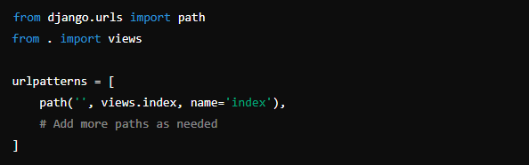

- Include App URLs in Project URLs:

In urls.py of your main project (myproject):

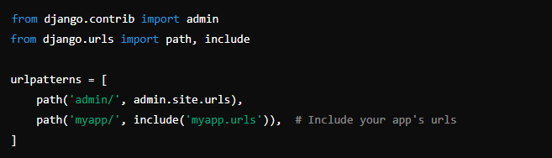

- Create Templates

Templates are HTML files that Django renders with data from views.
  - Create a Templates Directory:

    - Inside your app directory (myapp), create a directory named templates.

  - Create HTML Templates:

    - Create HTML files (e.g., index.html, base.html) inside the templates directory. Inside the myapp/templates/myapp directory, you can create your HTML templates.

  - Render Templates in Views:

    - In your views (views.py in myapp), return templates:

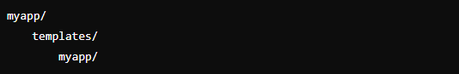

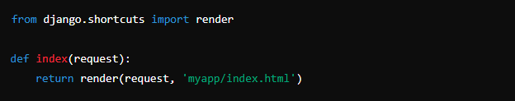

- Manage Static Files

Static files (CSS, JavaScript, images) are served by Django during development.

  - Create a Static Directory:

    - Inside your app directory (myapp), create a directory named static.

  - Add Static Files:

    - Place your static files (CSS, JS, images) inside myapp/static/myapp/.

  - Load Static Files in Templates:

    - Use the {% static %} template tag to load static files:
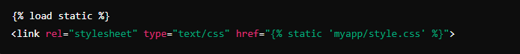

- Run the Development Server

Start the Development Server:

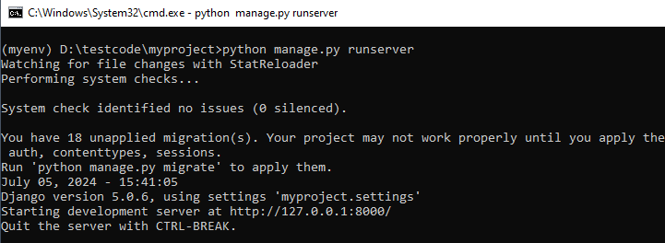

Django models

In Django, models are Python classes that represent database tables. They define the structure of the data and manage interactions with the database.

- Define a Model

Models are typically defined in the models.py file of your Django app (myapp/models.py). Each model class represents a database table, and each attribute of the class represents a database field.

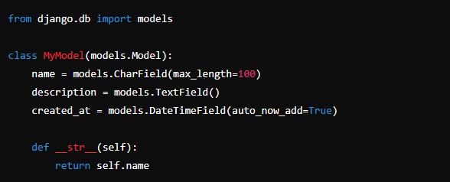

In this example:

- MyModel inherits from models.Model, indicating that it is a Django model.
- name, description, and created_at are fields of the model, defined using Django’s Field classes (CharField, TextField, DateTimeField, etc.).
- __str__() method provides a human-readable representation of the model instance.

- Make Migrations

After defining your models, you need to create database migrations. Migrations are Python files that Django uses to propagate changes you make to your models (like adding a new field or changing a field type) into your database schema.

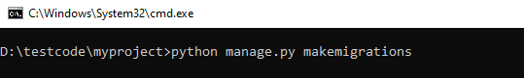

This command generates migration files based on the changes detected in your models and stores them in the myapp/migrations/ directory.

- Apply Migrations

To apply migrations and create database tables corresponding to your models:

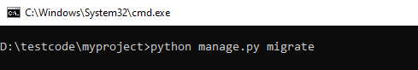

This command runs all pending migrations and updates your database schema.

- Using Models in Views

You can use your models in Django views to interact with data:

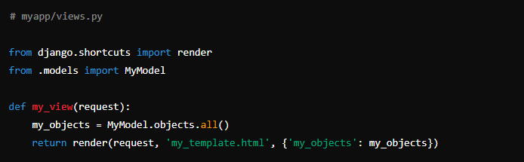

- Querying Models

You can perform various queries on your models using Django's ORM (Object-Relational Mapping):

