COLLEGE OF ENGINEERING THALASSERY


MINI PROJECT REPORT ON

WIRELESS CHARGING PARKING LOT AND PARKING MANAGEMENT

Submitted partial fulfillment of the requirement for the award of Degree of Bachelor of Technology in Electronics and Communication Engineering of APJ Abdul Kalam Technological University

By

ABHISHEK K (TLY22EC007) ANANDHU VK (TLY22EC029) AJAL RAJ PP(TLY22EC020) ANUDEV SS (TLY22EC031)

Under the guidance of

Ms. ANAGHA A

DEPARTMENT OF ELECTRONICS AND COMMUNICATION ENGINEERING -2025

COLLEGE OF ENGINEERING THALASSERY

DEPARTMENT OF ELECTRONICS AND COMMUNICATION ENGINEERING

VISION

To render activities that creates and transfers new knowledge in electronics and communication to meet the industrial needs and for the benefit of society.

MISSION

- Ensuring effective teaching learning process to provide in-depth knowledge of basic principles and its application in Electronics and communication Engineering.
- To educate the students to meet the growing challenges of industry.
- To develop professional attitudes and ethical values to have a productive career and to serve humanity

COLLEGE OF ENGINEERING THALASSERY

DEPT OF ELECTRONICS AND COMMUNICATION ENGG

CERTIFICATE

This is to certify that the mini-project entitled “WIRELESS CHARGING PARKING LOT AND PARKING MANAGEMENT” done by Abhishek K, Anandhu VK, Ajal Raj PP, Anudev SS during the year 2025 in the partial fulfillment for the award for the degree of the Bachelor of Technology in Electronics and Communication Engineering of the APJ Abdul Kalam Technological University.

Project Guide Project Coordinator & HOD
Ms. Anagha A  Assistant Professor | Dr. Sudheer V R  Assistant Professor

DECLARATION

We hereby declare that the mini project report “WIRELESS CHARGING PARKING LOT AND PARKING MANAGEMENT”, submitted for the fulfilment of the requirements for the award of degree of Bachelor of Technology of the APJ Abdul Kalam Technological University, Kerala is a bona fide work done by us under supervision of Assistant Prof. Anagha A in Electronics and Communication branch College of Engineering Thalassery. This submission represents our ideas in our own words and where ideas or words of others have been included, we have adequately and accurately cited and referenced the original sources. We also declare that we have adhered to ethics of academic honesty and integrity and have not misrepresented or fabricated any data or idea or fact or source in our submission. We understand that any violation of the above will be a cause for disciplinary action by the institute and/or the University and can also evoke penal action from the sources which have thus not been properly cited or from whom proper permission has not been obtained. This report has not been previously formed the basis for the award of any degree, diploma or similar title of any other University.

- ABHISHEK K

- ANANDHU VK

- AJAL RAJ PP

- ANUDEV SS

ACKNOWLEDGEMENT
We would like to express our sincere gratitude to everyone who contributed to the successful completion of this project, " WIRELESS CHARGING PARKING LOT AND PARKING MANAGEMENT.”. First of all, we extend our deepest appreciation to Principal Dr. Rajeev P for his external support and blessings showered on us to make our project success. We would like to express our sincere gratitude to the Head of ECE Department Dr. Sudheer V R. We consider it a privilege and honor to express our sincere gratitude to Mrs. Anagha A whose invaluable guidance and encouragement have been inevitable for the development of this project This report is all encompassing as this is never the work of one or two laboring in quite solitude. It is the product of many hands and countless hours from any people. Our thanks to all those who helped us in this project. We also wish to express my heartfelt thanks to college of engineering Thalassery and the Department of electronics and communication branch for providing the necessary resources and learning environment to carry out this research and all faculty members who helped us throughout our studies for their support and invaluable suggestions.

OBJECTIVE
1. Automated Vehicle Detection – Employ ultrasonic and IR sensors to precisely identify vehicle presence at parking spaces and the entrance, maintaining smooth operation.

2. Wireless Charging Activation – Employ a relay-controlled system to initiate charging automatically when a car is parked in a specific spot, maximizing energy consumption.

3. Real-Time Parking Space Monitoring – Show the number of vacant parking spaces on an LCD screen, assisting users in finding parking quickly.

4. Automated Gate Control – Add a servo motor-driven gate to open when empty and close when full to guarantee controlled entry and exit.

5. Energy Efficiency & Smart Power Management – Energize wireless charging only when it is necessary in order to limit energy wastage, thus the system is efficient and cost-cutting.

ABSTRACT

This project uses Arduino technology to create and implement a wireless charging and automatic smart parking system. The system incorporates a relay-controlled charging mechanism and automates car entry based on the availability of parking slots in real time. An infrared sensor at the gate detects the arrival of vehicles, and ultrasonic sensors are placed to track the occupancy of each parking space. The entry gate is driven by a servo motor and opens or closes in response to input from an infrared sensor and slot availability. The number of parking spaces that are available is dynamically updated via the system's 16x2 I2C LCD display. The device stops the gate from opening and shows the message "No Spots Available" if there are no parking spaces available. Furthermore, a relay module is built in to turn on a wireless charging or indicator system that runs on batteries when a car parks in a space. By improving parking management effectiveness, lowering the need for human involvement, and showcasing the incorporation of automated charging control, this project hopes to further the development of smart transportation and Internet of Things-based solutions.

CONTENTS
CHAPTER 1
INTRODUCTION
CHAPTER 2
DESIGN AND EXPLANATIONS
  - FLOWCHART
  - CIRCUIT DIAGRAM
    - WORKING
  - CIRCUIT DIAGRAM DESCRIPTION
    - ARDUINO UNO
    - IR SENSOR
    - ULTRASONIC SENSOR
    - DOUBLE CHANNEL RELAY MODULE
    - 16x2 LCD DISPLAY
    - SERVO MOTOR
    - 9V BATTERY
    - WIRELESS TRANSMITTER AND RECIEVER COIL
CHAPTER 3
RESULT
CONCLUSION
REFERENCE

LIST OF FIGURES

Fig 2.1. BLOCK DIAGRAM
Fig 2.2 CIRCUIT DIAGRAM
Fig 2.3.1 ARDUINO UNO
Fig.2.3.2 IR SENSOR
Fig 2.3.3 ULTRASONIC SENSSOR
Fig 2.3.4 DOUBLE CHANNEL RELAY MODULE
Fig 2.3.5 16x2 LCD DISPLAY
Fig.2.3.6 SERVO MOTOR
Fig 2.3.7 9V BATTERY
Fig 2.3.8 TRANSMITTER AND RECIEVER COIL

CHAPTER 1

INTRODUCTION
​In today's rapidly evolving urban environments, the exponential increase in vehicle ownership has intensified parking challenges, leading to congestion, inefficient space utilization, and heightened driver frustration. Traditional parking systems, often reliant on manual operations, struggle to meet the growing demand, resulting in wasted time and energy. The advent of smart technologies offers promising solutions to these issues by introducing automation and real-time monitoring into parking management.​
This project introduces a Wireless Charging Smart Parking System that seamlessly integrates automated vehicle detection, wireless charging capabilities, and real-time monitoring to enhance parking efficiency and user convenience. By leveraging advanced sensors and microcontroller technology, the system aims to optimize parking space utilization while providing a sustainable solution for electric vehicle (EV) charging.​

The core components of the system include ultrasonic sensors, infrared (IR) sensors, a servo motor, a relay-controlled wireless charging mechanism, and a liquid crystal display (LCD) for user interface. Ultrasonic sensors are strategically positioned to detect the presence of vehicles within parking spots, accurately monitoring occupancy status. An IR sensor at the entrance detects approaching vehicles, triggering the system to assess parking availability.​

A servo motor governs the operation of the entrance gate, ensuring it opens only when vacant parking spots are available. This automation prevents unauthorized access and reduces the need for human intervention, streamlining the parking process. Upon successful parking, the system activates a relay-controlled wireless charging mechanism, initiating the charging process for EVs automatically. This feature not only enhances user convenience but also promotes the adoption of electric vehicles by providing accessible charging infrastructure.​

An LCD screen provides drivers with real-time updates on available parking spaces, guiding them efficiently and reducing the time spent searching for spots. This dynamic information display contributes to a smoother parking experience and alleviates congestion within parking facilities. By integrating automation, Internet of Things (IoT) technologies, and wireless power transmission, the Wireless Charging Smart Parking System offers several notable benefits.

Automation of vehicle detection, gate control, and charging processes minimizes the need for manual oversight, leading to more efficient and error-free operations. Real-time monitoring and dynamic allocation of parking spaces ensure optimal use of available areas, reducing instances of improper parking and maximizing facility capacity. The integration of wireless charging supports the growing ecosystem of electric vehicles, encouraging sustainable transportation practices and reducing reliance on fossil fuels. Providing drivers with immediate information on parking availability and automating the charging process enhances convenience, reduces stress, and improves overall satisfaction.​

The Wireless Charging Smart Parking System represents a significant advancement in urban parking management by addressing common challenges through innovative technology. Its implementation can lead to more organized, efficient, and user-friendly parking environments, contributing to the broader goals of smart city initiatives and sustainable urban development. As cities continue to grow and the adoption of electric vehicles increases, such integrated systems will play a crucial role in shaping the future of urban mobility.

CHAPTER 2

DESIGN AND EXPLANATIONS

FLOW CHART

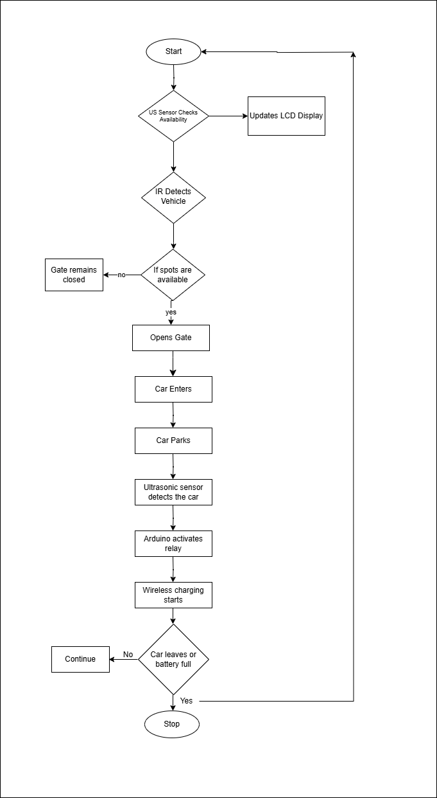
Fig 2.1. FLOW CHART

CIRCUIT DIAGRAM

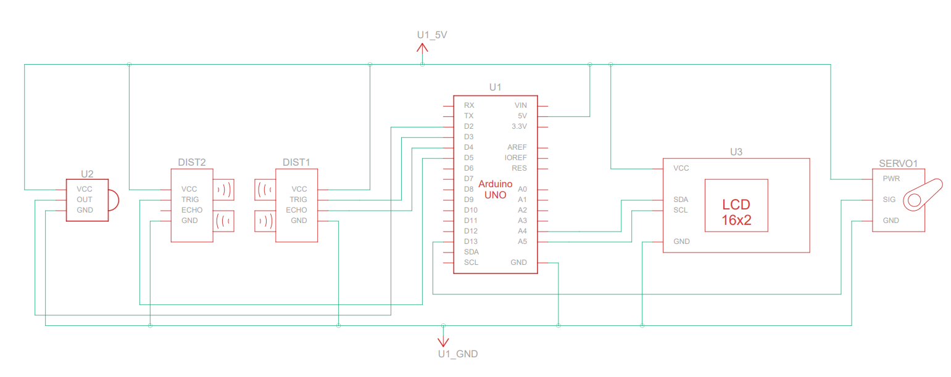
Fig 2.2 CIRCUIT DIAGRAM

WORKING
The smart parking and charging system automates vehicle entry, parking, and wireless charging using a combination of sensors and an Arduino-based control mechanism. When a vehicle approaches the entrance, an infrared (IR) sensor detects its presence and signals the system to check for an available parking space. The system uses ultrasonic sensors to scan the parking area. If a vacant spot is found, the servo motor operates the entrance gate, allowing the vehicle to enter. Simultaneously, an LCD display updates in real time, showing the number of available and occupied slots. This ensures that users are aware of the parking space status before entry.

Once the vehicle parks, ultrasonic sensors confirm its position and trigger the relay module to activate the wireless charging system. This system continuously monitors the vehicle, ensuring that wireless charging remains active until the vehicle leaves or the battery reaches full capacity. The charging system is designed to be efficient and seamless, eliminating the need for manual plug-in chargers. When the vehicle exits, the ultrasonic sensor detects the empty space, deactivates the wireless charging, and updates the LCD to reflect the available slot. The gate then reopens, allowing new vehicles to enter.

This automated system ensures efficient space utilization and streamlines parking management. By reducing the need for manual intervention, it minimizes delays and congestion in parking areas. The integration of wireless charging further enhances convenience for electric vehicle users by providing a hassle-free charging experience. Real-time monitoring through sensors allows the system to operate with high accuracy, ensuring that vehicles are parked optimally, and charging is only activated when necessary. This smart parking solution significantly improves urban infrastructure, making parking facilities more efficient, user-friendly, and sustainable.

CIRCUIT DIAGRAM DESCRIPTION

    - ARDUINO UNO
The Arduino UNO is a popular open-source microcontroller board based on the ATmega328P. It is widely used for embedded systems, robotics, and automation projects due to its ease of use, compatibility with various sensors and actuators, and support for programming via the Arduino IDE. In this project, the Arduino UNO acts as the central controller, managing all components to automate the parking and charging process. It reads input from the ultrasonic sensors (DIST1 & DIST2) to detect available and occupied parking slots and processes signals from the IR sensor (U2) to identify incoming vehicles. Based on this data, it controls the servo motor (SERVO1) to open or close the gate, ensuring smooth vehicle entry and exit. Additionally, the Arduino updates the 16x2 LCD display (U3) in real-time to show parking slot availability, making the system user-friendly. If a wireless charging system is integrated, the Arduino can also be programmed to activate charging when a vehicle is detected in the designated spot.
Fig 2.3.1 Arduino UNO
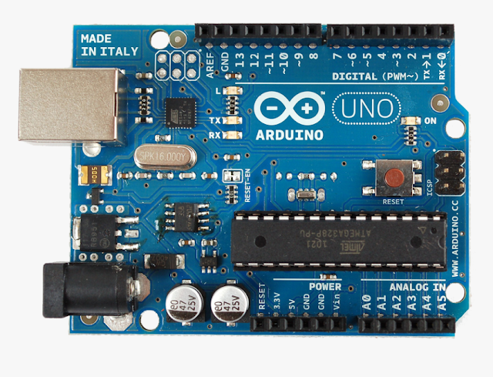

Features of Arduino UNO
The Arduino UNO is a microcontroller board based on the ATmega328P, designed for embedded systems, automation, and prototyping applications. It operates at 5V and supports an input voltage range of 7V to 12V, making it versatile for various power sources. The board has 14 digital input/output (I/O) pins, out of which 6 can be used as PWM outputs, allowing precise control of motors, servos, and LED brightness. It also includes 6 analog input pins, which can read varying voltage levels from sensors, making it ideal for interfacing with ultrasonic sensors, temperature sensors, and other analog components. The Arduino UNO runs at a clock speed of 16 MHz, ensuring efficient processing of instructions. It features 32 KB of Flash memory, with 0.5 KB reserved for the bootloader, enabling code storage for complex applications.
Additionally, it has 2 KB of SRAM for variable storage and 1 KB of EEPROM, which allows non-volatile data storage. For communication, the Arduino supports UART (serial communication), I2C, and SPI protocols, enabling seamless interfacing with multiple peripherals. It is programmed using the Arduino IDE via a USB Type-B connection, making coding and debugging convenient. These features make the Arduino UNO a powerful and adaptable microcontroller, ideal for projects requiring sensor integration, motor control, and real-time processing.

IR SENSOR
The IR (Infrared) sensor is an electronic device that detects objects or measures distances based on infrared light reflection. It consists of an IR LED (transmitter) that emits infrared light and a photodiode (receiver) that detects the reflected light from an object.
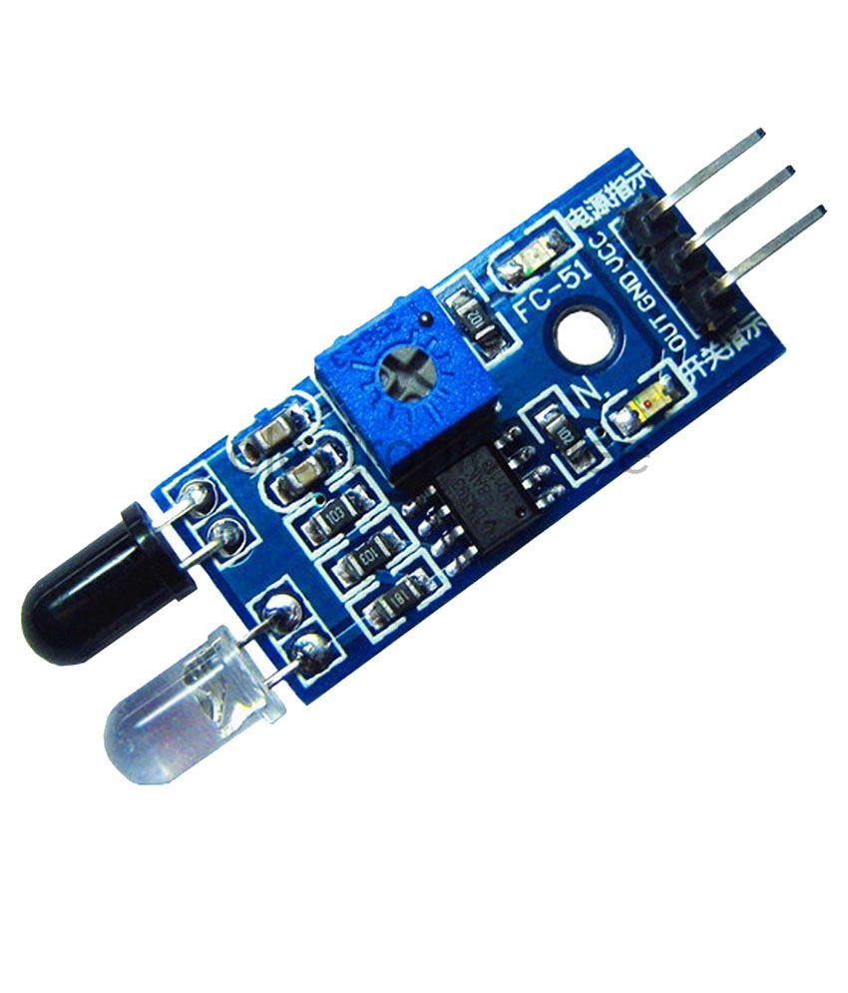

Fig 2.3.2 IR Sensor
When an object is within range, the IR light bounces back, and the sensor generates an output signal indicating the presence of the object. IR sensors operate on the principle of infrared radiation absorption and reflection, making them highly effective for applications like obstacle detection, line following, motion sensing, and proximity detection. These sensors typically work within a short-range (a few centimeters to a few meters) and are widely used in automation, security systems, and robotics. Most IR sensors operate at 3.3V to 5V and provide either analog or digital output, depending on the model.

In this project, the IR sensor is used for object detection. It continuously monitors the surroundings and detects the presence of an object in front of it. When an object is detected, the sensor sends a signal to the Arduino UNO, which processes the input and triggers the necessary response, such as displaying information on the LCD or activating the servo motor. This allows the system to respond dynamically based on object proximity, making it useful for automation and interactive applications.
Applications of IR Sensor

- Object Detection: Used in automation and robotics to detect obstacles and presence.
- Proximity Sensing: Commonly used in automatic doors, smartphones, and touchless taps.
- Security Systems: Integrated into surveillance and alarm systems for motion detection.
- Line Following Robots: Used in robotics to track lines on the ground for navigation.
- Industrial Automation: Employed in conveyor belt systems for product counting and sorting.
- Temperature Sensing: Infrared thermometers and thermal imaging cameras utilize IR sensors.
- Remote Controls: Found in TV remotes, air conditioners, and other electronic appliances.
- Biomedical Applications: Used in pulse oximeters to measure oxygen levels in blood.

Features:
- Operating Voltage: Typically ranges from 3.3V to 5V DC, making it compatible with microcontrollers like Arduino.
- Detection Range: Can detect objects within 2 cm to 30 cm, depending on the model.
- Output Type: Provides either analog or digital output based on the intensity of infrared light received.
- Wavelength: Operates in the infrared spectrum (700 nm - 1 mm) for object detection.
- Response Time: Fast response, usually in the range of microseconds to milliseconds, enabling real-time applications.
- Power Consumption: Low power consumption, making it suitable for battery-operated devices.
- Compact Design: Small, lightweight, and easy to integrate into embedded applications.
- Environmental Adaptability: Works in various lighting conditions but may require calibration to avoid interference from ambient light.
- Angle of Detection: Typically has a detection angle of 35° to 40°, ensuring reliable object sensing.
- Durability: Built for long-term use, with minimal wear and tear due to non-contact sensing.

ULTRASONIC SENSOR
An ultrasonic sensor is a device that uses sound waves to measure distances by emitting ultrasonic pulses and detecting their reflection from an object. The time taken for the pulse to travel to the object and back is used to calculate the distance using the speed of sound. These sensors are widely used in robotics, automation, and security systems due to their high accuracy, non-contact sensing capability, and resistance to environmental conditions like dust or lighting variations.

In this project, the ultrasonic sensor is used for distance measurement and object detection. It sends a high-frequency pulse, and when the pulse reflects off an object, the time delay is measured by the Arduino UNO, which then calculates the exact distance. The measured distance can be displayed on the LCD screen and is used to trigger other components, such as a servo motor for an automated gate. The integration of the ultrasonic sensor ensures precise and reliable object detection, which is crucial for applications like security systems or automated control mechanisms.

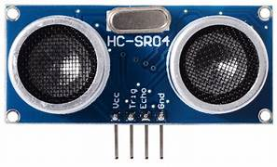

Fig 2.3.3 Ultrasonic Sensor

Features:

• Operating Voltage: 5V DC, making it compatible with microcontrollers like Arduino.
• Operating Frequency: Works at 40 kHz ultrasonic waves for precise distance measurement.
• Measuring Range: Can detect objects from 2 cm to 400 cm (4 meters) with high accuracy.
• Accuracy: Typically has an accuracy of ±3 mm, ensuring reliable readings.
• Output Type: Provides a digital signal (pulse width modulation - PWM) for distance measurement.
• Angle of Detection: Generally has a 30° to 40° beam width, allowing for targeted detection.

DOUBLE CHANNEL RELAY MODULE

A double channel relay module is an electrically operated switch that allows a low- voltage microcontroller (such as an Arduino UNO) to control high-power electrical devices like motors, lamps, fans, or solenoids. The relay works by using a small input signal to toggle an internal electromagnetic switch, which can then open or close a separate high-power circuit. The dual-channel design means this module can independently control two different devices, making it ideal for projects requiring automation.

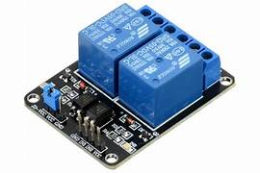

Fig 2.3.4 Double Channel Replay Module

In this project, the double channel relay module is used to control external electrical components based on the sensor readings. For instance, it can be used to activate a motor or open a gate when an object is detected by the IR or ultrasonic sensor. The Arduino UNO sends a signal to the relay, which then switches on or off the connected device. This enables efficient automation and remote control of high-power components, ensuring that the system operates effectively without the need for direct human intervention. The relay’s isolation properties also protect the Arduino from electrical damage, ensuring safe operation.

Features & Specifications of the Double Channel Relay Module

- Operating Voltage: Typically 5V DC, making it compatible with microcontrollers like Arduino.
- Relay Capacity: Each channel can handle up to 10A at 250V AC or 10A at 30V DC, allowing control of high-power devices.
- Number of Channels: Two independent relays, enabling control of two separate electrical loads.
- Trigger Voltage: Works with low-level trigger signals (3.3V–5V logic), making it compatible with microcontrollers.

16x2 LCD DISPLAY
A 16x2 LCD display is a widely used electronic component for visual output in embedded systems. It features two rows, each capable of displaying 16 characters, making it suitable for projects that require textual output. The display uses a Hitachi HD44780 controller, which allows easy interfacing with microcontrollers like Arduino UNO via either a 4-bit or 8-bit parallel communication mode. The LCD provides a clear, low-power solution for displaying real-time information, making it an essential component in numerous automation and monitoring projects.

In this project, the 16x2 LCD display is used to provide real-time feedback on sensor readings and system status. For example, when the IR or ultrasonic sensor detects an object, the display can show "Object Detected" along with relevant distance measurements. It can also be used to display system instructions, such as whether a relay has been activated or if a servo motor has moved. By providing a user-friendly visual interface, the LCD helps users monitor the system’s functionality without needing a computer.

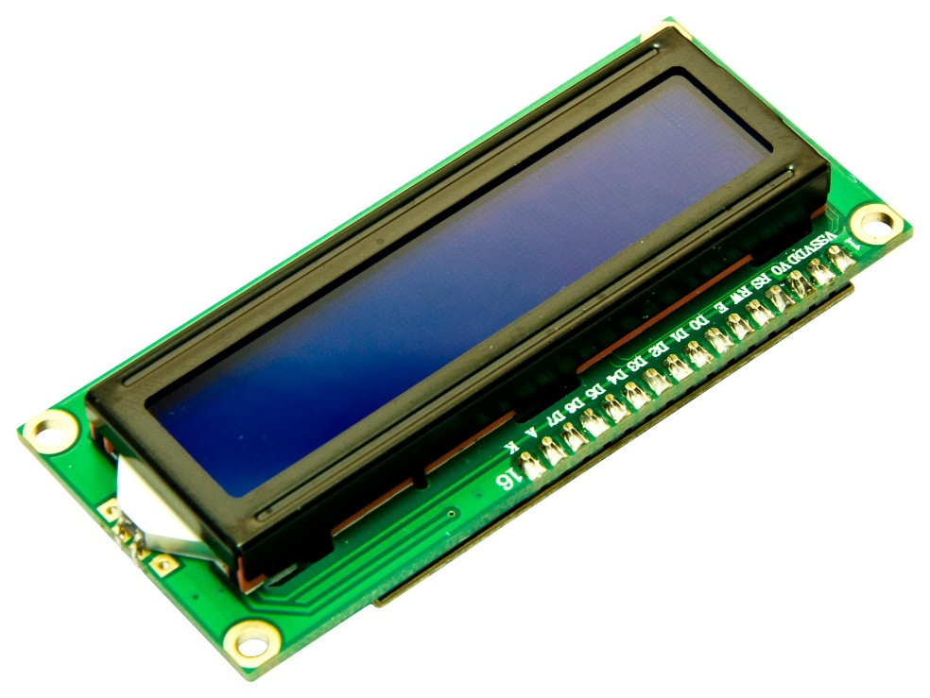

Fig 2.3.5 16x2 LCD Display

SERVO MOTOR
A servo motor is a rotary or linear actuator that allows precise control of angular or linear position, velocity, and acceleration. It operates based on a control signal (PWM) and consists of a motor, a position feedback sensor (often a potentiometer), and a control circuit.
Common Uses of Servo Motors
Servo motors are widely used in various applications that require precise motion control:
- Robotics – Used for controlling robotic arms, grippers, and humanoid movements.
- Automation & CNC Machines – Controls industrial machines, conveyor belts, and automated production lines.
- Aerospace – Used in flight control surfaces, drones, and navigation systems.
- RC Cars & Aircraft – Controls steering, throttle, and flaps in remote-controlled models.
- Medical Equipment – Used in prosthetic limbs, robotic surgery, and laboratory automation.
- Smart Parking Systems – Used for controlling gates and barriers (like in your wireless charging parking lot project).
- Camera Gimbals & Pan-Tilt Mechanisms – Used in surveillance cameras, photography, and videography.
- Home Automation – Used in smart locks, curtain automation, and robotic vacuum cleaners.
Servo Motor Specifications
- Torque – Measured in kg.cm (kilogram-centimetre) or oz.in (ounce-inch). Determines how much load the motor can move.
  - Example: MG996R (High Torque Servo) – 10 kg.cm at 6V.
- Speed – Measured in seconds per 60° rotation. Determines how fast the servo moves.
  - Example: SG90 Micro Servo – 0.12s/60° at 6V.
- Voltage Range – The required operating voltage, usually 4.8V to 7.4V.
  - Example: Standard servos work at 5V, high-power servos need 6V-7.4V.
- Control Signal (PWM) – Pulse Width Modulation (PWM) signal is used to set the position.
  - Typical PWM range:
    - 1ms = 0°, 1.5ms = 90° (center position), 2ms = 180°.
- Angle Range – Defines the maximum movement range (e.g., 0° to 180° or continuous rotation).
- Gearing –
  - Plastic gears – Found in low-power, lightweight servos (e.g., SG90).
  - Metal gears – More durable, used for higher torque applications (MG995, MG996R).
- Size & Weight – Important for compact applications like drones and RC vehicles

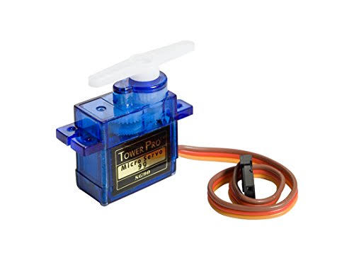
Fig 2.3.6 Servo motor

9V BATTERY

9V battery is a compact, rectangular battery commonly used in small electronic devices such as smoke detectors, remote controls, and Arduino projects. It typically has a nominal voltage of 9 volts and is available in different types, including alkaline, lithium, and rechargeable versions. Alkaline 9V batteries are the most common and provide a reliable power source for low-drain devices, while lithium versions offer longer life and better performance in high-drain applications. Rechargeable 9V batteries, usually based on NiMH or Li-ion technology, can be recharged multiple times, making them more cost-effective and environmentally friendly. The battery usually features snap connectors (one positive and one negative terminal) for easy connection. When used in Arduino projects, a 9V battery can be connected via a battery clip with a DC barrel jack or directly to the Vin and GND pins to supply power. However, due to its limited capacity, it is best suited for low-power applications.

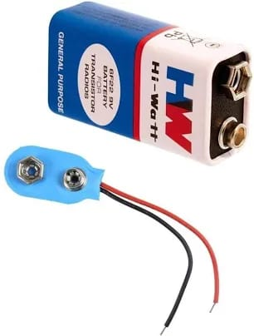
Fig 2.3.7 9V Battery

2.3.8 WIRELESS POWER TRANSMITTER AND RECIEVER COIL
A wireless transmitter coil and a receiver coil are the core components used in wireless power transfer (WPT) systems, such as in wireless charging for electric vehicles, smartphones, and other devices. Here's an overview:

1. Transmitter Coil

Purpose: Generates an alternating magnetic field to transfer power wirelessly.

How It Works:

An AC (alternating current) signal flows through the transmitter coil, producing an oscillating magnetic field around it.

This magnetic field induces a voltage in the receiver coil when placed within the range of the field.

Design:

Made of copper wire wound into a coil.

Often has a ferrite core to increase magnetic flux and efficiency.

Frequency usually ranges between 100 kHz and a few MHz depending on the application.

Examples:

Wireless charging pads.

Inductive cooktops.

RFID readers.

2. Receiver Coil

Purpose: Captures the magnetic field and converts it back into electric current.

How It Works:

When placed within the magnetic field of the transmitter coil, a voltage is induced in the receiver coil by electromagnetic induction.

This voltage is rectified and converted to DC for powering a device or charging a battery.

Design:

Similar in construction to the transmitter coil but optimized to receive power efficiently.

Positioned close to the transmitter coil to maximize power transfer efficiency.

Examples:

Wireless charging receivers in smartphones.

Electric vehicle wireless charging receivers.

Biomedical implants powered wirelessly.

3. Types of Wireless Power Transfer Methods

Inductive Coupling:

Close-range method, commonly used in Qi wireless charging for smartphones.

Resonant Inductive Coupling:

Increases distance and efficiency using resonant circuits.

Far-field (RF) Transmission:

Uses radio waves for longer-distance power transfer.

4. Efficiency and Considerations

Efficiency decreases with distance between the coils.

Proper coil alignment is critical for maximizing efficiency.

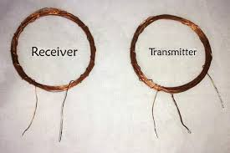
FIG 2.3.8 Transmitter and receiver coil

Chapter 3

RESULTS

The designed system successfully integrates multiple sensors and actuators to automate object detection and response mechanisms. The Arduino UNO acts as the central controller, processing data from the IR sensor and ultrasonic sensor to determine object presence and distance. The 16x2 LCD display provides real-time feedback, ensuring users can monitor system activity without requiring an external display.

When an object is detected, the system takes action based on predefined logic. The ultrasonic sensor measures the object's distance, and if it falls within a certain range, the relay module triggers a connected device (e.g., a motor or alarm). Additionally, the servo motor performs a mechanical action, such as opening a gate or moving an arm, based on the sensor input. The IR sensor further enhances detection, ensuring accurate responses in low-light conditions.

The project demonstrates a fully functional automated detection and response system, suitable for applications like automated doors, obstacle avoidance, and security systems. The system operates efficiently with minimal power consumption and provides clear user interaction through the LCD screen. Overall, the project achieves its goal of real-time object detection, automation, and user-friendly monitoring, making it highly applicable for real-world scenarios.

CONCLUSION

The implementation of this automated system successfully demonstrates the integration of Arduino UNO, sensors, relays, and actuators to create an efficient, real-time detection and response mechanism. By utilizing an IR sensor and ultrasonic sensor, the system effectively identifies objects and determines their position, ensuring precise activation of connected components. The relay module enables seamless control of external devices, while the servo motor automates mechanical movements, making the system adaptable for various applications.

The 16x2 LCD display provides clear, real-time updates, enhancing user interaction and monitoring. The system operates with high efficiency, minimal power consumption, and reliable accuracy, making it an ideal solution for automation-based applications such as smart parking systems, automated doors, security monitoring, and industrial automation.

Overall, this project successfully achieves its objectives of real-time object detection, automated control, and efficient monitoring, proving to be a practical and scalable solution for future advancements in automation and IoT-based systems. Further improvements, such as integrating wireless communication or advanced AI-based decision-making, could enhance the system's functionality and adaptability in smart infrastructure.

REFERENCE

Lu X, Wang P, Niyato D, Kim DI, Han Z. Wireless Charging Technologies: Fundamentals, Standards, and Network Applications. IEEE Commun Surv Tutorials, (2016);18(2):1413–52.

Sudhakar, M. V., Reddy, A. A., Mounika, K., Kumar, M. S., & Bharani, T. (2023). Development of smart parking management system. Materials Today: Proceedings, 80, 2794-2798.

Channamallu, S. S., Kermanshachi, S., Rosenberger, J. M., & Pamidimukkala, A. (2023). A review of smart parking systems. Transportation Research Procedia, 73, 289-296.

Fareq M, Fitra M, Irwanto M, Hasan S, Arinal M. Low wireless power transfer using Inductive Coupling for mobile phone charger. J Phys Conf Ser., 2014;495(1):1–5.

