LAB CYCLE 2

Program 1
AIM

Create a string grom the given string where the first and last character are exchanged
eg: python => nythop

Source Code

string=input("Enter a string\n")
new_string=string[-1]+string[1:-1]+string[0]
print(new_string)

Output

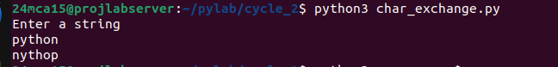

Program 2
AIM

Get a string from an input string where all occurance of the first character are repalced with “$” except the first character [eg : onion -> oni$n]

Source Code

str = input("Enter a string\n")
fchar=str[0]
str=str.replace(fchar,"$")
str=fchar+str[1:]
print(str))

Output
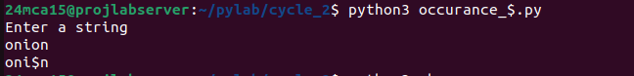

Program 3
AIM

Create a single seperated with space from two string by swapping the character at position 1
Eg : str1=”Hello” Str2=”World” ,then create a string str3 = “Hollo world”

Source Code

str1 = input("Enter the first string: ")
str2 = input("Enter the second string: ")
x=str1[0:1]+str2[1:2]+str1[2:]
y=str2[0:1]+str1[1:2]+str2[2:]
str3=x+" "+y
print(str3)

Output
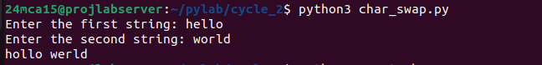

Program 4
AIM

Count the number of character (char frequency) in a string ?

Source Code

count_char.py
str=input("Enter a String : ")
word ={ }
for char in str:
if char in word:
word[char]+=1
else:
word[char]=1
print("Character Frequency")
for char,count in word.items():
print(f"{char}:{count}")

Output
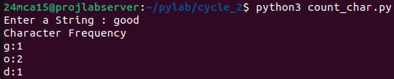

Program 5
AIM

Adding “ing” ath the end of a program string if it already ends with ‘ing’ then add ‘ly’

Source Code

str=input("Enter a String :")
if str[-3:]=="ing":
str=str[:-3]+"ly"
else:
str=str+"ing"
print("Modified string ",str)

Output

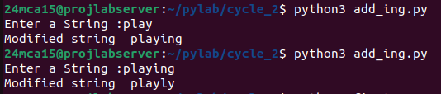

Program 6
AIM

Store a list of first names .count the occurance of “a” with in the list

Source Code

n=int(input("Enter the numbeer of name: "))
names=[]
for i in range(n):
name=input("Enter First name : ")
names.append(name)
count=0
for name in names:
for ch in name:
if ch=="a":
count+=1
print("total occurance of a : ",count)

Output
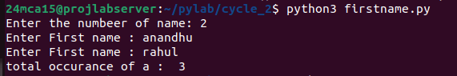

Program 7
AIM

Source Code

color_list1 = input("Enter the first list of colors (comma-separated): ").split(",")
color_list2 = input("Enter the second list of colors (comma-separated): ").split(",")

list1 = [item.strip() for item in color_list1]
list2 = [item.strip() for item in color_list2]
result = [item for item in list1 if item not in list2]

print("Values from color_list1 not contained in color_list2:", result)

Output
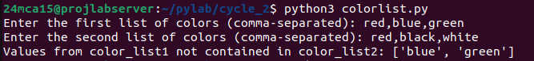

Program 8
AIM

Source Code

list=input("Enter a list of colors(comma seperated): ").split(',')
list=[items for items in list]
print("First color : ",list[0])
print("Last color : ",list[-1])

Output
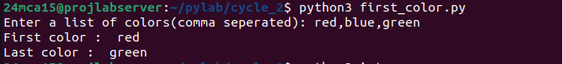

Program 9
AIM

Source Code

x=[]
values=input("enter alist of integer (comma seperated) : ").split(",")
for i in values:
if int(i)>100:
x.append("over")
else:
x.append(int(i))
print(x)

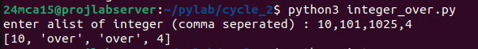
Output

Program 10
AIM

Source Code

list=input("ENTER A INTEGER VALUE (SEPERATED BY COMMA) : ").split(",")
list=[int(x)for x in list]
remove=[i for i in list if i%2!=0]
print("ORGINAL LIST : ",list)
print("NEW LIST WITHOUT EVEN NUMBER : ",remove)

Output
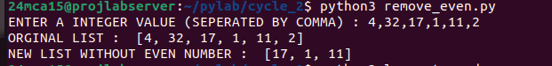

Program 11
AIM

Source Code

list=input("Enter a list of words seperated by space ").split(',')
longest_length=0
for word in list:
if len (word)>longest_length:
longest_length=len(word)
long_word=word
print("The longest word is ",long_word)
print("The length of the longest word is : ",longest_length)

Output
