CYCLE 4

Program 1
AIM
Write a program to print the fibonacci series using recussion

Source Code

def fibonacci(n):
if n<=1:
return n
else:
return fibonacci(n-1)+fibonacci(n-2)
def print_fibonacci_series(n):
for i in range(n):
print(fibonacci(i),end="")
n=int(input("Enter a Number ?"))
print_fibonacci_series(n)

Output

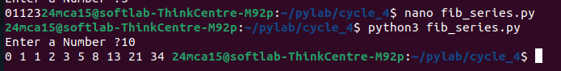

Program 2
AIM
Write the program to impliment a menu-driven calculator use seperator funcion for the diffrent operation.

Source Code

def add(x,y):
return x+y
def substract(x,y):
return x-y
def multiply(x,y):
return x*y
def divide(x,y):
if y!=0:
return x/y
else:
return "Error! Division by zero"
def modulus(x,y):
return x%y

def calculator():
while True:
print("\nSelect operation : ")
print("1.Add")
print("2.Substruct")
print("3.Multiply")
print("4.Divide")
print("5.Modulus")
print("6.Exit...")

choice=input("Enter choice (1/2/3/4/5/6) : ")
ef add(x,y):
return x+y
def substract(x,y):
return x-y
def multiply(x,y):
return x*y
def divide(x,y):
if y!=0:
return x/y
else:
return "Error! Division by zero"
def modulus(x,y):
return x%y

def calculator():
while True:
print("\nSelect operation : ")
print("1.Add")
print("2.Substruct")
print("3.Multiply")
print("4.Divide")
print("5.Modulus")
print("6.Exit...")

choice=input("Enter choice (1/2/3/4/5/6) : ")

if choice =='6':
print("Exiting the calculator,Goodbye!!")
break

try:
num1=float(input("Enter first number : "))
num2=float(input("Enter second number : "))

except ValueError:
print("Invalid input!Please enter numberic values:")
continue
if choice=='1':
print(f"{num1}+{num2}={add(num1,num2)}")
elif choice=='2':
print(f"{num1}+{num2}={substract(num1,num2)}")
elif choice=='3':
print(f"{num1}+{num2}={multiply(num1,num2)}")
elif choice=='4':
print(f"{num1}+{num2}={divide(num1,num2)}")
elif choice=='5':
print(f"{num1}+{num2}={modulus(num1,num2)}")
else:
print("invalid input! please select a valid operation")
calculator()
if choice =='6':
print("Exiting the calculator,Goodbye!!")
break

try:
num1=float(input("Enter first number : "))
num2=float(input("Enter second number : "))

except ValueError:
print("Invalid input!Please enter numberic values:")
continue
if choice=='1':
print(f"{num1}+{num2}={add(num1,num2)}")
elif choice=='2':
print(f"{num1}+{num2}={substract(num1,num2)}")
elif choice=='3':
print(f"{num1}+{num2}={multiply(num1,num2)}")
elif choice=='4':
print(f"{num1}+{num2}={divide(num1,num2)}")
elif choice=='5':
print(f"{num1}+{num2}={modulus(num1,num2)}")
else:
print("invalid input! please select a valid operation")
calculator()

Output

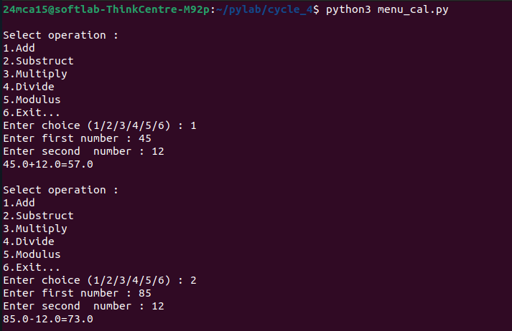

Program 3
AIM
Write a program to print the nth prime number: [suse function to check whether a number is prime or not]

Source Code

def is_prime(num):
if num <=1:
return False
for i in range(2,int(num **0.5)+1):
if num%i==0:
return False
return True

def nth_prime(n):
count=0
num=2
while count <n:
if is_prime(num):
count+=1
num+=1
return num-1

n=int(input("Enter the value of n :"))
print(f"The {n}th prime number is : {nth_prime(n)}")

Output
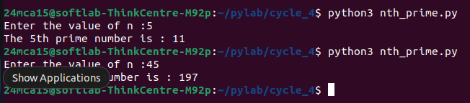
Program 4
AIM

Write a lambda function t find the area of Square rectanagle and triangle

Source Code

area_of_square=lambda side : side*side
area_of_rectangle=lambda length,width:length*width
area_of_triangle=lambda base,height:0.58 *base*height

side=int(input("Enter side"))
length=int(input("enter length"))
width=int(input("enter width "))
base=int(input("enter base "))
height=int(input("enter height "))
print(f"Area of square : {area_of_square(side)}")
print(f"Area of rectangle : {area_of_rectangle(length,width)}")
print(f"Area of triagnle : {area_of_triangle(base,height)}")

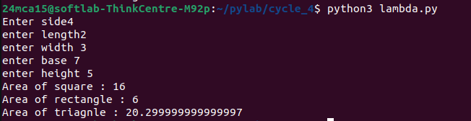
Output

Program 5
AIM

Write a program to display powers of 2 using anonymous function. [ Hint use map and
lambda function)

Source Code

numbers = [0, 1, 2, 3, 4, 5, 6, 7, 8]

powers_of_2 = map(lambda x: 2 ** x, numbers)

print(list(powers_of_2))

Output
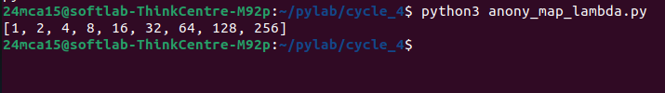

Program 6
AIM

Write a program to display multiples of 3 using anonymous function. [ Hint use filter and
lambda function)

Source Code

num = int(input("Enter the number of terms : "))
my_list = list(range(1, num+1))
multiples = list(filter(lambda x: x % 3 == 0, my_list))
print(f"Multiples of 3 : {multiples}")

Output
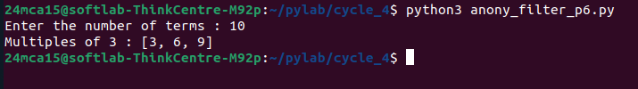

Program 7
AIM

Write a program to sum the series 1/1! + 4/2! + 27/3! + ….. + nth term. [ Hint
Use a function to find the factorial of a number].

Source Code

def factorial(num):
if num == 0 or num == 1:
return 1
else:
fact = 1
for i in range(2, num + 1):
fact *= i
return fact

def sum_series(n):
total_sum = 0
for i in range(1, n + 1):
term = (i ** i) / factorial(i)
total_sum += term
return total_sum

n = int(input("Enter the value of n: "))
result = sum_series(n)
print(f"The sum of the series up to the {n}th term is: {result}")

Output
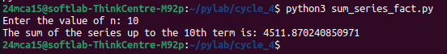

Program 8
AIM

Write a function called compare which takes two strings S1 and S2 and an integer n as
arguments. The function should return True if the first n characters of both the strings
are the same else the function should return False.

Source Code

def compare(S1, S2, n):

if len(S1) < n or len(S2) < n:
return False
return S1[:n] == S2[:n]
S1 = input("Enter first string: ")
S2 = input("Enter second string: ")
n = int(input("Enter the value of n: "))

result = compare(S1, S2, n)
print(f"The result of comparison is: {result}")

Output

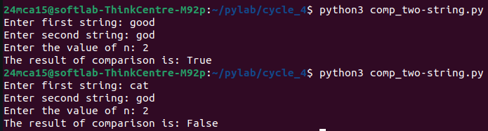
Program 9
AIM

Write a program to add variable length integer arguments passed to the function. [Also
demo the use of docstrings]

Source Code

def add_numbers(*args):
"""
Adds a variable number of integer arguments.
parameters:
*args:A variable length list of Integers to be added.
returns:
int:the sum of all the integers passed as argumens.
"""
if not all(isinstance(arg,int)for arg in args):
raise valueError("All arguments must be integers!!")
return sum(args)

print("sum of 1,2,3:",add_numbers(1,2,3))
print("sum of 10,20,30,40:",add_numbers(10,20,30,40))

Output

Program 10
AIM
Write a program using functions to implement these formulae for permutations and
combinations.
The Number of permutations of n objects taken r at a time: p(n, r) = n!/(n − r)!.
The Number of combinations of n objects taken r at a time is: c(n, r) = n!/(r! ∗ (n − r)!)]

Source Code

def factorial(num):
if num == 0 or num == 1:
return 1
else:
fact = 1
for i in range(2, num + 1):
fact *= i
return fact

def permutations(n, r):
return factorial(n) // factorial(n - r)

def combinations(n, r):
return factorial(n) // (factorial(r) * factorial(n - r))

n = int(input("Enter the value of n: "))
r = int(input("Enter the value of r: "))

p_result = permutations(n, r)
c_result = combinations(n, r)

print(f"The number of permutations p({n}, {r}) is: {p_result}")
print(f"The number of combinations c({n}, {r}) is: {c_result}")

Output
