CYCLE 7

Program 1
AIM

Write a Python program to read a file line by line and store it into a list.

Source Code

filename = 'example.txt'
lines = []
try:
with open(filename, 'r') as file:
for line in file:
lines.append(line.strip())
except FileNotFoundError:
print(f"The file {filename} was not found.")
except Exception as e:
print(f"An error occurred: {e}")

print(lines)

example.txt

hello world
python
oops

Output

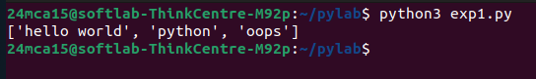

Program 2
AIM

Python program to copy odd lines of one file to other

Source Code

input_filename = 'input.txt'
output_filename = 'output.txt'

try:
with open(input_filename, 'r') as infile:
with open(output_filename, 'w') as outfile:
for index, line in enumerate(infile, start=1):
if index % 2 != 0:
outfile.write(line)
except FileNotFoundError:
print(f"The file {input_filename} was not found.")
except Exception as e:
print(f"An error occurred: {e}")

print(f"Odd lines from {input_filename} have been copied to {output_filename}.")

Output

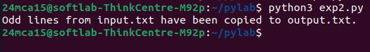
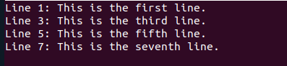

Program 3
AIM
Write a Python program to read each row from a given csv file and print a
list of strings

Source Code

import csv
filename = 'data.csv'

try:
with open(filename, mode='r', newline='') as csvfile:
csv_reader = csv.reader(csvfile)
for row in csv_reader:
print(row)
except FileNotFoundError:
print(f"The file {filename} was not found.")
except Exception as e:
print(f"An error occurred: {e}")

data.csv

Name,Age,City
Alice,30,New York
Bob,25,Los Angeles
Charlie,35,Chicago

Output

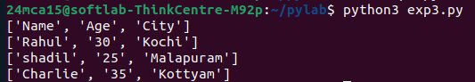

Program 4
AIM

Write a Python program to read specific columns of a given CSV file and
print the content of the columns.

Source Code

import csv
filename = 'data2.csv'
colnum=int(input("Enter columns "))
columns_to_read = [colnum]

try:
with open(filename, mode='r', newline='') as csvfile:
csv_reader = csv.reader(csvfile)
header = next(csv_reader)
print("Header:", [header[i] for i in columns_to_read])
for row in csv_reader:
selected_columns = [row[i] for i in columns_to_read]
print(selected_columns)
except FileNotFoundError:
print(f"The file {filename} was not found.")
except Exception as e:
print(f"An error occurred: {e}")

Output

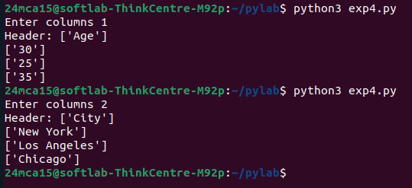
Program 5
AIM

Write a Python program to write a Python dictionary to a csv file. After
writing the CSV file, read the CSV file and display the content.

Source Code

import csv

def read_dictionary_from_user():
data_dict = []
while True:

name = input("Enter name (or type 'exit' to finish): ")
if name.lower() == 'exit':
break
age = input("Enter age: ")
city = input("Enter city: ")

data_dict.append({'Name': name, 'Age': age, 'City': city})
return data_dict

filename = 'output.csv'

data_dict = read_dictionary_from_user()

try:
with open(filename, mode='w', newline='') as csvfile:

csv_writer = csv.DictWriter(csvfile, fieldnames=data_dict[0].keys())
csv_writer.writeheader()

csv_writer.writerows(data_dict)

print(f"Data written to {filename} successfully.")

except Exception as e:
print(f"An error occurred while writing to the file: {e}")

try:
with open(filename, mode='r', newline='') as csvfile:
csv_reader = csv.reader(csvfile)
print("\nContent of the CSV file:")
for row in csv_reader:
print(row)

except FileNotFoundError:
print(f"The file {filename} was not found.")
except Exception as e:
print(f"An error occurred while reading the file: {e}")

Output

