LAB CYCLE 3

Program 1
AIM

Write a Program to find factorial of a number

Source Code

num = int(input("Enter a number :"))
fact=1
if num<0:
print("Factorial of negative number doesn't exist !")
elif num==0:
print("The Factorial of 0 is 1")
else:
for i in range (1,num+1):
fact=fact*i
print("The factorail of ",num,"is",fact)

Output

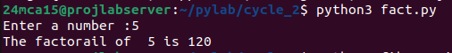

Program 2
AIM

Generate fibonacci series of n terms ?

Source Code

num=int(input("Entera number of terms : "))
a,b=0,1
if(num<=0):
print("Enter a positive :")
else:
print("fibonacci series: ")
for i in range(1,num+1):
print(a)
c=a+b
a,b=b,c

Output
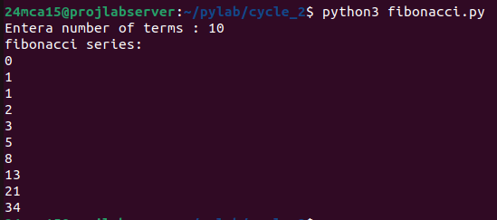

Program 3

AIM

Find the sum of all items in a list [using for loop]?

Source Code

number=[1,2,3,4,5]
total_sum=0
for num in number:
total_sum+=num
print("The sum of all items in the list is ",total_sum)

Output

Program 4

AIM

Generate a list of four digit number in a given range with all their digits even and the number is a perfect square ?

Source Code

even_digit_squares = []

for num in range(32, 100):
square = num * num
if 1000 <= square <= 9999:
square_str = str(square)
if (square_str[0] in "02468" and
square_str[1] in "02468" and
square_str[2] in "02468" and
square_str[3] in "02468"):
even_digit_squares.append(square)

print("Four-digit numbers that are perfect squares with all even digits:", even_digit_squares)

Output

Program 5

AIM

write a program using a for loop to print the multiplication table of n,where n entred by the user ?

Source Code

n = int(input("Enter a number: "))

print(f"Multiplication Table of {n}:")
for i in range(1, 11):
print(f"{n} x {i} = {n * i}")

Output
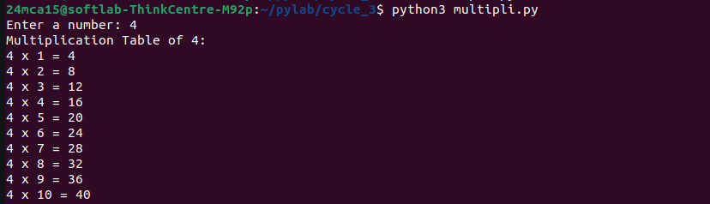

Program 6

AIM

write a program to display alternate prime number till (obtain n from user)

Source Code

N = int(input("Enter the value of N: "))
count = 0
print("Alternate prime numbers up to", N, "are:")

for num in range(2, N + 1):
is_prime = True
for i in range(2, int(num**0.5) + 1):
if num % i == 0:
is_prime = False
break

if is_prime:
if count % 2 == 0:
print(num, end=" ")
count += 1

Output

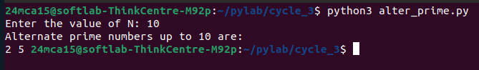

Program 7

AIM

write a program to compue and dispaly the sum of all integer that are divisible by 6 but not by 4,and that lie below a user-given upper limit ?

Source Code

upper_limit = int(input("Enter the upper limit :"))
total_sum =0

for num in range(1,upper_limit):
if num%6==0 and num%4!=0:
total_sum +=num
print("The sum of all integer below ",upper_limit," that are divisible by 6 but not by 4 is : ",total_sum)

Output
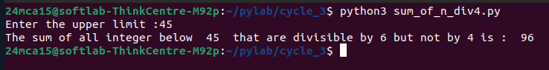

Program 8

AIM

Calculate the sum of the digits of each number within a specified range (from 1 to a user-desined upper limit ,print the sum only if it is prime)

Source Code

upper_limit = int(input("Enter the upper limit: "))

print("Sum of digits (prime values only) for each number in the range:")

for num in range(1, upper_limit + 1):

digit_sum = 0
temp = num
while temp > 0:
digit_sum += temp % 10
temp //= 10

if digit_sum <= 1:
continue

is_prime = True
for i in range(2, int(digit_sum**0.5) + 1):
if digit_sum % i == 0:
is_prime = False
break

if is_prime:
print(f"Number: {num}, Sum of Digits: {digit_sum}")

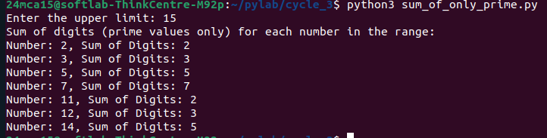
Output

Program 9

AIM

A number is input through the keyboard,write a program to determine if it is palindrome ?

Source Code

number=input("Enter a number : ")
is_palin=True
length = len(number)

for i in range(length//2):
if number[i]!=number[length -1-i]:
is_palin=False
break
if is_palin:
print(f"{number} is a palindrome number")
else:
print(f"{number} is not a palindrome number")

Output

Program 10

AIM

Write a program to generate all factors of a number [while loop] ?

Source Code

number=input("Enter a number : ")
is_palin=True
length = len(number)

for i in range(length//2):
if number[i]!=number[length -1-i]:
is_palin=False
break
if is_palin:
print(f"{number} is a palindrome number")
else:
print(f"{number} is not a palindrome number")

Output
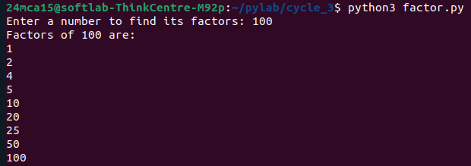

Program 11

AIM

Write a program to find whethter the given number is an amstrong number or not ?

Source Code

number = int(input("Enter a number: "))
original_number = number
sum_of_powers = 0
num_digits = len(str(number))

while number > 0:
digit = number % 10
sum_of_powers += digit ** num_digits
number //= 10

if original_number == sum_of_powers:
print(f"{original_number} is an Armstrong number.")
else:
print(f"{original_number} is not an Armstrong number.")

Output

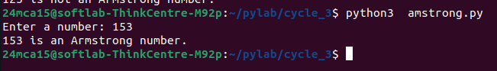

Program 12

AIM

Display the given prymid with the steps number accepeted from user ?
1
2 4
3 6 9
4 8 12 16

Source Code

N = int(input("Enter the number of steps: "))
for i in range(1, N + 1):

row = []
for j in range(1, i + 1):

value = j * i
row.append(str(value))
print(" ".join(row))

Output
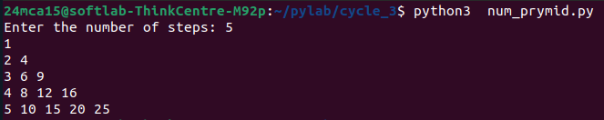

Program 13

AIM

Construct the following pattern using nested loop?

*
* *
* * *
* * * *
* * * * *
* * * *
* * *
* *
*

Source Code

rows = 5
for i in range(1, rows + 1):
for j in range(i):
print("*", end=" ")
print()
for i in range(rows - 1, 0, -1):
for j in range(i):
print("*", end=" ")
print()

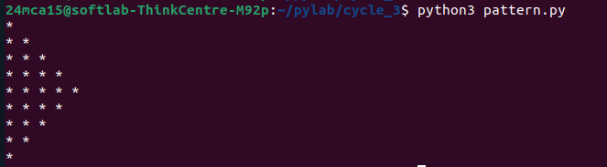
Output

