CYCLE 5

Program 1
AIM
write a program to determine wether a given year is a leap year [use calender module] in python

Source Code

import calendar
year=int(input("Enter a Year : "))

if calendar.isleap(year):
print(f"{year} is a leap year")
else:
print(f"{year} is not a laeap year")

Output
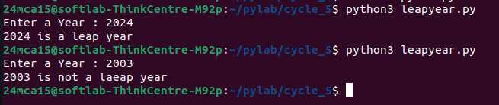

Program 2
AIM
write a program to script to display
- Current date and time
- current year
- month of year
- week number of the year
- weekday of the week
- day of year
- day of the month
- day of week [use time and date time module]

Source Code

import datetime
now=datetime.datetime.now()

current_date_time=now
print(f"Current date and time :{current_date_time}")

current_year=now.year
print(f"Current year : {current_year}")

current_month=now.month
print(f"Month of the year :{current_month}")

week_number=now.isocalendar()[1]
print(f"Week number of the year :{week_number} ")

weekday=now.weekday()
print(f"Wednesday of the week (0=monday,6=sunday): {weekday}")

day_of_year = now.timetuple().tm_yday
print(f"day of the year:{day_of_year}")

day_of_month=now.day
print(f"Day of the Month: {day_of_month}")

day_of_week=now.strftime("%A")
print(f"Day of the week : {day_of_week} ")

Output
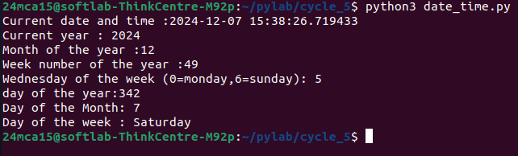

Program 3
AIM
write a program to print yesterday,today,tomorrow

Source Code

from datetime import datetime,timedelta
today=datetime.now()
yesterday=today-timedelta(days=1)
tomorrow=today+timedelta(days=1)
print("yesterday:",yesterday.strftime("%Y-%m-%d"))
print("today:",today.strftime("%Y-%m-%d"))
print("tomorrow:",tomorrow.strftime("%Y-%m-%d"))

Output

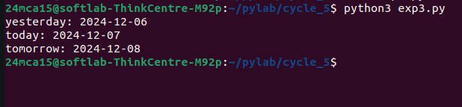

Program 4
AIM
write a function in file palindrome.py to check whether a string a=is palindroem or not import the module to find the longest palindrome substring in a given string by checking every possible substring and verify if it is a palindrome

Source Code

main.py
from palindrome import is_palindrome, longest_palindromic_substring

input_string =input("Enter a String : ")
longest_palindrome = longest_palindromic_substring(input_string)
print(f"The longest palindromic substring in \"{input_string}\" is \"{longest_palindrome}\"")

palindrome.py
def is_palindrome(s):
return s == s[::-1]

def longest_palindromic_substring(s):
n = len(s)
longest = ""
for i in range(n):
for j in range(i, n):
substring = s[i:j+1]
if is_palindrome(substring) and len(substring) > len(longest):
longest = substring
return longest

Output

Program 5
AIM
Create a package graphics with modules rectangle, circle and sub-package 3D-graphics
with modules cuboid and sphere. Include methods to find area and perimeter of
respective figures in each module. Write programs that find the area and perimeter of
figures by different importing statements. (Include selective import of modules and
import * statements)

Source Code

circle.py

Create a package graphics with modules rectangle, circle and sub-package 3D-graphics
with modules cuboid and sphere. Include methods to find area and perimeter of
respective figures in each module. Write programs that find the area and perimeter of
figures by different importing statements. (Include selective import of modules and
import * statements)

rectangle.py

def area(length,breadth):
return length*breadth
def perimeter(length,breadth):
return 2*(length+breadth)

cuboid.py

def area(length,width,height):
return 2*((length*width)+(width*height)+(height*length))
def perimeter(length,width,height):
return 4*(length+width+height)

sphere.py

import math
def area(radius):
return 4*math.pi*radius*radius
def volume(radius):
return 4/3*math.pi*radius*radius*radius

Output
