CYCLE 6

Program 1
AIM
Define a class to represent a bank account. Include the following details like name of the depositor, account number, type of account, balance amount in the account. Write methods to assign initial values, to deposit an amount, withdraw an amount after checking the balance, to display details such as name, account number, account type and balance.

Source Code

class BankAccount:
def __init__(self, name, account_number, account_type, balance):
self.name = name
self.account_number = account_number
self.account_type = account_type
self.balance = balance

def deposit(self, amount):
if amount > 0:
self.balance += amount
print(f"Deposited ₹{amount}. New balance: ₹{self.balance}")
else:
print("Invalid deposit amount. Please enter a positive amount.")

def withdraw(self, amount):
if amount > 0 and amount <= self.balance:
self.balance -= amount
print(f"Withdrew ₹{amount}. New balance: ₹{self.balance}")
else:
print("Insufficient balance or invalid withdrawal amount.")

def display_details(self):
print("Account Details:")
print(f"Name: {self.name}")
print(f"Account Number: {self.account_number}")
print(f"Account Type: {self.account_type}")
print(f"Balance: ₹{self.balance}")

name = input("Enter your name: ")
account_number = input("Enter your account number: ")
account_type = input("Enter your account type (Savings/Current): ")
balance = float(input("Enter your initial balance: "))

account = BankAccount(name, account_number, account_type, balance)

account.display_details()

while True:
choice = input("Enter 'd' to deposit, 'w' to withdraw, or 'q' to quit: ")

if choice == 'd':
amount = float(input("Enter the deposit amount: "))
account.deposit(amount)
elif choice == 'w':
amount = float(input("Enter the withdrawal amount: "))
account.withdraw(amount)
elif choice == 'q':
break
else:
print("Invalid choice. Please try again.")

account.display_details()

Output
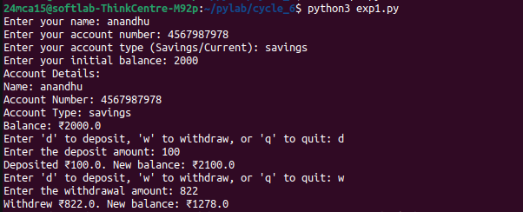

Program 2
AIM
Create a class Publisher with attributes publisher id and publisher name. Derive class Book from Publisher with attributes title and author.

Derive class Python from Book with attributes price and no_of_pages. Write a program that displays information about a Python book. Use base class constructor invocation and method overriding.

Source Code
class Publisher:
def __init__(self, publisher_id, publisher_name):
self.publisher_id = publisher_id
self.publisher_name = publisher_name

def display_info(self):
print(f"Publisher ID: {self.publisher_id}")
print(f"Publisher Name: {self.publisher_name}")

class Book(Publisher):
def __init__(self, publisher_id, publisher_name, title, author):
super().__init__(publisher_id, publisher_name)
self.title = title
self.author = author

def display_info(self):
super().display_info()
print(f"Title: {self.title}")
print(f"Author: {self.author}")

class Python(Book):
def __init__(self, publisher_id, publisher_name, title, author, price, no_of_pages):
super().__init__(publisher_id, publisher_name, title, author)
self.price = price
self.no_of_pages = no_of_pages

def display_info(self):
super().display_info()
print(f"Price: ${self.price}")
print(f"Number of Pages: {self.no_of_pages}")

def main():
print("Enter details of the Python book:")
publisher_id = input("Enter Publisher ID: ")
publisher_name = input("Enter Publisher Name: ")
title = input("Enter Book Title: ")
author = input("Enter Author Name: ")
price = float(input("Enter Price: "))
no_of_pages = int(input("Enter Number of Pages: "))

python_book = Python(
publisher_id=publisher_id,
publisher_name=publisher_name,
title=title,
author=author,
price=price,
no_of_pages=no_of_pages,
)

print("\nBook Details:")
python_book.display_info()

if __name__ == "__main__":
main()

Output
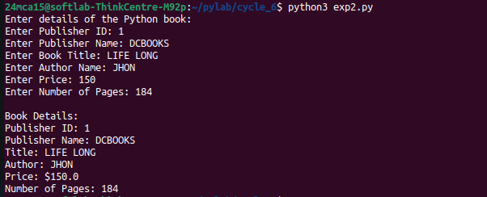

Program 3
AIM
Write a program that has an abstract class Polygon. Derive two classes Rectangle and Triangle from Polygon and write methods to get the details of their dimensions and hence calculate the area.

Source Code

from abc import ABC, abstractmethod

class Polygon(ABC):
@abstractmethod
def get_dimensions(self):
pass

@abstractmethod
def calculate_area(self):
pass

class Rectangle(Polygon):
def __init__(self):
self.length = 0
self.breadth = 0

def get_dimensions(self):
self.length = float(input("Enter the length of the rectangle: "))
self.breadth = float(input("Enter the breadth of the rectangle: "))

def calculate_area(self):
return self.length * self.breadth

class Triangle(Polygon):
def __init__(self):
self.base = 0
self.height = 0

def get_dimensions(self):
self.base = float(input("Enter the base of the triangle: "))
self.height = float(input("Enter the height of the triangle: "))

def calculate_area(self):
return 0.5 * self.base * self.height

def main():
print("Choose a polygon:")
print("1. Rectangle")
print("2. Triangle")
choice = int(input("Enter your choice (1 or 2): "))

if choice == 1:
polygon = Rectangle()
elif choice == 2:
polygon = Triangle()
else:
print("Invalid choice!")
return

polygon.get_dimensions()
area = polygon.calculate_area()
print(f"The area of the selected polygon is: {area}")

if __name__ == "__main__":
main()

Output

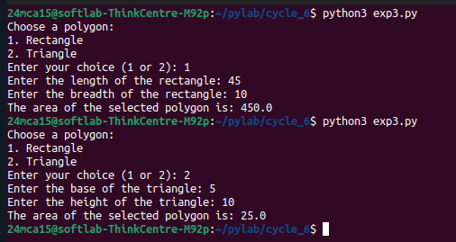

Program 4
AIM
Create a Rectangle class with attributes length and breadth and methods to find area and perimeter. Compare two Rectangle objects by their area.

Source Code

class Rectangle:
def __init__(self, length, breadth):
self.length = length
self.breadth = breadth

def area(self):
return self.length * self.breadth

def perimeter(self):
return 2 * (self.length + self.breadth)

def __lt__(self, other):
"""Compare if this rectangle's area is less than another rectangle's area."""
return self.area() < other.area()

def __eq__(self, other):
"""Check if this rectangle's area is equal to another rectangle's area."""
return self.area() == other.area()

def __gt__(self, other):
"""Compare if this rectangle's area is greater than another rectangle's area."""
return self.area() > other.area()

def main():

length1 = float(input("Enter the length of the first rectangle: "))
breadth1 = float(input("Enter the breadth of the first rectangle: "))
rect1 = Rectangle(length1, breadth1)

length2 = float(input("Enter the length of the second rectangle: "))
breadth2 = float(input("Enter the breadth of the second rectangle: "))
rect2 = Rectangle(length2, breadth2)

print(f"Rectangle 1 - Area: {rect1.area()}, Perimeter: {rect1.perimeter()}")
print(f"Rectangle 2 - Area: {rect2.area()}, Perimeter: {rect2.perimeter()}")

if rect1 > rect2:
print("The first rectangle has a larger area.")
elif rect1 < rect2:
print("The second rectangle has a larger area.")
else:
print("Both rectangles have the same area.")

if __name__ == "__main__":
main()

Output

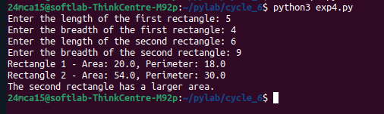
Program 5
AIM
Create a class Time with private attributes hour, minute and second. Overload ‘+’ operator to find sum of 2 times.

Source Code

class Time:
def __init__(self, hour, minute, second):
self.__hour = hour
self.__minute = minute
self.__second = second

def __add__(self, other):

total_seconds = self.__second + other.__second
total_minutes = self.__minute + other.__minute + (total_seconds // 60)
total_hours = self.__hour + other.__hour + (total_minutes // 60)

seconds = total_seconds % 60
minutes = total_minutes % 60
hours = total_hours % 24

return Time(hours, minutes, seconds)

def display(self):
print(f"{self.__hour:02}:{self.__minute:02}:{self.__second:02}")

def main():

print("Enter the first time:")
hour1 = int(input("Hour: "))
minute1 = int(input("Minute: "))
second1 = int(input("Second: "))
time1 = Time(hour1, minute1, second1)

print("Enter the second time:")
hour2 = int(input("Hour: "))
minute2 = int(input("Minute: "))
second2 = int(input("Second: "))
time2 = Time(hour2, minute2, second2)

total_time = time1 + time2

print("The sum of the two times is:")
total_time.display()

if __name__ == "__main__":
main()

Output

