Revenue & Profit Analysis

1. Calculate the overall Profit Margin (%) for the company and determine whether a 12.47% margin is healthy for a retail business. Support your answer with data.

2. Create a Category Performance Report showing Sales, Profit, Profit Margin (%), and Contribution to Total Revenue. Rank categories based on profitability rather than sales.

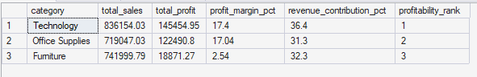

3. Technology generates the highest revenue and profit. Identify the key factors responsible for its superior performance compared to Furniture and Office Supplies.

Category & Sub- Category Analysis
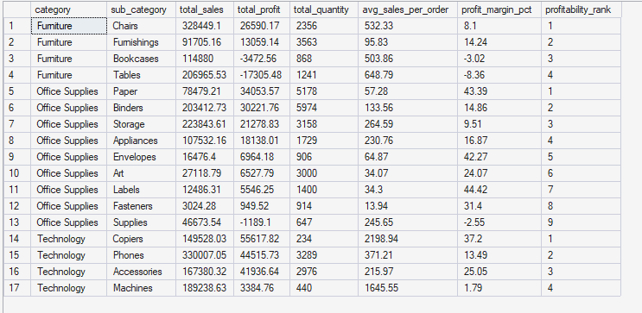

4. Create a Sub-Category Profitability Matrix and identify which sub-categories are destroying overall company profit.

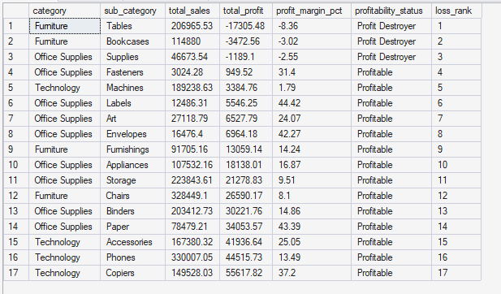

5. Tables generated a loss of over $17,000. Analyze:

Average Discount
Average Sales
Number of Orders
Profit Margin
and determine the root cause of losses.

6. Compare Tables and Bookcases with the top three profitable sub-categories. What operational or pricing differences exist?

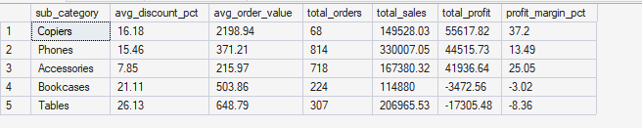

Discount Impact Analysis

7. Categorize discounts into:

0%
0–20%
20–40%
Above 40%

Calculate Sales, Profit, Profit Margin, and Order Count for each group.

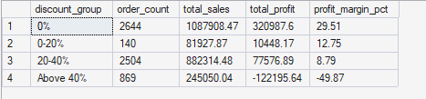

8. Determine the exact financial impact of discounts above 40% on company profitability.

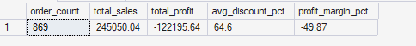

9. Create a chart showing the relationship between Discount % and Profit. Explain whether higher discounts consistently lead to lower profits.

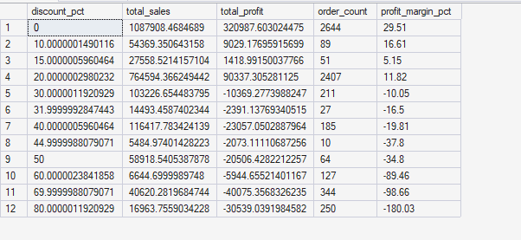

10. If management limits discounts to a maximum of 30%, estimate the potential improvement in profitability.

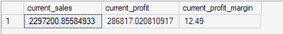

11. Create a Regional Scorecard showing:

Sales
Profit
Profit Margin
Average Discount
Return Rate
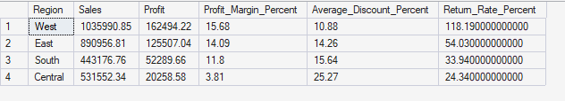

Identify the strongest and weakest region.

12. The West region leads in sales and profit. Determine whether its success comes from higher sales volume, better margins, lower returns, or a combination of factors.

State-Level Analysis

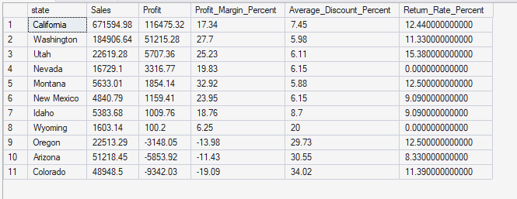

13. Analyze Texas, Ohio, and Pennsylvania in terms of:

Total Sales
Total Profit
Average Discount
Returned Orders
Loss-Making Products

Explain why these states generate heavy losses.

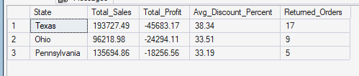

14. Create a Top 10 and Bottom 10 States dashboard and provide recommendations for improving performance in loss-making states.

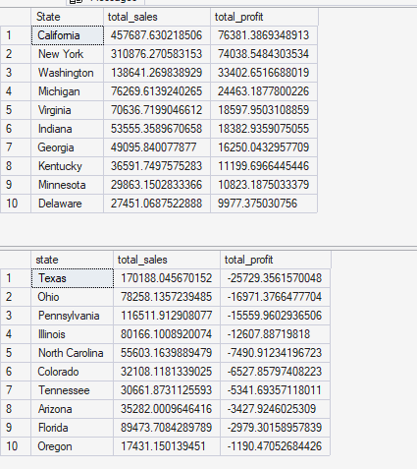

Growth Analysis

15. Calculate Year-over-Year Sales Growth and Profit Growth. Explain why sales growth has outpaced profit growth.

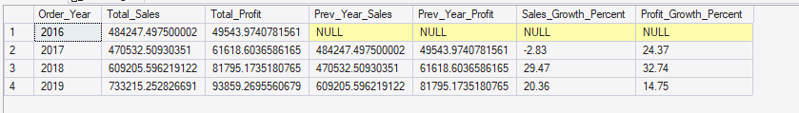

16. Identify whether increasing sales volume is actually improving business performance or simply increasing low-margin transactions.
select * from superstore
SELECT
YEAR(Order_Date) AS SalesYear,
SUM(profit) as Total_profit,
SUM(Quantity) AS Total_quantity,
SUM(Sales) AS Total_Revenue

ROUND(
(SUM(SalesAmount - CostAmount) * 100.0) /
NULLIF(SUM(SalesAmount), 0), 2
) AS GrossMarginPercent
FROM superstore
GROUP BY
YEAR(Order_Date),
MONTH(Order_Date)
ORDER BY
SalesYear,
SalesMonth;

Returns Analysis

17. Using the Returns sheet, calculate:

18. Identify which Categories, Sub-Categories, and Regions contribute most to returned orders. Provide recommendations to reduce returns.

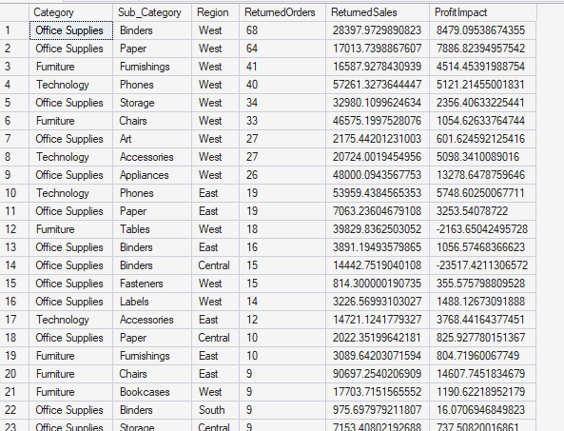

Dashboard & Decision Making

19. Build an Executive Dashboard containing:

Total Sales
Total Profit
Profit Margin
Return Rate
Top Category
Worst Category
Top State
Most Loss-Making State
Sales Trend

Explain why each KPI is important for management.

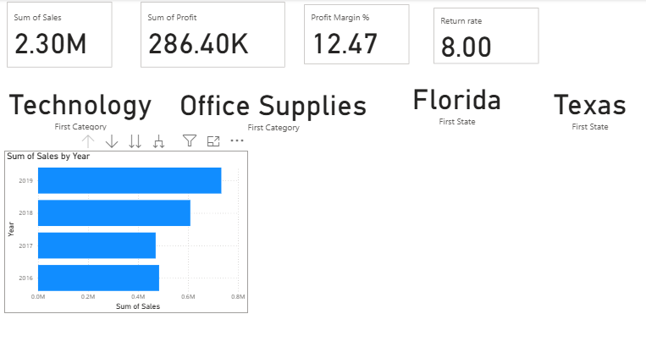

20. You have been hired as a Business Analyst. Based on the complete dataset, provide:

Top 5 Business Problems
Top 5 Opportunities
Top 5 Recommendations

Support every recommendation with quantitative evidence from the data.

Top 5 Business Problems
- High return rate reduces revenue and profit.
- Low-profit sub-categories generate sales but little or negative profit.
- Excessive discounts increase sales but reduce profit margins.
- Regional performance varies, with some regions underperforming.
- Higher sales volume does not always lead to higher profitability.

Top 5 Opportunities
- Expand high-margin categories.
- Reduce returns in high-return products.
- Optimize discount strategies.
- Focus on profitable regions and customer segments.
- Improve the product mix by promoting profitable items.

Top 5 Recommendations
- Reduce returns by improving product quality and descriptions to recover lost sales and profit.
- Limit deep discounts to protect profit margins.
- Invest in high-margin products to maximize profitability.
- Improve underperforming regions by addressing pricing, inventory, and logistics issues.
- Review unprofitable products and adjust pricing, sourcing, or discontinue low-performing items.

