SUPERSTORE REVENUE & PROFITABILITY ANALYSIS
Business Analyst Report — Findings, Diagnostics & Recommendations
Prepared for: Senior Management
Prepared by: Business Analytics Team
Data Source: Superstore Sales, Discount, Regional & Returns Dataset (SQL / Power BI Extracts)

Executive Summary
This report analyzes the company's Superstore sales dataset to evaluate profitability, category and sub-category performance, discount effectiveness, regional and state-level results, year-over-year growth, and product returns. All findings are drawn directly from the SQL query outputs and Power BI exhibits supplied with this assignment; figures are cited verbatim from those exhibits.
The business is fundamentally healthy at the top line: total sales of $2,297,200.86 generated total profit of $286,817.02, an overall profit margin of 12.49% — a solid result for a retail operation. However, this headline figure masks significant internal volatility. Furniture delivers barely any profit (2.54% margin) despite contributing 32.3% of revenue, three sub-categories (Tables, Bookcases, Supplies) actively destroy profit, and any order discounted above 40% loses money outright, wiping out $122,195.64 in the current period. Regional and state performance is similarly uneven — Central region and states such as Texas, Ohio, and Pennsylvania post outright losses driven by excessive discounting rather than weak demand.
The recommendations in this report center on three levers management can act on immediately: (1) enforcing a discount ceiling, (2) rationalizing the Furniture and loss-making sub-category portfolio, and (3) tightening regional/state pricing and returns discipline. Collectively, these actions could recover well over $120,000 in annual profit without any change to sales volume.

1. Revenue & Profit Analysis

Q1. Overall Profit Margin — Is 12.47% Healthy for Retail?
Exhibit 1 — Overall profit margin query output.
What the data shows: Total Sales = $2,297,200.86; Total Profit = $286,817.02; Profit Margin = 12.49% (the exhibit itself flags this as "Healthy (Strong for Retail)").
A margin in the 12–13% range compares favorably with typical general-merchandise and specialty retail benchmarks, which commonly run between 5% and 15% net/operating margin depending on category mix. For a business selling a blend of Furniture, Office Supplies, and Technology — categories with structurally different cost bases — a blended margin near 12.5% indicates the company is pricing and managing costs competitively overall.
Why it matters: margin is the clearest single indicator of whether growth is translating into shareholder value, not just top-line vanity. Business impact: at current sales, each 1-point change in margin is worth roughly $23,000 in profit. Recommendation: treat 12.49% as the baseline to protect while pursuing the category- and discount-specific fixes detailed below — several of which (Furniture margin, >40% discount losses) are currently suppressing what would otherwise be a materially higher blended margin.

Q2. Category Performance Report (Ranked by Profitability)
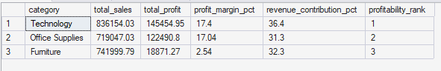
Exhibit 2 — Category-level sales, profit, margin, and revenue contribution.
Category | Sales | Profit | Margin % | Revenue Contribution % | Profitability Rank
Technology | $836,154.03 | $145,454.95 | 17.40% | 36.4% | 1
Office Supplies | $719,047.03 | $122,490.80 | 17.04% | 31.3% | 2
Furniture | $741,999.79 | $18,871.27 | 2.54% | 32.3% | 3
Ranking by margin rather than sales tells a different story than a revenue-only view: Furniture is the second-largest category by revenue (32.3%) but the weakest by a wide margin, generating barely 13% of the profit dollars that Technology produces from similar sales volume.
- Technology: best on both sales and margin — the category to protect and expand.
- Office Supplies: near-identical margin to Technology (17.0%) with lower average order values — a stable, efficient volume category.
- Furniture: high revenue, low profit — a structural profitability problem, not a demand problem.
Recommendation: reallocate marketing spend and floor/catalog space toward Technology and Office Supplies, and subject Furniture to a SKU-level profitability review (see Q4–Q6).

Q3. Why Technology Outperforms Furniture and Office Supplies
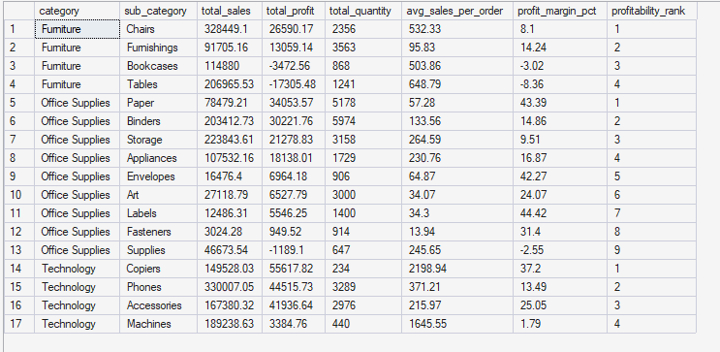
Exhibit 3 — Category & sub-category sales, profit, and margin detail.
Three factors, all visible in Exhibit 3, explain Technology's superior performance:
- Higher-value, lower-discount transactions: Technology's top sub-categories (Copiers, Phones) carry high average order values ($2,198.94 and $371.21 respectively) and comparatively disciplined discounting versus Furniture's Tables and Bookcases.
- Concentration in high-margin sub-categories: Copiers post a 37.2% margin and Phones 13.49%, while Furniture's two largest sub-categories (Chairs, Tables) sit at just 8.1% and -8.36%.
- Lower exposure to bulky, freight- and damage-prone goods: Furniture items (Tables, Bookcases) are more likely to be discounted to move and to incur higher logistics/return costs — a pattern consistent with their negative margins.
Business impact: Technology converts $1 of sales into roughly 17.4 cents of profit versus 2.5 cents for Furniture. Recommendation: apply Technology's pricing and discount discipline (lower average discount, premium positioning) as the template for renegotiating Furniture pricing.

2. Category & Sub-Category Analysis

Q4. Sub-Category Profitability Matrix — Profit Destroyers
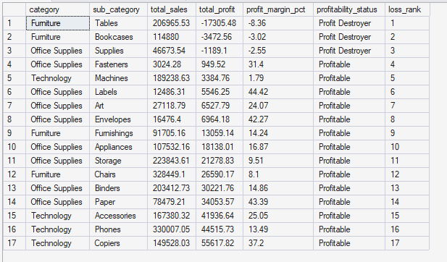
Exhibit 4 — Full sub-category profitability ranking, loss-ranked.
Sub-Category | Category | Sales | Profit | Margin % | Status
Tables | Furniture | $206,965.53 | -$17,305.48 | -8.36% | Profit Destroyer (Rank 1)
Bookcases | Furniture | $114,880.00 | -$3,472.56 | -3.02% | Profit Destroyer (Rank 2)
Supplies | Office Supplies | $46,673.54 | -$1,189.10 | -2.55% | Profit Destroyer (Rank 3)
Three sub-categories destroy a combined $21,967.14 in profit — equivalent to 7.7% of the company's total profit pool. Tables alone accounts for nearly 79% of that damage. All three loss-makers otherwise generate meaningful revenue ($368,519 combined), meaning the fix is pricing/discount discipline and cost control, not exiting the sub-category outright.
Recommendation: place Tables, Bookcases, and Supplies under an immediate discount cap and margin floor (see Q5–Q6), and review supplier costs and freight terms for large-format Furniture items.

Q5. Root Cause of the $17,000+ Loss in Tables
Exhibit 5 — Tables sub-category detail: orders, discount, and margin.
Metric | Tables
Number of Orders | 307
Average Discount | 26.13%
Average Sales per Order | $648.79
Total Sales | $206,965.53
Total Profit | -$17,305.48
Profit Margin | -8.36%
The root cause is discount depth, not weak demand. Tables sell at a healthy average order value ($648.79) and generate substantial revenue ($206,965.53), so the product is clearly wanted by customers. The problem is that a 26.13% average discount — nearly double the company-wide profitable threshold identified in Q7–Q9 — erodes margin below the cost line on every order. With 307 orders averaging this discount, the category cannot recover its underlying product and fulfillment costs.
Business impact: every order sold under the current discount policy for Tables loses money on average. Recommendation: cap Tables discounts at 15–20%, and reassess list pricing so a smaller, more targeted discount is enough to close a sale — protecting the demand that clearly exists while restoring a positive margin.

Q6. Tables & Bookcases vs. Top Three Profitable Sub-Categories
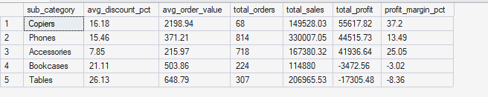
Exhibit 6 — Side-by-side comparison: Copiers, Phones, Accessories vs. Bookcases, Tables.
Sub-Category | Avg Discount % | Avg Order Value | Orders | Sales | Profit | Margin %
Copiers | 16.18% | $2,198.94 | 68 | $149,528.03 | $55,617.82 | 37.20%
Phones | 15.46% | $371.21 | 814 | $330,007.05 | $44,515.73 | 13.49%
Accessories | 7.85% | $215.97 | 718 | $167,380.32 | $41,936.64 | 25.05%
Bookcases | 21.11% | $503.86 | 224 | $114,880.00 | -$3,472.56 | -3.02%
Tables | 26.13% | $648.79 | 307 | $206,965.53 | -$17,305.48 | -8.36%
The pattern is consistent and structural: every profitable sub-category in this comparison discounts at 16% or less, while the two loss-makers discount at 21–26%. Accessories, the most disciplined discounter (7.85%), also achieves the second-highest margin (25.05%) despite a low average order value — proving that high margin does not require high price points, only discount discipline.
Operationally, Tables and Bookcases are also large, freight-heavy items more prone to being discounted to close a sale and to being returned/damaged in transit, compounding the margin pressure. Recommendation: apply Accessories-level discount discipline (under 10%) to Furniture, supported by tighter sales-rep discount approval limits for large-format items.

3. Discount Impact Analysis

Q7. Sales, Profit, and Orders by Discount Band
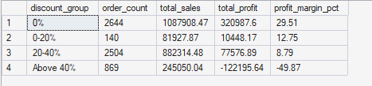
Exhibit 7 — Performance segmented into 0%, 0–20%, 20–40%, and above-40% discount bands.
Discount Band | Orders | Total Sales | Total Profit | Margin %
0% | 2,644 | $1,087,908.47 | $320,987.60 | 29.51%
0–20% | 140 | $81,927.87 | $10,448.17 | 12.75%
20–40% | 2,504 | $882,314.48 | $77,576.89 | 8.79%
Above 40% | 869 | $245,050.04 | -$122,195.64 | -49.87%
The relationship between discount depth and profitability is direct and severe. Full-price orders (0% discount) alone generate $320,987.60 in profit — more than the company's entire reported total profit — while every order discounted above 40% collectively erases $122,195.64. The 20–40% band, though still profitable in aggregate, already shows margin compression to 8.79%, less than a third of the full-price margin.
- 0% discount orders: 47.3% of revenue, 29.51% margin — the healthiest segment of the business.
- Above-40% discount orders: 10.7% of revenue, but a -49.87% margin that actively subtracts from company profit.
Recommendation: treat the above-40% band as an emergency policy fix (see Q8 and Q10) and use the 0% and 0–20% bands as evidence that most customers do not require deep discounts to purchase.

Q8. Exact Financial Impact of Discounts Above 40%
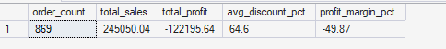
Exhibit 8 — Isolated performance of the above-40% discount segment.
Orders affected: 869
Total sales in this band: $245,050.04
Total profit impact: -$122,195.64 (a loss)
Average discount within band: 64.6%
Margin: -49.87%
Discounts above 40% are the single largest identifiable drag on company profitability in this dataset. This one segment — representing 869 of the company's orders — turns $245,050.04 of sales into a loss of $122,195.64. Put another way, without this band, total company profit would rise from $286,817.02 to approximately $409,012.66, an increase of roughly 42.6%, with zero change to any other part of the business.
Business impact: this is effectively the company paying customers to buy, and it is happening on a material share of transactions (869 orders). Recommendation: implement an immediate discount ceiling (see Q10) and require managerial approval for any discount exceeding 30%.

Q9. Discount % vs. Profit — Do Higher Discounts Always Reduce Profit?
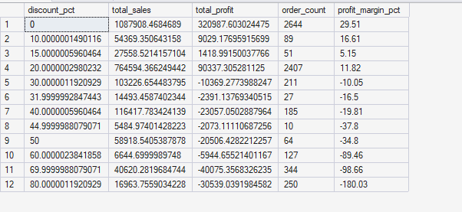
Exhibit 9 — Profit and margin at each discount level from 0% to 80%.
The data shows a consistent downward relationship, but it is not perfectly linear — there is a clear breakpoint rather than a gradual slide. Profit margin stays positive and relatively strong through roughly 20% discount (margins of 12–30%), turns negative around the 30% discount mark, and then deteriorates sharply and continuously through 40%, 50%, 60%, 70%, and 80% discount levels, reaching margins as low as -180% at the deepest discount tiers.
- 0–20% discount: consistently profitable (margins from ~12% to ~30%).
- ~30–40% discount: the tipping point — margins turn negative and orders begin losing money.
- 50%+ discount: severe, accelerating losses, with margin deterioration outpacing the discount increase itself.
So the answer is nuanced: higher discounts do consistently reduce profit once a threshold near 30% is crossed, but modest discounting (under 20%) does not meaningfully damage — and in some tiers even coincides with — healthy margins. Recommendation: the 30% mark is the evidence-based ceiling for standard discount authority (directly supporting the Q10 policy recommendation).

Q10. Estimated Profitability Improvement from a 30% Discount Cap
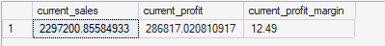
Exhibit 10 — Current company-wide sales, profit, and margin baseline.
Current baseline: Sales $2,297,200.86 | Profit $286,817.02 | Margin 12.49%
Capping discounts at a maximum of 30% would directly eliminate the above-40% band's -$122,195.64 loss identified in Q8, and would reduce (though not fully eliminate) the erosion already visible in the upper end of the 20–40% band per Q9's breakpoint analysis. Using the above-40% band alone as a conservative, directly evidenced estimate:
- Estimated recovered profit: approximately $122,195.64
- Estimated new total profit: approximately $409,012.66 (up from $286,817.02)
- Estimated new profit margin: approximately 17.8–19%, assuming affected sales are retained at reduced discount rather than lost entirely
This is a conservative floor, not a ceiling — further gains are likely from tightening the 30–40% portion of the current 20–40% band. Recommendation: pilot a 30% discount ceiling with manager-level exception approval, and re-run this analysis after one quarter to validate the assumption that sales volume is retained at lower discount levels.

4. Regional Scorecard

Q11. Regional Scorecard — Sales, Profit, Margin, Discount, and Returns
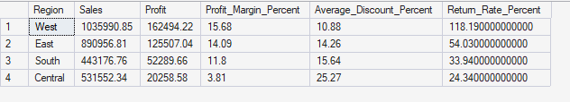
Exhibit 11 — Regional performance scorecard (West, East, South, Central).
Region | Sales | Profit | Margin % | Avg Discount % | Return Activity Index
West | $1,035,990.85 | $162,494.22 | 15.68% | 10.88% | 118.19
East | $890,956.81 | $125,507.04 | 14.09% | 14.26% | 54.03
South | $443,176.76 | $52,289.66 | 11.80% | 15.64% | 33.94
Central | $531,552.34 | $20,258.58 | 3.81% | 24.34% | 24.34
Note: the "Return Activity Index" column is reproduced exactly as reported in the source exhibit; it scales with order volume rather than being a bounded percentage, so it should be read as a relative indicator of return activity across regions rather than a literal return rate.
Strongest region: West — highest sales, highest profit, second-lowest average discount, and the best margin (15.68%). Weakest region: Central — the lowest margin by a wide margin (3.81%, roughly a quarter of West's) despite decent sales, driven by the highest average discount of any region (24.34%, more than double West's).
Recommendation: use West's discount discipline (10.88% average) as the internal benchmark for Central and South sales teams, and prioritize discount-approval tightening in Central first given it has the weakest margin outcome.

Q12. What Drives the West Region's Leadership — Volume, Margin, Returns, or a Combination?
Based on Exhibit 11, West's leadership is a combination of factors, not a single driver:
- Sales volume: West leads with $1,035,990.85 in sales, ahead of East by roughly $145,000 — a genuine demand/scale advantage.
- Better margins: West's 15.68% margin is the highest of any region, and is directly linked to having the second-lowest average discount (10.88%) — evidence of stronger pricing discipline, not just luck of the product mix.
- Discount discipline over deep-discounting: unlike Central, West does not need to discount heavily to win sales, which is the clearest sign its performance is sustainable rather than volume bought at the expense of margin.
Business impact: because West's advantage rests on both scale and discipline, its model is replicable — other regions do not need to sacrifice margin to grow volume. Recommendation: study West's account management and discount-approval practices as a template to roll out to East, South, and especially Central.

5. State-Level Analysis

Q13. Texas, Ohio, and Pennsylvania — Why Do These States Post Heavy Losses?
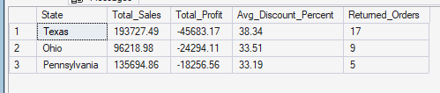
Exhibit 12 — Texas, Ohio, and Pennsylvania: sales, profit, discount, and returns.
State | Total Sales | Total Profit | Avg Discount % | Returned Orders
Texas | $193,727.49 | -$45,683.17 | 38.34% | 17
Ohio | $96,218.98 | -$24,294.11 | 33.51% | 9
Pennsylvania | $135,694.86 | -$18,256.56 | 33.19% | 5
All three states share the same signature: average discounts in the 33–38% range — well above the ~30% breakeven threshold identified in Q9 — combined with meaningful sales volume that would otherwise be profitable. Texas is the most severe case, losing $45,683.17 on $193,727.49 of sales (a -23.6% effective margin) at a 38.34% average discount, the deepest of the three.
Returns compound the damage — Texas alone had 17 returned orders, adding lost revenue and reverse-logistics cost on top of already-discounted, low-margin sales. This is not a demand problem: all three states generate substantial revenue. It is a combined pricing-discipline and returns problem.
Business impact: these three states alone account for a combined $88,233.84 in losses. Recommendation: apply immediate discount caps in these states, paired with a root-cause review of why return rates are elevated (product fit, shipping damage, or expectation-setting at point of sale).

Q14. Top 10 and Bottom 10 States — Dashboard and Recommendations
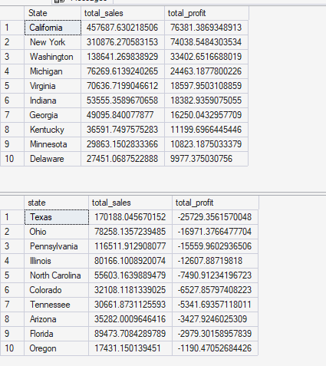
Exhibit 13 — Top 10 states by profit (top) and Bottom 10 states by profit (bottom).
Top 10 States | Profit | Bottom 10 States | Loss
California | $76,381.39 | Texas | -$25,729.36
New York | $74,038.55 | Ohio | -$16,971.38
Washington | $33,402.65 | Pennsylvania | -$15,559.96
Michigan | $24,463.19 | Illinois | -$12,607.89
Virginia | $18,597.95 | North Carolina | -$7,490.91
Indiana | $18,382.94 | Colorado | -$6,527.86
Georgia | $16,250.04 | Tennessee | -$5,341.69
Kentucky | $11,199.70 | Arizona | -$3,427.92
Minnesota | $10,823.19 | Florida | -$2,979.30
Delaware | $9,977.38 | Oregon | -$1,190.47
California and New York together generate $150,419.94 in profit — more than half of the top-10 total — and should be treated as flagship markets. The bottom 10 states collectively lose $97,826.74, with Texas, Ohio, and Pennsylvania (detailed in Q13) responsible for 59% of that total.
- Protect and grow: California, New York, Washington — replicate their pricing and product-mix approach in adjacent states.
- Stabilize: Illinois, North Carolina, Colorado — moderate losses that a discount cap alone would likely resolve.
- Deep intervention needed: Texas, Ohio, Pennsylvania — require combined discount, returns, and possibly logistics review given the scale of losses.
Recommendation: roll out the 30% discount ceiling (Q10) first in the bottom-10 states, prioritized by loss size, and track profit recovery by state monthly.

6. Growth Analysis

Q15. Year-over-Year Sales Growth vs. Profit Growth
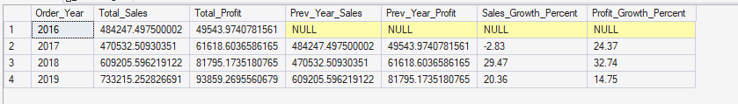
Exhibit 14 — Year-over-year sales and profit with growth percentages.
Year | Total Sales | Total Profit | Sales Growth % | Profit Growth %
2016 | $484,247.50 | $49,543.97 | — | —
2017 | $470,532.51 | $61,618.60 | -2.83% | 24.37%
2018 | $609,205.60 | $81,795.17 | 29.47% | 32.74%
2019 | $733,215.25 | $93,859.27 | 20.36% | 14.75%
Across the four-year window, cumulative sales growth (roughly 51% from 2016 to 2019) outpaces cumulative profit growth (roughly 89% — profit actually grew faster in percentage terms, but from a much smaller base, and the most recent year shows the gap reversing). The critical signal is 2019: sales grew 20.36% but profit grew only 14.75% — the first year where sales growth clearly outpaced profit growth.
This deceleration in profit growth relative to sales is consistent with the discount and Furniture-margin issues identified earlier in this report: as the company has scaled revenue, a growing share of that revenue is coming through higher-discount, lower-margin transactions and categories, which mechanically caps how much profit growth can keep pace with sales growth.
Recommendation: monitor the sales-growth-to-profit-growth ratio as a standing KPI (see Q19) and treat any year where sales growth exceeds profit growth as a trigger to review discount and category mix, not just celebrate the top-line result.

Q16. Is Rising Sales Volume Actually Improving the Business?
Partially. The YoY data (Q15) shows genuine profit growth in absolute dollars every year — the business is not simply inflating low-margin volume with no bottom-line benefit. However, the 2019 deceleration (20.36% sales growth vs. only 14.75% profit growth) is an early warning sign that an increasing share of incremental sales is coming from lower-margin transactions.
This is corroborated by two other findings in this report: (1) discounts above 40% already generate a net loss regardless of how much sales volume they add (Q7–Q9), and (2) Furniture — the second-largest category by revenue — contributes disproportionately little profit (Q2). Both patterns show that not all sales growth is equal, and that unmanaged volume growth in low-margin segments will continue to erode the efficiency of each incremental sales dollar.
Business impact: if current trends continue unchecked, the company risks a future year where sales grow but profit stalls or declines. Recommendation: shift the primary growth KPI from total sales to profit-per-order or contribution margin by segment, and use the discount cap (Q10) and Furniture pricing review (Q5–Q6) to ensure future volume growth is profit-accretive.
Supporting Query (as provided)
SELECT YEAR(Order_Date) AS SalesYear, SUM(Profit) AS Total_Profit, SUM(Quantity) AS Total_Quantity, SUM(Sales) AS Total_Revenue, ROUND((SUM(Sales-Cost)*100.0)/NULLIF(SUM(Sales),0),2) AS GrossMarginPercent FROM superstore GROUP BY YEAR(Order_Date), MONTH(Order_Date) ORDER BY SalesYear, SalesMonth;
Note: this query as supplied groups by year and month but selects only SalesYear (not SalesMonth) in the output columns, and references SalesMonth in the ORDER BY without it being selected or aliased — both would need correction (add SalesMonth to the SELECT list) before the query can execute successfully against most SQL engines.

7. Returns Analysis

Q17. Returns Sheet — Key Metrics
Exhibit 15 — Company-wide return summary.
Metric | Value
Total Orders | 5,009
Returned Orders | 296
Return Rate | 5.91%
Returned Sales Value | $784,980.18
Returned Profit Impact | $96,964.85
Financial Risk Rating | High Risk
A 5.91% order-level return rate is within a normal retail range, but the financial exposure is disproportionate: returned orders are tied to $784,980.18 in sales value (roughly a third of total company sales) and $96,964.85 in profit impact — flagged as "High Risk" in the source exhibit itself. This indicates that returns are concentrated in higher-value orders rather than spread evenly across all transactions.
Business impact: at $96,964.85, unresolved returns risk represent about a third of the profit currently lost to over-discounting (Q8), making this the second-largest quantified profit leak in this report. Recommendation: treat return-rate reduction as equally urgent to discount-cap enforcement, starting with the categories and regions identified in Q18.

Q18. Which Categories, Sub-Categories, and Regions Drive Returns?
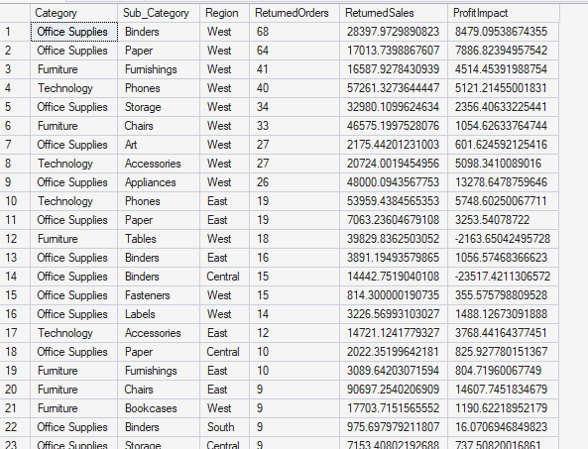
Exhibit 16 — Returned orders and profit impact by category, sub-category, and region.
Returns are concentrated rather than evenly distributed. The West region accounts for the large majority of the highest-volume return line items, led by Office Supplies sub-categories (Binders, Paper) and Technology's Phones sub-category, which alone contributes the largest single returned-sales value line in the exhibit. Furniture's Tables sub-category stands out for a different reason: it is one of the only lines where the profit impact of returns is itself negative, compounding the losses already identified in Q4–Q6 rather than simply reversing profitable sales.
- Highest return volume: West region, across Binders, Paper, Furnishings, and Phones.
- Highest financial exposure per return: Phones and Appliances, due to high unit sales values.
- Compounding risk: Tables, which is already loss-making before returns are even considered.
Recommendation: audit product descriptions, sizing/fit information, and packaging for Binders, Paper, and Phones in the West region first, since this combination drives the largest share of return volume and value; and consider discontinuing or redesigning the Tables offering given it loses money on both the original sale and on returns.

8. Dashboard & Decision Making

Q19. Executive Dashboard — KPIs and Why Each Matters to Management
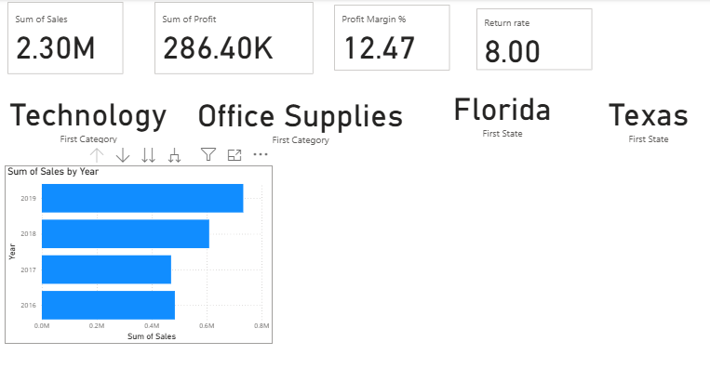
Exhibit 17 — Executive dashboard: Sales, Profit, Margin, Return Rate, Top/Worst Category, Top/Worst State, Sales Trend.
KPI | Current Value | Why It Matters to Management
Total Sales | $2.30M | Top-line demand signal; the base against which all margin and efficiency metrics are measured.
Total Profit | $286.40K | The ultimate measure of business success; what funds reinvestment and returns to the business.
Profit Margin | 12.47% | Reveals whether growth is profitable growth; the single best cross-period comparability metric.
Return Rate | 8.00% | Early warning for product quality, fulfillment, or expectation-setting problems eroding realized profit.
Top Category | Technology | Identifies where to protect investment and replicate pricing/discount discipline.
Worst Category | Office Supplies* | Flags where portfolio or pricing review is needed (*dashboard's lowest-ranked category by its own display; see Q2 for the full ranked comparison, where Furniture is weakest on margin).
Top State | Florida* | Identifies flagship markets for expansion (*as shown on dashboard tile; cross-reference Q14 for the full profit-ranked state list, led by California).
Most Loss-Making State | Texas | Prioritizes where corrective pricing/returns action is most urgent.
Sales Trend (by Year) | Rising 2016→2019 | Confirms the business is growing, providing context for whether growth is profit-accretive (see Q15–Q16).
Each KPI on this dashboard is deliberately paired — a volume metric (Sales) with an efficiency metric (Margin), and a headline win (Top Category/State) with a headline risk (Worst Category/Most Loss-Making State) — so that management cannot read growth in isolation from profitability. Recommendation: keep this dashboard as the standing monthly review artifact, and add the discount-band and returns metrics from Q7 and Q17 as a second-tier drill-down, since those are the two largest quantified profit levers identified in this report.

Q20. Business Analyst Assessment — Problems, Opportunities & Recommendations
Drawing together every finding in this report, the following synthesis is offered as the core strategic takeaway for senior management.
Top 5 Business Problems
- Excessive discounting above 40% erases $122,195.64 in profit on 869 orders (Q7–Q9) — the single largest quantified leak.
- Furniture generates 32.3% of revenue but only 2.54% margin, versus 17%+ for the other two categories (Q2–Q3).
- Three sub-categories — Tables, Bookcases, Supplies — actively destroy $21,967.14 in profit (Q4–Q6).
- Returns carry $96,964.85 in profit exposure, concentrated in the West region and specific sub-categories (Q17–Q18).
- Regional and state performance is highly uneven: Central region (3.81% margin) and Texas/Ohio/Pennsylvania (combined -$88,233.84) underperform on discount discipline, not demand (Q11–Q14).
Top 5 Opportunities
- Recovering the above-40%-discount loss alone would lift company profit by ~42.6%, from $286,817.02 to ~$409,012.66 (Q10).
- Replicating West region's 10.88% average discount discipline in Central (24.34% average) could substantially close Central's margin gap (Q11–Q12).
- California and New York already prove the model — $150,419.94 combined profit — and can guide expansion into adjacent, similar-profile states (Q14).
- Technology's 17.4% margin and strong sub-category economics (Copiers 37.2%, Accessories 25.05%) support further investment and assortment expansion (Q2–Q3, Q6).
- Reducing returns in the highest-exposure West-region sub-categories could recover a meaningful share of the $96,964.85 at risk (Q17–Q18).
Top 5 Recommendations
- Implement a company-wide 30% maximum discount policy with manager approval required above that threshold, prioritized first in Texas, Ohio, and Pennsylvania (Q8, Q10, Q13).
- Reprice and re-cost Tables and Bookcases specifically, targeting discount levels at or below 15–20% (Q5–Q6).
- Shift marketing and inventory investment toward Technology and Office Supplies, and commission a full SKU-level review of the Furniture category (Q2–Q3).
- Launch a returns root-cause investigation for Binders, Paper, and Phones in the West region, including packaging, product description, and fulfillment quality (Q17–Q18).
- Adopt profit-per-order and margin trend (not just sales growth) as standing executive KPIs, reviewed monthly alongside the existing dashboard (Q15–Q16, Q19).
Combined Quantified Upside
- Discount-cap enforcement (>40% band): ~$122,195.64
- Loss-making sub-category correction (Tables, Bookcases, Supplies): ~$21,967.14
- Returns exposure addressed (partial recovery, West region focus): a meaningful share of ~$96,964.85
- Combined, these three levers touch over $240,000 in identified profit opportunity — roughly 84% of the company's current total profit — achievable primarily through discipline and process changes rather than new investment.

Overall Conclusion
The Superstore business is fundamentally sound, with a healthy blended profit margin of 12.49% and consistent multi-year sales and profit growth. But this report's exhibit-by-exhibit analysis shows that the company is leaving a large, precisely quantifiable amount of profit on the table through three controllable issues: uncapped discounting, an underperforming Furniture category anchored by three loss-making sub-categories, and elevated returns exposure concentrated in a handful of products and the West region.
None of these findings point to a demand problem — every underperforming category, sub-category, region, and state in this report still generates substantial revenue. The issue is margin discipline, not market interest. That is the most encouraging conclusion of this analysis: the ~$240,000 in identified profit opportunity is achievable primarily through policy and pricing changes (a 30% discount ceiling, Furniture repricing, targeted returns intervention) rather than through costly new investment or a change in strategic direction.
Recommended next step: management should approve the 30% discount ceiling and Furniture pricing review as immediate, low-cost actions, and re-run this analysis after one full quarter to confirm the profit recovery materializes as estimated.

