🎬 NETFLIX OTT STREAMING
ANALYTICS REPORT
Comprehensive Viewer Behavior & Platform Performance Analysis

Dataset: 20,000 Streaming Records | Countries: 10 | Genres: 10 | Period: 2022–2024

📊 KEY PERFORMANCE INDICATORS

20,000  Total Users  Active Streamers | 31,779h  Total View Hours  Across All Genres | 95.3 min  Avg. Watch Duration  Per Session | $259,520  Total Revenue  Subscription Income

Crime  Top Genre  3,311 hrs watched | Japan  Top Country  3,249 view hours | Mobile  Top Device  5,130 users (25.7%) | Basic  Top Plan  6,732 subscribers

📝 EXECUTIVE SUMMARY

This report presents a comprehensive analysis of Netflix OTT streaming behavior across 20,000 users spanning 10 countries and 10 content genres. The dataset covers the period from 2000 to 2024 and captures key dimensions including device preferences, subscription tiers, age demographics, geographic distribution, and content consumption patterns.
The analysis reveals a highly balanced content ecosystem where Crime leads view hours at 3,311 hours, followed closely by Comedy and Romance. Japan emerges as the top-consuming country while Mobile devices dominate platform access. Revenue is driven primarily by Premium subscribers, who collectively generate $119,448—nearly double the Basic tier.
These insights are designed to inform content investment decisions, regional marketing strategies, and subscription tier optimization for the platform.

🎭 GENRE PERFORMANCE ANALYSIS

View Hours Distribution by Genre
Crime content leads all genres with 3,311 view hours, indicating strong audience appetite for suspenseful narratives. Comedy, Romance, and Animation follow closely, suggesting a diverse content preference across the user base. Thriller records the lowest view hours at 3,065 hours.
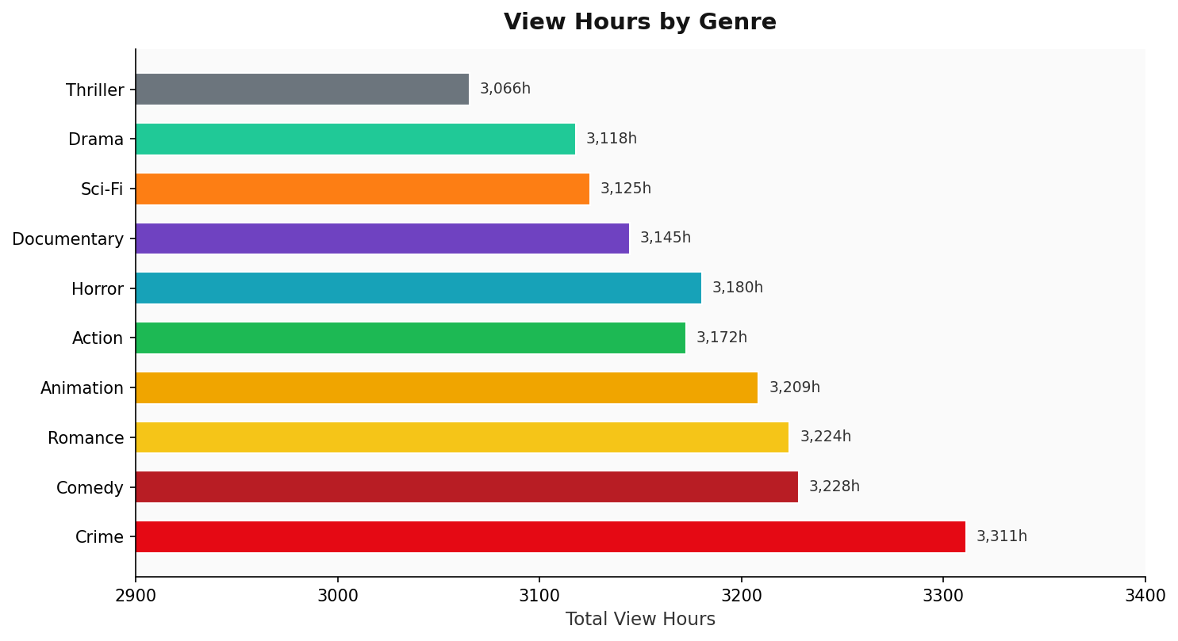

Genre-Level Summary Statistics

Genre | Total Users | View Hours | Avg Duration (min)
Crime | 2,049 | 3,311.4 | 96.96
Comedy | 2,031 | 3,228.3 | 95.37
Romance | 2,027 | 3,223.9 | 95.43
Animation | 2,021 | 3,208.6 | 95.26
Action | 1,998 | 3,172.5 | 95.27
Horror | 2,004 | 3,180.4 | 95.22
Documentary | 2,005 | 3,144.9 | 94.11
Sci-Fi | 1,975 | 3,125.1 | 94.94
Drama | 1,969 | 3,118.0 | 95.02
Thriller | 1,921 | 3,065.5 | 95.74

Key Genre Insights
- Crime content achieves the highest average watch duration (96.96 min), suggesting deeper viewer engagement.
- Documentary records the lowest average duration (94.11 min) and the second-lowest view hours overall.
- All genres maintain a remarkably consistent user base between 1,921 and 2,049 users, indicating balanced content curation.
- The total view hours across all genres sum to 31,778.5 hours, with an overall average session of 95.34 minutes.

📱 DEVICE & ACCESS ANALYSIS

Device Type Distribution
Mobile devices lead platform access with 5,130 users (25.7%), narrowly ahead of Smart TV (4,987), Tablet (4,944), and Laptop (4,939). The near-equal split across all four device types demonstrates the platform's strong multi-screen strategy and robust cross-device compatibility.
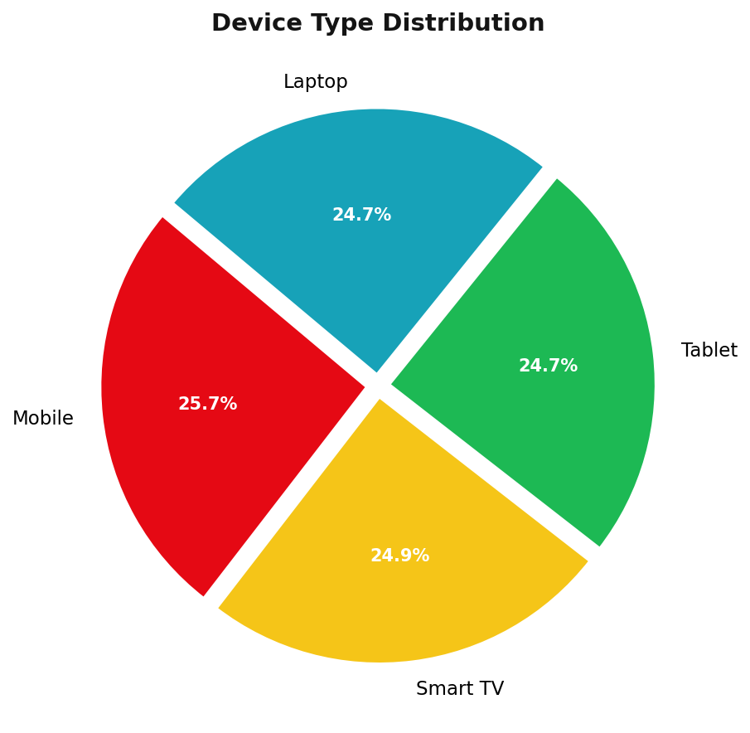

Device Usage Breakdown

Device Type | Users | Market Share
Mobile | 5,130 | 25.65%
Smart TV | 4,987 | 24.94%
Tablet | 4,944 | 24.72%
Laptop | 4,939 | 24.70%

Device Strategy Recommendations
- Mobile-first optimization should remain a priority given its leading market share.
- Smart TV investment is critical as it represents the premium at-home viewing experience aligned with higher subscription tiers.
- Tablet and Laptop users represent on-the-go professionals—ideal for targeted Standard and Premium plan promotions.
- Uniform device distribution suggests Netflix's responsive design and native apps are performing effectively across all platforms.

💳 SUBSCRIPTION & REVENUE ANALYSIS

Revenue by Subscription Type
Premium subscribers generate the highest total revenue at $119,448—accounting for 46% of total platform income. Despite Basic having the most users, its lower price point ($8/month) results in significantly lower revenue contribution. The Standard tier at $13/month sits comfortably in the middle.
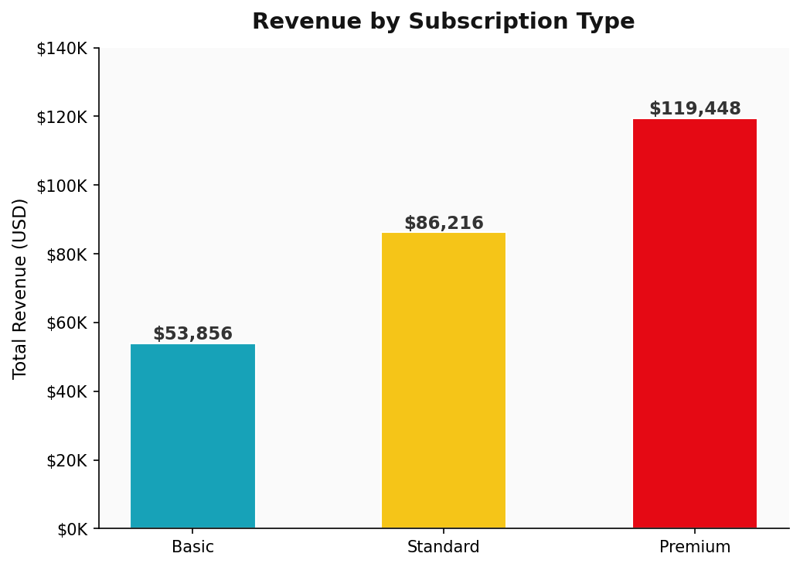

Subscription Type Split
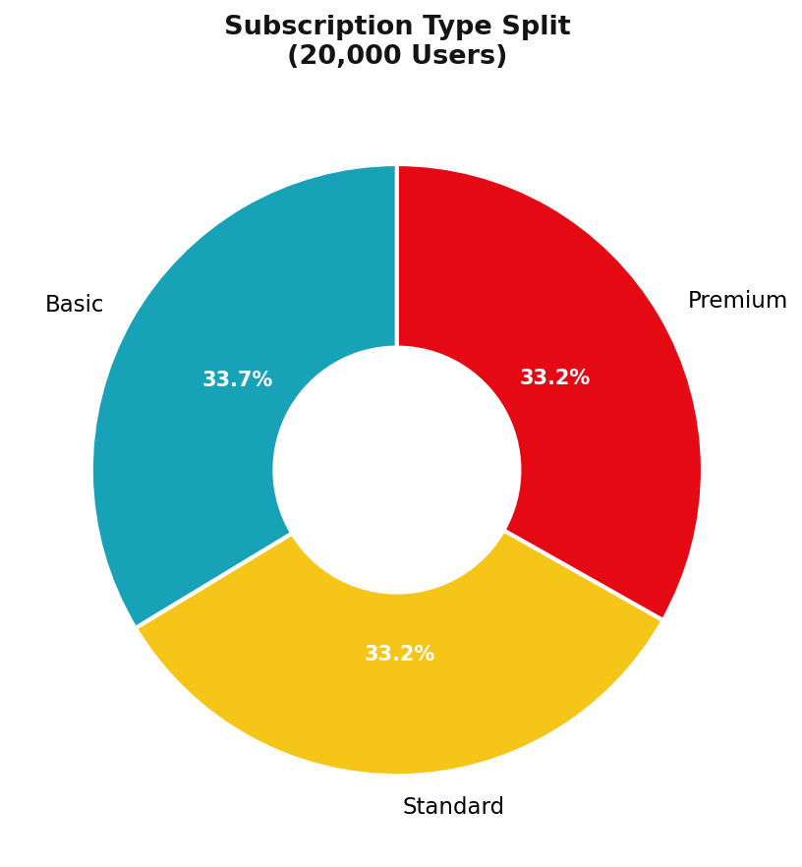

Subscription & Revenue Summary

Subscription | Users | Price/Month | Total Revenue | Revenue Share
Basic | 6,732 | $8 | $53,856 | 20.7%
Standard | 6,632 | $13 | $86,216 | 33.2%
Premium | 6,636 | $18 | $119,448 | 46.0%

Revenue Insights
- Premium subscribers generate 2.2x more revenue per user than Basic subscribers.
- All three subscription tiers maintain near-equal user counts (~6,600 each), indicating effective tier differentiation.
- Upselling Basic users to Standard could add approximately $33,000 in additional monthly revenue.
- The 46% revenue concentration in Premium highlights dependency on high-value users who should be prioritized for retention.

🌍 GEOGRAPHIC PERFORMANCE ANALYSIS

View Hours by Country
Japan leads all 10 countries in total view hours with 3,249 hours, followed by the UK (3,221 hrs) and India (3,210 hrs). Brazil records the lowest consumption at 3,131 hours. The tight spread of only ~118 hours between the highest and lowest countries indicates balanced global engagement.
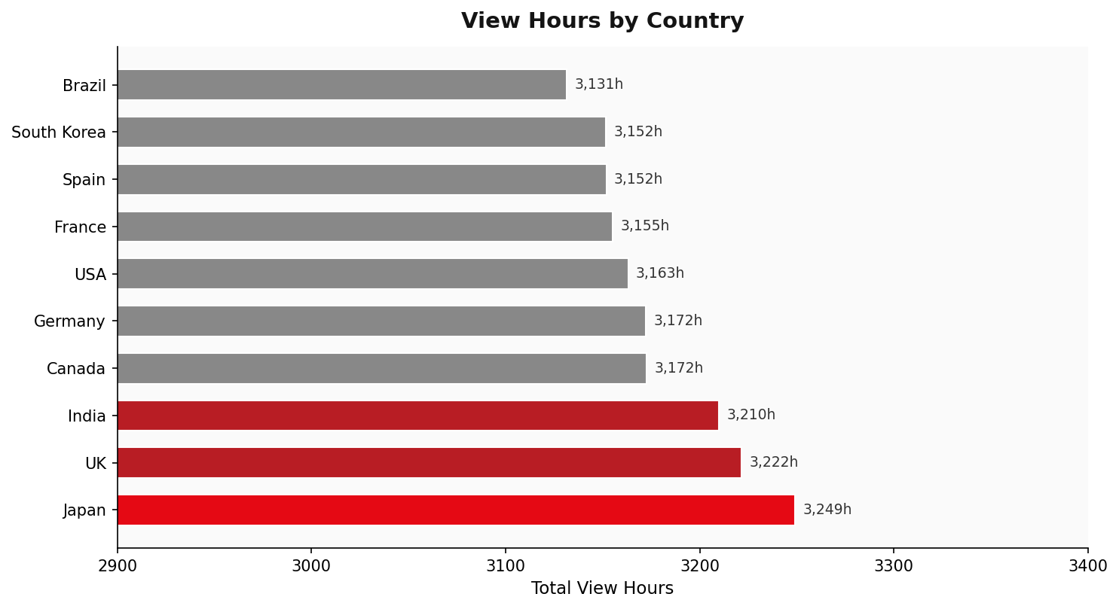

Country-Level Performance

Rank | Country | View Hours | Share
1 | Japan | 3,249.1 | 10.22%
2 | UK | 3,221.5 | 10.13%
3 | India | 3,209.9 | 10.10%
4 | Canada | 3,172.5 | 9.98%
5 | Germany | 3,172.2 | 9.98%
6 | USA | 3,163.1 | 9.95%
7 | France | 3,155.2 | 9.93%
8 | Spain | 3,151.9 | 9.92%
9 | South Korea | 3,151.8 | 9.92%
10 | Brazil | 3,131.4 | 9.85%

Geographic Insights
- Japan's leadership may reflect strong anime and J-drama content performance on the platform.
- India's top-3 position, given its large young population, signals significant growth potential.
- The balanced distribution across all 10 countries suggests effective global localization strategies.
- Brazil could benefit from targeted content investment in Portuguese-language originals to boost engagement.

👥 AUDIENCE DEMOGRAPHICS

Viewership by Age Group
The 13-17 age group records the highest viewership at 3,397 users, closely followed by the 18-24 group (3,392). Audiences aged 55+ represent the smallest segment with 3,211 users. Notably, the overall demographic distribution is remarkably even, with all age groups maintaining between 3,211 and 3,397 users.
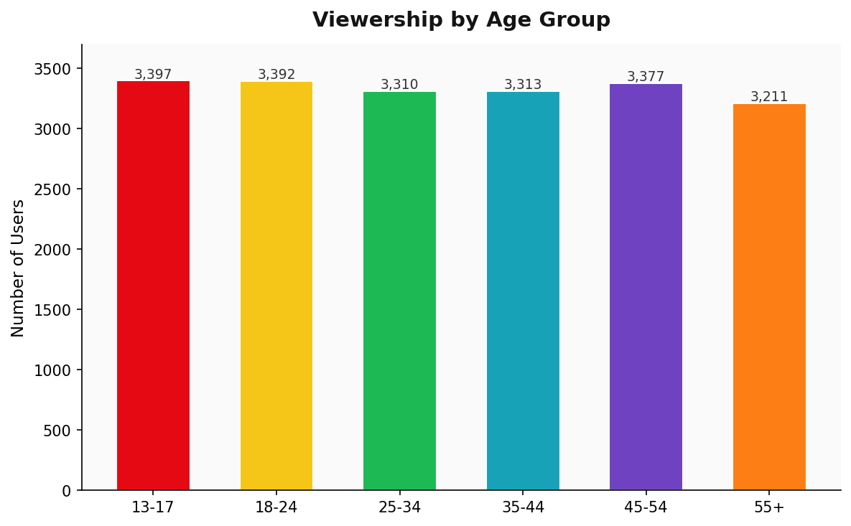

Age Group Breakdown

Age Group | Users | Share | Segment
13-17 | 3,397 | 17.0% | Gen Z (Younger)
18-24 | 3,392 | 17.0% | Gen Z (Older)
25-34 | 3,310 | 16.6% | Millennials
35-44 | 3,313 | 16.6% | Elder Millennials
45-54 | 3,377 | 16.9% | Gen X
55+ | 3,211 | 16.1% | Baby Boomers

Demographic Insights
- Teenage viewers (13-17) leading consumption underscores the importance of age-appropriate content curation and parental control features.
- The combined Gen Z audience (13-17 & 18-24) totals 6,789 users—the largest generational segment (34%)—pointing to the critical importance of trending, social media-connected content.
- The 55+ segment, though smallest, represents an underserved audience that could be targeted with documentary, drama, and classic film content.
- The near-uniform distribution across all ages validates Netflix's broad content library strategy.

🚀 STRATEGIC RECOMMENDATIONS

1. Content Strategy
- Double down on Crime and Comedy content, which lead both in view hours and user engagement.
- Invest in localised Japanese and Korean content to sustain Asia-Pacific leadership.
- Develop Portuguese-language originals for the Brazilian market to address underperformance.
- Expand Documentary offerings with shorter formats to increase average watch duration in the genre.

2. Subscription Growth
- Launch targeted upsell campaigns for Basic users, especially Smart TV owners who may benefit most from Premium quality.
- Introduce annual billing incentives for Standard subscribers to reduce churn and improve revenue predictability.
- Bundle Premium with exclusive early-access content to reinforce the premium tier's value proposition.
- Test a family plan at a mid-point price between Standard and Premium to capture household users.

3. Platform & Device
- Invest in mobile app performance optimisation, especially for emerging markets like India and Brazil where mobile is primary.
- Develop Smart TV-exclusive features (enhanced UI, spatial audio) to grow the Smart TV user base.
- Launch offline download promotions for Tablet and Laptop users to drive engagement during commute hours.

4. Audience Engagement
- Create dedicated content hubs for Gen Z (trending formats, short-form content, interactive features).
- Launch a 55+ focused category with classic cinema, documentaries, and lifestyle content.
- Implement personalised push notifications based on viewing patterns to re-engage inactive users in all age groups.

✅ CONCLUSION

The Netflix OTT Streaming Analysis reveals a platform with exceptional global reach and a well-balanced content ecosystem. With 20,000 active users across 10 countries consuming over 31,778 hours of content, the platform demonstrates strong foundational health.
The data highlights three critical priorities: (1) sustaining Crime and Comedy genre momentum through continued investment; (2) converting Basic subscribers to higher-tier plans to maximize the $259,520 revenue baseline; and (3) capitalizing on the dominant Gen Z demographic through mobile-first, trend-aware content experiences.
With strategic content localization, targeted subscription marketing, and continued cross-device optimization, Netflix is well-positioned to deepen its global subscriber base and drive sustainable revenue growth in the coming years.

— End of Report —

Prepared by: Anandi | Netflix OTT Streaming Analytics | Data Source: Internal Streaming Dataset (20,000 Records)
This report is generated from structured streaming data for analytical and strategic planning purposes.

