Employee Sentiment Analysis Report

1. Project Overview
This project analyzes employee email messages to understand employee sentiment and engagement.
The dataset contains employee emails including sender, subject, body, and date.
Sentiment analysis techniques were applied to classify each message into Positive, Negative, or Neutral.

The project includes:
- Sentiment labeling
- Exploratory Data Analysis (EDA)
- Employee sentiment scoring
- Employee ranking
- Flight risk identification
- Predictive modeling using linear regression

2. Dataset Description
Dataset used: test.csv
Dataset Structure:

Feature | Description
date | Date of the email
from | Sender email address
Subject | Email subject
body | Email message content

3. Data Cleaning
The dataset required preprocessing before analysis.
Steps performed:
- Converted date column to datetime format
- Filled missing values (body → 'No body', from → 'Unknown')
- Removed duplicate records
- Cleaned message body using regular expressions
- Combined Subject and body into one message column

4. Sentiment Labeling
Sentiment labeling was performed using the transformer model:
cardiffnlp/twitter-roberta-base-sentiment
Steps:
- Combine Subject and Body
- Classify messages into Positive, Neutral, or Negative
Output :
sentiment
Neutral 1437
Positive 607
Negative 147
Name: count, dtype: int64

5. Exploratory Data Analysis
EDA was performed to understand dataset patterns and trends.
Key analyses performed:
- Dataset structure inspection

- Sentiment distribution analysis
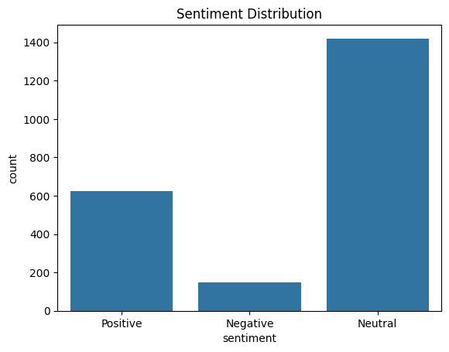
- Messages per month analysis
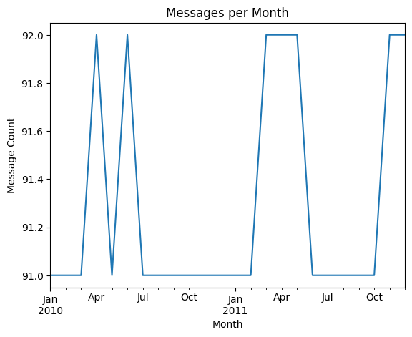
- Sentiment trends over time
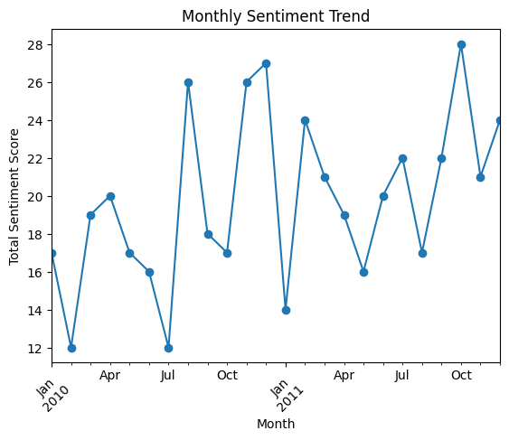

6. Employee Sentiment Score Calculation
Each message was converted to a numerical score:
Positive = +1
Neutral = 0
Negative = -1
Monthly sentiment scores were calculated for each employee.

7. Employee Ranking
Employees were ranked based on monthly sentiment scores.
Two rankings were created:
- Top three positive employees
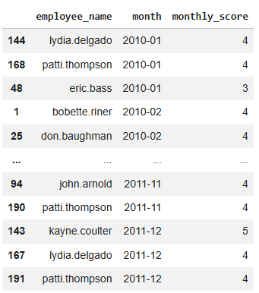

- Top three negative employees
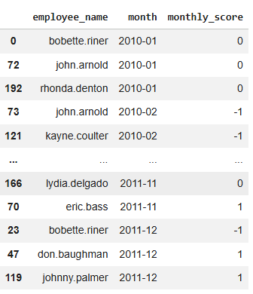

8. Flight Risk Identification
A flight risk is defined as any employee who sends 4 or more negative emails within a rolling 30‑day period.
Employees matching this condition were flagged as potential flight risks.
Output :
Flight Risk Employees: ['bobette.riner', 'eric.bass', 'john.arnold']

9. Predictive Modeling
A Linear Regression model was built to analyze sentiment trends.
Features used:
- message_count
- avg_message_length
Evaluation metrics: R² Score and RMSE.
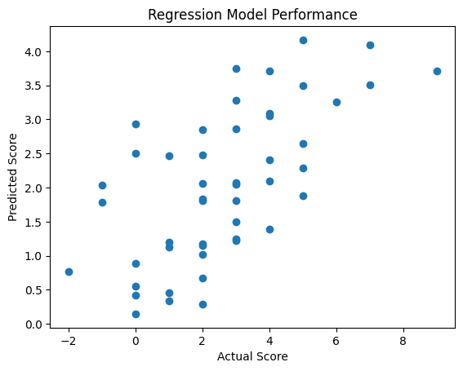

Output :
R2 Score: 0.30854325467317434
RMSE: 1.8642130813590885

10. Key Insights
- Most emails fall into the Neutral sentiment category.
- Some employees consistently show positive communication patterns.
- A small number of employees show frequent negative sentiment.
- Sentiment trends vary across months.

11. Conclusion
Sentiment analysis helps evaluate employee engagement through communication patterns.
The project demonstrates how LLM and statistical modeling can identify trends, rank employees, and detect potential flight risks.

