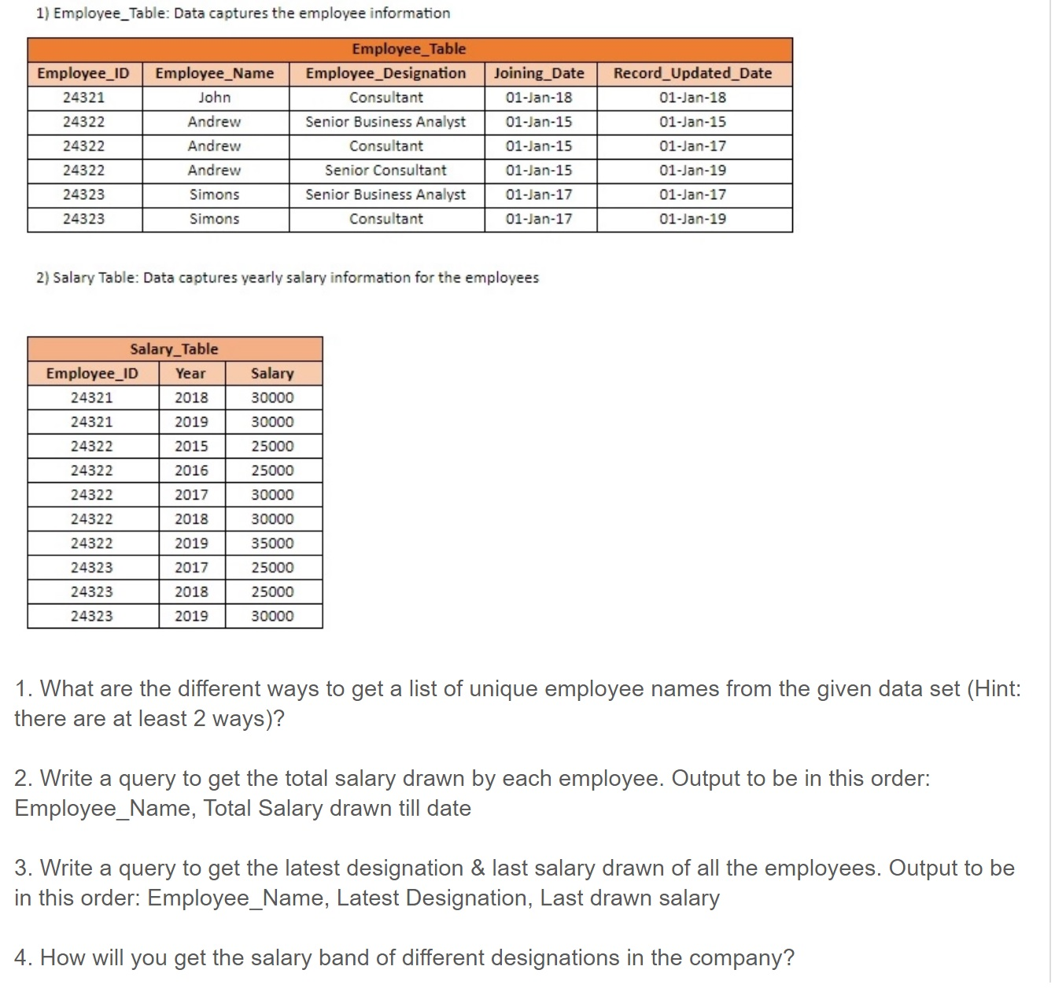

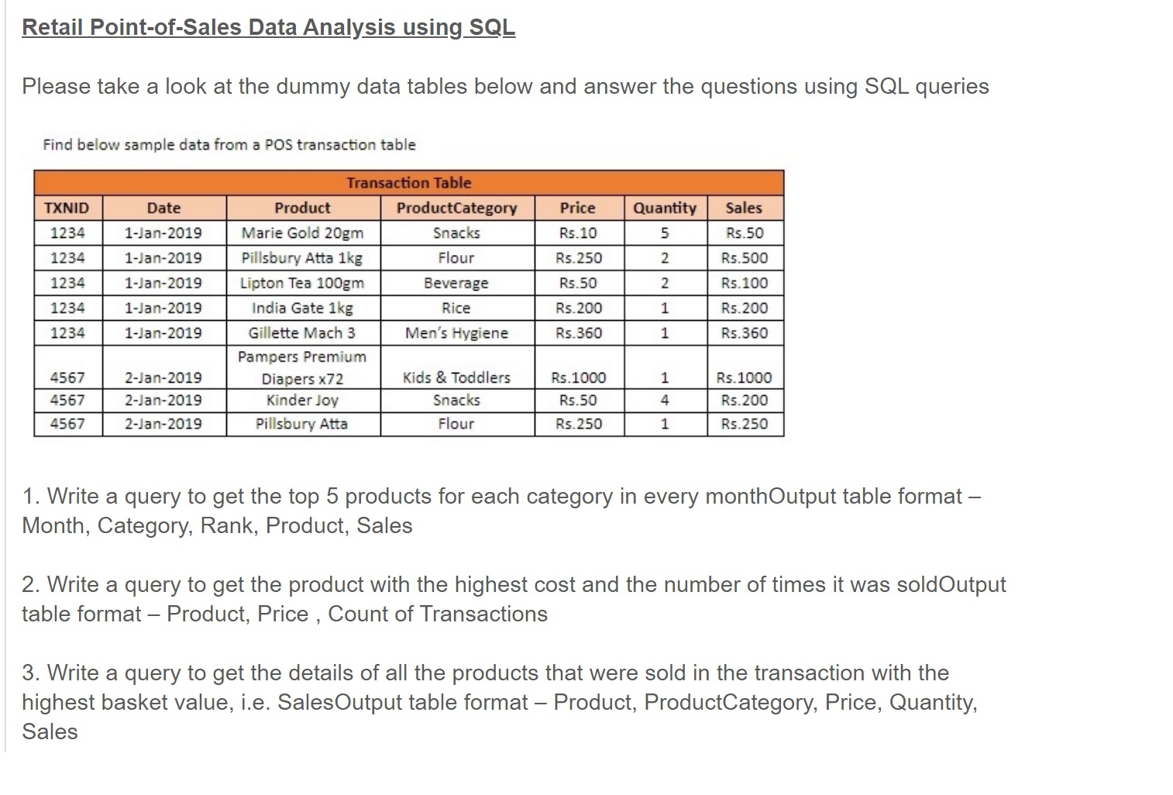

**1.Write SQL to show the count of new customers transacting in the store by date.**

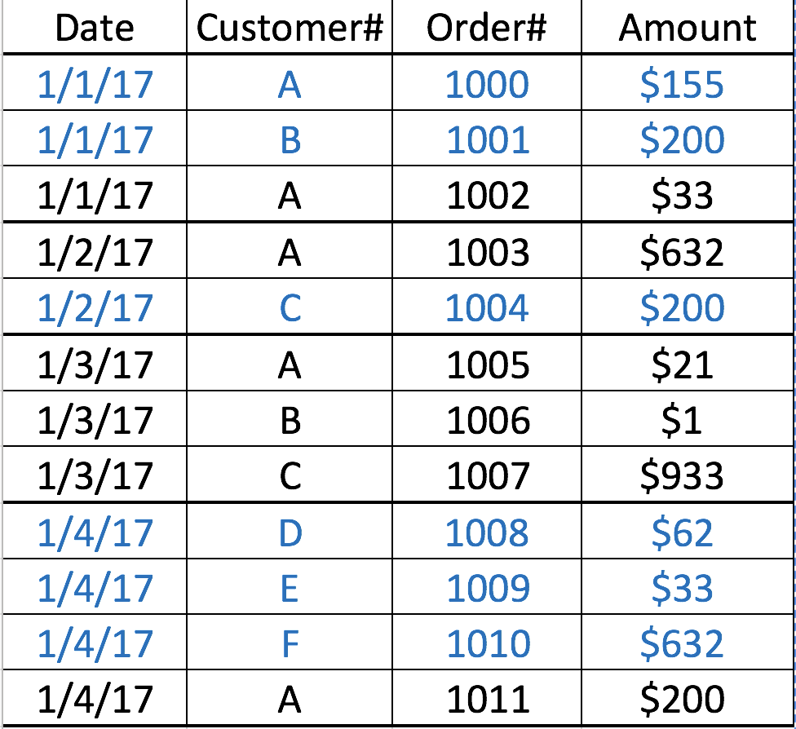

**2. Write SQL to identify the top selling product (Product Name)**

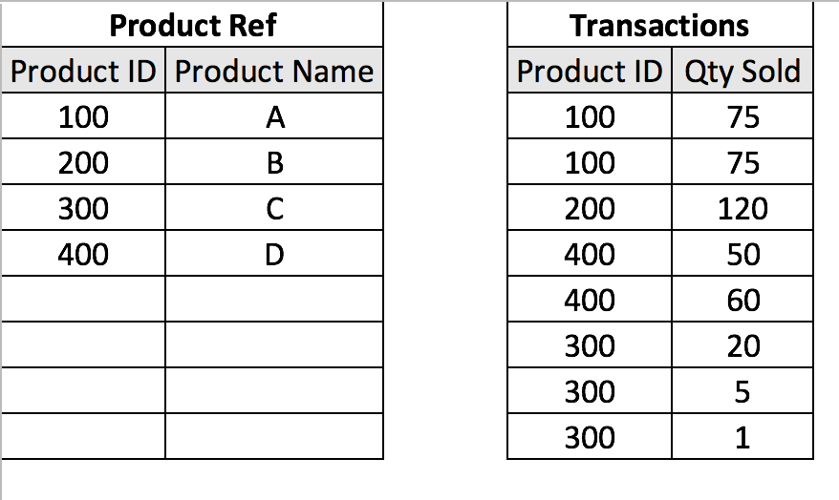

**3.Write SQL to identify the seniority rank of the employees based on Joining date**

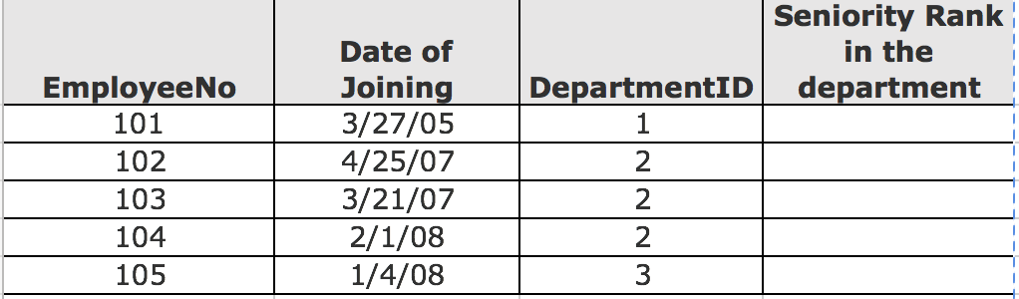

**4.Write a SQL to find all employees that make more than their manager in terms of salary.**

|  |  |  |
| --- | --- | --- |
| Emp-Id | Salary | Manager’s Emp-id |
| **5020** | $10,000 | 1000 |
| **1000** | $14,000 |  |
| 5021 | $8,000 | 5020 |
| **5050** | $11,000 | 5020 |
| **6020** | $12,000 | 1000 |
| 6021 | $8,000 | 6020 |
| 6022 | $8,000 | 6020 |
| 5501 | $8,000 | 5050 |

Re-download Data.

|  |  |  |
| --- | --- | --- |
| Customer# | App_id | Date |
| 1 | 971265422 | **2016-04-16** |
| 1 | 971265422 | **2016-05-15** |
| 1 | 971265422 | **2016-06-05** |
| 1 | 971265422 | **2016-06-05** |
| 1 | 971265422 | **2016-06-19** |

Construct **Attribution Start date and End date at person level**. Where "**Start date" is the date of re-download** and "**End date" is the date of next re-download or 29 days from the current re download date,**whichever is earlier. Ignore duplicate records, if there are multiple re downloads for the same day,

consider only one of them,

|  |  |  |
| --- | --- | --- |
| Customer# | start_dt | emd_dt |
| 1 | **2016-04-16** | **2016-05-14** |
| 1 | **2016-05-15** | **2016-06-04** |
| 1 | **2016-06-05** | **2016-06-18** |
| 1 | **2016-06-19** | **2016-07-17** |

|  |  |  |  |  |
| --- | --- | --- | --- | --- |
| Session-ID | Event ID | Event | Referrer |  |
| 1234 | 1000 | Entry | Facebook |  |
| 1234 | 1001 | Add to Cart |  |  |
| 1234 | 1002 | Add to Cart |  |  |
| 1234 | 1003 | Buy |  |  |
| 30001 | 20001 | Entry |  |  |
| 8799 | 1010 | Entry | Facebook |  |
| 8799 | 10201 | Add to Cart |  |  |
| 6779 | 1293 | Entry | Facebook |  |
| 6779 | 23124 | Add to Cart |  |  |
| 6779 | 6862 | Buy |  |  |
| 8688 | 7980 | Entry | Google |  |
| 8688 |  |  |  |  |

**************** HAPPY LEARNING************************************