MACHINE LEARNING

A hands-on workshop covering Linear Regression, Logistic Regression, Decision Trees, Random Forests and K-Means Clustering — ending in a complete Customer Churn Prediction project.
Duration: 4 hours / 240 minutes — instructor-led, live coding
Project files: customer_churn.csv and customer_churn.xlsx (provided separately)

HOW THIS SESSION RUNS
Every module follows the same rhythm: a real business problem, the intuition behind the algorithm, a picture, the code, and then you run it and argue about what came out. Roughly half of the 240 minutes is you typing, not the instructor talking.

Time allocation
Section | Content | Time
0. Setup | Colab check, dataset download | 5 min
1. ML Fundamentals | Traditional code vs ML, terminology, overfitting, train/test split + Practical 1 | 25 min
2. Supervised Learning | X and y, regression vs classification | 10 min
3. Linear Regression | Theory + first principles | 20 min
Practical 2 | Advertising spend → sales | 15 min
4. Logistic Regression | Sigmoid, probability, threshold, metrics | 20 min
Practical 3 | Churn classification + confusion matrix | 15 min
5. Decision Tree | Splits, purity, depth, overfitting | 15 min
Practical 4 | Train, visualise, tune depth | 15 min
6. Random Forest | Ensembles, bagging, feature importance | 15 min
Practical 5 | Forest vs single tree | 10 min
7. Unsupervised + K-Means | Clustering from first principles, elbow, scaling | 20 min
Practical 6 | Customer segmentation | 15 min
8. Model comparison | Choosing an algorithm + mental model recap | 10 min
9. End-to-End Project | Customer churn: EDA → pipeline → 3 models → business decision | 30 min
10. Wrap-up | Q&A, what to learn next | 5 min
TOTAL |  | 240 min

Getting started with Google Colab
- Go to colab.research.google.com and sign in with any Google account.
- Click File → New notebook.
- Click + Code to add a cell, paste a block from this workbook, press Shift + Enter.
- When a module needs the dataset, run the upload cell and pick customer_churn.csv from your computer.
Run this first — it confirms your environment is ready:
import numpy as np
import pandas as pd
import matplotlib.pyplot as plt
import seaborn as sns
import sklearn

print("numpy :", np.__version__)
print("pandas :", pd.__version__)
print("scikit-learn:", sklearn.__version__)
print("Environment is ready.")
KEY IDEA
Every code block in this workbook is self-contained: it imports what it needs and creates or loads its own data. Wherever randomness is involved we set random_state=42 or np.random.seed(42), so your numbers will match the ones quoted here.
Only two blocks need the provided file — the churn practicals and the final project. Everything else generates its own data inside the cell.
To load the project dataset in Colab:
from google.colab import files
uploaded = files.upload() # choose customer_churn.csv

import pandas as pd
df = pd.read_csv("customer_churn.csv")
print(df.shape)
df.head()

MODULE 1 — MACHINE LEARNING FUNDAMENTALS
25 minutes. Before any algorithm, we need one idea: what exactly is being learned, and by what.

1.1 Start with programming
A program is a set of instructions that turns input into output. You, the human, supply the instructions. The computer supplies the speed. This is rule-based programming, and it is spectacular when the rules are knowable.
Write a rule to detect a leap year:
def is_leap(year):
return year % 4 == 0 and (year % 100 != 0 or year % 400 == 0)
Three conditions and you are done, forever, with 100% accuracy. Nobody needs machine learning for leap years.

1.2 Where rule-based programming breaks
Now write the rules for this: “Will this customer cancel their subscription next month?”
Try it honestly. You might start with: if tenure is under 6 months, they will churn. But some new customers are delighted. So: if tenure < 6 months AND satisfaction < 5. But a customer with a two-year contract cannot leave easily. So add contract type. And price sensitivity. And how many support tickets they raised. And how those interact — a high price is fine if usage is high, but not if usage is low.
COMMON MISTAKE
The rules multiply faster than you can maintain them, the thresholds are guesses, and every combination interacts with every other one. Worse: the correct thresholds change every quarter as the market moves. A human simply cannot hand-tune a hundred interacting conditions from intuition.

1.3 So what is Machine Learning?
KEY IDEA
Machine learning is the practice of learning the rules from examples instead of writing them by hand. You show the algorithm thousands of past customers along with what actually happened to each one, and it works out which combinations of features predicted the outcome.
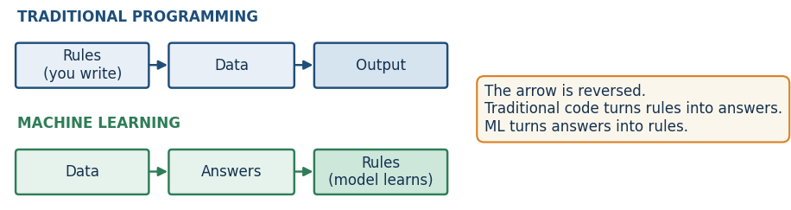
Figure 1.1 — The single most important diagram in this workbook. The arrow runs the other way.
This is the whole trick. Traditional programming consumes rules and produces answers. Machine learning consumes answers and produces rules. Those learned rules are what we call a model.

1.4 The vocabulary — one worked example
The problem: predict the price of a house from its area, number of bedrooms, age and location.
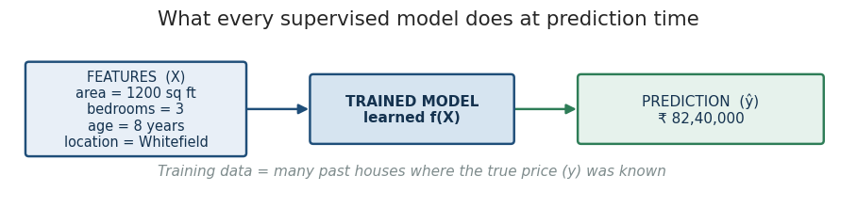
Figure 1.2 — Features go in, a prediction comes out. The model is whatever sits in the middle.
Term |  | What it means | In the house example
Feature (X) |  | An input the model is allowed to use | area, bedrooms, age, location
Target / label (y) |  | The answer we want to predict | price
Training data |  | Past rows where the answer is already known | 5,000 sold houses with their actual prices
Model |  | The learned relationship between X and y | price ≈ 2,860 × area + 154,000 × bedrooms − 39,000 × age
Training / fitting |  | The process of adjusting the model to reduce error | what .fit() does
Prediction / inference |  | Using the trained model on a new, unseen row | a house listed this morning
Parameters |  | Numbers the model learns by itself | the coefficients above
Hyperparameters |  | Settings you choose before training | tree depth, number of trees, K
Generalisation |  | Performing well on data never seen in training | the only thing that actually matters
INDUSTRY INSIGHT
The parameters vs hyperparameters distinction trips up almost everyone on day one. Simple test: if the number is discovered by .fit(), it is a parameter. If you typed it inside the brackets before calling .fit(), it is a hyperparameter.

1.5 The central problem: overfitting
A model that memorises the training data is not intelligent, it is a lookup table. It will score 100% on rows it has already seen and fall apart on a genuinely new customer. The opposite failure is a model too simple to notice the pattern at all.
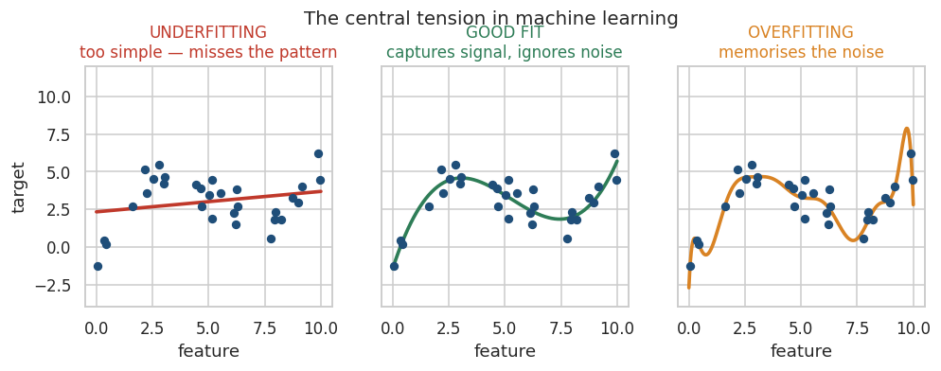
Figure 1.3 — Underfitting, a good fit, and overfitting on the same 30 points.
 | Underfitting | Overfitting
Symptom | Poor on training AND test data | Excellent on training, poor on test
Cause | Model too simple for the pattern | Model complex enough to memorise noise
Typical fix | More features, a more flexible model | Simplify, limit depth, more data, regularise

1.6 Train/test split — the honesty mechanism
Since a model can memorise, we must hide part of the data from it and grade it on that hidden part. There is no other way to know whether learning actually happened.
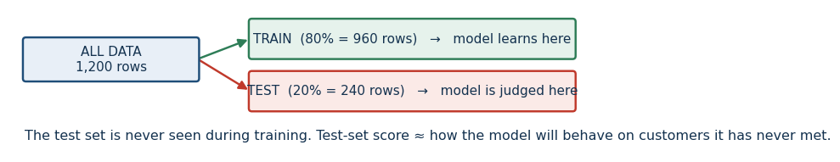
Figure 1.4 — Split first. Judge on data the model has never touched.
COMMON MISTAKE
Evaluating on the training data. If someone reports 99% accuracy and cannot tell you the size of their test set, the number means nothing.

HANDS-ON EXERCISE 1 — Your first ML workflow

Objective
Run a complete supervised learning workflow end to end so that the vocabulary becomes concrete.

Business scenario
A property portal wants an instant price estimate on the listing page, so sellers get a number before a human valuer visits.

Dataset
Generated inside the cell — 200 houses with area, bedrooms, age and price.

Tasks
- Create the dataset with the starter code below.
- Inspect it: .shape, .head(), .describe().
- Separate features X from target y.
- Split into train and test with test_size=0.2, random_state=42.
- Train a LinearRegression model.
- Score the model on the training set and on the test set.
- Print the learned coefficients and read them out loud in plain English.
- Predict the price of a 1,500 sq ft, 3-bedroom, 5-year-old house.
# Starter code — build the dataset
import numpy as np, pandas as pd

np.random.seed(42)
n = 200
houses = pd.DataFrame({
"area": np.random.randint(600, 3000, n),
"bedrooms": np.random.randint(1, 5, n),
"age_years": np.random.randint(0, 30, n),
})
houses["price"] = (2800 * houses["area"] + 150000 * houses["bedrooms"]
- 40000 * houses["age_years"] + np.random.normal(0, 300000, n)).round(0)
houses.head()
THINK BEFORE YOU RUN
- Which of the three features do you expect to matter most? Rank them before you look.
- Should the coefficient on age_years come out positive or negative?
- Will the training score be higher or lower than the test score? Why?
OBSERVE
- The gap between train R² and test R² — small gap means the model generalises.
- The size of each coefficient, and its sign.
- The MAE in rupees. Would a seller accept an estimate that is wrong by that much?
CHECKPOINT
Expected learning: you can name every object in the workflow — X, y, train, test, fit, predict, score — and you understand that the test score is the only one worth quoting.
DISCUSS
Mini quiz 1 (answers at the end of the workbook):
- Q1. Is “predict tomorrow’s electricity demand in MW” regression or classification?
- Q2. A model scores 0.99 on training data and 0.61 on test data. Name the problem and one fix.
- Q3. max_depth=5 — parameter or hyperparameter?

MODULE 2 — SUPERVISED LEARNING
10 minutes. Four of the five algorithms in this session are supervised. Here is what the word means.

2.1 What “supervised” actually refers to
The supervision is the answer column. For every training row somebody already knows the truth — this house sold for ₹82 lakh, this customer did leave, this transaction was fraud. The model makes a guess, is told the correct answer, measures how wrong it was, and adjusts. Repeat a few thousand times and it has learned a mapping from X to y.
KEY IDEA
Supervised learning needs labelled history. No labels, no supervised learning — which is precisely why Module 8 exists.

2.2 The only fork that matters: is y a number or a category?
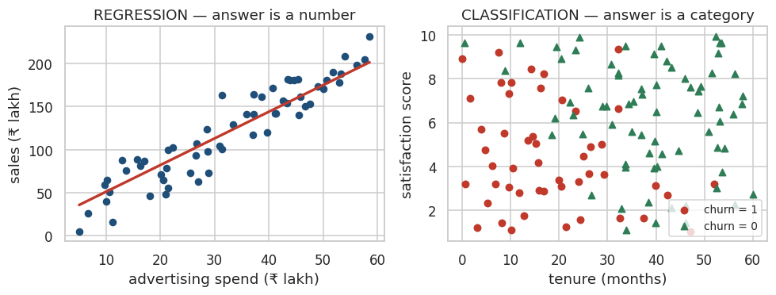
Figure 2.1 — Same idea, two different answer shapes.
 |  | Regression | Classification
Target y |  | A continuous number | One of a fixed set of categories
Question |  | “How much / how many?” | “Which one / will it?”
Output |  | 82.4 | Churn, or P(churn) = 0.82
Business examples |  | House price, sales forecast, delivery time, demand, lifetime value | Churn, fraud, spam, loan default, disease risk, lead conversion
Typical metrics |  | MAE, RMSE, R² | Accuracy, precision, recall, F1, ROC-AUC
Algorithms today |  | Linear Regression | Logistic Regression, Decision Tree, Random Forest
COMMON MISTAKE
A number stored in the column does not make it a regression problem. churn = 1 is a category wearing a numeric costume. Ask what the number means: if 1 and 0 are just names for two groups, it is classification.
INDUSTRY CHALLENGE
Thirty seconds each. Regression or classification?
- a) How many units of SKU-4471 will the Bengaluru warehouse ship next week?
- b) Will this credit-card transaction be disputed?
- c) What star rating (1–5) will this customer leave? (careful — there are two defensible answers)
- d) How many days until this machine part fails?

MODULE 3 — LINEAR REGRESSION
The simplest useful model in existence, and still the one most heavily used in business forecasting.

3.1 The business problem
“We spent ₹40 lakh on advertising last month and made ₹1.6 crore in sales. If we spend ₹60 lakh next month, what should we expect?”
The finance team needs a number, not a shrug. They also need to know how confident that number is, and what happens if they cut spend instead.

3.2 Why a simple rule fails
You could take an average ratio — sales are 4× spend — but that ignores the sales you would make with zero advertising, it ignores the other spend channels, and it treats one lucky month as truth. We want the relationship that fits all the historical months at once, with the smallest total error.

3.3 First principles — what is the model actually learning?
Plot every past month as a dot: spend on the x-axis, sales on the y-axis. The dots trend upward. Now draw a straight line through them. Infinitely many lines are possible. Training means choosing one.
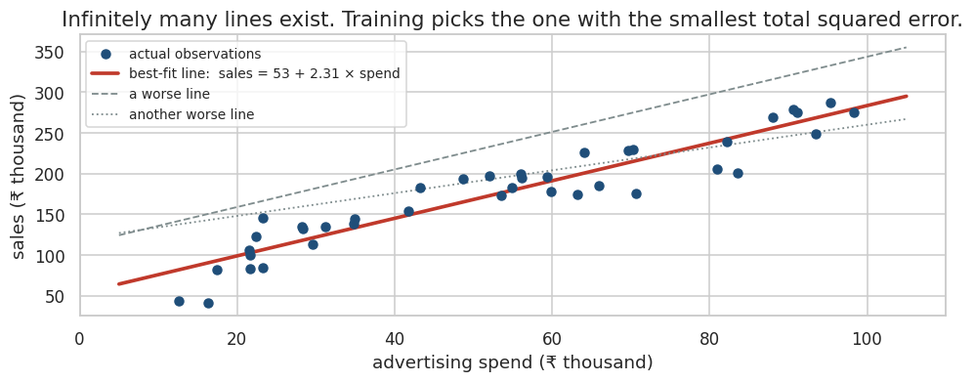
Figure 3.1 — Three candidate lines. Only one minimises total squared error.
KEY IDEA
The model is the line, and the line is fully described by two numbers: where it starts and how steeply it rises.
Prediction = Intercept + Slope × Feature

3.4 The formula, decoded
y = m x + b # school notation
y = b0 + b1 x1 # the same thing, ML notation
Symbol |  | Name | Meaning in the advertising example
y |  | Target / prediction | Predicted sales
x |  | Feature | Advertising spend
m or b₁ |  | Slope / coefficient | Extra sales for each additional ₹1 of spend
b or b₀ |  | Intercept | Sales you would still make at zero spend (baseline demand)
Real businesses have more than one lever, so we extend it:
y = b0 + b1*x1 + b2*x2 + b3*x3 + ... + bn*xn

# e.g. sales = 27.2 + 2.24*tv_spend + 3.07*digital_spend
Each coefficient now reads: the effect of this feature on sales, holding the other features constant. That phrase — holding the others constant — is what makes multiple regression far more useful than a pile of separate averages.

3.5 What “best fit” means: residuals and MSE
For each historical month, the line predicts something and reality was something else. The vertical gap is the residual.
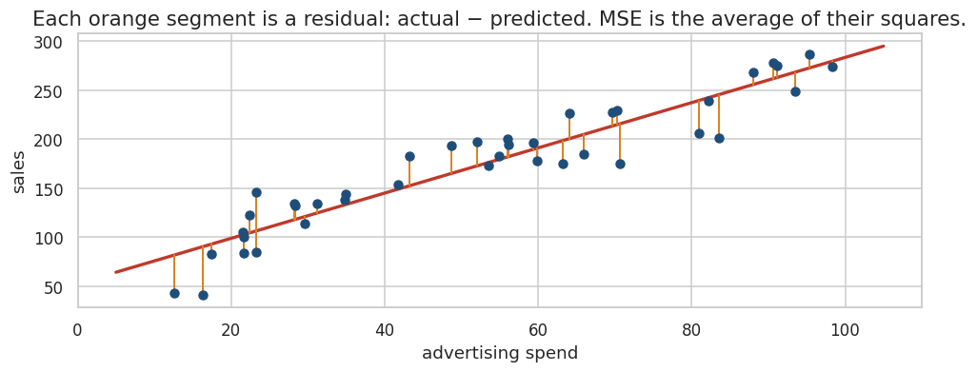
Figure 3.2 — Residual = actual − predicted. Training minimises the average of the squares of these.
residual = actual - predicted
MSE = average of (residual squared) # the cost / loss
RMSE = square root of MSE # back in original units
DISCUSS
Why square the residuals instead of just adding them up?
- Squaring stops +50 and −50 cancelling out to zero error.
- Squaring punishes one catastrophic miss far more than several small ones — usually what a business wants.

3.6 How training finds the minimum — gradient descent, intuitively
Picture the total error plotted against every possible slope. It forms a valley. Training starts at a random point on the hillside, measures which way is downhill, takes a small step, and repeats until steps stop helping. That is gradient descent, and it is how virtually all of modern ML is trained — including neural networks.
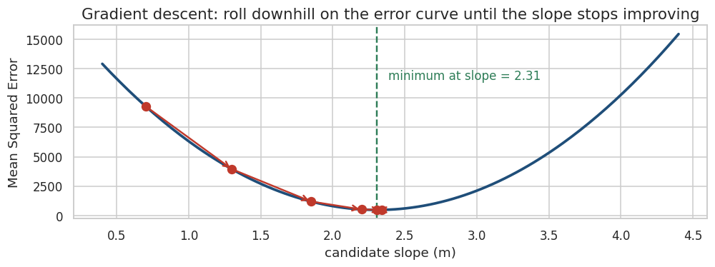
Figure 3.3 — Rolling downhill on the error curve. The green line is where training stops.
INDUSTRY INSIGHT
For plain linear regression, scikit-learn does not actually need gradient descent — there is an exact algebraic solution. We teach the descent picture anyway because it is the mental model for every model that cannot be solved exactly, which is most of them.

3.7 Reading the results
Metric | Reads as | Good when
MAE | Average absolute error, in original units — “we are typically off by ₹21.7 lakh” | You want a number the CFO understands immediately
MSE | Average squared error — no natural unit | Used internally as the training objective
RMSE | Square root of MSE, back in original units, penalises big misses more | Large errors are disproportionately costly
R² | Share of the variation in y the model explains, 0 to 1 | Comparing models on the same target
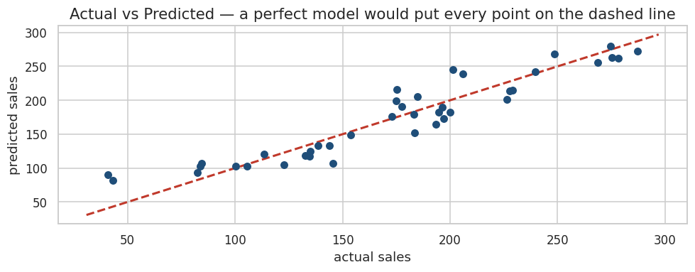
Figure 3.4 — Actual vs predicted. Systematic curvature here means a straight line was the wrong shape.

3.8 Linear Regression in industry
Question |  | Answer
Where is it used? |  | Sales and demand forecasting, price elasticity, marketing mix modelling, real-estate valuation, credit exposure, capacity planning
What does the ML team receive? |  | A tidy table: one row per period or per unit, with the numeric outcome attached
What does the model output? |  | A single number, plus interpretable coefficients
How is the output consumed? |  | Straight into a budget spreadsheet, a planning system or a pricing engine
What goes wrong? |  | Extrapolating far beyond the observed range; reading coefficients as causal; ignoring that two features move together
What happens after prediction? |  | A human plans against it, and the forecast is compared to actuals next month — that comparison is your monitoring
Use it when |  |  | Do NOT use it when
The target is a continuous number |  |  | The target is a category (use Module 4)
The relationship is roughly a straight line |  |  | The relationship curves or has sharp thresholds
You must explain the model to a business audience |  |  | Raw accuracy matters far more than explainability
You have few rows and need a stable baseline |  |  | There are strong interactions between features you cannot hand-code
COMMON MISTAKE
- Reading a coefficient as causation. “Spend drives sales” may be true, but the model only saw that they moved together.
- Extrapolating wildly. A model trained on spend between ₹5L and ₹100L knows nothing about ₹500L.
- Leaving obvious outliers in. Squared error means one absurd row can bend the entire line.

HANDS-ON EXERCISE 2 — Advertising spend → sales

Objective
Fit, evaluate and interpret a multiple linear regression, and translate the coefficients into a sentence a marketing head would act on.

Business scenario
You work in the analytics team of a consumer brand. The CMO splits budget between TV and digital and wants to know which rupee works harder.

Dataset
120 past campaigns, generated inside the cell: tv_spend, digital_spend, sales (all in ₹ lakh).

Tasks
- Create the dataset with the starter code.
- Inspect it — shape, head, describe.
- Visualise each feature against sales with a scatter plot.
- Split into train and test (test_size=0.2, random_state=42).
- Train LinearRegression on the training set.
- Predict on the test set.
- Calculate MAE.
- Calculate MSE.
- Calculate RMSE.
- Calculate R².
- Plot actual vs predicted with a 45-degree reference line.
- Print the intercept and both coefficients.
- Write one sentence for the CMO: which channel returns more per rupee, and what would you recommend?
# Starter code
import numpy as np, pandas as pd

np.random.seed(42)
n = 120
ads = pd.DataFrame({
"tv_spend": np.random.uniform(5, 100, n).round(1),
"digital_spend": np.random.uniform(2, 60, n).round(1),
})
ads["sales"] = (25 + 2.1*ads["tv_spend"] + 3.4*ads["digital_spend"]
+ np.random.normal(0, 30, n)).round(1)
ads.head()
THINK BEFORE YOU RUN
- Which coefficient will be larger — tv_spend or digital_spend?
- The intercept will come out around 27. What does a non-zero intercept mean for this business?
- Predict the R² before you run it. Above 0.9? Between 0.8 and 0.9? Below?
OBSERVE
- How close RMSE is to MAE. A big gap means a few large misses are dominating.
- Whether the actual-vs-predicted points hug the diagonal evenly, or bend away at one end.
INDUSTRY CHALLENGE
Add a deliberately irrelevant feature — ads["ceo_shoe_size"] = np.random.randint(6, 12, n) — retrain, and compare the test R². What happened, and what does that tell you about adding features “just in case”?
CHECKPOINT
Expected learning: you can read a coefficient as a business rate of return, and you know which error metric to quote to which audience.
DISCUSS
Mini quiz 2:
- Q4. RMSE is 28 and MAE is 22 on the same model. What does that gap suggest?
- Q5. Your R² on the training set is 0.88 and on the test set is 0.31. What happened?
- Q6. Would you use linear regression to predict which of three suppliers a customer picks? Why not?

MODULE 4 — LOGISTIC REGRESSION
Despite the name, this is a classification algorithm. It is the workhorse of risk scoring in banking, insurance and telecom.

4.1 The business problem
“A telecom company loses 28% of its customers every year. Acquiring a replacement costs five times what retaining one costs. Which customers are about to leave?”
The retention team can call maybe 200 people this month. They need those 200 names ranked by risk — not a vague sense that churn is bad.

4.2 Why linear regression cannot do this
The target is now churn = 0 or churn = 1. Nothing else exists. Fit a straight line to that and two things break immediately: the line predicts 1.4 for very new customers and −0.3 for very old ones, and neither number means anything. Worse, a single extreme customer drags the whole line and flips predictions for everybody else.
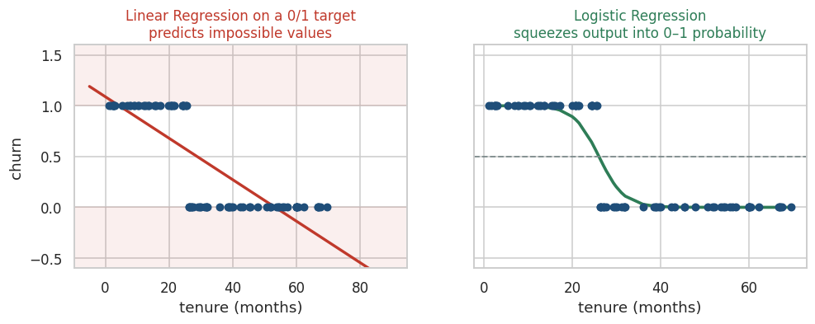
Figure 4.1 — Left: a straight line on a 0/1 target predicts impossible values. Right: the fix.

4.3 First principles — predict probability, not the class
The insight is to stop predicting the label and start predicting the probability of the label. Probability is continuous, which we know how to model, but it is trapped between 0 and 1, which a straight line is not.
So logistic regression does exactly what linear regression does — computes a weighted sum of the features — and then squeezes that unbounded number into the 0-to-1 range using the sigmoid function.
z = b0 + b1*x1 + b2*x2 + ... # identical to linear regression
p = 1 / (1 + e**(-z)) # the sigmoid: squeeze z into (0, 1)
class = 1 if p >= threshold else 0 # threshold is a BUSINESS choice
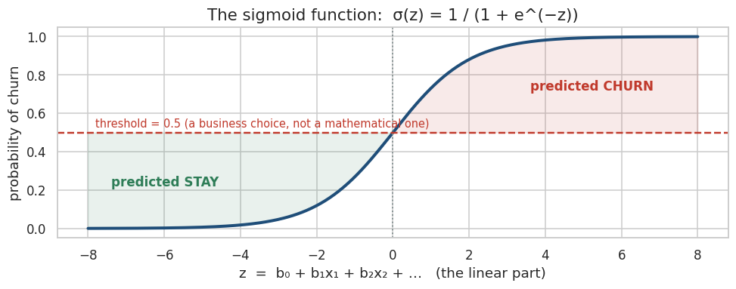
Figure 4.2 — The sigmoid. Note it never reaches 0 or 1, and it is steepest near the boundary.
KEY IDEA
Logistic regression is a linear model with a squashing function bolted on the end. The decision boundary it draws is still a straight line (or a flat plane) — the sigmoid changes the output, not the shape of the boundary.

4.4 The threshold is yours, not the algorithm's
scikit-learn defaults to 0.5, and almost every real project changes it. If a churner is worth ₹18,000 and a retention call costs ₹200, you should be willing to call a lot of people who were never going to leave. Lowering the threshold to 0.35 flags more customers: you catch more real churners and waste more calls.
Threshold | What happens | Choose it when
Lower (e.g. 0.30) | More customers flagged → higher recall, lower precision | Missing a churner is far more expensive than a wasted contact
Default 0.50 | Balanced, and rarely optimal for anything | You have no cost information yet
Higher (e.g. 0.70) | Fewer, more confident flags → higher precision, lower recall | Each intervention is expensive or intrusive (e.g. a fraud account freeze)

4.5 Reading the coefficients
Each coefficient shifts z, and therefore shifts the probability. A negative coefficient on tenure_months means: the longer someone has been a customer, the lower their churn probability, holding everything else constant. A positive coefficient on support_tickets means the opposite. This readability is exactly why regulated industries still prefer logistic regression — you can defend every input to an auditor.

4.6 Evaluation — why accuracy lies
Suppose 28% of customers churn. A model that predicts “nobody churns” for every single customer is 72% accurate and utterly worthless. Accuracy alone cannot distinguish it from a good model, so we open up the confusion matrix.
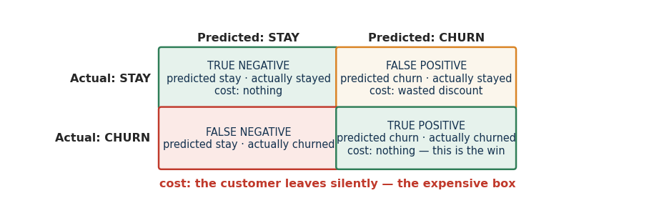
Figure 4.3 — The four outcomes, with what each one costs the business.
Metric | Formula | The question it answers
Accuracy | (TP + TN) / all | Overall, how often are we right? — misleading when classes are imbalanced
Precision | TP / (TP + FP) | Of the customers we flagged, how many really churned? — measures wasted effort
Recall | TP / (TP + FN) | Of all customers who really churned, how many did we catch? — measures missed revenue
F1-score | harmonic mean of the two | One number when you need to balance both
ROC-AUC | area under the ROC curve | How well does the model RANK risk, across every possible threshold?
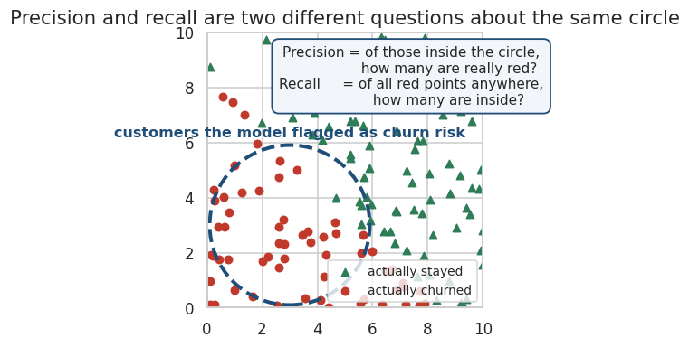
Figure 4.4 — Precision looks inside the circle. Recall looks at all the red points.
INDUSTRY INSIGHT
ROC-AUC is the metric a retention team actually cares about, even if they never say the word. They are not going to call everybody — they are going to call the top 200. All that matters is whether the riskiest customers sit at the top of the ranked list, and that is exactly what AUC measures.
DISCUSS
“If missing a churner is more expensive than contacting a non-churner, should we optimise precision or recall?”
Work it through with numbers before answering: a lost customer costs ₹18,000 of lifetime value; a retention call costs ₹200 plus a ₹500 discount if accepted. How many false positives is one avoided false negative worth?

4.7 Logistic Regression in industry
Question | Answer
Where is it used? | Churn, credit default and scorecards, fraud triage, lead conversion, insurance claim likelihood, clinical risk
What does the ML team receive? | One row per customer with behavioural and billing features, and a historic 0/1 outcome
What does the model output? | A probability between 0 and 1 for every customer, plus signed coefficients
How is the output consumed? | Pushed nightly into the CRM as a risk score; the retention team works the ranked list
What goes wrong? | Class imbalance ignored; threshold left at 0.5; a feature leaks the future (e.g. cancellation_date)
What happens after prediction? | A campaign runs, and its lift is measured against a holdout group that was deliberately not contacted
Use it when |  | Do NOT use it when
You need calibrated probabilities, not just labels |  | The boundary between classes is strongly curved
You must explain every driver to a regulator |  | Features interact in complex ways you cannot hand-code
You want a fast, stable, low-variance baseline |  | You have huge numbers of raw unstructured features

HANDS-ON EXERCISE 3 — Predicting churn

Objective
Train a probability model, build a confusion matrix by hand-reading it, and connect each cell to a rupee amount.

Business scenario
You are handed the telecom customer table and asked for a risk score the retention team can work through on Monday morning.

Dataset
customer_churn.csv — upload it to Colab first. For this exercise use only the numeric columns: tenure_months, monthly_charges, support_tickets, satisfaction_score, usage_hours.

Tasks
- Load the CSV and inspect it — shape, info, head.
- Identify the target column and check how balanced it is with value_counts(normalize=True).
- Select the five numeric features listed above and drop rows with missing values (we will handle imputation properly in the final project).
- Split into train and test, using stratify=y so both sets keep the same churn rate.
- Scale the features with StandardScaler — fit on train only.
- Train LogisticRegression(max_iter=1000, random_state=42).
- Predict classes on the test set.
- Predict probabilities with predict_proba and look at the first ten.
- Build the confusion matrix and plot it as a heatmap.
- Calculate accuracy, precision, recall and F1.
- Print the coefficients and sort them — which feature pushes churn up the hardest?
- Re-predict using a threshold of 0.35 instead of 0.5 and recompute precision and recall.
- State the business impact: at 0.35, how many extra churners do you catch, and how many extra pointless calls do you make?
THINK BEFORE YOU RUN
- Before running: which of the five features will have the strongest negative coefficient?
- If 28% of customers churn, what accuracy would a do-nothing model get? Write the number down.
- Will lowering the threshold to 0.35 raise precision or recall? Commit to an answer.
OBSERVE
- The bottom-left cell of the confusion matrix — those are customers you will lose silently.
- Whether recall is noticeably lower than precision. Why would that be, given the class imbalance?
- How much recall improves when the threshold drops, and what it costs in precision.
CHECKPOINT
Expected learning: you can look at four numbers in a confusion matrix and immediately say what each costs the business, and you understand that the threshold is a business dial, not a mathematical constant.
DISCUSS
Mini quiz 3:
- Q7. A fraud model has 99.4% accuracy on data where 0.6% of transactions are fraud. Is it good? What must you see next?
- Q8. Which cell of the confusion matrix is a false negative in churn terms, and what does it cost?
- Q9. A feature called days_since_cancellation_request boosts AUC to 0.99. What have you done?

MODULE 5 — DECISION TREE
The only algorithm here whose reasoning a non-technical manager can read line by line.

5.1 The business problem
“Can we make predictions using a sequence of business questions — the way a credit officer actually thinks?”
A loan officer does not compute a weighted sum. They ask: is income above a threshold? Then: does the applicant have existing defaults? Then: is the loan-to-value ratio acceptable? Each answer narrows the decision. A decision tree learns that exact structure from data — including which questions to ask, in which order, and at which cut-off.

5.2 What makes a good question?
Suppose you have 1,000 customers, 280 of whom churned. That group is mixed, so a coin flip is your only option. Now split them by contract type. Month-to-month customers turn out to be 44% churners; two-year contract customers are 8%. Both groups are purer than the group you started with, so the question was worth asking.
KEY IDEA
A split is good if it makes the resulting groups purer — closer to being all-churn or all-stay. The algorithm tries every feature at every possible cut-off, scores each split by how much impurity it removes, and picks the winner. Then it does the same thing again inside each new group.
Term |  | Plain-English meaning
Root node |  | The very first question, asked of every customer
Internal node |  | Any further question, asked only of the customers who reached it
Branch |  | The Yes / No path leaving a question
Leaf |  | A dead end — no more questions, this is the prediction
Split |  | One question plus its threshold, e.g. tenure_months ≤ 18.5
Depth |  | How many questions deep the tree is allowed to go
Gini / Entropy |  | Two ways of scoring impurity. 0 = perfectly pure group; higher = more mixed
Information gain |  | How much impurity a split removed. The algorithm greedily picks the biggest gain

5.3 A real tree, trained on our churn data
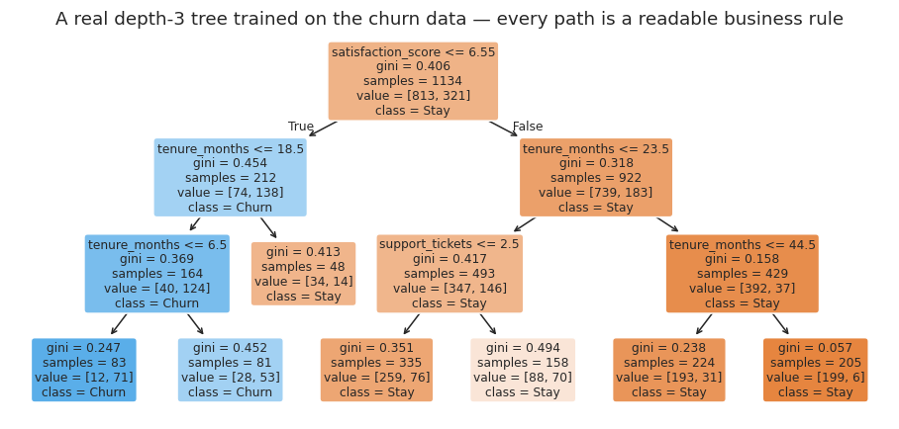
Figure 5.1 — A depth-3 tree. Read any top-to-bottom path and you have a business rule in English.
How to read it: the top box asks whether satisfaction_score is at or below 6.55. Customers who fail that test go right into the low-risk side of the tree. samples is how many training rows reached that node, value is how they split between stay and churn, and gini is how mixed the node still is. A leaf with gini near 0 is a group the tree is confident about.

5.4 Depth is the overfitting dial
Left unconstrained, a tree keeps asking questions until every leaf contains a single customer. It will then classify the training data perfectly and fail on anyone new — it has memorised individuals rather than learning patterns.
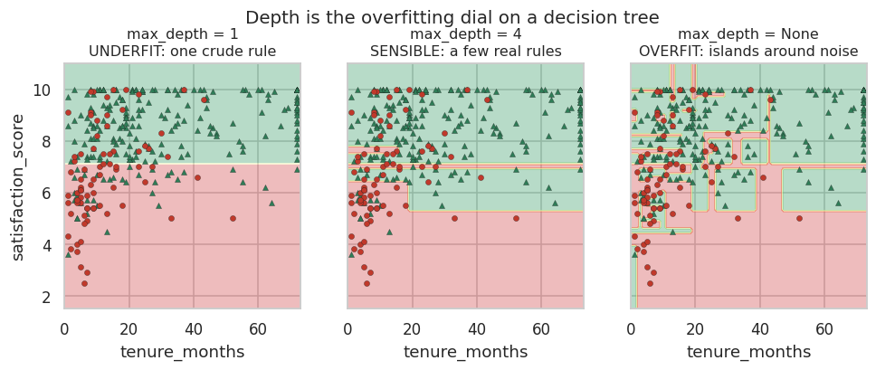
Figure 5.2 — Same data, three depths. The right-hand panel is carving out islands around individual noisy customers.
OBSERVE
In our own data, a fully grown tree hits 100% accuracy on training rows and drops to roughly 70% on the test set — while a depth-5 tree scores about 79% on both. That gap is overfitting, made visible in two numbers.
The hyperparameters that control it:
DecisionTreeClassifier(
max_depth=5, # hard ceiling on the number of questions
min_samples_leaf=20, # a leaf must represent at least 20 real customers
min_samples_split=50, # do not split a node holding fewer than 50 rows
random_state=42 # reproducibility
)

5.5 Decision Trees in industry
Question | Answer
Where is it used? | Loan and insurance eligibility, risk tiering, triage and routing rules, churn segmentation, clinical decision support
What does the ML team receive? | Mixed tabular data — numbers and categories together, missing values, no scaling needed
What does the model output? | A class or probability, plus a readable rule path for every single prediction
How is the output consumed? | Often the tree itself is the deliverable — extracted as if/else rules and hard-coded into an operational system
What goes wrong? | Left unpruned it overfits badly; change a few training rows and the whole tree can restructure
What happens after prediction? | Rules get reviewed by a domain expert, who will often override or simplify one
Strengths |  | Limitations
Fully explainable — you can print the rules |  | Overfits enthusiastically unless constrained
Captures non-linear relationships and interactions automatically |  | Unstable: small data changes can produce a very different tree
No scaling required; handles mixed feature types |  | A single tree usually generalises worse than an ensemble
Fast to train and to score |  | Biased toward features with many distinct values

HANDS-ON EXERCISE 4 — Trees and the depth dial

Objective
Train a decision tree, see overfitting happen in real numbers, and extract a business rule from the diagram.

Business scenario
The retention team does not trust black boxes. They want the model's logic written on a whiteboard before they will run the campaign.

Dataset
customer_churn.csv — the same five numeric features as Exercise 3, so the results are directly comparable.

Tasks
- Load the data and rebuild the same train/test split as Exercise 3 (random_state=42, stratify=y).
- Train DecisionTreeClassifier(random_state=42) with no depth limit.
- Print the accuracy on the training set AND on the test set. Note the gap.
- Retrain with max_depth = 2, 3, 5 and 10, printing both scores each time.
- Identify the depth where the test score stops improving — that is your sweet spot.
- Visualise the best tree with plot_tree, using feature_names and class_names.
- Evaluate the tuned tree with precision, recall and F1.
- Compare against the Logistic Regression results from Exercise 3.
- Read the root node aloud: what single question does the tree consider most informative?
- Write down two if/else business rules from the diagram that you could hand to the retention team today.
THINK BEFORE YOU RUN
- Which feature do you expect at the root — the one that separates churners best on its own?
- What will the training accuracy of an unlimited-depth tree be? Say the number before you run it.
- Will the tree beat Logistic Regression on this data? Take a position now and defend it later.
OBSERVE
- The train/test gap at each depth — this is the clearest picture of overfitting you will get all day.
- gini and samples at each leaf. A leaf holding 4 customers is not a rule, it is a coincidence.
INDUSTRY CHALLENGE
Change random_state to 7 and retrain the unconstrained tree. How much does the structure change? Now argue: would you deploy a model whose logic reshuffles when you reshuffle the rows?
CHECKPOINT
Expected learning: you can tune depth deliberately rather than by superstition, and you can convert a fitted tree into rules a business team can execute manually.

MODULE 6 — RANDOM FOREST
The default first choice for tabular business data almost everywhere in industry.

6.1 The business problem
“Our decision tree looks convincing, but it changes shape every time we refresh the data. Can we get its flexibility without its instability?”

6.2 The panel of doctors
You have an unusual set of symptoms. One doctor gives you a diagnosis. Are you satisfied? Most people ask for a second opinion — not because the first doctor is incompetent, but because any single expert has personal blind spots and idiosyncratic experience. A panel of ten doctors who trained at different hospitals will, on average, be right more often than any one of them, because their individual mistakes are different and tend to cancel out.
KEY IDEA
That is ensemble learning: combine many weak-ish, deliberately different models and aggregate their votes. The errors have to be uncorrelated for it to work — ten doctors who all trained under the same professor add nothing.
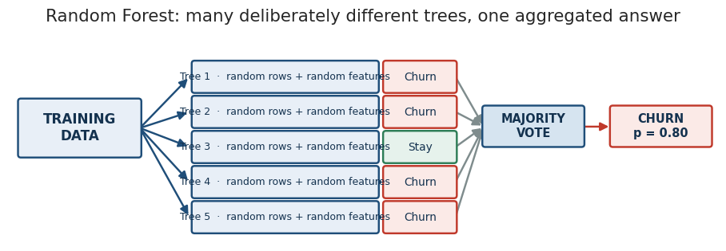
Figure 6.1 — Each tree sees a different slice of the data and a different subset of features.

6.3 Where the randomness comes from
Mechanism | What it does | Why it helps
Bootstrap sampling (bagging) | Each tree trains on a random sample of rows, drawn with replacement, so roughly a third of rows are left out of each tree | No two trees see the same dataset, so they cannot make identical mistakes
Random feature subsets | At every split, each tree may only consider a random handful of features | Stops one dominant feature appearing at the root of all 300 trees
Aggregation | Classification: majority vote. Probability: average across trees | Individual errors cancel; the consensus is far more stable than any member

6.4 Bias, variance, and what the forest actually fixes
 | Bias | Variance
What it is | Error from being too simple to capture the truth | Error from being too sensitive to the particular training rows
Looks like | Underfitting — wrong on everything | Overfitting — perfect on train, erratic on test
Single deep tree | Low bias | High variance — the problem
Random Forest | Still low bias | Much lower variance — the fix
This is the whole reason forests exist. A deep tree is already flexible enough to fit almost anything; its weakness is that it fits the noise too. Averaging hundreds of differently-wrong trees keeps the flexibility and cancels much of the noise.

6.5 Feature importance — useful, and easy to misuse
Because every split records how much impurity it removed, you can add that up across all trees and rank the features. This is often the single output business stakeholders find most interesting.
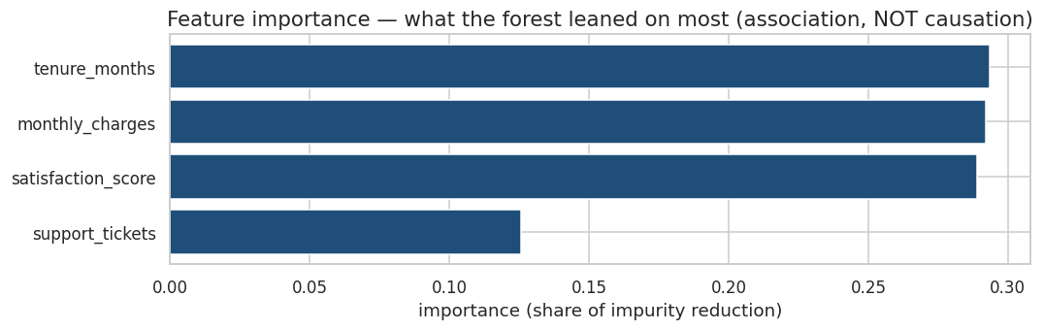
Figure 6.2 — Feature importance from a forest trained on our churn data.
COMMON MISTAKE
Feature importance is association, not causation. “Support tickets are important” does not mean closing the support desk will reduce churn. Unhappy customers raise tickets and leave; the tickets are a symptom sharing a cause with the churn. Importance also spreads itself thinly across correlated features, so a genuinely critical driver can look unimportant simply because a twin feature is sitting next to it.

6.6 How the three classifiers compare
Model |  | Main idea | Decision boundary | Explainability | Typical accuracy on tabular data
Logistic Regression |  | Weighted sum, then squash to a probability | A straight line / flat plane | Excellent — signed coefficients | Strong when the relationship really is roughly linear
Decision Tree |  | A sequence of yes/no rules | Axis-aligned rectangles | Excellent — printable rules | Moderate; overfits without pruning
Random Forest |  | Hundreds of varied trees, aggregated | Many rectangles, averaged into a smooth shape | Moderate — importances, but no single readable path | Usually the strongest of the three out of the box
INDUSTRY INSIGHT
A forest of 300 trees is 300 times slower to score than one tree, and cannot be printed on a whiteboard. In fraud detection, where decisions must be justified to a customer and a regulator, teams routinely ship the worse but explainable model. Accuracy is one input to the deployment decision, not the decision itself.

HANDS-ON EXERCISE 5 — Forest versus single tree

Objective
Quantify what the ensemble buys you, and interrogate the feature importances rather than accepting them.

Business scenario
The head of analytics wants one number to justify the extra complexity of a forest over the tree you already showed them.

Dataset
customer_churn.csv, same split as Exercises 3 and 4 so all three models are directly comparable.

Tasks
- Train RandomForestClassifier(n_estimators=300, max_depth=8, random_state=42).
- Predict on the test set.
- Calculate accuracy, precision, recall and F1.
- Put the tuned Decision Tree, the Random Forest and the Logistic Regression side by side in one comparison DataFrame.
- Extract feature_importances_ and sort them.
- Plot the importances as a horizontal bar chart.
- Name the top two features.
- For each of those two, write one sentence on whether you believe the relationship is causal, and how you would test it.
- Try n_estimators = 10, 50 and 300. At what point do the metrics stop improving?
THINK BEFORE YOU RUN
- How much accuracy do you expect the forest to gain over the single tree — 1 point, 5 points, 20 points?
- Which feature will top the importance ranking? Does it match the tree's root node from Exercise 4?
- Would 1,000 trees beat 300? What is the cost of finding out?
OBSERVE
- On this dataset, the forest does NOT clearly beat the simpler models. Note that carefully — it is the most useful result of the day.
- Whether recall stays stubbornly low across all three models. What does that tell you about the data rather than the algorithms?
INDUSTRY CHALLENGE
Your model says support_tickets is the second most important churn driver. A VP proposes making it harder to raise a ticket, so the count goes down. Explain, in two sentences, why this will not reduce churn — and what it will actually do to your model.
CHECKPOINT
Expected learning: ensembles reduce variance rather than working magic, and feature importance is a starting point for investigation, not a causal claim.
DISCUSS
Mini quiz 4:
- Q10. Why does a Random Forest overfit less than a single unpruned tree?
- Q11. Would you use a Random Forest to explain a loan rejection to a customer? Why or why not?
- Q12. Two features are almost perfectly correlated. What happens to their importance scores?

MODULE 7 — UNSUPERVISED LEARNING
Everything so far assumed somebody already knew the answers. Usually nobody does.

7.1 The situation
“We have 40,000 customers and no idea what kinds of customers we have.”
There is no churn column here, no price to predict, no label of any kind. Marketing wants to run different campaigns for different types of customer — but nobody has ever defined the types. There is nothing to supervise the learning with.
Supervised: X + y -> learn the relationship between them
Unsupervised: X -> discover structure that was already there
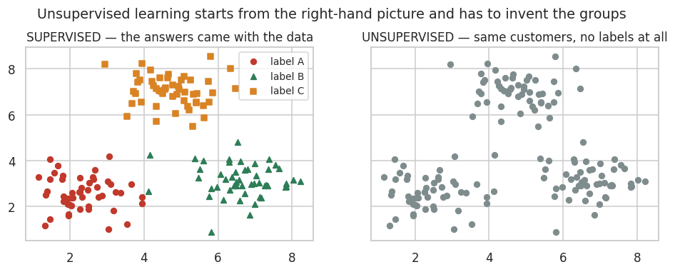
Figure 7.1 — Unsupervised learning starts from the right-hand picture and must invent the groups itself.

7.2 What “discovering structure” means
Without labels, the only thing available is similarity — which rows resemble which other rows. If customers naturally form dense clumps in feature space, those clumps are worth finding, because a clump is a group of people who behave alike and can therefore be sold to alike.
Concept |  | Meaning
No target label |  | There is no correct answer to compare against, so there is no accuracy score
Similarity |  | Usually measured as distance between rows in feature space
Grouping / clustering |  | Putting similar rows together and dissimilar rows apart
Segmentation |  | The business name for clustering applied to customers
Interpretation |  | Unavoidably human — the algorithm returns Cluster 0, 1, 2; you supply the meaning
INDUSTRY INSIGHT
Where it shows up: customer segmentation for campaigns, product and SKU grouping, store clustering for assortment planning, user-behaviour cohorts in apps, document and ticket grouping, and anomaly exploration where anything far from every cluster is worth a look.
COMMON MISTAKE
Expecting an accuracy number. There is no ground truth, so there is nothing to be accurate against. Clustering is judged by whether the groups are stable, distinct, and actionable — and the last one is a business judgement, not a metric.

MODULE 8 — K-MEANS CLUSTERING

8.1 The algorithm in six steps
K-Means is the most widely used clustering algorithm, and its logic is short enough to write on one line: guess where the group centres are, assign everyone to their nearest centre, move each centre to the middle of the people who chose it, and repeat.
1. Choose K, the number of clusters you want
2. Place K centroids at random positions
3. Assign every point to its NEAREST centroid
4. Move each centroid to the mean position of the points assigned to it
5. Repeat steps 3 and 4
6. Stop when the assignments stop changing
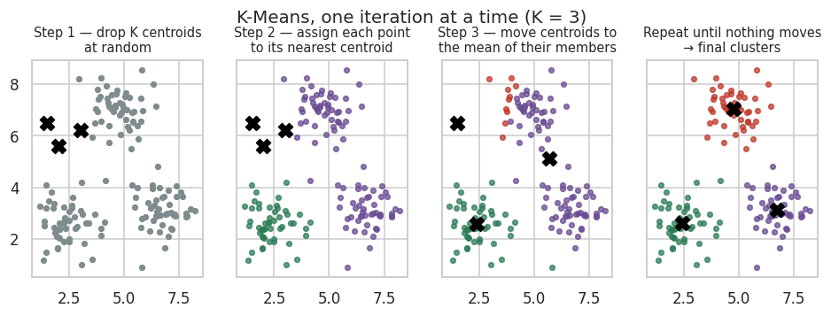
Figure 8.1 — The same 150 customers across four iterations. The black crosses are centroids.
Term | Meaning
Centroid | The mean position of all points currently in a cluster — the cluster's centre of gravity
Distance | How far a point is from a centroid, normally straight-line (Euclidean) distance
K | How many clusters you asked for. You must choose this before running
Inertia | The total squared distance from every point to its own centroid. Lower = tighter clusters
Convergence | The point at which no customer changes cluster any more

8.2 Choosing K — the elbow method
Inertia always falls as you add clusters — with K equal to the number of customers, every customer is their own cluster and inertia is zero. So you cannot simply minimise it. Instead, plot inertia against K and look for the bend where extra clusters stop buying meaningful tightness.
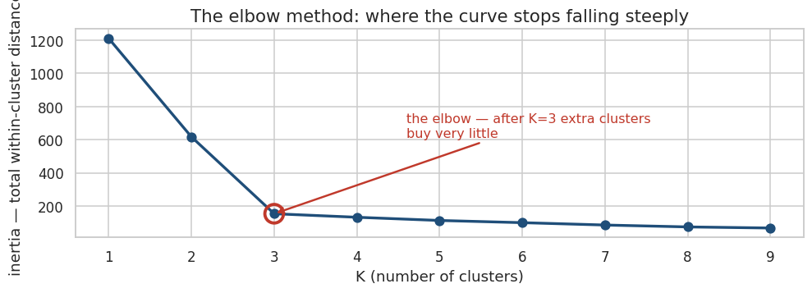
Figure 8.2 — After the elbow, each new cluster costs interpretability and returns very little.
INDUSTRY INSIGHT
The elbow is a suggestion, not an answer. If the elbow says 6 but the marketing team can only run 3 distinct campaigns, build 3 clusters. A statistically ideal segmentation nobody can act on is worth nothing.

8.3 Why scaling is not optional here
K-Means works on raw distance. If annual income runs from ₹1,50,000 to ₹25,00,000 and age runs from 18 to 70, then a one-year age difference contributes about 1 unit of distance while a modest income difference contributes tens of thousands. Age is arithmetically invisible. The algorithm will silently return income bands and call them customer segments.
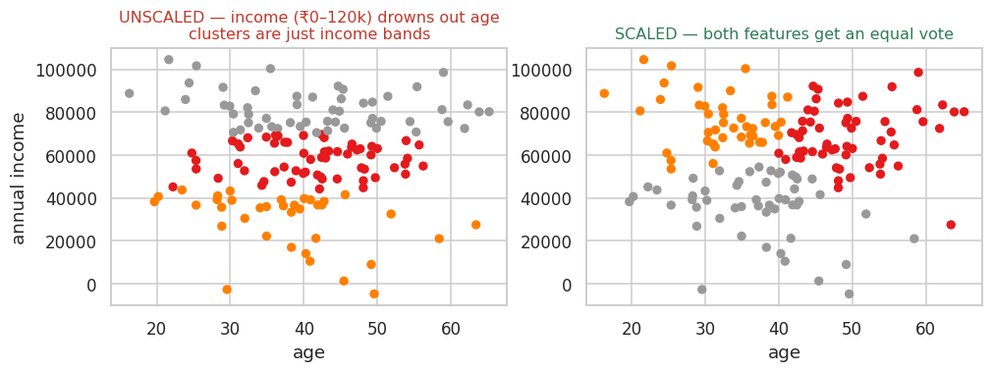
Figure 8.3 — Identical data and identical K. The only difference is StandardScaler.
from sklearn.preprocessing import StandardScaler

X_scaled = StandardScaler().fit_transform(X) # each feature: mean 0, std 1
KEY IDEA
Any algorithm that measures distance — K-Means, KNN, SVM — needs scaled features. Tree-based models (Decision Tree, Random Forest) do not, because they split one feature at a time and never compare units across features.

8.4 Limitations you must state out loud
Limitation | Consequence | What to do about it
You must choose K in advance | The answer depends on a number you guessed | Elbow plot plus silhouette score, then business judgement
Sensitive to feature scaling | The largest-magnitude feature dominates | Always scale first
Sensitive to initial centroid placement | Different runs can give different clusters | n_init=10 runs it repeatedly and keeps the best
Sensitive to outliers | One extreme customer can drag a centroid across the space | Cap or remove extremes before clustering
Assumes roughly round, similar-sized clusters | Long or crescent-shaped groups get split incorrectly | Try DBSCAN or hierarchical clustering instead

HANDS-ON EXERCISE 6 — Customer segmentation

Objective
Run a full segmentation, choose K defensibly, and turn anonymous cluster numbers into segments with names and campaigns attached.

Business scenario
A retail chain wants to stop sending one identical offer to everybody. You have age, annual income and an internal spending score. Marketing can run at most four distinct campaigns.

Dataset
300 customers, generated inside the cell.

Tasks
- Create the dataset with the starter code.
- Explore it — describe(), plus a scatter of income against spending score.
- Select the three clustering features: age, annual_income, spending_score.
- Scale them with StandardScaler.
- Run KMeans for K = 1 to 10, storing inertia each time.
- Plot the elbow curve.
- Choose K and justify it in one sentence.
- Fit the final model and attach the cluster labels back onto the original unscaled DataFrame.
- Visualise the clusters on the income vs spending scatter, coloured by cluster.
- Compute the mean of each feature per cluster with groupby.
- Give every cluster a business name based on those means.
- Propose one specific marketing action per cluster.
# Starter code
import numpy as np, pandas as pd

np.random.seed(42)
n = 300
mall = pd.DataFrame({
"age": np.random.randint(18, 70, n),
"annual_income": np.random.randint(150000, 2500000, n),
})
mall["spending_score"] = np.clip(
100 - mall["annual_income"]/30000 + np.random.normal(0, 18, n), 1, 100).round(0)
mall.head()
THINK BEFORE YOU RUN
- Look at how spending_score is built. What relationship between income and spending have we baked in?
- How many clusters do you expect the elbow to suggest?
- What would happen if you skipped the scaling step? Predict it, then actually try it.
OBSERVE
- The cluster means table — this is where the segments become real people.
- Roughly how many customers landed in each cluster. A cluster of 4 people is not a campaign.
- Re-run with a different random_state. Do the segments survive?
INDUSTRY CHALLENGE
Present your segments to the room in the format below. If you cannot complete the third line for a cluster, that cluster has no business value — say so out loud.
Cluster 2 → “Affluent Low-Engagement” → 77 customers → Action: premium concierge onboarding call
CHECKPOINT
Expected learning: clustering produces mathematical groups; humans produce segments. The algorithm has done half the job when it finishes.
DISCUSS
Mini quiz 5:
- Q13. Why can inertia never be used on its own to pick K?
- Q14. Why do Decision Trees not need feature scaling when K-Means does?
- Q15. Your five clusters are statistically clean but marketing says three of them look identical. Who is wrong?

MODULE 9 — CHOOSING BETWEEN THEM
Five algorithms, one page.

9.1 The comparison table
Algorithm | Learning | Output | Typical use | Explainability
Linear Regression | Supervised | A continuous number | Price, demand, sales forecast | Very high
Logistic Regression | Supervised | Probability → class | Churn, default, fraud triage | Very high
Decision Tree | Supervised | Class or value + rule path | Eligibility rules, risk tiers | Very high
Random Forest | Supervised | Class or value + importances | Robust tabular prediction | Moderate
K-Means | Unsupervised | Cluster membership | Customer segmentation | Moderate

9.2 How the five connect
Move from | To | Because
Linear Regression | Logistic Regression | Same weighted sum — add a sigmoid when the target is a category instead of a number
Logistic Regression | Decision Tree | Swap a single straight boundary for a sequence of readable rules that can bend
Decision Tree | Random Forest | One unstable expert becomes a panel; variance drops, explainability drops with it
Any supervised model | K-Means | Remove the target column entirely — now the task is to discover groups, not predict a known answer

9.3 There is no universally best algorithm
You saw this live in Exercise 5: the Random Forest did not beat Logistic Regression on our churn data, because the underlying relationship really is close to linear. Model choice depends on:
Consideration | Question to ask
The problem | Number, category, or no target at all?
The data | How many rows, how many features, how much missingness, how noisy?
Interpretability | Does anyone have a legal or practical right to an explanation?
Cost of errors | Is a false positive or a false negative more expensive here?
Latency | Must this score in 10 milliseconds inside a checkout flow?
Deployment | Who maintains it, how often is it retrained, what breaks when a feature disappears?
Business objective | What decision changes because of this model? If nothing changes, do not build it.

9.4 Your 10-second decision framework
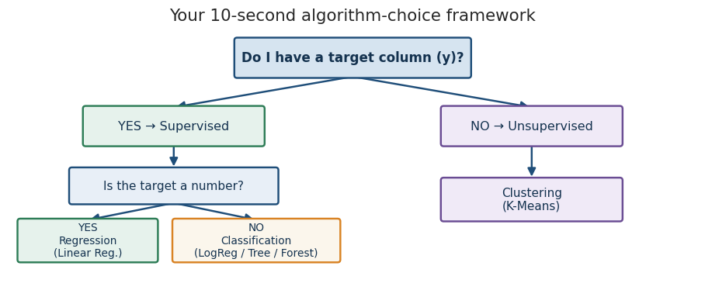
Figure 9.1 — Ninety per cent of real projects are resolved by these two questions.
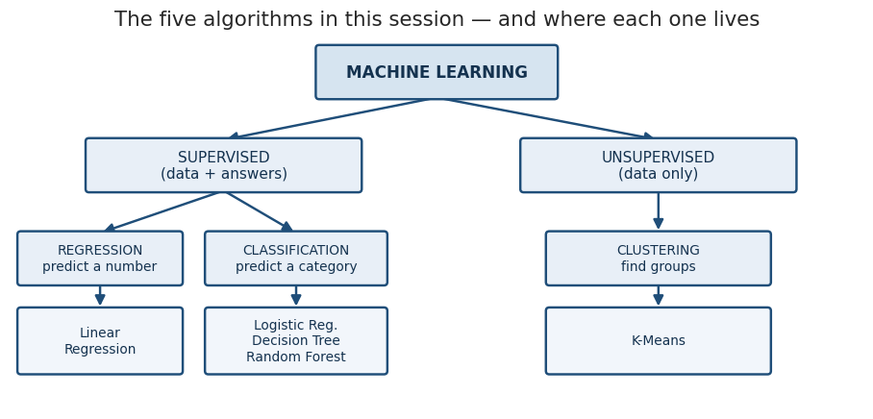
Figure 9.2 — The complete mental model for this session.

MODULE 10 — END-TO-END PROJECT: CUSTOMER CHURN
Everything from the last three hours, assembled into one workflow that resembles what an ML team actually ships.

10.1 The classroom challenge — do this BEFORE you look at any code
INDUSTRY CHALLENGE
“You are a data scientist at a telecom company. The business wants to reduce customer churn by 10%. You have customer information but no existing ML system. Design the ML approach.”
In pairs, ten minutes, write down your answers to all seven:
- 1. Problem type — supervised or unsupervised, regression or classification?
- 2. Target — what exactly is y, and over what time window?
- 3. Features — which columns are you allowed to use, and which must you refuse?
- 4. Algorithms — which two or three would you try first, and why those?
- 5. Evaluation metric — which single number will you optimise, and who agreed to it?
- 6. Business action — what happens to a customer scored at 0.82?
- 7. Risks — what could make this fail in production, or cause harm?
Only after every pair has answered do we open the notebook.

10.2 The business question
“Which customers are likely to churn, and how can the company use these predictions to reduce churn?”
Note the second half. A ranked list of risky customers is not a deliverable. A retention programme that measurably keeps more customers is.

10.3 The workflow
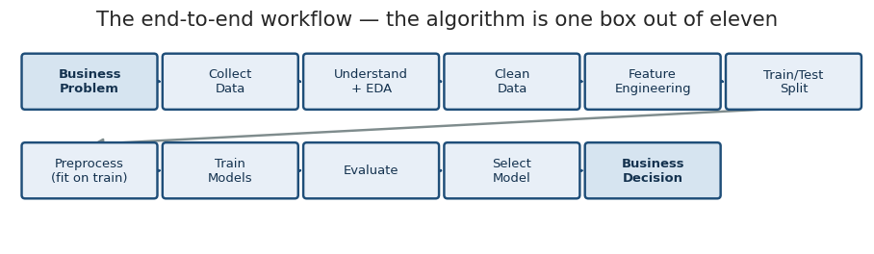
Figure 10.1 — Eleven stages. Model training is one of them, and rarely the hard one.

10.4 The dataset
customer_churn.csv — 1,206 rows (including a handful of deliberate duplicates), 15 columns, roughly 28% churn.
Column |  | Type | Meaning
customer_id |  | ID | Unique identifier — must NOT be used as a feature
gender |  | Categorical | Male / Female
age |  | Numeric | Customer age in years (has missing values)
region |  | Categorical | North / South / East / West
tenure_months |  | Numeric | Months as a customer, 1–72
contract_type |  | Categorical | Month-to-Month / One-Year / Two-Year
payment_method |  | Categorical | Electronic Check / Credit Card / Bank Transfer / UPI (has missing values)
internet_service |  | Categorical | Fiber / DSL / No Internet (has missing values)
customer_segment |  | Categorical | Basic / Standard / Premium
monthly_charges |  | Numeric | Current monthly bill
total_charges |  | Numeric | Lifetime billed amount (has missing values)
usage_hours |  | Numeric | Monthly usage in hours (has missing values)
support_tickets |  | Numeric | Tickets raised in the last 12 months
satisfaction_score |  | Numeric | Survey score 1–10 (has missing values)
churn |  | Target | 1 = left, 0 = stayed
INDUSTRY INSIGHT
The missing values, the duplicates and the wildly different scales are deliberate. Real customer tables look exactly like this, and preprocessing is where most of a real project's time goes.

10.5 Data leakage — the single most expensive mistake in ML
If you fit a scaler or an imputer on the whole dataset and then split, the training process has already absorbed information from the test rows — their mean, their spread, their most common category. Your test score becomes optimistic and you find out in production.
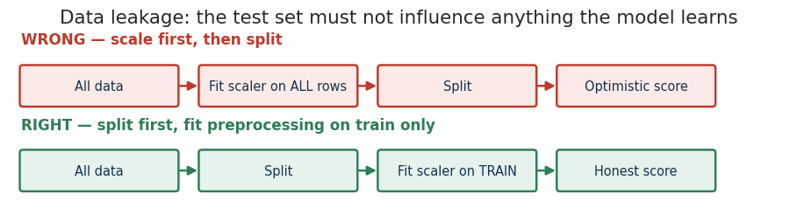
Figure 10.2 — Split first. Fit preprocessing on the training set only.
COMMON MISTAKE
The second kind of leakage is subtler and worse: a feature that could not possibly be known at prediction time. cancellation_reason, final_invoice_flag, retention_call_made — each one will give you a spectacular AUC and a useless model, because in production those columns are empty for exactly the customers you need to score. If a feature looks too good, assume leakage until proven otherwise.
Pipeline and ColumnTransformer exist to make leakage structurally difficult:
from sklearn.pipeline import Pipeline
from sklearn.compose import ColumnTransformer

# A Pipeline chains preprocessing + model into ONE object.
# When you call .fit(X_train), every step learns from X_train only.
# When you call .predict(X_test), those learned settings are simply applied.
# There is no way to accidentally leak, because there is no separate step to misuse.

10.6 Feature engineering
Raw columns are rarely the most informative form of the information they contain. Three transformations that carry real business meaning here:
New feature |  | How it is built | Why it might help
tenure_group |  | Bucket tenure_months into 0–6, 7–12, 13–24, 25–48, 49+ | Churn risk is not linear in tenure — the first six months are a cliff, then it flattens
avg_monthly_usage |  | usage_hours ÷ tenure_months | Separates a heavy user of two months from a light user of five years
support_ticket_rate |  | support_tickets ÷ tenure_months | Three tickets in month one is a crisis; three tickets over five years is normal
COMMON MISTAKE
Dividing by a column that can be zero. Every ratio above uses .clip(lower=1) on the denominator. Infinity propagates silently through scikit-learn and surfaces as an incomprehensible error forty lines later.

10.7 What you will build
Stage | What happens
Preprocessing | Numeric: median imputation → StandardScaler. Categorical: most-frequent imputation → OneHotEncoder(handle_unknown='ignore')
ColumnTransformer | Applies each of those branches to the right columns, in one object
Three pipelines | The identical preprocessor, wrapped with Logistic Regression, then Decision Tree, then Random Forest
Evaluation | Accuracy, precision, recall, F1, ROC-AUC, confusion matrix, classification report — for all three
Selection | Pick a model against the business cost of errors, not against the highest accuracy
Decision | Convert probabilities into a ranked call list with an expected-value justification
The complete, runnable solution is at the end of this workbook (26 cells). Do not open it until you have attempted the pipeline yourself.

10.8 From prediction to business decision
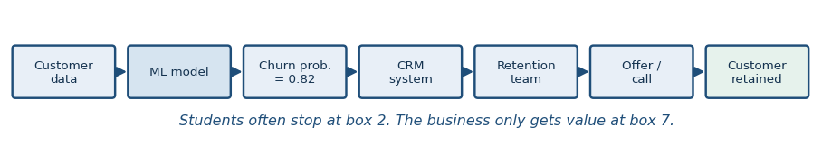
Figure 10.3 — The model is box two of seven.
Work the economics explicitly:
Quantity |  | Assumption | Consequence
Value of a retained customer |  | ₹18,000 lifetime value | This is what a false negative costs you
Cost of an intervention |  | ₹200 call + ₹500 discount if accepted | This is what a false positive costs you
Ratio |  | roughly 26 : 1 | You should accept about 25 wasted calls to save one customer
Therefore |  | Optimise recall, within capacity | Lower the threshold until the team's call capacity is full
KEY IDEA
A model is not the final product. A business decision is the final product.
The threshold you pick is where the mathematics hands over to the business, and it should be chosen in a room with the retention manager, not alone in a notebook.

10.9 The nine questions you must answer
CHECKPOINT
- 1. Which model performed best — and best according to which metric?
- 2. Which metric mattered most for this business problem, and why?
- 3. Which customers are high risk? Describe them in one sentence a manager would understand.
- 4. Which features appear important, and do you believe any of them are causal?
- 5. What action should the company take on Monday morning?
- 6. What happens if the model produces too many false positives?
- 7. What happens if the model misses churners?
- 8. How could the model be improved with more time or more data?
- 9. How would the company monitor this model after deployment?
On question 9 specifically: monitor the input distributions (has the customer mix shifted?), the score distribution (is the average risk drifting?), and the realised outcome (of the customers you flagged three months ago, how many actually left?). The third one arrives late but is the only ground truth you will ever get.
DISCUSS
Ethical considerations worth ten minutes, not ten seconds:
- Should gender or region be allowed as features in a model that decides who gets a discount?
- If the model systematically offers better retention deals to high-income customers, is that price discrimination or good business?
- The customers most likely to churn may also be the least profitable. Should you actually try to keep them?

FINAL 10-MINUTE RECAP

The mental model
MACHINE LEARNING
|
+----------------+----------------+
| |
SUPERVISED UNSUPERVISED
(data + answers) (data only)
| |
+--------+--------+ K-MEANS
| | segmentation
REGRESSION CLASSIFICATION
predict a predict a
number category
| |
Linear +--------+--------+
Regression | | |
Logistic Decision Random
Regression Tree Forest

One sentence each
Algorithm | The one sentence to remember
Linear Regression | Fit the straight line that minimises squared error, and read the coefficients as rates of return
Logistic Regression | The same weighted sum, squashed into a probability by a sigmoid, then cut at a threshold you choose
Decision Tree | Ask the question that best purifies the group, then do it again — until you tell it to stop
Random Forest | Hundreds of deliberately different trees vote, and their individual mistakes cancel out
K-Means | Guess the centres, assign everyone to the nearest, move the centres to the middle, repeat until still

The five things most likely to break your first real project
- Data leakage — a feature that knows the future, or preprocessing fitted before the split.
- Optimising accuracy on imbalanced data, and shipping a model that predicts the majority class.
- Leaving the threshold at 0.5 because that is the default.
- Presenting feature importance as if it were causation.
- Delivering a model instead of a decision, and wondering why nobody used it.

Where to go next
- Cross-validation — because a single train/test split is itself a random draw.
- Gradient boosting (XGBoost, LightGBM) — usually the strongest tabular models in industry today.
- Class-imbalance handling — class_weight, resampling, and threshold optimisation.
- SHAP values — per-prediction explanations that work even for a forest.
- MLOps basics — model registries, drift monitoring, scheduled retraining.

PRACTICAL EXERCISE SOLUTIONS
Complete, executable Google Colab code for every hands-on exercise. Each block is self-contained — paste it into a fresh cell and run it. Exercises 3, 4 and 5 need customer_churn.csv uploaded first.
KEY IDEA
Every block below was executed before this workbook was produced. The numbers quoted in the interpretation comments are the numbers the code actually printed, not estimates. If your output differs, check that random_state=42 survived your edits.

SOLUTION 1 — Your first ML workflow
import numpy as np
import pandas as pd
import matplotlib.pyplot as plt
from sklearn.model_selection import train_test_split
from sklearn.linear_model import LinearRegression
from sklearn.metrics import mean_absolute_error, r2_score

np.random.seed(42)
n = 200
houses = pd.DataFrame({
"area": np.random.randint(600, 3000, n),
"bedrooms": np.random.randint(1, 5, n),
"age_years": np.random.randint(0, 30, n),
})
houses["price"] = (2800 * houses["area"] + 150000 * houses["bedrooms"]
- 40000 * houses["age_years"] + np.random.normal(0, 300000, n)).round(0)

print(houses.shape)
print(houses.describe().round(0))

# 1. Features and target
X = houses[["area", "bedrooms", "age_years"]]
y = houses["price"]

# 2. Split BEFORE training
X_train, X_test, y_train, y_test = train_test_split(
X, y, test_size=0.2, random_state=42)

# 3. Train
model = LinearRegression()
model.fit(X_train, y_train)

# 4. Score on both sets
pred = model.predict(X_test)
print("\nTrain R2:", round(model.score(X_train, y_train), 3))
print("Test R2:", round(r2_score(y_test, pred), 3))
print("Test MAE: Rs", round(mean_absolute_error(y_test, pred), 0))

# 5. Read the coefficients out loud
print("\nIntercept:", round(model.intercept_, 0))
for feature, coef in zip(X.columns, model.coef_):
print(f" {feature:<10} {coef:>12,.0f}")

# 6. Predict a new house
new_house = pd.DataFrame([{"area": 1500, "bedrooms": 3, "age_years": 5}])
print("\nPredicted price: Rs", round(model.predict(new_house)[0], 0))

# INTERPRETATION
# area ~ +2,864 -> each extra square foot adds about Rs 2,864
# bedrooms ~ +154,376 -> each extra bedroom adds about Rs 1.54 lakh
# age_years ~ -39,187 -> each year of age removes about Rs 39,000
# Train and test R2 are close (0.979 vs 0.960) -> the model generalises.
WHAT THE OUTPUT SHOWS
Train R² 0.979 vs test R² 0.960 — a small gap, so the model generalises. Each extra square foot is worth about ₹2,864, each bedroom about ₹1.54 lakh, and each year of age costs about ₹39,000.

SOLUTION 2 — Advertising spend → sales
import numpy as np
import pandas as pd
import matplotlib.pyplot as plt
from sklearn.model_selection import train_test_split
from sklearn.linear_model import LinearRegression
from sklearn.metrics import mean_absolute_error, mean_squared_error, r2_score

np.random.seed(42)
n = 120
ads = pd.DataFrame({
"tv_spend": np.random.uniform(5, 100, n).round(1),
"digital_spend": np.random.uniform(2, 60, n).round(1),
})
ads["sales"] = (25 + 2.1*ads["tv_spend"] + 3.4*ads["digital_spend"]
+ np.random.normal(0, 30, n)).round(1)

print(ads.head())
print(ads.describe().round(1))

# Visualise both relationships
fig, axes = plt.subplots(1, 2, figsize=(12, 4))
axes[0].scatter(ads["tv_spend"], ads["sales"], color="#1F4E79", s=25)
axes[0].set_xlabel("TV spend"); axes[0].set_ylabel("sales")
axes[0].set_title("TV spend vs sales")
axes[1].scatter(ads["digital_spend"], ads["sales"], color="#2E7D57", s=25)
axes[1].set_xlabel("Digital spend"); axes[1].set_ylabel("sales")
axes[1].set_title("Digital spend vs sales")
plt.tight_layout(); plt.show()

# Split, train, predict
X = ads[["tv_spend", "digital_spend"]]
y = ads["sales"]
X_train, X_test, y_train, y_test = train_test_split(
X, y, test_size=0.2, random_state=42)

lin = LinearRegression().fit(X_train, y_train)
pred = lin.predict(X_test)

# All four metrics
mae = mean_absolute_error(y_test, pred)
mse = mean_squared_error(y_test, pred)
rmse = np.sqrt(mse)
r2 = r2_score(y_test, pred)
print(f"\nMAE : {mae:.2f}")
print(f"MSE : {mse:.2f}")
print(f"RMSE: {rmse:.2f}")
print(f"R2 : {r2:.3f}")

# Actual vs predicted
plt.figure(figsize=(6, 5))
plt.scatter(y_test, pred, color="#1F4E79", s=35)
plt.plot([y_test.min(), y_test.max()], [y_test.min(), y_test.max()],
"r--", lw=2)
plt.xlabel("actual sales"); plt.ylabel("predicted sales")
plt.title("Actual vs Predicted"); plt.tight_layout(); plt.show()

# Coefficients
print("\nIntercept:", round(lin.intercept_, 2))
for f, c in zip(X.columns, lin.coef_):
print(f" {f:<15} {c:>7.3f}")

# BUSINESS ANSWER
# Digital returns about 3.07 units of sales per unit spent; TV returns 2.24.
# At the current spend levels, shifting marginal budget from TV to digital
# should raise sales. Caveat: the data only covers TV spend of 5-100 and
# digital of 2-60. This model cannot tell you what happens at digital = 200,
# where saturation almost certainly sets in.
WHAT THE OUTPUT SHOWS
Digital returns roughly 3.07 units of sales per unit spent against TV's 2.24 — but only within the spend range the model has actually seen. R² lands near 0.875.

SOLUTION 3 — Predicting churn with Logistic Regression
import numpy as np
import pandas as pd
import matplotlib.pyplot as plt
import seaborn as sns
from sklearn.model_selection import train_test_split
from sklearn.preprocessing import StandardScaler
from sklearn.linear_model import LogisticRegression
from sklearn.metrics import (confusion_matrix, accuracy_score, precision_score,
recall_score, f1_score, roc_auc_score,
classification_report)

df = pd.read_csv("customer_churn.csv")
print(df.shape)
print(df["churn"].value_counts(normalize=True).round(3))

num_cols = ["tenure_months", "monthly_charges", "support_tickets",
"satisfaction_score", "usage_hours"]
data = df[num_cols + ["churn"]].dropna()
X = data[num_cols]
y = data["churn"]

X_train, X_test, y_train, y_test = train_test_split(
X, y, test_size=0.2, random_state=42, stratify=y)

# Scale: fit on TRAIN only, then apply to both
scaler = StandardScaler().fit(X_train)
X_train_s = scaler.transform(X_train)
X_test_s = scaler.transform(X_test)

log = LogisticRegression(max_iter=1000, random_state=42).fit(X_train_s, y_train)

pred = log.predict(X_test_s)
proba = log.predict_proba(X_test_s)[:, 1]
print("\nFirst 10 probabilities:", proba[:10].round(3))

# Confusion matrix as a heatmap
cm = confusion_matrix(y_test, pred)
plt.figure(figsize=(5, 4))
sns.heatmap(cm, annot=True, fmt="d", cmap="Blues", cbar=False,
xticklabels=["Pred stay", "Pred churn"],
yticklabels=["Actual stay", "Actual churn"])
plt.title("Confusion matrix - threshold 0.5")
plt.tight_layout(); plt.show()

print("\nAccuracy :", round(accuracy_score(y_test, pred), 3))
print("Precision:", round(precision_score(y_test, pred), 3))
print("Recall :", round(recall_score(y_test, pred), 3))
print("F1 :", round(f1_score(y_test, pred), 3))
print("ROC-AUC :", round(roc_auc_score(y_test, proba), 3))
print("\n", classification_report(y_test, pred, target_names=["Stayed", "Churned"]))

# Coefficients: which feature pushes churn up hardest?
coefs = pd.Series(log.coef_[0], index=num_cols).sort_values()
print(coefs.round(3))

# Lower the threshold to catch more churners
pred_035 = (proba >= 0.35).astype(int)
print("\nThreshold 0.50 -> recall", round(recall_score(y_test, pred), 3),
"| precision", round(precision_score(y_test, pred), 3))
print("Threshold 0.35 -> recall", round(recall_score(y_test, pred_035), 3),
"| precision", round(precision_score(y_test, pred_035), 3))

cm2 = confusion_matrix(y_test, pred_035)
print("\nExtra churners caught:", cm2[1, 1] - cm[1, 1])
print("Extra wasted contacts:", cm2[0, 1] - cm[0, 1])

# BUSINESS ANSWER
# tenure_months has the strongest negative coefficient: every additional month
# as a customer sharply reduces churn probability. support_tickets is the
# strongest positive driver.
# Dropping the threshold from 0.50 to 0.35 catches 8 more real churners at the
# cost of 23 extra calls. At Rs 18,000 lifetime value versus Rs 700 per contact,
# 8 saved customers are worth far more than 23 wasted calls - so the lower
# threshold is clearly the right business choice here.
WHAT THE OUTPUT SHOWS
Accuracy 0.825, precision 0.761, recall 0.556, ROC-AUC 0.840. Recall is the weak spot: at the default threshold the model misses nearly half the churners. Dropping the threshold to 0.35 catches 8 more churners for 23 extra calls — obviously worth it at ₹18,000 versus ₹700.

SOLUTION 4 — Decision tree and the depth dial
import pandas as pd
import matplotlib.pyplot as plt
from sklearn.model_selection import train_test_split
from sklearn.tree import DecisionTreeClassifier, plot_tree
from sklearn.metrics import (accuracy_score, precision_score,
recall_score, f1_score)

df = pd.read_csv("customer_churn.csv")
num_cols = ["tenure_months", "monthly_charges", "support_tickets",
"satisfaction_score", "usage_hours"]
data = df[num_cols + ["churn"]].dropna()
X, y = data[num_cols], data["churn"]
X_train, X_test, y_train, y_test = train_test_split(
X, y, test_size=0.2, random_state=42, stratify=y)

# Unconstrained tree - watch it memorise
full = DecisionTreeClassifier(random_state=42).fit(X_train, y_train)
print("UNLIMITED DEPTH")
print(" train:", round(full.score(X_train, y_train), 3))
print(" test :", round(full.score(X_test, y_test), 3))
print(" actual depth grown:", full.get_depth())

# Sweep the depth
print("\ndepth train test recall")
for depth in [2, 3, 5, 10, None]:
t = DecisionTreeClassifier(max_depth=depth, random_state=42).fit(X_train, y_train)
print(f"{str(depth):>5} {t.score(X_train, y_train):.3f} "
f"{t.score(X_test, y_test):.3f} {recall_score(y_test, t.predict(X_test)):.3f}")

# Best tree
best = DecisionTreeClassifier(max_depth=5, min_samples_leaf=20,
random_state=42).fit(X_train, y_train)
pred = best.predict(X_test)
print("\nTuned tree (depth 5)")
print(" Accuracy :", round(accuracy_score(y_test, pred), 3))
print(" Precision:", round(precision_score(y_test, pred), 3))
print(" Recall :", round(recall_score(y_test, pred), 3))
print(" F1 :", round(f1_score(y_test, pred), 3))

# Visualise (depth 3 so the picture stays readable)
show = DecisionTreeClassifier(max_depth=3, min_samples_leaf=25,
random_state=42).fit(X_train, y_train)
plt.figure(figsize=(18, 8))
plot_tree(show, feature_names=num_cols, class_names=["Stay", "Churn"],
filled=True, rounded=True, fontsize=9)
plt.title("Churn decision tree (depth 3)")
plt.tight_layout(); plt.show()

# INTERPRETATION
# The unlimited tree hits 1.000 on training and drops to about 0.70 on test:
# textbook overfitting. Depth 5 scores roughly 0.79 on both.
# Root question: satisfaction_score <= 7.05 - the tree considers dissatisfaction
# the single most informative signal.
# Two rules for the retention team, read straight off the diagram:
# IF satisfaction <= 7.05 AND tenure <= 18.5 months -> HIGH RISK, call this week
# IF satisfaction > 7.05 AND tenure > 18.5 months -> LOW RISK, no action
WHAT THE OUTPUT SHOWS
Unlimited depth: 1.000 on train, 0.695 on test — the tree grew to depth 18 and memorised individuals. Depth 5: about 0.79 on both. The root split is satisfaction_score ≤ 7.05.

SOLUTION 5 — Random Forest versus a single tree
import pandas as pd
import matplotlib.pyplot as plt
from sklearn.model_selection import train_test_split
from sklearn.preprocessing import StandardScaler
from sklearn.linear_model import LogisticRegression
from sklearn.tree import DecisionTreeClassifier
from sklearn.ensemble import RandomForestClassifier
from sklearn.metrics import (accuracy_score, precision_score,
recall_score, f1_score, roc_auc_score)

df = pd.read_csv("customer_churn.csv")
num_cols = ["tenure_months", "monthly_charges", "support_tickets",
"satisfaction_score", "usage_hours"]
data = df[num_cols + ["churn"]].dropna()
X, y = data[num_cols], data["churn"]
X_train, X_test, y_train, y_test = train_test_split(
X, y, test_size=0.2, random_state=42, stratify=y)

def score_model(name, model, scale=False):
if scale:
sc = StandardScaler().fit(X_train)
model.fit(sc.transform(X_train), y_train)
pred = model.predict(sc.transform(X_test))
proba = model.predict_proba(sc.transform(X_test))[:, 1]
else:
model.fit(X_train, y_train)
pred = model.predict(X_test)
proba = model.predict_proba(X_test)[:, 1]
return {"Model": name,
"Accuracy": accuracy_score(y_test, pred),
"Precision": precision_score(y_test, pred),
"Recall": recall_score(y_test, pred),
"F1": f1_score(y_test, pred),
"ROC-AUC": roc_auc_score(y_test, proba)}

rf = RandomForestClassifier(n_estimators=300, max_depth=8, random_state=42)
results = pd.DataFrame([
score_model("Logistic Regression",
LogisticRegression(max_iter=1000, random_state=42), scale=True),
score_model("Decision Tree (d=5)",
DecisionTreeClassifier(max_depth=5, random_state=42)),
score_model("Random Forest", rf),
]).round(3)
print(results.to_string(index=False))

# Feature importance
imp = pd.Series(rf.feature_importances_, index=num_cols).sort_values()
plt.figure(figsize=(8, 4))
imp.plot(kind="barh", color="#1F4E79")
plt.title("Random Forest feature importance")
plt.xlabel("importance"); plt.tight_layout(); plt.show()
print("\n", imp.sort_values(ascending=False).round(3))

# Does more trees help?
print("\nn_estimators accuracy recall")
for n_trees in [10, 50, 300]:
m = RandomForestClassifier(n_estimators=n_trees, max_depth=8,
random_state=42).fit(X_train, y_train)
p = m.predict(X_test)
print(f"{n_trees:>12} {accuracy_score(y_test, p):.3f} {recall_score(y_test, p):.3f}")

# INTERPRETATION
# The forest does NOT beat Logistic Regression here. That is the real lesson:
# this data was generated by a roughly linear process, so the linear model is
# already close to the ceiling and the ensemble has nothing extra to find.
# Top features: tenure_months and satisfaction_score.
# Causality: neither is safely causal. Low satisfaction and churn plausibly
# share an upstream cause (a bad service experience). To test it you would need
# an experiment - randomly intervene on a subset and compare churn rates.
# More trees is not automatically better: 50 trees scores slightly higher than
# 300 here. Beyond roughly 50 the metrics simply fluctuate with noise.
WHAT THE OUTPUT SHOWS
Logistic Regression wins on every metric here. The forest is not broken — the data was generated by a near-linear process, so there is no non-linear structure left for the ensemble to exploit.

SOLUTION 6 — Customer segmentation with K-Means
import numpy as np
import pandas as pd
import matplotlib.pyplot as plt
from sklearn.preprocessing import StandardScaler
from sklearn.cluster import KMeans

np.random.seed(42)
n = 300
mall = pd.DataFrame({
"age": np.random.randint(18, 70, n),
"annual_income": np.random.randint(150000, 2500000, n),
})
mall["spending_score"] = np.clip(
100 - mall["annual_income"]/30000 + np.random.normal(0, 18, n), 1, 100).round(0)

print(mall.describe().round(0))

feats = ["age", "annual_income", "spending_score"]

# Scaling is mandatory: income is in lakhs, age is in tens
X_scaled = StandardScaler().fit_transform(mall[feats])

# Elbow
inertias = []
for k in range(1, 11):
km = KMeans(n_clusters=k, n_init=10, random_state=42).fit(X_scaled)
inertias.append(km.inertia_)

plt.figure(figsize=(8, 4))
plt.plot(range(1, 11), inertias, "o-", color="#1F4E79", lw=2)
plt.xlabel("K"); plt.ylabel("inertia")
plt.title("Elbow curve"); plt.grid(True); plt.tight_layout(); plt.show()

# Fit the chosen K
K = 4
kmeans = KMeans(n_clusters=K, n_init=10, random_state=42)
mall["cluster"] = kmeans.fit_predict(X_scaled)

# Visualise on the two most business-relevant axes
plt.figure(figsize=(8, 5))
plt.scatter(mall["annual_income"], mall["spending_score"],
c=mall["cluster"], cmap="Set1", s=40)
plt.xlabel("annual income"); plt.ylabel("spending score")
plt.title(f"Customer segments (K={K})")
plt.tight_layout(); plt.show()

# Profile the segments - THIS is where clusters become segments
profile = mall.groupby("cluster")[feats].mean().round(0)
profile["customers"] = mall["cluster"].value_counts().sort_index()
print(profile)

# BUSINESS NAMING AND ACTIONS
# (your cluster numbers may differ - read the profile table, not the numbers)
# Cluster with young + low income + high spending -> "Young Enthusiastic Spenders"
# Action: referral programme and app-first offers; they engage cheaply.
# Cluster with older + low income + high spending -> "Loyal Value Seekers"
# Action: loyalty points and bundle discounts.
# Cluster with older + high income + low spending -> "Affluent Low-Engagement"
# Action: premium concierge onboarding call - highest upside per customer.
# Cluster with young + high income + low spending -> "Untapped Professionals"
# Action: premium product trials and lifestyle campaigns.
#
# NOTE: K-Means returned four mathematical groups. Every name and every action
# above was supplied by a human reading the profile table.
WHAT THE OUTPUT SHOWS
Four clean segments emerge, separated mainly by income and spending score, with age splitting them further. The algorithm supplied the groups; you supplied the names and the campaigns.

MINI QUIZ — INSTRUCTOR ANSWERS
Q | Answer
1 | Regression. Megawatts is a continuous quantity, so the answer is a number rather than a category.
2 | Overfitting. The model memorised the training rows. Fixes: limit model complexity (shallower tree, fewer features), gather more training data, or apply regularisation.
3 | A hyperparameter — you typed it before calling .fit(). The thresholds the tree discovers inside each node are the parameters.
4 | RMSE above MAE means a few large errors are inflating the squared term. The typical prediction is off by about 22, but some are off by far more. Investigate those rows.
5 | Severe overfitting, or a train/test split that is not comparable — for example a time-ordered dataset split randomly, or preprocessing fitted before the split.
6 | No. Supplier choice is an unordered category. Linear regression would output meaningless values like 2.4 and would falsely imply that supplier 3 is somehow “more” than supplier 1. Use classification.
7 | No — a model predicting “never fraud” scores 99.4% on that data. Demand the confusion matrix, precision and recall on the fraud class, and the ROC-AUC.
8 | Bottom-left: actual churn, predicted stay. It costs the full lifetime value of the customer, because nobody ever tried to save them.
9 | You leaked the target. That column only exists after the customer has already decided to leave, so it will be empty in production for exactly the customers you need to score.
10 | Each tree sees a different bootstrap sample of rows and a random subset of features at every split, so their errors are largely uncorrelated. Averaging cancels much of the individual noise while keeping the shared signal.
11 | Generally not. A forest cannot produce a single readable reason path, and lending decisions usually carry a legal right to explanation. Ship logistic regression or a shallow tree, or add SHAP values on top.
12 | Importance splits between them, so both look only moderately important. A genuinely critical driver can appear unimportant purely because a near-duplicate feature is sitting beside it.
13 | Inertia falls monotonically as K rises, reaching zero when every point is its own cluster. Minimising it would always pick the largest possible K.
14 | Trees split one feature at a time and never compare distances across features, so units are irrelevant. K-Means computes straight-line distance across all features at once, so the largest-magnitude feature dominates.
15 | Neither is wrong — the criteria differ. Statistical separation is not the same as commercial distinctiveness. If three segments would receive the same campaign, merge them; a segmentation nobody can act on has no value.

END-TO-END PROJECT — COMPLETE SOLUTION
Twenty-six cells, in order. Paste each one into its own Colab cell and run them sequentially from the top. Cell 2 requires customer_churn.csv to be uploaded first.
KEY IDEA
This entire notebook was executed end to end before publication. Every metric quoted in this workbook came from running exactly this code against exactly the supplied CSV — nothing here is illustrative or invented.
HANDS-ON
Upload the dataset first:
from google.colab import files
files.upload() # choose customer_churn.csv

Cell 1 — Imports
# Everything used in this project. All of it ships with Google Colab.
import numpy as np
import pandas as pd
import matplotlib.pyplot as plt
import seaborn as sns

from sklearn.model_selection import train_test_split
from sklearn.pipeline import Pipeline
from sklearn.compose import ColumnTransformer
from sklearn.impute import SimpleImputer
from sklearn.preprocessing import StandardScaler, OneHotEncoder
from sklearn.linear_model import LogisticRegression
from sklearn.tree import DecisionTreeClassifier
from sklearn.ensemble import RandomForestClassifier
from sklearn.metrics import (accuracy_score, precision_score, recall_score,
f1_score, roc_auc_score, confusion_matrix,
classification_report, ConfusionMatrixDisplay)

sns.set_theme(style="whitegrid")
RANDOM_STATE = 42 # one seed, used everywhere, so results are reproducible
print("Imports ready.")

Cell 2 — Load the data
# In Colab, upload the file first:
# from google.colab import files
# files.upload() # choose customer_churn.csv
df = pd.read_csv("customer_churn.csv")
print("Rows:", df.shape[0], "| Columns:", df.shape[1])
df.head()

Cell 3 — Inspect the data
df.info()
print("\n--- Numeric summary ---")
print(df.describe().round(2))
print("\n--- Target balance ---")
print(df["churn"].value_counts())
print(df["churn"].value_counts(normalize=True).round(3))

Cell 4 — Data quality
print("Missing values per column:")
print(df.isna().sum()[df.isna().sum() > 0])

print("\nDuplicate rows:", df.duplicated().sum())
df = df.drop_duplicates().reset_index(drop=True)
print("Rows after removing duplicates:", len(df))

# customer_id is an identifier, not information. Never let a model use it.
print("\nUnique customer_ids:", df["customer_id"].nunique())

Cell 5 — EDA
fig, axes = plt.subplots(2, 3, figsize=(16, 8))

# 1. Target distribution
df["churn"].value_counts().plot(kind="bar", ax=axes[0, 0], color=["#2E7D57", "#C0392B"])
axes[0, 0].set_title("Churn distribution (0 = stayed, 1 = left)")
axes[0, 0].tick_params(axis="x", rotation=0)

# 2. Churn rate by contract type
df.groupby("contract_type")["churn"].mean().sort_values().plot(
kind="barh", ax=axes[0, 1], color="#1F4E79")
axes[0, 1].set_title("Churn rate by contract type")

# 3. Churn rate by customer segment
df.groupby("customer_segment")["churn"].mean().plot(
kind="bar", ax=axes[0, 2], color="#1F4E79")
axes[0, 2].set_title("Churn rate by customer segment")
axes[0, 2].tick_params(axis="x", rotation=0)

# 4. Tenure distribution split by churn
sns.histplot(data=df, x="tenure_months", hue="churn", bins=30,
ax=axes[1, 0], palette=["#2E7D57", "#C0392B"])
axes[1, 0].set_title("Tenure by churn")

# 5. Satisfaction split by churn
sns.boxplot(data=df, x="churn", y="satisfaction_score", hue="churn",
legend=False, ax=axes[1, 1], palette=["#2E7D57", "#C0392B"])
axes[1, 1].set_title("Satisfaction score by churn")

# 6. Correlation heatmap (numeric columns only)
num_cols = df.select_dtypes(include=np.number).columns
sns.heatmap(df[num_cols].corr(), annot=True, fmt=".2f", cmap="RdBu_r",
center=0, ax=axes[1, 2], annot_kws={"size": 7})
axes[1, 2].set_title("Correlation heatmap")

plt.tight_layout()
plt.show()

# Churn rate by tenure bucket, printed as a table
print(df.groupby(pd.cut(df["tenure_months"], [0, 6, 12, 24, 48, 100]),
observed=True)["churn"].agg(["mean", "count"]).round(3))

Cell 6 — Feature engineering
# Only transformations with a business justification.
df["tenure_group"] = pd.cut(
df["tenure_months"], bins=[0, 6, 12, 24, 48, 100],
labels=["0-6m", "7-12m", "13-24m", "25-48m", "49m+"]).astype(str)

# .clip(lower=1) prevents division by zero producing inf
df["avg_monthly_usage"] = df["usage_hours"] / df["tenure_months"].clip(lower=1)
df["support_ticket_rate"] = df["support_tickets"] / df["tenure_months"].clip(lower=1)

print(df[["tenure_months", "tenure_group", "avg_monthly_usage",
"support_ticket_rate"]].head())

Cell 7 — Define X and y
# Drop the target, and drop customer_id (an identifier carries no signal
# and lets the model memorise individuals).
X = df.drop(columns=["churn", "customer_id"])
y = df["churn"]

print("Feature matrix:", X.shape)
print("Churn rate:", round(y.mean(), 3))

Cell 8 — Train/test split
# stratify=y keeps the same churn rate in both sets.
# This happens BEFORE any preprocessing — that is what prevents data leakage.
X_train, X_test, y_train, y_test = train_test_split(
X, y, test_size=0.2, random_state=RANDOM_STATE, stratify=y)

print("Train:", X_train.shape, "| churn rate:", round(y_train.mean(), 3))
print("Test :", X_test.shape, "| churn rate:", round(y_test.mean(), 3))

Cell 9 — Identify feature types
numeric_features = X.select_dtypes(include=np.number).columns.tolist()
categorical_features = X.select_dtypes(exclude=np.number).columns.tolist()

print("Numeric :", numeric_features)
print("Categorical:", categorical_features)

Cell 10 — Numerical pipeline
# Median imputation (robust to outliers), then scaling.
# Scaling matters for Logistic Regression; it is harmless for trees.
numeric_transformer = Pipeline(steps=[
("imputer", SimpleImputer(strategy="median")),
("scaler", StandardScaler()),
])
print(numeric_transformer)

Cell 11 — Categorical pipeline
# Fill gaps with the most common category, then one-hot encode.
# handle_unknown="ignore" stops the pipeline crashing if a category
# appears in production that was never seen during training.
categorical_transformer = Pipeline(steps=[
("imputer", SimpleImputer(strategy="most_frequent")),
("onehot", OneHotEncoder(handle_unknown="ignore")),
])
print(categorical_transformer)

Cell 12 — ColumnTransformer
# Routes each group of columns to the right transformer, in one object.
preprocessor = ColumnTransformer(transformers=[
("num", numeric_transformer, numeric_features),
("cat", categorical_transformer, categorical_features),
])
print(preprocessor)

Cell 13 — Logistic Regression pipeline
logreg_pipeline = Pipeline(steps=[
("preprocessor", preprocessor),
("model", LogisticRegression(max_iter=1000, random_state=RANDOM_STATE)),
])
print(logreg_pipeline)

Cell 14 — Train Logistic Regression
# .fit() runs the whole chain: impute -> scale -> encode -> train,
# and every step learns from the TRAINING data only.
logreg_pipeline.fit(X_train, y_train)
print("Logistic Regression trained.")

Cell 15 — Evaluate Logistic Regression
def evaluate(name, pipeline, X_test, y_test, threshold=0.5):
"""Score a fitted pipeline and return a dict of metrics."""
proba = pipeline.predict_proba(X_test)[:, 1]
pred = (proba >= threshold).astype(int)
results = {
"Model": name,
"Accuracy": accuracy_score(y_test, pred),
"Precision": precision_score(y_test, pred, zero_division=0),
"Recall": recall_score(y_test, pred),
"F1": f1_score(y_test, pred),
"ROC-AUC": roc_auc_score(y_test, proba),
}
print(f"--- {name} (threshold {threshold}) ---")
print(classification_report(y_test, pred, target_names=["Stayed", "Churned"]))
print("Confusion matrix [[TN FP] [FN TP]]:")
print(confusion_matrix(y_test, pred))
return results

logreg_results = evaluate("Logistic Regression", logreg_pipeline, X_test, y_test)

Cell 16 — Decision Tree pipeline
# max_depth and min_samples_leaf are the anti-overfitting controls.
tree_pipeline = Pipeline(steps=[
("preprocessor", preprocessor),
("model", DecisionTreeClassifier(max_depth=5, min_samples_leaf=20,
random_state=RANDOM_STATE)),
])
print(tree_pipeline)

Cell 17 — Train Decision Tree
tree_pipeline.fit(X_train, y_train)
print("Train accuracy:", round(tree_pipeline.score(X_train, y_train), 3))
print("Test accuracy:", round(tree_pipeline.score(X_test, y_test), 3))

Cell 18 — Evaluate Decision Tree
tree_results = evaluate("Decision Tree", tree_pipeline, X_test, y_test)

Cell 19 — Random Forest pipeline
rf_pipeline = Pipeline(steps=[
("preprocessor", preprocessor),
("model", RandomForestClassifier(n_estimators=300, max_depth=10,
min_samples_leaf=5,
random_state=RANDOM_STATE, n_jobs=-1)),
])
print(rf_pipeline)

Cell 20 — Train Random Forest
rf_pipeline.fit(X_train, y_train)
print("Train accuracy:", round(rf_pipeline.score(X_train, y_train), 3))
print("Test accuracy:", round(rf_pipeline.score(X_test, y_test), 3))

Cell 21 — Evaluate Random Forest
rf_results = evaluate("Random Forest", rf_pipeline, X_test, y_test)

Cell 22 — Model comparison
comparison = pd.DataFrame([logreg_results, tree_results, rf_results]).round(3)
print(comparison.to_string(index=False))

comparison.set_index("Model")[["Accuracy", "Precision", "Recall", "F1"]].plot(
kind="bar", figsize=(11, 4), rot=0, colormap="Blues_r", edgecolor="black")
plt.title("Model comparison on the test set")
plt.ylim(0, 1)
plt.legend(loc="lower right")
plt.tight_layout()
plt.show()

Cell 23 — Confusion matrices side by side
fig, axes = plt.subplots(1, 3, figsize=(15, 4))
for ax, (name, pipe) in zip(axes, [("Logistic Regression", logreg_pipeline),
("Decision Tree", tree_pipeline),
("Random Forest", rf_pipeline)]):
ConfusionMatrixDisplay.from_estimator(
pipe, X_test, y_test, ax=ax, cmap="Blues",
display_labels=["Stayed", "Churned"], colorbar=False)
ax.set_title(name)
plt.tight_layout()
plt.show()

print("Bottom-left cell = FALSE NEGATIVES = churners we failed to flag.")

Cell 24 — Feature importance
# Pull the feature names back out of the fitted ColumnTransformer.
fitted_pre = rf_pipeline.named_steps["preprocessor"]
feature_names = fitted_pre.get_feature_names_out()

importances = pd.Series(
rf_pipeline.named_steps["model"].feature_importances_,
index=feature_names).sort_values(ascending=False).head(15)

plt.figure(figsize=(10, 5))
importances.sort_values().plot(kind="barh", color="#1F4E79")
plt.title("Top 15 features — Random Forest")
plt.xlabel("importance")
plt.tight_layout()
plt.show()

print(importances.round(4))

Cell 25 — Business interpretation: build the call list
# The retention team can contact 200 customers this month.
# Lower the threshold to catch more real churners, then rank by risk.
best_pipeline = logreg_pipeline # chosen on ROC-AUC + explainability
probabilities = best_pipeline.predict_proba(X_test)[:, 1]

risk = X_test.copy()
risk["churn_probability"] = probabilities.round(3)
risk["actual_churn"] = y_test.values
risk = risk.sort_values("churn_probability", ascending=False)

print("Top 10 highest-risk customers:")
print(risk[["tenure_months", "contract_type", "monthly_charges",
"support_tickets", "satisfaction_score",
"churn_probability", "actual_churn"]].head(10).to_string())

# How good is the ranking? Check the churn rate in the top 20%.
top_20pct = risk.head(int(len(risk) * 0.2))
print("\nChurn rate overall :", round(y_test.mean(), 3))
print("Churn rate in top 20% :", round(top_20pct["actual_churn"].mean(), 3))
print("Lift over random calling:",
round(top_20pct["actual_churn"].mean() / y_test.mean(), 2), "x")

Cell 26 — Final business recommendation
# Economics: a retained customer is worth Rs 18,000; an intervention costs Rs 700.
VALUE_RETAINED = 18000
COST_CONTACT = 700
RETENTION_SUCCESS_RATE = 0.30 # 30% of contacted churners are saved

print("Threshold Flagged TruePos FalsePos Recall Expected value (Rs)")
for t in [0.20, 0.30, 0.40, 0.50, 0.60]:
pred = (probabilities >= t).astype(int)
tn, fp, fn, tp = confusion_matrix(y_test, pred).ravel()
value = tp * RETENTION_SUCCESS_RATE * VALUE_RETAINED - (tp + fp) * COST_CONTACT
print(f"{t:>8.2f} {tp+fp:>7} {tp:>7} {fp:>8} "
f"{recall_score(y_test, pred):>6.3f} {value:>12,.0f}")

print("""
RECOMMENDATION
--------------
1. Deploy Logistic Regression. It matched or beat the tree-based models on
ROC-AUC here, scores instantly, and every coefficient can be explained to
a regulator or an account manager.
2. Set the threshold by expected value, not by convention. The table above
shows which threshold maximises rupees, not accuracy.
3. Work the ranked list, not the labels. The retention team should call
customers in descending probability order until capacity runs out.
4. Hold out a control group. Leave 10% of flagged customers uncontacted so
the campaign's true lift can be measured. Without this you will never
know whether the model or the market caused the change.
5. Monitor monthly: input drift, score drift, and realised churn among
customers flagged three months ago.
""")

What the run actually produced
Test set of 240 customers, 28% of whom churned:
Model | Accuracy | Precision | Recall | F1 | ROC-AUC
Logistic Regression | 0.821 | 0.731 | 0.567 | 0.639 | 0.828
Decision Tree | 0.788 | 0.667 | 0.478 | 0.557 | 0.783
Random Forest | 0.800 | 0.679 | 0.537 | 0.600 | 0.825
Ranking quality (Cell 25): the churn rate among the 20% of customers the model ranked riskiest is 0.771, against a base rate of 0.279 — a lift of 2.76×. Calling that top slice finds nearly three times as many churners as calling at random, which is the number the retention manager actually cares about.
Threshold economics (Cell 26): expected value rises as the threshold falls, from about ₹1.60 lakh at 0.60 to about ₹2.15 lakh at 0.20 on this test set. The mathematics says go lower; the retention team's call capacity is what stops you.
READ THESE THREE THINGS
- Logistic Regression wins on this dataset. The simplest model is genuinely the best one here, and no amount of forest tuning changes that.
- Recall sits between 0.48 and 0.57 for all three models. That ceiling is a property of the data, not of the algorithms — real churn contains genuine randomness that no model can recover.
- The Decision Tree scores lowest on ROC-AUC because a single tree produces coarse, stepped probabilities, which makes for poor ranking even when its labels are reasonable.
DISCUSS
Now answer the nine business questions from Module 10.9, using your own run's numbers. The metrics are the easy half — questions 5 through 9 are the ones that separate an analyst from a data scientist.

APPENDIX — DATASET GENERATOR
You do not need this to run the course; customer_churn.csv is provided. It is included so instructors can regenerate the data, change the class balance, adjust the noise level, or create a fresh variant for an assessment.
The churn label is generated from a logistic model over tenure, contract type, support tickets, satisfaction, price and payment method, plus deliberate Gaussian noise. That noise is why no model in this workbook exceeds about 0.84 ROC-AUC — the ceiling is built in on purpose, because datasets that can be predicted perfectly teach the wrong lesson.
import numpy as np
import pandas as pd

rng = np.random.default_rng(42)
N = 1200

gender = rng.choice(["Male", "Female"], N, p=[0.51, 0.49])
region = rng.choice(["North", "South", "East", "West"], N, p=[0.28, 0.27, 0.22, 0.23])
contract_type = rng.choice(["Month-to-Month", "One-Year", "Two-Year"], N, p=[0.52, 0.28, 0.20])
payment_method = rng.choice(["Electronic Check", "Credit Card", "Bank Transfer", "UPI"],
N, p=[0.33, 0.25, 0.22, 0.20])
internet_service = rng.choice(["Fiber", "DSL", "No Internet"], N, p=[0.46, 0.42, 0.12])
customer_segment = rng.choice(["Basic", "Standard", "Premium"], N, p=[0.40, 0.38, 0.22])

age = np.clip(rng.normal(41, 13, N), 18, 78).round().astype(int)

# Longer contracts imply longer-standing customers
base_tenure = {"Month-to-Month": 14, "One-Year": 30, "Two-Year": 46}
tenure_months = np.array([np.clip(rng.exponential(base_tenure[c]) + rng.normal(4, 3), 1, 72)
for c in contract_type]).round().astype(int)

seg_price = {"Basic": 32, "Standard": 55, "Premium": 82}
net_price = {"Fiber": 22, "DSL": 8, "No Internet": -6}
monthly_charges = np.clip([seg_price[s] + net_price[i] + rng.normal(0, 7)
for s, i in zip(customer_segment, internet_service)], 15, 130).round(2)

total_charges = (monthly_charges * tenure_months * rng.normal(1.0, 0.05, N)).round(2)

usage_hours = np.clip(rng.gamma(4, 9, N)
+ np.where(internet_service == "Fiber", 14, 0)
+ np.where(internet_service == "No Internet", -12, 0), 1, 160).round(1)

support_tickets = rng.poisson(np.clip(1.4 + 2.4*(tenure_months < 8)
+ 1.1*(internet_service == "Fiber"), 0.2, None))

satisfaction_score = np.clip(9.0 - 0.55*support_tickets - 0.015*(monthly_charges - 55)
+ 0.02*tenure_months + rng.normal(0, 1.3, N), 1, 10).round(1)

# Churn as a logistic function of the real drivers, plus irreducible noise
z = (0.55
- 0.055*tenure_months
+ 1.35*(contract_type == "Month-to-Month")
- 0.55*(contract_type == "Two-Year")
+ 0.30*support_tickets
- 0.34*satisfaction_score
+ 0.020*(monthly_charges - 55)
+ 0.45*(payment_method == "Electronic Check")
- 0.010*(usage_hours - 40)
+ 0.25*(customer_segment == "Basic")
+ rng.normal(0, 1.15, N)) # <- the ceiling on any model's accuracy
churn = (rng.random(N) < 1/(1 + np.exp(-z))).astype(int)

df = pd.DataFrame({
"customer_id": [f"CUST{1000+i}" for i in range(N)],
"gender": gender, "age": age, "region": region,
"tenure_months": tenure_months, "contract_type": contract_type,
"payment_method": payment_method, "internet_service": internet_service,
"customer_segment": customer_segment, "monthly_charges": monthly_charges,
"total_charges": total_charges, "usage_hours": usage_hours,
"support_tickets": support_tickets, "satisfaction_score": satisfaction_score,
"churn": churn,
})

# Deliberate messiness so students must actually preprocess
for col, frac in [("total_charges", 0.035), ("satisfaction_score", 0.055),
("usage_hours", 0.025), ("payment_method", 0.03),
("internet_service", 0.02), ("age", 0.015)]:
idx = rng.choice(N, int(N*frac), replace=False)
df.loc[idx, col] = np.nan

df = pd.concat([df, df.sample(6, random_state=1)], ignore_index=True) # duplicates
df = df.sample(frac=1, random_state=42).reset_index(drop=True) # shuffle

df.to_csv("customer_churn.csv", index=False)
df.to_excel("customer_churn.xlsx", index=False)
print(df.shape, "| churn rate:", round(df["churn"].mean(), 3))

End of workbook. The algorithms were the easy part. Deciding what to do with a probability of 0.82 is the job.

