Python: Inside Out

Module 0 - Welcome and setup
Open Colab before anything else so nobody is stuck on setup while the session runs.
- Go to colab.research.google.com and sign in with a Google account.
- Click File > New notebook.
- Type the cell below and press Shift + Enter.
import sys, platform
print("Python version :", sys.version.split()[0])
print("Implementation :", platform.python_implementation())
print("Ready to go!")

Module 1 - The history of Python

1.1 A holiday project that got out of hand
In December 1989, Guido van Rossum was a researcher at CWI in Amsterdam with a quiet Christmas week and an itch to scratch. He had worked on a teaching language called ABC, which he admired but found frustratingly closed - you could not extend it. He set out to write a scripting language for the Amoeba distributed operating system that kept ABC's readability but was open, extensible, and practical.
The name is not from the snake. Van Rossum was a fan of Monty Python's Flying Circus, and wanted a name that was short, slightly irreverent and memorable. The snake came later, from publishers looking for a cover image.
One decision from those first weeks still shapes every Python file written today: indentation defines blocks. Most languages use braces and treat whitespace as decoration. Python made the visual structure and the logical structure the same thing, so badly indented code is not just ugly - it is a different program, or no program at all.

1.2 The timeline that matters
Year | Release | Why it mattered
1989 | First lines written | A Christmas break project at CWI, Amsterdam
1991 | Python 0.9.0 | First public release: classes, exceptions, functions, core types
1994 | Python 1.0 | lambda, map, filter, reduce - functional ideas arrive
2000 | Python 2.0 | List comprehensions, Unicode, and a cycle-detecting garbage collector
2008 | Python 3.0 | A deliberate break in compatibility to fix text, division and print
2008-2020 | The 2 vs 3 split | Twelve years of migration pain; Python 2 finally retired in 2020
2015-2020 | The data science boom | NumPy, pandas, scikit-learn, TensorFlow and PyTorch make Python the default
2020 | Python 3.9 | A new PEG parser replaces the old LL(1) grammar
2022 | Python 3.11 | The specialising adaptive interpreter: 10-60% faster on real workloads
2023 | Python 3.12 | Clearer error messages, faster comprehensions, per-interpreter GIL groundwork
2024 | Python 3.13 | Experimental free-threaded build - the first crack in the GIL

Two governance details worth a minute: Python evolves through PEPs (Python Enhancement Proposals), public design documents anyone can read - PEP 8 for style and PEP 20 for philosophy are the famous ones. And in 2018 Van Rossum stepped down as "Benevolent Dictator For Life"; the language is now steered by an elected Steering Council.
LIVE DEMO Run "import this" in a Colab cell. It prints the Zen of Python - 19 aphorisms that explain the design taste behind the language. Read out three of them and ask which one the room disagrees with most.
import this
Python was released in 1991, before Java, before JavaScript, before the web as we know it. Why do you think it took roughly twenty-five years to become the most popular language? (Answer to steer toward: the ecosystem, not the syntax. Python won when NumPy and pandas made it the glue between C libraries and human beings.)

Module 2 - Why Python, and what it gives you

2.1 The honest case for Python
Reason | What it means in practice
Readable by default | Code is read far more often than written. Python reads close to pseudocode, so handovers and reviews are cheaper.
Batteries included | The standard library covers JSON, CSV, dates, HTTP, databases, threads and testing with no install.
The ecosystem | Over 500,000 packages on PyPI. Whatever you need - dashboards, ML, scraping, cloud SDKs - someone has built it.
Glue language | The heavy lifting sits in C, C++, Rust or Fortran. Python orchestrates it. You get C speed with Python ergonomics.
One language, many jobs | Data engineering, analytics, ML, web backends, automation and DevOps all use the same syntax.
Hiring and community | Huge talent pool, huge answer pool. Most problems you hit have already been solved publicly.

2.2 Where Python is the wrong choice
Credibility comes from naming the limits, not hiding them. Cover these briefly.
- Raw CPU-bound speed. Pure Python loops are roughly 10 to 100 times slower than C. The fix is to not write those loops - push them into NumPy, pandas or the database.
- True multi-core threading. The GIL serialises bytecode execution. Use processes or compiled extensions instead (covered in Module 3).
- Memory footprint. An integer costs about 28 bytes rather than 8, because everything is a full object.
- Mobile and browser front-ends. Not Python's territory. Swift, Kotlin and JavaScript own it.

2.3 Features worth demonstrating, not just listing
Feature | One-line meaning | Why a learner cares
Interpreted | No separate compile step in your workflow | Edit and run instantly in Colab
Dynamically typed | Names have no fixed type; objects carry the type | Fast prototyping, fewer declarations
Strongly typed | Python refuses silly conversions like "5" + 5 | Bugs surface loudly rather than silently
Everything is an object | Functions, classes and modules are all values | Enables decorators, callbacks, plugins
Automatic memory | Reference counting plus a cycle collector | No malloc or free to manage
Rich collections | list, tuple, set, dict built into the language | Real data structures without a library
Comprehensions | Build a collection in one readable expression | Less boilerplate than loops
Cross platform | Same code on Windows, Linux, macOS, cloud | Write once, run where the data is

LIVE DEMO Run these four cells one at a time and predict each output before you press Run. The third one is the reveal - Python is dynamic but not sloppy.
# 1. Dynamic typing - the name is a label, the object carries the type
x = 42
print(type(x))
x = "now I am a string"
print(type(x))

# 2. Everything is an object, even functions
def greet(name):
return f"Hello {name}"

say = greet # functions can be assigned like any value
print(say("Anand"), type(greet))

# 3. Strong typing - this raises TypeError, and that is a good thing
try:
print("5" + 5)
except TypeError as e:
print("TypeError:", e)

# 4. Comprehensions - one line instead of four
squares = [n * n for n in range(10) if n % 2 == 0]
print(squares)

Module 3 - How Python works internally
This is the heart of the session. Most people describe Python as "an interpreted language", which hides what actually happens. CPython is two machines in sequence: a compiler that turns your text into bytecode, and a virtual machine that executes that bytecode on a stack. Nearly every Python quirk and every performance characteristic falls out of that design.

3.1 The complete architecture
When you run a .py file, the source passes through four stages before a single operation is performed.
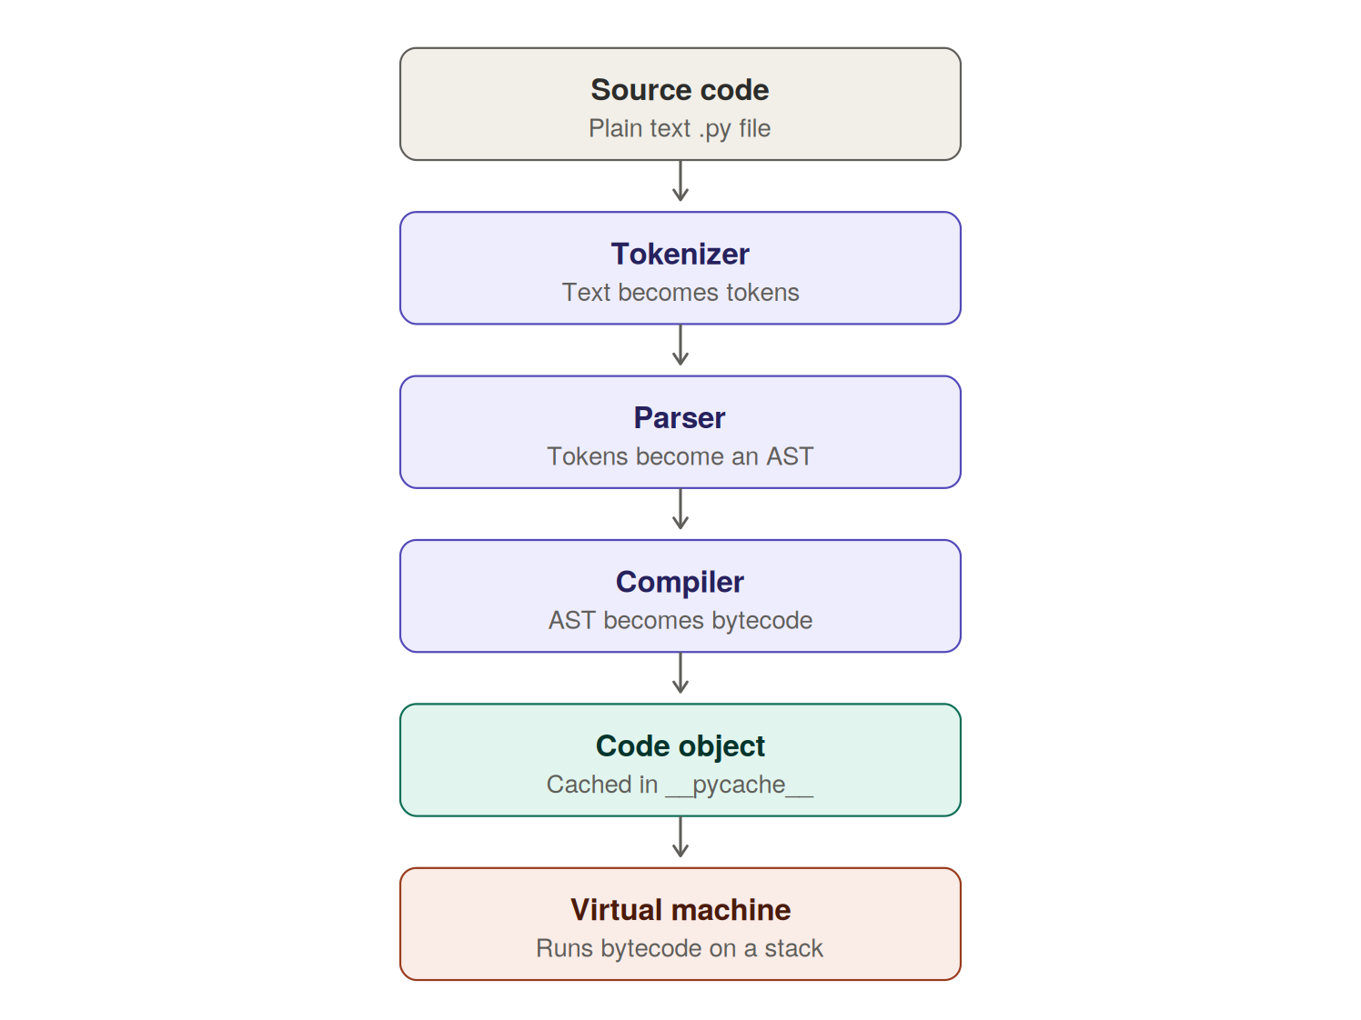
Figure 1 - The CPython execution pipeline, from source text to running bytecode
Stage | Input | Output | What it does
Tokenizer | Source text | Token stream | Splits text into names, operators and literals; turns indentation into INDENT and DEDENT tokens
Parser | Tokens | AST | Builds an abstract syntax tree using a PEG parser (since Python 3.9); this is where SyntaxError comes from
Compiler | AST | Bytecode | Flattens the tree into a linear instruction sequence and applies small optimisations
Virtual machine | Code object | Effects | Runs the evaluation loop in ceval.c, one opcode at a time

The compiler's output is a code object, which bundles the bytecode with the constants, variable names and stack-depth metadata the VM needs. For imported modules this is cached in __pycache__ so the compile step is skipped next time. Your top-level script is never cached, which is why it recompiles on every run.
LIVE DEMO Show all three intermediate forms of the same one-line program. Learners are usually surprised that they can see inside the interpreter this easily.
import ast, dis

src = "y = a + b * 2"

print("----- 1. TOKENS -----")
import io, tokenize
for tok in tokenize.generate_tokens(io.StringIO(src).readline):
if tok.string.strip():
print(f"{tokenize.tok_name[tok.type]:<12} {tok.string!r}")

print("\n----- 2. ABSTRACT SYNTAX TREE -----")
print(ast.dump(ast.parse(src), indent=2))

print("\n----- 3. BYTECODE -----")
dis.dis(src)

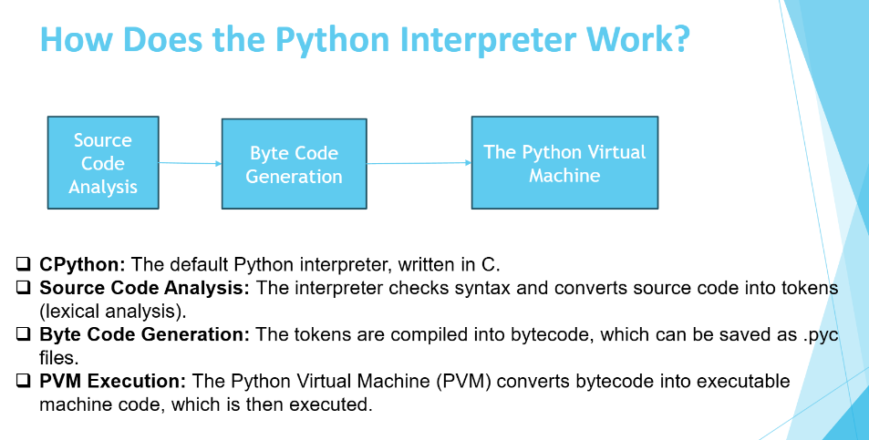
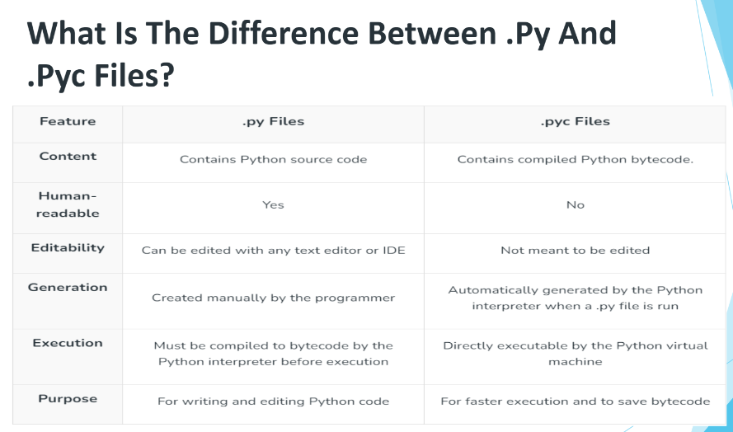

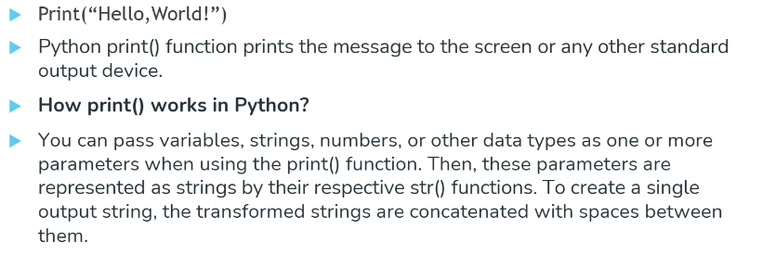

3.2 Python is a stack machine
CPython has no registers. Every instruction pushes operands onto, or pops them off, an evaluation stack belonging to the current frame. The compiler is responsible for emitting instructions in an order that leaves the stack balanced.
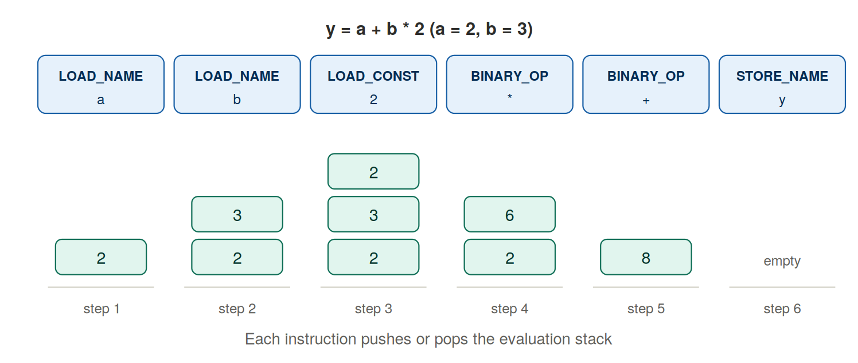
Figure 2 - Executing y = a + b * 2 one opcode at a time, with the stack after each step
Notice that operator precedence is not evaluated at runtime. It is baked into the instruction order at compile time - the multiply is emitted before the add, so it simply happens first. Notice also that the stack slots never hold raw numbers. Every slot holds a pointer to a heap object, which leads straight into the next section.
LIVE DEMO Compare two functions that do the same thing. The bytecode explains the speed difference far better than a stopwatch does.
import dis

def with_loop(items):
total = 0
for x in items:
total += x
return total

def with_builtin(items):
return sum(items)

print("=== with_loop ===")
dis.dis(with_loop)
print("=== with_builtin ===")
dis.dis(with_builtin)

# Now measure it
data = list(range(1_000_000))
import time
t0 = time.time(); with_loop(data); t1 = time.time()
t2 = time.time(); with_builtin(data); t3 = time.time()
print(f"\nPython loop : {t1-t0:.4f} s")
print(f"Built-in sum: {t3-t2:.4f} s")
Both functions produce the same answer. Why is the built-in several times faster? (Answer: the loop dispatches several opcodes per element inside the Python VM; sum() runs one C loop with no per-element dispatch. This is exactly why NumPy and pandas exist.)

3.3 The object model - everything is a labelled box on the heap
Every value in Python is a heap-allocated object with a common header. There are no primitives, and no split between value types and reference types.
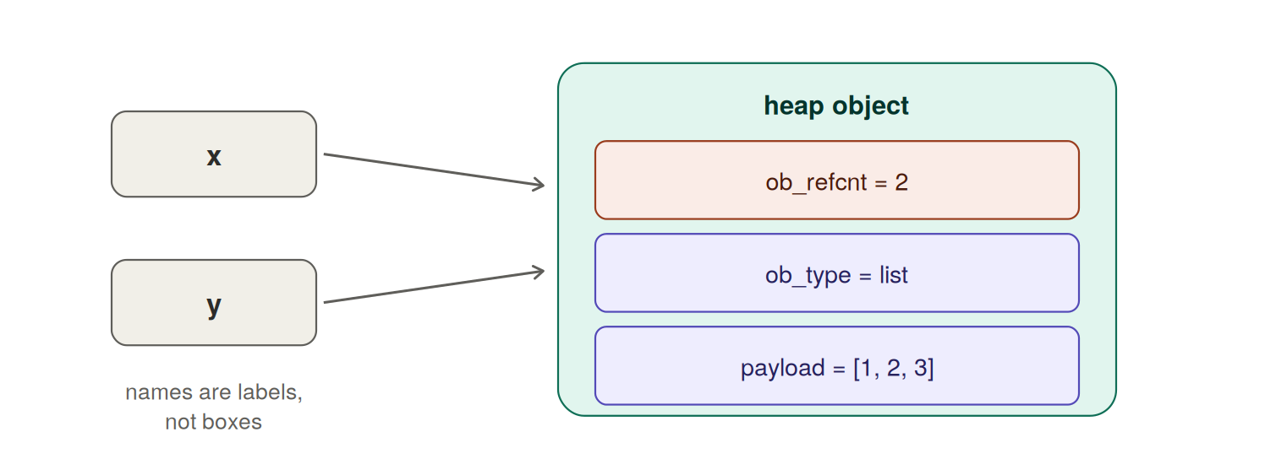
Figure 3 - Two names pointing at one object. Assignment binds a label; it never copies.
Header field | Purpose
ob_refcnt | How many references currently point at this object
ob_type | Pointer to the type object, which supplies methods and behaviour
payload | The actual data: digits for an int, a character buffer for a str, a pointer array for a list

LIVE DEMO This cell contains the two identity gotchas that every Python interview asks about. Let the room predict each output first - they will get at least one wrong.
import sys

# A name is a label, not a box
x = [1, 2, 3]
y = x # no copy - a second label on the same object
y.append(4)
print("x is now:", x) # x changed too
print("same object?", x is y, "| same id:", id(x) == id(y))

# A real copy needs to be asked for
z = x.copy()
z.append(99)
print("x after copying z:", x, "| z:", z, "| x is z:", x is z)

# Small integers are cached and shared
a, b = 256, 256
c, d = 257, 257
print("256 is 256 ->", a is b) # True - cached
print("257 is 257 ->", c is d) # False - separate objects

# Equality vs identity
print("equal values? ", [1,2] == [1,2]) # True
print("same object? ", [1,2] is [1,2]) # False

# The size of an object
print("bytes for int 42 :", sys.getsizeof(42))
print("bytes for [] :", sys.getsizeof([]))
THE CLASSIC BUG A mutable default argument is created once, when the function is defined - not on every call. def add(item, bucket=[]) will accumulate across calls forever. Use bucket=None and create the list inside the function. This single behaviour has caused more production incidents than any other Python feature.

3.4 Memory management - counting, then sweeping

Reference counting
Whenever a new reference appears - binding a name, appending to a container, passing an argument, capturing in a closure - CPython increments ob_refcnt. When a reference disappears, it decrements. The moment the count reaches zero, the object is deallocated immediately, inside that decrement, with no scan and no delay. That is why a file opened without a context manager is usually still closed promptly in CPython, and why relying on that behaviour breaks on other implementations.

Reference cycles, and why counting is not enough
Counting alone cannot free objects that reference each other. Each keeps the other alive even when nothing outside can reach them.
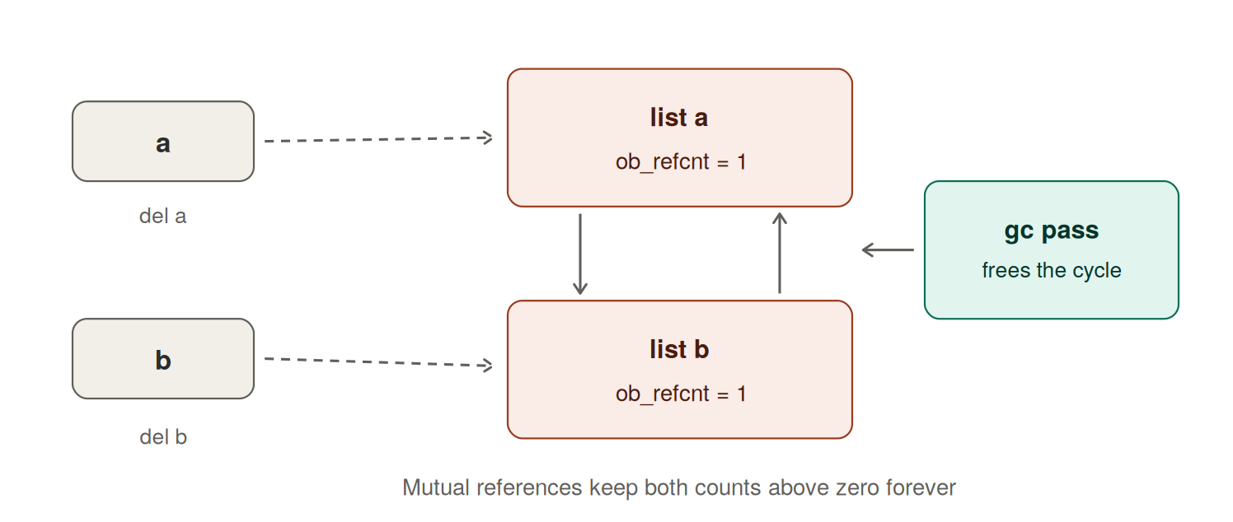
Figure 4 - An unreachable cycle. Both counts stay at 1 until the collector sweeps through.
A generational mark-and-sweep collector handles these. It tracks only container types - list, dict, set, tuple, class instances - since only those can form a cycle. Integers, floats and strings are never tracked. Collection is triggered by allocation volume, not by time: exceeding the generation-0 threshold (default 700 net allocations) triggers a pass, survivors are promoted, and every tenth pass escalates to the next generation. Generation 2 is the full-heap scan, and the expensive one.
# gc is Python's built-in garbage collector module

import gc, sys

# Reference counting in action
x = [1, 2, 3]
print("refcount after x =", sys.getrefcount(x)) # extra +1 from the function call
y = x
print("refcount after y = x:", sys.getrefcount(x))
del y
print("refcount after del y:", sys.getrefcount(x))

# Now build a cycle that counting cannot free
class Node:
def __init__(self, name):
self.name = name
self.peer = None

a, b = Node("a"), Node("b")
a.peer = b
b.peer = a # the cycle
del a, b # names gone, objects are not

gc.collect() # clear anything already pending
before = len(gc.get_objects())
collected = gc.collect()
print("\nGC thresholds :", gc.get_threshold())
print("Objects tracked:", before)
print("Collected in this pass:", collected)

3.5 The GIL - one lock to rule them all
Those reference count updates are not atomic. Rather than lock every object individually, CPython serialises bytecode execution behind a single Global Interpreter Lock. Only one thread executes Python bytecode at a time, no matter how many cores the machine has.
- Threads help with I/O. The lock is released around blocking calls - network, disk, database round trips - so concurrent I/O scales well.
- Threads do not help with CPU work. Pure-Python computation across threads is serialised regardless of core count.
- The workarounds: multiprocessing, C or Rust extensions that release the lock, or vectorised libraries such as NumPy that spend their time in compiled code.
import time, threading

def burn(n=8_000_000):
total = 0
for i in range(n):
total += i
return total

# Sequential
t0 = time.time(); burn(); burn(); seq = time.time() - t0

# "Parallel" with two threads
t0 = time.time()
threads = [threading.Thread(target=burn) for _ in range(2)]
for t in threads: t.start()
for t in threads: t.join()
par = time.time() - t0

print(f"Sequential : {seq:.2f} s")
print(f"Two threads : {par:.2f} s")
print(f"Speed-up : {seq/par:.2f}x (expect roughly 1x, not 2x - that is the GIL)")
ASK THE ROOM If threads cannot speed up this loop, why does every web framework still use them? (Answer: web servers spend their time waiting on sockets and databases, not computing. The GIL is released during that wait.)

3.6 Module 3 recap
Question an interviewer asks | The one-line answer
Is Python compiled or interpreted? | Both. It compiles to bytecode, then interprets that bytecode on a stack machine.
What is a .pyc file? | A cached code object for an imported module, stored in __pycache__.
Why is Python slow? | Per-opcode dispatch plus pointer chasing on every operand. Vectorised libraries bypass both.
How is memory freed? | Reference counting frees immediately at zero; a generational collector handles cycles.
What is the GIL? | One lock that serialises bytecode execution, making refcount updates safe.
Does a = b copy data? | No. It binds a second name to the same object and increments the refcount.

Module 4 - Mini project 1: retail customer analytics
Business case. A grocery chain has four weeks of transaction data. The management team wants four answers: which products earn the most, who the most valuable customers are, which products are bought together, and who is about to stop shopping with us. The whole thing is solved with list, tuple, set and dict - no libraries at all.

4.1 Choosing the right collection
Type | Ordered | Changeable | Duplicates | Use it for | In this project
list | Yes | Yes | Yes | A sequence you will grow or reorder | The transaction log
tuple | Yes | No | Yes | A fixed record; can be a dict key | One completed sale
set | No | Yes | No | Uniqueness and overlap questions | Unique customers, baskets
dict | Yes (3.7+) | Yes | Keys unique | Lookups and aggregation by key | Revenue and customer stats

4.2 The full notebook code
Paste this into a single Colab cell and run it. Every section prints its own output, so learners can follow along even if they fall behind.
# =====================================================================
# MINI PROJECT 1 : Retail Customer Analytics with Core Python
# Business case : A grocery chain wants to know its best products,
# loyal customers, frequently co-bought pairs, and
# who is at risk of churning.
# Tools used : list, tuple, set, dict (no external libraries)
# =====================================================================

# ---------------------------------------------------------------
# STEP 1 - RAW DATA : a LIST of TUPLES
# Each transaction is a tuple, because a completed sale must never
# change. Tuples are immutable, hashable and memory-light.
# (order_id, customer_id, product, quantity, price, week)
# ---------------------------------------------------------------
transactions = [
(1001, "C01", "milk", 2, 55.0, 1),
(1002, "C02", "bread", 1, 40.0, 1),
(1003, "C01", "eggs", 1, 90.0, 1),
(1004, "C03", "milk", 3, 55.0, 1),
(1005, "C02", "milk", 1, 55.0, 2),
(1006, "C01", "bread", 2, 40.0, 2),
(1007, "C04", "coffee", 1, 320.0, 2),
(1008, "C03", "eggs", 2, 90.0, 2),
(1009, "C01", "milk", 1, 55.0, 3),
(1010, "C05", "coffee", 2, 320.0, 1),
(1011, "C03", "bread", 1, 40.0, 3),
(1012, "C02", "eggs", 1, 90.0, 3),
(1013, "C01", "coffee", 1, 320.0, 4),
(1014, "C06", "milk", 4, 55.0, 4),
(1015, "C03", "milk", 2, 55.0, 4),
(1016, "C02", "bread", 3, 40.0, 4),
(1017, "C03", "coffee", 1, 320.0, 4),
(1018, "C02", "milk", 2, 55.0, 4),
]

print("Total transactions loaded:", len(transactions))
print("One record looks like :", transactions[0])

# Tuple unpacking - the readable way to read a record
order_id, customer_id, product, qty, price, week = transactions[0]
print(f"Order {order_id}: {customer_id} bought {qty} x {product} = Rs.{qty * price:.2f}")

# ---------------------------------------------------------------
# STEP 2 - SETS : unique things, membership tests, overlaps
# ---------------------------------------------------------------
all_customers = {t[1] for t in transactions} # set comprehension
all_products = {t[2] for t in transactions}

print("\nUnique customers:", len(all_customers), sorted(all_customers))
print("Unique products :", len(all_products), sorted(all_products))

week1_customers = {t[1] for t in transactions if t[5] == 1}
week4_customers = {t[1] for t in transactions if t[5] == 4}

print("Active in week 1 :", sorted(week1_customers))
print("Active in week 4 :", sorted(week4_customers))
print("Retained (in both weeks):", sorted(week1_customers & week4_customers)) # intersection
print("Lost after week 1 :", sorted(week1_customers - week4_customers)) # difference
print("New in week 4 :", sorted(week4_customers - week1_customers))
print("Ever active :", sorted(week1_customers | week4_customers)) # union

# ---------------------------------------------------------------
# STEP 3 - DICTIONARIES : the aggregation workhorse
# ---------------------------------------------------------------
revenue_by_product = {}
units_by_product = {}

for _, cust, prod, qty, price, week in transactions:
revenue_by_product[prod] = revenue_by_product.get(prod, 0.0) + qty * price
units_by_product[prod] = units_by_product.get(prod, 0) + qty

print("\n--- Revenue by product ---")
for prod, rev in sorted(revenue_by_product.items(), key=lambda kv: kv[1], reverse=True):
print(f"{prod:<8} Rs.{rev:>8.2f} ({units_by_product[prod]} units)")

# Customer-level metrics: dict of dicts
customer_stats = {}
for _, cust, prod, qty, price, week in transactions:
if cust not in customer_stats:
customer_stats[cust] = {"spend": 0.0, "orders": 0, "weeks": set(), "products": set()}
customer_stats[cust]["spend"] += qty * price
customer_stats[cust]["orders"] += 1
customer_stats[cust]["weeks"].add(week)
customer_stats[cust]["products"].add(prod)

print("\n--- Customer scorecard ---")
print(f"{'cust':<6}{'spend':>10}{'orders':>8}{'weeks':>7}{'variety':>9}")
for cust in sorted(customer_stats):
s = customer_stats[cust]
print(f"{cust:<6}{s['spend']:>10.2f}{s['orders']:>8}{len(s['weeks']):>7}{len(s['products']):>9}")

# ---------------------------------------------------------------
# STEP 4 - CUSTOMER SEGMENTATION (a simple business rule)
# ---------------------------------------------------------------
LATEST_WEEK = max(t[5] for t in transactions)

segments = {"champion": [], "loyal": [], "at_risk": [], "one_time": []}
for cust, s in customer_stats.items():
last_seen = max(s["weeks"])
recency = LATEST_WEEK - last_seen
if s["spend"] >= 500 and recency == 0:
segments["champion"].append(cust)
elif s["orders"] >= 3 and recency <= 1:
segments["loyal"].append(cust)
elif recency >= 2:
segments["at_risk"].append(cust)
else:
segments["one_time"].append(cust)

print("\n--- Segments ---")
for name, members in segments.items():
print(f"{name:<10}: {sorted(members)}")

# ---------------------------------------------------------------
# STEP 5 - MARKET BASKET : which products travel together?
# Sets make the co-occurrence logic trivial.
# ---------------------------------------------------------------
baskets = {}
for _, cust, prod, qty, price, week in transactions:
baskets.setdefault((cust, week), set()).add(prod)

pair_counts = {}
for basket in baskets.values():
items = sorted(basket)
for i in range(len(items)):
for j in range(i + 1, len(items)):
pair = (items[i], items[j]) # tuple key - lists cannot be dict keys
pair_counts[pair] = pair_counts.get(pair, 0) + 1

print("\n--- Product pairs bought in the same visit ---")
if pair_counts:
for pair, count in sorted(pair_counts.items(), key=lambda kv: kv[1], reverse=True):
print(f"{pair[0]:<8} + {pair[1]:<8} -> {count} time(s)")
else:
print("No multi-item baskets found")

# ---------------------------------------------------------------
# STEP 6 - THE BUSINESS ANSWER
# ---------------------------------------------------------------
top_product = max(revenue_by_product, key=revenue_by_product.get)
top_customer = max(customer_stats, key=lambda c: customer_stats[c]["spend"])
total_revenue = sum(revenue_by_product.values())

print("\n================ EXECUTIVE SUMMARY ================")
print(f"Total revenue : Rs.{total_revenue:.2f}")
print(f"Best-selling product : {top_product} (Rs.{revenue_by_product[top_product]:.2f})")
print(f"Most valuable client : {top_customer} (Rs.{customer_stats[top_customer]['spend']:.2f})")
print(f"Customers at risk : {sorted(segments['at_risk'])}")
print(f"Retention week1->4 : {len(week1_customers & week4_customers)}/{len(week1_customers)} customers")
print("===================================================")

4.3 Talking points while the code runs
- Why tuples for transactions? A completed sale must never change. Tuples are immutable, hashable and lighter than lists.
- Why sets for retention? Retained, lost and new customers are set intersection, difference and difference. One operator each, instead of nested loops.
- Why a tuple as the dictionary key? Product pairs need a composite key. Lists cannot be dict keys because they are mutable and therefore unhashable; tuples can.
- Why setdefault? It creates the empty set on first touch, avoiding an "if key not in dict" check on every row.

4.4 Extension exercises
- Add a discount field to each transaction tuple and recompute net revenue. What breaks, and why is that a good thing?
- Find customers who bought coffee but never bought milk, using set operations only.
- Rank weeks by revenue. Which week was strongest?
- Replace the manual counting with collections.Counter and collections.defaultdict, then compare the line counts.

Module 5 - Python for Data Science and ML
The goal here is flavour, not depth. Learners should leave knowing what the tools are for and having trained one real model themselves.

5.1 The ecosystem in one table
Library | What it does | The one-line reason it exists
NumPy | N-dimensional arrays and vectorised maths | Stores numbers in one contiguous C buffer instead of a million Python objects
pandas | Labelled tables: DataFrame and Series | SQL-like joins, groupby and filtering, in memory
matplotlib | Plotting | Turns a column into a picture your manager understands
scikit-learn | Classical machine learning | One consistent fit / predict interface across dozens of algorithms
TensorFlow, PyTorch | Deep learning | GPU training for neural networks
Seaborn, Plotly | Statistical and interactive charts | Prettier defaults, interactive dashboards

All of these are pre-installed in Colab. Connect this back to Module 3: every one of them is a wrapper around compiled code. They exist precisely because the Python-object-per-value model is too slow and too heavy for bulk numeric work.
LIVE DEMO The single most convincing cell of the session. Run it right after the GIL demo - it proves the point about pushing loops out of Python.
import numpy as np, time

size = 5_000_000
py_list = list(range(size))
np_array = np.arange(size)

t0 = time.time()
result_py = [x * 2 for x in py_list]
t_py = time.time() - t0

t0 = time.time()
result_np = np_array * 2
t_np = time.time() - t0

print(f"Pure Python list : {t_py:.4f} s")
print(f"NumPy array : {t_np:.4f} s")
print(f"NumPy is roughly {t_py/t_np:.0f}x faster on the same operation")

5.2 The standard workflow
Every data science project, from a homework notebook to a production pipeline, follows the same six steps. The project below walks all six.
Step | What you do | Typical tool
1. Get data | Load from CSV, database, API or generate it | pandas, SQL
2. Explore | Shapes, distributions, correlations, missing values | pandas, matplotlib
3. Prepare | Clean, encode, scale, split into train and test | pandas, scikit-learn
4. Train | Fit one or more models on the training data | scikit-learn
5. Evaluate | Score on unseen test data, inspect the errors | scikit-learn metrics
6. Predict | Score new records and hand them to the business | The fitted model

THE RULE THAT MATTERS MOST Fit the scaler and the model on the training data only, then apply them to the test data. If any information from the test set leaks into training, the score becomes a lie and the model fails in production. Say this out loud twice.

5.3 Mini project 2: predicting customer churn
Business case. A telecom operator loses subscribers every month. The retention team can only call a few hundred people, so they need a ranked list of who is most likely to leave. We generate a realistic dataset, explore it, train two models, compare them, find out what drives churn, and score four new customers.
Paste this into one Colab cell. It needs no file upload and no internet - everything is generated with a fixed random seed, so every learner sees the same numbers.
# =====================================================================
# MINI PROJECT 2 : Telecom Customer Churn Prediction (end to end)
# Business case : predict which subscribers will leave next month so
# the retention team can call them first.
# Stack : numpy -> pandas -> matplotlib -> scikit-learn
# Runs offline in Google Colab. No file upload, no internet needed.
# =====================================================================

import numpy as np
import pandas as pd
import matplotlib.pyplot as plt

from sklearn.model_selection import train_test_split
from sklearn.preprocessing import StandardScaler
from sklearn.linear_model import LogisticRegression
from sklearn.ensemble import RandomForestClassifier
from sklearn.metrics import accuracy_score, classification_report, confusion_matrix, roc_auc_score

pd.set_option("display.width", 120)
np.random.seed(42) # same numbers for everyone in the room

# ---------------------------------------------------------------
# STEP 1 - CREATE THE DATASET (numpy generates it, pandas holds it)
# ---------------------------------------------------------------
n = 1200

tenure_months = np.random.randint(1, 60, n)
monthly_charges = np.round(np.random.uniform(200, 1500, n), 2)
support_calls = np.random.poisson(2, n)
data_gb = np.round(np.random.uniform(1, 60, n), 1)
is_on_contract = np.random.binomial(1, 0.55, n)

# Hidden business logic: unhappy customers churn.
# Short tenure, high bills, many support calls, no contract -> risk up.
risk = (
-0.06 * tenure_months
+ 0.0022 * monthly_charges
+ 0.45 * support_calls
- 1.30 * is_on_contract
- 0.02 * data_gb
+ 0.5
)
prob = 1 / (1 + np.exp(-risk))
churn = np.random.binomial(1, prob)

df = pd.DataFrame({
"tenure_months": tenure_months,
"monthly_charges": monthly_charges,
"support_calls": support_calls,
"data_gb": data_gb,
"on_contract": is_on_contract,
"churn": churn,
})

print("Shape:", df.shape)
print(df.head())

# ---------------------------------------------------------------
# STEP 2 - EXPLORE (this is 80% of a real data science job)
# ---------------------------------------------------------------
print("\nChurn rate: {:.1%}".format(df["churn"].mean()))
print("\nAverages by churn group:")
print(df.groupby("churn").mean(numeric_only=True).round(2))

print("\nCorrelation with churn:")
print(df.corr(numeric_only=True)["churn"].sort_values(ascending=False).round(3))

fig, axes = plt.subplots(1, 3, figsize=(15, 4))
df.groupby("churn")["tenure_months"].mean().plot(kind="bar", ax=axes[0],
color=["#1D9E75", "#D85A30"], rot=0)
axes[0].set_title("Average tenure by churn")
axes[0].set_xlabel("0 = stayed, 1 = churned")

df.groupby("support_calls")["churn"].mean().plot(marker="o", ax=axes[1], color="#534AB7")
axes[1].set_title("Churn rate vs support calls")
axes[1].set_ylabel("churn rate")

df.groupby("on_contract")["churn"].mean().plot(kind="bar", ax=axes[2],
color=["#D85A30", "#1D9E75"], rot=0)
axes[2].set_title("Churn rate by contract")
axes[2].set_xlabel("0 = no contract, 1 = on contract")

plt.tight_layout()
plt.show()

# ---------------------------------------------------------------
# STEP 3 - SPLIT AND SCALE
# ---------------------------------------------------------------
X = df.drop(columns="churn")
y = df["churn"]

X_train, X_test, y_train, y_test = train_test_split(
X, y, test_size=0.25, random_state=42, stratify=y
)
print("\nTrain rows:", len(X_train), " Test rows:", len(X_test))

scaler = StandardScaler()
X_train_s = scaler.fit_transform(X_train) # fit on TRAIN only
X_test_s = scaler.transform(X_test) # never fit on test

# ---------------------------------------------------------------
# STEP 4 - TRAIN TWO MODELS AND COMPARE
# ---------------------------------------------------------------
logreg = LogisticRegression(max_iter=1000)
logreg.fit(X_train_s, y_train)
pred_lr = logreg.predict(X_test_s)

rf = RandomForestClassifier(n_estimators=200, random_state=42)
rf.fit(X_train, y_train) # trees do not need scaling
pred_rf = rf.predict(X_test)

print("\nLogistic Regression accuracy: {:.3f}".format(accuracy_score(y_test, pred_lr)))
print("Random Forest accuracy: {:.3f}".format(accuracy_score(y_test, pred_rf)))
print("Logistic Regression ROC AUC : {:.3f}".format(
roc_auc_score(y_test, logreg.predict_proba(X_test_s)[:, 1])))

print("\nClassification report (Logistic Regression):")
print(classification_report(y_test, pred_lr, target_names=["stayed", "churned"]))

cm = confusion_matrix(y_test, pred_lr)
print("Confusion matrix:")
print(pd.DataFrame(cm,
index=["actual stayed", "actual churned"],
columns=["predicted stayed", "predicted churned"]))

# ---------------------------------------------------------------
# STEP 5 - WHICH FEATURES DRIVE CHURN?
# ---------------------------------------------------------------
importance = pd.Series(rf.feature_importances_, index=X.columns).sort_values()
print("\nFeature importance (Random Forest):")
print(importance.round(3))

plt.figure(figsize=(7, 3.5))
importance.plot(kind="barh", color="#378ADD")
plt.title("What drives churn")
plt.tight_layout()
plt.show()

# ---------------------------------------------------------------
# STEP 6 - SCORE NEW CUSTOMERS (this is what goes to production)
# ---------------------------------------------------------------
new_customers = pd.DataFrame({
"tenure_months": [2, 48, 6, 30],
"monthly_charges": [1400, 450, 1200, 700],
"support_calls": [6, 0, 4, 1],
"data_gb": [5.0, 40.0, 12.0, 25.0],
"on_contract": [0, 1, 0, 1],
})

risk_score = logreg.predict_proba(scaler.transform(new_customers))[:, 1]
new_customers["churn_probability"] = np.round(risk_score, 3)
new_customers["action"] = np.where(risk_score > 0.5, "CALL NOW", "monitor")

print("\n--- Retention worklist ---")
print(new_customers.sort_values("churn_probability", ascending=False))

5.4 What to point out in the output
- Accuracy near 75 percent, ROC AUC near 0.85. Good, not perfect - which is realistic. A model that scores 99 percent on the first try usually has a leak.
- The confusion matrix is the business conversation. A missed churner costs a customer; a false alarm costs one phone call. Those are not equally expensive, so the 0.5 threshold is a business decision, not a technical one.
- Feature importance matches intuition. Tenure, monthly charges and support calls dominate. When importance contradicts intuition, investigate before trusting it.
- The final table is the actual deliverable. Not the accuracy score - the ranked worklist the retention team can act on this morning.
ASK : The model says a customer has a 0.998 probability of churning. What should the business actually do, and what would you need to know before spending money on them? (Steer toward: expected lifetime value versus the cost of the intervention. A high-risk, low-value customer may not be worth saving.)

Wrap-up

Closing quiz - run it as a rapid-fire round
Question | Answer
Who created Python, and in which year did work begin? | Guido van Rossum, December 1989
Where does the name come from? | Monty Python's Flying Circus, not the snake
What are the four stages from source to execution? | Tokenizer, parser, compiler, virtual machine
What does __pycache__ hold? | Compiled bytecode for imported modules
Is Python a register machine or a stack machine? | A stack machine - no registers
What happens when a refcount reaches zero? | The object is deallocated immediately
What does the garbage collector handle that counting cannot? | Reference cycles between container objects
Why can two threads not speed up a Python loop? | The GIL serialises bytecode execution
Which collection type can be a dictionary key: list or tuple? | Tuple, because it is immutable and hashable
Why is NumPy so much faster than a list comprehension? | Contiguous memory and one C loop, with no per-element dispatch

The five things to remember
- Python compiles to bytecode, then runs it on a stack machine. It is not "just interpreted".
- A name is a label on a heap object. Assignment never copies.
- Memory is freed by reference counting, with a generational collector for cycles.
- The GIL makes threads useful for I/O and useless for CPU-bound loops.
- When Python feels slow, the fix is to move the loop out of Python - into NumPy, pandas, or the database.

